Lesson 18: Sampling Variability in the Sample Mean

Classwork
Exercises 1-7: Random Segments
The worksheet contains $100$ segments of different lengths. The length of a segment is the number of rectangles spanned on the grid. For example, segment $2$ has length $5$.
- Briefly review the sheet and estimate of the mean length of the segments. Will your estimate be close to the actual mean? Why or why not?

- Look at the sheet. With which of the statements below would you agree? Explain your reasoning.
The mean length of the segments is:
  - close to $1$
  - close to $8$
  - around $5$
  - between $2$ and $5$

- Follow your teacher’s directions to select ten random numbers between $1$ and $100$. For each random number, start at the upper left cell with a segment value of $2$, and count down and to the right the number of cells based on the random number selected. The number in the cell represents the length of a randomly selected segment.
  - On a number line, graph the lengths of the corresponding segments on the worksheet.

  - Find the mean and standard deviation of the lengths of the segments in your sample. Mark the mean length on your graph from part (a).

- Your sample provides some information about the mean length of the segments in one random sample of size $10$, but that sample is only one among all the different possible random samples. Let’s look at other random samples and see how the means from those samples compare to the mean segment length from your random sample.
Record the mean segment length for your random sample on a post-it note, and post the note in the appropriate place on the number line your teacher set up.
  - Jonah looked at the plot and said, “Wow, our means really varied.” What do you think he meant?

  - Describe the simulated sampling distribution of mean segment lengths for samples of size $10$.

  - How did your first estimate (from Exercise 1) compare to your sample mean from the random sample? How did it compare to the means in the simulated distribution of the sample means from the class?

- Collect the values of the sample means from the class.
  - Find the mean and standard deviation of the simulated distribution of the sample means.

  - Interpret the standard deviation of the simulated sampling distribution in terms of the length of the segments.

  - What do you observe about the values of the means in the simulated sampling distribution that are within two standard deviations from the mean of the sampling distribution?

- Generate another set of ten random numbers, find the corresponding lengths on the sheet, and calculate the mean length for your sample. Put a post-it note with your sample mean on the second number line. Then answer the following questions:
  - Find the mean and standard deviation of the simulated distribution of the sample means.

  - Interpret the standard deviation of the simulated sampling distribution in terms of the length of the segments.

  - What do you observe about the values of the means in the simulated sampling distribution that are within two standard deviations from the mean of the sampling distribution?

- Suppose that we know the actual mean of all the segment lengths is $2.78$ units.
  - Describe how the population mean relates to the two simulated distributions of sample means.

  - Tonya was concerned that neither of the simulated distributions of sample means had a value around $5$, but some of the segments on the worksheet were $5$ units long and some were as big as $8$ units long. What would you say to Tonya?

Lesson Summary
In this lesson you drew a sample from a population and found the mean of that sample.
- Drawing many samples of the same size from the same population and finding the mean of each of those samples allows you to build a simulated sampling distribution of the sample means for the samples you generated.
- The mean of the simulated sampling distribution of sample means is close to the population mean.
- In the two examples of simulated distributions of sample means we generated, most of the sample means seemed to fall within two standard deviations of the mean of the simulated distribution of sample means.

Problem Set

- The three distributions below relate to the population of all of the random segment lengths and to samples drawn from that population. The eight phrases below could be used to describe a whole graph or a value on the graph. Identify where on the appropriate graph the phrases could be placed. (For example, segment of length $2$ could be placed by any of the values in the column for $2$ on the plot labeled “Length.”)

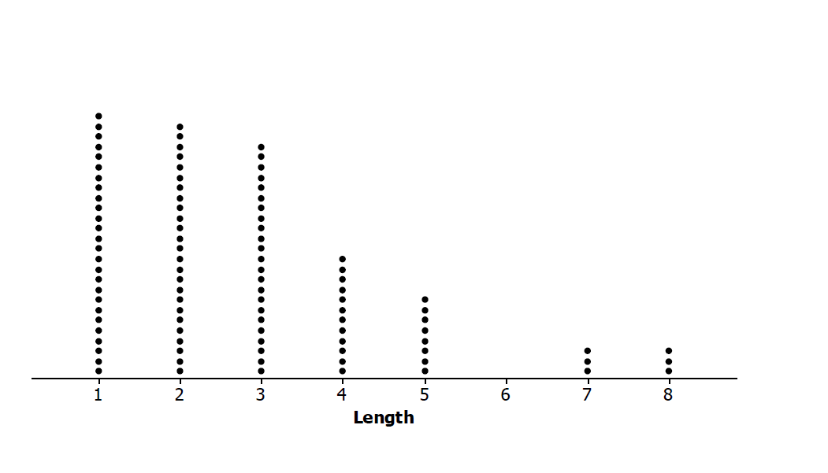

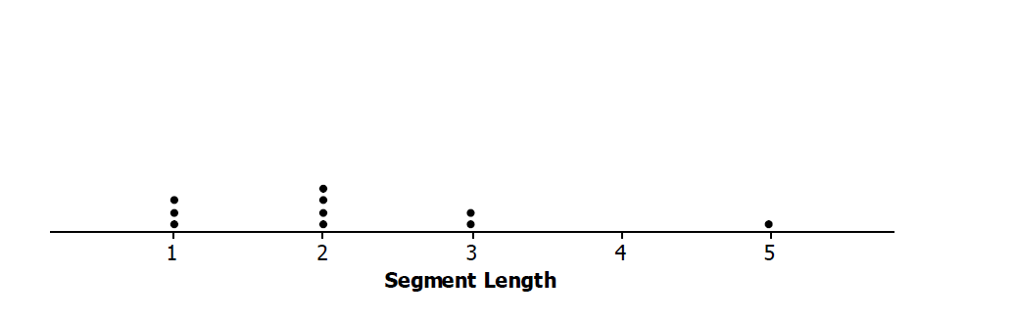

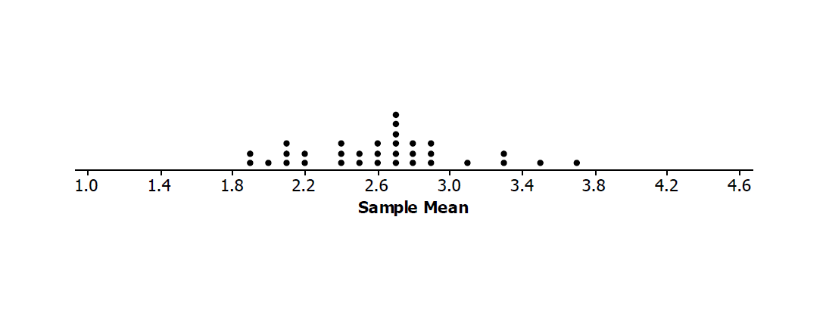

  - Random sample of size $10$ of segment lengths
  - Segment of length $2$
  - Sample mean segment length of $2$
  - Mean of sampling distribution, $2.6$
  - Simulated distribution of sample means
  - Sample segment lengths
  - Population of segment lengths
  - Mean of all segment lengths, $2.78$

- The following segment lengths were selected in four different random samples of size $10$.

Lengths Sample A | Lengths Sample B | Lengths Sample C | Lengths Sample D
$$1$$ | $$1$$ | $$1$$ | $$2$$
$$2$$ | $$3$$ | $$5$$ | $$2$$
$$1$$ | $$1$$ | $$1$$ | $$7$$
$$5$$ | $$2$$ | $$3$$ | $$2$$
$$3$$ | $$1$$ | $$4$$ | $$5$$
$$1$$ | $$5$$ | $$2$$ | $$2$$
$$2$$ | $$3$$ | $$2$$ | $$3$$
$$2$$ | $$4$$ | $$4$$ | $$5$$
$$3$$ | $$3$$ | $$3$$ | $$5$$
$$1$$ | $$3$$ | $$4$$ | $$4$$

  - Find the mean segment length of each sample.
  - Find the mean and standard deviation of the four sample means.
  - Interpret your answer to part (b) in terms of the variability in the sampling process.

- Two simulated sampling distributions of the mean segment lengths from random samples of size $10$ are displayed below.
Distribution A  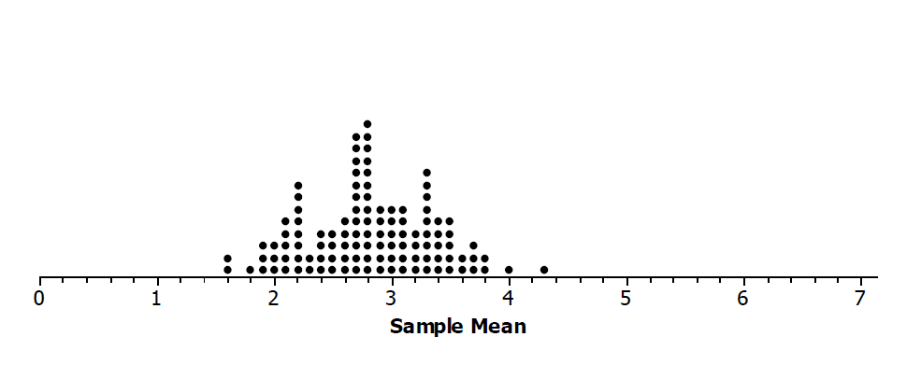 | Distribution B  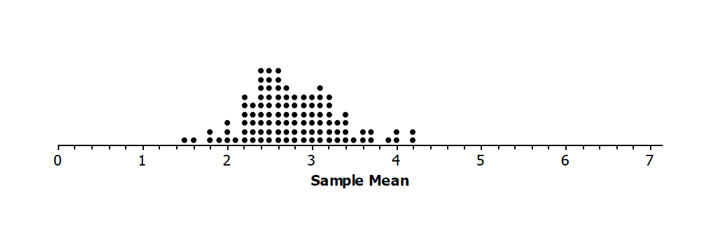

  - Compare the two distributions with respect to shape, center, and spread.
  - Distribution A has a mean of $2.82$, and Distribution B has a mean of $2.77$. How do these means compare to the population mean of $2.78$?
  - Both Distribution A and Distribution B have a standard deviation $0.54$. Make a statement about the distribution of sample means that makes use of this standard deviation.

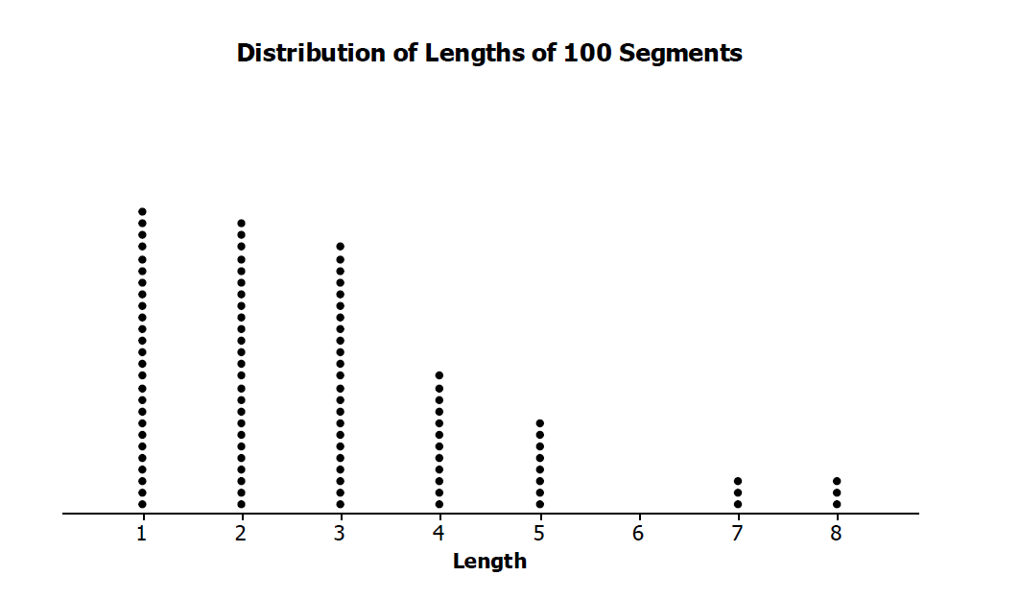
- The population distribution of all the segment lengths is shown in the dot plot below. How does the population distribution compare to the two simulated sampling distributions of the sample means in Problem 3?

