|  |
| --- |
|  |

Lesson 17: Margin of Error when Estimating a Population Proportion

Student Outcomes

* Students use data from a random sample to estimate a population proportion.
* Students calculate and interpret margin of error in context.
* Students know the relationship between sample size and margin of error in the context of estimating a population proportion.

Lesson Notes

A general approach for finding a margin of error involves using the standard deviation of a sample proportion. With appropriate sample sizes, of all sample proportions will be within *about* two standard deviations of the true population proportion. Therefore, due to natural sampling variability, of all samples will have a sample proportion of , where is the margin of error. The first half of this lesson leads students through an example of finding and interpreting the standard deviation of a sampling distribution for a sample proportion. The focus of the second half of the lesson centers on the concept that if a sample size is large, then the sampling distribution of the sample proportion is approximately normal. To use the normal model for a sampling distribution, the “Success-Failure” condition (in which and , and the “” condition (i.e., the sample size is no larger than of the population) must both be met.

Classwork

Scaffolding:

Some students may have trouble moving from the count of the number of successes to the proportion. Suppose there are seniors out of high school students.

* To find the proportion, divide the number of successes by the sample size:
* To find the percentage, multiply the proportion by :

In this lesson, you will find and interpret the standard deviation of a simulated distribution for a sample proportion and use this information to calculate a margin of error for estimating the population proportion.

Exercises 1–6 (18 minutes): Standard Deviation for Proportions

In this set of exercises, students find and interpret the standard deviation of a sample proportion. Note that there is a shift in the notation to account for the sampling context, where the sample proportion of successes—denoted by and read as p-hat—is a statistic obtained from the sample, as opposed to , which is the proportion of successes in the entire population.

Exercises 1–6: Standard Deviations for Proportions

In the previous lesson, you used simulated sampling distributions to learn about sampling variability in the sample proportion and the margin of error when using a random sample to estimate a population proportion. However, finding a margin of error using simulation can be cumbersome and can take a long time for each situation. Fortunately, given the consistent behavior of the sampling distribution of the sample proportion for random samples, statisticians have developed a formula that will allow you to find the margin of error quickly and without simulation.

1. of students participating in sports at Union High School are female (a proportion of ).
   1. If you took many random samples of students who play sports and made a dot plot of the proportion of females in each sample, where do you think this distribution will be centered? Explain your thinking.

Answers will vary. of is , so I would expect the sampling distribution to be centered around females or .

* 1. In general, for any sample size, where do you think the center of a simulated distribution of the sample proportion of females in sports at Union High School will be?

The sampling distribution should be centered at around . Some samples will result in a sample proportion of females that is greater than and some will result in a sample proportion of females that is less than , but the sample proportions should center around .

1. Below are two simulated sampling distributions for the sample proportion of females in random samples from all the students at Union High School.

|  |  |
| --- | --- |
| Simulated Sampling Distribution 1 | Simulated Sampling Distribution 2 |

* 1. Based on the two sampling distributions above, what do you think is the population proportion of females?

Answers will vary, but students should give an answer around .

* 1. One of the sampling distributions above is based on random samples of size , and the other is based on random samples of size . Which sampling distribution corresponds to the sample size of ? Explain your choice.

Simulated Sampling Distribution 2 corresponds to the sample size of . I chose this one because it is more spread out—there is more sample-to-sample variability in Simulated Sampling Distribution 2 than in Simulated Sampling Distribution 1.

1. Remember from your earlier work in statistics that distributions were described using shape, center, and spread. How was spread measured?

The spread of a distribution was measured with either the standard deviation or (sometimes) the interquartile range.

1. In previous lessons, you saw a formula for the standard deviation of the sampling distribution of the sample mean. There is also a formula for the standard deviation of the sampling distribution of the sample proportion. For random samples of size , the standard deviation can be calculated using the following formula:

, where is the value of the population proportion and is the sample size.

* 1. If the proportion of females at Union High School is , what is the standard deviation of the distribution of the sample proportions of females for random samples of size ? Round your answer to three decimal places.
  2. The proportion of males at Union High School is . What is the standard deviation of the distribution of the sample proportions of males for random samples of size ? Round your answer to three decimal places.
  3. Think about the graphs of the two distributions in parts (a) and (b). Explain the relationship between your answers using the center and spread of the distributions.

Possible answer: The two distributions are alike, but one is centered at and the other at . The spread, as measured by the standard deviation of the two distributions, will be the same.

1. Think about the simulations that your class performed in the previous lesson and the simulations in Exercise 2 above.
   1. Was the sampling variability in the sample proportion greater for samples of size or for samples of size ? In other words, does the sample proportion tend to vary more from one random sample to another when the sample size is or ?

There was more variability from sample to sample when the sample size was .

* 1. Explain how the observation that the variability in the sample proportions decreases as the sample size increases is supported by the formula for the standard deviation of the sample proportion.

You divide by in the formula, and as (a positive whole number) increases, the result of the division will be smaller.

1. Consider the two simulated sampling distributions of the proportion of females in Exercise 2 where the population proportion was . Recall that you found for Distribution 1, and for Distribution 2.
   1. Find the standard deviation for each distribution. Round your answer to three decimal places.

In Simulated Sampling Distribution 1, , and the standard deviation is .

In Simulated Sampling Distribution 2, , and the standard deviation is .

* 1. Make a sketch and mark off the intervals one standard deviation from the mean for each of the two distributions. Interpret the intervals in terms of the proportion of females in a sample.

|  |  |
| --- | --- |
| Simulated Sampling Distribution 1:  The interval is from to . Typically the proportion of females in a sample of size will be between to or about –. | Simulated Sampling Distribution 2:  The interval is from to . In a sample of size , the proportion of females will typically be between to or about . |

In general, three results about the sampling distribution of the sample proportion are known:

* The sampling distribution of the sample proportion is centered at the actual value of the population proportion, .
* The sampling distribution of the sample proportion is less variable for larger samples than for smaller samples. The variability in the sampling distribution is described by the standard deviation of the distribution, and the standard deviation of the sampling distribution for random samples of size is , where is the value of the population proportion. This standard deviation is usually estimated using the sample proportion, which is denoted by (read as p-hat), to distinguish it from the population proportion. The formula for the estimated standard deviation of the distribution of sample proportions is .
* As long as the sample size is large enough that the sample includes at least successes and failures, the sampling distribution is approximately normal in shape. That is, a normal distribution would be a reasonable model for the sampling distribution.

Exercises 7–12 (17 minutes): Using the Standard Deviation with Margin of Error

The focus of this exercise set centers on the fact that if the sample size is large, the sampling distribution of the sample proportion is approximately normal. Combining this information with what students have learned about normal distributions leads to the fact that about of the sample proportions will be within two standard deviations of the value of the population (the mean of the sampling distribution). Note that if the population proportion is close to or either no one or everyone has the characteristic of interest, and the normal approximation to the sampling distribution, is not appropriate unless the sample size is very, very large. To use the result based on the normal distribution, values of and should satisfy and . This is the same as saying that the sample is large enough and you would expect to see at least successes and failures in the sample. In addition to this “Success-Failure” condition, a “” condition must also be met. The sample size must be less than of the population to ensure that samples are independent.

**MP.2**

Building from this normal approximation to the sampling distribution of , you can create a formula for the margin of error, dependent on the sample size and the proportion of successes observed in the sample.

In Exercise 9, interested and motivated students might analyze the change in the rate at which the margin of error decreases and note that it is not constant; the margin of error is decreasing at a smaller and smaller rate as the sample size increases, which suggests a possible limiting factor.

**MP.2**

In Exercises 11 and 12, students look for and make use of structure as they consider the formula for margin of error and reason about how margin of error is affected by sample size and the value of the sample proportion.

**MP.7**

Exercises 7-12: Using the Standard Deviation with Margin of Error

1. 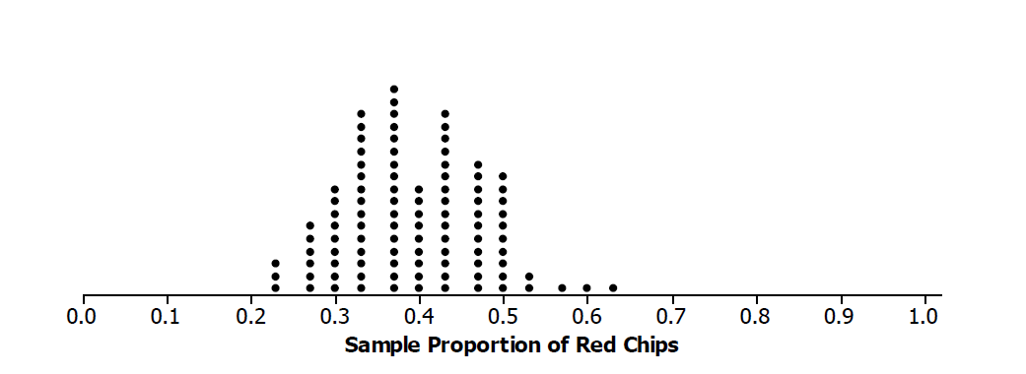In the work above, you investigated a simulated sampling distribution of the proportion of females in a sample of size drawn from a population with a known proportion of females. The simulated distribution of the proportion of red chips in a sample of size drawn from a population with a known proportion of is displayed below.
   1. Use the formula for the standard deviation of the sample proportion to calculate the standard deviation of the sampling distribution. Round your answer to three decimal places.

The standard deviation should be about .

* 1. The distribution from Exercise 2 for a sample of size is below. How do the two distributions compare?



The shapes of the two sampling distributions of the proportions are slightly different, but they both center at and have the same estimated standard deviation, .

* 1. How many of the values of the sample proportions are within one standard deviation of ? How many are within two standard deviations of ?

The typical distance of the values from is one standard deviation, between and . All but two of the values are within two standard deviations from , or between and . See the dot plot below.



In general, for a known population proportion, about of the outcomes of a simulated sampling distribution of a sample proportion will fall within two standard deviations of the population proportion. One caution is that if the proportion is close to or , this general rule may not hold unless the sample size is very large. You can build from this to estimate a proportion of successes for an unknown population proportion and calculate a margin of error without having to carry out a simulation.

If the sample is large enough to have at least of each of the two possible outcomes in the sample, but small enough to be no more than of the population, the following formula (based on an observed sample proportion can be used to calculate the margin of error. The standard deviation involves the parameter that is being estimated. Because is often not known, statisticians replace with its estimate in the standard deviation formula. This estimated standard deviation is called the standard error of the sample proportion.

* 1. Suppose you draw a random sample of chips from a mystery bag and find red chips. Find *,* the sample proportion of red chips, and the standard error.

and the standard error is

* 1. Interpret the standard error.

The sample proportion was , so I estimate that the proportion of red chips in the bag is . The actual population proportion probably isn’t exactly equal to , but I expect that my estimate is within of the actual value.

When estimating a population proportion, margin of error can be defined as the maximum expected difference between the value of the population proportion and a sample estimate of that proportion (the farthest away from the actual population value that you think your estimate is likely to be).

|  |
| --- |
| If is the sample proportion for a random sample of size from some population, and if the sample size is large enough: |

1. Henri and Terence drew samples of size from a mystery bag. Henri drew red chips, and Terence drew red chips. Find the margins of error for each student.

Henri’s estimated margin of error is ; Terence’s estimated margin of error is .

1. Divide the problems below among your group, and find the sample proportion of successes and the estimated margin of error in each situation:
   1. Sample of size , red chips

Sample proportion of red chips = or ; estimated margin of error = or .

* 1. Sample of size , red chips

Sample proportion of red chips = or ; estimated margin of error = or %.

* 1. Sample of size 80, 20 red chips

Sample proportion of red chips = or ; estimated margin of error = or

* 1. Sample of size , red chips

Sample proportion of red chips = or ; estimated margin of error = or

1. Look at your answers to Exercise 2.
   1. What conjecture can you make about the relation between sample size and margin of error? Explain why your conjecture makes sense.

Possible answer: As the sample size increases, the margin of error decreases. If you have a larger sample size, you can get a better estimate of the proportion of successes that are in the population, so the margin of error should be smaller.

* 1. Think about the formula for a margin of error. How does this support or refute your conjecture?

Possible answer: In the formula for the margin of error, the sample size is in the denominator of a fraction. If the sample size is large, that means the result of the division gets smaller. So, if the proportion is the same for three different-sized random samples, the smallest result would be when you divided by the largest sample size.

1. Suppose that a random sample of size will be used to estimate a population proportion.
   1. Would the estimated margin of error be greater if or ? Support your answer with appropriate calculations.  
        
      *For* , *estimated margin of error*

*For* , *estimated margin of error*

The estimated margin of error is greater when .

* 1. Would the estimated margin of error be greater if or ? Support your answer with appropriate calculations.

For , estimated margin of error

*For* , *estimated margin of error*

*The estimated margin of error is greater when .*

* 1. 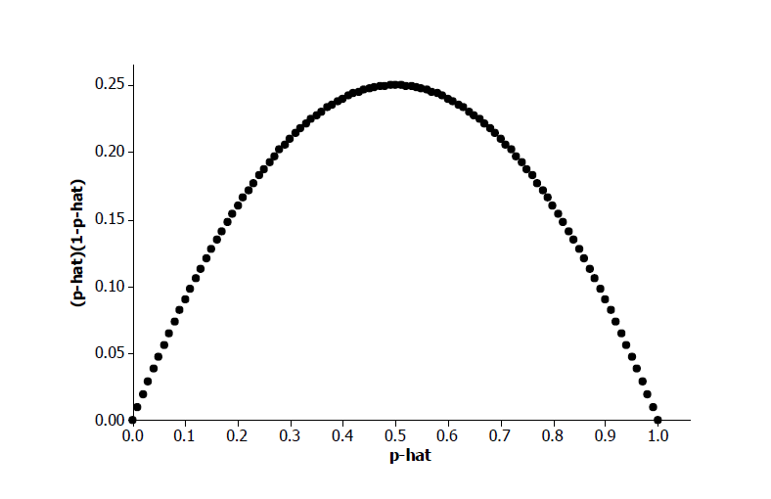For what value of do you think the estimated margin of error will be greatest? (Hint: Draw a graph of as ranges from to .)

The estimated margin of error is greater when . The value of is greatest when (See graph below.) This value is in the numerator of the fraction in the formula for margin of error, so the margin of error is greatest when .

Closing (5 minutes)

* How does the work you did earlier on normal distributions relate to the margin of error?
  + *Possible answer: In a normal distribution, about of the outcomes are within two standard deviations of the mean. We used the same thinking to get the margin of error formula.*
* How will your thinking about the margin of error change in each of the following situations?
* a poll of randomly selected people found favor changing the voting age;
* a sample of red chips from a mystery bag found red chips;
* cars in a random sample of cars sold by a dealer were white.
  + *Possible answer: In all of the examples, the sample proportion and the sample size are the same and would give the same margin of error.*
* Why is it important to have a random sample when you are finding a margin of error?
  + *Possible answer: A random sample is important because you need to know that the behavior of the sample you choose should be fairly consistent across different samples. Having randomly selected samples is the only way to be sure of this.*

Ask students to summarize the main ideas of the lesson in writing or with a neighbor. Use this as an opportunity to informally assess comprehension of the lesson. The Lesson Summary below offers some important ideas that should be included.

Exit Ticket (5 minutes)

Lesson Summary

* Because random samples behave in a consistent way, a large enough sample size allows you to find a formula for the standard deviation of the sampling distribution of a sample proportion. This can be used to calculate the margin of error: , where is the proportion of successes in a random sample of size .
* The sample size is large enough to use this result for estimated margin of error if there are at least of each of the two outcomes.
* The sample size should not exceed of the population.
* As the sample size increases, the margin of error decreases.

Name Date

Lesson 17: Margin of Error when Estimating a Population Proportion

Exit Ticket

1. Find the estimated margin of error when estimating the proportion of red chips in a mystery bag if red chips were drawn from the bag in a random sample of chips.
2. Explain what your answer to Problem 1 tells you about the number of red chips in the mystery bag.
3. How could you decrease your margin of error? Explain why this works.

Exit Ticket Sample Solutions

1. Find the estimated margin of error when estimating the proportion of red chips in a mystery bag if red chips were drawn from the bag in a random sample of chips.

The margin of error would be .

1. Explain what your answer to Problem 1 tells you about the number of red chips in the mystery bag.

Possible answer: The sample proportion of is likely to be within of the actual value of the population proportion. This means that the proportion of red chips in the bag might be somewhere between and or about – red chips.

1. How could you decrease your margin of error? Explain why this works.

Margin of error could be decreased by increasing sample size. The larger the sample size, the smaller the standard deviation, thus the smaller the margin of error.

Problem Set Sample Solutions

1. Different students drew random samples of size from the mystery bag. The number of red chips each drew is given below. In each case, find the margin of error for the proportions of the red chips in the mystery bag.
   1. red chips

The margin of error will be .

* 1. red chips

The margin of error will be .

* 1. red chips

The margin of error will be .

1. The school newspaper at a large high school reported that out of randomly selected students favor assigned parking spaces. Compute the margin of error. Interpret the resulting interval in context.

The margin of error will be . The resulting interval is or from to . The proportion of students who favor assigned parking spaces is from to .

1. A newspaper in a large city asked women the following: “Do you use organic food products (such as milk, meats, vegetables, etc.)?” women answered “yes.” Compute the margin of error. Interpret the resulting interval in context.

The margin of error will be . The resulting interval is or from to . The proportion of women who use organic food products is between and .

1. The results of testing a new drug on people with a certain disease found that of them improved when they used the drug. Assume these people can be regarded as a random sample from the population of all people with this disease. Based on these results, would it be reasonable to think that more than half of the people with this disease would improve if they used the new drug? Why or why not?

Possible answer: The margin of error would be about or about , which means that the sample proportion of is likely to be within of the value of the actual population proportion. That means that the population proportion might be as small as or, so it is not reasonable to think that more than half of the people with the disease would improve if they used the new drug.

1. A newspaper in New York took a random sample of registered voters from New York City and found that favored a certain candidate for governor of the state. A second newspaper polled registered voters in upstate New York and found that people favored this candidate. Explain how you would interpret the results.

Possible answer: In New York City, the proportion of people who favor the candidate is or from to . In upstate New York, the proportion of people who favor this candidate is or from to . Because the margins of error for the two candidates produce intervals that overlap, you cannot really say that the proportion of people who prefer this candidate is different for people in New York City and people in upstate New York.

1. In a random sample of students in a large suburban school, reported having a pet, resulting in the interval . While in a large urban school, out of students reported having a pet, resulting in the interval . Because these two intervals do not overlap, there appears to be a difference in the proportion of suburban students owning a pet and the proportion of urban students owning a pet. Suppose the sample size of the suburban school was only but still reported having a pet. Also, suppose the sample size of the urban school was and still reported having a pet. Is there still a difference in the proportion of students owning a pet in suburban schools and urban schools? Why does this occur?

The resulting intervals are as follows:

For suburban students: or from to

For urban students: or from to

No, there does not appear to be a difference in the proportion of students owning a pet in suburban and urban schools. This occurred because the margins of error are larger due to the smaller sample size.

1. Find an article in the media that uses a margin of error. Describe the situation (an experiment, an observational study,) and interpret the margin of error for the context.

Possible answer: Students might bring in poll results from a newspaper.