Lesson 15: Sampling Variability in the Sample Proportion

Student Outcomes
- Students understand the term “sampling variability” in the context of estimating a population proportion.
- Students understand that the standard deviation of the sampling distribution of the sample proportion offers insight into the accuracy of the sample proportion as an estimate of the population proportion.

Lesson Notes
This lesson has the same student outcomes as Lesson 14, which investigated the effect of sample size on the variability of a sampling distribution of sample proportions. This lesson uses technology — either the website www.rossmanchance.com/applets/CoinTossing/CoinToss.html or a graphing calculator— to construct a sampling distribution of the proportion of heads for a different number of coin flips. Students are asked to describe the effect on the variability of the sampling distribution as the number of flips increases.

Classwork
Example 1 (5 minutes)
Introduce the following scenario to the students. Before showing the steps of the simulation, discuss how students could use the beans used in Lesson 14 to design a simulation. For this scenario, $50\%$ of the beans would be black. Students would then randomly select $40$ beans (with replacement) to calculate the proportion of black beans in the sample.
It is also important that that students understand that we are assuming the principal’s claim is correct. We are trying to determine if a sample proportion of $0.40$ is a likely result when the population proportion is $0.50$.
MP.1

Example 1
A high school principal claims that $50\%$ of the school’s students walk to school in the morning. A student attempts to verify the principal’s claim by taking a random sample of $40$ students and asking them if they walk to school in the morning. Sixteen of the sampled students say they usually walk to school in the morning, giving a sample proportion of $\frac{16}{40}=0.40$, which seem to dispel the principal’s claim of $50\%$. But could the principal be correct that the proportion of all students who walk to school is $50\%$?
MP.3
- Make a conjecture about the answer.
- Develop a plan for how to respond.
Help the student make a decision on the principal’s claim by investigating what kind of sample proportions you would expect to see if the principal’s claim of $50\%$ is true. You will do this by using technology to simulate the flipping of a coin $40$ times.

At this point, teachers may choose to explain how to use technology to perform the simulation. Depending on available technology, students can use either a graphing calculator or a coin-tossing applet to perform simulations. (Note: Using the applet may save time during the lesson, allowing opportunities for more class discussion.)

Using the coin tossing applet at the website:
- Use the Coin Tossing Simulation – Rossman/Chance Applet Collection | Go to: www.rossmanchance.com/applets/CoinTossing/CoinToss.html
- For this example: enter $0.5$ for the probability of heads, $40$ for the number of tosses, and $1$ for the number of repetitions. Then click on “Toss Coins.” | 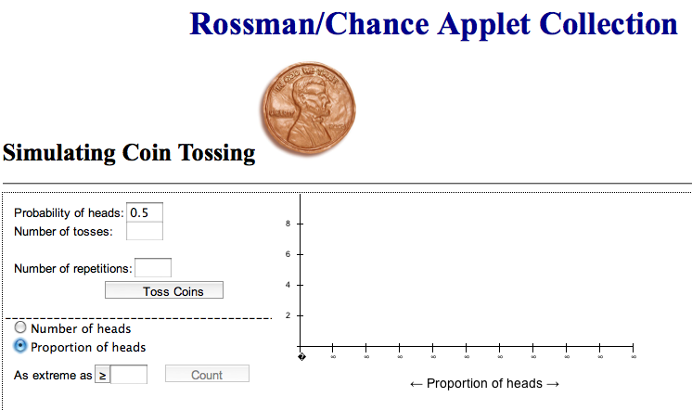

Using a TI-84 Graphing Calculator:
Note: The following steps show how to use a TI-84 Graphing Calculator to simulate the flipping of a coin $40$ times and then to calculate the sample proportion.  - Select MATH and highlight <PRB> | 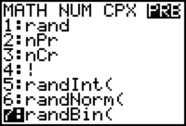
- Choose: $7$ RandBin(

- Input: RandBin($40,0.5$)/$40$ | 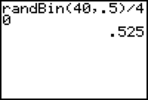
- Press ENTER | In this example, the $0.525$ is the proportion of heads that were observed in the simulated flip of $40$ coins.

Exploratory Challenge 1/Exercises 1–9 (15 minutes)
Students should work independently or in pairs on Exercises 1–3. As the students report their proportions of heads, enter the reported proportions into a list if you are using a graphing calculator or into a list using computer graphing software. Once all of the students have reported two sample proportions, construct a graph (histogram or dot plot) of the class data. Students should work on Exercises 4–9 in groups. Discuss answers as a class.
Even though each student could construct their own sampling distribution, in this first example, each student is generating just two sample proportions of heads. This way it mirrors what was done in Lesson 14. The sampling distribution is constructed using sample proportions from the entire class.

Exploratory Challenge 1/Exercises 1–9
In Exercises 1–9, students should assume that the principal is correct that $50\%$ of the population of students walk to school. Designate heads to represent a student who walks to school.
- Simulate $40$ flips of a fair coin. Record your observations in the space below.
Answers will vary . Sample response:
T T T H H H T H H H T T T H T T H H H
H T H H T H T H T T H T T T H T H T T
T T

- What is the sample proportion of heads in your sample of $40$? Report this value to your teacher.
Answers will vary. Sample response: $\frac{18}{40}=0.45.$

- Repeat Exercises 1 and 2 to obtain a second sample of $40$ coin flips.
Answers will vary.

Your teacher will display a graph of all the students’ sample proportions of heads.
Note: The following is an example of a sampling distribution of sample proportions of heads in $40$ flips of a coin.

- Describe the shape of the distribution.
Answers will vary. The shape of the distribution shown above is slightly skewed.

- What was the smallest sample proportion observed?
Answers will vary. In the sample graph, $0.25$.

- What was the largest sample proportion observed?
Answers will vary. In the sample graph, $0.65$.

- Estimate the center of the distribution of sample proportions.
Answers will vary. In the sample graph, about $0.50$.

Your teacher will report the mean and standard deviation of the sampling distribution created by the class.
Answers will vary. The mean will be approximately $0.5$, and the standard deviation will be approximately $0.079$. From the sample graph, the mean is $0.493$, and the standard deviation is $0.085$.
- How does the mean of the sampling distribution compare with the population proportion of $0.50$?
Answers will vary. From the sample response, the population proportion of $0.50$ is very close to the mean of the sampling distribution.

- Recall that a student took a random sample of $40$ students and found that the sample proportion of students who walk to school was $0.40$. Would this have been a surprising result if the actual population proportion were $0.50$ as the principal claims?
Answers will vary. Based on the sample responses, the value of $0.40$ is about one standard deviation from the mean. There were quite a few samples in the simulation that resulted in sample proportions that were $0.40$ or smaller. Hence, a value of $0.40$ would not be a surprising result if the population was $0.50$.

Example 2 (3minutes): Sampling Variability
Give students a moment to think, write, and/or speak about the question posed in the example.
Example 2: Sampling Variability
MP.3
What do you think would happen to the sampling distribution you constructed in the previous exercises had everyone in class taken a random sample of size $80$ instead of $40$? Justify your answer. This will be investigated in the following exercises.
Answers will vary. The results would be more accurate because there are more samples.

Now explain how students can generate their own sampling distributions using technology. The steps are slightly different than before as students are now performing the simulation $40$ times. Again, teachers should consider using the applet in order to save time.

Using the Coin Tossing Applet at the Website:
- Use the Coin Tossing Simulation – Rossman/Chance Applet Collection | Go to: www.rossmanchance.com/applets/CoinTossing/CoinToss.html
- For this example, enter $0.5$ for the probability of heads, $80$ for the number of tosses, and $40$ for the number of repetitions. Also check the box proportion of heads and the box for summary statistics.

Using a TI-84 Graphing Calculator:
Note: The following steps show how to use a TI-84 Graphing Calculator to simulate the flipping of a coin $80$ times to calculate the sample proportion, repeating the process for a total of $40$ times.

- Select MATH and highlight <PRB>

- Choose: $7$ RandBin(

- Input: RandBin($80,0.5,40$)/$80$→L₁  Use the RandBin operation and input $80$ for the sample size, $0.5$ for the population proportion, divide by $80$, store the results in L1, and then repeat $40$ times. | 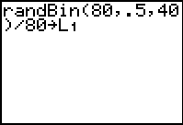
- Press ENTER and view the results in L₁.  To view the relevant statistics, go to the STAT menu and highlight <CALC>.  Choose option 1: 1–Var Stats. | 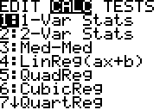
- Students may also choose to view a histogram of the sample proportions in L₁.  Go to STAT PLOT. <2ND> and <Y=>  Make sure Plot 1 is turned on, and highlight the histogram.  The following window is useful in viewing the histogram. | 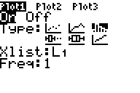  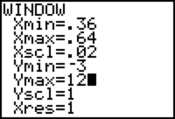

Exploratory Challenge 2/Exercises 10–22 (15 minutes)
MP.5
In this set of exercises, students use technology to carry out simulations in order to study sampling variability. Students should work independently or in pairs on Exercises 10–22.

Exploratory Challenge 2/Exercises 10–22
- Use technology and simulate $80$ coin flips. Calculate the proportion of heads. Record your results in the space below.
Answers will vary. Sample response: $\frac{39}{80}=0.4875$.
- Repeat flipping a coin $80$ times until you have recorded a total of $40$ sample proportions.
Answers will vary. See Exercise 12 for a dot plot of the sampling distribution of the proportion of heads in $80$ flips of a coin.

- Construct a dot plot of the $40$ sample proportions.
- Describe the shape of the distribution.
Answers will vary. From the sample response, the distribution is symmetric and mound shaped.

- What was the smallest proportion of heads observed?
Answers will vary. From the sample response, $0.39$.

- What was the largest proportion of heads observed?
Answers will vary. From the sample response, $0.63$.

- Using technology, find the mean and standard deviation of the distribution of sample proportions.
Answers will vary. The mean will be approximately $0.5$, and the standard deviation will be approximately $0.055$. In the example above, the mean $= 0.508$ , and the standard deviation $= 0.061.$

- Compare your results with the others in your group. Did you have similar means and standard deviations?
Answers will vary. All the groups should have similar means and standard deviations.

- How does the mean of the sampling distribution based on $40$ simulated flips of a coin (Exercise 1) compare to the mean of the sampling distribution based on $80$ simulated coin flips?
Both of the means will be approximately equal to $0.50$.

- Describe what happened to the sampling variability (standard deviation) of the distribution of sample proportions as the number of simulated coin flips increased from $40$ to $80$.
The standard deviation decreased as the number of coin flips went from $40$ to $80$.

- What do you think would happen to the variability (standard deviation) of the distribution of sample proportions if the sample size for each sample were $200$ instead of $80$? Explain.
The standard deviation will decrease as the sample size increases.

- Recall that a student took a random sample of $40$ students and found that the sample proportion of students who walk to school was $0.40$. If the student had taken a random sample of $80$ students instead of $40$, would this have been a surprising result if the actual population proportion was $0.50$ as the principal claims?
Answers will vary. Generally this would be a surprising result. The value of $0.40$ is now about two standard deviations from the mean. Only two of the $40$ simulated samples resulted in a sample proportion of $0.40$ or smaller. A sample proportion of $0.40$ would be a fairly surprising result.

- What do you think would happen to the sampling distribution you constructed in the previous exercises if everyone in class took a random sample of size 80 instead of 40? Justify your answer.
MP.3
Answers will vary. The more samples, the more accurate the simulation will be because the standard deviation decreases as sample size increases.

Closing (2 minutes)
- Ask students to summarize the main ideas of the lesson in writing or with a neighbor. Use this as an opportunity to informally assess comprehension of the lesson. The Lesson Summary below offers some important ideas that should be included.

Lesson Summary
The sampling distribution of the sample proportion can be approximated by a graph of the sample proportions for many different random samples. The mean of the sample proportions will be approximately equal to the value of the population proportion.
As the sample size increases, the sampling variability in the sample proportion decreases – the standard deviation of the sample proportions decreases.

Exit Ticket (5 minutes)

Name Date
Lesson 15: Sampling Variability in the Sample Proportion

Exit Ticket

Below are three dot plots of the proportion of tails in $20$, $60$, or $120$ simulated flips of a coin. The mean and standard deviation of the sample proportions are also shown for each of the three dot plots. Match each dot plot with the appropriate number of flips. Clearly explain how you matched the plots with the number of simulated flips.

Dot Plot 1  Mean = $0.502$  Standard deviation = $0.046$  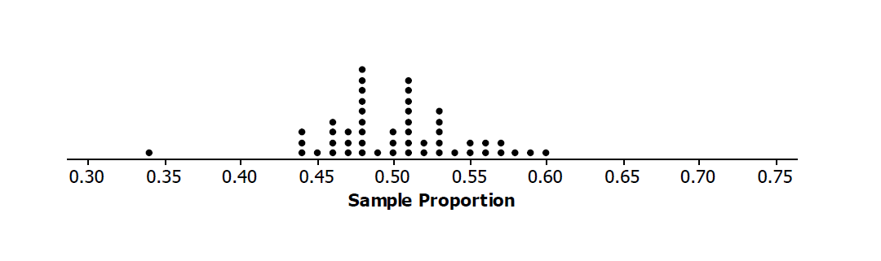 | Sample Size:_________  Explain:

Dot Plot 2  Mean = $0.518$  Standard deviation = $0.064$  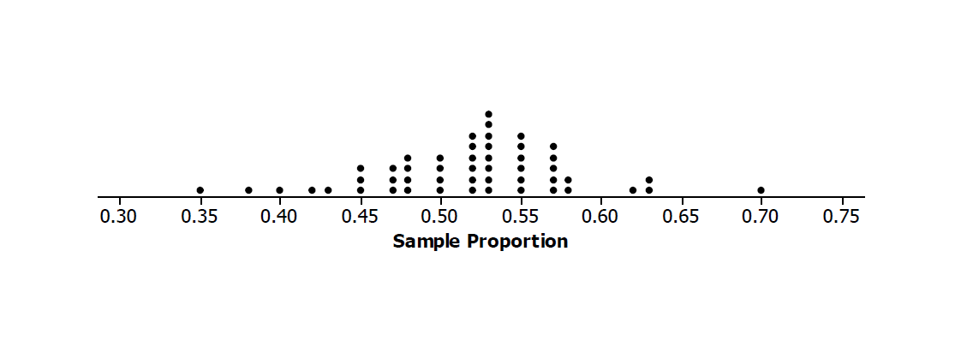 | Sample Size:_________  Explain:

Dot Plot 3  Mean = $0.498$  Standard deviation = $0.110$  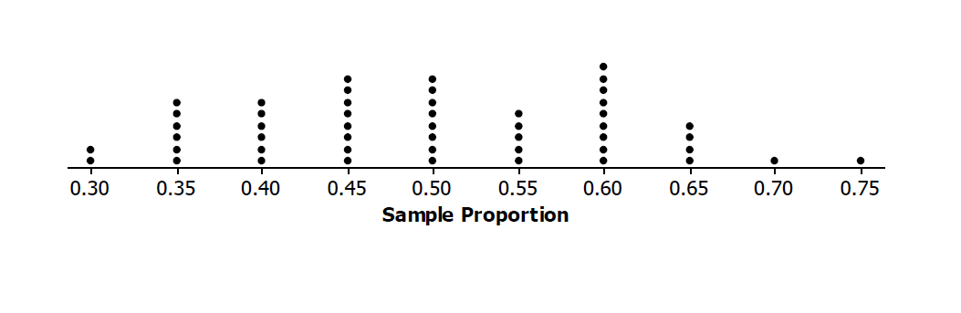 | Sample Size:_________  Explain:

Exit Ticket Sample Solutions

Below are three dot plots of the proportion of tails in $20$, $60$, or $120$ simulated flips of a coin. The mean and standard deviation of the sample proportions are also shown for each of the three dot plots. Match each dot plot with the appropriate number of flips. Clearly explain how you matched the plots with the number of simulated flips.

Dot Plot 1  Mean = $0.502$  Standard deviation = $0.046$ | Sample Size: $120$ flips of the coin  Explain: As the number of flips increases, the standard deviation decreases. The sampling distribution based on $120$ flips has the smallest standard deviation.
Dot Plot 2  Mean = $0.518$  Standard deviation = $0.064$ | Sample Size: $60$ flips of the coin  Explain: As sampling size increases, the standard deviation decreases. Because this sample size falls between the other two, its standard deviation will be between the standard deviations of the other sample sizes.
Dot Plot 3  Mean = $0.498$  Standard deviation = $0.110$ | Sample Size: $20$ flips of the coin  Explain: This standard deviation is the largest, which means that the sample size must be the smallest.

Problem Set Sample Solutions

- A student conducted a simulation of $30$ coin flips. Below is a dot plot of the sampling distribution of the proportion of heads. This sampling distribution has a mean of $0.51$ and a standard deviation of $0.09$.
  - Describe the shape of the distribution.
Approximately symmetric. Some students may think that the distribution is slightly skewed to the left.

  - Describe what would have happened to the mean and the standard deviation of the sampling distribution of the sample proportions if the student had flipped a coin $50$ times, calculated the proportion of heads, and then repeated this process for a total of $30$ times.
The mean would be approximately equal to $0.51$, and the standard deviation would be less than $0.09$.

- What effect does increasing the sample size have on the mean of the sampling distribution?
Increasing the sample size does not affect the mean of the sampling distribution. The mean of the sampling distribution is approximately equal to the population mean for any sample size.

- What effect does increasing the sample size have on the standard deviation of the sampling distribution?
Increasing the sample size decreases the standard deviation of the sampling distribution.

- A student wanted to decide whether or not a particular coin was fair (i.e., the probability of flipping a head is $0.5$). She flipped the coin $20$ times, calculated the proportion of heads, and repeated this process a total of $40$ times. Below is the sampling distribution of sample proportions of heads. The mean and standard deviation of the sampling distribution is $0.379$ and $0.091$. Do you think this was a fair coin? Why or why not?
If the coin was fair, the sampling distribution should be centered at about $0.50$. Here, the sampling distribution is centered pretty far to the left of $0.50$. Hence, it is unlikely that the probability of heads for this coin would be $0.50$.

- The same student flipped the coin $100$ times, calculated the proportion of heads, and repeated this process a total of $40$ times. Below is the sampling distribution of sample proportions of heads. The mean and standard deviation of the sampling distribution is $0.405$ and $0.046$. Do you think this was a fair coin? Why or why not?
If the coin was fair, the sampling distribution should be centered at about $0.50$. Here, the sampling distribution is centered pretty far to the left of $0.50$. Hence, it is unlikely that the probability of heads for this coin would be $0.50$.

