Lesson 14: Sampling Variability in the Sample Proportion

Student Outcomes
- Students understand the term “sampling variability” in the context of estimating a population proportion.
- Students understand that the standard deviation of the sampling distribution of the sample proportion offers insight into the accuracy of the sample proportion as an estimate of the population proportion.

Lesson Notes
This lesson and the next revisit the concept of sampling variability in the sample proportion, introduced in Grade 7 (Module 5, Lessons 17–19). Students use simulation to approximate the sampling distribution of the sample proportion and explore how to use that simulation to anticipate estimation error. In this lesson, students will use a physical simulation process. (In the next lesson, they will use technology to carry out a simulation.)
Together, this and Lesson 15 should span a total of two class periods.

Materials needed:
- Large bag of white dried beans
- Large bag of black dried beans
- Brown paper bags, each containing $60$ white and $40$ black dried beans
- One brown paper bag with beans for each group of two students

Classwork
Scaffolding:
- For struggling students, poll the class asking how many pay attention to calories when making lunch choices.
- For advanced students, have them develop a statistical question and describe how it could be answered using a poll.
Example 1 (3 minutes): Polls
Read and discuss Example 1 as a class. Ask students the following question posed in the text and summarized below. Discuss their answers as a class.
- If you were to take a random sample of $20$ Americans, how many would you predict would say that they pay a great deal attention to nutritional information?
  - $0.40\left(20\right)≈8$ or about $8$ people
The above answer is based on the statement that $40\%$ of the public said they pay “a great deal” of attention to nutritional information.

Example 1: Polls
A recent poll stated that $40\%$ of Americans pay “a great deal” or a “fair amount” of attention to the nutritional information that restaurants provide. This poll was based on a random sample of $2,027$ adults living in the U.S.
The $40\%$ corresponds to a proportion of $0.40,$ and $0.40$ is called a sample proportion. It is an estimate of the proportion of all adults who would say they pay “a great deal” or a “fair amount” of attention to the nutritional information that restaurants provide. If you were to take a random sample of $20$ Americans, how many would you predict would say that they pay attention to nutritional information? In this lesson, you will investigate this question by generating distributions of sample proportions and investigating patterns in these distributions.
Your teacher will give your group a container of dried beans. Some of the beans in the container are black. With your classmates, you are going see what happens when you take a sample of beans from the container and use the proportion of black beans in the sample to estimate the proportion of black beans in the container (a population proportion).

Exploratory Challenge 1/Exercises 1–9 (20minutes)
In these exercises, students use data from a sample to estimate a population proportion and generalize from a sample to the population. Handout the paper bags full of dried beans to each group of two students. Instruct each student to take a random sample of $20$ beans. (This sampling should be done with replacement.) Ideally, the class will have calculated between $25$ to $30$ sample proportions.
MP.2
While students take their random samples, draw a number line on the board. (Make the line long enough to accommodate students’ post-it notes.) The scale on the line should range from approximately $0.1$ to $0.7$ in increments of $0.05$.
Let students work in their groups on Exercises 1–3. After the class graph has been constructed, have students work on Exercises 4–9 in their groups. Discuss the answers as a class.

Exploratory Challenge 1/Exercises 1–9
- Each person in the group should randomly select a sample of $20$ beans from the container by carefully mixing all the beans and then selecting one bean and recording its color. Replace the bean, mix the bag, and continue to select one bean at a time until $20$ beans have been selected. Be sure to replace each bean and mix the bag before selecting the next bean. Count the number of black beans in your sample of $20$.
Answers will vary, but the number of black beans will center around $8$.

- What is the proportion of black beans in your sample of $20$? (Round your answer to $2$ decimal places.) This value is called the sample proportion of black beans.
Answers will vary, but the sample proportions will center around $0.4$.

- Write your sample proportion on a post-it note, and place the note on the number line that your teacher has drawn on the board. Place your note above the value on the number line that corresponds to your sample proportion.
Class data will vary. One possible sampling distribution is shown below.
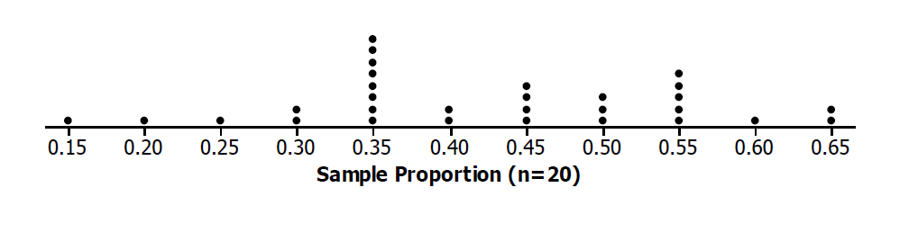
The graph of all the students’ sample proportions is called a distribution of the sampling distribution of sample proportions. This sampling distribution is an approximation of the actual sampling distribution of all possible samples of size $20$.
Scaffolding:
- Depending on the context, the term approximate is used as either a noun or a verb (or an adjective).
- For ELL students, making it clear that this same term can be used in related but different ways, with different linguistic functions, can be useful.
- Choral repetition/rehearsal and/or a graphic organizer may help students who are struggling.

- Describe the shape of the distribution.
Answers might vary, but the shape is generally mound shaped.

- What was the smallest sample proportion observed?
Answers will vary. Based on the sample graph: $0.15$.

- What was the largest sample proportion observed?
Answers will vary. Based on the sample graph: $0.65$.

- What sample proportion occurred most often?
Answers will vary, but the sample proportion should be around $0.4$. Based on the sample graph: $0.35$.

- Using technology, find the mean and standard deviation of the sample proportions used to construct the sampling distribution created by the class.
Answers will vary, but the mean will be approximately $0.4$, and the standard deviation will be approximately $0.11$.

- How does the mean of the sampling distribution compare with the population proportion of $0.40$?
Answers will vary, but the two values should be about the same. In theory, the mean of the sampling distribution of sample proportions is equal to the population proportion.

Example 2 (2 minutes): Sampling Variability
Pose the question in the example to the class. Allow for multiple responses. The following exercises provide students the opportunity to test their conjectures about treatment differences in the context of a statistical experiment.
MP.3
Example 2: Sampling Variability
What do you think would happen to the sampling distribution if everyone in class took a random sample of $40$ beans from the container? To help answer this question, you will repeat the process described in Example 1, but this time you will draw a random sample of $40$ beans instead of $20$.
Exploratory Challenge 2/Exercises 10–21 (15 minutes)
Let students continue to work in groups to complete the remaining exercises.

Exploratory Challenge 2/Exercises 10–21
- Take a random sample with replacement of $40$ beans from the container. Count the number of black beans in your sample of $40$ beans.
Answers will vary, but the number of black beans will center around $16$.

- What is the proportion of black beans in your sample of $40$? (Round your answer to $2$ decimal places.)
Answers will vary, but the sample proportions will center around $0.40$.

- Write your sample proportion on a post-it note, and place it on the number line that your teacher has drawn on the board. Place your note above the value on the number line that corresponds to your sample proportion.
Class data will vary. One possible sampling distribution is shown below.
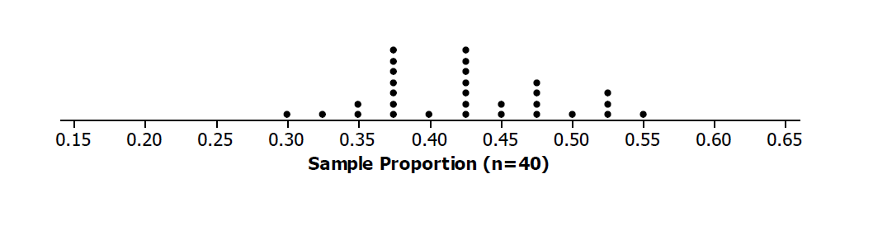

- Describe the shape of the distribution.
Answers may vary, but the shape is generally mound shaped.

- What was the smallest sample proportion observed?
Answers will vary. Based on the sample graph: $0.30$.

- What was the largest sample proportion observed?
Answers will vary. Based on the sample graph: $0.55$.

- What sample proportion occurred most often?
Answer will vary, but will be approximately $0.4$.

- Using technology, find the mean and standard deviation of the sample proportions used to construct the sampling distribution created by the class.
Answers will vary, but the mean will be approximately $0.4$, and the standard deviation approximately $0.08$.
- How does the mean of the sampling distribution compare with the population proportion of $0.40$?
Answers will vary, but the two values should be about the same. In theory, the mean of the sampling distribution of sample proportions is equal to the population proportion.

- How does the mean of the sampling distribution based on random samples of size $20$ compare to the mean of the sampling distribution based on random samples of size $40$?
The two means are approximately the same, about $0.4$.

- As the sample size increased from $20$ to $40$ describe what happened to the sampling variability (standard deviation of the distribution of sample proportions)?
The standard deviation of the distribution of the sample proportions based on a sample size of $40$ is less than the standard deviation of the distribution of the sample proportions based on a sample size of $20$.

- What do you think would happen to the variability (standard deviation) of the distribution of sample proportions if the sample size for each sample were $80$ instead of $40$? Explain.
Because the standard deviation decreased as sample size increased from $20$ to $40$, I expect that the standard deviation will decrease further when the sample size is $80$.

Closing (2 minutes)
Ask students to summarize the main ideas of the lesson in writing or with a neighbor. Use this as an opportunity to informally assess comprehension of the lesson. The Lesson Summary below offers some important ideas that should be included.
Lesson Summary
The sampling distribution of the sample proportion can be approximated by a graph of the sample proportions for many different random samples. The mean of the sampling distribution of the sample proportions will be approximately equal to the value of the population proportion.
As the sample size increases, the sampling variability in the sample proportion decreases – the standard deviation of the sampling distribution of the sample proportions decreases.

Exit Ticket (3 minutes)

Name Date
Lesson 14: Sampling Variability in the Sample Proportion

Exit Ticket

A group of eleventh graders wanted to estimate the population proportion of students in their high school who drink at least one soda per day. Each student selected a different random sample of $30$ students and calculated the proportion that drink at least one soda per day. The dot plot below shows the sampling distribution. This distribution has a mean of $0.51$ and a standard deviation of $0.09$.
- Describe the shape of the distribution.

- What is your estimate for the proportion of all students who would report that they drink at least one soda per day?

- If, instead of taking random samples of $30$ students in the high school, the eleventh graders randomly selected samples of size $60$, describe what will happen to the standard deviation of the sampling distribution of the sample proportions.
Exit Ticket Sample Solutions

A group of eleventh graders wanted to estimate the population proportion of students in their high school who drink at least one soda per day. Each student selected a different random sample of $30$ students from the high school and calculated the proportion that drink at least one soda per day. The dot plot below shows the sampling distribution. This distribution has a mean of $0.51$ and a standard deviation of $0.09$.

- Describe the shape of the distribution.
Approximately symmetric centered around $0.50$.

- What is your estimate for the proportion of all students who would report that they drink at least one soda per day?
$0.51$ – the mean of the sampling distribution.

- If, instead of taking random samples of $30$ students in the high school, the eleventh graders randomly selected samples of size $60$, describe what will happen to the standard deviation of the sampling distribution of the sample proportions.
The standard deviation will decrease.

Problem Set Sample Solutions
Use this space to describe any specific details about the problem set for teacher reference.

- A class of $28$ eleventh graders wanted to estimate the proportion of all juniors and seniors at their high school with part-time jobs after school. Each eleventh grader took a random sample of $30$ juniors and seniors and then calculated the proportion with part-time jobs. Following are the $28$ sample proportions.
$$0.7, 0.8, 0.57, 0.63, 0.7, 0.47, 0.67, 0.67, 0.8, 0.77, 0.4, 0.73, 0.63, 0.67, 0.6, 0.77, 0.77, 0.77, 0.53, 0.57,$$
$$0.73, 0.7, 0.67, 0.7, 0.77, 0.57, 0.77, 0.67$$

  - Construct a dot plot of the sample proportions.
  - Describe the shape of the distribution.
Skewed to the left.

  - Using technology, find the mean and standard deviation of the sample proportions.
Mean $=$ $0.67.$
Standard deviation $=$ $0.1.$

  - Do you think that the proportion of all juniors and seniors at the school with part-time jobs could be $0.7$? Do you think it could be $0.5$? Justify your answers based on your dot plot.
It is likely that the proportion of all juniors and seniors with part-time jobs could be $0.70$ since $0.70$ is near the center of the dot plot. It is unlikely that the proportion of all juniors and seniors is $0.5$ since there are very few samples with a sample proportion of $0.5$ or less.

  - Suppose the eleventh graders had taken random samples of size $60$. How would the distribution of sample proportions based on samples of size $60$ differ from the distribution for samples of size $30$?
The sampling distribution would be mound shaped with approximately the same mean as the sampling distribution based on size $30,$ but the standard deviation of the sampling distribution based on size $60$ would be smaller than one based on samples of size $30$.

- A group of eleventh graders wanted to estimate the proportion of all students at their high school who suffer from allergies. Each student in one group of eleventh graders took a random sample of $20$ students, while another group of eleventh graders each took a random sample of 40 students. Below are the two sampling distributions (shown as histograms) of the sample proportions of high school students who said that they suffer from allergies. Which histogram is based on random samples of size $40$? Explain.
Histogram A is based on random samples of size $40$ because it has less variability than Histogram B.

Histogram A  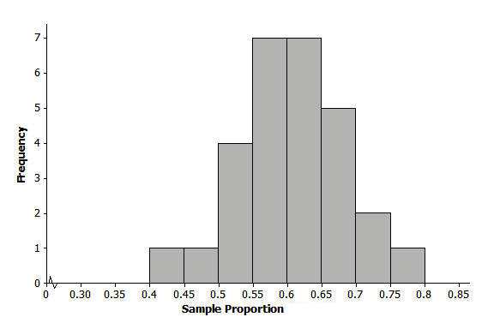 | 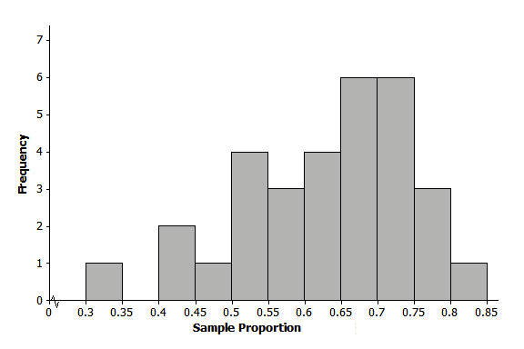  Histogram B

- The nurse in your school district would like to study the proportion of all high school students in the district who usually get at least eight hours of sleep on school nights. Suppose each student in your class takes a random sample of $20$ high school students in the district and each calculates their sample proportion of students who said that they usually get at least eight hours of sleep on school nights. Below is a histogram of the sampling distribution.

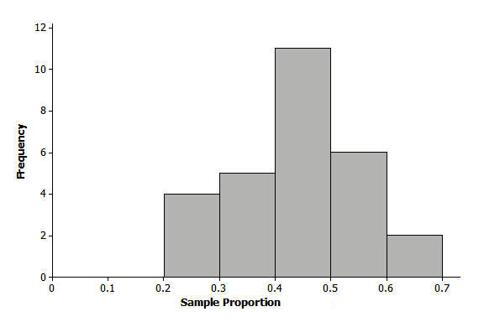

  - Do you think that the proportion of all high school students who usually get at least eight hours of sleep on school nights could have been $0.4$? Do you think it could have been $0.55$? Could it have been $0.75$? Justify your answers based on the histogram.
The proportion of all high school students who usually get at least eight hours of sleep is likely around $0.4$ since that is near the center of the sampling distribution. The proportion could be $0.55$ since that is still close to the center of the distribution. It is unlikely that the proportion of all high school students is $0.75$ since none of the samples produced sample proportions as large as $0.75$.

  - Suppose students had taken random samples of size $60$. How would the distribution of sample proportions based on samples of size $60$ differ from those of size $20$?
The means of the two distributions would be relatively close, but the standard deviation of the distribution based on samples of size $60$ would be smaller than the standard deviation of the distribution based on sample sizes of $20$.

