Lesson 14: Sampling Variability in the Sample Proportion

Classwork
Example 1: Polls
A recent poll stated that $40\%$ of Americans pay “a great deal” or a “fair amount” of attention to the nutritional information that restaurants provide. This poll was based on a random sample of $2,027$ adults living in the U.S.
The $40\%$ corresponds to a proportion of $0.40,$ and $0.40$ is called a sample proportion. It is an estimate of the proportion of all adults who would say they pay “a great deal” or a “fair amount” of attention to the nutritional information that restaurants provide. If you were to take a random sample of $20$ Americans, how many would you predict would say that they pay attention to nutritional information? In this lesson, you will investigate this question by generating distributions of sample proportions and investigating patterns in these distributions.
Your teacher will give your group a container of dried beans. Some of the beans in the container are black. With your classmates, you are going see what happens when you take a sample of beans from the container and use the proportion of black beans in the sample to estimate the proportion of black beans in the container (a population proportion).

Exploratory Challenge 1/Exercises 1-9
- Each person in the group should randomly select a sample of $20$ beans from the container by carefully mixing all the beans and then selecting one bean and recording its color. Replace the bean, mix the bag, and continue to select one bean at a time until $20$ beans have been selected. Be sure to replace each bean and mix the bag before selecting the next bean. Count the number of black beans in your sample of $20$.

- What is the proportion of black beans in your sample of $20$? (Round your answer to $2$ decimal places.) This value is called the sample proportion of black beans.

- Write your sample proportion on a post-it note, and place the note on the number line that your teacher has drawn on the board. Place your note above the value on the number line that corresponds to your sample proportion.
The graph of all the students’ sample proportions is called a distribution of the sampling distribution of sample proportions. This sampling distribution is an approximation of the actual sampling distribution of all possible samples of size $20$.

- Describe the shape of the distribution.

- What was the smallest sample proportion observed?

- What was the largest sample proportion observed?

- What sample proportion occurred most often?

- Using technology, find the mean and standard deviation of the sample proportions used to construct the sampling distribution created by the class.

- How does the mean of the sampling distribution compare with the population proportion of $0.40$?

Example 2: Sampling Variability
What do you think would happen to the sampling distribution if everyone in class took a random sample of $40$ beans from the container? To help answer this question, you will repeat the process described in Example 1, but this time you will draw a random sample of $40$ beans instead of $20$.

Exploratory Challenge 2/Exercises 10-21
- Take a random sample with replacement of $40$ beans from the container. Count the number of black beans in your sample of $40$ beans.

- What is the proportion of black beans in your sample of $40$? (Round your answer to $2$ decimal places.)

- Write your sample proportion on a post-it note, and place it on the number line that your teacher has drawn on the board. Place your note above the value on the number line that corresponds to your sample proportion.

- Describe the shape of the distribution.

- What was the smallest sample proportion observed?

- What was the largest sample proportion observed?

- What sample proportion occurred most often?

- Using technology, find the mean and standard deviation of the sample proportions used to construct the sampling distribution created by the class.

- How does the mean of the sampling distribution compare with the population proportion of $0.40$?

- How does the mean of the sampling distribution based on random samples of size $20$ compare to the mean of the sampling distribution based on random samples of size $40$?

- As the sample size increased from $20$ to $40$ describe what happened to the sampling variability (standard deviation of the distribution of sample proportions)?

- What do you think would happen to the variability (standard deviation) of the distribution of sample proportions if the sample size for each sample were $80$ instead of $40$? Explain.

Problem Set
Lesson Summary
The sampling distribution of the sample proportion can be approximated by a graph of the sample proportions for many different random samples. The mean of the sampling distribution of the sample proportions will be approximately equal to the value of the population proportion.
As the sample size increases, the sampling variability in the sample proportion decreases – the standard deviation of the sampling distribution of the sample proportions decreases.

- A class of 28 eleventh graders wanted to estimate the proportion of all juniors and seniors at their high school with part-time jobs after school. Each eleventh grader took a random sample of $30$ juniors and seniors and then calculated the proportion with part-time jobs. Following are the $28$ sample proportions.
$0.7$, $0.8$, $0.57$, $0.63$, $0.7$, $0.47$, $0.67$, $0.67$, $0.8$, $0.77$, $0.4$, $0.73$, $0.63$, $0.67$, $0.6$, $0.77$, $0.77$, $0.77$, $0.53$, $0.57, 0.73$, $0.7,$ $0.67$, $0.7$, $0.77$, $0.57$, $0.77$, $0.67$
  - Construct a dot plot of the sample proportions.
  - Describe the shape of the distribution.
  - Using technology, find the mean and standard deviation of the sample proportions.
  - Do you think that the proportion of all juniors and seniors at the school with part-time jobs could be $0.7$? Do you think it could be $0.5$? Justify your answers based on your dot plot.
  - Suppose the eleventh graders had taken random samples of size $60$. How would the distribution of sample proportions based on samples of size $60$ differ from the distribution for samples of size $30$?

- A group of eleventh graders wanted to estimate the proportion of all students at their high school who suffer from allergies. Each student in one group of eleventh graders took a random sample of $20$ students, while another group of eleventh graders each took a random sample of 40 students. Below are the two sampling distributions (shown as histograms) of the sample proportions of high school students who said that they suffer from allergies. Which histogram is based on random samples of size $40$? Explain.

Histogram A  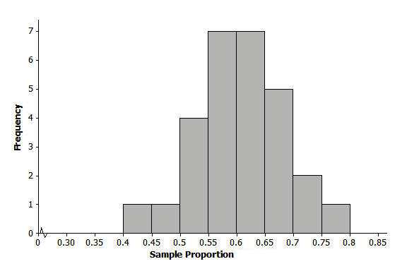 | Histogram B  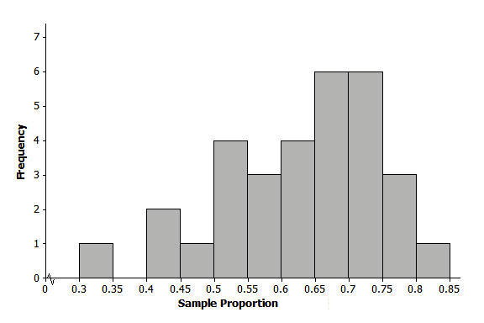

- The nurse in your school district would like to study the proportion of all high school students in the district who usually get at least eight hours of sleep on school nights. Suppose each student in your class takes a random sample of $20$ high school students in the district and each calculates their sample proportion of students who said that they usually get at least eight hours of sleep on school nights. Below is a histogram of the sampling distribution.
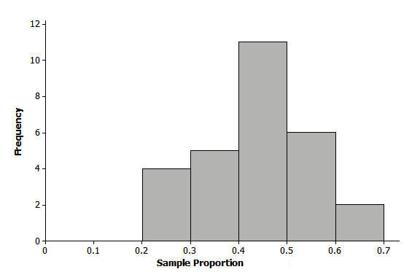

  - Do you think that the proportion of all high school students who usually get at least eight hours of sleep on school nights could have been $0.4$? Do you think it could have been $0.55$? Could it have been $0.75$? Justify your answers based on the histogram.
  - Suppose students had taken random samples of size $60$. How would the distribution of sample proportions based on samples of size $60$ differ from those of size $20$?

