Lesson 8: Distributions—Center, Shape, and Spread

Classwork
Example 1: Center, Shape and Spread
Have you ever noticed how sometimes batteries seem to last a long time, and other times the batteries seem to last only a short time?
The histogram below shows the distribution of battery life (hours) for a sample of $40$ batteries of the same brand. When studying a distribution, it is important to think about the shape, center, and spread of the data.
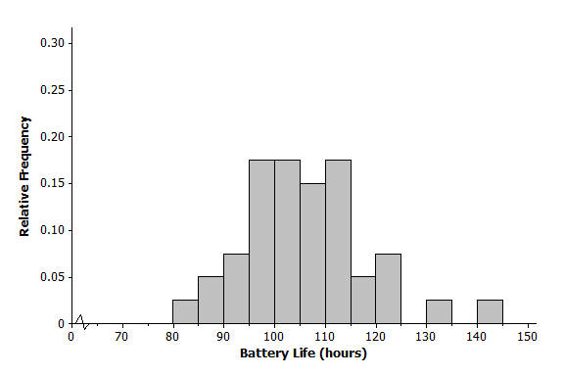

Exercises
- Would you describe the distribution of battery life as approximately symmetric or as skewed? Explain your answer.

- Is the mean of the battery life distribution closer to $95$, $105$, or $115$ hours? Explain your answer.

- Consider $5$, $10$, or $25$ hours as an estimate of the standard deviation for the battery life distribution.
  - Consider $5$ hours as an estimate of the standard deviation. Is it a reasonable description of a typical distance from the mean? Explain your answer.

  - Consider $10$ hours as an estimate of the standard deviation. Is it a reasonable description of a typical distance from the mean? Explain your answer.

  - Consider $25$ hours as an estimate of the standard deviation. Is it a reasonable description of a typical distance from the mean? Explain your answer.

The histogram below shows the distribution of the greatest drop (in feet) for $55$ major roller coasters in the U.S.
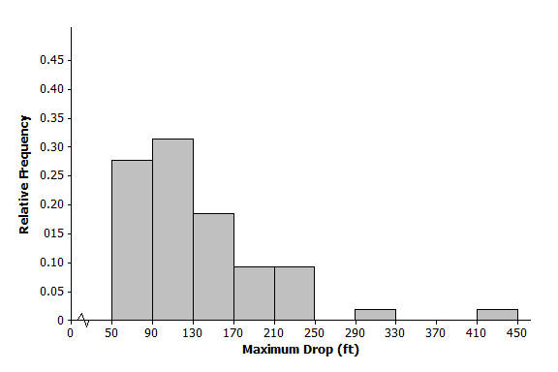

- Would you describe this distribution of roller coaster maximum drop as approximately symmetric or as skewed? Explain your answer.

- Is the mean of the maximum drop distribution closer to $90$, $135$, or $240$ feet? Explain your answer.

- Is the standard deviation of the maximum drop distribution closer to $40$, $70$, or $100$ hours? Explain your answer.

- Consider the following histograms: Histogram 1, Histogram 2, Histogram 3, and Histogram 4. Descriptions of four distributions are also given. Match the description of a distribution with the appropriate histogram.
Histogram | Distribution
$$1$$
$$2$$
$$3$$
$$4$$
Description of distributions:
Distribution | Shape | Mean | Standard Deviation
$$A$$ | Skewed to the right | $$100$$ | $$10$$
$$B$$ | Approximately symmetric, mound shaped | $$100$$ | $$10$$
$$C$$ | Approximately symmetric, mound shaped | $$100$$ | $$40$$
$$D$$ | Skewed to the right | $$100$$ | $$40$$

Histograms:
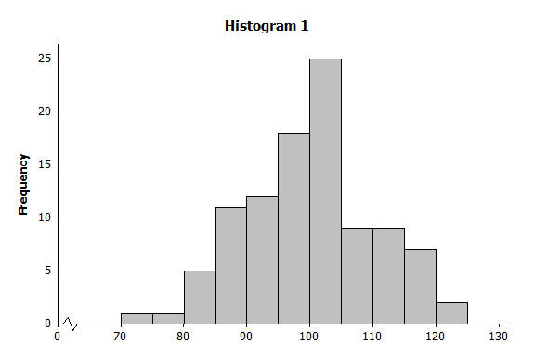  Histogram 1  Histogram 2 | 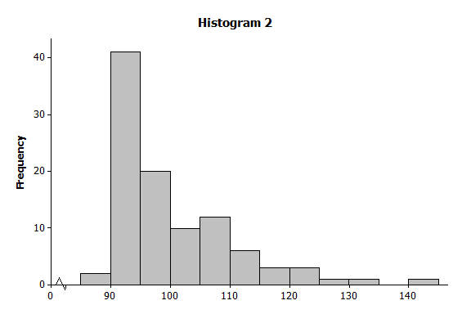
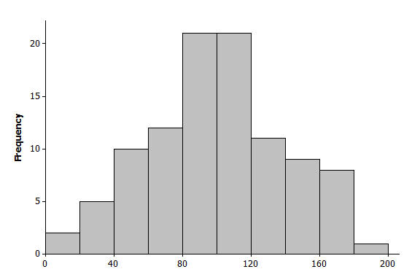  Histogram 3 | 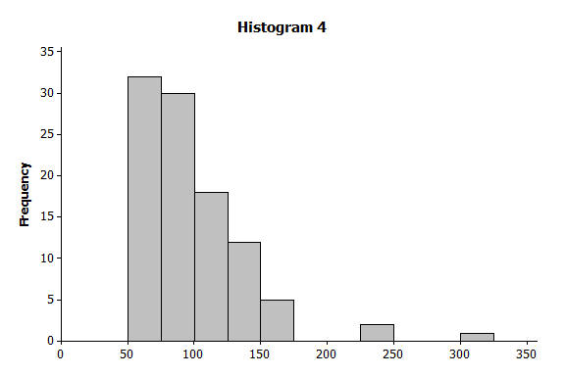  Histogram 4

- The histogram below shows the distribution of gasoline tax per gallon for the $50$ states and the District of Columbia in 2010. Describe the shape, center, and spread of this distribution.
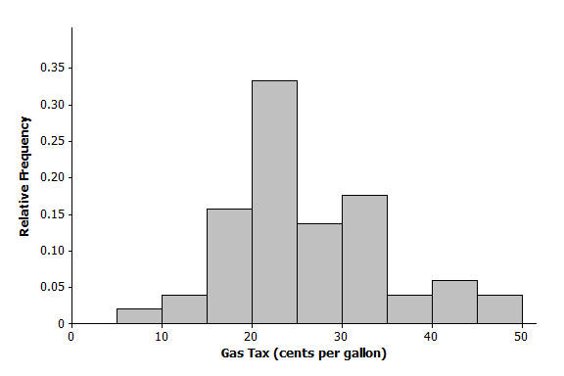

- The histogram below shows the distribution of the number of automobile accidents per year for every $1,000$ people in different occupations. Describe the shape, center, and spread of this distribution.
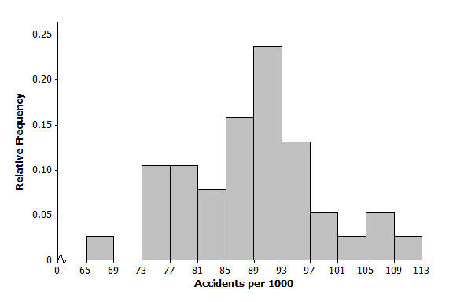

Lesson Summary
Distributions are described by the shape (symmetric or skewed), the center, and the spread (variability) of the distribution.
A distribution that is approximately symmetric can take different forms.
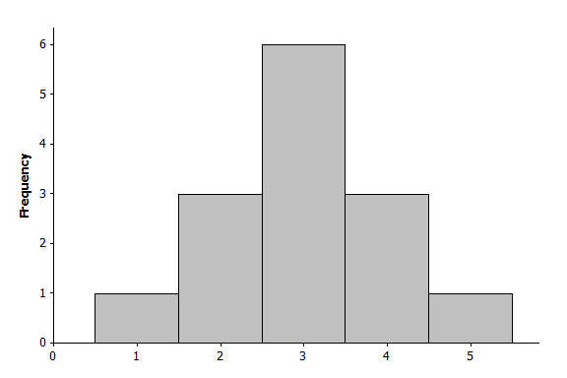 | 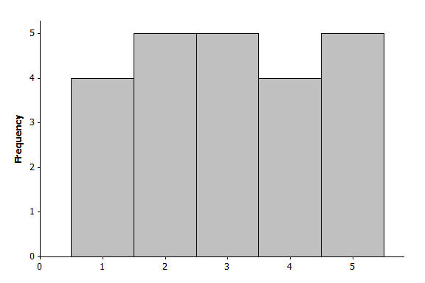
A distribution is described as mound shaped if it is approximately symmetric and has a single peak.
A distribution is skewed to the right or skewed to the left if one of its tails is longer than the other.
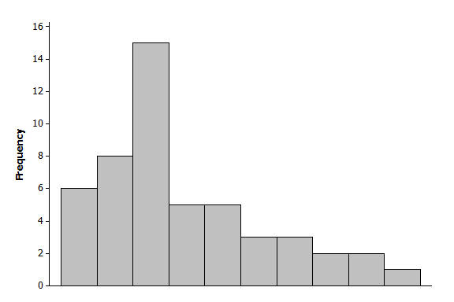  Skewed to the right | 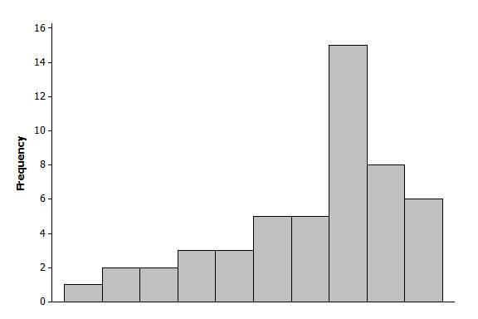  Skewed to the left
The mean of a distribution is interpreted as a typical value and is the average of the data values that make up the distribution.
The standard deviation is a value that describes a typical distance from the mean.

Problem Set

- For each of the following histograms, describe the shape, and give estimates of the mean and standard deviation of the distributions.
  - Distribution of head circumferences (mm)
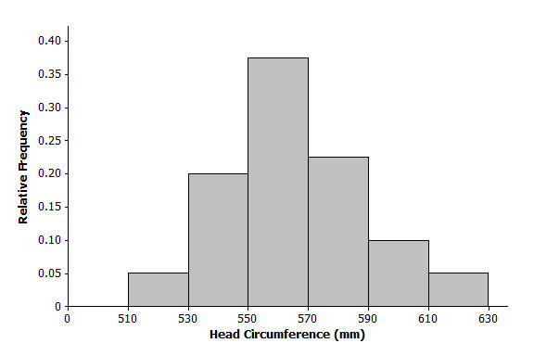

  - Distribution of NBA arena seating capacity
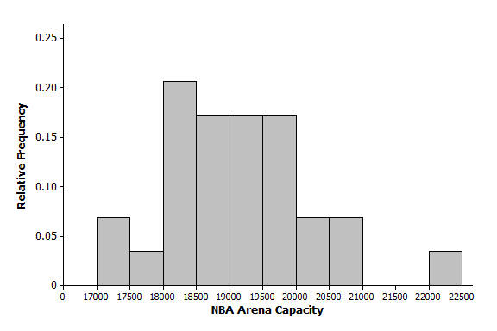

- For the each of the following, match the description of each distribution with the appropriate histogram.
Histogram | Distribution
$$1$$
$$2$$
$$3$$
$$4$$

Description of distributions:
Distribution | Shape | Mean | Standard Deviation
$$A$$ | Approximately symmetric, mound shaped | $$50$$ | $$5$$
$$B$$ | Approximately symmetric, mound shaped | $$50$$ | $$10$$
$$C$$ | Approximately symmetric, mound shaped | $$30$$ | $$10$$
$$D$$ | Approximately symmetric, mound shaped | $$30$$ | $$5$$

Histogram 1  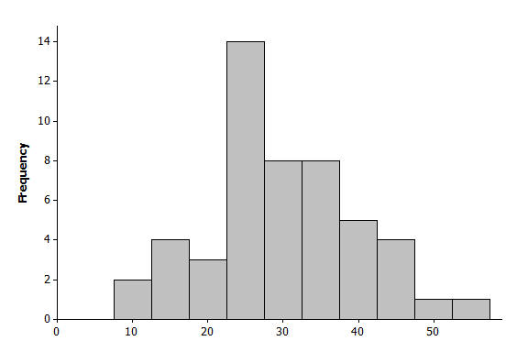 | Histogram 2  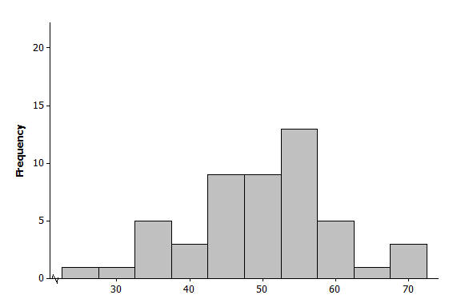
Histogram 3  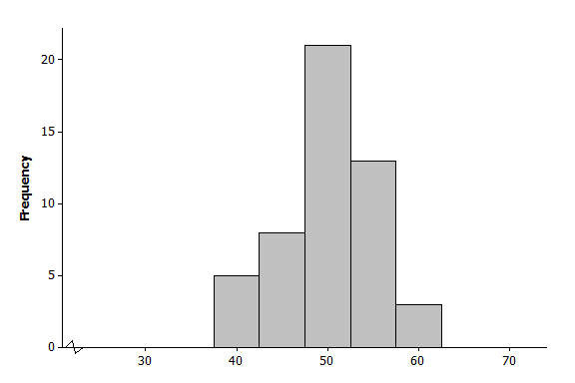 | Histogram 4  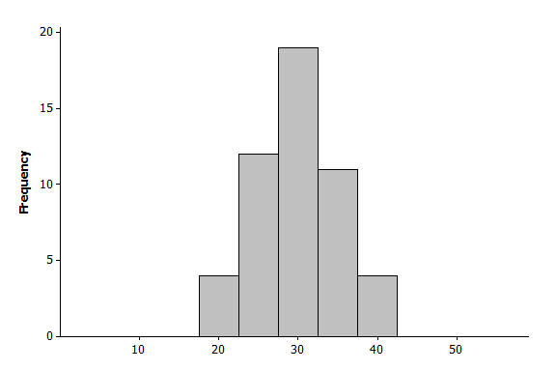

- Following are the number of calories in a basic hamburger (one meat patty with no cheese) at various fast food restaurants around the country.
$380$, $790$, $680$, $460$,$725$, $1130$, $240$, $260$, $930$,$331$, $710$, $680$, $1080$, $612$,$1180$,$400$, $866$, $700$, $1060$, $270$, $550$,$380$, $940$,$280$, $940$, $550$, $549$, $937$, $820$, $870$,$250$, $740$
  - Draw a dot plot on the scale below.

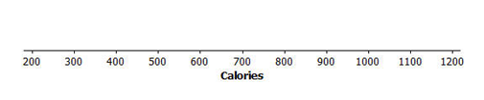
  - Describe the shape of the calorie distribution.
  - Using technology, find the mean and standard deviation of the calorie data.
  - Why do you think there is a lot of variability in the calorie data?

