Lesson 5: Events and Venn Diagrams

Classwork
Example 1: Shading Regions of a Venn Diagram
At a high school, some students play soccer and some do not. Also, some students play basketball and some do not. This scenario can be represented by a Venn diagram, as shown below. The circle labeled $S$ represents the students who play soccer, the circle labeled $B$represents the students who play basketball, and the rectangle represents all the students at the school.
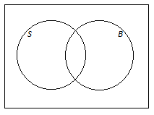
On the Venn diagrams provided, shade the region representing the students who
- play soccer. | - do not play soccer.
- play soccer and basketball. | - play soccer or basketball.
Exercise 1
- An online bookstore offers a large selection of books. Some of the books are works of fiction, and some are not. Also, some of the books are available as e-books, and some are not. Let $F$ be the set of books that are works of fiction, and let $E$be the set of books that are available as e-books. On the Venn diagrams provided, shade the regions representing books that are
- available as e-books.  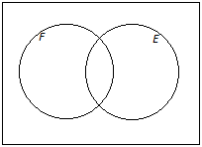 | - not works of fiction.
- works of fiction and available as e-books. | - works of fiction or available as e-books.
- neither works of fiction nor available as e-books. | - works of fiction that are not available as e-books.

Example 2: Showing Numbers of Possible Outcomes (and Probabilities) in a Venn Diagram
Think again about the school introduced in Example 1. Suppose that $230$ students play soccer, $190$ students play basketball, and $60$ students play both sports. There are a total of $500$ students at the school.
  - Complete the Venn diagram below by writing the numbers of students in the various regions of the diagram.
  - How many students play basketball but not soccer?

  - Suppose that a student will be selected at random from the school.
    - What is the probability that the selected student plays both sports?

    - Complete the Venn diagram below by writing the probabilities associated with the various regions of the diagram.

Example 3: Adding and Subtracting Probabilities
Think again about the online bookstore introduced in Exercise 1, and suppose that $62\%$ of the books are works of fiction, $47\%$ are available as e-books, and $14\%$ are available as e-books but are not works of fiction. A book will be selected at random.

  - Using a Venn diagram, find the probability that the book
will be

    - a work of fiction and available as an e-book.

    - neither a work of fiction nor available as an e-book.

  - Return to the information given at the beginning of the question: $62\%$ of the books are works of fiction, $47\%$ are available as e-books, and $14\%$ are available as e-books but are not works of fiction.

    - How would this information be shown in a hypothetical 1000 table? (Show your answers in the table provided below.)
 | Fiction | Not Fiction | Total
Available as E-Book
Not Available as E-Book
Total |  |  | $$1,000$$

    - Complete the hypothetical 1000 table given above.

    - Complete the table below showing the probabilities of the events represented by the cells in the table.
 | Fiction | Not Fiction | Total
Available as E-Book
Not available as E-Book
Total

    - How do the probabilities in your table relate to the probabilities you calculated in part (a)?

Exercises 2–3
- When a fish is selected at random from a tank, the probability that it has a green tail is $0.64$, the probability that it has red fins is $0.25$, and the probability that it has both a green tail and red fins is $0.19$.
  - Draw a Venn diagram to represent this information.
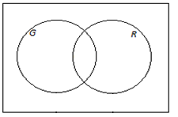

  - Find the probability that the fish has
    - red fins but does not have a green tail.

    - a green tail but not red fins.

    - neither a green tail nor red fins.

  - Complete the table below showing the probabilities of the events corresponding to the cells of the table.
 | Green tail | Not green tail | Total
Red Fins
Not Red Fins
Total

- In a company, $43\%$ of the employees have access to a fax machine, $38\%$ have access to a fax machine and a scanner, and $24\%$ have access to neither a fax machine nor a scanner. Suppose that an employee will be selected at random. Using a Venn diagram, calculate the probability that the randomly selected employee will not have access to a scanner. (Note that Venn diagrams and probabilities use decimals or fractions, not percentages.) Explain how you used the Venn diagram to determine your answer.
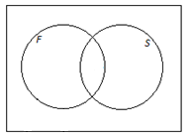

Lesson Summary
In a probability experiment, the events can be represented by circles in a Venn diagram.
Combinations of events using “and,” “or,” and “not” can be shown by shading the appropriate regions of the Venn diagram.
The number of possible outcomes can be shown in each region of the Venn diagram; alternatively, probabilities may be shown. The number of outcomes in a given region (or the probability associated with it) can be calculated by adding or subtracting the known numbers of possible outcomes (or probabilities).

Problem Set

- On a flight, some of the passengers have frequent flier status and some do not. Also, some of the passengers have checked baggage and some do not. Let the set of passengers who have frequent flier status be $F$ and the set of passengers who have checked baggage be $C$. On the Venn diagrams provided, shade the regions representing passengers who
- have frequent flier status and have checked baggage.  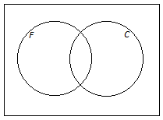 | - have frequent flier status or have checked baggage.
- do not have both frequent flier status and checked baggage. | - have frequent flier status or do not have checked baggage.

- For the scenario introduced in Problem 1, suppose that, of the $400$ people on the flight, $368$ have checked baggage, $228$ have checked baggage but do not have frequent flier status, and $8$ have neither frequent flier status nor checked baggage.
  - Using a Venn diagram, calculate the number of people on the
flight who
    - have frequent flier status and have checked baggage.
    - have frequent flier status.

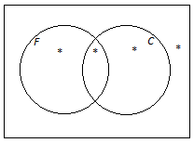
  - In the Venn diagram provided below, write the probabilities of the events associated with the regions marked with a star (*).

- When an animal is selected at random from those at a zoo, the probability that it is North American (meaning that its natural habitat is in the North American continent) is $0.65$, the probability that it is both North American and a carnivore is $0.16$, and the probability that it is neither American nor a carnivore is $0.17$.
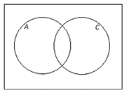
  - Using a Venn diagram, calculate the probability that a randomly selected animal is a carnivore.

  - Complete the table below showing the probabilities of the events corresponding to the cells of the table.
 | American | Not American | Total
Carnivore
Not carnivore
Total

- This question introduces the mathematical symbols for “and,” “or,” and “not.”
Considering all the people in the world, let $A$ be the set of Americans (citizens of the United States), and let $B$ be the set of people who have brothers.
- The set of people who are Americans and have brothers is represented by the shaded region in the Venn diagram below.
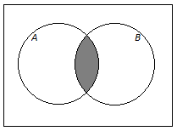
This set is written $A∩B$ (read “$A$ intersect $B$”), and the probability that a randomly selected person is American and has a brother is written $P(A∩B)$.
- The set of people who are Americans or have brothers is represented by the shaded region in the Venn diagram below.
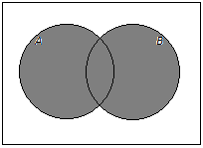

This set is written $A∪B$ (read “$A$ union $B$”), and the probability that a randomly selected person is American or has a brother is written $P(A∪B)$.
- The set of people who are not Americans is represented by the shaded region in the Venn diagram below.
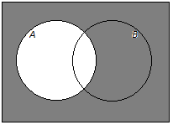
This set is written $A^{C}$ (read “$A$ complement”), and the probability that a randomly selected person is not American is written $P\left(A^{C}\right).$
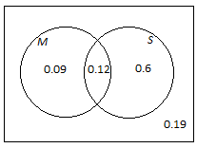
Now think about the cars available at a dealership. Suppose a car is selected at random from the cars at this dealership. Let the event that the car has manual transmission be denoted by $M$, and let the event that the car is a sedan be denoted by $S$. The Venn diagram below shows the probabilities associated with four of the regions of the diagram.
  - What is the value of $P(M∩S)$?
  - Complete this sentence using and/or:
$P(M∩S)$ is the probability that a randomly selected car has a manual transmission is a sedan.
  - What is the value of $P(M ∪ S)$?
  - Complete this sentence using and/or:
$P(M∪S)$ is the probability that a randomly selected car has a manual transmission is a sedan.
  - What is the value of $P(S^{C})$?
  - Explain the meaning of $P(S^{C})$.

