|  |
| --- |
|  |

Lesson 33: The Million Dollar Problem

Student Outcomes

* Students use geometric series to calculate how much money should be saved each month to have million in assets within a specified amount of time.

Lesson Notes

In Lesson 33, amortization calculators and other online calculators are not advanced enough to easily develop a savings plan that will result in earning million in assets by the time the student reaches the age of . Students continue their exploration of the formula for the future value of a structured savings plan from Lesson 29 (**A-SSE.B.4**).

We continue to use the formula from Lesson 29. The formula is discussed more extensively in Lesson 29, but it is always good to remember: The finance formulas in these lessons are direct applications of the sum for a geometric sequence and compound interest formula. Throughout these lessons, we have re-derived these formulas in different contexts for two reasons: firstly, so that students recognize the usefulness of geometric series, and secondly, so that students can make the realization that the types of financial activities (savings plans, car loans, credit cards, etc.) initially appear to be different, but in the end all require the same calculation. The goal is for students to continue to build the formulas from geometric series until they are proficient with the meaning and uses of the formulas.

In the future amount of the annuity formula stated above, the amount of money that somebody wants to have in the future is . The amount deposited (which is generically called the payment) per compounding period is , and the interest per compounding period is . The total number of compounding periods is . The amount of money it will take the person to save this amount is the monthly payment times the number of payments, . When the annuity is representing a loan, the monthly payment times the number of payments is called the total cost of a loan.

For loans, we rewrite the basic compound interest formula as , set it equal to the formula above from Lesson 29, and solve for the annuity’s principal . In this context, the present value of the annuity is the same as the principal of the loan (i.e., the loan amount). The present value of an annuity can be thought of as the lump sum amount one would need to invest now in order to earn the future value of an annuity through compound interest alone.

In this modeling lesson, you have the option of including the appreciation (or depreciation) rate of the property value. An interactive map of appreciation rates can be found at <http://www.neighborhoodscout.com/ny/rates>, and this source claims that the statewide average since is . We will use this rate in the sample answers throughout the lesson. The example house used in this lesson will continue to be the house from Lesson 32.

Some fundamental budgeting is included to provide the framework for the house purchase. The material students developed in Lesson 31 is used to provide flexibility to budgets and to discuss paying off debts in the context of budgets. Students develop and combine functions for the appreciation of their home, the balance in a savings account, and the value of their car to answer the question of the lesson: How can I accumulate in assets (**F-BF.A.1b**)?

A copy of the modeling cycle flowchart is included below to assist with the modeling portions of these lessons. Whenever students consider a modeling problem, they need first to identify variables representing essential features in the situation, formulate a model to describe the relationships between the variables, analyze and perform operations on the relationships, interpret their results in terms of the original situation, validate their conclusions, and either improve the model or report their conclusions and their reasoning. The exercises provided in this lesson suggest and provide a road map for you to structure the lesson around the modeling cycle flowchart, but they are only a road map: How much you use the exercises is left to your discretion and as time permits. For example, you may wish to start the class with just the opening question on saving million in years and let the students decide how to move through the modeling cycle on their own without using the exercise questions as prompts. Regardless, each student’s report should take into consideration the ideas discussed in the exercises.

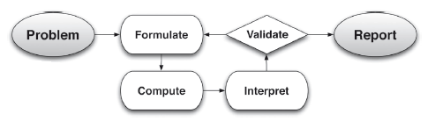

Classwork

Opening (4 minutes)

* Now that you are in your mid-twenties, own a car, a house, and have a career, the question remains: What savings plan would you need to generate a in assets over the next years?
* What assets do we have that we can include?
  + *House, car, and savings.*
* Over the long run, property values generally appreciate, but most cars will depreciate. Assume the used car you bought back in Lesson 30 is depreciating and not an asset. But the house you bought does hold value (called equity), and that equity is an asset. Let’s focus specifically on the value of your house from Lesson 32. What formula can we use to calculate the value of your house in years?
  + *The formula is , where is the appreciation rate per year (this can be researched on the internet to find your local appreciation rate). The average appreciation rate for New York is .*

Inform students what appreciation rate they should use for their house.

* After finding this value, the problem then becomes, “How much do you need to deposit monthly to add up to after years?” What type of problem does this sound like?
  + *This sounds like a structured savings plan like we studied in Lesson29.*

Opening Exercise (15 minutes)

Take the time for students to calculate the estimated value of their home and record the results. Have students plot their appreciation curve over years and compare both the appreciated values of their homes and the graphs they produce with each other (**F-IF.C.7e**, **F-IF.C.8**, **F-IF.C.9**).

Opening Exercise

In Problem 1 of the Problem Set of Lesson 32, you calculated the monthly payment for a -year mortgage at a annual interest rate for the house you chose. You will need that monthly payment for these questions.

* 1. About how much do you expect your home to be worth in years?

Answers will vary, but should follow similar steps. For example:

Step 1: Step 2:

My home will be worth about if it continues to appreciate at an average rate of every year.

* 1. For , plot the graph of the function where is the appreciation rate and is the initial value of your home.



* 1. Compare the image of the graph you plotted in part (b) with a partner, and write your observations of the differences and similarities. What do you think is causing the differences that you see in the graphs? Share your observations with another group to see if your conclusions are correct.

**MP.3**

Answers will vary. Although the growth rate is the same for all students in the class, depending on the initial value of the home, different homes will appreciate more quickly than others. For instance, a house that is will increase to in years. This increase is about less than the increase for a initial value. The differences are caused by the differences in initial value. Since the rate of increase is a percentage and exponential, the increase is markedly different for more expensive homes and will be even more significant as years increase.

Your friend Julia bought a home at the same time as you but chose to finance the loan over years. Julia also was able to avoid a down payment and financed the entire value of her home. This allowed her to purchase a more expensive home, but years later she still has not paid off the loan. Consider the following amortization table representing Julia’s mortgage, and answer the following questions by comparing the table with your graph.

|  |  |  |  |
| --- | --- | --- | --- |
| Payment # | Beginning Balance | Payment on Interest | Payment on Principal |
|  |  |  |  |
|  |  |  |  |
|  |  |  |  |
|  |  |  |  |
|  |  |  |  |

* 1. In Julia’s neighborhood, her home has grown in value at around per year. Considering how much she still owes the bank, how much of her home does she own after years (the equity in her home)? Express your answer in dollars to the nearest thousand and as a percent of the value of her home.

Julia’s home is worth ; about . She owes , which still leaves . This means she owns about of her home or of her home.

* 1. Reasoning from your graph in part (b) and the table above, if both you and Julia sell your homes in years at the homes’ appreciated values, who would have more equity?

Answers will vary. Any student whose home is worth more than initially will have more equity than Julia after years, which should be clear from the graph.

* 1. How much more do you need to save over years to have assets over ?

Answers will vary. For example:

I will need to save in the next years.

Mathematical Modeling Exercises (17 minutes)

Have students work individually or in pairs to figure out the monthly payment they need to save up to million in assets over years. Although compounded quarterly is used as the interest rate on the account, if time permits or with more advanced students, multiple interest rates may be given to different groups of students and the differences between the accounts analyzed and discussed.

The question of what type of account is being used for savings is left to the discretion of the teacher and may be omitted from the discussion. Possibilities include bonds, CDs, and stocks. Bonds and CDs are relatively secure and safe investments but have maximum interest rates around – annually. The stock market may seem like a risky place to invest, but mutual funds based upon stocks over the long run can provide relatively stable growth. For a list of stock market annual growth rates as well as a compound annual growth rate (CAGR) calculator, please visit <http://www.moneychimp.com/features/market_cagr.htm>. The data suggests that the CAGR is around per year adjusted for inflation, which we have rounded to to give the most optimistic calculations—an annual interest rate of compounded quarterly will double about every years.

Throughout these exercises the modeling cycle should be emphasized so that students use the process correctly. If necessary, draw on the board the modeling flowchart included at the beginning of the lesson to keep students on task.

Mathematical Modeling Exercises

Assume you can earn interest annually, compounded monthly, in an investment account. Develop a savings plan so that you will have million in assets in years (including the equity in your paid-off house).

1. Use your answer to Opening Exercise, part (g) as the future value of your savings plan.
   1. How much will you have to save every month to save up million in assets?

Answers will vary. For example, since , , and ,

The monthly payment to save in years at interest compounded quarterly would be .

You should not expect students to answer this problem as easily as the answer above implies. Walk around the room encouraging students to try a simpler problem first—maybe one where they earn after making four payments. Also, the answer above is the shortest answer possible. Many of your students may need to write out a geometric series inductively to get what the deposits and interest earned will look like. Above all, these last few modeling lessons are meant to let students figure out the solution on their own, so please give them the time to do so. Challenge students who get the answer quickly with the following questions: How is the formula derived? What does it mean?

* 1. Recall the monthly payment to pay off your home in years (from Problem 1 of the Problem Set of Lesson 32). How much are the two together? What percentage of your monthly income is this for the profession you chose?

The monthly payment on a -year loan was about (a annual interest loan on for a house with down for years). The savings payment coupled with the monthly mortgage comes to about .

Answers will vary on the percentage of monthly income.

It is very likely that the total amount of the two may exceed of the monthly income. If so, you can lead your students to recalculate a more reasonable scenario like taking years to generate million in assets. Have them come up with the plan.

1. Write a report supported by the calculations you did above on how to save million (or more) in your lifetime.

Answers will vary.

You may wish to assign this as homework so students can type up their plan, make a slide presentation, blog about it, write it in their journal, etc.

Closing (4 minutes)

Debrief students on their understanding of the mathematics of finance. Suggested questions are listed below with likely responses. Have students answer on their own or with a partner in writing.

* What formula made all of our work with structured savings plans, credit cards, and loans possible?
  + *The formula for the sum of a finite geometric sequence is .*
* What does each part of the formula for the sum of a finite geometric sequence represent?
  + *The th partial sum is , is the first term, is the common ratio, and is the number of terms.*
* How does this translate to the formula for the future value of a structured savings plan?
  + *Structured savings plans are geometric series with initial terms standing for recurring payment, is the common ratio, and is the total number of payments. The sum of all the payments and the interest they earn is the future value of the structured savings plan, . We get which simplifies to .*

The next question is included as a reminder to students to reconnect the work they did in Lessons 30, 31, and 32 with Lesson 33.

* For loans and credit cards, we set the future value of a savings plan equal to the future value of a compound interest account to find the present value, or balance of the loan. State the formula for the present value of a loan, and identify its parts.
  + *The present value of a loan is derived from which simplifies to   
    . The present value or balance of the loan is , is the recurring payment, is the interest rate, and is the number of payments.*

Exit Ticket (5 minutes)

Name Date

Lesson 33: The Million Dollar Problem

Exit Ticket

1. At age , you begin planning for retirement at . Knowing that you have years to save up for retirement and expecting an interest rate of per year compounded monthly throughout the years, how much do you need to deposit every month to save up million for retirement?
2. Currently, your savings for each month is capped at . If you start investing all of this into a savings plan earning interest annually, compounded monthly, then how long will it take to save ? (Hint: Use logarithms.)

Exit Ticket Sample Solutions

1. At age , you begin planning for retirement at . Knowing that you have years to save up for retirement and expecting an interest rate of per year, compounded monthly, throughout the years, how much do you need to deposit every month to save up million for retirement?

You need to deposit every month for years to save million at interest.

1. Currently, your savings for each month is capped at . If you start investing all of this into a savings plan earning interest annually, compounded monthly, then how long will it take to save ? (Hint: Use logarithms.)

It would take years and months to save up with only deposited every month.

Problem Set Sample Solutions

1. Consider the following scenario: You would like to save up after years and plan to set up a structured savings plan to make monthly payments at interest annually, compounded monthly.
   1. What lump sum amount would you need to invest at this interest rate in order to have after years?

You would need to deposit now to save up to .

* 1. Use an online amortization calculator to find the monthly payment necessary to take a loan for the amount in part (a) at this interest rate and for this time period.
  2. Use to solve for .

The monthly payment would be .

* 1. Compare your answers to part (b) and part (c). What do you notice? Why did this happen?

The answers are the same. The present value of an annuity is the cost of a loan and can be found by setting the loan equal to the compound interest formula, which is what we did originally. Once we had the cost of a loan, the amortization calculator was able to find the monthly payment. In part (c) we used the future value of an annuity to find the same quantity.

1. For structured savings plans, the future value of the savings plan as a function of the number of payments made at that point is an interesting function to examine. Consider a structured savings plan with a recurring payment of made monthly and an annual interest rate of compounded monthly.
   1. State the formula for the future value of this structured savings plan as a function of the number of payments made. Use for the function name.
   2. Graph the function you wrote in part (a) for .

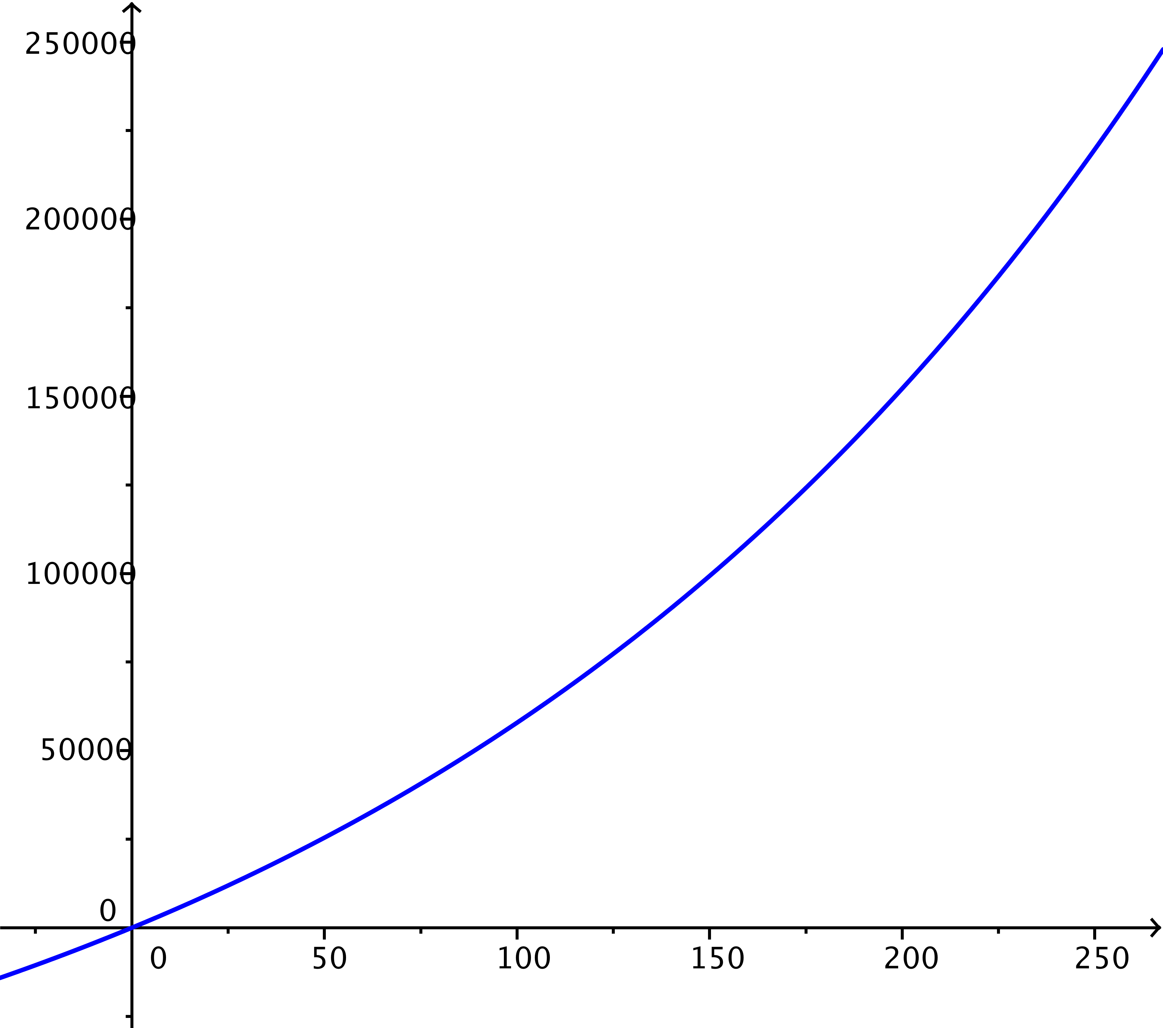

* 1. State any trends that you notice for this function.

The function appears to be exponential in nature. It is increasing at an increasing rate.

* 1. What is the approximate value of the function for ?
  2. What is the domain of ? Explain.

Since the compounding is monthly, the domain of is normally considered to be a positive integer (i.e., the number of periods).

* 1. If the domain of the function is restricted to natural numbers, is the function a geometric sequence? Why or why not?

No, the function is not a geometric sequence, since it does not have a common ratio. For instance, from to , the value of the ratio is approximately , but from to , the value of the ratio is .

* 1. Recall that the th partial sums of a geometric sequence can be represented with . It is true that for positive integers , since it is a geometric sequence; that is, . State the geometric sequence whose sums of the first terms are represented by this function.

The geometric sequence has first term and common ratio . It can be written as

* 1. April has been following this structured savings plan for years. April says that taking out the money and starting over will not affect the total money earned because the interest rate does not change. Explain why April is incorrect in her reasoning.

The function is increasing exponentially, so the larger the balance, the more it grows. If the money is taken out, then the growth would be reset back to the beginning, although you would have that money.

1. Henry plans to have in property in years and would like to save up to million by depositing each month at interest per year, compounded monthly. Tina’s structured savings plan over the same time span is described in the following table:

|  |  |
| --- | --- |
| Deposit # | Amount Saved |
|  |  |
|  |  |
|  |  |
|  |  |
|  |  |
|  |  |
|  |  |
|  |  |

* 1. Who has the higher interest rate? Who pays more every month?

From the table it looks like Tina pays more every month, but Henry has the higher interest rate. Henry would have about after payments, but Tina has more at that point. After payments, Henry will save up , while Tina has only saved . Over long periods of time, a higher interest rate will eventually beat larger payments.

* 1. At the end of years, who has more money from their structured savings plan? Does this agree with what you expected? Why or why not?

Henry has more, but just barely. The larger payment Tina was making was not enough to stay ahead of Henry for years, but he looks to have just passed her recently.

* 1. At the end of years, who has more money from their structured savings plan?

Henry will have extended his lead significantly by this point. Once he overtakes Tina, his savings will continue to grow at a faster rate than Tina’s savings.

1. Edgar and Paul are two brothers that both get an inheritance of . Both plan to save up over in years. Edgar takes his inheritance and deposits the money into an investment account earning interest annually, compounded monthly, payable at the end of years. Paul spends his inheritance but uses a structured savings plan that is represented by the sequence with in order to save up more than .
   1. Which of the two has more money at the end of years?

Let represent Edgar’s savings and represent Paul’s savings.

Then .

* 1. What are the pros and cons of both brothers’ plans? Which would you rather do? Why?

Edgar only has to make a single payment, and he inherited the money, so it does not come out of his normal budget. He does not have to worry about the account again, but he makes less money than Paul overall and cannot access the money until the end of the years. Edgar also pays much less than Paul does.

Paul ends up paying in order to save up his million, but he does this slowly over the years, so he does not have a huge pinch at any point in time. He spends his inheritance, so he will need to pay a lot more taxes up front on the amount. Paul ends up saving more money in the long run.

Answers will vary between the two plans and may include a combination of both.