Lesson 32: Buying a House

Student Outcomes
- Students model the scenario of buying a house.
- Students recognize that a mortgage is mathematically equivalent to car loans studied in Lesson 30 and apply the present value of annuity formula to a new situation.

Lesson Notes
In the Problem Set of Lesson 31, students selected both a future career and a home that they would like to purchase. In this lesson, the students investigate the question of whether or not they can afford the home that they have selected on the salary of the career that they have chosen. We will not develop the standard formulas for mortgage payments, but rather the students will use the concepts from prior lessons on buying a car and paying off a credit card balance to decide for themselves how to model mortgage payments (MP.4). Have students work in pairs or small groups through this lesson, but each student should be working through their own scenario with their own house and their own career. That is, the students will be deciding together how to approach the problem, but they will each be working with their own numbers.
If you teach in a region where the cost of living is particularly high, the median starting salaries given in the list in Problem 9 of Lesson 31 may need to be appropriately adjusted upward in order to make any home purchase feasible in this exercise. Use your professional judgment to make these adjustments.
The students have the necessary mathematical tools to model the payments on a mortgage, but they may not realize it. Allow them to struggle, to debate, and to persevere with the task of deciding how to model this situation (MP.1). It will eventually become apparent that the process of buying a house is only slightly more complicated mathematically than the process of buying a car and that the present value of an annuity formula developed in Lesson 30 applies in this situation (A-SSE.B.4). The formula
$$A_{p}=R\left(\frac{1-{\left(1+i\right)}^{-n}}{i}\right)$$
can be solved for the monthly payment $R$:
$$R=\frac{A_{p}⋅i}{1-{\left(1+i\right)}^{-n}},$$
and this formula can be used to answer many of the questions in this lesson. Students may apply the formulas immediately, or they may investigate the balance on the mortgage without using the formulas, which will lead them to develop these formulas on their own. Be sure to ask students to explain their thinking in order to accurately assess their understanding of the mathematics.

Classwork
Opening (3 minutes)
- As part of your homework last night, you have selected a potential career that interests you, and you have selected a house that you would like to purchase.
Scaffolding:
For struggling students, illustrate the concepts of mortgage, escrow, and down payments using a concrete example with sample values.
Call on a few students to ask them to share the careers that they have selected, the starting salary, and the price of the home they have chosen.
- Today you will answer the following question: Can you afford the house that you have chosen? There are a few constraints that you need to keep in mind.
- The total monthly payment for your house cannot exceed $30\%$ of your monthly salary.
- Your payment includes the payment of the loan for the house and payments into an account called an escrow account, which is used to pay for taxes and insurance on your home.
- Mortgages are usually offered with $30$, $20,$ or $15$-year repayment options. You will start with a $30$-year mortgage.
- You need to make a down payment on the house, meaning that you pay a certain percentage of the price up front and borrow the rest. You will make a $10\%$ down payment for this exercise.
Scaffolding:
Struggling students may need to be presented with a set of carefully structured questions:
- What is the monthly salary for the career you chose?
- What is $30\%$ of your monthly salary?
- How much money needs to be paid into the escrow account each year?
- How much money needs to be paid into the escrow account each month?
- What is the most expensive house that the bank will allow you to purchase?
- Is a mortgage like a car loan?
- What is the formula we used to model a car loan?
- Which of the values $A_{p}$, $n$, $i$, and $R$ do we know?
- Can you rewrite that formula to isolate the $R$?
- What is the monthly payment according to the formula?
- Will the bank allow you to purchase the house that you have chosen?

Mathematical Modeling Exercise (25 minutes)
Students may immediately recognize that the previous formulas from Lessons 30 and 31 can be applied to a mortgage, or they may investigate the balance on the mortgage without using the formulas. Both approaches are presented in the sample responses below.
Mathematical Modeling Exercise
Now that you have studied the mathematics of structured savings plans, buying a car, and paying down a credit card debt, it’s time to think about the mathematics behind the purchase of a house. In the problem set in Lesson 31, you selected a future career and a home to purchase. The question of the day is this: Can you buy the house you have chosen on the salary of the career you have chosen? You need to adhere to the following constraints:
- Mortgages are loans that are usually offered with $30$-, $20$-, or $15$-year repayment options. You will start with a $30$-year mortgage.
- The annual interest rate for your mortgage will be $5\%.$
- Your payment includes the payment of the loan for the house and payments into an account called an escrow account, which is used to pay for taxes and insurance on your home. We will approximate the annual payment to escrow as $1.2\%$ of the home’s selling price.
- The bank will only approve a mortgage if the total monthly payment for your house, including the payment to the escrow account, does not exceed $30\%$ of your monthly salary.
- You have saved up enough money to put a $10\%$ down payment on this house.

- Will the bank approve you for a $30$-year mortgage on the house that you have chosen?
I chose the career of a graphic designer, with a starting salary of $\$39,900$. My monthly salary is
$\$39,\frac{900}{12}= \$3,325$.
Thirty percent of my $\$3,325$ monthly salary is $\$997.50$.
I found a home that is suitable for $\$190,000$.
I need to contribute $0.012\left(190,000\right)=2,280$ to escrow for the year, which means I need to pay$\$190$ to escrow each month.
I will make a $\$19,000$ down payment, meaning that I need a mortgage for $\$171,000$.

APPROACH 1: We can think of the total owed on the house in two different ways.
- If we had placed the original loan amount $A_{p}=171,000$ in a savings account earning $5\%$ annual interest, then the future amount in $30$years would be $A_{f}=A_{p}{\left(1+i\right)}^{360}$.
- If we deposit a payment of $R$ into an account monthly and let the money in the account accumulate and earn interest for $30$ years, then the future value is
$$A_{f}=R+R\left(1+i\right)+R{\left(1+i\right)}^{2}+⋯R{\left(1+i\right)}^{359} \\ =R\sum_{k=0}^{359}{{\left(1+i\right)}^{k}} \\ =R\left(\frac{1-{\left(1+i\right)}^{360}}{1-\left(1+i\right)}\right) \\ =R\left(\frac{{\left(1+i\right)}^{360}-1}{i}\right)$$
Setting these two expressions for $A_{f}$ equal to each other, we have
$$A_{p}{\left(1+i\right)}^{360}= R\left(\frac{{\left(1+i\right)}^{360}-1}{i}\right)\text{,}$$
so
$$R=\frac{A_{p}⋅i⋅ {\left(1+i\right)}^{360}}{{\left(1+i\right)}^{360}-1}\text{,}$$
which can also be expressed as$$R=\frac{A_{p}⋅i }{{1-\left(1+i\right)}^{-360}}\text{.}$$
This is the formula for the present value of an annuity, but rewritten to isolate $R$.
Then using my values of $A_{p}$, $i$ and $n$ we have
$$R=\frac{171000\left(0.004167\right)}{1-{\left(1.004167\right)}^{-360}} \\ R=918.01\text{.}$$
Then, the monthly payment on the house I chose would be $R+190=1,108.01$. The bank will not lend me the money to buy this house because $\$1,108.01$ is higher than $\$997.50$.

APPROACH 2: From Lesson$30$, we know that the present value of an annuity formula is $A_{p}=R\left(\frac{1-{\left(1+i\right)}^{-n}}{i}\right)$, where $i$ is the monthly interest rate, $R$ is the monthly payment, and $n$ is the number of months in the term. In my example, $i=\frac{0.05}{12}≈0.004167$, $R$ is unknown, $n=12⋅30=360$, and $A_{p}=171,000.$ We can solve the above formula for $R$, then we can substitute the known values of the variables and calculate the resulting payment $R$.
$$A_{p}=R\left(\frac{1-{\left(1+i\right)}^{-n}}{i}\right) \\ A_{p}⋅i=R\left(1-{\left(1+i\right)}^{-n}\right) \\ R=\frac{A_{p}⋅i}{1-{\left(1+i\right)}^{-n}}$$
Then using my values of $A_{p}$, $i$ and $n$ we have
$$R=\frac{171000\left(0.004167\right)}{1-{\left(1.004167\right)}^{-360}} \\ R=918.01\text{.}$$
Then, the monthly payment on the house I chose would be $R+190=1,108.01$. The bank will not lend me the money to buy this house because $\$1,108.01$ is higher than $\$997.50$.

- Answer either (a) or (b) as appropriate.
  - If your bank approved you for a $30$-year mortgage, do you meet the criteria for a $20$-year mortgage? If you could get a mortgage for any number of years that you want, what is the shortest term for which you would qualify?
(This scenario did not happen in this example.)

  - If your bank did not approve you for the $30$-year mortgage, what is the maximum price of a house that fits your budget?
Scaffolding:
Mortgage rates can be as low as $3.0\%$, and in the $1990$s rates were often as high as $10\%.$Ask early finishers to compute the maximum price of a house that they can afford first with an annual interest rate of $5\%$, then with an annual interest rate of $3\%,$ and then with an annual interest rate of $10\%.$
The maximum that the bank will allow for my monthly payment is $30\%$ of my monthly salary, which is $\$997.50$. This includes the payment to the loan and to escrow. If the total price of the house is$H$ dollars, then I will make a down payment of $0.001H$ and finance $0.9H$. Using the present value of an annuity formula, we have
$$0.9H=R\left(\frac{1-{\left(1+i\right)}^{-n}}{i}\right) \\ 0.9H=R\left(\frac{1-{\left(1.004167\right)}^{-360}}{0.004167}\right) \\ 0.9H=R(186.282)$$
However, $R$ represents just the payment to the loan and not the payment to the escrow account. We know that the escrow portion is one-twelfth of $1.2\%$ of the house value. If we denote the total amount paid for the loan and escrow by $P$, then $P=R+0.001H$, so $R=P-0.001H$. We know that the largest value for $P$ is
$P=997.50$, so then
$$0.9H=R(186.282) \\ 0.9H=\left(997.50-0.001H\right)\left(186.282\right) \\ 0.9H=185816-0.186282H \\ 1.086282H=185816 \\ H=171,056.87$$
Then, I can only afford a house that is priced at or below $\$171,056.87$.
Discussion (9 minutes)
As time permits, ask students to present their results to the class and to explain their thinking. Select students who were approved for their mortgage and those who were not approved to make presentations. Be sure that students who did not immediately recognize that the present value of an annuity formula applies to a mortgage understand that this method is valid. Then, debrief the modeling exercise with the following questions:
- If the bank did not approve your loan, what are your options?
  - I could wait to purchase the house and save up a larger down payment, I could get a higher-paying job, or I could look for a more reasonably priced house.
- What would happen if the annual interest rate on your mortgage increased to $8\%$?
  - If the annual interest rate on the mortgage increased to $8\%$, then the monthly payments would increase dramatically since the loan term is always fixed.
- Why does the bank limit the amount of the mortgage to $30\%$ of your income?
  - The bank wants to ensure that you will pay back the loan and that you will not overextend your finances.

Closing (3 minutes)
Ask students to summarize the lesson with a partner or in writing by responding to the following questions:
- Which formula from the previous lessons was useful to calculate the monthly payment on the mortgage? Why did that formula apply to this situation?
- How is a mortgage like a car loan? How is it different?
- How is paying a mortgage like paying a credit card balance? How is it different?

Exit Ticket (5 minutes)

Name Date
Lesson 32: Buying a House

Exit Ticket

- Recall the present value of an annuity formula, where $A_{p}$ is the present value, $R$ is the monthly payment, $i$ is the monthly interest rate, and $n$ is the number of monthly payments:
$$A_{p}=R\left(\frac{1-{\left(1+i\right)}^{-n}}{i}\right) .$$
Rewrite this formula to isolate $R.$

- Suppose that you want to buy a house that costs $\$175,000$. You can make a $10\%$down payment, and $1.2\%$ of the house’s value is paid into the escrow account each month.
  - Find the monthly payment for a $30$-year mortgage on this house.

  - Find the monthly payment for a $15$-year mortgage on this house.

Exit Ticket Sample Solutions

- Recall the present value of an annuity formula, where $A_{p}$ is the present value, $R$ is the monthly payment, $i$ is the monthly interest rate, and $n$ is the number of monthly payments:
$$A_{p}=R\left(\frac{1-{\left(1+i\right)}^{-n}}{i}\right)\text{.}$$
Rewrite this formula to isolate $R$.
$$R=\frac{A_{p}}{\frac{1-{\left(1+i\right)}^{-n}}{i}}$$
$$R=\frac{A_{p}⋅i}{1-{\left(1+i\right)}^{-n}}$$

- Suppose that you want to buy a house that costs $\$175,000$. You can make a $10\%$down payment, and $1.2\%$ of the house’s value is paid into the escrow account each month.
  - Find the total monthly payment for a $30$-year mortgage at $4.25\%$ interest on this house.
We have $A_{p}=0.9\left(175,000\right)=157,500$, and the monthly escrow payment is$\frac{1}{12}\left(0.012\right)\left(\$175,000\right)=\$175$. The monthly interest rate $i$ is given by $i=\frac{0.045}{12}=0.00375$, and $n-12⋅30=360$. Then the formula from Problem 1 gives
$$R=\frac{A_{p}⋅i}{1-{\left(1+i\right)}^{-n}} \\ =\frac{\left(157500\right)\left(0.00375\right)}{1-{\left(1.00375\right)}^{-360}} \\ =798.03$$
Thus, the payment to the loan is $\$798.03$ each month. Then the total monthly payment is $\$798.03+\$175=\$973.03$.

  - Find the total monthly payment for a $15$-year mortgage at $3.75\%$ interest on this house.
We have $A_{p}=0.9\left(175,000\right)=157,500,$ and the monthly escrow payment is$\frac{1}{12}\left(0.012\right)\left(\$175,000\right)=\$175$. The monthly interest rate $i$ is given by $i=\frac{0.0375}{12}=0.003125$, and $n-12⋅15=180$. Then the formula from Problem 1 gives
$$R=\frac{A_{p}⋅i}{1-{\left(1+i\right)}^{-n}} \\ =\frac{\left(157500\right)\left(0.003125\right)}{1-{\left(1.003125\right)}^{-180}} \\ =1145.38$$
Thus, the payment to the loan is $\$1145.38$ each month. Then the total monthly payment is $\$1,145.38+\$175=\$1,320.38.$

Problem Set Sample Solutions
The results of Exercise 1 are needed for the modeling exercise in Lesson 33, in which students make a plan to save up $\$1,000,000$ in assets in $15$ years, including paying off their home in that time.

- Use the house you selected to purchase in the Problem Set from Lesson 31 for this problem.
  - What was the selling price of this house?
Student responses will vary. The sample response will continue to use a house that sold for $\$190,000$.

  - Calculate the total monthly payment, $R$, for a $15$-year mortgage at $5\%$ annual interest, paying $10\%$ as a down payment and an annual escrow payment that is $1.2\%$ of the full price of the house.
Using the payment formula with $A_{p}=0.9\left(190,000\right)=171,000$, $i=\frac{0.05}{12}≈0.004167$, and
$n=15⋅12=180$, we have
$$R=\frac{A_{p}⋅i}{1-{\left(1+i\right)}^{-n}} \\ =\frac{\left(171000\right)\left(0.004167\right)}{1-{\left(1.004167\right)}^{-180}} \\ =1,352.29$$
The escrow payment is$\frac{1}{12}(0.012)(\$190,000)=\$190$. The total monthly payment is
$\$1352.29+\$190=\$1,542.29$.

- In the summer of $2014$, the average listing price for homes for sale in the Hollywood Hills was $\$2,663,995$.
  - Suppose you want to buy a home at that price with a $30$-year mortgage at $5.25\%$annual interest, paying $10\%$as a down payment and with an annual escrow payment that is $1.2\%$ of the full price of the home. What is your total monthly payment on this house?
Using the payment formula with $A_{p}=0.9\left(2663995\right)=2,397,595.50$, $i=\frac{0.0525}{12}≈0.004375$, and
$n=360$, we have
$$R=\frac{A_{p}⋅i}{1-{\left(1+i\right)}^{-n}} \\ =\frac{\left(2397595.50\right)\left(0.004375\right)}{1-{\left(1.004375\right)}^{-360}} \\ =13,239.60$$
The escrow payment is$\frac{1}{12}\left(0.012\right)\left(\$2,663,995\right)=\$2,664.00$. The total monthly payment is $\$13,239.60+\$2,664=\$15,903.60$.

  - How much is paid in interest over the life of the loan?
The total amount paid is $\$13,239.60(60)=\$4,766,256$, and the purchase price was $\$2,663,995$. The amount of interest is the difference $\$4,766,256-\$2,663,995=\$2,102,261$.

- Suppose that you would like to buy a home priced at $\$200,000$. You will make a payment of $10\%$of the purchase price and pay $1.2\%$ of the purchase price into an escrow account annually.
  - Compute the total monthly payment and the total interest paid over the life of the loan for a $30$-year mortgage at $4.8\%$ annual interest.
Using the payment formula with $A_{p}=0.9\left(200,000\right)=180,000$, $i=\frac{0.048}{12}=0.004$, and $n=360$, we have
$$R=\frac{A_{p}⋅i}{1-{\left(1+i\right)}^{-n}} \\ =\frac{\left(180,000\right)\left(0.004\right)}{1-{\left(1.004\right)}^{-360}} \\ =994.40$$
The escrow payment is$\frac{1}{12}\left(0.012\right)\left(\$200,000\right)=\$200.00$. The total monthly payment is
$\$994.40+\$200=\$1,194.40$.
The total amount of interest is the difference between the total amount paid, $360\left(\$994.40\right)=\$357,984$, and the selling price$\$200,000$, so the total interest paid is $\$157,984$.

  - Compute the total monthly payment and the total interest paid over the life of the loan for a $20$-year mortgage at $4.8\%$ annual interest.
Using the payment formula with $A_{p}=0.9\left(200,000\right)=180,000$, $i=\frac{0.048}{12}=0.004$, and $n=240$, we have
$$R=\frac{A_{p}⋅i}{1-{\left(1+i\right)}^{-n}} \\ =\frac{\left(180,000\right)\left(0.004\right)}{1-{\left(1.004\right)}^{-240}} \\ =1,168.12$$
The escrow payment is$\frac{1}{12}\left(0.012\right)\left(\$200,000\right)=\$200.00$. The total monthly payment is
$\$1,168.12+\$200=\$1,368.12$.
The total amount of interest is the difference between the total amount paid,
$240\left(\$1,168.12\right)=\$280,348.80$, and the selling price,$\$200,000$, so the total interest paid is $\$80,348.80$.

  - Compute the total monthly payment and the total interest paid over the life of the loan for a $15$-year mortgage at $4.8\%$ annual interest.
Using the payment formula with $A_{p}=0.9\left(200,000\right)=180,000$, $i=\frac{0.048}{12}=0.004$, and $n=180$, we have
$$R=\frac{A_{p}⋅i}{1-{\left(1+i\right)}^{-n}} \\ =\frac{\left(180,000\right)\left(0.004\right)}{1-{\left(1.004\right)}^{-180}} \\ =1,404.75$$
The escrow payment is$\frac{1}{12}\left(0.012\right)\left(\$200,000\right)=\$200.00$. The total monthly payment is
$\$1,404.75+\$200=\$1,604.75$.
The total amount of interest is the difference between the total amount paid,
$180\left(\$1,404.75\right)=\$252,855$, and the selling price,$\$200,000$, so the total interest paid is $\$52,855$.

- Suppose that you would like to buy a home priced at $\$180,000$. You will qualify for a $30$-year mortgage at $4.5\%$ annual interest and pay $1.2\%$ of the purchase price into an escrow account annually.
  - Calculate the total monthly payment and the total interest paid over the life of the loan if you make a $3\%$ down payment.
With a three percent down payment, you need to borrow $A_{p}=0.97\left(\$180,000\right)=\$174,600$. We have
$i=\frac{0.045}{12}=0.00375$, and $n=360$, so
$$R=\frac{A_{p}⋅i}{1-{\left(1+i\right)}^{-n}} \\ =\frac{\left(174,600\right)\left(0.00375\right)}{1-{\left(1.00375\right)}^{-360}} \\ =884.67$$
The escrow payment is$\frac{1}{12}\left(0.012\right)\left(\$180,000\right)=\$180.00$. The total monthly payment is
$\$884.67+\$180=\$1,064.67$.
The total amount of interest is the difference between the total amount paid,
$360\left(\$884.67\right)=\$318,481.20$, and the selling price$, \$180,000$, so the total interest paid is $\$138,481.20$.

  - Calculate the total monthly payment and the total interest paid over the life of the loan if you make a $10\%$ down payment.
With a ten percent down payment, you need to borrow $A_{p}=0.9\left(\$180,000\right)=\$162,000$. We have
$i=\frac{0.045}{12}=0.00375$, and $n=360$, so
$$R=\frac{A_{p}⋅i}{1-{\left(1+i\right)}^{-n}} \\ =\frac{\left(162,000\right)\left(0.00375\right)}{1-{\left(1.00375\right)}^{-360}} \\ =820.83$$
The escrow payment is$\frac{1}{12}\left(0.012\right)\left(\$180,000\right)=\$180.00$. The total monthly payment is
$\$820.83+\$180=\$1,000.83$.
The total amount of interest is the difference between the total amount paid,
$360\left(\$820.83\right)=\$295,498.80$, and the selling price$, \$180,000$, so the total interest paid is $\$115,498.80$.

  - Calculate the total monthly payment and the total interest paid over the life of the loan if you make a $20\%$down payment.
With a twenty percent down payment, you need to borrow $A_{p}=0.8\left(\$180,000\right)=\$144,000.$We have
$i=\frac{0.045}{12}=0.00375$, and $n=360$, so
$$R=\frac{A_{p}⋅i}{1-{\left(1+i\right)}^{-n}} \\ =\frac{\left(144,000\right)\left(0.00375\right)}{1-{\left(1.00375\right)}^{-360}} \\ =712.56$$
The escrow payment is$\frac{1}{12}\left(0.012\right)\left(\$180,000\right)=\$180.00$. The total monthly payment is
$\$712.56+\$180=\$892.56$.
The total amount of interest is the difference between the total amount paid,
$360\left(\$712.56\right)=\$256,521.60$, and the selling price,$\$180,000$, so the total interest paid is $\$76,521.60$.
  - Summarize the results of parts (a), (b), and (c) in the chart below.
Percent down payment | Amount of  down payment | Total interest  paid
$$3\%$$ | $$\$5,400$$ | $$\$138,481.20$$
$$10\%$$ | $$\$18,000$$ | $$\$115,498.80$$
$$20\%$$ | $$\$36,000$$ | $$\$76,521.60$$

- The following amortization table shows the amount of payments to principal and interest on a $\$100,000$ mortgage at the beginning and the end of a $30$-year loan. These payments do not include payments to the escrow account.
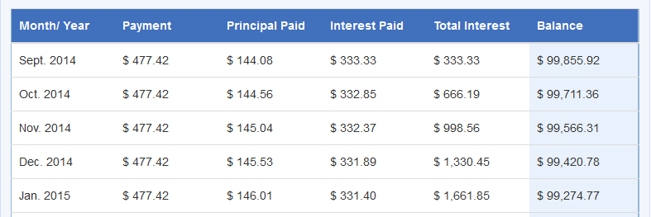
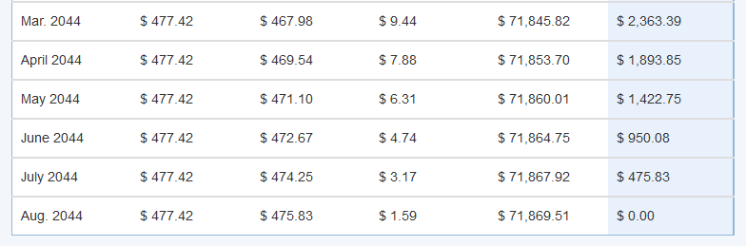

  - What is the annual interest rate for this loan? Explain how you know.
Since the first interest payment is $i⋅\$100,000=\$333.33$, the monthly interest rate is $i=0.0033333$, and the annual interest rate is then $12i≈0.044$, so$i=4\%$.

  - Describe the changes in the amount of principal paid each month as the month $n$ gets closer to $360$.
As $n$ gets closer to $360$, the amount of the payment that is allocated to principal increases to nearly the entire payment.

  - Describe the changes in the amount of interest paid each month as the month $n$ gets closer to $360$.
As $n$ gets closer to $360$, the amount of the payment that is allocated to interest decreases to nearly zero.

- Suppose you want to buy a $\$200,000$ home with a $30$-year mortgage at $4.5\%$annual interest paying $10\%$ down with an annual escrow payment that is $1.2\%$ of the price of the home.
  - Disregarding the payment to escrow, how much do you pay toward the loan on the house each month?
$$R=\frac{A_{p}⋅i}{1-{\left(1+i\right)}^{-n}} \\ =\frac{\left(180000\right)\left(0.00375\right)}{1-{\left(1.00375\right)}^{-360}} \\ =912.03$$

  - What is the total monthly payment on this house?
The monthly escrow payment is$\frac{1}{12}\left(0.012\right)\left(200,000\right)=200$, so the total monthly payment is $\$1,112.03$.

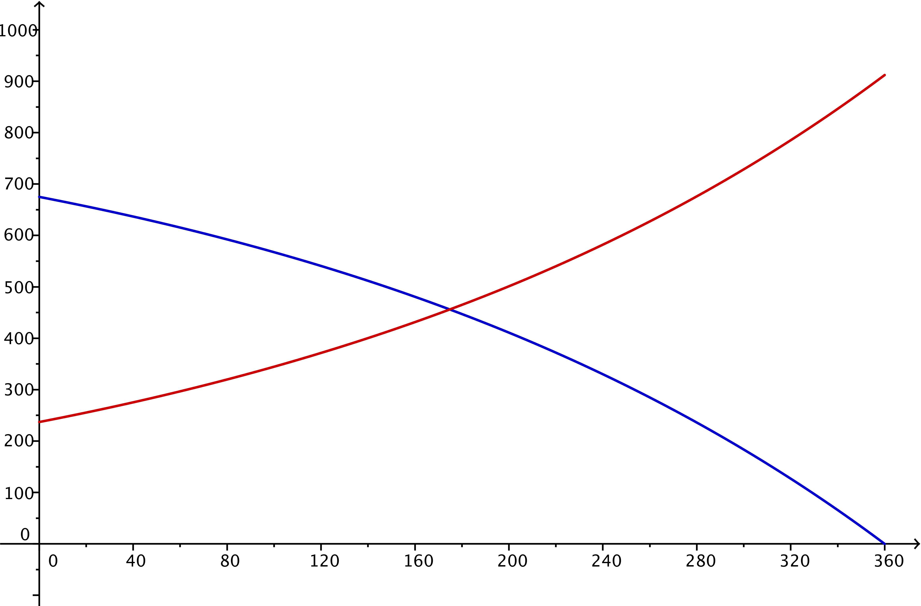
  - The graph below depicts the amount of your payment from part (b) that goes to the interest on the loan and the amount that goes to the principal on the loan. Explain how you can tell which graph is which.
The amount paid to interest starts high and decreases, while the amount paid to principal starts low and then increases over the life of the loan. Thus, the blue curve that starts around $675$ and decreases represents the amount paid to interest, and the red curve that starts around $240$ and increases represents the amount paid to principal.

- Student loans are very similar to both car loans and mortgages. The same techniques used for car loans and mortgages can be used for student loans. The difference between student loans and other types of loans is that usually students are not required to pay anything until $6$ months after they stop being full-time students.
  - An unsubsidized student loan will accumulate interest while a student remains in school. Sal borrows $\$9,000$ his first term in school at an interest rate of $5.95\%$ per year compounded monthly and never makes a payment. How much will he owe $4\frac{1}{2}$ years later? How much of that amount is due to compounded interest?
This is a compound interest problem without amortization since Sal does not make any payments.
$$9,000⋅{\left(1+\frac{0.0595}{12}\right)}^{54}≈11,755.40$$
Sal will owe $\$11,755.40$ at the end of $4\frac{1}{2}$ years. Since he borrowed $\$9,000$, he owes $\$2,755.40$ in interest.
  - If Sal pays the interest on his student loan every month while he is in school, how much money has he paid?
Since Sal pays the interest on his loan every month, the principal never grows. Every month, the interest is calculated by
$$9,000⋅\frac{0.0595}{12}≈\$44.63\text{.}$$
If Sal pays $\$44.63$ every month for $4\frac{1}{2}$ years, he will have paid $\$2,410.02$.

  - Explain why the answer to part (a) is different than the answer to part (b).
If Sal pays the interest each month, as in part (b), then no interest ever compounds. If he skips the interest payments while he is in school, then the compounding process charges interest on top of interest, increasing the total amount of interest owed on the loan.

- Consider the sequence $a_{0}=10,000$, $a_{n}=a_{n-1}⋅\frac{1}{10}$ for $n≥1$.
  - Write the explicit form for the $n$^{th} term of the sequence.
$$a_{1}=10,000\left(\frac{1}{10}\right)=1000 \\ a_{2}=\frac{1}{10}\left(a_{1}\right)= 10,000 {\left(\frac{1}{10}\right)}^{2} \\ a_{3}=\frac{1}{10}\left(a_{2}\right)=10,000{\left(\frac{1}{10}\right)}^{3} \\ ⋮ \\ a_{n}=10,000 {\left(\frac{1}{10}\right)}^{n}$$

  - Evaluate $\sum_{k=0}^{4}{a_{k}}$.
$$\sum_{k=0}^{4}{a_{k}}=10,000+1,000+100+10+1=11,111$$

  - Evaluate $\sum_{k=0}^{6}{a_{k}}$.
$$\sum_{k=0}^{6}{a_{k}}=10,000+1,000+100+10+1+0.1+0.01=11,111.11$$

  - Evaluate $\sum_{k=0}^{8}{a_{k}}$using the sum of a geometric series formula.
$$\sum_{k=0}^{8}{a_{k}=10,000\frac{\left(1-r^{8}\right)}{1-r}} \\ =10,000\frac{\left(1-{\left(\frac{1}{10}\right)}^{8}\right)}{1-\frac{1}{10}} \\ =11,111.1111$$

  - Evaluate $\sum_{k=0}^{10}{a_{k}}$ using the sum of a geometric series formula.
$$\sum_{k=0}^{10}{a_{k}=10,000\frac{\left(1-r^{10}\right)}{1-r}} \\ =10,000\frac{\left(1-{\left(\frac{1}{10}\right)}^{10}\right)}{1-\frac{1}{10}} \\ =11,111.111111$$

  - Describe the value of $\sum_{k=0}^{n}{a_{k}}$ for any value of $n≥4$.
The value of $\sum_{k=0}^{n}{a_{k}}$ for any $n≥4$ is $11,111.\underset{n-4 ones}{\underbrace{111⋯1}}$.

