Lesson 32: Buying a House

Classwork
Mathematical Modeling Exercise
Now that you have studied the mathematics of structured savings plans, buying a car, and paying down a credit card debt, it’s time to think about the mathematics behind the purchase of a house. In the Problem Set in Lesson 31, you selected a future career and a home to purchase. The question of the day is this: Can you buy the house you have chosen on the salary of the career you have chosen? You need to adhere to the following constraints:
- Mortgages are loans that are usually offered with $30$-, $20$-, or $15$-year repayment options. You will start with a $30$-year mortgage.
- The annual interest rate for your mortgage will be $5\%.$
- Your payment includes the payment of the loan for the house and payments into an account called an escrow account, which is used to pay for taxes and insurance on your home. We will approximate the annual payment to escrow as $1.2\%$ of the home’s selling price.
- The bank will only approve a mortgage if the total monthly payment for your house, including the payment to the escrow account, does not exceed $30\%$ of your monthly salary.
- You have saved up enough money to put a $10\%$ down payment on this house.

- Will the bank approve you for a $30$-year mortgage on the house that you have chosen?

- Answer either (a) or (b) as appropriate.
  - If your bank approved you for a $30$-year mortgage, do you meet the criteria for a $20$-year mortgage? If you could get a mortgage for any number of years that you want, what is the shortest term for which you would qualify?
  - If your bank did not approve you for the $30$-year mortgage, what is the maximum price of a house that fits your budget?

Problem Set

- Use the house you selected to purchase in the Problem Set from Lesson 31 for this problem.
  - What was the selling price of this house?
  - Calculate the total monthly payment, $R$, for a $15$-year mortgage at $5\%$ annual interest, paying $10\%$ as a down payment and an annual escrow payment that is $1.2\%$ of the full price of the house.

- In the summer of $2014$, the average listing price for homes for sale in the Hollywood Hills was $\$2,663,995.$
  - Suppose you want to buy a home at that price with a $30$-year mortgage at $5.25\%$annual interest, paying $10\%$as a down payment and with an annual escrow payment that is $1.2\%$ of the full price of the home. What is your total monthly payment on this house?
  - How much is paid in interest over the life of the loan?

- Suppose that you would like to buy a home priced at $\$200,000$. You will make a payment of $10\%$of the purchase price and pay $1.2\%$ of the purchase price into an escrow account annually.
  - Compute the total monthly payment and the total interest paid over the life of the loan for a $30$-year mortgage at $4.8\%$ annual interest.
  - Compute the total monthly payment and the total interest paid over the life of the loan for a $20$-year mortgage at $4.8\%$ annual interest.
  - Compute the total monthly payment and the total interest paid over the life of the loan for a $15$-year mortgage at $4.8\%$ annual interest.

- Suppose that you would like to buy a home priced at $\$180,000$. You will qualify for a $30$-year mortgage at $4.5\%$ annual interest and pay $1.2\%$ of the purchase price into an escrow account annually.
  - Calculate the total monthly payment and the total interest paid over the life of the loan if you make a $3\%$ down payment.
  - Calculate the total monthly payment and the total interest paid over the life of the loan if you make a $10\%$ down payment.
  - Calculate the total monthly payment and the total interest paid over the life of the loan if you make a $20\%$down payment.
  - Summarize the results of parts (a), (b), and (c) in the chart below.
Percent down payment | Amount of  down payment | Total interest  paid
$$3\%$$
$$10\%$$
$$20\%$$

- The following amortization table shows the amount of payments to principal and interest on a $\$100,000$ mortgage at the beginning and the end of a $30$-year loan. These payments do not include payments to the escrow account.

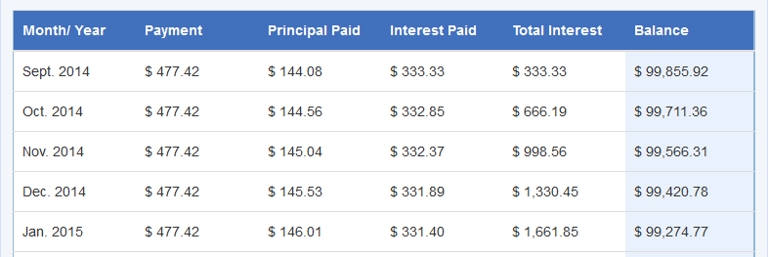
$$⋮$$
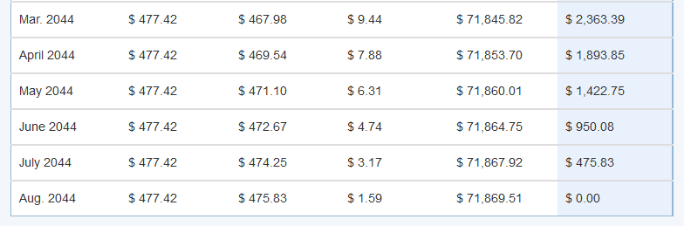
  - What is the annual interest rate for this loan? Explain how you know.
  - Describe the changes in the amount of principal paid each month as the month $n$ gets closer to $360.$
  - Describe the changes in the amount of interest paid each month as the month $n$ gets closer to $360$.

- Suppose you want to buy a $\$200,000$ home with a $30$-year mortgage at $4.5\%$annual interest paying $10\%$ down with an annual escrow payment that is $1.2\%$ of the price of the home.
  - Disregarding the payment to escrow, how much do you pay toward the loan on the house each month?
  - What is the total monthly payment on this house?
  - The graph below depicts the amount of your payment from part (b) that goes to the interest on the loan and the amount that goes to the principal on the loan. Explain how you can tell which graph is which.
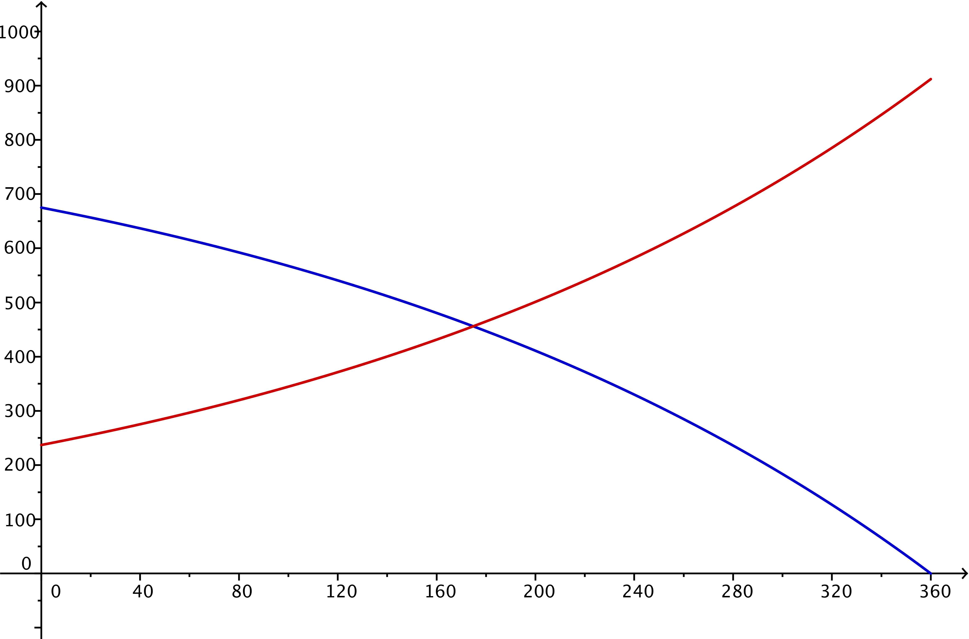

- Student loans are very similar to both car loans and mortgages. The same techniques used for car loans and mortgages can be used for student loans. The difference between student loans and other types of loans is that usually students are not required to pay anything until $6$ months after they stop being full-time students.
  - An unsubsidized student loan will accumulate interest while a student remains in school. Sal borrows $\$9,000$ his first term in school at an interest rate of $5.95\%$ per year compounded monthly and never makes a payment. How much will he owe $4\frac{1}{2}$ years later? How much of that amount is due to compounded interest?
  - If Sal pays the interest on his student loan every month while he is in school, how much money has he paid?
  - Explain why the answer to part (a) is different than the answer to part (b).

- Consider the sequence $a_{0}=10000$, $a_{n}=a_{n-1}⋅\frac{1}{10}$ for $n≥1$.
  - Write the explicit form for the $n$^{th} term of the sequence.
  - Evaluate $\sum_{k=0}^{4}{a_{k}}$.
  - Evaluate $\sum_{k=0}^{6}{a_{k}}$.
  - Evaluate $\sum_{k=0}^{8}{a_{k}}$using the sum of a geometric series formula.
  - Evaluate $\sum_{k=0}^{10}{a_{k}}$ using the sum of a geometric series formula.
  - Describe the value of $\sum_{k=0}^{n}{a_{k}}$ for any value of $n≥4$.

