Lesson 30: Buying a Car

Classwork
Opening Exercise
Write a sum to represent the future amount of a structured savings plan (i.e., annuity) if you deposit $\$250$ into an account each month for $5$years that pays $3.6\%$ interest per year, compounded monthly. Find the future amount of your plan at the end of $3$ years.

Example
Jack wanted to buy a $\$9,000$ $2$-door sports coupe but could not pay the full price of the car all at once. He asked the car dealer if she could give him a loan where he paid a monthly payment. She told him she could give him a loan for the price of the car at an annual interest rate of $3.6\%$ compounded monthly for $60$months ($5$ years).
The problems below exhibit how Jack’s car dealer used the information above to figure out how much his monthly payment of $R$ dollars per month should be.
  - First, the car dealer imagined how much she would have in an account if she deposited $\$9,000$ into the account and left it there for $60$ months at an annual interest rate of $3.6\%$ compounded monthly. Use the compound interest formula $F=P{\left(1+i\right)}^{n}$ to calculate how much she would have in that account after $5$ years. This is the amount she would have in the account after $5$ years if Jack gave her $\$9,000$ for the car, and she immediately deposited it.

  - Next, she figured out how much would be in an account after $5$ years if she took each of Jack’s payments of $R$ dollars and deposited it into a bank that earned $3.6\%$ per year (compounded monthly). Write a sum to represent the future amount of money that would be in the annuity after $5$ years in terms of $R$, and use the sum of a geometric series formula to rewrite that sum as an algebraic expression.

  - The car dealer then reasoned that, to be fair to her and Jack, the two final amounts in both accounts should be the same—that is, she should have the same amount in each account at the end of $60$ months either way. Write an equation in the variable $R$ that represents this equality.

  - She then solved her equation to get the amount $R$ that Jack would have to pay monthly. Solve the equation in part (c) to find out how much Jack needed to pay each month.

Exercise
A college student wants to buy a car and can afford to pay $\$200$ per month. If she plans to take out a loan at $6\%$ interest per year with a recurring payment of $\$200$ per month for four years, what price car can she buy?

Mathematical Modeling Exercise
In the Problem Set of Lesson 29, you researched the price of a car that you might like to own. In this exercise, you will determine how much a car payment would be for that price for different loan options.
If you did not find a suitable car, select a car and selling price from the list below:
Car | Selling Price
$2005$ Pickup Truck | $$\$9000$$
$2007$ Two-Door Small Coupe | $$\$7500$$
$2003$ Two-Door Luxury Coupe | $$\$10,000$$
$2006$ Small SUV | $$\$8000$$
$2008$Four-Door Sedan | $$\$8500$$
  - When you buy a car, you must pay sales tax and licensing and other fees. Assume that sales tax is $6\%$ of the selling price and estimated license/title/fees will be $2\%$ of the selling price. If you put a $\$1,000$ down payment on your car, how much money will you need to borrow to pay for the car and taxes and other fees?

  - Using the loan amount you computed above, calculate the monthly payment for the different loan options shown below:
Loan 1 | $36$-month loan at $2\%$
Loan 2 | $48$-month loan at $3\%$
Loan 3 | $60$-month loan at $5\%$

  - Which plan, if any, will keep your monthly payment under $\$175$? Of the plans under $\$175$ per month, why might you choose a plan with fewer months even though it costs more per month?

Lesson Summary
The total cost of car ownership includes many different costs in addition to the selling price, such as sales tax, insurance, fees, maintenance, interest on loans, gasoline, etc.
The present value of an annuity formula can be used to calculate monthly loan payments given a total amount borrowed, the length of the loan, and the interest rate. The present value $A_{p}$ (i.e., loan amount) of an annuity consisting of $n$ recurring equal payments of size $R$ and interest rate $i$ per time period is
$$A_{p}=R⋅\frac{1-{\left(1+i\right)}^{-n}}{i} .$$
Amortization tables and online loan calculators can also help you plan for buying a car.
The amount of your monthly payment depends on the interest rate, the down payment, and the length of the loan.

Problem Set

- Benji is $24$years old and plans to drive his new car about $200$miles per week. He has qualified for first-time buyer financing, which is a $60$-month loan with $0\%$ down at an interest rate of $4\%.$Use the information below to estimate the monthly cost of each vehicle.
CAR A: $2010$ Pickup Truck for $\$12,000$, $22$ miles per gallon
CAR B: $2006$ Luxury Coupe for $\$11,000$, $25$ miles per gallon
Gasoline: $\$4.00$ per gallon New vehicle fees: $\$80$ Sales Tax: $4.25\%$
Maintenance Costs:
($2010$ model year or newer): $10\%$ of purchase price annually
($2009$ model year or older): $20\%$ of purchase price annually
Insurance:
Average Rate Ages 25–29 | $\$100$ per month
If you are male  If you are female | Add $\$10$ per month  Subtract $\$10$ per month
Type of Car  Pickup Truck  Small Two-Door Coupe or Four-Door Sedan  Luxury Two- or Four-Door Coupe | Subtract $\$10$ per month  Subtract $\$10$ per month  Add $\$15$ per month
Ages 18–25 | Double the monthly cost
  - How much money will Benji have to borrow to purchase each car?
  - What is the monthly payment for each car?
  - What are the annual maintenance costs and insurance costs for each car?
  - Which car should Benji purchase? Explain your choice.
- Use the total initial cost of buying your car from the lesson to calculate the monthly payment for the following loan options.
Option | Number of Months | Down Payment | Interest Rate | Monthly Payment
Option A | $48$ months | $$\$0$$ | $$2.5\%$$
Option B | $60$months | $$\$500$$ | $$3.0\%$$
Option C | $60$ months | $$\$0$$ | $$4.0\%$$
Option D | $36$ months | $$\$1000$$ | $$0.9\%$$
  - For each option, what is the total amount of money you will pay for your vehicle over the life of the loan?
  - Which option would you choose? Justify your reasoning.

- Many lending institutions will allow you to pay additional money toward the principal of your loan every month. The table below shows the monthly payment for an $\$8,000$loan using Option A above if you pay an additional $\$25$ per month.
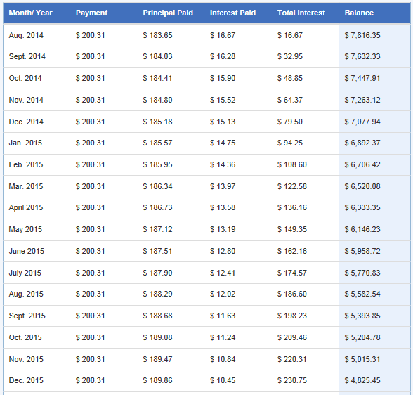
Note: The months from January $2016$ to December $2016$ are not shown.
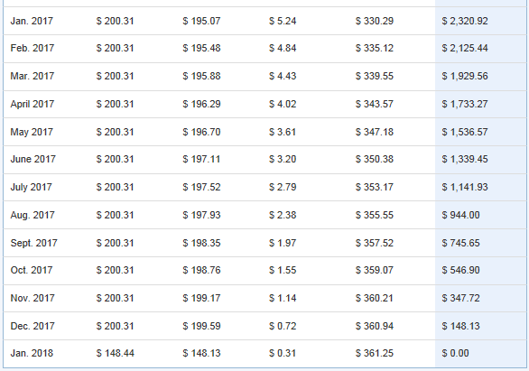
How much money would you save over the life of an $\$8,000$ loan using Option A if you paid an extra $\$25$ per month compared to the same loan without the extra payment toward the principal?

- Suppose you can afford only $\$200$ a month in car payments and your best loan option is a $60$-month loan at $3\%.$ How much money could you spend on a car? That is, calculate the present value of the loan with these conditions.

- Would it make sense for you to pay an additional amount per month toward your car loan? Use an online loan calculator to support your reasoning.

- What is the sum of each series?
  - $900+900{\left(1.01\right)}^{1}+900{\left(1.01\right)}^{2}+…+900{\left(1.01\right)}^{59}$
  - $\sum_{n=0}^{47}{15,000{\left(1+\frac{0.04}{12}\right)}^{n}}$

- Gerald wants to borrow $\$12,000$ in order to buy an engagement ring. He wants to repay the loan by making monthly installments for two years. If the interest rate on this loan is $9\frac{1}{2}\%$ per year, compounded monthly, what is the amount of each payment?

- Ivan plans to surprise his family with a new pool using his Christmas bonus of $\$4200$ as a down payment. If the price of the pool is $\$9,500$ and Ivan can finance it at an interest rate of $2\frac{7}{8}\%$ per year, compounded quarterly, how long is the loan for if he pays $\$285.45$ per quarter?

- Jenny wants to buy a car by making payments of $\$120$ per month for three years. The dealer tells her that she will need to put a down payment of $\$3,000$ on the car in order to get a loan with those terms at a $9\%$ interest rate per year, compounded monthly. How much is the car that Jenny wants to buy?

- Kelsey wants to refinish the floors in her house and estimates that it will cost $\$39,000$ to do so. She plans to finance the entire amount at $3\frac{1}{4}\%$ interest per year, compounded monthly for $10$ years. How much is her monthly payment?

- Lawrence coaches little league baseball and needs to purchase all new equipment for his team. He has $\$489$ in donations, and the team’s sponsor will take out a loan at $4\frac{1}{2}\%$ interest per year, compounded monthly for one year, paying up to $\$95$ per month. What is the most that Lawrence can purchase using the donations and loan?

