Lesson 28: Newton’s Law of Cooling, Revisited

Student Outcomes
- Students apply knowledge of exponential and logarithmic functions and transformations of functions to a contextual situation.

Lesson Notes
Newton’s law of cooling is a complex topic that appears in physics and calculus; the formula can be derived using differential equations. In Algebra I (Module 3), students completed a modeling lesson in which Newton’s law of cooling was simplified to focus on the idea of applying transformations of functions to a contextual situation. In this lesson, students take another look at Newton’s law of cooling, this time incorporating their knowledge of the number $e$ and logarithms. Students now have the capability of finding the decay constant, $k$, for a contextual situation through the use of logarithms (F-LE.A.4). Students expand their understanding of exponential functions and transformations to build a function that models the temperature of a cooling body by adding a constant function to a decaying exponential and relate these functions to the model (F-BF.A.1.b). The entire lesson highlights modeling with mathematics (MP.4) and also provides students with an opportunity to interpret scenarios using Newton’s law of cooling when presented with functions represented in various ways (numerically, graphically, algebraically, or verbally) (F-IF.C.9).

Classwork
Opening (2 minutes)
Review the formula $T\left(t\right)=T_{a}+\left(T_{0} – T_{a}\right)∙e^{-kt}$that was first introduced in Algebra I. There is one difference in the current presentation of the formula; in Algebra I, the base was expressed as $2.718$ because students had not yet learned about the number $e$. Allow students a minute to examine the given formula. Before they begin working, discuss each parameter in the formula as a class.
- What does $T_{a}$ represent? $T_{0}$? $k$? $T(t)$?
MP.2
  - The notation $T_{a}$ represents the temperature surrounding the object, often called the “ambient temperature.” The initial temperature of the object is denoted by $T_{0}$. The constant $k$ is called the decay constant. The temperature of the object after time t has elapsed is denoted by $T(t)$.
- Is $e$ one of the parameters in the formula?
  - No; the number $e$ is a constant that is approximately equal to $2.718$.
- Assuming that the temperature of the object is greater than the temperature of the environment, is this formula an example of exponential growth or decay?
  - It is an example of decay, because the temperature will be decreasing.
- Why would it be decay when the base $e$ is greater than $1$? Shouldn’t that be exponential growth?
  - Because the base is raised to a negative exponent. The negative reflects the graph about the $y$-axis making it decay rather than growth. If we rewrite the exponential expression using properties of exponents, we see that $e^{-kt}={\left(\frac{1}{e}\right)}^{kt}$, and $\frac{1}{e}<1$. In this form, we can clearly identify exponential decay.
Newton’s law of cooling is used to model the temperature of an object of some temperature placed in an environment of a different temperature. The temperature of the object $t$hours after being placed in the new environment is modeled by the formula
Scaffolding:
Use the interactive demonstration on Wolfram Alpha that was used in Algebra I to assist in analyzing the formula.
http://demonstrations.wolfram.com/NewtonsLawOfCooling/
$$T\left(t\right)=T_{a}+\left(T_{0} – T_{a}\right)∙e^{-kt},$$
where:
$T(t)$ is the temperature of the object after a time of $t$ hours has elapsed,
$T_{a}$ is the ambient temperature (the temperature of the surroundings), assumed to be constant and not impacted by the cooling process,
$T_{0}$ is the initial temperature of the object, and
$k$ is the decay constant.

Mathematical Modeling Exercise 1 (15 minutes)
Have students work in groups on parts (a) and (b) of the exercise. Circulate the room and provide assistance as needed. Stop and debrief to ensure that students set up the equations correctly. Discuss the next scenario as a class before having students continue through the exercise.
Mathematical Modeling Exercise 1
A crime scene investigator is called to the scene of a crime where a dead body has been found. He arrives at the scene and measures the temperature of the dead body at $9:30$ p.m. to be $78.3°F$. He checks the thermostat and determines that the temperature of the room has been kept at $74°F$. At $10:30$ p.m., the investigator measures the temperature of the body again. It is now $76.8°F$. He assumes that the initial temperature of the body was $98.6°F$ (normal body temperature). Using this data, the crime scene investigator proceeds to calculate the time of death. According to the data he collected, what time did the person die?
  - Can we find the time of death using only the temperature measured at $9:30$p.m.? Explain.
No. There are two parameters that are unknown, $k$ and $t$. We need to know the decay constant, $k$, in order to be able to find the elapsed time.

  - Set up a system of two equations using the data.
Let $t_{1}$ represent the elapsed time from the time of death until $9:30$ when the first measurement was taken, and let $t_{2}$ represent the elapsed time between the time of death and $10:30$ when the second measurement was taken. Then $t_{2}=t_{1}+1$. We have the following equations:
$$T(t_{1})=74+\left(98.6-74\right)e^{-kt_{1}} \\ T(t_{2})=74+\left(98.6-74\right)e^{-kt_{2}}.$$
Substituting in our known value $T\left(t_{1}\right)=78.3$ and $T\left(t_{2}\right)=76.8$, we get the system:
$$78.3=74+\left(98.6-74\right)e^{-kt_{1}} \\ 76.8=74+\left(98.6-74\right)e^{-k(t_{1}+1)}.$$

- Why do we need two equations to solve this problem?
  - Because there are two unknown parameters.
- What does $t_{1}$ represent in the equation? Why does the second equation contain $(t_{1}+1)$ instead of just $t_{1}$?
  - The variable $t_{1}$ represents the elapsed time from time of death to $9:30$ p.m. The second equation uses ${(t}_{1}+1)$ because the time of the second measurement is one hour later, so one additional hour has passed.
- Joanna set up her equations as follows:
MP.2
&
MP.3
$$78.3=74+\left(98.6-74\right)e^{-k(t_{2}-1)} \\ 76.8=74+\left(98.6-74\right)e^{-kt_{2}}$$
- In her equations, what does $t_{2}$represent?
  - Elapsed time from time of death to $10:30$ p.m.
- Will she still find the same time of death? Explain why.
If students are unsure, have some groups work through the problem using one set of equations and some using the other. Re-address this question at the end.
  - Yes, she will still get the same time of death. She will get a value of $t$ that is one hour greater since she is measuring elapsed time to $10:30$ rather than $9:30$, but she will still get the same time of death.
- Now that we have this system of equations, how should we go about solving it?
MP.1
Allow students to struggle with this for a few minutes. They may propose subtracting $74$from both sides or subtracting $98.6-74$.
$$4.3=24.6e^{-kt_{1}} \\ 2.8=24.6e^{-k(t_{1}+1)}$$
- What do we need to do now?
  - Combine the two equations in some way using the method of substitution or elimination.
- What is our goal in doing this?
  - We want to eliminate one of the variables.
- Would it be helpful to subtract the two equations? If students say yes, have them try it.
  - No. Subtracting one equation from the other did not eliminate a variable.
- How else could we combine the equations?
  - We could use the multiplication property of equality to divide $4.2$by $2.8$ and $24.6e^{-kt_{1}}$ by $24.6e^{-k\left(t_{1}+1\right)}$.
If nobody offers this suggestion, lead students to the idea by reminding them of the properties of exponents. If we divide the exponential expressions, we will subtract the exponents and eliminate the variable $t_{1}$.
Have students continue the rest of the problem in groups.

  - Find the value of the decay constant, $k$.
$$4.3=24.6e^{-kt_{1}} \\ 2.8=24.6e^{-k(t_{1}+1)} \\ \frac{4.3}{2.8}=e^{-kt_{1}+k\left(t_{1}+1\right)} \\ \frac{4.3}{2.8}=e^{k} \\ ln\left(\frac{4.3}{2.8}\right)={ln(e}^{k}) \\ ln\left(\frac{4.3}{2.8}\right)=k≈0.429$$

  - What was the time of death?
$$4.3=24.6e^{-0.429t_{1}} \\ \frac{4.3}{24.6}=e^{-0.429t_{1}} \\ ln\left(\frac{4.3}{24.6}\right)={ln(e}^{-0.429t_{1}}) \\ ln\left(\frac{4.3}{24.6}\right)=-0.429t_{1} \\ 4.0656= t_{1}$$
The person died approximately $4$ hours before $9:30$ p.m., so the time of death was approximately $5:30$ p.m.

- Would we get the same time of death if we used the set of equations where $t_{2}$represents time elapsed from death until $10:30$ p.m.?
  - Yes.

Mathematical Modeling Exercise 2 (10 minutes)
Allow students time to work in groups before discussing responses as a class. During the debrief, share and discuss work from different groups.
Mathematical Modeling Exercise 2
A pot of tea is heated to $90°C$. A cup of the tea is poured into a mug and taken outside where the temperature is $18°C$. After $2$ minutes, the temperature of the cup of tea is approximately $65°C$.
  - Determine the value of the decay constant, $k$.
$$T\left(2\right)=18+\left(90-18\right)e^{-k∙2}=65 \\ 72e^{-2k}=47 \\ e^{-2k}=\frac{47}{72} \\ -2k=ln\left(\frac{47}{72}\right) \\ k≈ 0.2133$$

  - Write a function for the temperature of the tea in the mug, T, in $°C$, as a function of time, $t,$ in minutes.
$$T\left(t\right)=18+72 e^{-0.213t}$$

  - Graph the function $T$.
Scaffolding:
Provide students who are struggling with a graphing calculator or other graphing utility so that they can better focus on the key concepts of the lesson.

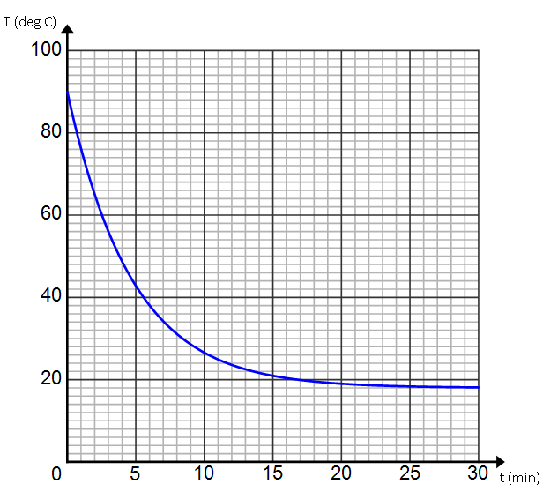

  - Use the graph of $T$ to describe how the temperature decreases over time.
Because the temperature is decreasing exponentially, the temperature drops rapidly at first and then slows down. After about $25$minutes, the temperature of the tea levels off.

  - Use properties of exponents to rewrite the temperature function in the form $T\left(t\right)=18+72{\left(1+r\right)}^{t}$.
$$T\left(t\right)=18+72 e^{-0.213 t} \\ =18+72{\left(e^{-0.213}\right)}^{t} \\ ≈18+72{\left(0.8082\right)}^{t} \\ ≈18+72{\left(1-0.1918\right)}^{t}$$

  - In Lesson 26, we saw that the value of $r$ represents the percent change of a quantity that is changing according to an exponential function of the form $f\left(t\right)=A{\left(1+r\right)}^{t}$. Describe what $r$ represents in the context of the cooling tea.
The number $r$ represents the percent change in the difference between the temperature of the tea and the temperature of the room. Because $r=-0.1918$, the temperature difference is decreasing by $19.18\%$ each minute.

  - As more time elapses, what temperature does the tea approach? Explain using both the context of the problem and the graph of the function $T$.
The temperature of the tea approaches $18°C$. Within the context of the problem, this makes sense because that is the ambient temperature (the outside temperature), so when the tea reaches $18°C$ it will stop cooling. Looking at the expression of the function $T$, the number $18$ represents a vertical translation so as $t→∞$,
$T→18$.

Mathematical Modeling Exercise 3 (10 minutes)
Newton’s law of cooling also applies when a cooler object is placed in a warmer surrounding temperature. (In this case, we could call it Newton’s Law of Heating.) Allow students time to work in groups before discussing responses as a class. During the debrief, share and discuss work from different groups.
Mathematical Modeling Exercise 3
Two thermometers are sitting in a room that is $22°C$. When each thermometer reads $22°C$, the thermometers are placed in two different ovens. Select data for the temperature $T$ of each thermometer (in $°C$) $t$ minutes after being placed in the oven is provided below.
Thermometer 1:
$t$(minutes) | $$0$$ | $$2$$ | $$5$$ | $$8$$ | $$10$$ | $$14$$
$T$ ($°C)$ | $$22$$ | $$75$$ | $$132$$ | $$173$$ | $$175$$ | $$176$$
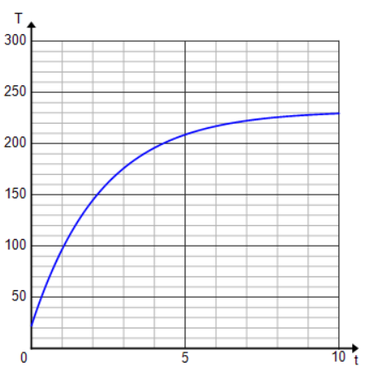
Thermometer 2:

- Do the table and graph given for each thermometer support the statement that Newton’s law of cooling also applies when the surrounding temperature is warmer? Explain.
Yes. The graph shows a reflected exponential curve, which would indicate that a similar formula could be used. From both the table and the graph, it can be seen that the temperature increases rapidly at first and then levels off to the temperature of its surroundings; this coincides with what happens when an object is cooling (that is, the temperature decreases rapidly and then levels off).

- Which thermometer was placed in a hotter oven? Explain.
Thermometer 2 was placed in a hotter oven. The graph shows its temperature leveling off at approximately $230°C$, while the table indicates that thermometer 1 levels off at approximately $176°C.$

- Using a generic decay constant, $k,$without finding its value, write an equation for each thermometer expressing the temperature as a function of time.
Thermometer 1: $T\left(t\right)=176+\left(22-176\right)e^{-kt}$
Thermometer 2: $T\left(t\right)=230+\left(22-230\right)e^{-kt}$
- How do the equations differ when the surrounding temperature is warmer than the object rather than cooler as in previous examples?
In the case where we are placing a cool object into a warmer space, the coefficient in front of the exponential expression is negative rather than positive.

- How do the graphs differ when the surrounding temperature is warmer than the object rather than cooler as in previous examples?
In the case where we are placing a cool object into a warmer space, the graph increases rather than decreases. The negative coefficient in front of the exponential expression causes the graph to reflect across the$x$-axis.

Closing (3 minutes)
Use the closing to highlight how this lesson built on their experiences from Algebra I with exponential decay and transformations of functions as well as the content learned in this module, such as the number $e$ and logarithms.
- For Exercise 2$,$ describe the transformations required to graph $T$ starting from the graph of the natural exponential function $f\left(t\right)=e^{t}$.
  - The graph is reflected across the $y$-axis, stretched both vertically and horizontally, and translated up.
- Why were logarithms useful in exploring Newton’s law of cooling?
  - It allowed us to find the decay constant or the amount of time elapsed, both of which involve solving an exponential equation.
- How do you find the percent rate of change of the temperature difference from the Newton’s law of cooling equation?
  - Rewrite $T\left(t\right)=T_{0}+\left(T_{a}-T_{0}\right)e^{-kt}$ as $T\left(t\right)=T_{0}+\left(T_{a}-T_{0}\right){\left(e^{-k}\right)}^{t}$, then express $e^{-k}$ as $e^{-k}=1-r$, for some number $r$. Then $r$ represents the percent rate of change of the temperature difference.

Exit Ticket (5 minutes)
Name Date
Lesson 28: Newton’s Law of Cooling, Revisited

Exit Ticket

A pizza, heated to a temperature of $400°F$, is taken out of an oven and placed in a $75°F$ room at time $t=0$ minutes. The temperature of the pizza is changing such that its decay constant,$k$, is $0.325.$ At what time is the temperature of the pizza $150°F$ and, therefore, safe to eat? Give your answer in minutes.

Exit Ticket Sample Solutions

A pizza, heated to a temperature of $400°$ Fahrenheit, is taken out of an oven and placed in a $75°$F room at time $t=0$ minutes. The temperature of the pizza is changing such that its decay constant,$k$, is $0.325$. At what time is the temperature of the pizza $150°$F and, therefore, safe to eat? Give your answer in minutes.
$$T\left(t\right)=75+\left(400-75\right)e^{-0.325t}=150 \\ 325e^{-0.325t}=75 \\ e^{-0.325t}=\frac{75}{325} \\ -0.325t≈ln\left(\frac{75}{325}\right) \\ t≈4.512$$
The pizza will reach $150°F$ after approximately $4\frac{1}{2}$ minutes.

Problem Set Sample Solutions

- Experiments with a covered cup of coffee show that the temperature (in degrees Fahrenheit) of the coffee can be modeled by the following equation:
$$f\left(t\right)= 112e^{-0.08t}+ 68,$$
where the time is measured in minutes after the coffee was poured into the cup.
  - What is the temperature of the coffee at the beginning of the experiment?
$$180°F$$

  - What is the temperature of the room?
$$68°F$$

  - After how many minutes is the temperature of the coffee $140°F$? Give your answer to $3$ decimal places.
$5.523$ minutes.

  - What is the temperature of the coffee after how many minutes have elapsed?
The temperature will be slightly above $68°F.$

  - What is the percent rate of change of the difference between the temperature of the room and the temperature of the coffee?
$$f\left(t\right)=112\left(e^{-0.08t}\right)+68 \\ =112{\left(e^{-0.08}\right)}^{t}+68 \\ ≈112{\left(0.9231\right)}^{t}+68 \\ ≈112{\left(1-0.0769\right)}^{t}+68$$
Thus, the percent rate of change of the temperature difference is a decrease of $7.69\%$ each minute.

- Suppose a frozen package of hamburger meat is removed from a freezer that is set at $0°F$ and placed in a refrigerator that is set at $38°F$. Six hours after being placed in the refrigerator, the temperature of the meat is $12°F$.
  - Determine the decay constant, $k$.
$$k=0.063$$

  - Write a function for the temperature of the meat, $T$in Fahrenheit, as a function of time, $t$ in hours.
$$T\left(t\right)=38-38e^{-0.063t}$$

  - Graph the function $T$.
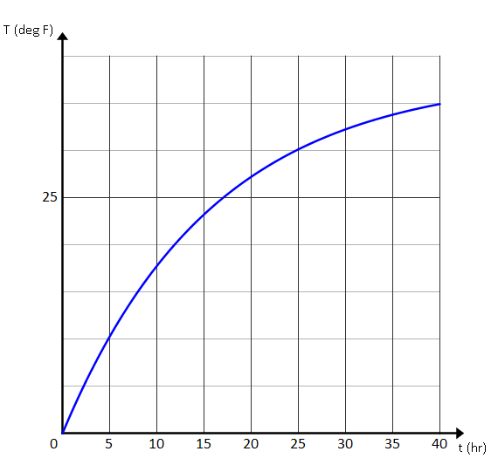

  - Describe the transformations required to graph the function$T$ beginning with the graph of the natural exponential function $f(t)=e^{t}.$
The graph is stretched horizontally, reflected across the $y$-axis, stretched vertically, reflected across the$x$-axis, and translated up.

  - How long will it take the meat to thaw (reach a temperature above $32°F$)? Give answer to three decimal places.
$29.299$ hours

  - What is the percent rate of change of the difference between the temperature of the refrigerator and the temperature of the meat?
$$T\left(t\right)=38-38e^{-0.063t} \\ =38-38{\left(0.9389\right)}^{t} \\ =38-38{\left(1-0.0611\right)}^{t}$$
So, the percent rate of change in the difference of temperature is $6.11\%$.

- The table below shows the temperature of biscuits that were removed from an oven at time $t=0$.
$t$ (min) | $$0$$ | $$10$$ | $$20$$ | $$30$$ | $$40$$ | $$50$$ | $$60$$
$T$ ($°$ C) | $$100$$ | $$34.183$$ | $$22.514$$ | $$20.446$$ | $$20.079$$ | $$20.014$$ | $$20.002$$

  - What is the initial temperature of the biscuits?
$100°C$

  - What does the ambient temperature (room temperature) appear to be?
$20°C$

  - Use the temperature at $t=10$ minutes to find the decay constant,$k$.
$k=0.173$

  - Confirm the value of $k$by using another data point from the table.
$T\left(40\right)=20+80e^{-0.173∙40}=20.079$

  - Write a function for the temperature of the biscuits (in Celsius) as a function of time in minutes.
$T\left(t\right)=20+80e^{-0.173t}$

  - Graph the function $T$.
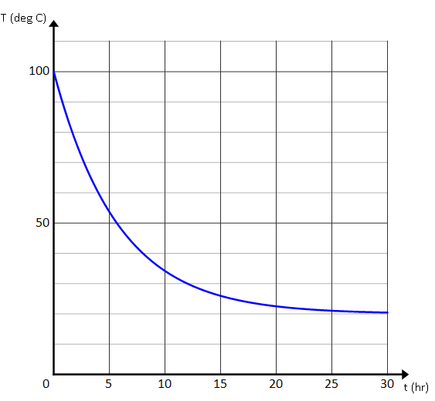

- Match each verbal description with its correct graph and write a possible equation expressing temperature as a function of time.
  - A pot of liquid is heated to a boil and then placed on a counter to cool.
(iii), $T\left(t\right)=75+(212-75)e^{-kt}$ (Equations will vary.)

  - A frozen dinner is placed in a preheated oven to cook.
(ii), $T\left(t\right)=400+(32-400)e^{-kt}$ (Equations will vary.)

  - A can of room-temperature soda is placed in a refrigerator.
(i), $T\left(t\right)=40+(75-40)e^{-kt}$ (Equations will vary.)

(i) | 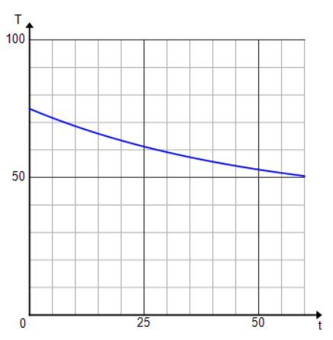 | (ii) | 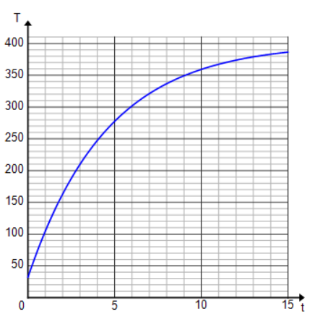
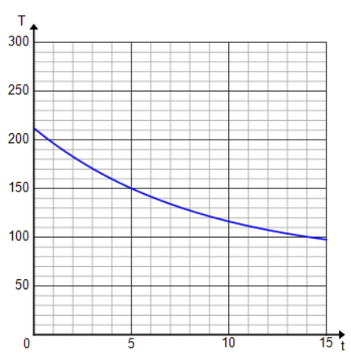
(iii)

