Lesson 28: Newton’s Law of Cooling, Revisited

Classwork
Newton’s law of cooling is used to model the temperature of an object of some temperature placed in an environment of a different temperature. The temperature of the object $t$hours after being placed in the new environment is modeled by the formula
$$T\left(t\right)=T_{a}+\left(T_{0} – T_{a}\right)∙e^{-kt},$$
where:
$T(t)$ is the temperature of the object after a time of $t$ hours has elapsed,
$T_{a}$ is the ambient temperature (the temperature of the surroundings), assumed to be constant and not impacted by the cooling process,
$T_{0}$ is the initial temperature of the object, and
$k$ is the decay constant.

Mathematical Modeling Exercise 1
A crime scene investigator is called to the scene of a crime where a dead body has been found. He arrives at the scene and measures the temperature of the dead body at $9:30$ p.m. to be $78.3°F$. He checks the thermostat and determines that the temperature of the room has been kept at $74°F$. At $10:30$ p.m., the investigator measures the temperature of the body again. It is now $76.8°F$. He assumes that the initial temperature of the body was $98.6°F$ (normal body temperature). Using this data, the crime scene investigator proceeds to calculate the time of death. According to the data he collected, what time did the person die?
  - Can we find the time of death using only the temperature measured at $9:30$p.m.? Explain.

  - Set up a system of two equations using the data.

  - Find the value of the decay constant, $k$.

  - What was the time of death?

Mathematical Modeling Exercise 2
A pot of tea is heated to $90°C$. A cup of the tea is poured into a mug and taken outside where the temperature is $18°C$. After $2$ minutes, the temperature of the cup of tea is approximately $65°C$.
  - Determine the value of the decay constant, $k$.

  - Write a function for the temperature of the tea in the mug, $T$, in $°C$, as a function of time, $t,$ in minutes.

  - Graph the function $T$.
  - Use the graph of $T$ to describe how the temperature decreases over time.

  - Use properties of exponents to rewrite the temperature function in the form $T\left(t\right)=18+72{\left(1+r\right)}^{t}$.

  - In Lesson 26, we saw that the value of $r$ represents the percent change of a quantity that is changing according to an exponential function of the form $f\left(t\right)=A{\left(1+r\right)}^{t}$. Describe what $r$ represents in the context of the cooling tea.

  - As more time elapses, what temperature does the tea approach? Explain using both the context of the problem and the graph of the function $T$.

Mathematical Modeling Exercise 3
Two thermometers are sitting in a room that is $22°C$. When each thermometer reads $22°C$, the thermometers are placed in two different ovens. Select data for the temperature $T$ of each thermometer (in $°C$) $t$ minutes after being placed in the oven is provided below.
Thermometer 1:
$t$(minutes) | $$0$$ | $$2$$ | $$5$$ | $$8$$ | $$10$$ | $$14$$
$T$ ($°C)$ | $$22$$ | $$75$$ | $$132$$ | $$173$$ | $$175$$ | $$176$$
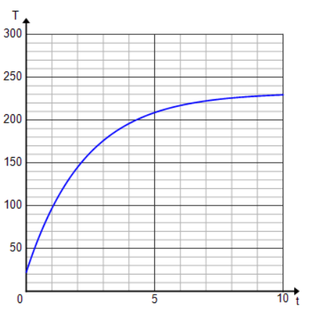
Thermometer 2:

  - Do the table and graph given for each thermometer support the statement that Newton’s law of cooling also applies when the surrounding temperature is warmer? Explain.

  - Which thermometer was placed in a hotter oven? Explain.

  - Using a generic decay constant, $k,$without finding its value, write an equation for each thermometer expressing the temperature as a function of time.

  - How do the equations differ when the surrounding temperature is warmer than the object rather than cooler as in previous examples?

  - How do the graphs differ when the surrounding temperature is warmer than the object rather than cooler as in previous examples?

Problem Set

- Experiments with a covered cup of coffee show that the temperature (in degrees Fahrenheit) of the coffee can be modeled by the following equation:
$f\left(t\right)= 112e^{-0.08t}+ 68,$
where the time is measured in minutes after the coffee was poured into the cup.
  - What is the temperature of the coffee at the beginning of the experiment?
  - What is the temperature of the room?
  - After how many minutes is the temperature of the coffee $140°F$? Give your answer to $3$ decimal places.
  - What is the temperature of the coffee after how many minutes have elapsed?
  - What is the percent rate of change of the difference between the temperature of the room and the temperature of the coffee?

- Suppose a frozen package of hamburger meat is removed from a freezer that is set at $0°$F and placed in a refrigerator that is set at $38°$F. Six hours after being placed in the refrigerator, the temperature of the meat is $12°$F.
  - Determine the decay constant, $k$.
  - Write a function for the temperature of the meat, $T$in Fahrenheit, as a function of time, $t$ in hours.
  - Graph the function $T$.
  - Describe the transformations required to graph the function$T$ beginning with the graph of the natural exponential function $f(t)=e^{t}.$
  - How long will it take the meat to thaw (reach a temperature above $32°F$)? Give answer to three decimal places.
  - What is the percent rate of change of the difference between the temperature of the refrigerator and the temperature of the meat?

- The table below shows the temperature of biscuits that were removed from an oven at time $t=0$.
$t$ (min) | $$0$$ | $$10$$ | $$20$$ | $$30$$ | $$40$$ | $$50$$ | $$60$$
$T$ ($°$C) | $$100$$ | $$34.183$$ | $$22.514$$ | $$20.446$$ | $$20.079$$ | $$20.014$$ | $$20.002$$

  - What is the initial temperature of the biscuits?
  - What does the ambient temperature (room temperature) appear to be?
  - Use the temperature at $t=10$ minutes to find the decay constant,$k$.
  - Confirm the value of $k$by using another data point from the table.
  - Write a function for the temperature of the biscuits (in Celsius) as a function of time in minutes.
  - Graph the function $T$.

- Match each verbal description with its correct graph and write a possible equation expressing temperature as a function of time.
  - A pot of liquid is heated to a boil and then placed on a counter to cool.
  - A frozen dinner is placed in a preheated oven to cook.
  - A can of room-temperature soda is placed in a refrigerator.

(i) | 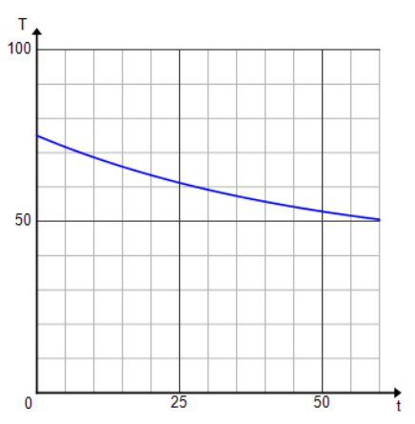 | (ii) | 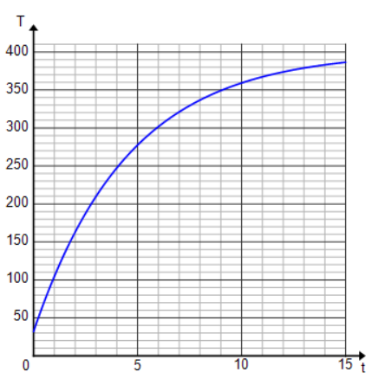
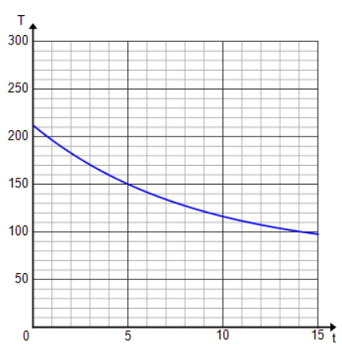
(iii)

