|  |
| --- |
|  |

Lesson 27: Modeling with Exponential Functions

Student Outcomes

* Students create exponential functions to model real-world situations.
* Students use logarithms to solve equations of the form for .
* Students decide which type of model is appropriate by analyzing numerical or graphical data, verbal descriptions, and by comparing different data representations.

Lesson Notes

In this summative lesson, students write exponential functions for different situations to describe the relationships between two quantities (**F-BF.A.1a**). This lesson uses real U.S. Census data to demonstrate how to create a function of the form that could be used to model quantities that exhibit exponential growth or decay. Students must use properties of exponents to rewrite exponential expressions in order to interpret the properties of the function   
(**F-IF.C.8b**). They will estimate populations at a given time and determine the time when a population will reach a certain value by writing exponential equations (**A-CED.A.1**) and solving them analytically (**F-LE.A.4**). In Algebra I, students solved these types of problems graphically or numerically, but we have developed the necessary skills in this module to solve these problems algebraically. The data is presented in different forms (**F-IF.C.9**), and students use average rate of change (**F-IF.B.6**) to decide which type of function is most appropriate between linear or exponential functions (**F-LE.A.1**). Students have several different methods for determining the formula for an exponential function from given data: using a calculator’s regression feature, solving for the parameters in the function analytically, and estimating the growth rate from a table of data (as covered in this lesson). This lesson ties those methods together and asks students to determine which seem most appropriate (MP.4).

*Scaffolding:*

* If students struggle with the opening question, use this problem to provide a more concrete approach:

Given the ordered pairs and , we could write the following functions:

Match each function to the appropriate verbal description and explain how you made your choice.

A: A plant seedling is tall, and each week the height increases by a fixed amount. After three weeks, the plant is tall.

B: Bacteria are dividing in a petri dish. Initially there are bacteria and three weeks later, there are.

Classwork

Opening (1 minute)

Pose this question, which will recall the work students did in Lesson 22:

* If you only have two data points, how should you decide which type of function to use to model the data?
  + *Two data points could be modeled using a linear, quadratic, sinusoidal, or exponential function. You would have to have additional information or know something about the real-world situation to make a decision about which model would be best.*

The Opening Exercise has students review how to find a linear and exponential model given two data points. Later in the lesson, students are then given more information about the data and asked to select and refine a model.

Opening Exercise (5 minutes)

*Scaffolding:*

* For students who struggle with the algebraic manipulations, encourage them to use the statistical features of a graphing calculator to create a linear regression and an exponential regression equation in part (ii) of each Opening Exercise.

Give students time to work this Opening Exercise either independently or with a partner. Observe whether they are able to successfully write a linear and an exponential function for this data. If most of your students cannot complete these exercises without your assistance, then you will need to make adjustments during the lesson to help them build fluency with writing a function from given numerical data.

Opening Exercise

The following table contains U.S. population data for the two most recent census years, and .

|  |  |
| --- | --- |
| Census Year | U.S. Population (in millions) |
|  |  |
|  |  |

* 1. Steve thinks the data should be modeled by a linear function.
     1. What is the average rate of change in population per year according to this data?

The average rate of change is million people per year.

**MP.3**

* + 1. Write a formula for a linear function, that will estimate the population years since the year .
  1. Phillip thinks the data should be modeled by an exponential function.
     1. What is the growth rate of the population per year according to this data?

The population will increase by the factor every years. To determine the yearly rate, we would need to express as the product of equal numbers (e.g., ten times). The annual rate would be .

* + 1. Write a formula for an exponential function, that will estimate the population years since the year .

Start with . Substitute into the formula to solve for .

Thus, .

Next, substitute the value of and the ordered pair into the formula to solve for .

Thus, when you round to the ten-thousandths place and

* 1. Who has the correct model? How do you know?

You cannot determine who has the correct model without additional information. However, populations over longer intervals of time tend to grow exponentially if environmental factors do not limit the growth, so Phillip’s model is likely to be more appropriate.

Discussion (3 minutes)

Before students start working in pairs or small groups on the modeling exercises, debrief the Opening Exercise with the following discussion to ensure that all students are prepared to begin the Modeling Exercise.

* What function best modeled the given data? Allow students to debate about whether they chose a linear or an exponential model, and encourage them to provide justification for their decision.
* What does the number represent?

**MP.7**

* + *The initial population in the year was million people.*
* What does the number represent?
  + *The population is increasing by a factor of each year.*
* How does rewriting the base as help us to understand the population growth rate?
  + *We can see the population is increasing by approximately every year according to our model.*

Mathematical Modeling Exercises 1–14 (24 minutes)

These problems ask students to compare their model from the Opening Exercise to additional models created when given additional information about the U.S. population, and then ask students to use additional data to find a better model. Students should form small groups and work these exercises collaboratively. Provide time at the end of this portion of the lesson for different groups to share their rationale for the choices that they made. Students are exposed to both tabular and graphical data (**F-IF.C.9**) as they work through these exercises. They must use the properties of exponents to interpret and compare exponential functions (**F-IF.C.8b**).

Exercise 11 requires access to the Internet to look up the current population estimate for the U.S. If students do not have convenient Internet access, you can either display the website <http://www.census.gov/popclock>, which would be an interesting way to introduce this exercise, or look up the current population estimate at the onset of class and provide this information to the students. The U.S. population clock is updated every or seconds, so it will show a dramatic population increase through a single class period.

Mathematical Modeling Exercises 1–14

In this challenge, you will continue to examine U.S. census data to select and refine a model for the population of the United States over time.

1. The following table contains additional U.S. census population data. Would it be more appropriate to model this data with a linear or an exponential function? Explain your reasoning.

**MP.3**

|  |  |
| --- | --- |
| Census Year | U.S. Population  (in millions of people) |
|  |  |
|  |  |
|  |  |
|  |  |
|  |  |
|  |  |
|  |  |
|  |  |
|  |  |
|  |  |
|  |  |
|  |  |

*Scaffolding:*

* For students who are slow to recognize data as linear or exponential, create an additional column that shows the average rate of change and reinforce that unless those values are very close to a constant, a linear function is not the best model.

It is not clear by looking at a graph of this data whether it lies on an exponential curve or a line. However, from the context, we know that populations tend to grow as a constant factor of the previous population, so we should use an exponential function to model it. The graph below uses to represent the year .

OR

The differences between consecutive population values do not remain constant and in fact get larger as time goes on, but the quotients of consecutive population values are nearly constant around . This indicates that a linear model is not appropriate but an exponential model is.

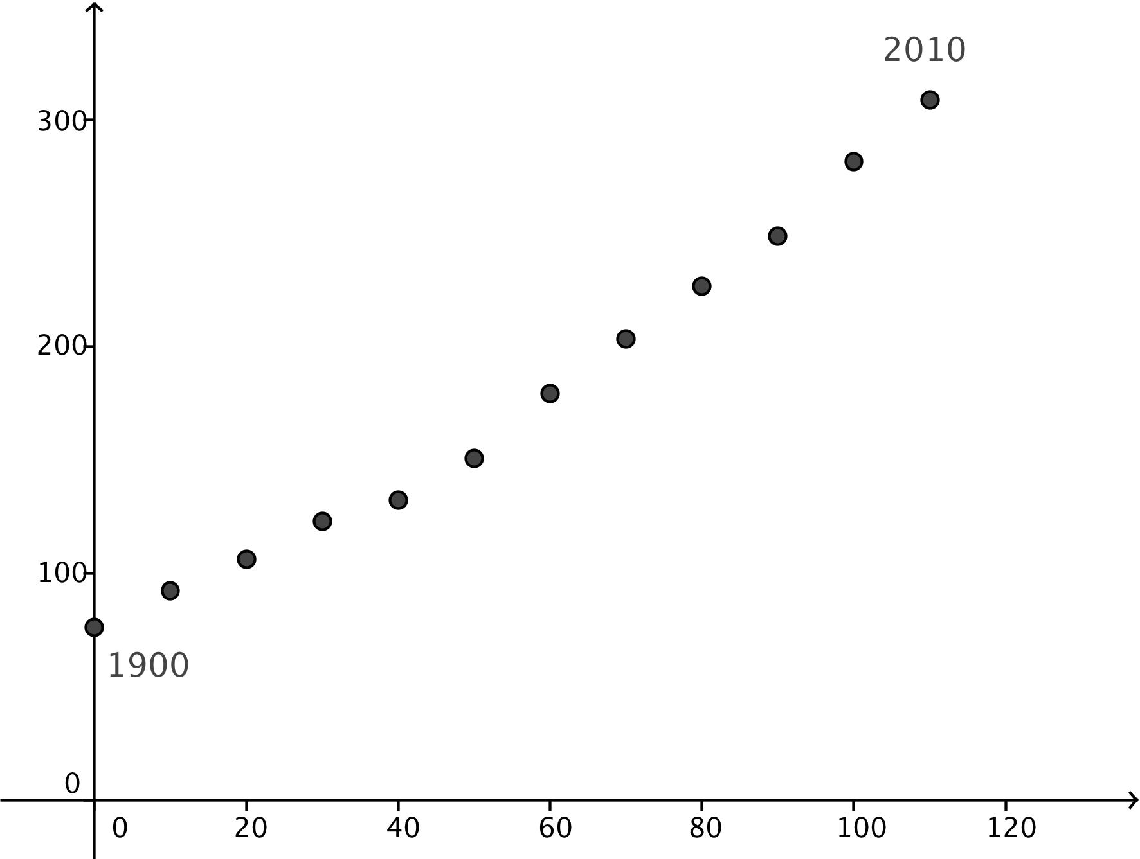

After the work in Lesson 22, students should know that a situation such as this one involving population growth should be modeled by an exponential function. However, the reasoning used by each group of students will vary. Some may plot the data and note the characteristic shape of an exponential curve. Some may calculate the quotients and differences between consecutive population values. If time permits, have students share the reasoning they used to decide which type of function to use.

1. Use a calculator’s regression capability to find a function, , that models the U.S. Census Bureau data from to .

*Scaffolding:*

* Students may need to be shown how to use the calculator to find the exponential regression function.

Using a graphing calculator and letting the year correspond to gives the following exponential regression equation.

1. Find the growth factor for each -year period and record it in the table below. What do you observe about these growth factors?

|  |  |  |
| --- | --- | --- |
| Census Year | US Population  (in millions of people) | Growth Factor  (-year period) |
|  |  | -- |
|  |  |  |
|  |  |  |
|  |  |  |
|  |  |  |
|  |  |  |
|  |  |  |
|  |  |  |
|  |  |  |
|  |  |  |
|  |  |  |
|  |  |  |

The growth factors are fairly constant around .

1. For which decade is the -year growth factor the lowest? What factors do you think caused that decrease?

The -year growth factor is lowest in the s, which is the decade of the Great Depression.

1. Find an average -year growth factor for the population data in the table. What does that number represent? Use the average growth factor to find an exponential function, , that can model this data.

Averaging the -year growth factors gives ; using our previous form of an exponential function; this means that the growth rate satisfies, so . This represents a population increase every ten years. The function has an initial value , so is then given by , where represents year since.

1. You have now computed three potential models for the population of the United States over time: functions , , and . Which one do you expect would be the most accurate model based on how they were created? Explain your reasoning.

Student responses will vary. Potential responses:

* I expect that function that we found through exponential regression on the calculator will be the most accurate because it used all of the data points to compute the coefficients of the function.
* I expect that the function will be most accurate because it uses only the most recent population values.

Students should notice that function is expressed in terms of a -year growth rate (the exponent is ), while the other two functions are expressed in terms of single-year growth rates (the exponent is ). In Exercise 8, encourage students to realize that they will need to use properties of exponents to rewrite the exponential expression in in the form with an annual growth rate so that the three functions can be compared in Exercise 10  
(**F-IF.C.8b**). Through questioning, lead students to notice that time does not have the same meaning for all three functions , and . In Exercise 9, they will need to transform function so that corresponds to the year instead of . This is the equivalent of translating the graph of horizontally to the right by units.

1. Summarize the three formulas for exponential models that you have found so far: Write the formula, the initial populations, and the growth rates indicated by each function. What is different between the structures of these three functions?

We have the three models:

* : Population is million in the year ; annual growth rate is
* : Population is million in the year ; annual growth rate is .
* : Population is million in the year ; -year growth rate is .

Function is expressed in terms of a -year growth factor instead of an annual growth factor as in functions and . Function has the year corresponding to while in functions and the year represents the year

*Scaffolding:*

* Struggling students may need to be explicitly told that they need to re-express in the form with an annual growth rate .

1. Rewrite the functions **, , and** as needed in terms of an annual growth rate.

We need to use properties of exponents to rewrite .

1. **Transform the functions as needed so that the time represents the same year in functions , and Then compare the values of the initial populations and annual growth rates indicated by each function.**

In function , represents the year , and in functions and , represents the year .

*Scaffolding:*

* Struggling students may need to be explicitly told that they need to translate function so that represents the year for all three functions.

Thus, we need to translate function horizontally to the right by years, giving a new function:

Then we have the three functions:

* Function has the largest initial population and the smallest growth rate at increase per year.
* Function has the smallest initial population and the largest growth rate at increase per year.

1. Which of the three functions is the best model to use for the U.S. census data from to ? Explain your reasoning.

Student responses will vary.

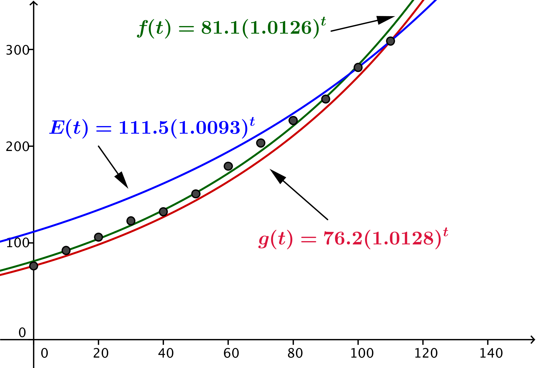Possible response: Graphing all three functions together with the data, we see that function appears to be the closest to all of the data points.

1. The US Census Bureau website <http://www.census.gov/popclock> displays the current estimate of both the United States and world populations.
   1. What is today’s current estimated population of the US?

This will vary by the date. The solution shown here will use the population million and the date August , .

* 1. If time represents the year , what is the value of for today’s date? Give your answer to two decimal places.

August is the th day of the year, so the time is . We will use .

* 1. Which of the functions , , and gives the best estimate of today’s population? Does that match what you expected? Justify your reasoning.

The function gives the closest value to today’s estimated population, but all three functions produce estimates that are too high. Possible response: I had expected that function , which was obtained through regression, to produce the closest population estimate, so this is a surprise.

* 1. With your group, discuss some possible reasons for the discrepancy between what you expected in Exercise 8 and the results of part (c) above.

Student responses will vary.

1. Use the model that most accurately predicted today’s population in Exercise 9, part (c) to predict when the U.S. population will reach half a billion.

Half a billion is million. Set the formula for equal to and solve for .

**MP.3**

Assuming the same rate of growth, the population will reach half a billion people years from the year , in the year.

1. Based on your work so far, do you think this is an accurate prediction? Justify your reasoning.

Student responses will vary. Possible response: From what we know of population growth, the data should most likely be fit with an exponential function, however the growth rate appears to be decreasing because the models that use all of the census data produce estimates for the current population that are too high. I think the population will reach half a billion sometime after the year because the US Census Bureau expects the growth rate to slow down. Perhaps the United States is reaching its capacity and cannot sustain the same exponential rate of growth into the future.

1. Here is a graph of the US population since the census began in . Which type of function would best model this data? Explain your reasoning.

Figure : Source U.S. Census Bureau

The shape of the curve indicates that an exponential model would be the best choice. You could model the data for short periods of time using a series of piecewise linear functions, but the average rate of change in the early years is clearly less than that in later years. A linear model would also not make sense because at some point in the past you would have had a negative number of people living in the U.S.

Exercises 15–16 (6 minutes)

Exercises 15–16 are provided for students who complete the Modeling Exercises. You might consider assigning these exercises as additional Problem Sets for the rest of the class.

In these two exercises, students are asked to compare different exponential population models. They will need to rewrite them to interpret the parameters when they compare the functions and apply the formula to solve a variety of problems. They are asked to compare the functions that model this data with an actual graph of the data. These problems are examples of **F-IF.C.8b**, **F-LE.A.1**, **F-LE.A.4**, and **F-IF.C.9**.

Exercises 15–16

1. The graph below shows the population of New York City during a time of rapid population growth.

Finn averaged the -year growth rates and wrote the function , where is the time in years since .

Gwen used the regression features on a graphing calculator and got the function , where is the time in years since .

* 1. Rewrite each function to determine the annual growth rate for Finn’s model and Gwen’s model.

Finn’s function: . The annual growth rate is .

Gwen’s function has a growth rate of .

* 1. What is the predicted population in the year for each model?

It will be the value of the function when . Finn: . Gwen: .

* 1. Lenny calculated an exponential regression using his graphing calculator and got the same growth rate as Gwen, but his initial population was very close to . Explain what data Lenny may have used to find his function.

He may have used the actual year for his time values; where Gwen represented year by , Lenny may have represented year by . If you translate Gwen’s function units to the right write the resulting function in the form , the value of would be very small.

and

* 1. When does Gwen’s function predict the population will reach ? How does this compare to the graph?

***Solve the equation: .***

Gwen’s model predicts that the population will exceed one million after years, which would be during the year . It appears that the population was close to one million around so the model does a fairly good job of estimating the population.

* 1. Based on the graph, do you think an exponential growth function would be useful for predicting the population of New York in the years after ?

The graph appears to be increasing but curving downwards, and an exponential model with a base greater than would always be increasing at an increasing rate, so its graph would curve upwards. The difference between the function and the data would be increasing, so this is probably not an appropriate model.

1. Suppose each function below represents the population of a different US city since the year .
   1. Complete the table below. Use the properties of exponents to rewrite expressions as needed to help support your answers.

|  |  |  |  |  |
| --- | --- | --- | --- | --- |
| City Population Function  ( is years since ) | Population in the Year | Annual Growth/Decay Rate | Predicted in | Between Which Years Did the Population Double? |
|  |  | growth |  | Between and |
|  |  | growth |  | Between and |
|  |  | decay |  | Never |
|  |  | growth |  | Between and |

* 1. Could the function , where is years since also represent the population of one of these cities? Use the properties of exponents to support your answer.

Yes, it could represent the population in the city with function . The expression for any real number . Also, , which would make sense if the point of reference in time is years apart.

* 1. Which cities are growing in size, and which are decreasing according to these models?

The cities represented by functions , , and are growing because their base value is greater than . The city represented by function is shrinking because is less than .

* 1. Which of these functions might realistically represent city population growth over an extended period of time?

Based on the United States and New York City data, it is unlikely that a city in the United States could sustain a growth rate every two years for an extended period of time as indicated by function and its predicted population in the year . The other functions seem more realistic, with annual growth or decay rates similar to other city populations we examined.

Closing (2 minutes)

Have students respond to this question either in writing or with a partner.

* How do you decide when an exponential function would be an appropriate model for a given situation?
  + *You must consider the real-world situation to determine whether growth or decay by a constant factor is appropriate or not. Analyzing patterns in the graphs or data tables can also help.*
* Which method do you prefer for determining a formula for an exponential function?
  + *Student responses will vary. A graphing calculator provides a statistical regression equation, but you have to type in the data to use that feature.*
* Why did we rewrite the expression for function ?
  + *We can more easily compare the properties of functions if they have the same structure.*

Then review the points in the Lesson Summary.

Lesson Summary

To model data with an exponential function:

* Examine the data to see if there appears to be a constant growth or decay factor.
* Determine a growth factor and a point in time to correspond to .
* Create a function to model the situation , where is the growth factor every years and is the value of when.

Logarithms can be used to solve for when you know the value of in an exponential function model.

Exit Ticket (4 minutes)

Name Date

Lesson 27: Modeling with Exponential Functions

Exit Ticket

1. The table below gives the average annual cost (e.g., tuition, room, and board) for four-year public colleges and universities. Explain why a linear model might not be appropriate for this situation.

|  |  |
| --- | --- |
| Year | Average Annual Cost |
|  |  |
|  |  |
|  |  |
|  |  |

1. Algebraically determine an exponential function to model this situation.
2. Use the properties of exponents to rewrite the function from Problem 2 to determine an annual growth rate.
3. If this trend continues, when will the average annual cost of attendance exceed ?

Exit Ticket Sample Solutions

1. The table below gives the average annual cost (e.g., tuition, room, and board) for four-year public colleges and universities. Explain why a linear model might not be appropriate for this situation.

|  |  |
| --- | --- |
| Year | Average Annual Cost |
|  |  |
|  |  |
|  |  |
|  |  |

A linear function would not be appropriate because the average rate of change is not constant.

1. Write an exponential function to model this situation.

If you calculate the growth factor every years, you get the following values.

The average of these growth factors is .

Then the average annual cost in dollars years after is

1. Use the properties of exponents to rewrite the function from Problem 2 to determine an annual growth rate.

We know that and . Thus the annual growth rate is .

1. If this trend continues, when will the average annual cost exceed ?

We need to solve the equation .

The cost will exceed after years, which will be in the year .

Problem Set Sample Solutions

1. Does each pair of formulas described below represent the same sequence? Justify your reasoning.
   1. , and for .

Yes. Checking the first few terms in each sequence gives the same values. Both sequences start with and are repeatedly multiplied by .

* 1. , and for .

No. The first two terms are the same, but the third term is different.

* 1. for and for .

Yes. The first terms are equal and , and the next term is found by multiplying the previous term by in both sequences.

1. Tina is saving her babysitting money. She has in the bank, and each month she deposits another . Her account earns interest compounded monthly.
   1. Complete the table showing how much money she has in the bank for the first four months.

|  |  |
| --- | --- |
| Month | Amount |
|  |  |
|  |  |
|  |  |
|  |  |

* 1. Write a recursive sequence for the amount of money she has in her account after months.

,

1. Assume each table represents values of an exponential function of the form where is a positive real number and and are real numbers. Use the information in each table to write a formula for in terms of for parts (a)–(d).

|  |  |  |  |  |  |  |
| --- | --- | --- | --- | --- | --- | --- |
| a. |  |  |  | b. |  |  |
|  |  |  |  |  |  |  |
|  |  |  |  |  |  |  |
|  |  | |  |  |  | |
|  |  |  |  |  |  |  |
| c. |  |  |  | d. |  |  |
|  |  |  |  |  |  |  |
|  |  |  |  |  |  |  |
|  |  | |  |  |  | |

* 1. Rewrite the expressions for each function in parts (a)–(d) to determine the annual growth or decay rate.

For part (a), so the annual growth factor is , and the annual growth rate is .

For part (b), so the annual growth factor is , so the annual growth rate is , meaning that the quantity is decaying at a rate of

For part (c), so the annual growth factor is and the annual growth rate is .

For part (a), so the annual growth factor is and the annual growth rate is , which is a decay rate of .

* 1. For parts (a) and (c), determine when the value of the function is double its initial amount.

For part (a), solve the equation for .

For part (c), solve the equation for . The solution is .

* 1. For parts (b) and (d), determine when the value of the function is half its initial amount.

For part (b), solve the equation for . The solution is .

For part (d), solve the equation for. The solution is .

1. When examining the data in Example 1, Juan noticed the population doubled every five years and wrote the formula . Use the properties of exponents to show that both functions grow at the same rate per year.

Using properties of exponents, . The annual growth is . In the other function, the annual growth is .

1. The growth of a tree seedling over a short period of time can be modeled by an exponential function. Suppose the tree starts out tall and its height increases by per year. When will the tree be ft. tall?

***We model the growth of the seedling by , where is measured in years, and we find that when years. The exact solution is***

1. Loggerhead turtles reproduce every – years, laying approximately eggs in a clutch. Studying the local population, a biologist records the following data in the second and fourth years of her study:

|  |  |
| --- | --- |
| Year | Population |
|  |  |
|  |  |

* 1. Find an exponential model that describes the loggerhead turtle population in year .

From the table, we see that and . So, the growth rate over two years is . Since , and ,we know that, so . Then , so . Thus, and then . Since , we see that . Therefore,

* 1. According to your model, when will the population of loggerhead turtles be over ? Give your answer in years and months.

The population of loggerhead turtles will be over after year , which is roughly years and months.

1. The radioactive isotope seaborgium- has a half-life of seconds, which means that if you have a sample of of seaborgium-, then after seconds half of the sample has decayed (meaning it has turned into another element), and only of seaborgium- remain. This decay happens continuously.
   1. Define a sequence , , , … so that represents the amount of a sample that remains after minutes.

In one minute, the sample has been reduced by half two times, leaving only of the sample. We can represent this by the sequence. (Either form is acceptable.)

* 1. Define a function that describes the amount of seaborgium- that remains of a sample after minutes.
  2. Does your sequence from part (a) and your function from part (b) model the same thing? Explain how you know.

The function models the amount of seaborgium- as it constantly decreases every fraction of a second, and the sequence models the amount of seaborgium- that remains only in -second intervals. They model nearly the same thing, but not quite. The function is continuous and the sequence is discrete.

* 1. How many minutes does it take for less than of seaborgium- to remain from the original - sample? Give your answer to the nearest minute.

*The sequence is , , , , , so after minutes there is less than of the original sample remaining.*

1. Compare the data for the amount of substance remaining for each element: strontium-, magnesium-, and bismuth.

Strontium- (grams) vs. time (hours)



|  |  |
| --- | --- |
| Radioactive Decay of Magnesium- | |
|  | hours |
|  |  |
|  |  |
|  |  |
|  |  |
|  |  |

* 1. Which element decays most rapidly? How do you know?

Magnesium- decays most rapidly. It loses half its amount every hours.

* 1. Write an exponential function for each element that shows how much of a sample will remain after days. Rewrite these expressions to show precisely how their exponential decay rates compare to confirm your answer to part (a).
* Strontium-: We model the remaining quantity by where is in days. Rewriting the expression gives a growth factor of , so .
* Magnesium-: We model the remaining quantity by where is in days. Rewriting the expression give a growth factor of , so
* Bismuth: We model the remaining quantity by where is in days. Rewriting the expression gives a growth factor of , so .

The function with the smallest daily growth factor is decaying the fastest, so magnesium- decays the fastest.

1. The growth of two different species of fish in a lake can be modeled by the functions shown below where is time in months since January . Assume these models will be valid for at least years.

Fish A:

Fish B:

According to these models, explain why the fish population modeled by function will eventually catch up to the fish population modeled by function . Determine precisely when this will occur.

The fish population with the larger growth rate will eventually exceed the population with a smaller growth rate, so eventually Fish A will have a larger population.

Solve the equation for to determine when the populations will be equal. After that point in time, the population of Fish A will exceed the population of Fish B.

The solution is

During the fourth year, the population of Fish A will catch up to and then exceed the population of Fish B.

1. When looking at U.S. minimum wage data, you can consider the nominal minimum wage, which is the amount paid in dollars for an hour of work in the given year. You can also consider the minimum wage adjusted for inflation. Below are a table showing the nominal minimum wage and a graph of the data when the minimum wage is adjusted for inflation. Do you think an exponential function would be an appropriate model for either situation? Explain your reasoning.

|  |  |
| --- | --- |
| Year | Nominal Minimum Wage |
|  |  |
|  |  |
|  |  |
|  |  |
|  |  |
|  |  |
|  |  |
|  |  |
|  |  |
|  |  |
|  |  |
|  |  |
|  |  |
|  |  |
|  |  |

Student solutions will vary. The inflation-adjusted minimum wage is clearly not exponential because it does not strictly increase or decrease. The other data when graphed does appear roughly exponential, and a good model would be .

1. A dangerous bacterial compound forms in a closed environment but is immediately detected. An initial detection reading suggests the concentration of bacteria in the closed environment is one percent of the fatal exposure level. Two hours later, the concentration has increased to four percent of the fatal exposure level.
   1. Develop an exponential model that gives the percent of fatal exposure level in terms of the number of hours passed.
   2. Doctors and toxicology professionals estimate that exposure to two-thirds of the bacteria’s fatal concentration level will begin to cause sickness. Provide a rough time limit (to the nearest minutes) for the inhabitants of the infected environment to evacuate in order to avoid sickness.

Inhabitant should evacuate before hours and minutes to avoid becoming sick.

* 1. A prudent and more conservative approach is to evacuate the infected environment before bacteria concentration levels reach of the fatal level. Provide a rough time limit (to the nearest minutes) for evacuation in this circumstance.

Inhabitants should evacuate within hours and minutes to avoid becoming sick at this conservative level.

* 1. When will the infected environment reach of the fatal level of bacteria concentration (to the nearest minute)?

Inhabitants should evacuate within hours and minutes to avoid fatal levels.

1. Data for the number of users at two different social media companies is given below. Assuming an exponential growth rate, which company is adding users at a faster annual rate? Explain how you know.

|  |  |  |  |  |
| --- | --- | --- | --- | --- |
| Social Media Company A | |  | Social Media Company B | |
| Year | Number of Users (Millions) |  | Year | Number of Users (Millions) |
|  |  |  |  |  |
|  |  |  |  |  |

Company A: The number of users (in millions) can be modeled by where is the initial amount and is time in years since.

Company B: The number of users (in millions) can be modeled by where is the initial amount and is time in years since .

Rewriting the expressions, you can see that Company A’s annual growth factor is and Company B’s annual growth factor is . Thus, Company A is growing at the faster rate of compared to Company B’s .