Lesson 25: Geometric Sequences and Exponential Growth and Decay

Student Outcomes
- Students use geometric sequences to model situations of exponential growth and decay.
- Students write geometric sequences explicitly and recursively and translate between the two forms.

Lesson Notes
In Algebra I, students learned to interpret arithmetic sequences as linear functions and geometric sequences as exponential functions but both in simple contexts only. In this lesson, which focuses on exponential growth and decay, students construct exponential functions to solve multi-step problems. In the homework, they do the same with linear functions. The lesson addresses focus standard F-BF.A.2, which asks students to write arithmetic and geometric sequences both recursively and with an explicit formula, use them to model situations, and translate between the two forms. These skills are also needed to develop the financial formulas in Topic E.
In general, a sequence is defined by a function $f$ from a domain of positive integers to a range of numbers that can be either integers or real numbers depending on the context, or other nonmathematical objects that satisfy the equation
$f(n)=a_{n}$. When that function is expressed as an algebraic function of the index variable $n$, then that expression of the function is called the explicit form of the sequence (or explicit formula). For example, the function $f: N→Z$, which satisfies $f\left(n\right)=3^{n}$ for all $n≥0$ is the explicit form for the sequence $3$, $9$, $27$, $81$, .... If the function is expressed in terms of the previous terms of the sequence and an initial value, then that expression of the function is called the recursive form of the sequence (or recursive formula). The recursive formula for the sequence $3$, $9$, $27$, $81$, ... is $a_{n}=3a_{n-1}$, with
$a_{0}=3$.
It is important to note that sequences can be indexed by starting with any integer. The convention in Algebra I was that the indices usually started at $1$. In Algebra II, we will often—but not always—start our indices at $0$. In this way, we start counting at the zero term, and count $0$,$1$,$2$ … instead of $1$,$2$,$3$ … . However, we will not explicitly direct students to list the 3rd or 10th term in a sequence to avoid confusion.

Classwork
Opening Exercise (8 minutes)
The opening exercise is essentially a reprise of the use in Algebra I of an exponential decay model with a geometric sequence.

Opening Exercise
Scaffolding:
- Students who struggle in calculating the heights, even with a calculator, should have a much easier time getting the terms and seeing the pattern if the rebound is changed to $50\%$ instead of $60\%$.
- Ask advanced students to develop a model without the scaffolded questions presented here.
Suppose a ball is dropped from an initial height $h_{0}$ and that each time it rebounds, its new height is $60\%$ of its previous height.
  - What are the first four rebound heights $h_{1}$, $h_{2}$, $h_{3}$, and $h_{4}$ after being dropped from a height of $h_{0}=10 ft.$?
The rebound heights are $h_{1}=6 ft.$, $h_{2}=3.6 ft.$, $h_{3}=2.16 ft.$, and $h_{4}=1.296 ft.$

  - Suppose the initial height is $A ft$. What are the first four rebound heights? Fill in the following table:
Rebound | Height ($ft.$)
$$1$$ | $$0.6A$$
$$2$$ | $$0.36A$$
$$3$$ | $$0.216A$$
$$4$$ | $$0.1296A$$

  - How is each term in the sequence related to the one that came before it?
Each term is $0.6$ times the previous term.

  - Suppose the initial height is $A ft.$ and that each rebound, rather than being $60\%$ of the previous height, is $r$ times the previous height, where $0<r<1$. What are the first four rebound heights? What is the $n$^{th} rebound height?
The rebound heights are $h_{1}=Ar$,$h_{2}=Ar^{2}$,$h_{3}=Ar^{3}$, and $h_{4}=Ar^{4} ft.$ The $n$^{th} rebound height is
$$h_{n}=ar^{n} ft.$$

  - What kind of sequence is the sequence of rebound heights?
The sequence of rebounds is geometric (geometrically decreasing).

  - Suppose that we define a function $f$ with domain all real numbers so that $f(1)$ is the first rebound height, $f(2)$ is the second rebound height, and continuing so that $f(k)$ is the $k$^{th} rebound height for positive integers $k$. What type of function would you expect $f$ to be?
Since each bounce has a rebound height of $r$ times the previous height, the function $f$ should be exponentially decreasing.

  - On the coordinate plane below, sketch the height of the bouncing ball when $A=10$ and
$r=0.60$, assuming that the highest points occur at $x=1$, $2$, $3$, $4$, ….
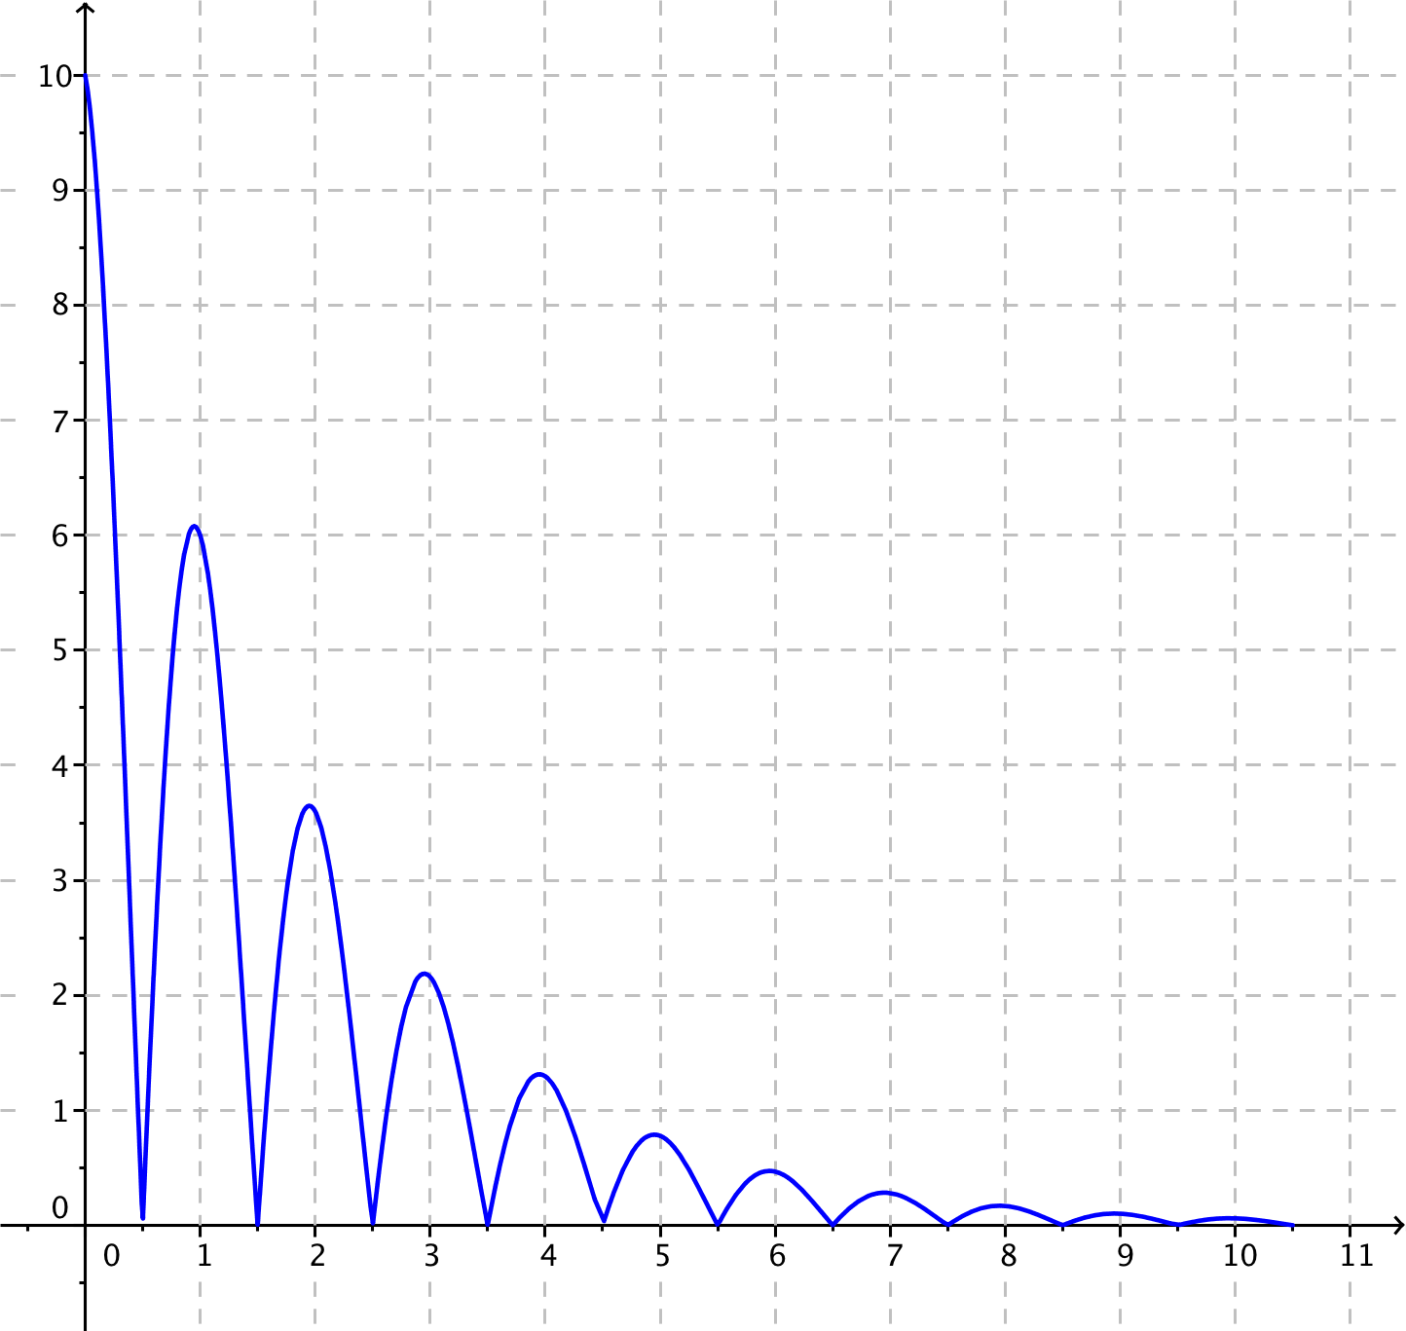

  - Does the exponential function $f\left(x\right)=10{(0.60)}^{x}$ for real numbers $x$ model the height of the bouncing ball? Explain how you know.
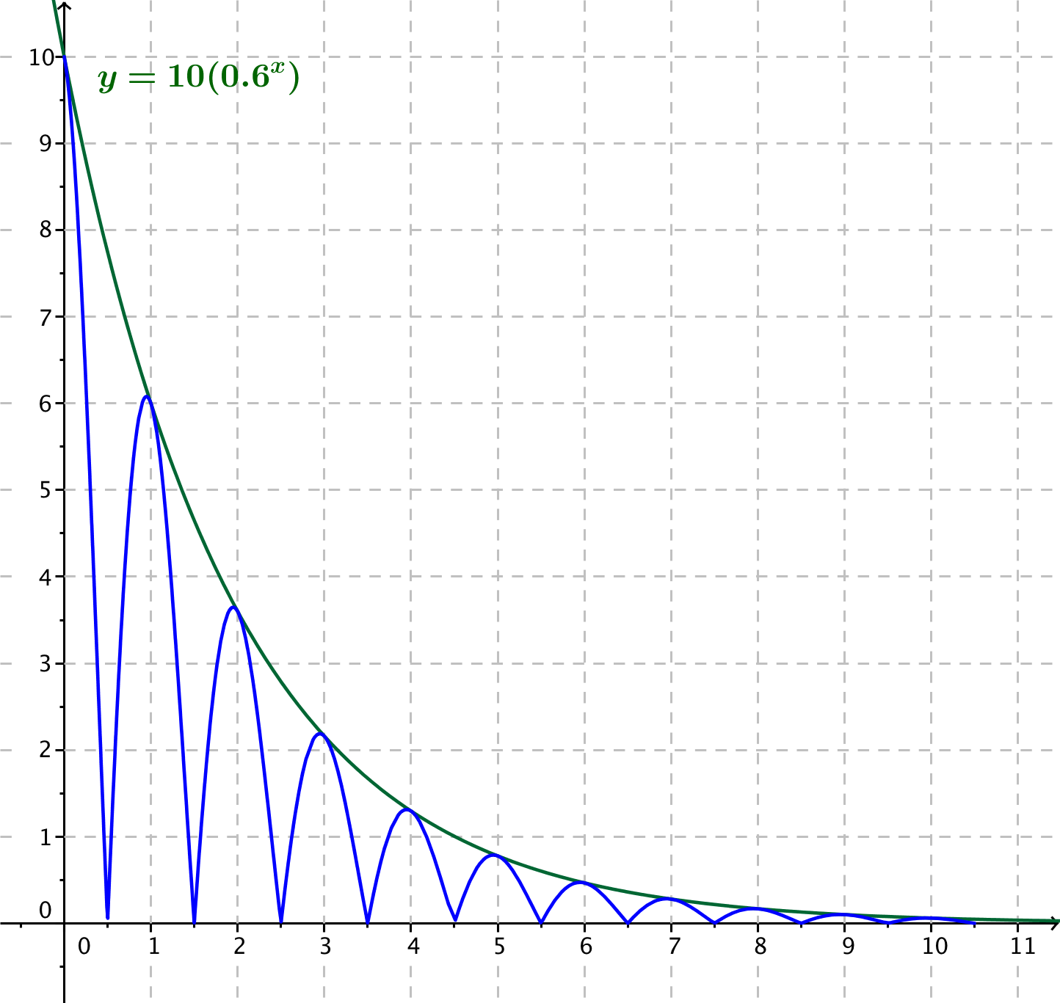
No. Exponential functions do not have the same behavior as a bouncing ball. The graph of $f$ is the smooth curve that connects the points at the “top” of the rebounds, as shown in the graph at right.

  - What does the function $f\left(n\right)=10{\left(0.60\right)}^{n}$ for integers $n≥0$ model?
The exponential function $f\left(n\right)=10{\left(0.60\right)}^{n}$ models the height of the rebounds for integer values of $n$.

Exercise 1 (4 minutes)
While students are working on Exercise 1, circulate around the classroom to ensure student comprehension. After students complete the exercise, debrief to make sure that everyone understands that the salary model is linear and not exponential.
Scaffolding:
- If students struggle with calculating the earnings or visualizing the graph, have them calculate the salary for the first five days and make a graph of those earnings.
Exercises

  - Jane works for a video game development company that pays her a starting salary of $\$100$ a day, and each day she works, she earns $\$100$ more than the day before. How much does she earn on day $5$?
On day $5$, she earns $\$500$.

  - If you were to graph the growth of her salary for the first $10$ days she worked, what would the graph look like?
The graph would be a set of points lying on a straight line.

  - What kind of sequence is the sequence of Jane’s earnings each day?
The sequence of her earnings is arithmetic (that is, the sequence is arithmetically increasing).

Discussion (2 minutes)
Pause here to ask students the following questions:
- What have we learned so far? What is the point of the previous two exercises?
  - There are two different types of sequences, arithmetic and geometric, that model different ways that quantities can increase or decrease.
- What do you recall about geometric and arithmetic sequences from Algebra I?
  - To get from one term of an arithmetic sequence to the next, you add a number $d$, called the common difference. To get from one term of a geometric sequence to the next you multiply by a number $r$, called the common quotient (or common ratio).
For historical reasons, the number $r$ that we call the common quotient is often referred to as the common ratio, which is not fully in agreement with our definition of ratio. Using the term is acceptable because its use is so standardized in mathematics.

Exercise 2 (9 minutes)
Students use a geometric sequence to model the following situation and develop closed and recursive formulas for the sequence. Then they find an exponential model first using base $2$ and then using base $e$ and solve for doubling time. Students should work in pairs on these exercises, using a calculator for calculations. They should be introduced to $P_{0}$ as the notation for the original number of bacteria (at time $t=0$) and also the first term of the sequence, which we refer to as the zero term. Counting terms starting with $0$ means that if we represent our sequence by a function $f$, then
$P_{n}=f(n)$ for integers $n≥0$.

This is an appropriate time to mention to students that we often use a continuous function to model a discrete phenomenon. In this example, the function that we use to represent the bacteria population takes on non-integer values. We need to interpret these function values according to the situation—it is not appropriate to say that the population consists of a non-integer number of bacteria at a certain time, even if the function value is non-integer. In these cases, students should round their answers to an integer that makes sense in the context of the problem.

- A laboratory culture begins with $1,000$bacteria at the beginning of the experiment, which we will denote by time $0$ hours. By time $2$ hours, there were $2,890$ bacteria.
Scaffolding:
- Students may need the hint that in the Opening Exercise, they wrote the terms of a geometric sequence so they can begin with the first three terms of such a sequence and use it to find $r$.
  - If the number of bacteria is increasing by a common factor each hour, how many bacteria were there at time $1$ hour? At time $3$ hours?
If $P_{0}$is the original population, the first three terms of the geometric sequence are $P_{0}, P_{0}r$, and $P_{0}r^{2}$. In this case, $P_{0}=1000$ and ${P_{2}=P}_{0}r^{2}=2890$, so${ r}^{2}=2.89$
and $r=1.7$. Therefore, ${P_{1}=P}_{0}r=1700$ and ${P_{3}=P}_{0}r^{3}=2890∙1.7=4913$.

  - Find the explicit formula for term $P_{n}$ of the sequence in this case.
$$P_{n}=P_{0}r^{n}=1000{\left(1.7\right)}^{n}$$

  - How would you find term $P_{n+1}$ if you know term $P_{n}$? Write a recursive formula for $P_{n+1}$ in terms of $P_{n}$.
You would multiply the $n$th term by $r$, which in this case is $1.7$. We have $P_{n+1}=1.7 P_{n}$.

  - If $P_{0}$ is the initial population, the growth of the population $P_{n}$ at time $n$ hours can be modeled by the sequence $P_{n}=P(n)$, where $P$ is an exponential function with the following form:
$P(n)=P_{0}2^{kn}$, where $k>0$.
Find the value of $k$ and write the function $P$ in this form. Approximate $k$ to four decimal places.
We know that $P(n)= 1000{\left(1.7\right)}^{n}$ and $1.7=2^{log_{2}\left(1.7\right)}$, with $k=log_{2}\left(1.7\right)=\frac{log\left(1.7\right)}{log\left(2\right)} ≈0.7655$.
Thus, we can express $P$ in the form:
$P(n)=1000\left(2^{0.7655n}\right)$.

  - Use the function in part (d) to determine the value of $t$ when the population of bacteria has doubled.
We need to solve $2000=1000\left(2^{0.7655t}\right)$, which happens when the exponent is $1$.
$$0.7655t=1 \\ t=\frac{1}{0.7655} \\ t≈1.306$$
This population doubles in roughly $1.306$ hours, which is about $1$ hour and $18$ minutes.

  - If $P_{0}$ is the initial population, the growth of the population $P$ at time $t$ can be expressed in the following form:
$P(n)=P_{0}e^{kn}$, where $k>0$.
Find the value of $k$, and write the function $P$ in this form. Approximate $k$ to four decimal places.
Substituting in the formula for $t=2$, we get $2890=1000e^{2k}.$ Solving for $k$, we get $k=ln\left(1.7\right)≈0.5306$.
Thus, we can express $P$ in the form:
$P\left(t\right)=1000\left(e^{0.5306t}\right)$.
  - Use the formula in part (d) to determine the value of $t$ when the population of bacteria has doubled.
Substituting in the formula with $k=0.5306$, we get $2000=1000e^{0.5306t}$. Solving for $t$, we get
$t=\frac{ln\left(2\right)}{0.5306}≈1.306$, which is the same value we found in part (e).

Discussion (4 minutes)
Students should share their solutions to Exercise 2 with the rest of the class, giving particular attention to parts (b) and (c).
MP.3
Part (b) of Exercise 2 presents what is called the explicit formula (or closed form) for a geometric sequence, whereas part (c) introduces the idea of a recursive formula. Students need to understand that given any two terms in a geometric (or arithmetic) sequence, they can derive the explicit formula. In working with recursion, they should understand that it provides a way of defining a sequence given one or more initial terms by using the $n$^{th} term of the sequence to find the $(n+1)$^{st} term (or, by using the $(n-1)$^{st} term to find the $n$^{th} term).
Discuss with students the distinction between the two functions:
$P\left(n\right)=1000\left(2^{0.7655n}\right)$ for integers $n≥0$, and
$P\left(t\right)=1000(2^{0.7655t})$ for real numbers $t≥0$.
In the first case, the function $P$ as a function of an integer $n$ represents the population at discrete times $n=0$, $1$, $2$, … ,
while $P$ as a function of a real number $t$ represents the population at any time $t≥0$, regardless of whether that time is an integer. If we graphed these two functions, the first graph would be the points $\left(0, P\left(0\right)\right)$, $\left(1, P\left(1\right)\right)$, $\left(2, P\left(2\right)\right)$, etc., and the second graph would be the smooth curve drawn through the points of the first graph. We can use either statement of the function to define a sequence $P_{n}=P(n)$ for integers $n$. This was discussed in Opening Exercise part (h), as the difference between the graph of the points at the top of the rebounds of the bouncing ball and the graph of the smooth curve through those points.
Our work earlier in the module that extended the laws of exponents to the set of all real numbers applies here to extend a discretely defined function such as $P\left(n\right)=1000\left(2^{0.7655n}\right)$ for integers $n≥0$ to the continuously-defined function$P\left(t\right)=1000(2^{0.7655t})$ for real numbers $t≥0$. Then, we can solve exponential equations involving sequences using our logarithmic tools.
Students may question why we could find two different exponential representations of the function $P$ in parts (d) and (f) of Exercise 2. We can use the properties of exponents to express an exponential function in terms of any base. In Lesson 6 earlier in the module, we saw that the functions $H\left(t\right)=ae^{t}$ for real numbers $a$ have rate of change equal to $1$. For this reason, which is important in calculus and beyond, we usually prefer to use base $e$ for exponential functions.

Exercises 3–4 (5 minutes)
Students should work on these exercises in pairs. They can take turns calculating terms in the sequences. Circulate the room and observe students to call on to share their work with the class before proceeding to the next and final set of exercises.

- The first term $a_{0}$ of a geometric sequence is$-5$, and the common ratio $r$ is $-2$.
Scaffolding:
- Students may need the hint that in the Opening Exercise, they wrote the terms of a geometric sequence so they can begin with the first three terms of such a sequence and use it to find $r$.
Scaffolding:
- Students may need the hint that in the Opening Exercise, they wrote the terms of a geometric sequence so they can begin with the first three terms of such a sequence and use it to find $r$.
  - What are the terms $a_{0}, a_{1}$, and $a_{2}$?
$$a_{0}=-5 \\ a_{1}=10 \\ a_{2}=-20$$

  - Find a recursive formula for this sequence.
The recursive formula is $a_{n+1}=-2a_{n}$, with $a_{0}= -5$.

  - Find an explicit formula for this sequence.
The explicit formula is $a_{n}=-5{\left(-2\right)}^{n}$, for $n≥0$.

  - What is term $a_{9}$?
Using the explicit formula, we find: $a_{9}=\left(-5\right)∙{\left(-2\right)}^{9}=2560$.

  - What is term $a_{10}$?
One solution is to use the explicit formula: $a_{10}=\left(-5\right)∙{\left(-2\right)}^{10}=-5120$.
Another solution is to use the recursive formula: ${a_{10}=a}_{9}∙\left(-2\right)=-5120$.

- Term $a_{4}$ of a geometric sequence is $5.8564$, and term $a_{5}$ is $-6.44204$.
  - What is the common ratio $r$?
We have $r=\frac{-6.44204}{5.8564}=-1.1$. The common ratio is $-1.1$.

  - What is term $a_{0}$?
From the definition of a geometric sequence, $a_{4}=a_{0}r^{4}=5.8564$, so $a_{0}=\frac{5.8564}{{\left(-1.1\right)}^{4}} =\frac{5.8564}{1.4641}=4$.

  - Find a recursive formula for this sequence.
The recursive formula is $a_{n+1}=-1.1\left(a_{n}\right)$ with $a_{0}=4$.

  - Find an explicit formula for this sequence.
The explicit formula is $a_{n}=4{\left(-1.1\right)}^{n}$, for $n≥0$.

Exercises 5–6 (4 minutes)
This final set of exercises in the lesson attends to F-BF.A.2, and asks students to translate between explicit and recursive formulas for geometric sequences. Students should continue to work in pairs on these exercises.

- The recursive formula for a geometric sequence is $a_{n+1}=3.92{(a}_{n})$ with $a_{0}=4.05$. Find an explicit formula for this sequence.
The common ratio is $3.92$, and the initial value is $4.05$, so the explicit formula is
$a_{n}=4.05{\left(3.92\right)}^{n}$ for $n≥0$.
- The explicit formula for a geometric sequence is $a_{n}=147{\left(2.1\right)}^{3n}$. Find a recursive formula for this sequence.
First, we rewrite the sequence as $a_{n}=147{\left(2.1^{3}\right)}^{n}=147{\left(9.261\right)}^{n}$. We then see that the common ratio is $9.261$, and the initial value is $147$, so the recursive formula is
$a_{n+1}=\left(9.261\right)a_{n} \text{with} a_{0}=147$.

Closing (4 minutes)
Debrief students by asking the following questions and taking answers as a class:
- If we know that a situation can be described using a geometric series, how can we create the geometric series for that model? How is the geometric series related to an exponential function with base $e$?
  - The terms of the geometric series are determined by letting $P_{n}=P(n)$ for an exponential function
$P(n)=P_{0}e^{kn}$, where $P_{0}$ is the initial amount, $n$ indicates the term of the series, and $e^{k}$ is the growth rate of the function. Depending on the data given in the situation, we can use either the explicit formula or the recursive formula to find the common ratio $r=e^{k}$ of the geometric sequence and its initial term $P_{0}$.
- Do we need to use an exponential function base $e$?
  - No. We can choose any base that we want for an exponential function, but mathematicians often choose base $e$ for exponential and logarithm functions.
Although arithmetic sequences are not emphasized in this lesson, they do make an appearance in the Problem Set. For completeness, the lesson summary includes both kinds of sequences. The two formulas and the function models for each type of sequence are summarized in the box below, which can be reproduced and posted in the classroom:
Lesson Summary
Arithmetic Sequence: A sequence is called arithmetic if there is a real number $d$ such that each term in the sequence is the sum of the previous term and $d$.
- Explicit formula: Term $a_{n}$ of an arithmetic sequence with first term $a_{0}$ and common difference $d$ is given by $a_{n}=a_{0}+nd,$ for $n≥0$.
- Recursive formula: Term $a_{n+1}$ of an arithmetic sequence with first term $a_{0}$ and common difference $d$ is given by $a_{n+1}=a_{n}+d$, for $n≥0$.
Geometric Sequence: A sequence is called geometric if there is a real number $r$ such that each term in the sequence is a product of the previous term and $r$.
- Explicit formula: Term $a_{n}$ of a geometric sequence with first term $a_{0}$ and common ratio $r$ is given by $a_{n}=a_{0}r^{n},$ for $n≥0$.
- Recursive formula: Term $a_{n+1}$ of a geometric sequence with first term $a_{0}$ and common ratio $r$ is given by $a_{n+1}=a_{n}r$.

Exit Ticket (5 minutes)

Name Date
Lesson 25: Geometric Sequences and Exponential Growth and Decay

Exit Ticket

- Every year, Mikhail receives a $3\%$ raise in his annual salary. His starting annual salary was $\$40,000$.
  - Does a geometric or arithmetic sequence best model Mikhail’s salary in year $n$? Explain how you know.

  - Find a recursive formula for a sequence, $S_{n}$, which represents Mikhail’s salary in year $n$.

- Carmela’s annual salary in year $n$ can be modeled by the recursive sequence $C_{n+1}=1.05 C_{n}$, where $C_{0}=\$75,000$.
  - What does the number $1.05$ represent in the context of this problem?

  - What does the number $\$75,000$ represent in the context of this problem?

  - Find an explicit formula for a sequence that represents Carmela’s salary.

Exit Ticket Sample Solutions

- Every year, Mikhail receives a $3\%$ raise in his annual salary. His starting annual salary was $\$40,000$.
  - Does a geometric or arithmetic sequence best model Mikhail’s salary in year $n$? Explain how you know.
Because Mikhail’s salary increases by a multiple of itself each year, a geometric series will be an appropriate model.

  - Find a recursive formula for a sequence, $S_{n},$ which represents Mikhail’s salary in year $n$.
Mikhail’s annual salary can be represented by the sequence $S_{n+1}=1.03 S_{n}$ with $S_{0}=\$40,000$.

- Carmela’s annual salary in year $n$ can be modeled by the recursive sequence $C_{n+1}=1.05 C_{n}$, where
$C_{0}=\$75,000$.
  - What does the number $1.05$ represent in the context of this problem?
The $1.05$ is the growth rate of her salary with time; it indicates that she is receiving a $5\%$ raise each year.

  - What does the number $\$75,000$ represent in the context of this problem?
Carmela’s starting annual salary was $\$75,000$, before she earned any raises.

  - Find an explicit formula for a sequence that represents Carmela’s salary.
Carmela’s salary can be represented by the sequence $C_{n}=\$75,000 {\left(1.05\right)}^{n}$.

Problem Set Sample Solutions

- Convert the following recursive formulas for sequences to explicit formulas.
  - $a_{n+1}=4.2+a_{n}$ with $a_{0}=12$
$a_{n}=12+4.2n$ for $n≥0$

  - $a_{n+1}= 4.2a_{n}$ with $a_{0}=12$
$a_{n}=12{\left(4.2\right)}^{n}$ for $n≥0$

  - $a_{n+1}= \sqrt{5} a_{n}$ with $a_{0}=2$
$a_{n}=2{\left(\sqrt{5}\right)}^{n}$ for $n≥0$

  - $a_{n+1}= \sqrt{5}+a_{n}$ with $a_{0}=2$
$a_{n}=2+n\sqrt{5}$ for $n≥0$

  - $a_{n+1} =π a_{n}$ with $a_{0}=π$
$a_{n}=π{\left(π\right)}^{n}=π^{n+1}$ for $n≥0$
- Convert the following explicit formulas for sequences to recursive formulas.
  - $a_{n}=\frac{1}{5}(3^{n})$ for $n≥0$
$a_{n+1}= 3 a_{n}$ with $a_{0}=\frac{1}{5}$

  - $a_{n}=16-2n$ for $n≥0$
$a_{n+1}= a_{n}-2$ with $a_{0}=16$

  - $a_{n}=16{\left(\frac{1}{2}\right)}^{n}$ for $n≥0$
$a_{n+1}=\frac{1}{2}a_{n}$ with $a_{0}=16$

  - $a_{n}=71-\frac{6}{7}n$ for $n≥0$
$a_{n+1}= a_{n}-\frac{6}{7}$ with $a_{0}=71$

  - $a_{n}=190{\left(1.03\right)}^{n}$ for $n≥0$
$a_{n+1}= 1.03 a_{n}$ with $a_{0}=190$

- If a geometric sequence has $a_{1}=256$ and $a_{8}=512$, find the exact value of the common ratio $r$.
The recursive formula is $a_{n+1}= a_{n}⋅r$ , so we have
$$a_{8}=a_{7}\left(r\right) \\ =a_{6}\left(r^{2}\right) \\ =a_{5}\left(r^{3}\right) \\ ⋮⋮=a_{1}\left(r^{7}\right) \\ 512=256\left(r^{7}\right) \\ 2=r^{7} \\ r=\sqrt[7]{2} \text{.}$$

- If a geometric sequence has $a_{2}=495$ and $a_{6}=311$, approximate the value of the common ratio $r$ to four decimal places.
The recursive formula is $a_{n+1}= a_{n}⋅r$, so we have
$$a_{6}=a_{5}\left(r\right) \\ =a_{4}\left(r^{2}\right) \\ =a_{3}\left(r^{3}\right) \\ =a_{2}\left(r^{4}\right) \\ 311=495\left(r^{4}\right) \\ r^{4}=\frac{311}{495} \\ r=\sqrt[4]{\frac{311}{495}}≈0.8903 \text{.}$$

- Find the difference between the terms $a_{10}$ of an arithmetic sequence and a geometric sequence, both of which begin at term $a_{0}$ and have $a_{2}=4$ and $a_{4}=12$.
Arithmetic: The explicit formula has the form $a_{n}=a_{0}+nd$, so $a_{2}=a_{0}+2d$ and $a_{4}=a_{0}+4d$. Then
$a_{4}-a_{2}=12-4=8$ and $a_{4}-a_{2}={(a}_{0}+4d)-(a_{0}+2d)$, so that $8=2d$ and $d=4$. Since $d=4$, we know that $a_{0}=a_{2}-2d=4-8= -4$. So, the explicit formula for this arithmetic sequence is $a_{n}= -4+4n$. We then know that $a_{10}=-4+40=36$.
Geometric: The explicit formula has the form $a_{n}=a_{0}(r^{n})$, so $a_{2}=a_{0}(r^{2})$ and $a_{4}=a_{0}\left(r^{4}\right)$, so $\frac{a_{4}}{a_{2}}r^{2}$ and
$\frac{a_{4}}{a_{2}}=\frac{12}{4}=3$. Thus, $r^{2}=3$, so $r=±\sqrt{3}$. Since $r^{2}=3$, we have $a_{2}=4=a_{0}\left(r^{2}\right)$, so that $a_{0}=\frac{4}{3}$. Then the explicit formula for this geometric sequence is $a_{n}=\frac{4}{3}{\left(±\sqrt{3}\right)}^{n}$. We then know that
$a_{10}=\frac{4}{3}{\left(±\sqrt{3}\right)}^{10}=\frac{4}{3}\left(3^{5}\right)=4\left(3^{4}\right)=324$.
Thus, the difference between the terms $a_{10}$ of these two sequences is $324-36=288$.

- Given the geometric series defined by the following values of $a_{0}$ and $r$, find the value of $n$ so that$a_{n}$ has the specified value.
  - $a_{0}=64$, $r=\frac{1}{2}$, $a_{n}=2$
The explicit formula for this geometric series is $a_{n}= 64{\left(\frac{1}{2}\right)}^{n}$ and $a_{n}=2$.
$$2=64{\left(\frac{1}{2}\right)}^{n} \\ \frac{1}{32}={\left(\frac{1}{2}\right)}^{n} \\ {\left(\frac{1}{2}\right)}^{5}={\left(\frac{1}{2}\right)}^{n} \\ n=5$$
Thus, $a_{5}=2$.

  - $a_{0}=13$, $r=3$, $a_{n}=85293$
The explicit formula for this geometric series is $a_{n}=13{\left(3\right)}^{n}$, and we have $a_{n}= 85293.$
$$13{\left(3\right)}^{n}=85293 \\ 3^{n}=6561 \\ 3^{n}=3^{8} \\ n=8$$
Thus, $a_{8}=85293$.

  - $a_{0}=6.7$, $r=1.9$, $a_{n}=7804.8$
The explicit formula for this geometric series is $a_{n}=6.7{\left(1.9\right)}^{n}$, and we have $a_{n}=7804.8$.
$$6.7{\left(1.9\right)}^{n}=7804.8 \\ {\left(1.9\right)}^{n}=1164.9 \\ n log\left(1.9\right)= log\left(1164.9\right) \\ n=\frac{log\left(1164.9\right)}{log\left(1.9\right)}=11$$
Thus, $a_{11}=7804.8$.

  - $a_{0}=10958$, $r=0.7$, $a_{n}=25.5$
The explicit formula for this geometric series is $a_{n}=10958{\left(0.7\right)}^{n}$, and we have $a_{n}=25.5$.
$$10958{\left(0.7\right)}^{n}=25.5 \\ log\left(10958\right)+n log\left(0.7\right)=log\left(25.5\right) \\ n=\frac{log\left(25.5\right)-log\left(10958\right)}{log\left(0.7\right)} \\ n=17$$
Thus, $a_{17}=25.5$.

- Jenny planted a sunflower seedling that started out $5 cm$ tall, and she finds that the average daily growth is $3.5 cm$.
  - Find a recursive formula for the height of the sunflower plant on day $n$.
$h_{n+1}= 3.5+h_{n}$ with $h_{0}=5$

  - Find an explicit formula for the height of the sunflower plant on day $n≥0$.
$$h_{n}=5+3.5n$$

- Kevin modeled the height of his son (in inches) at age $n$ years for $n=2, 3, …, 8$ by the sequence
$h_{n}=34+3.2(n-2)$. Interpret the meaning of the constants $34$and$3.2$ in his model.
MP.2
At age $2$, Kevin’s son was $34 in.$ tall, and between the ages of $2$and $8$ he grew at a rate of $3.2 in.$ per year.

- Astrid sells art prints through an online retailer. She charges a flat rate per order for an order processing fee, sales tax, and the same price for each print. The formula for the cost of buying $n$ prints is given by $P_{n}=4.5+12.6 n.$
  - Interpret the number $4.5$ in the context of this problem.
The $4.5$ represents a $\$4.50$ order processing fee.
MP.2

  - Interpret the number $12.6$ in the context of this problem.
The number $12.6$ represents the cost of each print, including the sales tax. (MP.2)

  - Find a recursive formula for the cost of buying $n$ prints.
$P_{n}= 12.6+P_{n-1}$ with $P_{1}=17.10$
(Notice that it makes no sense to have $P_{0}$ be the starting value, since that means you need to pay the processing fee when you do not place an order.)

- A bouncy ball rebounds to $90\%$ of the height of the preceding bounce. Craig drops a bouncy ball from a height of $20 ft.$
  - Write out the sequence of the heights $h_{1}, h_{2}, h_{3}$, and $h_{4}$ of the first four bounces, counting the initial height as $h_{0}=20$.
$$h_{1}=18 \\ h_{2}=16.2 \\ h_{3}=14.58 \\ h_{4}=13.122$$

  - Write a recursive formula for the rebound height of a bouncy ball dropped from an initial height of $20 ft.$
$h_{n+1}= 0.9 h_{n}$ with $h_{0}=20$

  - Write an explicit formula for the rebound height of a bouncy ball dropped from an initial height of $20 ft.$
$h_{n}=20{\left(0.9\right)}^{n}$ for $n≥0$

  - How many bounces will it take until the rebound height is under $6 ft.$?
$$20{\left(0.9\right)}^{n}<6 \\ n log\left(0.9\right)< log\left(6\right)-log\left(20\right) \\ n>\frac{log\left(6\right)- log\left(20\right)}{log\left(0.9\right)} \\ n>11.42$$
So, it takes$12$ bounces for the bouncy ball to rebound under $6 ft.$

  - Extension: Find a formula for the minimum number of bounces needed for the rebound height to be under $y ft.$, for a real number $0<y<20$.
$$20{\left(0.9\right)}^{n}<y \\ n log\left(0.9\right)< log\left(y\right)-log\left(20\right) \\ n>\frac{log\left(y\right)- log\left(20\right)}{log\left(0.9\right)}$$
Rounding this up to the next integer with the ceiling function, it takes $\left\lceil \frac{log\left(y\right)- log\left(20\right)}{log\left(0.9\right)}\right\rceil$ bounces for the bouncy ball to rebound under $y ft.$

- Show that when a quantity $a_{0}=A$ is increased by $x\%$, its new value is $a_{1}=A\left(1+\frac{x}{100}\right)$. If this quantity is again increased by $x\%$, what is its new value $a_{2}$? If the operation is performed $n$ times in succession, what is the final value of the quantity $a_{n}$?
We know that $x\%$ of a number $A$ is represented by $\frac{x}{100}A$. Thus, when $a_{0}=A$ is increased by $x\%$, the new quantity is
$$a_{1}=A+\frac{x}{100}A \\ =A\left(1+\frac{x}{100}\right).$$
If we increase it again by $x\%$, we have
$$a_{2}=a_{1}+\frac{x}{100}a_{1} \\ =\left(1+\frac{x}{100}\right)a_{1} \\ =\left(1+\frac{x}{100}\right)\left(1+\frac{x}{100}\right)a_{0} \\ ={\left(1+\frac{x}{100}\right)}^{2}a_{0}.$$
If we repeat this operation $n$ times, we find that
$$a_{n}={\left(1+\frac{x}{100}\right)}^{n}a_{0}.$$
- When Eli and Daisy arrive at their cabin in the woods in the middle of winter, the internal temperature is $40°F$.
  - Eli wants to turn up the thermostat by $2°F$ every $15$ minutes. Find an explicit formula for the sequence that represents the thermostat settings using Eli’s plan.
Let $n$ represent the number of $15$-minute increments. Then, $E\left(n\right)=40+2n$.

  - Daisy wants to turn up the thermostat by $4\%$ every $15$ minutes. Find an explicit formula for the sequence that represents the thermostat settings using Daisy’s plan.
Let $n$ represent the number of $15$-minute increments. Then, $D\left(n\right)=40{\left(1.04\right)}^{n}$.

  - Which plan will get the thermostat to $60°$F most quickly?
Making a table of values, we see that Eli’s plan will set the thermostat to $60°F$ first.
$$n$$ | Elapsed Time | $$E(n)$$ | $$D(n)$$
$$0$$ | $0$minutes | $$40$$ | $$40.00$$
$$1$$ | $15$ minutes | $$42$$ | $$41.60$$
$$2$$ | $30$ minutes | $$44$$ | $$43.26$$
$$3$$ | $45$ minutes | $$46$$ | $$45.00$$
$$4$$ | $1$ hour | $$48$$ | $$46.79$$
$$5$$ | $1$hour $15$minutes | $$50$$ | $$48.67$$
$$6$$ | $1$hour$30$ minutes | $$52$$ | $$50.61$$
$$7$$ | $1$ hour $45$ minutes | $$54$$ | $$52.64$$
$$8$$ | $2$ hours | $$56$$ | $$54.74$$
$$9$$ | $2$hours $15$minutes | $$58$$ | $$56.93$$
$$10$$ | $2$hours$30$ minutes | $$60$$ | $$59.21$$

  - Which plan will get the thermostat to $72°F$ most quickly?
Continuing the table of values from part (c), we see that Daisy’s plan will set the thermostat to $72°F$ first.
$$n$$ | Elapsed Time | $$E(n)$$ | $$D(n)$$
$$11$$ | $2$hours $45$minutes | $$62$$ | $$61.58$$
$$12$$ | $3$hours | $$64$$ | $$64.04$$
$$13$$ | $3$hours $15$minutes | $$66$$ | $$66.60$$
$$14$$ | $3$hours $30$minutes | $$68$$ | $$69.27$$
$$15$$ | $3$hours $45$minutes | $$70$$ | $$72.04$$

- In nuclear fission, one neutron splits an atom causing the release of two other neutrons, each of which splits an atom and produces the release of two more neutrons, and so on.
  - Write the first few terms of the sequence showing the numbers of atoms being split at each stage after a single atom splits. Use $a_{0}=1$.
$a_{0}=1$, $a_{1}=2$, $a_{2}=4$, $a_{3}=8$

  - Find the explicit formula that represents your sequence in part (a).
$$a_{n}=2^{n}$$

  - If the interval from one stage to the next is one-millionth of a second, write an expression for the number of atoms being split at the end of one second.
At the end of one second $n=1,000,000$, so $2^{1,000,000}$ atoms are being split.

  - If the number from part (c) were written out, how many digits would it have?
The number of digits in a number $x$ is given by rounding up$log\left(x\right)$ to the next largest integer; that is, by the ceiling of $log(x)$, $\left\lceil log(x)\right\rceil$. Thus, there are $\left\lceil log\left(2^{1,000,000}\right)\right\rceil$ digits.
Since $log\left(2^{1,000,000}\right)=1,000,000 log\left(2\right)≈301,030$, there will be $301,030$ digits in the number $2^{1,000,000}$.

