Lesson 24: Solving Exponential Equations

Student Outcomes
- Students apply properties of logarithms to solve exponential equations.
- Students relate solutions to $f\left(x\right)=g(x)$ to the intersection point(s) on the graphs of $y=f(x)$ and $y=g(x)$ in the case where $f$ and $g$ are constant or exponential functions.

Lesson Notes
Much of our previous work with logarithms in Topic B provided students with the particular skills needed to manipulate logarithmic expressions and solve exponential equations. Although students have solved exponential equations in earlier lessons in Topic B, this is the first time that they solve such equations in the context of exponential functions. In this lesson, students solve exponential equations of the form $ab^{ct}=d$ using properties of logarithms developed in Lessons 12 and 13 (F-LE.A.4). For an exponential function $f,$ students solve equations of the form $f\left(x\right)=c$ and write a logarithmic expression for the inverse (F-BF.B.4a). Additionally, students solve equations of the form $f\left(x\right)=g(x)$ where $f$ and $g$ are either constant or exponential functions (A-REI.D.11). Examples of exponential functions in this lesson draw from Lesson 7, in which the growth of a bacteria population was modeled by the function $P\left(t\right)=2^{t},$ and Lesson 23, in which students modeled the growth of an increasing number of beans with a function $f\left(t\right)=a\left(b^{t}\right)$, where $a≈1$ and $b≈1.5$.
Students will need to use technology to calculate logarithmic values and to graph linear and exponential functions.

Classwork
Opening Exercise (4 minutes)
The Opening Exercise is a simple example of solving an exponential equation of the form $ab^{ct}=d.$ Allow students to work independently or in pairs to solve this problem. Circulate around the room to check that all students know how to apply a logarithm to solve this problem. Students can choose to use either a base $2$ or base $10$ logarithm.
Opening Exercise
In Lesson 7, we modeled a population of bacteria that doubled every day by the function $P\left(t\right)=2^{t}$, where $t$ was the time in days. We wanted to know the value of $t$ when there were $10$ bacteria. Since we did not know about logarithms at the time, we approximated the value of $t$ numerically, and we found that $P\left(t\right)=10$ at approximately $t≈3.32$ days.
Use your knowledge of logarithms to find an exact value for $t$ when $P\left(t\right)=10$, and then use your calculator to approximate that value to $4$ decimal places.
Since $P\left(t\right)=2^{t}$, we need to solve $2^{t}=10$.
$$2^{t}=10 \\ t\log\left(2\right)=\log\left(10\right) \\ t=\frac{1}{\log\left(2\right)} \\ t≈3.3219$$
Thus, the population will reach $10$ bacteria in approximately $3.3219$ days.
Discussion (2 minutes)
Ask students to describe their solution method for the Opening Exercise. Make sure that solutions are discussed using both base $10$ and base $2$ logarithms. If all students used the common logarithm to solve this problem, then present the following solution using the base $2$ logarithm:
$$2^{t}=10 \\ \log_{2}\left(2^{t}\right)=\log_{2}\left(10\right) \\ t=\log_{2}\left(10\right) \\ t=\frac{\log\left(10\right)}{\log\left(2\right)} \\ t=\frac{1}{\log\left(2\right)} \\ t≈3.3219$$
The remaining exercises ask students to solve equations of the form $f(x)=c$or $f\left(x\right)=g(x)$, where $f$ and $g$ are exponential functions (F-LE.A.4, F-BF.B.4a, A-REI.D.11). For the remainder of the lesson, allow students to work either independently or in pairs or small groups on the exercises. Circulate to ensure students are on task and solving the equations correctly. After completing Exercises 1–4, debrief students to check for understanding, and ensure they are using appropriate strategies to complete problems accurately before moving on to Exercises 5–10.

Exercises 1–4 (25 minutes)
Exercises
- Fiona modeled her data from the bean-flipping experiment in Lesson 23 by the function $f\left(t\right)=1.263{\left(1.357\right)}^{t}$, and Gregor modeled his data with the function $g\left(t\right)=0.972{\left(1.629\right)}^{t}$.
  - Without doing any calculating, determine which student, Fiona or Gregor, accumulated $100$ beans first. Explain how you know.
MP.2
Since the base of the exponential function for Gregor’s model, $1.629$, is larger than the base of the exponential function for Fiona’s model, $1.357$, Gregor’s model will grow more quickly than Fiona’s, and he will accumulate $100$ beans before Fiona does.
Scaffolding:
Have struggling students begin this exercise with functions $f\left(t\right)=7\left(2^{t}\right)$ and $g\left(t\right)=4(3^{t})$.
  - Using Fiona’s model …
    - How many trials would be needed for her to accumulate $100$ beans?
We need to solve the equation $f\left(t\right)=100$ for $t$.
$$1.263{\left(1.357\right)}^{t}=100 \\ 1.357^{t}=\frac{100}{1.263} \\ t log\left(1.357\right)=log\left(\frac{100}{1.263}\right) \\ t log\left(1.357\right)=log\left(100\right)-log\left(1.263\right) \\ t=\frac{2-log\left(1.263\right)}{log\left(1.357\right)} \\ t≈14.32$$
So, it takes $15$ trials for Fiona to accumulate $100$ beans.
    - How many trials would be needed for her to accumulate $1,000$ beans?
We need to solve the equation $f\left(t\right)=1000$ for $t$.
$$1.263{\left(1.357\right)}^{t}=1000 \\ 1.357^{t}=\frac{1000}{1.263} \\ t log\left(1.357\right)=log\left(\frac{1000}{1.263}\right) \\ t log\left(1.357\right)=log\left(1000\right)-log\left(1.263\right) \\ t=\frac{3-log\left(1.263\right)}{log\left(1.357\right)} \\ t≈21.86$$
So, it takes $22$ trials for Fiona to accumulate $1,000$ beans.

  - Using Gregor’s model …
    - How many trials would be needed for him to accumulate$100$ beans?
We need to solve the equation $g\left(t\right)=100$ for $t$.
$$0.972{\left(1.629\right)}^{t}=100 \\ 1.629^{t}=\frac{100}{0.972} \\ t log\left(1.629\right)=log\left(\frac{100}{0.972}\right) \\ t log\left(1.629\right)=log\left(100\right)-log\left(0.972\right) \\ t=\frac{2-log\left(0.972\right)}{log\left(1.629\right)} \\ t≈9.50$$
So, it takes $10$ trials for Gregor to accumulate $100$ beans.

    - How many trials would be needed for him to accumulate $1,000$ beans?
We need to solve the equation $g\left(t\right)=1000$ for $t$.
$$0.972{\left(1.629\right)}^{t}=1000 \\ 1.629^{t}=\frac{1000}{0.972} \\ t log\left(1.629\right)=log\left(\frac{1000}{0.972}\right) \\ t log\left(1.629\right)=log\left(1000\right)-log\left(0.972\right) \\ t=\frac{3-log\left(0.972\right)}{log\left(1.629\right)} \\ t≈14.21$$
So, it takes $15$ trials for Gregor to accumulate $1,000$ beans.

  - Was your prediction in part (a) correct? If not, what was the error in your reasoning?
Responses will vary. Either students made the correct prediction, or they did not recognize that the base $b$ determines the growth rate of the exponential function so the larger base $1.629$ causes Gregor’s function to grow much more quickly than Fiona’s.

- Fiona wants to know when her model $f\left(t\right)=1.263{\left(1.357\right)}^{t}$ predicts accumulations of $500$,$5,000$, and $50,000$ beans, but she wants to find a way to figure it out without doing the same calculation three times.
  - Let the positive number $c$ represent the number of beans that Fiona wants to have. Then solve the equation $1.263{\left(1.357\right)}^{t}=c$ for $t$.
$$1.263{\left(1.357\right)}^{t}=c \\ 1.357^{t}=\frac{c}{1.263} \\ t log\left(1.357\right)=log\left(\frac{c}{1.263}\right) \\ t log\left(1.357\right)=log\left(c\right)-log\left(1.263\right) \\ t=\frac{log(c)-log\left(1.263\right)}{log\left(1.357\right)}$$

  - Your answer to part (a) can be written as a function $M$ of the number of beans $c$, where $c>0$. Explain what this function represents.
The function $M\left(c\right)=\frac{log(c)-log\left(1.263\right)}{log\left(1.357\right)}$calculates the number of trials it will take for Fiona to accumulate $c$ beans.

  - When does Fiona’s model predict that she will accumulate …
    - $500$ beans?
$$M\left(500\right)=\frac{log(500)-log\left(1.263\right)}{log\left(1.357\right)}≈19.59$$
According to her model, it will take Fiona $20$ trials to accumulate $500$ beans.

    - $5,000$ beans?
$$M\left(5000\right)=\frac{log(5000)-log\left(1.263\right)}{log\left(1.357\right)}≈27.14$$
According to her model, it will take Fiona $28$ trials to accumulate $5,000$ beans.

    - $50,000$ beans?
$$M\left(50000\right)=\frac{log(50000)-log\left(1.263\right)}{log\left(1.357\right)}≈34.68$$
According to her model, it will take Fiona $35$ trials to accumulate $50,000$ beans.

- Gregor states that the function $g$ that he found to model his bean-flipping data can be written in the form
$g\left(t\right)=0.972(10^{log\left(1.629\right)t})$. Since $log\left(1.629\right)≈0.2119$, he is using $g\left(t\right)=0.972(10^{0.2119t})$ as his new model.
  - Is Gregor correct? Is $g\left(t\right)=0.972\left(10^{log\left(1.629\right)t}\right)$ an equivalent form of his original function? Use properties of exponents and logarithms to explain how you know.
Yes, Gregor is correct. Since $10^{log\left(1.629\right)}= 1.629$, and $10^{log(1.629)t}={\left(10^{log(1.629)}\right)}^{t}≈10^{0.2119t}$, Gregor is right that $g\left(t\right)=0.972\left(10^{0.2119t}\right)$ is a reasonable model for his data.

  - Gregor also wants to find a function that will help him to calculate the number of trials his function $g$ predicts it will take to accumulate $500$, $5,000$, and $50,000$ beans. Let the positive number $c$ represent the number of beans that Gregor wants to have. Solve the equation $0.972\left(10^{0.2119t}\right)=c$ for $t$.
$$0.972\left(10^{0.2119t}\right)=c \\ 10^{0.2119t}=\frac{c}{0.972} \\ 0.2119t=log\left(\frac{c}{0.972}\right) \\ t=\frac{log\left(c\right)-log\left(0.972\right)}{0.2119}$$

  - Your answer to part (b) can be written as a function $N$ of the number of beans $c$, where $c>0$. Explain what this function represents.
The function $N\left(c\right)=\frac{log\left(c\right)-log\left(0.972\right)}{0.2119}$calculates the number of trials it will take for Gregor to accumulate $c$ beans.

  - When does Gregor’s model predict that he will accumulate …
    - $500$ beans?
$$N\left(500\right)=\frac{log\left(500\right)-log\left(0.972\right)}{0.2119}≈12.80$$
According to his model, it will take Gregor $13$ trials to accumulate $500$ beans.

    - $5,000$ beans?
$$N\left(500\right)=\frac{log\left(5000\right)-log\left(0.972\right)}{0.2119}≈17.51$$
According to his model, it will take Gregor $18$ trials to accumulate $5,000$ beans.

    - $50,000$ beans?
$$N\left(50000\right)=\frac{log\left(50000\right)-log\left(0.972\right)}{0.2119}≈22.23$$
According to his model, it will take Gregor $23$ trials to accumulate $50,000$ beans.

- Helena and Karl each change the rules for the bean experiment. Helena started with four beans in her cup and added one bean for each that landed marked-side up for each trial. Karl started with one bean in his cup but added two beans for each that landed marked-side up for each trial.
  - Helena modeled her data by the function $h\left(t\right)=4.127\left(1.468^{t}\right)$. Explain why her values of $a=4.127$ and $b=1.468$ are reasonable.
Since Helena starts with four beans, we should expect that $a≈4$, so a value $a=4.127$ is reasonable. Because she is using the same rule for adding beans to the cup as we did in Lesson 23, we should expect that $b≈1.5$. Thus, her value of $b=1.468$ is reasonable.

  - Karl modeled his data by the function $k\left(t\right)=0.897(1.992^{t})$. Explain why his values of $a=0.897$ and
$b=1.992$ are reasonable.
Since Karl starts with one bean, we should expect that $a≈1$, so a value $a=0.897$ is reasonable. Because Karl adds two beans to the cup for each that lands marked-side up, he adds two beans instead of one, we should expect that the number of beans roughly doubles with each trial. That is, we should expect $b≈2$. Thus, his value of $b=1.992$ is reasonable.
  - At what value of $t$ do Karl and Helena have the same number of beans?
We need to solve the equation $h\left(t\right)=k(t)$ for $t$.
$$4.127\left(1.468^{t}\right) =0.897\left(1.992^{t}\right) \\ log\left(4.127\left(1.468^{t}\right)\right)=log\left(0.897\left(1.992^{t}\right)\right) \\ log\left(4.127\right)+ log\left(1.468^{t}\right)=log\left(0.897\right)+log\left(1.992^{t}\right) \\ log\left(4.127\right)+t log\left(1.468\right)=log\left(0.897\right)+t log\left(1.992\right) \\ t log\left(1.992\right)-t log\left(1.468\right)=log\left(4.127\right)-log\left(0.897\right) \\ t\left(log\left(1.992\right)-log\left(1.468\right)\right)=log\left(4.127\right)-log\left(0.897\right) \\ t\left(log\left(\frac{1.992}{1.468}\right)\right)=log\left(\frac{4.127}{0.897}\right) \\ t\left(0.13256\right)≈0.66284 \\ t≈5.0003$$
Thus, after trial number $5$, Karl and Helena have the same number of beans.

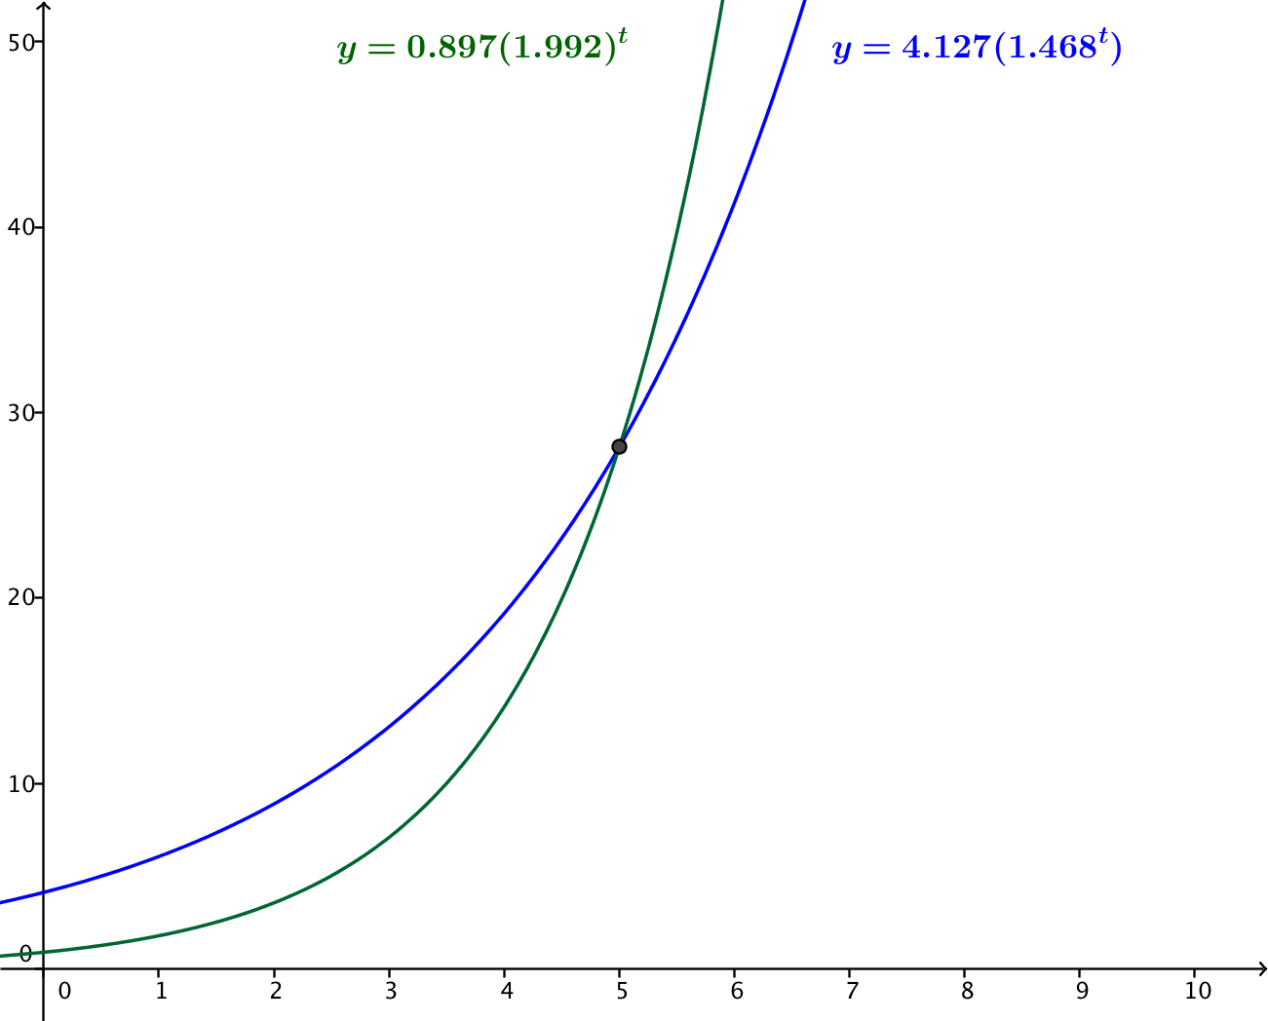
  - Use a graphing utility to graph $y=h(t)$ and $y=k(t)$ for $0<t<10$.

  - Explain the meaning of the intersection point of the two curves $y=h(t)$ and $y=k(t)$ in the context of this problem.
The two curves intersect at the $t$-value where Helena and Karl have the same number of beans. The $y$-value indicates the number of beans they both have after five trials.

  - Which student reaches $20$ beans first? Does the reasoning you used with whether Gregor or Fiona would get to $100$ beans first hold true here? Why or why not?
Helena reaches $20$ beans first. Although the function modeling Helena’s beans has a smaller base, Karl’s does not catch up to Helena until after five trials. After five trials, Karl’s will always be greater, and he will reach $100$ beans first. The logic we applied to comparing Gregor’s model and Fiona’s model does not apply here because Helena and Karl do not start with the same initial number of beans.

Debrief students after they complete Exercises 1–4 to ensure understanding of the exercises and strategies used to solve the exercises before continuing. Exercises 5–10 let students solve exponential functions using what they know about logarithms. After completing Exercises 5–10, debrief students about when it is necessary to use logarithms to solve exponential equations and when it is not. Exercises 7, 8, and 9 are examples of exercises that do not require logarithms to solve but may be appropriate to solve with logarithms depending on the preferences of students.

Exercise 5–10 (7 minutes)
For the following functions $f$and$g$, solve the equation $f\left(x\right)=g\left(x\right)$. Express your solutions in terms of logarithms.
- $f\left(x\right)=10{\left(3.7\right)}^{x+1}$, $g\left(x\right)=5{\left(7.4\right)}^{x}$
Scaffolding:
- Challenge advanced students to solve Exercise 6 in more than one way, for example, by using first the logarithm base 5 and then the logarithm base 3, and compare the results.
- Advanced students should be able to solve Exercises 7–$9$ without logarithms by expressing each function with a common base, but logarithms may be easier and more reliable for students struggling with the exponential properties.
$$10{\left(3.7\right)}^{x+1}=5{\left(7.4\right)}^{x} \\ 2{\left(3.7\right)}^{x+1}=7.4^{x} \\ log\left(2\right)+log\left(3.7^{x+1}\right)=log\left(7.4^{x}\right) \\ log\left(2\right)+\left(x+1\right) log\left(3.7\right)=x log\left(7.4\right) \\ log\left(2\right)+ x log\left(3.7\right)+ log\left(3.7\right)= x log\left(7.4\right) \\ log\left(2\right)+ log\left(3.7\right)= x\left(log\left(7.4\right)- log\left(3.7\right)\right) \\ log\left(7.4\right)= x log\left(\frac{7.4}{3.7}\right) \\ log\left(7.4\right)= x log\left(2\right) \\ x=\frac{log\left(7.4\right)}{log\left(2\right)}$$

- $f\left(x\right)=135{\left(5\right)}^{3x+1}$,$g(x)=75{\left(3\right)}^{4-3x}$
$$135{\left(5\right)}^{3x+1}=75{\left(3\right)}^{4-3x} \\ 9{\left(5\right)}^{3x+1}=5{\left(3\right)}^{4-3x} \\ log\left(9\right)+\left(3x+1\right)log\left(5\right)=log\left(5\right)+\left(4-3x\right)log\left(3\right) \\ 2 log\left(3\right)+3x log\left(5\right)+ log\left(5\right)= log\left(5\right)+4 log\left(3\right)- 3x log\left(3\right) \\ 3x\left(log\left(5\right)+ log\left(3\right)\right)= 4 log\left(3\right)- 2 log\left(3\right) \\ 3x log\left(15\right)= 2 log\left(3\right) \\ x=\frac{2 log\left(3\right)}{3 log\left(15\right)}$$
- $f\left(x\right)=100^{x^{3}+x^{2}-4x}$,$g(x)=10^{2x^{2}-6x }$
$$1{00}^{x^{3}+x^{2}-4x}=10^{2x^{2}-6x} \\ {\left(10^{2}\right)}^{x^{3}+x^{2}-4x}=10^{2x^{2}-6x} \\ 2\left(x^{3}+x^{2}-4x\right)=2x^{2}-6x \\ x^{3}+x^{2}-4x=x^{2}-3x \\ x^{3}-x=0 \\ x\left(x^{2}-1\right)= 0 \\ x\left(x+1\right)\left(x-1\right)=0 \\ x=0\text{,} x=-1\text{, or} x=1$$

- $f\left(x\right)=48\left(4^{x^{2}+3x}\right)$,$g(x)=3\left(8^{x^{2}+4x+4}\right)$
$$48\left(4^{x^{2}+3x}\right)=3\left(8^{x^{2}+4x+4}\right) \\ 16\left(4^{x^{2}+3x}\right)=8^{x^{2}+4x+4} \\ 2^{4}\left({\left(2^{2}\right)}^{x^{2}+3x}\right)={\left(2^{3}\right)}^{x^{2}+4x+4} \\ 2^{2x^{2}+6x+4}=2^{3x^{2}+12x+12} \\ 2x^{2}+6x+4=3x^{2}+12x+12 \\ x^{2}+6x+8=0 \\ \left(x+4\right)\left(x+2\right)= 0 \\ x=-4 \text{or }x=-2$$

- ${f\left(x\right)=e}^{sin^{2}\left(x\right)}, g(x)=e^{cos^{2}\left(x\right)}$
$$e^{sin^{2}\left(x\right)}=e^{cos^{2}\left(x\right)} \\ sin^{2}\left(x\right)=cos^{2}\left(x\right) \\ sin\left(x\right)= cos\left(x\right) \text{or} sin\left(x\right)= -cos\left(x\right) \\ x=\frac{π}{4}+kπ \text{or} x=\frac{3π}{4}+kπ \text{for all integers} k$$

- $f\left(x\right)={(0.49)}^{cos\left(x\right)+sin\left(x\right)}, g\left(x\right)=(0{.7)}^{2 sin\left(x\right)}$
$$(0.{49)}^{cos\left(x\right)+sin\left(x\right)}=(0.7)^{2 sin\left(x\right)} \\ log\left((0.{49)}^{cos\left(x\right)+sin\left(x\right)}\right)=log\left(0.7)^{2 sin\left(x\right)}\right) \\ \left(cos\left(x\right)+sin\left(x\right)\right)log\left(0.49\right)=2 sin\left(x\right)log\left(0.7\right) \\ \left(cos\left(x\right)+sin\left(x\right)\right)log\left(0.7^{2}\right)=2 sin\left(x\right) log\left(0.7\right) \\ 2\left(cos\left(x\right)+ sin\left(x\right)\right)log\left(0.7\right)=2 sin\left(x\right) log\left(0.7\right) \\ 2 cos\left(x\right)+ 2 sin\left(x\right)= 2 sin\left(x\right) \\ cos\left(x\right)=0 \\ x=\frac{π}{2}+kπ \text{for all integers} k$$

Closing (3 minutes)
Ask students to respond to the following prompts either in writing or orally to a partner.
- Describe two different approaches to solving the equation $2^{x+1}=3^{2x}$. Do not actually solve the equation.
  - You could begin by taking the logarithm base 10 of both sides, or the logarithm base 2 of both sides. (Or, you could even take the logarithm base 3 of both sides.)
- Could the graphs of two exponential functions $f\left(x\right)=2^{x+1}$ and $g\left(x\right)=3^{2x}$ ever intersect at more than one point? Explain how you know.
  - No. The graphs of these functions will always be increasing. They will intersect at one point, but once they cross once they cannot cross again. For large values of $x$, the quantity $3^{2x}$ will always be greater than $2^{x+1}$, so the graph of $g$ will end up above the graph of $f$ after they cross.

- Discuss how the starting value and base affect the graph of an exponential function and how this can help you compare exponential functions.
  - The starting value determines the $y$-intercept of an exponential function, so it determines how large or small the function is when $x=0$. The base is ultimately more important and determines how quickly the function increases (or decreases). When comparing exponential functions, the function with the larger base will always overtake the function with the smaller base no matter how large the value when $x=0$.
- If $f\left(x\right)=2^{x+1}$ and $g\left(x\right)=3^{2x}$, is it possible for the equation $f\left(x\right)=g(x)$ to have more than one solution?
  - No. Solutions to the equation $f\left(x\right)=g(x)$ correspond to $x$-values of intersection points of the graphs of $y=f(x)$ and $y=g(x)$. Since these graphs can intersect no more than once, the equation can have no more than one solution.

Exit Ticket (4 minutes)

Name Date
Lesson 24: Solving Exponential Equations

Exit Ticket

Consider the functions $f\left(x\right)=2^{x+6}$ and $g\left(x\right)=5^{2x}$.
  - Use properties of logarithms to solve the equation $f\left(x\right)=g\left(x\right)$. Give your answer as a logarithmic expression, and approximate it to two decimal places.

  - Verify your answer by graphing the functions $y=f(x)$ and $y=g\left(x\right)$ in the same window on a calculator, and sketch your graphs below. Explain how the graph validates your solution to part (a).

Exit Ticket Sample Solutions

Consider the functions $f\left(x\right)=2^{x+6}$ and $g\left(x\right)=5^{2x}$.
  - Use properties of logarithms to solve the equation $f\left(x\right)=g\left(x\right)$. Give your answer as a logarithmic expression, and approximate it to two decimal places.
$$2^{x+6}=5^{2x} \\ \left(x+6\right)log\left(2\right)=2x log\left(5\right) \\ 2x log\left(5\right)- x log\left(2\right)= 6 log\left(2\right) \\ x=\frac{6 log\left(2\right)}{2 log\left(5\right)- log\left(2\right)} \\ x=\frac{log\left(64\right)}{log\left(25\right)-log\left(2\right)} \\ x=\frac{log\left(64\right)}{log\left(\frac{25}{2}\right)} \\ x≈1.65$$
Any of the final three forms are acceptable, and other correct forms using logarithms with other bases (such as base 2) are possible.

  - Verify your answer by graphing the functions $y=f(x)$ and $y=g(x)$ in the same window on a calculator, and sketch your graphs below. Explain how the graph validates your solution to part (a).
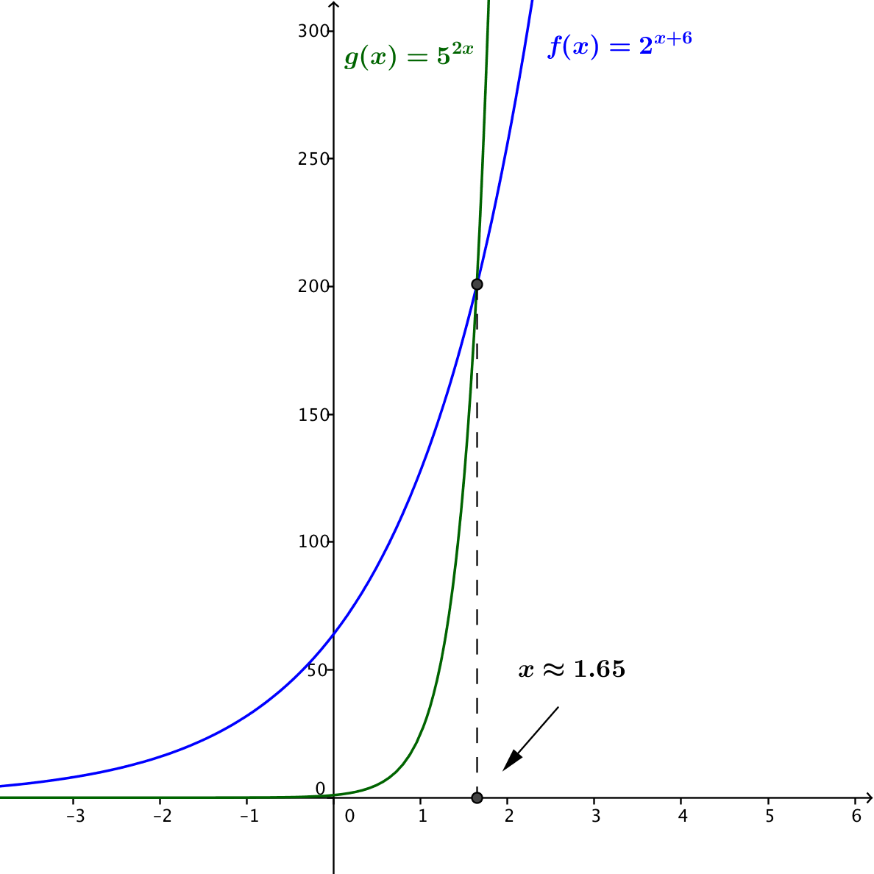
Because the graphs of $y=f(x)$ and $y=g(x)$ intersect when $x≈1.65$, we know that the equation
$f\left(x\right)=g(x)$ has a solution at approximately $x=1.65$.

Problem Set Sample Solutions

- Solve the following equations.
  - $2⋅5^{x+3}=6250$
$$5^{x+3}=3125 \\ 5^{x+3}=5^{5} \\ x+3=5 \\ x=2$$

  - $3⋅6^{2x}=648$
$$6^{2x}=216 \\ 6^{2x}=6^{3} \\ 2x=3 \\ x=\frac{3}{2}$$

  - $5⋅2^{3x+5}=10240$
$$2^{3x+5}=2048 \\ 2^{3x+5}=2^{11} \\ 3x+5=11 \\ 3x=6 \\ x=2$$

  - $4^{3x-1}=32$
$$4^{3x-1}=2^{5} \\ 2^{2⋅\left(3x-1\right)}=2^{5} \\ 6x-2=5 \\ 6x=7 \\ x=\frac{7}{6}$$

  - $3⋅2^{5x}=216$
$$2^{5x}=72 \\ 5x⋅\ln\left(2\right)=\ln\left(72\right) \\ x=\frac{\ln\left(72\right)}{5⋅\ln\left(2\right)} \\ x≈1.234$$
Note: Students can also use common logs to solve for the solution.

  - $5⋅{11}^{3x}=120$
$${11}^{3x}=24 \\ 3x⋅\ln\left(11\right)=\ln\left(24\right) \\ x=\frac{\ln\left(24\right)}{3⋅\ln\left(11\right)} \\ x≈0.442$$
Note: Students can also use common logs to solve for the solution.

  - $7⋅9^{x}=5405$
$$9^{x}=\frac{5405}{7} \\ x⋅\ln\left(9\right)=\ln\left(\frac{5405}{7}\right) \\ x=\frac{\ln\left(\frac{5405}{7}\right)}{\ln\left(9\right)} \\ x≈3.026$$
Note: Students can also use common logs to solve for the solution.

  - $\sqrt{3}⋅3^{3x}=9$
Solution using properties of exponents:
$$3^{\frac{1}{2}}⋅3^{3x}=3^{2} \\ 3^{\frac{1}{2}+3x}=3^{2} \\ \frac{1}{2}+3x=2 \\ x=\frac{1}{2}$$

  - $\log{(400)}⋅8^{5x}=\log\left(160000\right)$
$$8^{5x}=\frac{\log\left(160000\right)}{\log\left(400\right)} \\ 8^{5x}=2 \\ 8^{5x}=8^{\frac{1}{3}} \\ 5x=\frac{1}{3} \\ x=\frac{1}{15}$$

- Lucy came up with the model $f\left(t\right)=0.701{\left(1.382\right)}^{t}$ for the first bean activity. When does her model predict that she would have $1,000$ beans?
$$1000=0.701{\left(1.382\right)}^{t} \\ log\left(1000\right)=\log\left(0.701\right)+t\log\left(1.382\right) \\ t=\frac{log\left(1000\right)-\log\left(0.701\right)}{\log\left(1.382\right)} \\ t≈22.45$$
Lucy’s model predicts that it will take $23$ trials to have over $1,000$ beans.
- Jack came up with the model $g\left(t\right)=1.033{\left(1.707\right)}^{t}$ for the first bean activity. When does his model predict that he would have $50,000$ beans?
$$50,000=1.033{\left(1.707\right)}^{t} \\ \log\left(50000\right)=\log\left(1.033\right)+t\log\left(1.707\right) \\ t=\frac{\log\left(50000\right)-\log\left(1.033\right)}{\log\left(1.707\right)} \\ t≈20.17$$
Jack’s model predicts that it will take $21$ trials to have over $50,000$ beans.

- If instead of beans in the first bean activity you were using fair coin, when would you expect to have $\$1,000,000$?
One million dollars is $10^{8}$ pennies. Using fair pennies, we can model the situation by $f\left(t\right)=1.5^{t}$.
$$10^{8}=1.5^{t} \\ 8=t\log\left(1.5\right) \\ t=\frac{8}{\log\left(1.5\right)}$$
$$t≈45.43$$
We should expect it to take $46$ trials to reach more than $\$1$ million using fair pennies.

- Let $f\left(x\right)=2⋅3^{x}$ and $g\left(x\right)=3⋅2^{x}$.
  - Which function is growing faster as $x$ increases? Why?
The function $f$ is growing faster due to its larger base, even though $g\left(0\right)>f(0)$.

  - When will $f\left(x\right)=g(x)$?
$$f\left(x\right)=g\left(x\right) \\ 2⋅3^{x}=3⋅2^{x} \\ \ln\left(2⋅3^{x}\right)=\ln\left(3⋅2^{x}\right) \\ \ln\left(2\right)+x\ln\left(3\right)=\ln\left(3\right)+x\ln\left(2\right) \\ x\ln\left(3\right)-x\ln\left(2\right)=\ln\left(3\right)-\ln\left(2\right) \\ x\ln\left(\frac{3}{2}\right)=\ln\left(\frac{3}{2}\right) \\ x=1$$
Note: Students can also use common logs to solve for the solution.

- A population of E. coli bacteria can be modeled by the function $E\left(t\right)=500{\left(11.547\right)}^{t},$ and a population of Salmonella bacteria can be modeled by the function $S\left(t\right)=4000{\left(3.668\right)}^{t}$, where $t$ measures time in hours.
  - Graph these two functions on the same set of axes. At which value of $t$does it appear that the graphs intersect?
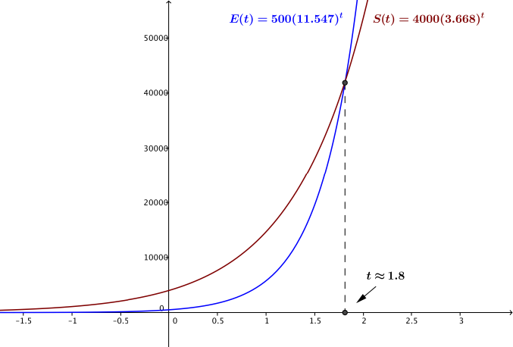
From the graph, it appears that the two curves intersect at $t≈1.8$ hours.

  - Use properties of logarithms to find the time $t$ when these two populations are the same size. Give your answer to two decimal places.
$$E\left(t\right)=S\left(t\right) \\ 500{\left(11.547\right)}^{t}=4000{\left(3.668\right)}^{t} \\ 11.547^{t}=8{\left(3.668\right)}^{t} \\ t log\left(11.547\right)=log\left(8\right)+t log\left(3.668\right) \\ t\left(log\left(11.547\right)-log\left(3.668\right)\right)=log\left(8\right) \\ t=\frac{log\left(8\right)}{log\left(11.547\right)-log\left(3.668\right)} \\ t≈1.81329$$
It takes approximately $1.81$ hours for the populations to be the same size.

- Chain emails contain a message suggesting you will have bad luck if you do not forward the email to others. Suppose a student started a chain email by sending the message to $10$ friends and asking those friends to each send the same email to $3$ more friends exactly one day after receiving the message. Assuming that everyone that gets the email participates in the chain, we can model the number of people who will receive the email on the $n$^{th} day by the formula $E\left(n\right)=10(3^{n})$, where $n=0$ indicates the day the original email was sent.
  - If we assume the population of the United States is $318$ million people and everyone who receives the email sends it to $3$ people who have not received it previously, how many days until there are as many emails being sent out as there are people in the United States?
$$318(10^{6})=10⋅3^{n} \\ 318\left(10^{5}\right)= 3^{n} \\ \log\left(318\right)+log\left(10^{5}\right)=n⋅\log\left(3\right) \\ log\left(318\right)+5=n∙log(3) \\ n=\frac{5+log(318)}{\log\left(3\right)} \\ n≈15.72$$
So by the $16$^{th} day, more than $318$million emails are being sent out.
  - The population of earth is approximately $7.1$ billion people. On what day will $7.1$ billion emails be sent out?
$$7.1\left(10^{9}\right)=10\left(3^{n}\right) \\ 7.1\left(10^{8}\right)=3^{n} \\ \log\left(7.1(10^{8}\right)) =n⋅\log\left(3\right) \\ n=\frac{8+log\left(7.1\right)}{\log\left(3\right)} \\ n≈18.5514$$
By the $19$^{th} day, more than $7.1$ billion emails will be sent.

- Solve the following exponential equations.
  - $10^{\left(3x-5\right)}=7^{x}$
$$10^{3x-5}=7^{x} \\ 3x-5=x log\left(7\right) \\ x\left(3-log\left(7\right)\right)=5 \\ x=\frac{5}{3-log\left(7\right)}$$

  - $3^{\frac{x}{5}}=2^{4x-2}$
$$3^{\frac{x}{5}}=2^{4x-2} \\ \frac{x}{5} log\left(3\right)=\left(4x-2\right)log\left(2\right) \\ 4x log\left(2\right)-x\frac{log\left(3\right)}{5}=2 log\left(2\right) \\ x\left(4 log\left(2\right)-\frac{log\left(3\right)}{5}\right)=2 log\left(2\right) \\ x=\frac{2 log\left(2\right)}{4 log\left(2\right)-\frac{log\left(3\right)}{5}}$$

  - $10^{x^{2}+5}=100^{2x^{2}+x+2}$
$$10^{x^{2}+5}=100^{2x^{2}+x+2} \\ x^{2}+5=\left(2x^{2}+x+2\right)log\left(100\right) \\ x^{2}+5=4x^{2}+2x+4 \\ 3x^{2}+2x-1=0 \\ \left(3x-1\right)\left(x+1\right)=0 \\ x=\frac{1}{3} \text{or} x=-1$$

  - $4^{x^{2}-3x+4}=2^{5x-4}$
$$4^{x^{2}-3x+4}=2^{5x-4} \\ {(x}^{2}-3x+4)\log_{2}\left(4\right)=(5x-4) \log_{2}\left(2\right) \\ 2\left(x^{2}-3x+4\right)= 5x-4 \\ 2x^{2}-6x+8=5x-4 \\ 2x^{2}-11x+12=0 \\ \left(2x-3\right)\left(x-4\right)=0 \\ x=\frac{3}{2}\text{or} x=4$$

- Solve the following exponential equations.
  - ${\left(2^{x}\right)}^{x}=8^{x}$
$$2^{x^{2}}=8^{x} \\ x^{2}log_{2}\left(2\right)=x log_{2}\left(8\right) \\ x^{2}=3x \\ x^{2}-3x=0 \\ x\left(x-3\right)=0 \\ x=0\text{ or} x=3$$

  - ${\left(3^{x}\right)}^{x}=12$
$$3^{x^{2}}=12 \\ x^{2}log\left(3\right)=log(12) \\ x^{2}=\frac{log\left(12\right)}{log\left(3\right)} \\ x=\sqrt{\frac{log\left(12\right)}{log\left(3\right)}} \text{or} x=-\sqrt{\frac{log\left(12\right)}{log\left(3\right)}}$$

- Solve the following exponential equations.
  - $10^{x+1}-10^{x-1}=1,287$
$$10^{x+1}-10^{x-1}=1,287 \\ 100\left(10^{x-1}\right)-10^{x-1}=1,287 \\ 10^{x-1}\left(100-1\right)=1,287 \\ 99\left(10^{x-1}\right)=1,287 \\ 10^{x-1}=13 \\ x-1=log\left(13\right) \\ x=log\left(13\right)+ 1$$

  - $2(4^{x})+4^{x+1}=342$
$$2\left(4^{x}\right)+4^{x+1}=342 \\ 2\left(4^{x}\right)+4\left(4^{x}\right)=342 \\ 6\left(4^{x}\right)=342 \\ 4^{x}=57 \\ x=log_{4}\left(57\right)=\frac{log\left(57\right)}{log\left(4\right)}=\frac{1}{2}log_{2}\left(57\right)$$
- Solve the following exponential equations.
  - ${\left(10^{x}\right)}^{2}-3\left(10^{x}\right)+2=0$ Hint: Let $u={10}^{x}$, and solve for $u$ before solving for $x.$
Let $u=10^{x}$. Then
$$u^{2}-3u+2=0 \\ \left(u-2\right)\left(u-1\right)=0 \\ u=2 \text{or} u=1$$
If $u=2$, we have $2=10^{x}$, and then $x=log\left(2\right)$.
If $u=1$, we have $1=10^{x}$, and then $x=0$.
Thus, the two solutions to this equation are $0$ and $log(2)$.

  - ${\left(2^{x}\right)}^{2}-3\left(2^{x}\right)-4=0$
Let $u=2^{x}.$
$$u^{2}-3u-4=0 \\ \left(u-4\right)\left(u+1\right)=0 \\ u=4 \text{or} u=-1$$
If $u=4$, we have $2^{x}=4$, and then $x=2$.
If $u=-1$, we have $2^{x}=-1$, which has no solution.
Thus, the only solution to this equation is $2$.

  - $3{\left(e^{x}\right)}^{2}-8\left(e^{x}\right)-3=0$
Let $u=e^{x}$.
$${3u}^{2}-8u-3=0 \\ \left(u-3\right)\left(3u+1\right)=0 \\ u=3 \text{or} u=-\frac{1}{3}$$
If $u=3$, we have $e^{x}=3$, and then $x=ln(3)$.
If $u=-\frac{1}{3}$, we have $e^{x}= -\frac{1}{3}$, which has no solution because $e^{x}>0$ for every value of $x$.
Thus, the only solution to this equation is $ln(3)$.

  - $4^{x}+7\left(2^{x}\right)+12=0$
Let $u=2^{x}$.
$${\left(2^{x}\right)}^{2}+7\left(2^{x}\right)+12=0 \\ u^{2}+7u+12=0 \\ \left(u+3\right)\left(u+4\right)=0 \\ u=-3 \text{or} u=-4$$
But $2^{x}>0$ for every value of $x$, thus there are no solutions to this equation.

  - ${\left(10^{x}\right)}^{2}-2\left(10^{x}\right)-1=0$
Let $u={10}^{x}$.
$$u^{2}-2u-1=0 \\ u=1+\sqrt{2} \text{or} u=1-\sqrt{2}$$
If $u=1+\sqrt{2}$, we have ${10}^{x}=1+\sqrt{2}$, and then $x=log\left(1+\sqrt{2}\right)$.
If $u=1-\sqrt{2}$, we have ${10}^{x}=1-\sqrt{2}$, which has no solution because $1-\sqrt{2}<0$.
Thus, the only solution to this equation is $log\left(1+\sqrt{2}\right)$.

- Solve the following systems of equations.
a. | $$2^{x+2y}=8 \\ 4^{2x+y}=1$$ | $$2^{x+2y}=2^{3} \\ 4^{2x+y}=4^{0}$$  $$x+2y=3 \\ 2x+y=0$$  $$x+2y=3 \\ 4x+2y=0$$  $$y=2 \\ x=-1$$
b. | $$2^{2x+y-1}=32 \\ 4^{x-2y}=2$$ | $$2^{2x+y-1}=2^{5} \\ {\left(2^{2}\right)}^{x-2y}=2^{1}$$  $$2x+y-1=5 \\ 2\left(x-2y\right)=1$$  $$2x+y=6 \\ 2x-4y=1$$  $$y=1 \\ x=\frac{5}{2}$$
c. | $$2^{3x}=8^{2y+1} \\ 9^{2y}=3^{3x-9}$$ | $$2^{3x}={\left(2^{3}\right)}^{2y+1} \\ {\left(3^{2}\right)}^{2y}=3^{3x-9}$$  $$3x=3\left(2y+1\right) \\ 2\left(2y\right)=\left(3x-9\right)$$  $$3x-6y=3 \\ 3x-4y=9$$  $$y=3 \\ x=7$$

- Because $f\left(x\right)=log_{b}(x)$ is an increasing function, we know that if $p<q$, then $log_{b}\left(p\right)<log_{b}(q)$. Thus, if we take logarithms of both sides of an inequality, then the inequality is preserved. Use this property to solve the following inequalities.
  - $4^{x}>\frac{5}{3}$
$$4^{x}>\frac{5}{3} \\ log\left(4^{x}\right)>log\left(\frac{5}{3}\right) \\ x log\left(4\right)> log\left(5\right)-log\left(3\right) \\ x>\frac{log\left(5\right)-log\left(3\right)}{log\left(4\right)}$$

  - ${\left(\frac{2}{7}\right)}^{x}>9$
$${\left(\frac{2}{7}\right)}^{x}>9 \\ x log\left(\frac{2}{7}\right)>log\left(9\right)$$
But, remember that $log\left(\frac{2}{7}\right)<0$, so we need to divide by a negative number. We then have$$x<\frac{log\left(9\right)}{log\left(2\right)-log\left(7\right)}$$

  - $4^{x}>8^{x-1}$
$${\left(2^{2}\right)}^{x}>{\left(2^{3}\right)}^{x-1} \\ 2^{2x}>2^{3x-3} \\ 2x>3x-3 \\ 3>x$$

  - $3^{x+2}>$ $5^{3-2x}$
$$3^{x+2}>5^{3-2x} \\ \left(x+2\right)log\left(3\right)>\left(3-2x\right)log\left(5\right) \\ 2x log\left(5\right)+ x log\left(3\right)> 3 log\left(5\right)- 2 log\left(3\right) \\ x>\frac{3 log\left(5\right)- 2 log\left(3\right)}{2 log\left(5\right)+ log\left(3\right)} \\ x>\frac{log\left(\frac{125}{9}\right)}{log\left(75\right)}$$

  - ${\left(\frac{3}{4}\right)}^{x}>{\left(\frac{4}{3}\right)}^{x+1}$
$${\left(\frac{3}{4}\right)}^{x}>{\left(\frac{4}{3}\right)}^{x+1} \\ x log\left(\frac{3}{4}\right)>\left(x+1\right)log\left(\frac{4}{3}\right) \\ x\left(log\left(\frac{3}{4}\right)-log\left(\frac{4}{3}\right)\right)>log\left(\frac{4}{3}\right)$$
But, $log\left(\frac{3}{4}\right)=-log\left(\frac{4}{3}\right)$, so we have
$$x\left(-log\left(\frac{4}{3}\right)-log\left(\frac{4}{3}\right) \right)>log\left(\frac{4}{3}\right) \\ x\left(-2 log\left(\frac{4}{3}\right)\right)>log\left(\frac{4}{3}\right)$$
But, $-2 log\left(\frac{4}{3}\right)<0$, so we need to divide by a negative number, so we have
$$x<\frac{log\left(\frac{4}{3}\right)}{-2 log\left(\frac{4}{3}\right) } \\ x<-\frac{1}{2}$$

