Lesson 23: Bean Counting

Student Outcomes
- Students gather experimental data and determine which type of function is best to model the data.
- Students use properties of exponents to interpret expressions for exponential functions.

Lesson Notes
In the main activity in this lesson, students will work in pairs to gather their own data, plot it (MP.6), and apply the methods of Lesson 22 to decide which type of data to use in modeling the data (MP.4, MP.7). Students should use calculators (or other technological tools) to fit the data with an exponential function (MP.5). Since each group of students will generate its own set of data, each group will find different functions to model the data, but all of those functions should be in the form $f\left(t\right)=a(b^{t})$, where $a≈1$ and $b≈1.5$. Take time to discuss why the functions differ between groups and yet are closely related due to probability. If time permits, at the end of the activity average each group’s values of the constants $a$ and $b$; the averages should be very close to $1$ and $1.5$, respectively (F-LE.B.5).
In the Problem Set, students will investigate the amount of time for quantities to double, triple, or increase by a factor of $10$ using these functions and others like them. For example, students will rewrite functions $f(t)=a\left(b^{t}\right)$ in an equivalent form $f\left(t\right)=a(2^{\log_{2}\left(b\right)t})$ and interpret the exponent (F-IF.C.8b).

Materials
Each team of two students will gather data using the following materials:
- At least $50$ small, flippable objects marked differently on the two sides. One inexpensive source for these objects would be dried beans, spray painted on one side and left unpainted on the other. Buttons or coins would also work. Throughout this lesson, these objects will be referred to as beans.
- Two paper cups: one to hold the beans, and the other to shake up and dump out the beans onto the paper plate.
- A paper plate (to keep the beans from ending up all over the floor).
- A calculator capable of plotting data and performing exponential regression.

Classwork
Scaffolding:
If students are collectively struggling with the concepts of exponential growth and modeling, consider extending this to a 2-day lesson. Devote the entire first day to Exercise 1 on exponential growth, and the second day to Exercise 2 on exponential decay.
Opening (3 minutes)
Divide the class into groups of 2–3 students. Smaller groups are better for this exercise, so have students work in pairs if possible. Before distributing the needed materials, model the process for gathering data for two trials. Then, provide each team with a cup containing at least $50$ beans, an empty cup, a paper plate, and a calculator.

- In this lesson, we will gather some data and then decide which type of function to use to model it. In the previous lesson, we studied different types of functions we could use to model data in different situations. What were those types of functions?
  - Linear, quadratic, sinusoidal, and exponential functions
- Suppose you are gathering data from an experiment, measuring a quantity on evenly spaced time intervals. How can you recognize from the context that data should be modeled by a linear function?
Accompany the discussion of different model types with visuals showing graphs of each type.
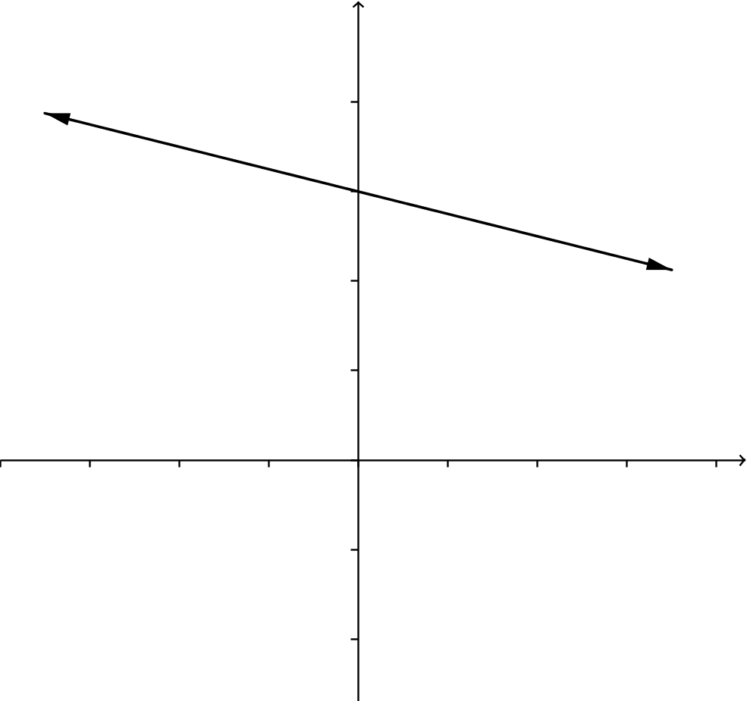
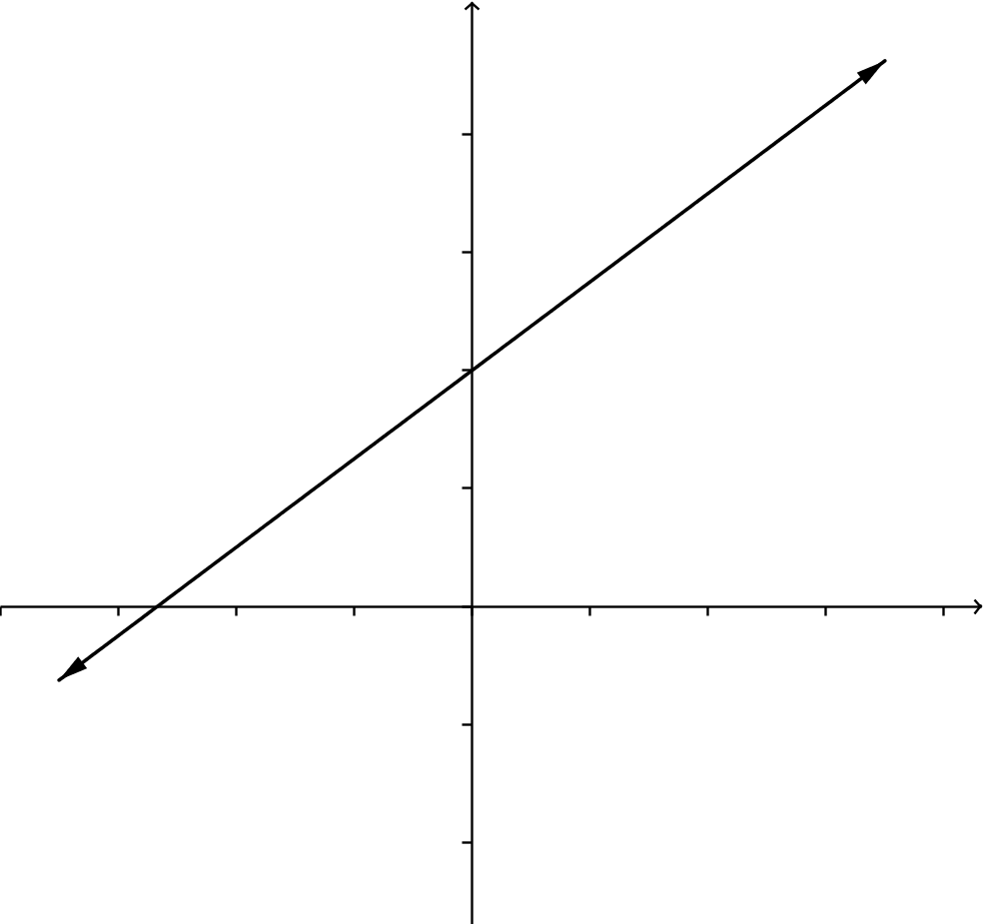
  - If we expect the data values to increase (or decrease) at an even rate, then the data points should roughly lie on a line.

- How do you recognize that data should be modeled by a quadratic function?
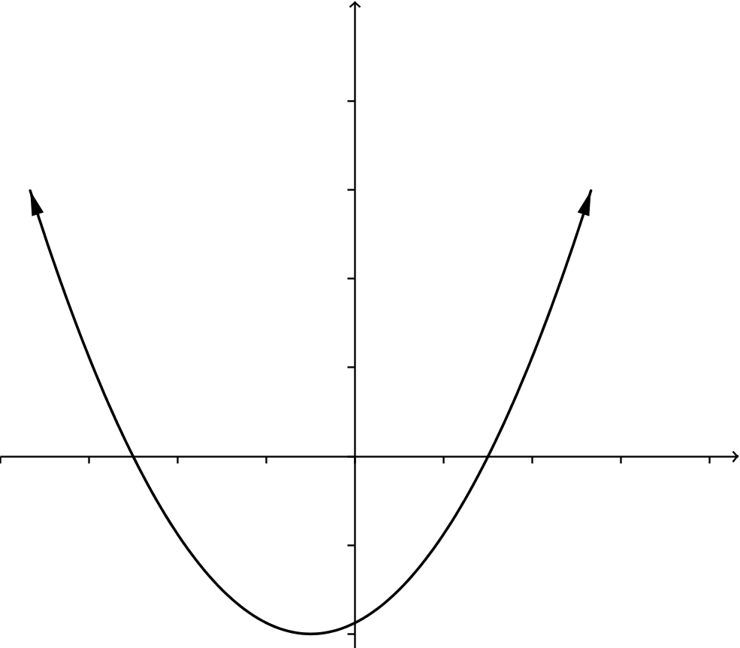
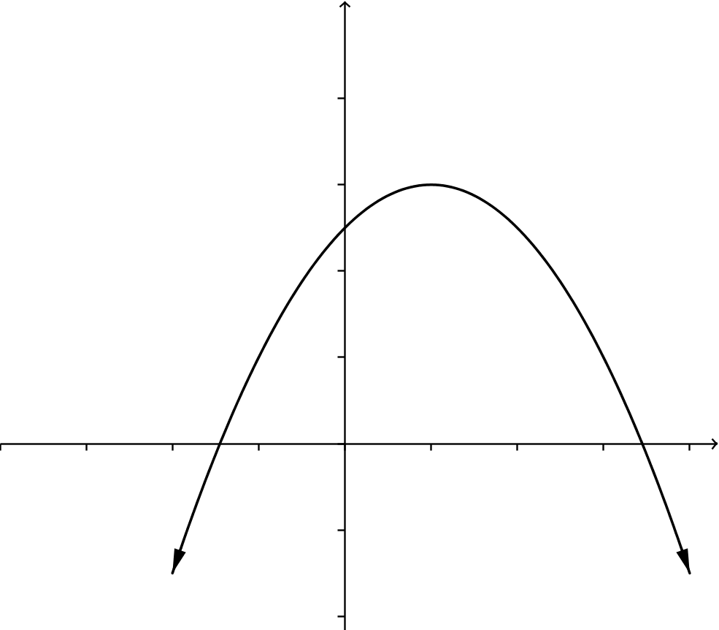
  - If we expect the distance between data values to increase or decrease at a constant rate, then the data points should roughly lie on a parabola.

- How do you recognize that data should be modeled by a sinusoidal function?
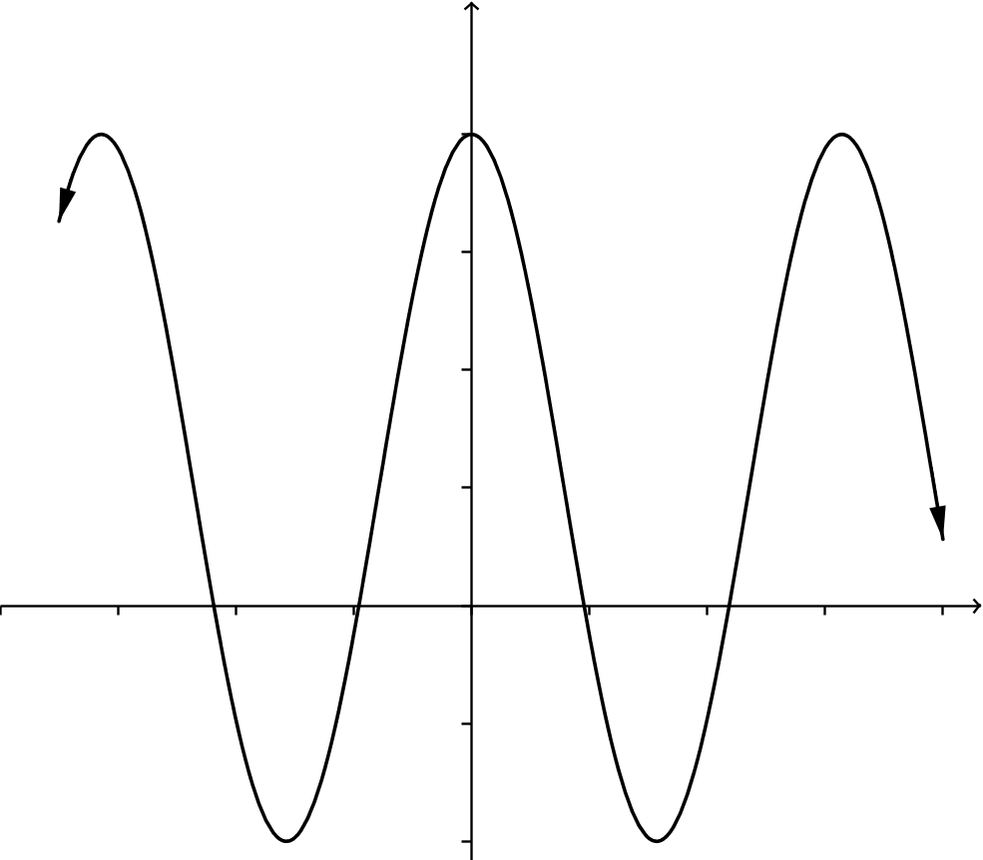
  - If we expect the data values to repeat periodically due to a repeating phenomenon, then the data points should roughly lie on a sinusoidal curve.

- How do you recognize that data should be modeled by an exponential function?
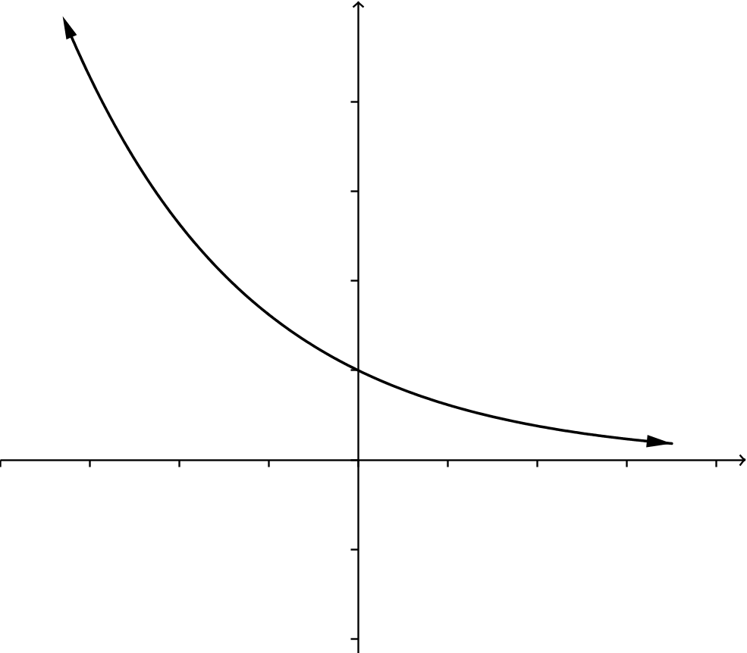
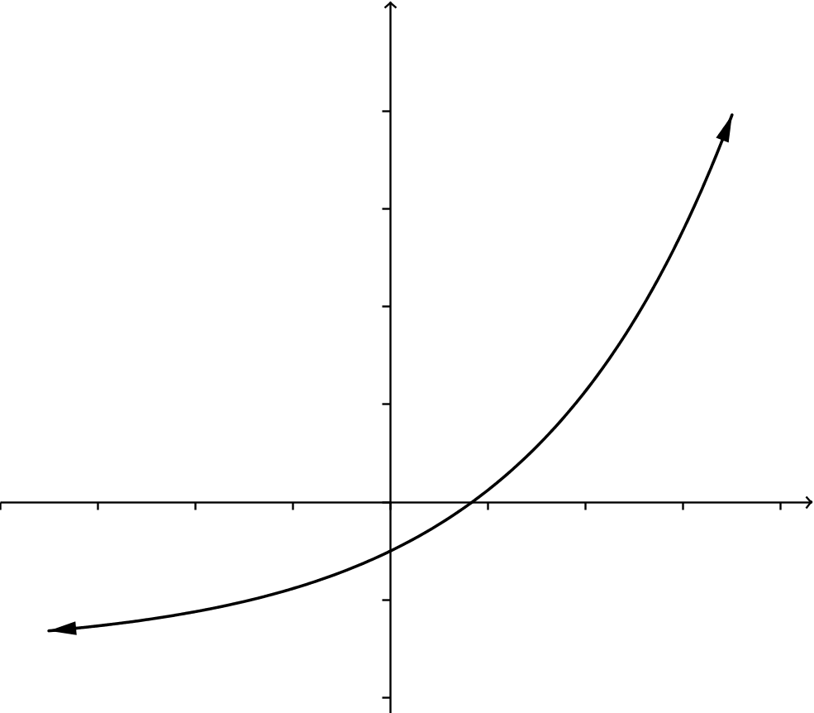
  - If we expect the data values to increase (or decrease) proportionally to the current quantity, then the data points should roughly lie on an exponential curve.

- To gather data, we do the following: Start with one bean in one cup, and keep the other beans in the spare cup. Dump the single bean onto the paper plate, and record in the table if it lands marked-side up. If it lands marked-side up, then add another bean to the cup. This is the first trial.
- You now have either one or two beans in your cup. Shake the cup gently, then dump the beans onto the plate and record how many land marked-side up. Either $0$ ,$1$ , or $2$ beans will land marked-side up. Add that number of beans to your cup. This is the second trial.
- Repeat this process until you either have done $10$ trials or have run out of beans in the spare cup.
- After you have gathered your data, plot the data on the coordinate grid provided. Plot the trial number on the horizontal axis and the number of beans in the cup at the start of the trial on the vertical axis.

Mathematical Modeling Exercise 1 (15 minutes)
Circulate around the room while the students gather data for this exercise to ensure that they all understand the process for flipping the beans, adding new beans to the cup, and recording data.
Mathematical Modeling Exercises
- Working with a partner, you are going to gather some data, analyze the data, and find a function to use to model the data. Be prepared to justify your choice of function to the class.
  - Gather your data: For each trial, roll the beans from the cup to the paper plate. Count the number of beans that land marked-side up, and add that many beans to the cup. Record the data in the table below. Continue until you have either completed $10$ trials or the number of beans at the start of the trial exceeds the number that you have.
Trial Number,  $$t$$ | Number of Beans  at Start of Trial | Number of Beans That  Landed Marked-Side Up
$$1$$ | $$1$$
$$2$$
$$3$$
$$4$$
$$5$$
$$6$$
$$7$$
$$8$$
$$9$$
$$10$$

  - Based on the context in which you gathered this data, which type of function would best model your data points?
Since the number of beans we add at each toss is roughly half of the beans we had at the start of that turn, the data should be modeled by an exponential function.

  - Plot the data: Plot the trial number on the horizontal axis and the number of beans in the cup at the start of the trial on the vertical axis. Be sure to label the axes appropriately and to choose a reasonable scale for the axes.

  - Analyze the data: Which type of function would best fit your data? Explain your reasoning.
Students should see that the data follows a clear pattern of exponential growth, and they should decide to model it with an exponential function.

  - Model the data: Enter the data into the calculator and use the appropriate type of regression to find an equation that fits this data. Round the constants to two decimal places.
Answers will vary but should be of the form $f\left(t\right)=a(b^{t})$, where $a$ is near $1$ and $b$ is near $1.5$.

Discussion (5 minutes)
After students complete Exercise 1, have them write the equations that they found to model their data on the board, displayed by the document camera, or on poster board visible to all students. After all groups have reported their equations, debrief the class with questions like the following:
- What type of equation did you use to model your data?
  - We used an exponential function.

- Why did you choose this type of equation?
  - The number of beans will always increase, and the amount it increases depends on the current number of beans that we have.
- Why did all of the teams get different equations?
  - We all had different data because each roll of the beans is different. Each bean has a $50\%$ chance of landing marked-side up, but that does not mean that half of the beans always land marked-side up. Probability does not guarantee that an event will happen.
- Look at the function $f\left(t\right)=a(b^{t})$ that models your data and interpret the value of the constant $a$.
MP.2
&
MP.7
  - The number $a$ is the number of beans we started with (according to the model).
- Look at the function $f\left(t\right)=a(b^{t})$ that models your data and interpret the value of the base $b$.
  - The base $b$ is the growth factor. This means that the number of beans is multiplied by $b$ with each toss.
- If the beans landed perfectly with $50\%$ of them marked-side up every time, what would we expect the value of $b$ to be?
  - If half of the beans always landed marked-side up, then the number of beans would increase by $50\%$ with each trial, so that the new amount would be $150\%$ of the old amount. That is, the number of beans would be multiplied by $1.5$ at each trial. Then, the value of $b$ would be $1.5$.
- From the situation we are modeling, what would we expect the value of the coefficient $a$ to be?
  - For an exponential function of the form $f\left(t\right)=a(b^{t})$, we have $f\left(0\right)=a$, so $a$ represents our initial number of beans. Thus, we should have a value of $a$ near $1$.
- Why didn’t your values of $a$ and $b$ turn out to be $a=1$ and $b=1.5$?
  - Even though the probability says that we have a $50\%$ chance of the beans landing marked-side up, this does not mean that half of the beans will always land marked-side up.
- Let’s look at the constants in the equations $f\left(t\right)=a(b^{t})$ that the groups found to fit their data.
- Have the students calculate the average values of the coefficients $a$ and the base $b$ from each group’s equation.
  - Answers will vary. The average value of $a$ should be near $1$, and the average value of $b$ should be near $1.5.$
Create an exponential function $f\left(t\right)=a_{avg}{\left(b_{avg}\right)}^{t}$, where $a_{avg}$ and $b_{avg}$ represent the average values of the coefficient $a$ and base $b$ from each group’s equation.
- What would happen to the values of $a_{avg}$ and $b_{avg}$ if we had data from $1,000$ groups?
  - The value of $a_{avg}$ should get very close to $1$ and the value of $b_{avg}$ should get very close to $1.5$.

Mathematical Modeling Exercise 2 (10 minutes)

- This time, we are going to start with $50$ beans in your cup. Roll the beans onto the plate and remove any beans that land marked-side up. Repeat until you have no beans remaining.
  - Gather your data: For each trial, roll the beans from the cup to the paper plate. Count the number of beans that land marked-side up, and remove that many beans from the plate. Record the data in the table below. Repeat until you have no beans remaining.
Trial Number,  $$t$$ | Number of Beans  at Start of Trial | Number of Beans That  Landed Marked-Side Up
$$1$$ | $$50$$
$$2$$
$$3$$
$$4$$
$$5$$
$$6$$
$$7$$
$$8$$
$$9$$
$$10$$

  - Plot the data: Plot the trial number on the horizontal axis and the number of beans in the cup at the start of the trial on the vertical axis. Be sure to label the axes appropriately and choose a reasonable scale for the axes.

  - Analyze the data: Which type of function would best fit your data? Explain your reasoning.
Students should see that the data follows a clear pattern of exponential decay, and they should decide to model it with an exponential function.

  - Make a prediction: What do you expect the values of $a$ and $b$ to be for your function? Explain your reasoning.
Using an exponential function $f\left(t\right)=a(b^{t})$, the value of $a$ is the initial number of beans, so we should expect $a$ to be near $50$. The number of beans decreases by half each time, so we would expect $b=0.5$.

  - Model the data: Enter the data into the calculator. Do not enter your final data point of $0$ beans. Use the appropriate type of regression to find an equation that fits this data. Round the constants to two decimal places.
Answers will vary but should be of the form $f\left(t\right)=a(b^{t})$, where $a$ is near $50$ and $b$ is near $0.5$.
Discussion (5 minutes)
After students complete Exercise 2, have them write the equations that they found to model their data in a shared location visible to all students. Prompt students to look for patterns in the equations produced by different groups and to revisit their answers from part (d) if necessary.
- What type of equation did you use to model your data?
  - We used an exponential function.
- Why did you choose this type of equation?
  - The number of beans will always decrease, and the amount it decreases depends on the current number of beans that we have.
- Let’s look at the different constants in the equations $f\left(t\right)=a(b^{t})$ that the groups found to fit the data. Have students calculate the average values of the coefficients $a$ and the base $b$ from each group’s equation.
  - Answers will vary. The average value of $a$ should be near $50$, and the average value of $b$ should be near $0.5.$
- From the situation we are modeling, what would we expect the values of the coefficient $a$ and the base $b$ to be?
MP.2
&
MP.7
  - For an exponential function of the form $f\left(t\right)=a(b^{t})$, we have $f\left(0\right)=a$. Thus, $a$ represents our initial number of beans, and we should have a value of $a$ near $50$. The number of beans should be cut in half at each trial, so we should have a value of $b$ near $0.5$.
- How many trials did it take before you had no beans left?
  - Answers will vary but should be somewhere around seven trials.
- What is the range of your exponential function? Does it include zero?
  - The range of the exponential function is $(0,∞)$, so it does not include zero.
- How can we explain the discrepancy between the fact that the function that you are using to model the number of beans can never be zero, but the number of beans left at the end of the activity is clearly zero?
  - The exponential function only approximates the number of beans. The number of beans is always an integer, while the values taken on by the exponential function are real numbers. That is, our function takes on values that are closer and closer to zero, without ever actually being zero, but if we were to round it to integers, then it rounds to zero.

Closing (3 minutes)
Have students respond to the following questions individually in writing or orally with a partner.
- What sort of function worked best to model the data we gathered from Mathematical Modeling Exercise 1 where we added beans?
  - We used an increasing exponential function.
- Why was this the best type of function?
  - The number of beans added was roughly a multiple of the current number of beans; if the beans had behaved perfectly and half of them always landed with the marked-side up, we would have added half the number of beans each time.

- Why could we expect to model this data with a function $f\left(t\right)={\left(1.5\right)}^{t}$?
  - When we add half of the beans, that means that the current number of beans is being multiplied by
$1+0.5=1.5$. With an exponential function, we get from one data point to the next by multiplying by a constant. For this function, the constant is $1.5$.
- Why did an exponential function work best to model the data from Mathematical Modeling Exercise 2, in which the number of beans was reduced at each trial?
  - The number of beans removed at each trial was roughly half the current number of beans. The function that models this is $f\left(t\right)={\left(\frac{1}{2}\right)}^{t}$, which is a decreasing exponential function.

Exit Ticket (4 minutes)
Name Date
Lesson 23: Bean Counting

Exit Ticket

Suppose that you were to repeat the bean activity, but in place of beans, you were to use six-sided dice. Starting with one die, each time a die is rolled with a $6$ showing, you add a new die to your cup.
  - Would the number of dice in your cup grow more quickly or more slowly than the number of beans did? Explain how you know.

  - A sketch of one sample of data from the bean activity is shown below. On the same axes, draw a rough sketch of how you would expect the line of best fit from the dice activity to look.
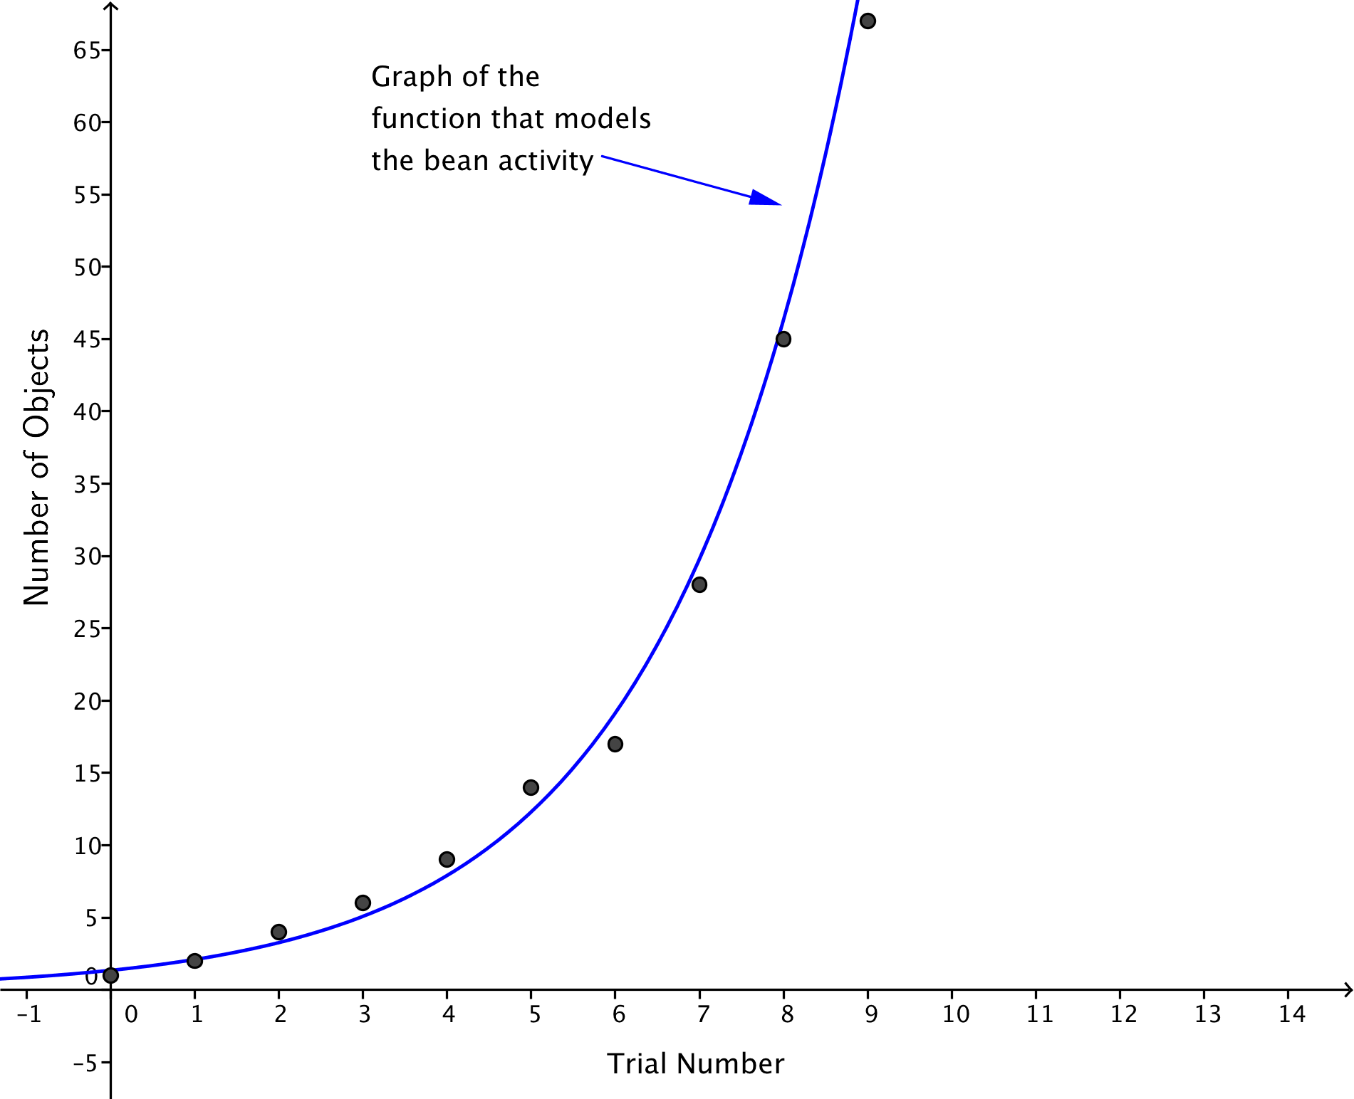
Exit Ticket Sample Solutions

Suppose that you were to repeat the bean activity, but in place of beans, you were to use six-sided dice. Starting with one die, each time a die is rolled with a 6 showing, you add a new die to your cup.
  - Would the number of dice in your cup grow more quickly or more slowly than the number of beans did? Explain how you know.
The number of dice in the cup should grow much more slowly because the probability of rolling a $6$ is $\frac{1}{6}$, while the probability of flipping a bean marked-side up is roughly $\frac{1}{2}$. Thus, the beans should land marked-side up, and thus, increase the number of beans in our cup about half of the time, while the dice would show a $6$ only $\frac{1}{6}$ of the time. As an example, it could be expected to take one or two flips of the first bean to get a bean to show the marked side, causing us to add one, but it could be expected to take six rolls of the first die to get a $6$, causing us to add another die.

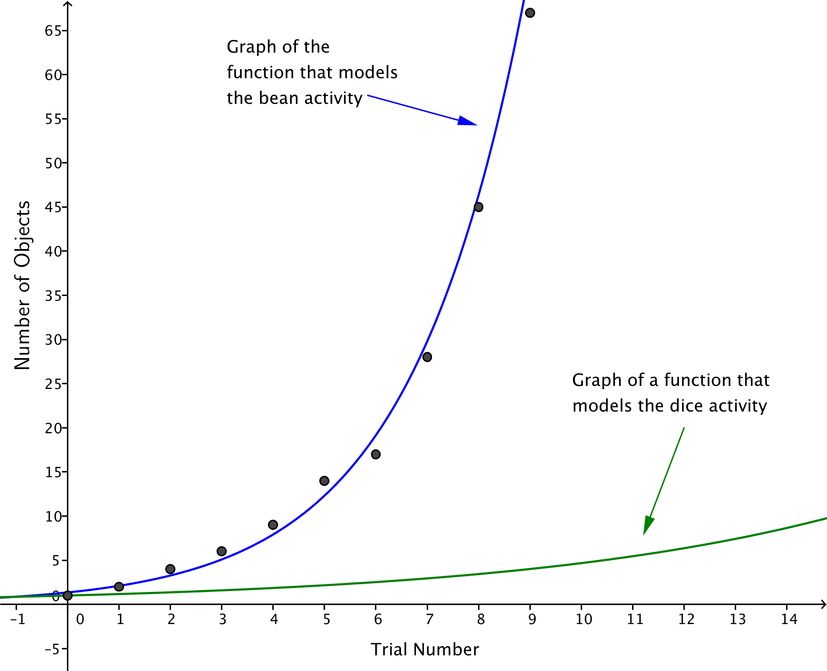
  - A sketch of one sample of data from the bean activity is shown below. On the same axes, draw a rough sketch of how you would expect the line of best fit from the dice activity to look.

Problem Set Sample Solutions

- For this problem, we will consider three scenarios for which data has been collected and functions have been found to model the data, where $a$, $b$, $c$, $d$, $p$, $q$, $r$, $s$, $t$, and $u$ are positive real number constants.
    - The function $f\left(t\right)=a∙b^{t}$ models the original bean activity (Mathematical Modeling Exercise 1). Each bean is painted or marked on one side, and we start with one bean in the cup. A trial consists of throwing the beans in the cup and adding one more bean for each bean that lands marked-side up.
    - The function $g\left(t\right)=c∙d^{t}$ models a modified bean activity. Each bean is painted or marked on one side, and we start with one bean in the cup. A trial consists of throwing the beans in the cup and adding two more beans for each bean that lands marked-side up.
    - The function $h\left(t\right)=p∙q^{t}$ models the dice activity from the Exit Ticket. Start with one six-sided die in the cup. A trial consists of rolling the dice in the cup and adding one more die to the cup for each die that lands with a $6$ showing.
    - The function $j\left(t\right)=r∙s^{t}$ models a modified dice activity. Start with one six-sided die in the cup. A trial consists of rolling the dice in the cup and adding one more die to the cup for each die that lands with a $5$ or a $6$ showing.
    - The function $k\left(t\right)=u∙v^{t}$ models a modified dice activity. Start with one six-sided die in the cup. A trial consists of rolling the dice in the cup and adding one more die to the cup for each die that lands with an even number showing.

  - What values do you expect for $a$, $c$, $p$, $r$, and $u$?
The values of these four constants should each be around $1$ because the first data point in all four cases is $\left(1,0\right)$.

  - What value do you expect for the base $b$ in the function $f\left(t\right)=a∙b^{t}$?
We know from the class activity that $b≈1.5$ because the number of beans grows by roughly half of the current amount at each trial.

  - What value do you expect for the base $d$ in the function $g\left(t\right)=c∙d^{t}$?
Suppose we have $4$ beans in the cup. We should expect half of them to land marked-side up. Then, we would add $2∙2=4$ beans to the cup, doubling the amount that we had. This is true for any number of beans; if we had $n$ beans, then $\frac{n}{2}$ should land marked-side up, so we would add $n$ beans, doubling the amount. Thus, values of the function $g$ should double, so $d≈2$.

  - What value do you expect for the base $q$ in the function $h\left(t\right)=p∙q^{t}$?
For this function $h$, we expect that the quantity increases by $\frac{1}{6}$ of the current quantity at each trial. Then,
$q≈1+\frac{1}{6}$, so $q≈\frac{7}{6}$.

  - What value do you expect for the base $s$ in the function $j\left(t\right)=r∙s^{t}$?
The probability of rolling a $5$ or $6$ is $\frac{1}{3}$, so we would expect that the number of dice increases by $\frac{1}{3}$ of the current quantity at each trial. Thus, we expect $s≈1+\frac{1}{3}$, which means that $s≈\frac{4}{3}$.

  - What value do you expect for the base $v$ in the function $k\left(t\right)=u∙v^{t}$?
The probability of rolling an even number on a six-sided die is the same as the probability of getting the marked-side up on a bean, so we would expect that $f$ and $k$ are the same function. Thus, $v≈1.5$.

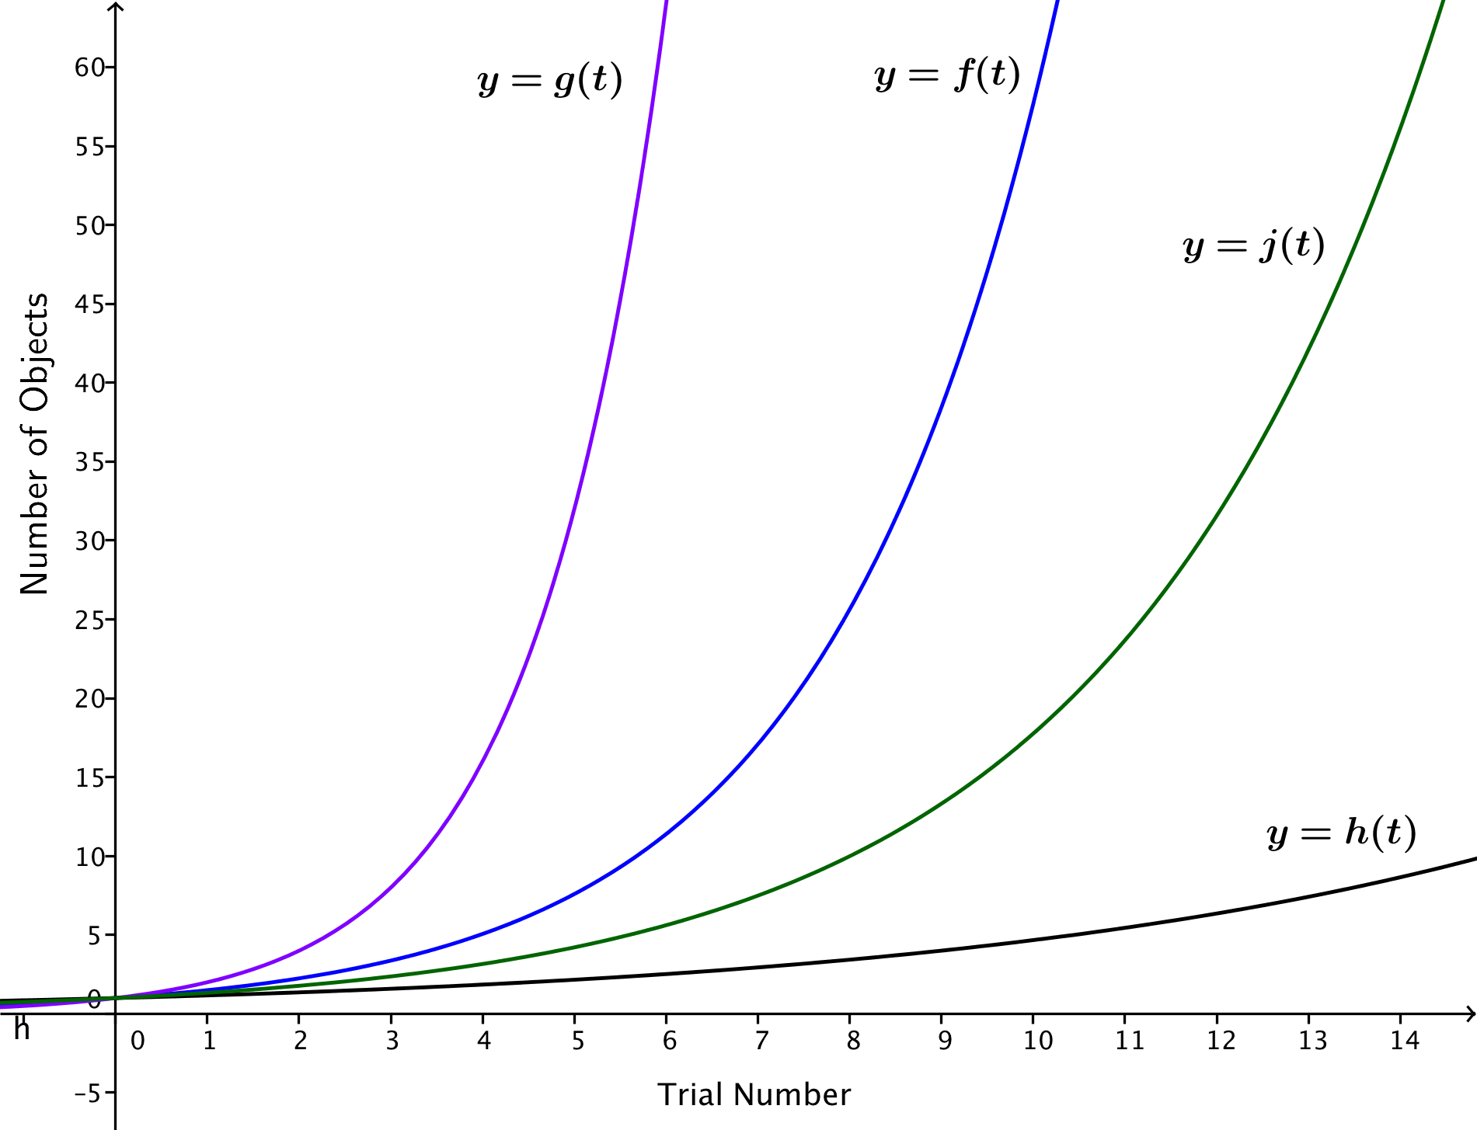
  - The following graphs represent the four functions $f$, $g$, $h$, and $j$. Identify which graph represents which function.

- Teams 1, 2, and 3 gathered data as shown in the tables below, and each team modeled the data using an exponential function of the form $f\left(t\right)=a∙b^{t}$.
  - Which team should have the highest value of $b$? Which team should have the lowest value of $b$? Explain how you know.
Team 1 |  |  | Team 2 |  |  | Team 3
Trial Number, $t$ | Number of Beans |  | Trial Number, $t$ | Number of Beans |  | Trial Number, $t$ | Number of Beans
$$0$$ | $$1$$ |  | $$0$$ | $$1$$ |  | $$0$$ | $$1$$
$$1$$ | $$1$$ |  | $$1$$ | $$1$$ |  | $$1$$ | $$2$$
$$2$$ | $$2$$ |  | $$2$$ | $$1$$ |  | $$2$$ | $$3$$
$$3$$ | $$2$$ |  | $$3$$ | $$2$$ |  | $$3$$ | $$5$$
$$4$$ | $$4$$ |  | $$4$$ | $$2$$ |  | $$4$$ | $$8$$
$$5$$ | $$6$$ |  | $$5$$ | $$3$$ |  | $$5$$ | $$14$$
$$6$$ | $$8$$ |  | $$6$$ | $$5$$ |  | $$6$$ | $$26$$
$$7$$ | $$14$$ |  | $$7$$ | $$7$$ |  | $$7$$ | $$46$$
$$8$$ | $$22$$ |  | $$8$$ | $$12$$ |  | $$8$$ | $$76$$
$$9$$ | $$41$$ |  | $$9$$ | $$18$$ |  | $$9$$
$$10$$ | $$59$$ |  | $$10$$ | $$27$$ |  | $$10$$
The larger the value of the base $b$, the larger the function will be at $t=10$. Since team 3 had the most beans at the end (they used their $50$ beans first), their equation should have the highest value of the base $b$. Team 2 has the smallest number of beans after $10$ trials, so team 2 should have the smallest value of the base $b.$

  - Use a graphing calculator to find the equation that best fits each set of data. Do the equations of the functions provide evidence that your answer in part (a) is correct?
Team 1’s equation: $f_{1}(t)=0.7378{\left(1.5334\right)}^{t}$
Team 2’s equation:$f_{2}\left(t\right)=0.6495{\left(1.4245\right)}^{t}$
Team 3’s equation: $f_{3}\left(t\right)=1.0328{\left(1.7068\right)}^{t}$
As predicted, Team 2 has the smallest value of $b$, and Team 3 has the largest value of $b$.

- Omar has devised an activity in which he starts with $15$ dice in his cup. A trial consists of rolling the dice in the cup and adding one more die to the cup for each die that lands with a $1$, $2$, or $3$ showing.
  - Find a function $f\left(t\right)=a(b^{t})$ that Omar would expect to model his data.
$$f\left(t\right)=15{\left(\frac{3}{2}\right)}^{t}$$

  - Solve the equation $f\left(t\right)=30$. What does the solution mean?
$$15{\left(\frac{3}{2}\right)}^{t}=30 \\ {\left(\frac{3}{2}\right)}^{t}=2 \\ t=\frac{log\left(2\right)}{log\left(\frac{3}{2}\right)} \\ t≈1.71$$
So, Omar should have more than $30$ dice by the second trial, after rolling and adding dice twice.

  - Omar wants to know in advance how many trials it should take for his initial quantity of $15$dice to double. He uses properties of exponents and logarithms to rewrite the function from part (a) as an exponential function of the form$f\left(t\right)=a\left(2^{t⋅log_{2}(b)}\right)$.
$$f\left(t\right)=15\left(2^{t⋅log_{2}\left(\frac{3}{2}\right)}\right)≈15(2^{0.5850t})$$

  - Has Omar correctly applied the properties of exponents and logarithms to obtain an equivalent expression for his original equation in part (a)? Explain how you know.
Yes. The expressions are equal by the property of exponents.
$$\left(2^{t⋅log_{2}\left(\frac{3}{2}\right)}\right)={\left(2^{log_{2}\left(\frac{3}{2}\right)}\right)}^{t}={\left(\frac{3}{2}\right)}^{t}$$
Thus,
$$15\left(2^{t⋅log_{2}\left(\frac{3}{2}\right)}\right)=15{\left(\frac{3}{2}\right)}^{t}.$$

  - Explain how the modified formula from part (c) allows Omar to easily find the expected amount of time, $t$, for the initial quantity of dice to double.
The quantity is doubled at a time $t$ for which $t⋅log_{2}\left(\frac{3}{2}\right)=1$. Thus, we solve the equation $t⋅log_{2}\left(\frac{3}{2}\right)=1$ to find $t=\frac{1}{log_{2}\left(\frac{3}{2}\right)}≈1.71$. This agrees with our answer to part (b).

- Brenna has devised an activity in which she starts with $10$ dice in her cup. A trial consists of rolling the dice in the cup and adding one more die to the cup for each die that lands with a $6$ showing.
  - Find a function $f\left(t\right)=a(b^{t})$ that you would expect to model her data.
$$f\left(t\right)=10{\left(\frac{7}{6}\right)}^{t}$$

  - Solve the equation $f\left(t\right)=30$. What does your solution mean?
$$10{\left(\frac{7}{6}\right)}^{t}=30 \\ {\left(\frac{7}{6}\right)}^{t}=3 \\ t=\frac{log\left(3\right)}{log\left(\frac{7}{6}\right)} \\ t≈7.13$$
Brenna’s quantity of dice should reach $30$ by the eighth trial.

  - Brenna wants to know in advance how many trials it should take for her initial quantity of $10$ dice to triple. Use properties of exponents and logarithms to rewrite your function from part (a) as an exponential function of the form$f\left(t\right)=a\left(3^{ct}\right)$.
Since $\frac{7}{6}=3^{log_{3}\left(\frac{7}{6}\right)}$, we have ${\left(\frac{7}{6}\right)}^{t}={\left(3^{log_{3}\left(\frac{7}{6}\right)}\right)}^{t}=3^{t⋅log_{3}\left(\frac{7}{6}\right)}$. Then, $f(t)=10\left(3^{t⋅log_{3}\left(\frac{7}{6}\right)}\right)$.

  - Explain how your formula from part (c) allows you to easily find the expected amount of time, $t$, for the initial quantity of dice to triple.
The quantity triples when $3^{t⋅log_{3}\left(\frac{7}{6}\right)}=3$, so that $t⋅log_{3}\left(\frac{7}{6}\right)=1$. Then, we solve that equation to find the value of $t$: $t=log_{3}\left(\frac{7}{6}\right)≈7.13.$

  - Rewrite the formula for the function $f$ using a base-$10$ exponential function.
Since $\frac{7}{6}={10}^{log\left(\frac{7}{6}\right)}$, we have ${\left(\frac{7}{6}\right)}^{t}={\left({10}^{log\left(\frac{7}{6}\right)}\right)}^{t}={10}^{t⋅log\left(\frac{7}{6}\right)}$. Then, $f(t)=10\left({10}^{t⋅log\left(\frac{7}{6}\right)}\right)$.

  - Use your formula from part (e) to find out how many trials it should take for the quantity of dice to grow to $100$ dice.
The quantity will be $100$ when ${10}^{t⋅log\left(\frac{7}{6}\right)}=10$, so that $t⋅log\left(\frac{7}{6}\right)= 1$. Then, $t=\frac{1}{log\left(\frac{7}{6}\right)}≈14.94$, so that the quantity should exceed $100$ by the $15$^{th} trial.

- Suppose that one bacteria population can be modeled by the function $P_{1}\left(t\right)=500\left(2^{t}\right)$ and a second bacteria population can be modeled by the function $P_{2}\left(t\right)=500\left(2.83^{t}\right)$, where $t$ measures time in hours. Keep four digits of accuracy for decimal approximations of logarithmic values.
  - What does the $500$ mean in each function?
In each function, the $500$ means that each population has $500$ bacteria at the onset of the experiment.

  - Which population should double first? Explain how you know.
Since $2.83>2$, the second population is growing at a faster rate than the first, so it should double more quickly.
  - How many hours and minutes will it take until the first population doubles?
The first population doubles every hour, since the base of the exponential function is $2$. Thus, the first population doubles in one hour.

  - Rewrite the formula for $P_{2}(t)$ in the form $P_{2}\left(t\right)=a\left(2^{ct}\right)$, for some real numbers $a$ and $c$.
$$P_{2}\left(t\right)=500{\left(2.83\right)}^{t} \\ =500{\left(2^{log_{2}\left(2.83\right)}\right)}^{t} \\ =500\left(2^{t⋅log_{2}\left(2.83\right)}\right)$$

  - Use your formula in part (d) to find the time, $t$, in hours and minutes until the second population doubles.
The second population doubles when $t⋅log_{2}\left(2.83\right)=1$, which happens when $t=\frac{1}{log_{2}\left(2.83\right)}.$ Thus,
$t≈0.6663$ hours, which is approximately $40$ minutes.

- Copper has antibacterial properties, and it has been shown that direct contact with copper alloy C11000 at $20°C$ kills $99.9\%$ of all methicillin-resistant Staphylococcus aureus (MRSA) bacteria in about $75$ minutes. Keep four digits of accuracy for decimal approximations of logarithmic values.
  - A function that models a population of $1,000$ MRSA bacteria $t$ minutes after coming in contact with copper alloy C11000 is $P\left(t\right)=1000{\left(0.912\right)}^{t}$. What does the base $0.912$ mean in this scenario?
The base $0.912$ means that $91.2\%$ of the MRSA bacteria remain at the end of each minute.

  - Rewrite the formula for $P$ as an exponential function with base $\frac{1}{2}$.
Since $0.912={\left(\frac{1}{2}\right)}^{log_{\frac{1}{2}}\left(0.912\right)}={\left(\frac{1}{2}\right)}^{-log_{2}\left(0.912\right)}$, we have
$$P\left(t\right)=1000\left(0.912^{t}\right) \\ =1000{\left(\frac{1}{2}\right)}^{-t⋅log_{2}\left(0.912\right)}\text{.}$$

  - Explain how your formula from part (b) allows you to easily find the time it takes for the population of MRSA to be reduced by half.
The population of MRSA is reduced by half when the exponent is $1$. This happens when $–t⋅log_{2}\left(0.912\right)=1$, so $t=-\frac{1}{log_{2}\left(0.912\right)}≈7.52$ minutes. Thus, half of the MRSA bacteria die every $7\frac{1}{2}$ minutes.

