Lesson 23: Bean Counting

Classwork
Mathematical Modeling Exercises
- Working with a partner, you are going to gather some data, analyze it, and find a function to use to model it. Be prepared to justify your choice of function to the class.
  - Gather your data: For each trial, roll the beans from the cup to the paper plate. Count the number of beans that land marked side up, and add that many beans to the cup. Record the data in the table below. Continue until you have either completed $10$ trials or the number of beans at the start of the trial exceeds the number that you have.
Trial Number, $t$ | Number of Beans  at Start of Trial | Number of Beans That  Landed Marked-Side Up
$$1$$ | $$1$$
$$2$$
$$3$$
$$4$$
$$5$$
$$6$$
$$7$$
$$8$$
$$9$$
$$10$$

  - Based on the context in which you gathered this data, which type of function would best model your data points?

  - Plot the data: Plot the trial number on the horizontal axis and the number of beans in the cup at the start of the trial on the vertical axis. Be sure to label the axes appropriately and to choose a reasonable scale for the axes.

  - Analyze the data: Which type of function would best fit your data? Explain your reasoning.

  - Model the data: Enter the data into the calculator and use the appropriate type of regression to find an equation that fits this data. Round the constants to two decimal places.

- This time, we are going to start with $50$ beans in your cup. Roll the beans onto the plate and remove any beans that land marked-side up. Repeat until you have no beans remaining.
  - Gather your data: For each trial, roll the beans from the cup to the paper plate. Count the number of beans that land marked-side up, and remove that many beans from the plate. Record the data in the table below. Repeat until you have no beans remaining.
Trial Number, $t$ | Number of Beans  at Start of Trial | Number of Beans That  Landed Marked-Side Up
$$1$$ | $$50$$
$$2$$
$$3$$
$$4$$
$$5$$
$$6$$
$$7$$
$$8$$
$$9$$
$$10$$

  - Plot the data: Plot the trial number on the horizontal axis and the number of beans in the cup at the start of the trial on the vertical axis. Be sure to label the axes appropriately and choose a reasonable scale for the axes.

  - Analyze the data: Which type of function would best fit your data? Explain your reasoning.

  - Make a prediction: What do you expect the values of $a$ and $b$ to be for your function? Explain your reasoning.

  - Model the data: Enter the data into the calculator. Do not enter your final data point of $0$ beans. Use the appropriate type of regression to find an equation that fits this data. Round the constants to two decimal places.

Problem Set

- For this exercise, we will consider three scenarios for which data has been collected and functions have been found to model the data, where $a$, $b$, $c$, $d$, $p$, $q$, $r$, $s$, $t,$ and $u$ are positive real number constants.
- The function $f\left(t\right)=a∙b^{t}$ models the original bean activity (Mathematical Modeling Exercise 1). Each bean is painted or marked on one side, and we start with one bean in the cup. A trial consists of throwing the beans in the cup and adding one more bean for each bean that lands marked side up.
- The function $g\left(t\right)=c∙d^{t}$ models a modified bean activity. Each bean is painted or marked on one side, and we start with one bean in the cup. A trial consists of throwing the beans in the cup and adding two more beans for each bean that lands marked side up.
- The function $h\left(t\right)=p∙q^{t}$ models the dice activity from the Exit Ticket. Start with one six-sided die in the cup. A trial consists of rolling the dice in the cup and adding one more die to the cup for each die that lands with a $6$ showing.
- The function $j\left(t\right)=r∙s^{t}$ models a modified dice activity. Start with one six-sided die in the cup. A trial consists of rolling the dice in the cup and adding one more die to the cup for each die that lands with a $5$ or a $6$ showing.
- The function $k\left(t\right)=u∙v^{t}$ models a modified dice activity. Start with one six-sided die in the cup. A trial consists of rolling the dice in the cup and adding one more die to the cup for each die that lands with an even number showing.
  - What values do you expect for $a$, $c$, $p$, $r,$and $u$?
  - What value do you expect for the base $b$ in the function $f\left(t\right)=a∙b^{t}$?
  - What value do you expect for the base $d$ in the function $g\left(t\right)=c∙d^{t}$?
  - What value do you expect for the base $q$ in the function $h\left(t\right)=p∙q^{t}$?
  - What value do you expect for the base $s$ in the function $j\left(t\right)=r∙s^{t}$?
  - What value do you expect for the base $v$ in the function $k\left(t\right)=u∙v^{t}$?
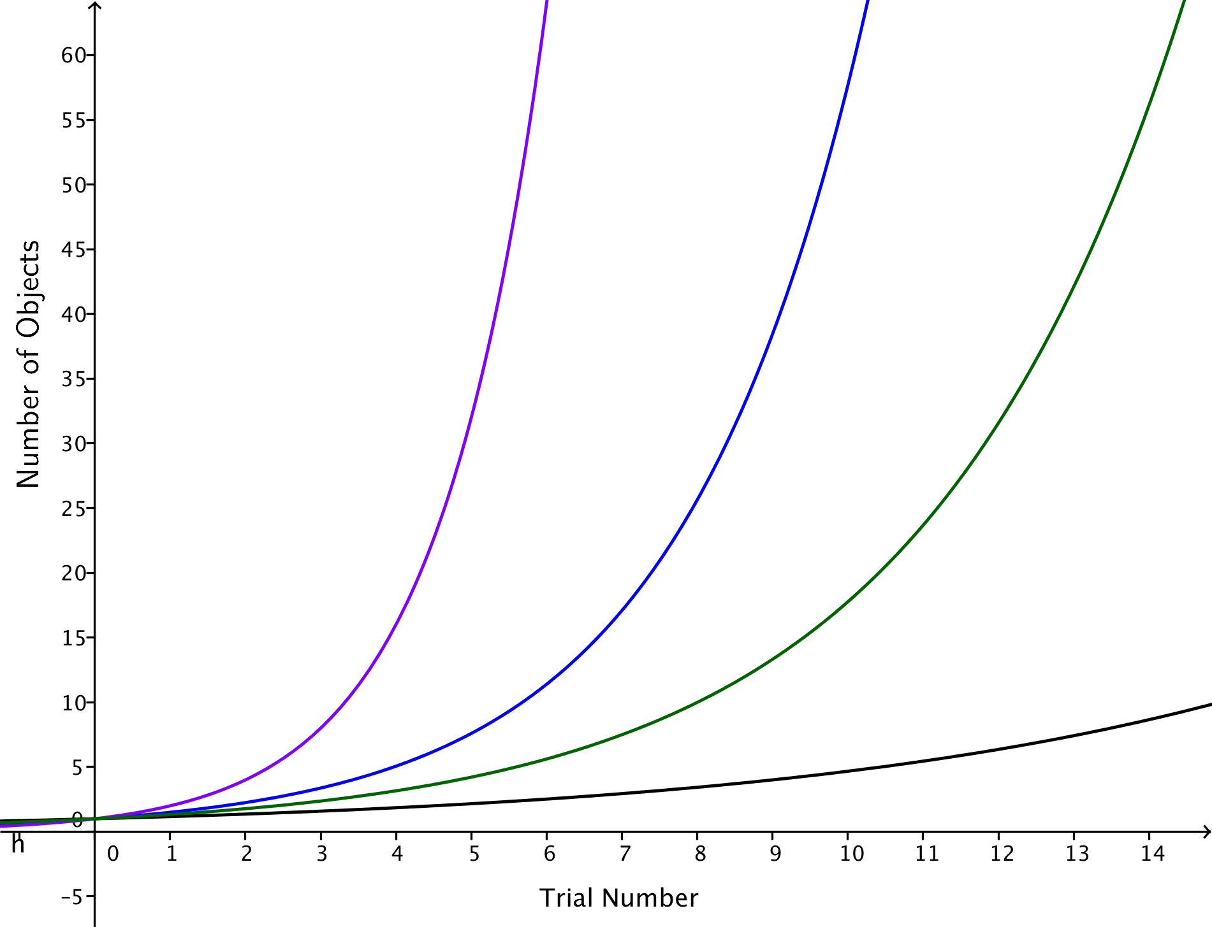
  - The following graphs represent the four functions $f$, $g$, $h$, and $j$. Identify which graph represents which function.

- Teams 1, 2, and 3 gathered data as shown in the tables below, and each team modeled their data using an exponential function of the form $f\left(t\right)=a∙b^{t}$.
  - Which team should have the highest value of $b$? Which team should have the lowest value of $b$? Explain how you know.
Team 1 |  |  | Team 2 |  |  | Team 3
Trial Number, $t$ | Number of Beans |  | Trial Number, $t$ | Number of Beans |  | Trial Number, $t$ | Number of Beans
$$0$$ | $$1$$ |  | $$0$$ | $$1$$ |  | $$0$$ | $$1$$
$$1$$ | $$1$$ |  | $$1$$ | $$1$$ |  | $$1$$ | $$2$$
$$2$$ | $$2$$ |  | $$2$$ | $$1$$ |  | $$2$$ | $$3$$
$$3$$ | $$2$$ |  | $$3$$ | $$2$$ |  | $$3$$ | $$5$$
$$4$$ | $$4$$ |  | $$4$$ | $$2$$ |  | $$4$$ | $$8$$
$$5$$ | $$6$$ |  | $$5$$ | $$3$$ |  | $$5$$ | $$14$$
$$6$$ | $$8$$ |  | $$6$$ | $$5$$ |  | $$6$$ | $$26$$
$$7$$ | $$14$$ |  | $$7$$ | $$7$$ |  | $$7$$ | $$46$$
$$8$$ | $$22$$ |  | $$8$$ | $$12$$ |  | $$8$$ | $$76$$
$$9$$ | $$41$$ |  | $$9$$ | $$18$$ |  | $$9$$
$$10$$ | $$59$$ |  | $$10$$ | $$27$$ |  | $$10$$

  - Use a graphing calculator to find the equation that best fits each set of data. Do the equations of the functions provide evidence that your answer in part (a) is correct?

- Omar has devised an activity in which he starts with $15$ dice in his cup. A trial consists of rolling the dice in the cup and adding one more die to the cup for each die that lands with a $1$, $2$, or $3$ showing.
  - Find a function $f\left(t\right)=a(b^{t})$ that Omar would expect to model his data.
  - Solve the equation $f\left(t\right)=30$. What does the solution mean?
  - Omar wants to know in advance how many trials it should take for his initial quantity of $15$dice to double. He uses properties of exponents and logarithms to rewrite the function from part (a) as an exponential function of the form$f\left(t\right)=a\left(2^{t⋅log_{2}(b)}\right)$.
  - Has Omar correctly applied the properties of exponents and logarithms to obtain an equivalent expression for his original equation in part (a)? Explain how you know.
  - Explain how the modified formula from part (c) allows Omar to easily find the expected amount of time, $t$, for the initial quantity of dice to double.

- Brenna has devised an activity in which she starts with $10$ dice in her cup. A trial consists of rolling the dice in the cup and adding one more die to the cup for each die that lands with a $6$ showing.
  - Find a function $f\left(t\right)=a(b^{t})$ that you would expect to model her data.
  - Solve the equation $f\left(t\right)=30$. What does your solution mean?
  - Brenna wants to know in advance how many trials it should take for her initial quantity of $10$ dice to triple. Use properties of exponents and logarithms to rewrite your function from part (a) as an exponential function of the form$f\left(t\right)=a\left(3^{ct}\right)$.
  - Explain how your formula from part (c) allows you to easily find the expected amount of time, $t$, for the initial quantity of dice to triple.
  - Rewrite the formula for the function $f$ using a base $10$ exponential function.
  - Use your formula from part (e) to find out how many trials it should take for the quantity of dice to grow to $100$ dice.

- Suppose that one bacteria population can be modeled by the function $P_{1}\left(t\right)=500\left(2^{t}\right)$ and a second bacteria population can be modeled by the function $P_{2}\left(t\right)=500\left(2.83^{t}\right)$, where $t$ measures time in hours. Keep four digits of accuracy for decimal approximations of logarithmic values.
  - What does the $500$ mean in each function?
  - Which population should double first? Explain how you know.
  - How many hours and minutes will it take until the first population doubles?
  - Rewrite the formula for $P_{2}(t)$ in the form $P_{2}\left(t\right)=a\left(2^{ct}\right)$, for some real numbers $a$ and $c$.
  - Use your formula in part (d) to find the time, $t$, in hours and minutes until the second population doubles.

- Copper has antibacterial properties, and it has been shown that direct contact with copper alloy C11000 at $20°C$ kills $99.9$% of all methicillin-resistant Staphylococcus aureus (MRSA) bacteria in about $75$ minutes. Keep four digits of accuracy for decimal approximations of logarithmic values.
  - A function that models a population of $1,000$ MRSA bacteria $t$ minutes after coming in contact with copper alloy C11000 is $P\left(t\right)=1000{\left(0.912\right)}^{t}$. What does the base $0.912$ mean in this scenario?
  - Rewrite the formula for $P$ as an exponential function with base $\frac{1}{2}$.
  - Explain how your formula from part (b) allows you to easily find the time it takes for the population of MRSA to be reduced by half.

