|  |
| --- |
|  |

Lesson 21: The Graph of the Natural Logarithm Function

Student Outcomes

* Students understand that the change of base property allows us to write every logarithm function as a vertical scaling of a natural logarithm function.
* Students graph the natural logarithm function and understand its relationship to other base logarithm functions. They apply transformations to sketch the graph of natural logarithm functions by hand.

Lesson Notes

The focus of this lesson is developing fluency with sketching graphs of the natural logarithm function by hand and understanding that because of the change of base property of logarithms, every logarithm function can be expressed as a vertical scaling of the natural logarithm function (or any other base logarithm we choose, for that matter). This helps to explain why calculators typically prominently feature a common logarithm button and a natural logarithm button. Students may question why we care so much about natural logarithms in mathematics. The importance of the particular base will become apparent when they study calculus and learn that is equal to the area under the reciprocal function from to ; that is, .

This lesson begins by challenging students to compare and contrast logarithm functions with different bases in a group exploration. Students complete a graphic organizer to help focus their learning at the end of the exploration. During the exploration, students should be encouraged to use technology. The focus should be on observing the patterns and making generalizations (MP.7, MP.8). A quick set of exercises primes students to explain their observations using the change of base property of logarithms. Once we have established that this property guarantees that graphs of logarithmic functions of one base are a vertical scaling of a graph of a logarithmic function of any other base, we tie the lesson back to the natural logarithm function. The lesson closes with demonstrations and practice with graphing natural logarithm functions to build fluency with creating sketches by hand (**F-IF.B.4**).

Classwork

Opening (3 minutes)

Ask students to predict how the graphs of logarithm functions are alike and how they are different when we consider different bases. Post this question on the board, give students a minute or two to think about their response, and then have them share with a partner. Take a few responses from the entire class, but do not really provide any concrete answers at this point. Student responses and the quality of their conversations will help you gauge their understanding of graphs of logarithm functions up to this point and help you decide how to support student learning during the rest of this lesson.

**MP.1**

* How are the graphs of , , and similar? How are they different?
  + *They are always increasing for and have one -intercept at . As the base changes, they appear to increase more or less rapidly. They all have the same domain and range.*

Exploratory Challenge (15 minutes)

Have students work in groups of 4–5. Each group will need access to graphing technology for each student or pair of students, the student materials for this lesson, chart paper or personal white boards, and markers. Have each student select at least one base value from the following list: . Using a graphing calculator or other graphing technology, students should independently explore how their selected base logarithm function’s graph compares to the graph of the common logarithm function . Next, have them describe what they observed in writing and report it to their group members. As a group, students then categorize their findings based on the value of and record their observations on chart paper. Have each group present their findings to the entire class. As you debrief this exploration as a whole class, focus on clarifying student language in their descriptions and encourage students to revise their written descriptions to further clarify what they wrote. Student work should be similar to the sample responses shown below.

*Scaffolding:*

* For English language learners, the graphic organizer provides some scaffolding, but sentence frames may also help students respond to part (c) in this exploration. For example,

“Compared to the graph of , the graph of my function was ______.”

OR

”My function’s graph was a ____________ transformation of the graph of

* For advanced learners, rather than provide the explicit steps listed in the Exploratory Challenge, present the problem on the board, give them technology and chart paper, and start them on the group presentation.

Exploratory Challenge

**MP.8**

Your task is to compare graphs of base logarithm functions to the graph of the common logarithm function and summarize your results with your group. Recall that the base of the common logarithm function is . A graph of is provided below.

* 1. Select at least one base value from this list: . Write a function in the form for your selected base value, .

***Students should use one of the numbers from the list to write their function. For example, .***

* 1. Graph the functions and in the same viewing window using a graphing calculator or other graphing application, and then add a sketch of the graph of to the graph of shown below.

Several graphs are shown at the end of this exploration.



* 1. Describe how the graph of for the base you selected compares to the graph of .

Answers will vary depending on the base selected. For example, when the base is , the graph of appears to be a vertical scaling of the common logarithm function by a factor less than .

* 1. Share your results with your group and record observations on the graphic organizer below. Prepare a group presentation that summarizes the group’s findings.

**MP.8**

|  |  |
| --- | --- |
| How does the graph of compare to the graph of for various values of ? | |
|  | The function is decreasing. Its graph is a reflection about the horizontal axis of the graph of a logarithm function whose base is the reciprocal of . |
|  | When is between and , the graph of appears to be a vertical scaling of the graph of by a factor greater than . As gets closer to , the graph of gets closer to the graph of and appears less steep. |
|  | When is greater than , the graph of appears to be a vertical scaling of the graph of by a factor between and . As grows, the graph of grows at a slower rate and appears to move closer to the horizontal axis than the graphs of functions whose bases are closest to . |

A graph of logarithm functions with several of the bases listed is shown below.

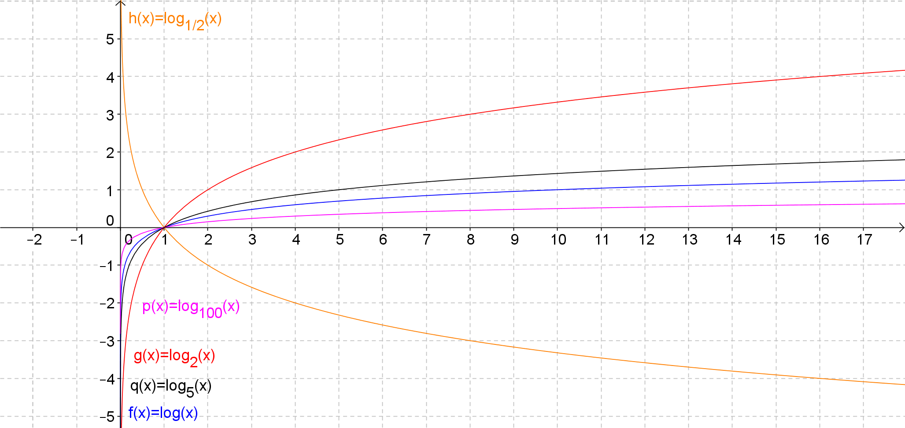

As the groups work through this exploration, be sure to guide them to appropriate conclusions without explicitly telling them answers. After or during the group presentations, ask questions such as the ones listed below to clarify student understanding.

**MP.3**

**&**

**MP.7**

* Why are the functions decreasing when is between and ?
  + *Consider . Then, , and . If , then . As increases, becomes larger in magnitude while staying negative, so decreases. Thus, the function is decreasing.*
  + *The exponential function for bases between and is a decreasing function, so when we have a logarithm function with these bases, the range values will also decrease as the domain values increase.*
* How does the graph of relate to the graph of ? Explain why this relationship exists.

**MP.3**

**&**

**MP.7**

* + *The graphs appear to be reflections of one another about the horizontal axis. The graphs of and are reflections about the vertical axis because . Thus, when we exchange the domain and range values to form the related logarithm functions, they will also be reflections of one another, but about the horizontal axis.*
* Why do smaller bases produce steeper graphs and larger bases produce flatter graphs?
  + *Logarithmic functions with a smaller base grow at a faster rate, making the graph steeper. For example, , and . The same input () produces a smaller output as the size of the base increases.*
* Where would the graph of sit in relation to these graphs? How do you know?
  + *The graph of would be in between the two graphs of and because is a number between and .*
* The graphs of these functions appear to be vertical scalings of each other. How could we prove that this is true?
  + *We would have to show that we can rewrite each function as a constant multiple of another logarithm function.*

Check to make sure each student has recorded appropriate information in the graphic organizer in part (d) before moving on. Post the group presentations on the board for reference during the rest of this lesson.

Exercise 1 (5 minutes)

Announce that now we will explore how all these graphs are related using a property of logarithms. Students should be able to complete this exercise quickly. Some students may already start to understand why the graphs appeared the way they did in the Exploratory Challenge as they work through these exercises.

Exercise 1

Use the change of base property to rewrite each function as a common logarithm.

Base Base (Common logarithm)

Discussion (5 minutes)

Lead a discussion to help students observe that each function in base is divided by a constant (which is the same as multiplying by the reciprocal of that number). Have students explore the values of the constants using their calculators, and have them make sense of why the graphs appear the way they do compared to the graph of the common logarithm function. For example, . When dividing by a number between and you get the same result as multiplying by its reciprocal, which is a number greater than The values of and are negative, which explains why the graphs of those functions are a vertical scaling and a reflection of the graph of the common logarithm function. When the base is greater than , we are dividing by a number greater than , which is the same as multiplying by a number between and which compresses the graph vertically.

* How do the functions from Exercise 1 that you wrote in base compare to the function ?
  + *They are a constant multiple of the function . For example, , so the function   
     could also be written as .*
* Approximate the values of the constants in the functions from Exercise 1. How do those values help to explain why the graphs are a vertical stretch of the common logarithm function when the base is between and , and a vertical compression when the base is greater than ? Why are the functions decreasing when the base is between and ?
  + *When the base is between and , the common logarithms are between and . Dividing by a number between and is the same as multiplying by a number larger than , which will scale the graph vertically by a factor greater than For bases greater than , the common logarithm function is multiplied by a number between and . The functions decrease when the base is between and because the common logarithms of those numbers are less than .*

Next, revisit the question posed earlier regarding the graph of , the natural logarithm function, as a way to transition into the last portion of this lesson.

* Where would the graph of sit in relation to these graphs? How do you know?
  + *The graph of would be in between the two graphs of and because is a number between and .*

**Example 1 (5 minutes): The Graph of the Natural Logarithm Function**

The example that follows demonstrates how to sketch the graph of the natural logarithm function by hand and shows more precisely where it sits in relation to base and base logarithm functions.

Example 1: The Graph of the Natural Logarithm Function

Graph the natural logarithm function below to demonstrate where it sits in relation to the base and base logarithm functions.

The graphs are not labeled. You can question students about this to informally assess their understanding at this point.

* Which graph is , and which one is ? How can you tell?
  + *Since the base is smaller, the logarithm function base grows more quickly than the base logarithm function, so the red graph is the graph of . You can also verify which graph is which by identifying a few points and substituting them into the equations to see which is true. For example, the blue graph appears to contain the point . Since , the blue graph represents the common logarithm function.*

Remind students that . Create a table of values like the one shown below and then plot these points. Connect the points with a smooth curve. When students are sketching by hand in the next example, have them plot fewer points, perhaps where the -values are integers only.

|  |  |
| --- | --- |
|  |  |
|  |  |
|  |  |
|  |  |
|  |  |
|  |  |
|  |  |
|  |  |

The solution is graphed below with several points labeled on the graph of .

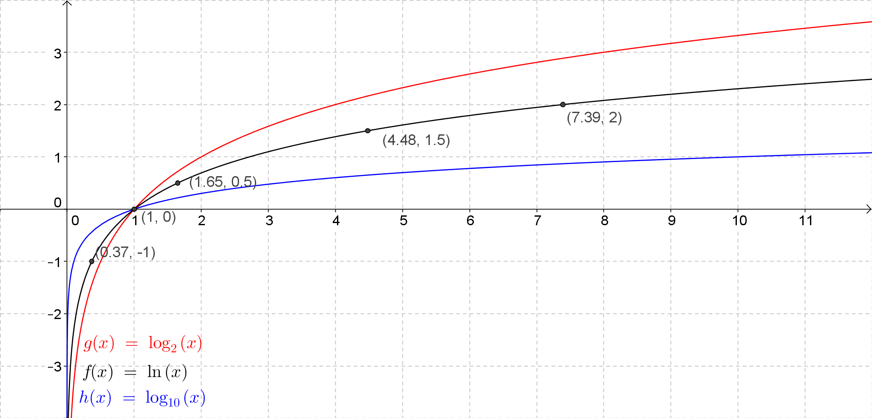

Example 2 (5 minutes)

In this example, part (a) models how to sketch graphs by applying transformations. Then, show students in part (b) how to rewrite the function as a natural logarithm function, and sketch the graph by applying transformations of the graph of . Model the transformations in stages. First, sketch the graph of ; next, sketch a second graph applying the first transformation; finally, sketch a graph applying the last transformation to the second graph you made.

Example 2

Graph each function by applying transformations of the graphs of the natural logarithm function.



***The graph of is the graph of shifted horizontally unit to the right, stretched vertically by a factor of .***

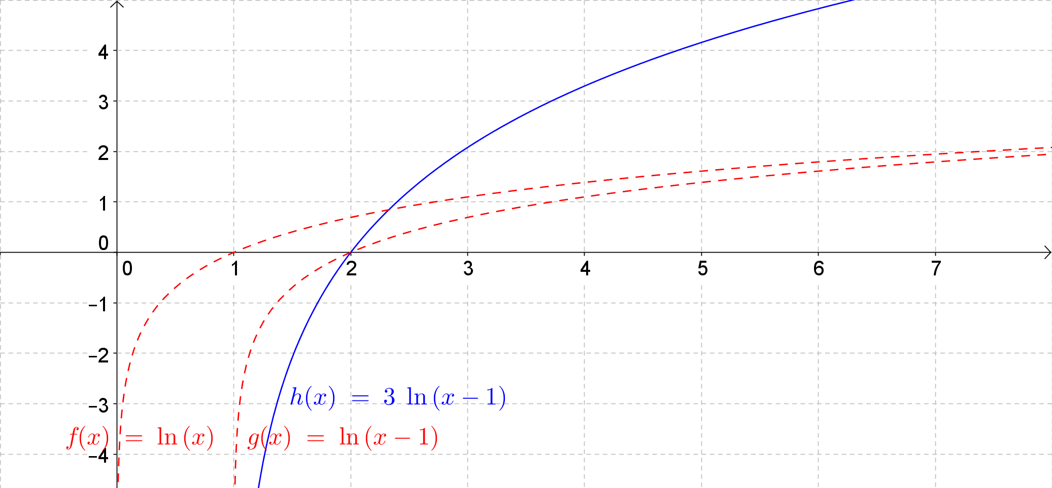

***First, write as a natural logarithm function.***

***Since* *, the graph of g will be the graph of scaled vertically by a factor of approximately and translated down units.***

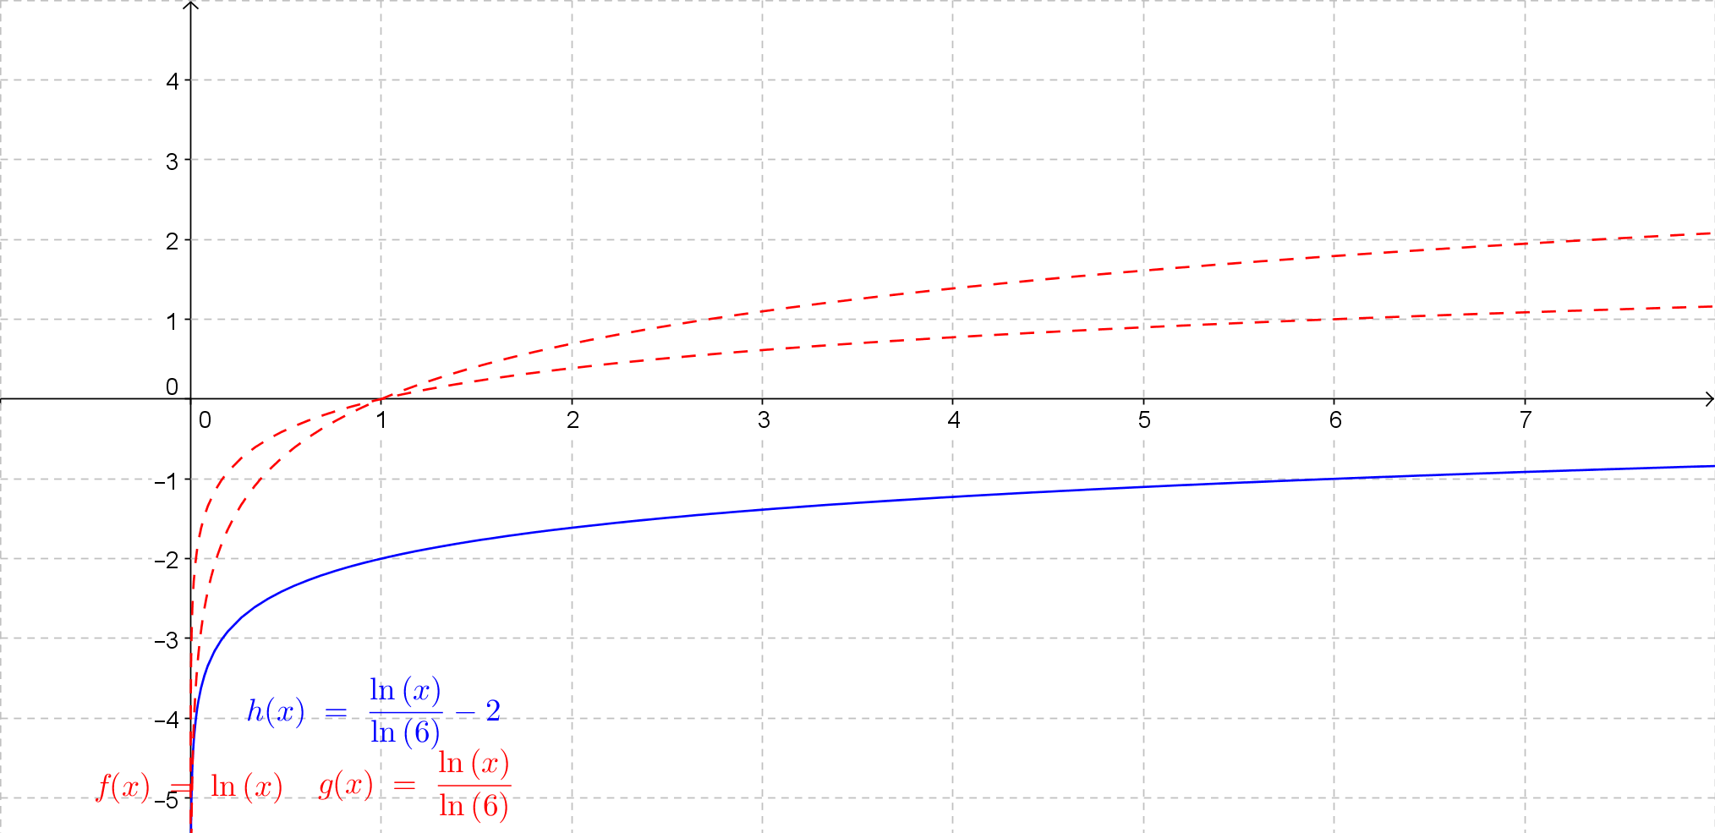

Closing (2 minutes)

Have students summarize what they have learned in this lesson by revisiting the question from the Opening. Students should revise their initial responses and either discuss their answers with a partner or write a brief individual reflection. The responses should be similar to what is listed in the Lesson Summary.

* How are the graphs of logarithm functions with different bases alike? How are they different?
  + *They have the same -intercept and when the base is greater than , the functions are increasing. They all have the same domain and range. They are different because as the base changes, the steepness of the graph of the function changes. Larger bases grow at slower rates.*
* How does the change of base property guarantee that every logarithm function could be expressed in the form ?
  + *The change of base property guarantees that we can convert any logarithmic expression in base to a natural logarithmic expression where the denominator of the expression is constant.*

Exit Ticket (5 minutes)

Name Date

Lesson 21: The Graph of the Natural Logarithm Function

Exit Ticket

1. Describe the graph of as a transformation of the graph of .
2. Sketch the graphs of and by hand.



1. Explain where the graph of would sit in relation to the graph of . Justify your answer using properties of logarithms and your knowledge of transformations of graph of functions.

Exit Ticket Sample Solutions

1. Describe the graph of as a transformation of the graph of .

The graph of is the graph of translated units to the left, reflected about the horizontal axis, and translated up units.



1. Sketch the graphs of and by hand.
2. Explain where the graph of would sit in relation to the graph of . Justify your answer using properties of logarithms and your knowledge of transformations of graph of functions.

***Since , the graph of would be a vertical shift and a vertical scaling by a factor greater than of the graph of .***

Problem Set Sample Solutions

1. Rewrite each logarithm function as a natural logarithm function.
2. Describe each function as a transformation of the natural logarithm function .

The graph of is the graph of translated units to the left and scaled vertically by a factor of .

The graph of is the graph of translated unit to the right, reflected about , and then reflected about the horizontal axis.

The graph of is the graph of translated up units.

***The graph of is the graph of translated up units and scaled vertically by a factor of*** *.*

1. Sketch the graphs of each function in Problem 2 and identify the key features including intercepts, decreasing or increasing intervals, and the vertical asymptote.
   1. The equation of the vertical asymptote is . The -intercept is . The graph is increasing for all   
      . The -intercept is approximately .

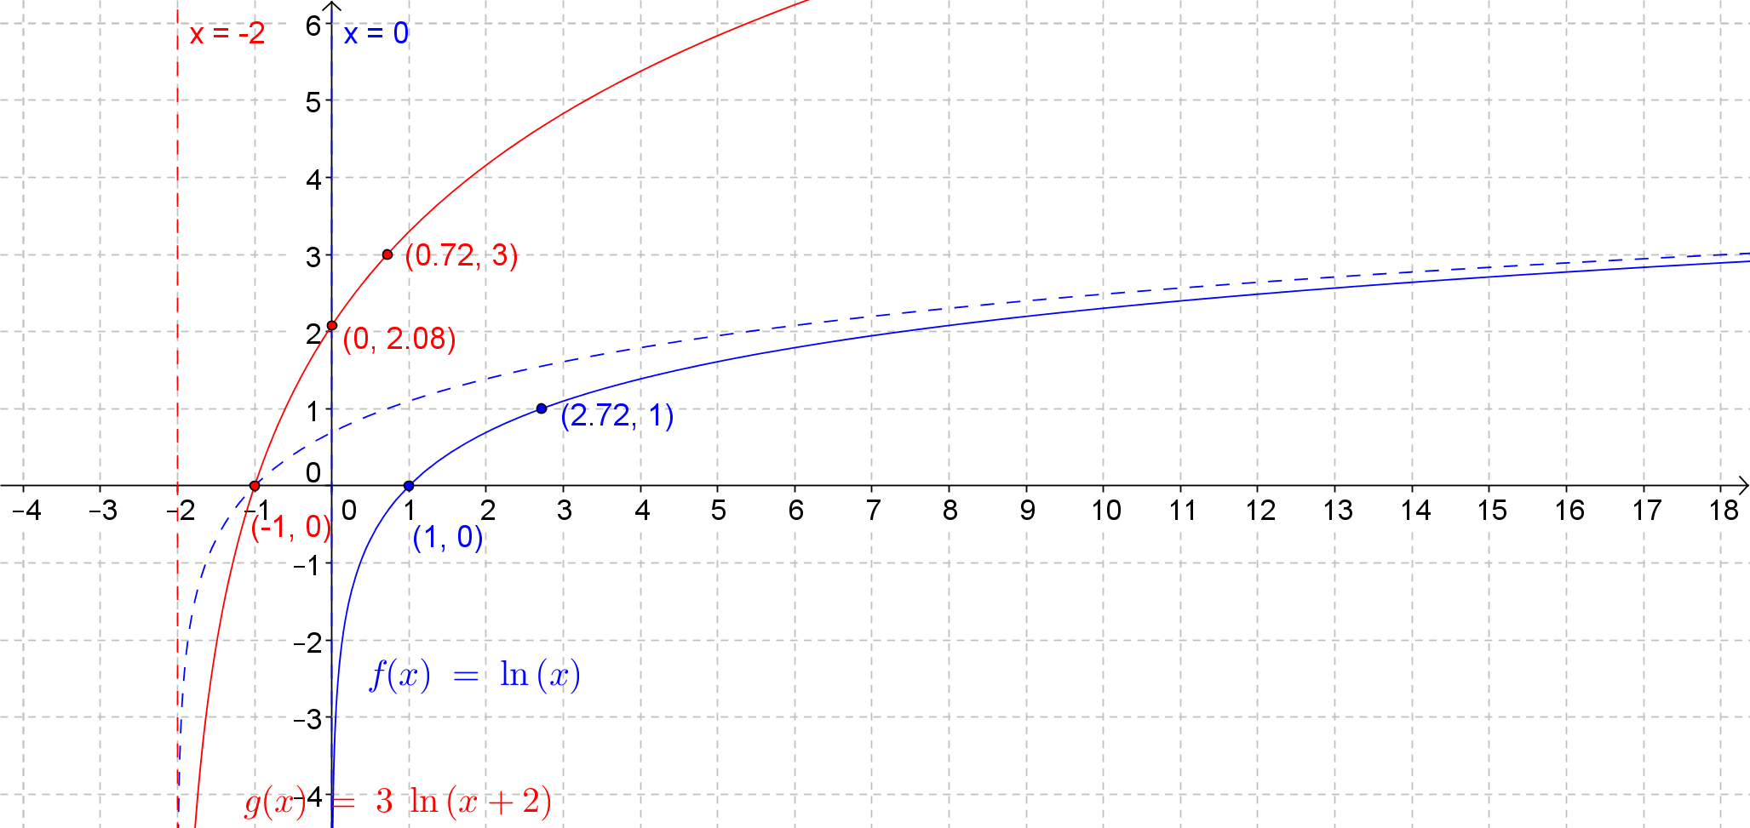

* 1. The equation of the vertical asymptote is . The -intercept is . The graph is increasing for all . The -intercept is .

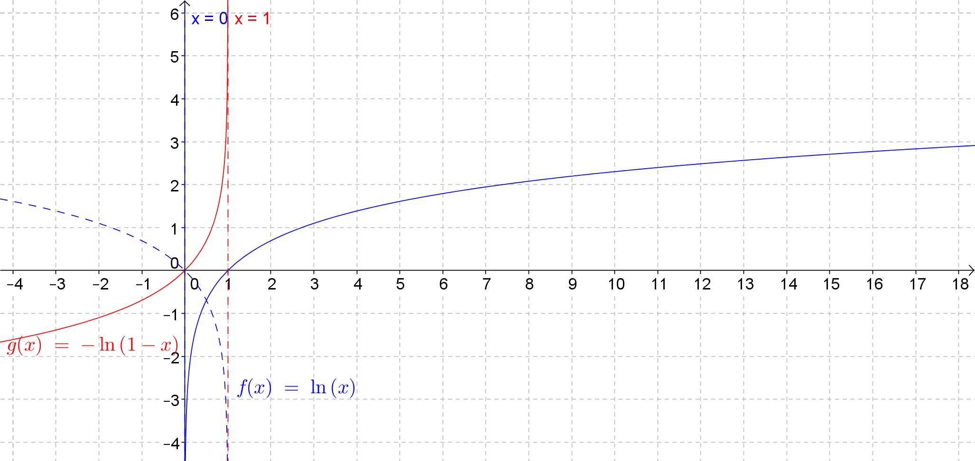

* 1. The equation of the vertical asymptote is . The -intercept is approximately . The graph is increasing for all .

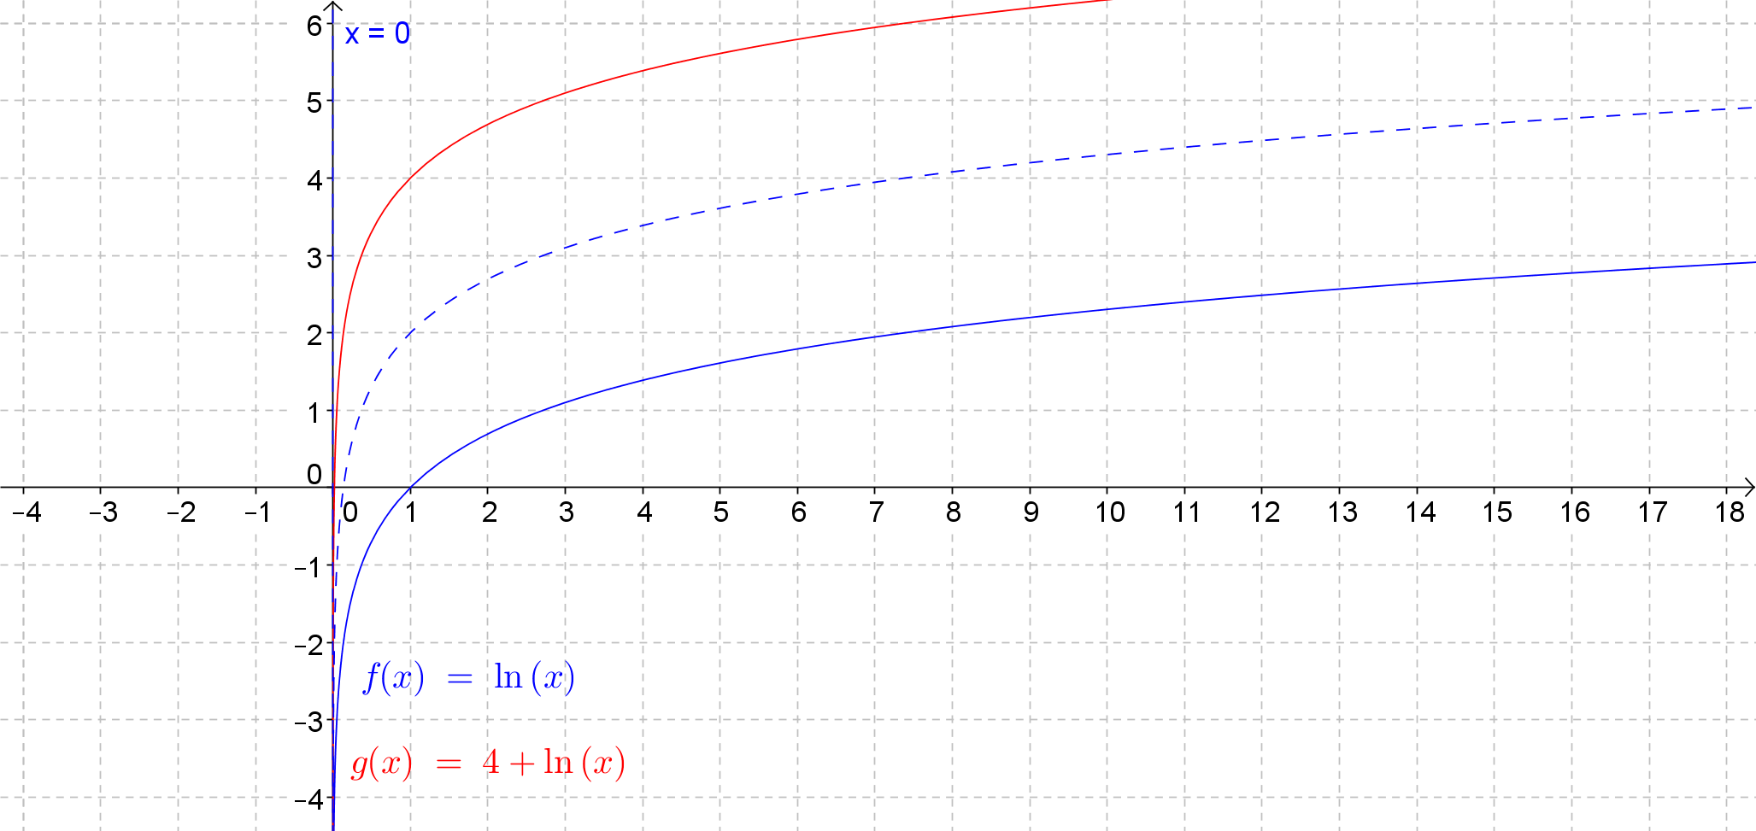

* 1. The equation of the vertical asymptote is . The -intercept is . The graph is increasing for all   
     .

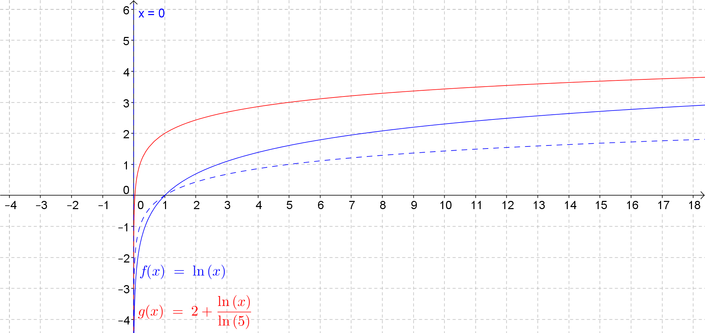

1. Solve the equation graphically.

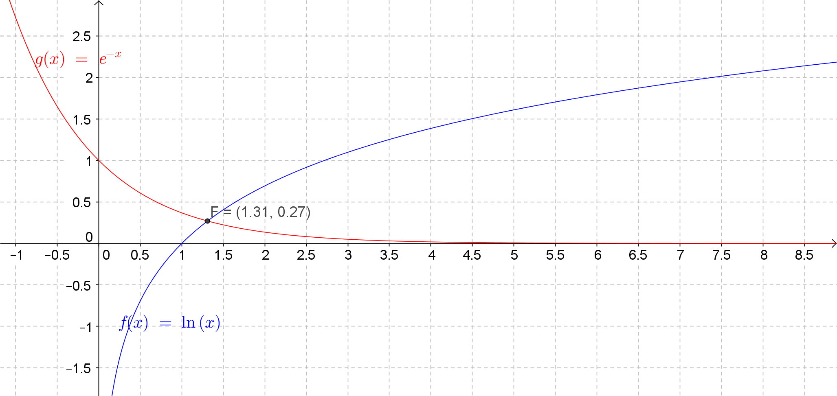

1. Use a graphical approach to explain why the equation has only one solution.

The graphs intersect in only one point , so the equation has only one solution.

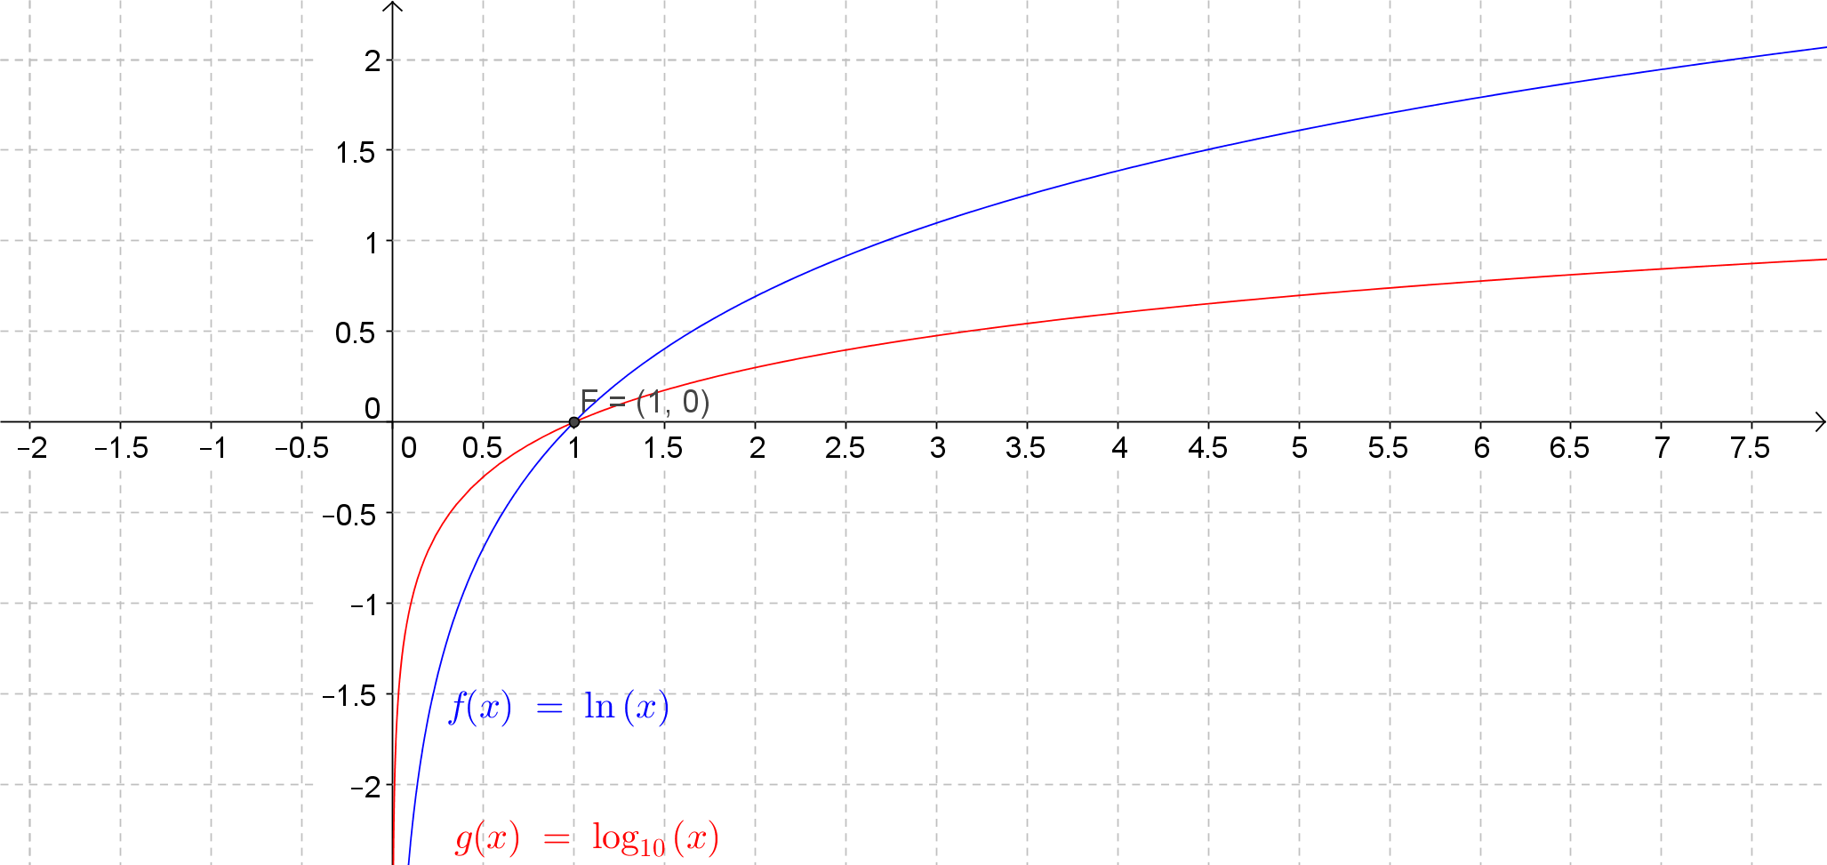

1. Juliet tried to solve this equation as shown below using the change of base property and concluded there is no solution because . Construct an argument to support or refute her reasoning.

**MP.3**

***Juliet’s approach works as long as , which occurs when . The solution to this equation is . When you divide both sides of an equation by an algebraic expression, you need to impose restrictions so that you are not dividing by . In this case, Juliet divided by , which is not valid if . This division caused the equation in the third and final lines of her solution to have no solution; however, the original equation is true when is***

1. Consider the function given by for and .
   1. What are the values of and ?

, ,

* 1. Why is the value excluded from the domain of this function?

The value is excluded from the domain because is not a base of an exponential function since it would produce the graph of a constant function. Since logarithm functions by definition are related to exponential functions, we cannot have a logarithm with base .

* 1. Find a value so that .

***The value of that satisfies this equation is .***

* 1. Find a value so that .

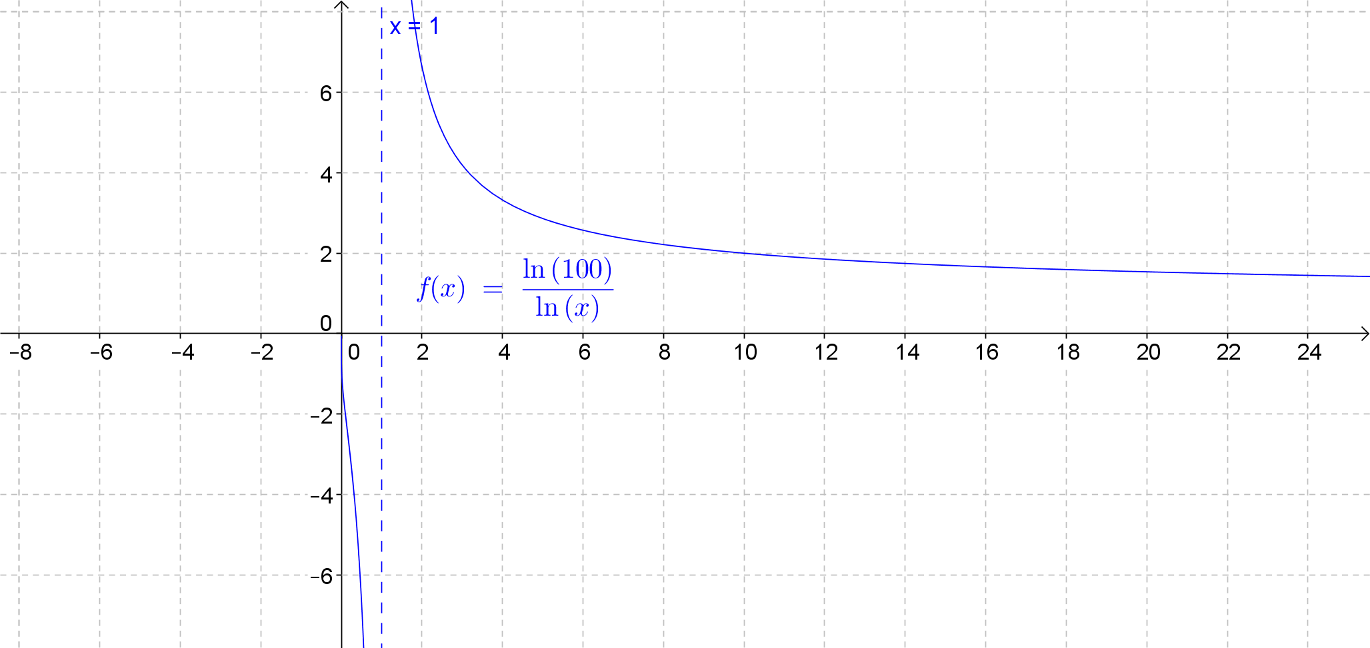The value of that satisfies this equation is .

* 1. Sketch a graph of for   
      and .