|  |
| --- |
|  |

Lesson 20: Transformations of the Graphs of Logarithmic and Exponential Functions

Student Outcomes

* Students study transformations of the graphs of logarithmic functions.
* Students use the properties of logarithms and exponents to produce equivalent forms of exponential and logarithmic expressions. In particular, they notice that different types of transformations can produce the same graph due to these properties.

Lesson Notes

Students revisit the use of transformations to produce graphs of exponential and logarithmic functions (**F-BF.B.3**,  
**F-IF.B.4**, **F-IF.C.7e**). They make and verify conjectures about why certain transformations of the graphs of functions produce the same graph by applying the properties to produce equivalent expressions (MP.3). This work leads to a general form of both logarithmic and exponential functions where the given parameters can be quickly analyzed to determine key features and to sketch graphs of logarithmic and exponential functions (MP.7, MP.8). This lesson reinforces sketching graphs of functions by applying knowledge of transformations and the properties of logarithms and exponents.

Classwork

Opening Exercise (8 minutes)

Since much of the work on this lesson will involve the connections between scaling and translating graphs of functions, this Opening Exercise presents students with an opportunity to reflect on what they already know about transformations of graphs of functions using a simple polynomial function and the sine function. Observe students carefully as they work on these exercises to gauge how much re-teaching or additional support may be needed in the Exploratory Challenge that follows. If students struggle to recall their knowledge of transformations, you may need to provide additional guidance and practice throughout the lesson. A grid is provided for students to use when sketching the graphs in Opening Exercise, part (a), but students could also complete this exercise using graphing technology.

Opening Exercise

* 1. Sketch the graphs of the three functions , , and .
     1. Describe the transformations that will take the graph of to the graph of .

The graph of is a horizontal scaling by a factor of and a vertical translation up unit of the graph of .

* + 1. Describe the transformations that will take the graph of to the graph of .

The graph of is a vertical scaling by a factor of and a vertical translation up unit of the graph of .

* + 1. Explain why and from parts (i) and (ii) are equivalent functions.

These functions are equivalent and have the same graph because the expressions and are equivalent. The blue graph shown is the graph of , and the red graph is the graph of and

*Scaffolding:*

* For students who struggle with visual processing, provide larger graph paper and/or colored pencils to color code their graphs.
* For struggling students, prominently display the properties of logarithms and exponents on the board or on chart paper in your room for visual reference. Refer students back to these charts during the exploration with questions such as: “Which property could you use to rewrite the expression?”
  1. Describe the transformations that will take the graph of to the graph of .

The graph of is a horizontal scaling by a factor of and a vertical translation down units of the graph of .

* 1. Describe the transformations that will take the graph of to the graph of .

The graph of is a vertical scaling by a factor of and a vertical translation down units of the graph of .

* 1. Explain why and from parts (b)–(c) are *not* equivalent functions.

These functions are not equivalent because they do not have the same graphs, and the two expressions are not equivalent.

Have students share responses and revise their work in small groups. Be sure to emphasize that students need to label graphs since many of them appear on the same set of axes. Lead a brief whole-group discussion that focuses on the responses to Opening Exercise part (a-iii) and part (d). Perhaps have one or two students share their written response with the whole class, using either the board or the document camera. Check to make sure students are actually writing responses to these questions.

Conclude this discussion by helping students to understand the following ideas that, as will be demonstrated later, are also true with graphs of logarithmic and exponential functions.

* Certain transformations of the graph of a function can be identical to other transformations depending on the properties of the given function.
* For example, the function is either a horizontal translation of unit to the left or a vertical translation of unit up of the graph of . Similarly, has the same graph as   
  , but could be described using different transformations of the graph of .

Announce to students that in this lesson, they will explore the properties of logarithms and exponents to understand graphing transformations of those types of functions, and they will explore when two different functions have the same graph in order to reinforce those properties.

Exploratory Challenge (15 minutes)

Students should work in small groups to complete this sequence of questions. Provide support to individual groups or students as you move around the classroom. As you circulate, keep questioning students as to the meaning of a logarithm with questions like those below.

*Scaffolding:*

Use technology to support learners who are still struggling with arithmetic and need visual reinforcement. Students can investigate using graphing calculators or online graphing programs. Newer calculators and graphing programs have a function built in. On older models, you may need to coach students to use the change of base property to enter these functions (i.e., to graph , you will need to enter the expression into the graphing calculator).

* What does mean?
  + *The exponent when the number is written as a power of .*
* Why is negative?
  + *It is negative because , and the logarithm is the exponent when the number is written as a power of .*

**MP.1**

* What will be the domain and range of the function ? Why does this make sense given the definition of a logarithm?
  + *The domain is all real numbers greater than . The range is all real numbers. This makes sense because the range of the exponential function is all real numbers greater than the domain is all real numbers, and the logarithmic function base is the inverse of the exponential function base .*

You can extend this lesson by using graphing software such as GeoGebra to create parameterized graphs with sliders (variables and that can be dynamically changed while viewing graphs). By manipulating the values of and in the functions and , you can verify that the graphs of and  
 are the same. This result reinforces properties of logarithms since . Students and teachers can similarly confirm the other examples in this lesson as well.

Exploratory Challenge

* 1. Sketch the graph of by identifying and plotting at least five key points. Use the table below to help you get started.

The graph of is blue, and the graph of and is red on the solution graph shown below.

* 1. Describe the transformations that will take the graph of to the graph of .

The graph of is a horizontal scaling by a factor of of the graph of .

* 1. Describe the transformations that will take the graph of to the graph of .

The graph of is a vertical translation up units of the graph of .

* 1. Complete the table below for , , and and describe any patterns that you notice.

**MP.3**

**&**

**MP.8**

|  |  |  |  |
| --- | --- | --- | --- |
|  |  |  |  |
|  |  |  |  |
|  |  |  |  |
|  |  |  |  |
|  |  |  |  |
|  |  |  |  |
|  |  |  |  |

The functions and have the same range values at each domain value in the table.

* 1. Graph the three functions on the same coordinate axes and describe any patterns that you notice.

See graphs above. The graphs of and are identical.

* 1. Use a property of logarithms to show that and are equivalent.

***By the product property and the definition of logarithm,* .**

Call the entire class together at this point to debrief their work so far. Make sure students understand that by applying the product or quotient property of logarithms, they can rewrite a single logarithmic expression as a sum or difference. In this way, a horizontal scaling of the graph of a logarithmic function will produce the same graph as a vertical translation. The next three parts can be used to informally assess student understanding of the idea that two different transformations can produce the same graph because of the properties of logarithms.

* 1. Describe the graph of as a vertical translation of the graph of . Justify your response.

***The graph of is a vertical translation down units of the graph of because***

* 1. Describe the graph of as a horizontal scaling of the graph of . Justify your response.

***The graph of is a horizontal scaling by a factor of of the graph of because  
 .***

**MP.3**

* 1. Do the functions and have the same graphs? Justify your reasoning.

**MP.3**

No, they do not. By substituting for in both and you can see that the graphs of the two functions will not have the same -coordinate at this point. Therefore, the graphs cannot be the same if at least one point is different.

Carefully review the answers to the preceding questions to check for student understanding. Students may struggle with expressing as in part (h). In the last portion of the Exploratory Challenge, students turn their attention to exponential functions and apply the properties of exponents to explain why graphs of certain exponential functions are identical. Circulate around the room while students are working and encourage them to create the graph of the “parent” function by plotting key points on the graph of the function and then transforming those key points according to the transformation they described.

* 1. Use properties of exponents to explain why graphs of and are identical.

Using the power property of exponents, . Since the expressions are equal, the graphs of the functions would be the same.

* 1. Use the properties of exponents to predict what the graphs of and will look like compared to one another. Describe the graphs of and as transformations of the graph of . Confirm your prediction by graphing and on the same coordinate axes.

The graphs of these two functions will be the same since by the multiplication property of exponents and the commutative property. The graph of is the graph of scaled vertically by a factor of . The graph of is the graph of translated horizontally units to the left.



**2 units left**

**multiply by 4**

**MP.7**

* 1. Graph , , and on the same coordinate axes. Describe the graphs of and as transformations of the graph of. Use the properties of exponents to explain why and are equivalent.

The graph of and the graph of are both reflections about the vertical axis of the graph of . They are equivalent because by the definition of a negative exponent and the power property of exponents.



**Reflect about vertical axis**

Have groups volunteer to present their findings on the last three parts of the Exploratory Challenge. When debriefing, model both transformations for students by marking the sketch as shown in the solutions above.

Discuss these transformations.

* In part (k), how do you see the transformations that produce the graphs of and from the graph of ?
  + *I see the horizontal translation of units to the left, but others might see the vertical scaling that takes each -value and multiplies it by .*
* In part (l), how do the transformations validate the definition of a negative exponent?
  + *Since the graphs of and were identical, we have visual confirmation that which can only be true if .*

Then, have students respond to the reflection question below in writing or with a partner.

* How do the properties of logarithms and exponents justify the fact that different transformations of the graph of a function can sometimes produce the same graph?
  + *We can use the properties to rewrite logarithmic and exponential expressions in equivalent forms that then represent different transformations of the same original function.*

If time permits, you can also tie these transformations to a simple real-world context. For example, if we rewrite the function as students can see that adding 3 to would be like going three years forward in time. This means the population doubled three times, which is why we are multiplying by .

**Example 1 (4 minutes): Graphing Transformations of the Logarithm Functions**

Introduce the general form of a logarithm function, noting that we do not need a horizontal scaling parameter since a horizontal scaling can always be rewritten as a vertical translation. Continue to reinforce learning from the previous lessons by asking students why the restrictions on and are necessary. Students should be able to work through part (a) without your assistance, but monitor their work to make sure that all students have the correct answer to refer to when they work the Problem Set. Model your expectations for sketching the graphs of logarithm functions in part (b) so students are able to produce accurate and precise graphs. Demonstrate how to plot the key points, and then transform the individual points to produce the graph of

**MP.7**

**&**

**MP.8**

**MP.2**

Example 1: Graphing Transformations of the Logarithm Functions

The general form of a logarithm function is given by , where , , , and are real numbers such that is a positive number not equal to , and .

* 1. Given , describe the graph of as a transformation of the common logarithm function.

The graph of is a horizontal translation units to the right, a vertical scaling by a factor of , and a vertical translation up units of the graph of the common logarithm function.

* 1. Graph the common logarithm function and on the same coordinate axes.



The common logarithm function is shown in blue, and the graph of is shown in red. Notice the key points that students should include on their hand-drawn sketches.

**Example 2 (4 minutes): Graphing Transformations of Exponential Functions**

Introduce the general form of the exponential function, noting that we do not need a horizontal scaling or a horizontal translation since these can always be rewritten using the properties of exponents. Demonstrate, or let students work with a partner on part (a), and make sure students have correct work to refer to when they work on the Problem Set. Since earlier lessons applied transformations to graphing exponential functions, parts (b), (c), and (d) should move along rather quickly. Continue to reinforce your expectations for sketching graphs of functions using transformations.

Example 2: Graphing Transformations of Exponential Functions

The general form of the exponential function is given by , where , , and are real numbers such that is a positive number not equal to .

**MP.7**

**&**

**MP.8**

* 1. Use the properties of exponents to transform the function to the general form, and then graph it. What are the values of , , and ?

Using the properties of exponents, . Thus, so , **,** and .

* 1. Describe the graph of as a transformation of the graph of .

The graph of is a vertical scaling by a factor of and a vertical translation down units of the graph of .

* 1. Describe the graph of as a transformation of the graph of .

The graph of is a horizontal scaling by a factor of , a vertical scaling by a factor of , and a vertical translation down units of the graph of .

* 1. Graph using transformations.



The graph of is shown in black, and the graph of is shown in blue.

Exercises 1–4 (4 minutes)

Students can work on these exercises independently or with a partner. Monitor their work by circulating around the classroom and checking for accuracy. Encourage students to describe the graph of as a transformation of the graph of in more than one way and to justify their answer analytically. In particular, emphasize how rewriting the expression using the properties of logarithms can make sketching the graphs easier because a horizontal scaling is revealed to have the same effect as a vertical translation when graphing logarithm functions.

Exercises 1–4

Graph each pair of functions by first graphing and then graphing by applying transformations of the graph of . Describe the graph of as a transformation of the graph of .

1. and

The graph of is the graph of translated unit to the right and stretched vertically by a factor of .

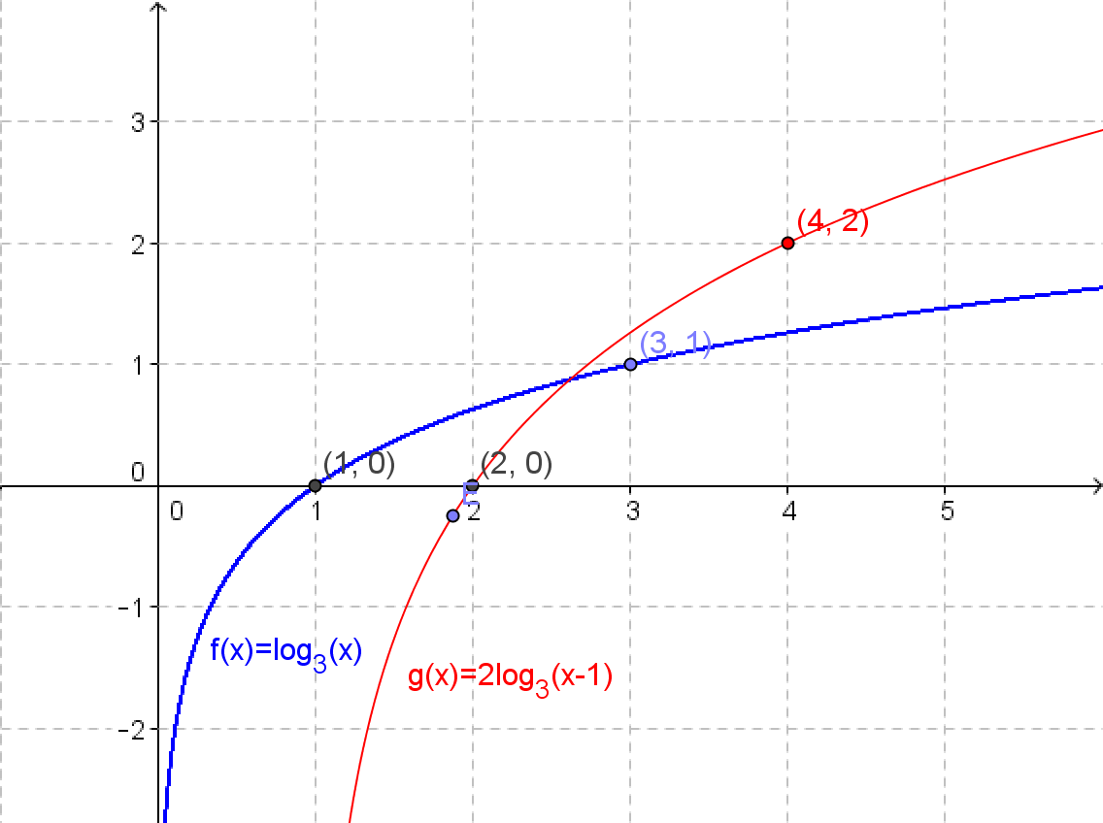

1. and

***Because of the product property of logarithms, . The graph of is the graph of translated vertically units.***

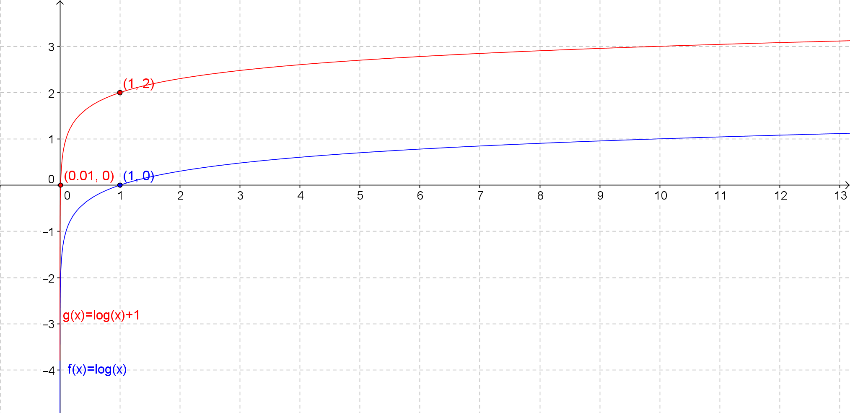

1. and

***Since by the product property of logarithms and the distributive property, the graph of is the graph of translated units to the left, reflected across the horizontal axis, and translated down unit.***

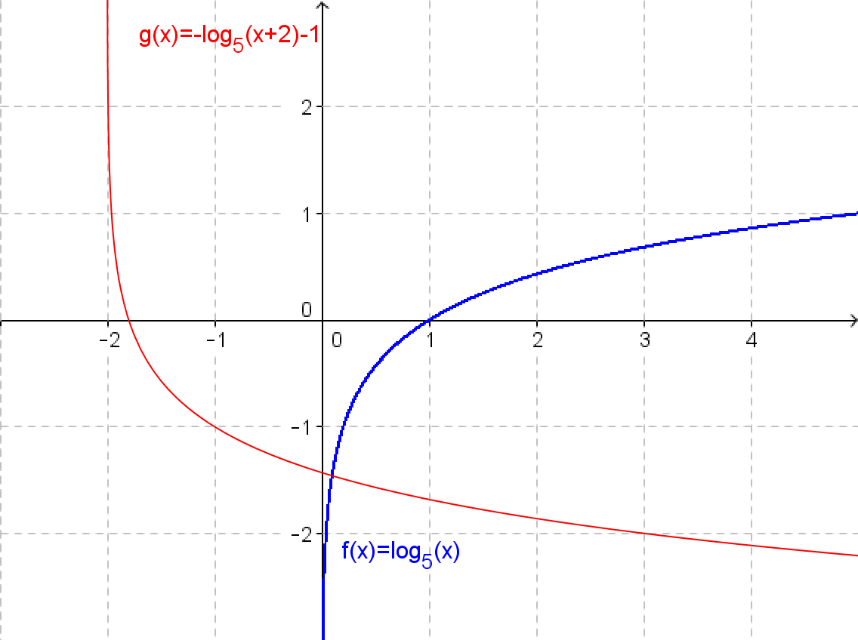

1. and

Since by the properties of exponents and the commutative property, the graph of is the graph of reflected across the horizontal axis and compressed by a factor of.

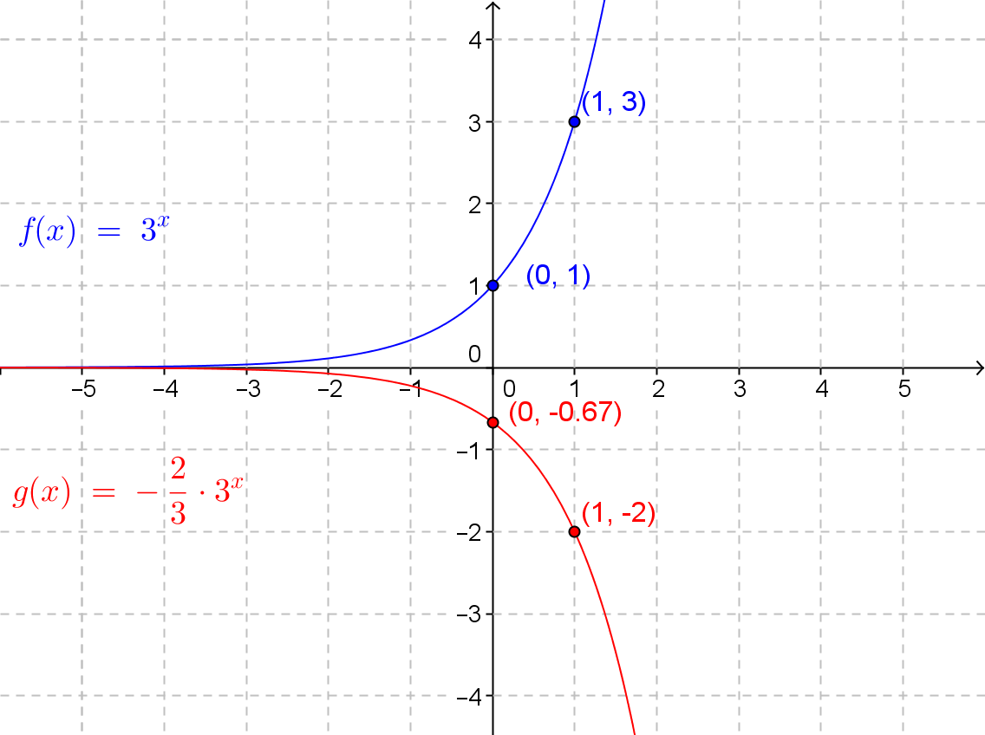

The graph above shows how to obtain the graph of from the graph of by reflecting about the horizontal axis and vertically scaling by a factor of. A few points are labeled to illustrate the transformations.

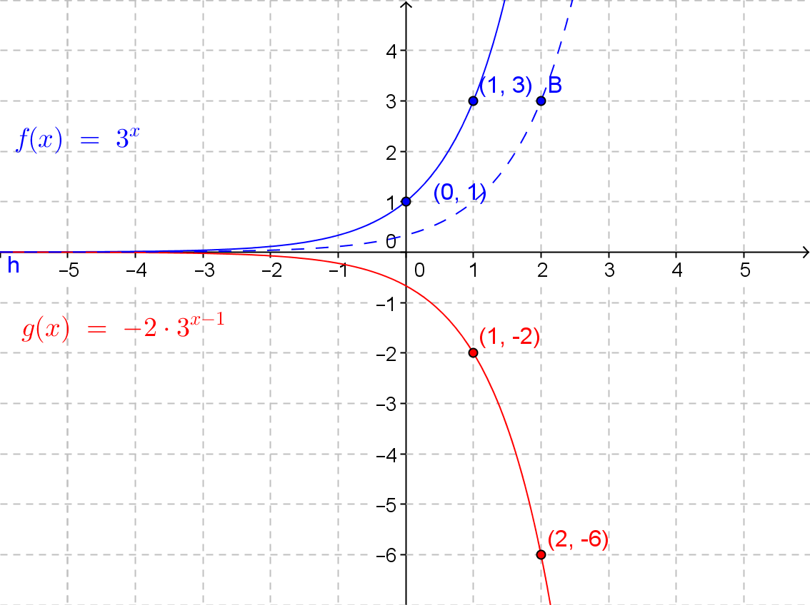

This graph shows the graph of obtained from the graph of with a horizontal translation, a reflection across the horizontal axis, and a vertical scaling. A few points are labeled to illustrate the transformations.

After a few minutes, have different groups share how they saw the transformations and discuss when it is advantageous to rewrite an expression before graphing and when it is not. For example, it might be easier in Exercise 10 to simply translate the graph unit to the right rather than scale it by a factor of . Also, make sure students are including a sketch of the end behavior of the functions.

Closing (5 minutes)

Provide students with an opportunity to summarize their learning with a partner by responding to the questions below. Their summaries will provide you with additional evidence of their understanding of this lesson.

* How do you apply properties of logarithms or exponents to rewrite and in general form?
  + *Using the product properties: , so in general form where , , and in the general form.*
  + *Using the product properties: , so in general form where and .*
* How do transformations help you to sketch quick and accurate graphs of functions?
  + *If you can make a basic logarithm or exponential function graph for a given base, then transformations can be used to quickly sketch a new function that is based on the original function.*

A summary of the key points of this lesson is provided. Review them with your class before they begin the Exit Ticket.

Lesson Summary

**General form of a logarithmic function: such that , , and are real numbers, is any positive number not equal to , and .**

**General form of an exponential function: such that and are real numbers, and is any positive number not equal to .**

**The properties of logarithms and exponents can be used to rewrite expressions for functions in equivalent forms that can then be graphed by applying transformations.**

Exit Ticket (5 minutes)

Name Date

Lesson 20: Transformations of the Graphs of Logarithmic and Exponential Functions

Exit Ticket

1. Express in the general form of a logarithmic function, . Identify , , , and .
2. Use the structure of when written in general from to describe the graph of as a transformation of the graph of .
3. Graph anad on the same coordinate axes.

Exit Ticket Sample Solutions

1. Express in the general form of a logarithmic function, . Identify , , , and .

***Since , the function is , and ,   
, , and .***

1. Use the structure of when written in general form to describe the graph of as a transformation of the graph of .

The graph of is the graph of reflected about the horizontal axis and translated down unit.

1. Graph and on the same coordinate axes.

The graph of is shown in blue, and the graph of is shown in red.

Problem Set Sample Solutions

1. Describe each function as a transformation of the graph of a function in the form . Sketch the graph of and the graph of by hand. Label key features such as intercepts, increasing or decreasing intervals, and the equation of the vertical asymptote.

***The graph of is the graph of translated horizontally units to the right. The graph is increasing on . The -intercept is , and the vertical asymptote is .***

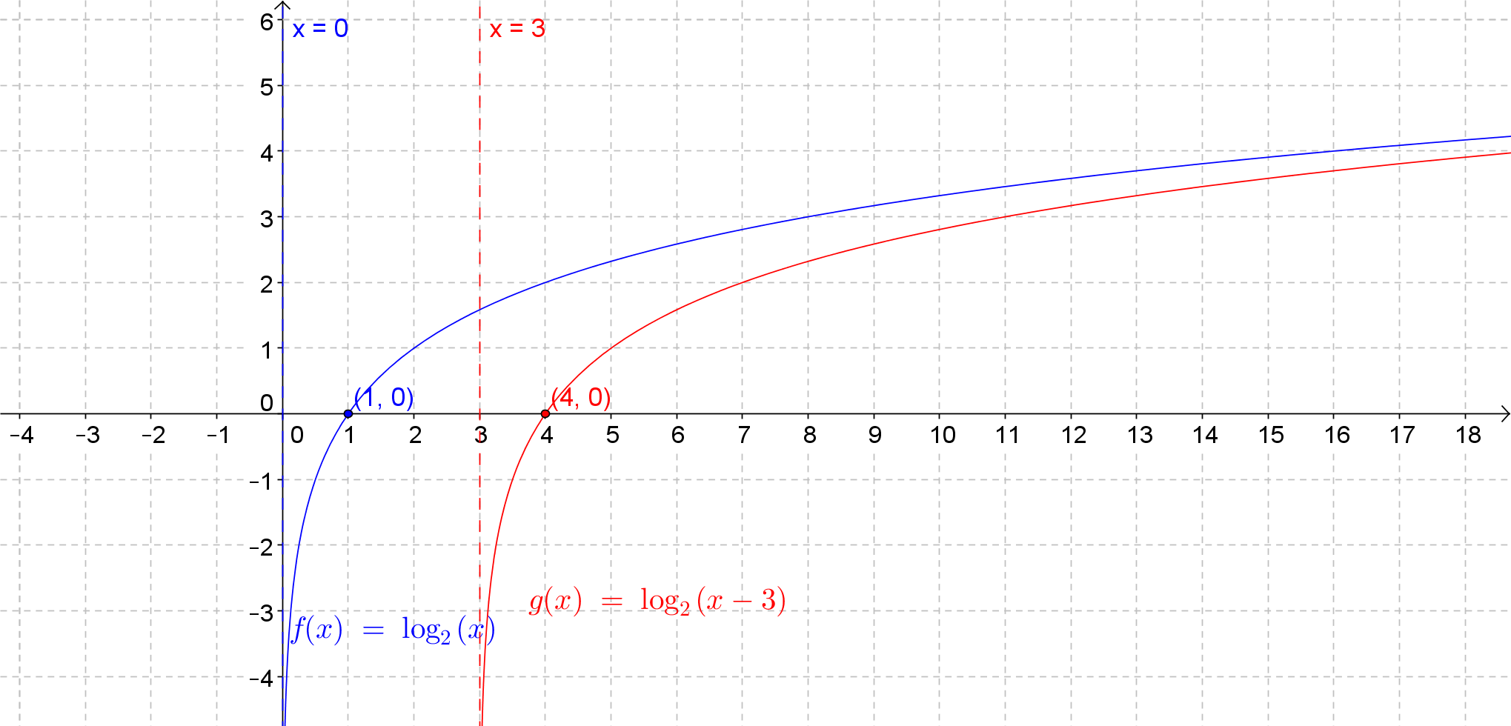

***The graph of is the graph of translated vertically up units. The graph is increasing on . The -intercept is . The vertical asymptote is . The point is included to illustrate the vertical translation.***

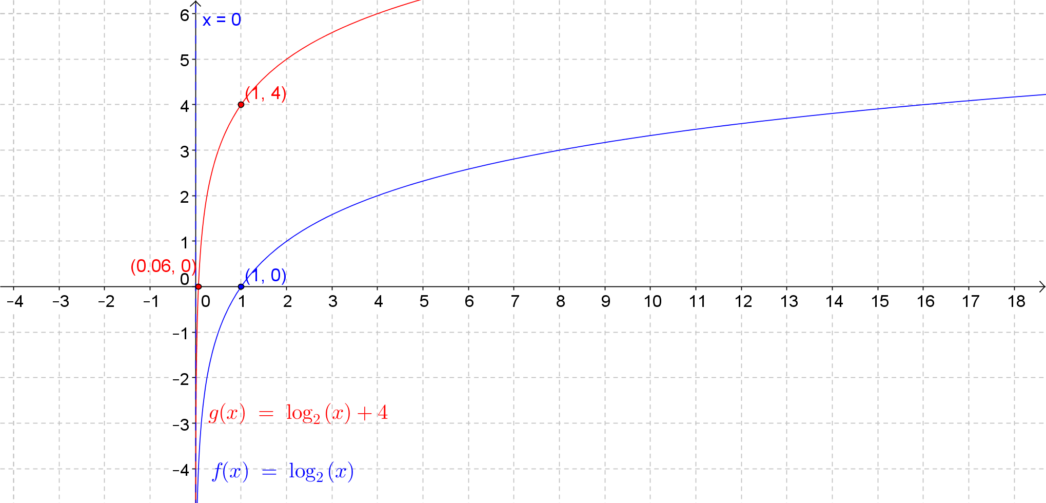

***The graph of is the graph of reflected about the horizontal axis and translated vertically up units. The graph is decreasing on . The -intercept is . The vertical asymptote is . The reflected graph and the final graph are both shown in the solution. The point is included to show the vertical translation.***

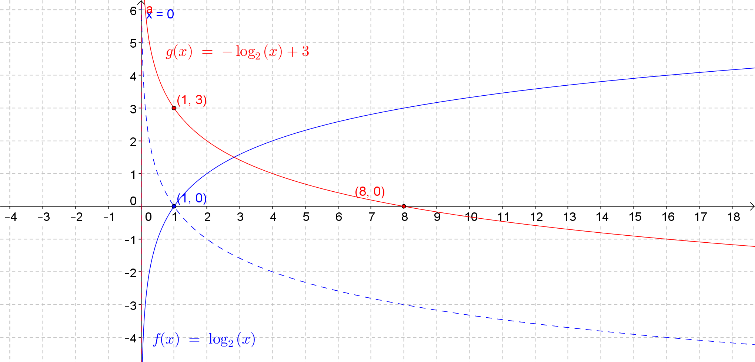

***The graph of is the graph of stretched vertically by a factor of and translated horizontally units to the right. The graph is increasing on . The -intercept is and the vertical asymptote is   
. The points and are labeled to help illustrate the transformations.***

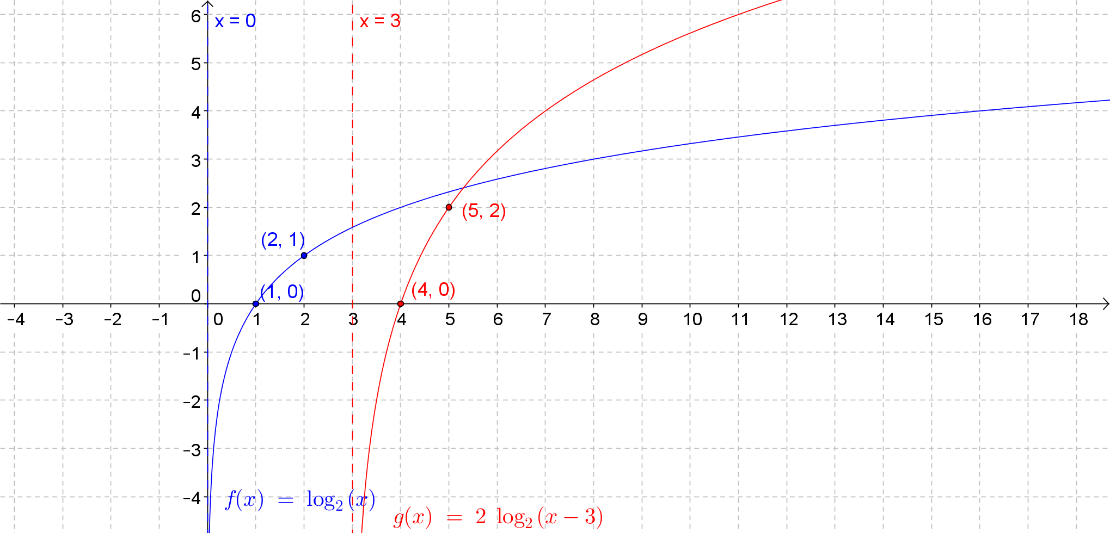

1. Each function graphed below can be expressed as a transformation of the graph of . Write an algebraic function for and , and state the domain and range.

***for . The domain of is , and the range of is all real numbers.***

***for .******The domain of is , and the range of is all real numbers.***

**

Figure 1: Graphs of and the function



Figure 2: Graphs of and the function

1. Describe each function as a transformation of the graph of a function in the form . Sketch the graph of and the graph of by hand. Label key features such as intercepts, increasing or decreasing intervals, and the horizontal asymptote. (Estimate when needed from the graph.)

The graph of is the graph of scaled vertically by a factor of and translated vertically down unit. The equation of the horizontal asymptote is . The -intercept is and the -intercept is approximately . The graph of is increasing for all real numbers.

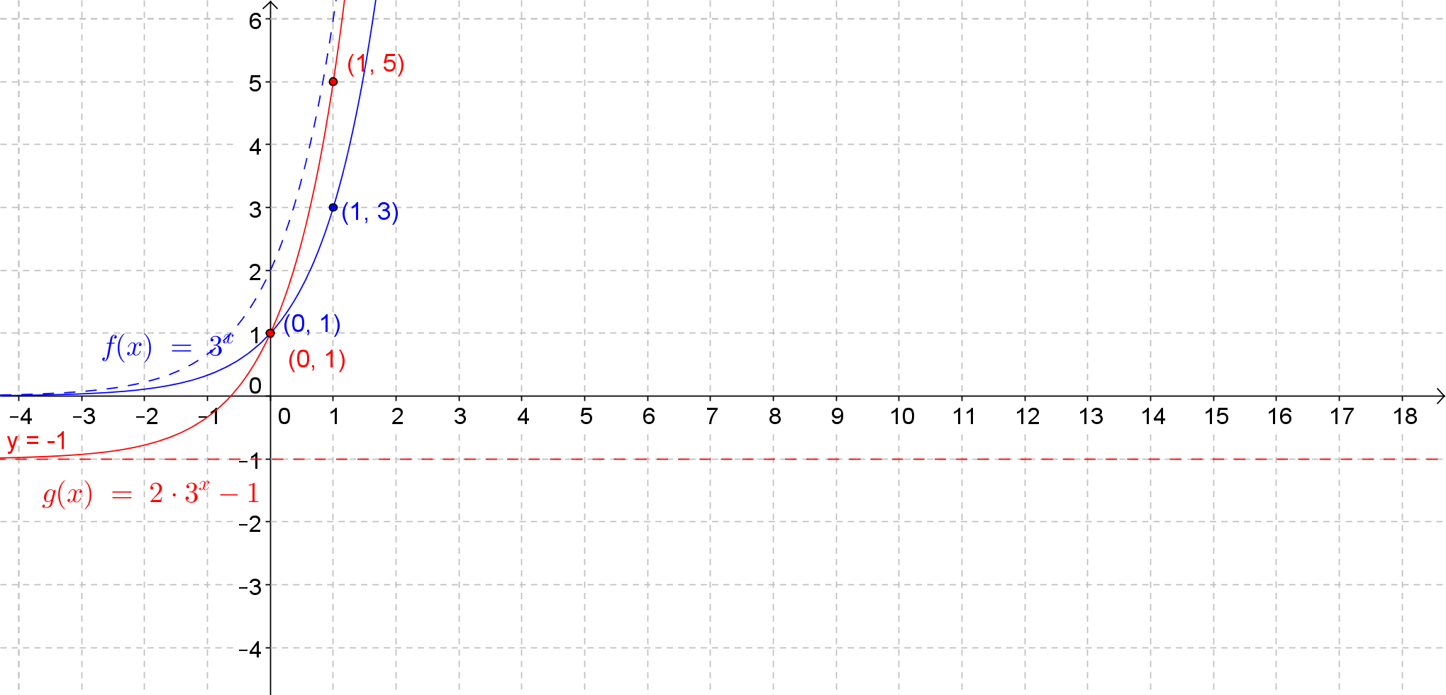

The graph of is the graph of translated vertically up units. The equation of the horizontal asymptote is . The -intercept is . There is no -intercept. The graph is increasing for all real numbers.

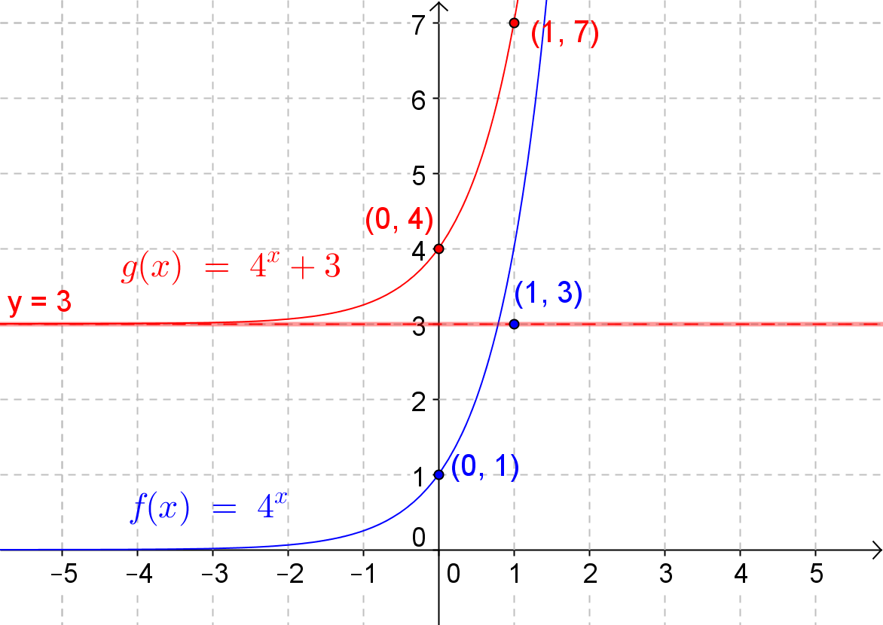

The graph of is the graph of translated horizontally units to the right OR the graph of scaled vertically by a factor of . The equation of the horizontal asymptote is . The -intercept is . There is no -intercept, and the graph is increasing for all real numbers.

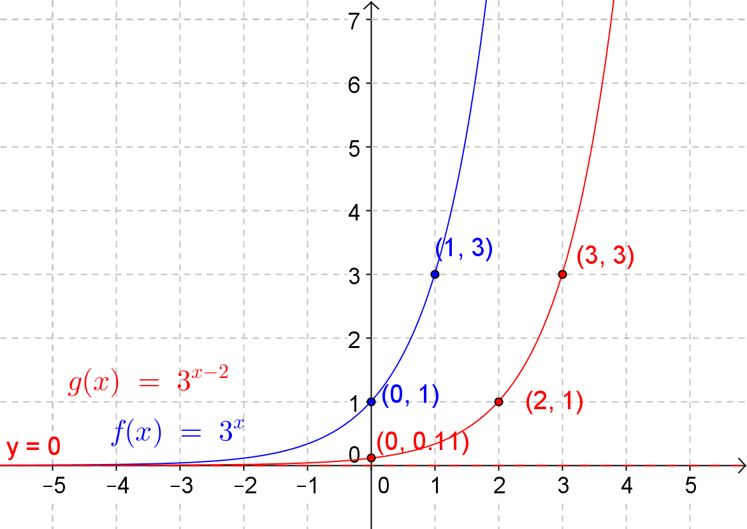

The graph of is the graph of reflected about the horizontal axis and then translated vertically up unit. The equation of the horizontal asymptote is . The -intercept is , and the -intercept is also . The graph of is decreasing for all real numbers.

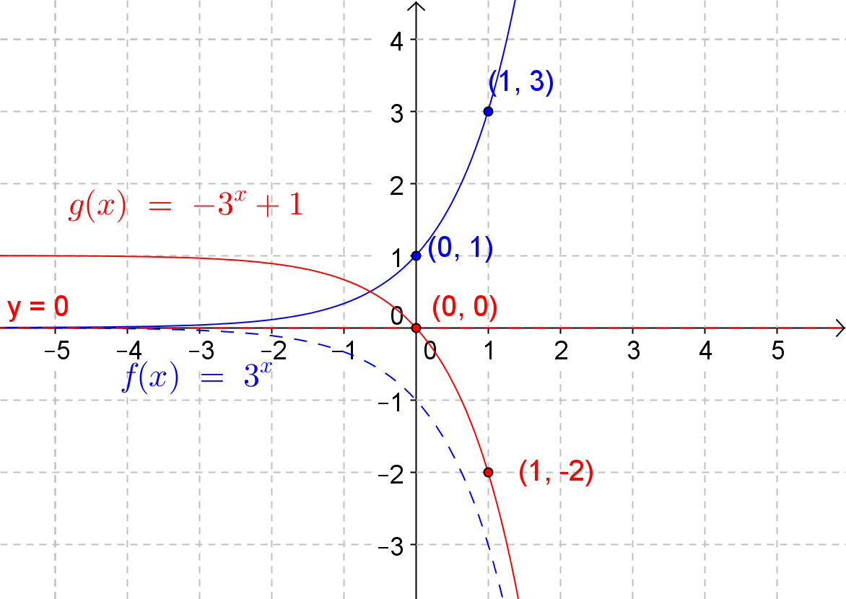

1. Using the function , create a new function whose graph is a series of transformations of the graph of with the following characteristics:

* The graph of is decreasing for all real numbers.
* The equation for the horizontal asymptote is .
* The -intercept is .

One possible solution is .

1. Using the function , create a new function whose graph is a series of transformations of the graph of with the following characteristics:

* The graph of is increasing for all real numbers.
* The equation for the horizontal asymptote is .
* The -intercept is .

One possible solution is .

1. Given the function :
   1. Write the function as an exponential function with base . Describe the transformations that would take the graph of to the graph of .

Thus, . The graph of is the graph of reflected about the vertical axis and scaled vertically by a factor of

* 1. Write the function as an exponential function with base . Describe two different series of transformations that would take the graph of to the graph of .

Thus, or . To obtain the graph of from the graph of , you can scale the graph horizontally by a factor of , reflect the graph about the vertical axis, and scale it vertically by a factor of . Or, you can scale the graph horizontally by a factor of , reflect the graph about the vertical axis, and translate the resulting graph horizontally units to the right.

1. Explore the graphs of functions in the form for . Explain how the graphs of these functions change as the values of increase. Use a property of logarithms to support your reasoning.

**MP.3**

***The graphs appear to be a vertical scaling of the common logarithm function by a factor of . This is true because of the property of logarithms that states .***

1. Use a graphical approach to solve each equation. If the equation has no solution, explain why.

***This equation has no solution because the graphs of and are horizontal translations of each other. Thus, their graphs do not intersect, and the corresponding equation has no solution.***

***This equation has no solution because , which means that the graphs of   
 and are a vertical translation of each other. Thus, their graphs do not intersect, and the corresponding equation has no solution.***

***The solution is the -coordinate of the intersection point of the graphs of and  
. Since the graph of the function defined by the right side of the equation is a reflection across the horizontal axis and a vertical translation of the graph of the function defined by the left side of the equation, the graphs of these functions will intersect in exactly one point.***

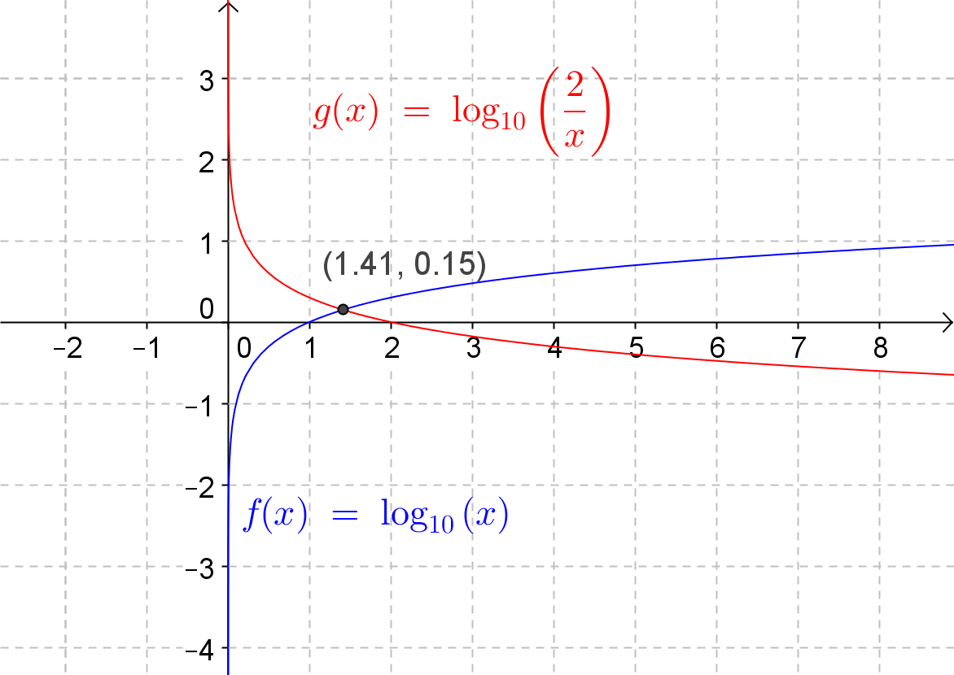

* 1. Show algebraically that the exact solution to the equation in part (c) is .

Since , the exact solution is .

1. Make a table of values for *for . Graph this function for . Use properties of logarithms to explain what you see in the graph and the table of values.*

The table indicates that the function is equal to for all values of greater than .

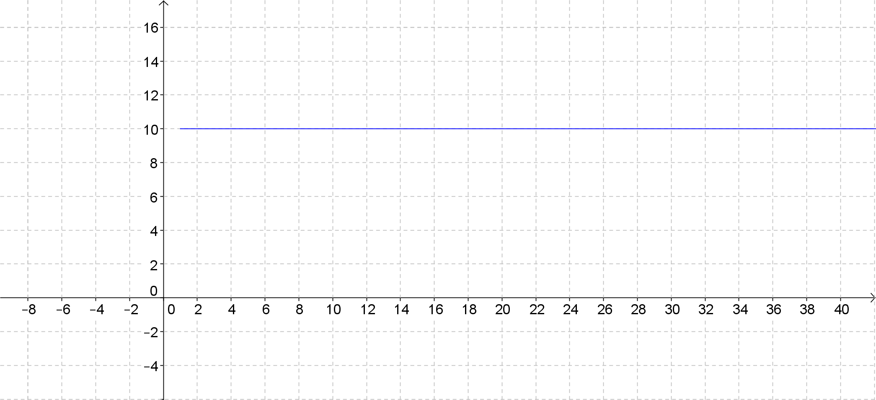

***The expression for all because. Therefore, when we substitute into the expression , we get , which is equal to according to the definition of a logarithm.***