Lesson 19: The Inverse Relationship Between Logarithmic and Exponential Functions

Student Outcomes
- Students will understand that the logarithm function base $b$ and the exponential function base $b$ are inverse functions.

Lesson Notes
In the previous lesson, students learned that if they reflected the graph of a logarithmic function across the diagonal line with equation $y=x$, then the reflection is the graph of the corresponding exponential function, and vice-versa. In this lesson, we formalize this graphical observation with the idea of inverse functions. Students have not yet been exposed to the idea of an inverse function, but it is natural for us to have that discussion in this module. In particular, this lesson attends to these standards:
F-BF.B.4a: Solve an equation of the form $f\left(x\right)=c$ for a simple function $f$ that has an inverse and write an expression for the inverse.
F-LE.A.4: For exponential models, express as a logarithm the solution to $ab^{ct}=d$ where $a$, $c$, and $d$ are numbers and the base $b$ is $2$, $10,$ or $e$; evaluate the logarithm using technology.
In order to clarify the procedure for finding an inverse function, we start with algebraic functions before returning to transcendental logarithms and exponential functions.
Note: You might want to consider splitting this lesson over two days.

Classwork
Opening Exercise (8 minutes)
Before talking about inverse functions, review the idea of inverse operations. At this point, students have had a lot of practice thinking of division as undoing multiplication (in other words, multiplying by $5$, and then dividing by $5$ gives back the original number) and thinking of subtraction as “undoing” addition.
You may also want to recall for your students the compositions of two transformations. For example, in geometry, the image of a counterclockwise rotation of a triangle $△ABC$ by $30°$ around a point $P$ is a new triangle congruent to the original. If we apply a $30°$ clockwise rotation to this new triangle around $P$ (rotation by $-30°$), the image is the original triangle again. That is, the rotation $R_{P,-30°}$ “undoes” the rotation $R_{P, 30°}$: $R_{P,-30°}\left(R_{P,30°}\left(△ABC\right)\right)=△ABC$.
In this lesson, we will study functions that “undo” other functions, that is, given a function $f$, sometimes there is another function, $g$, such that if an output value of $f$ is inputted into $g$, the output of $g$ gives back the original number inputted into $f$. Such a function $g$ is called the inverse of the function $f$, just as division is the of multiplication.

Opening Exercise
  - Consider the mapping diagram of the function $f$ below. Fill in the blanks of the mapping diagram of $g$ to construct a function that “undoes” each output value of $f$ by returning the original input value of $f$. (The first one is done for you.)
$$-2$$ $3$
$8$
$9$
$$15$$

$$4$$___
___
___
___

Domain Range
$$g$$
$$1 \\ 2 \\ 3 \\ 4 \\ 5$$

$$3 \\ 15 \\ 8 \\ -2 \\ 9$$

Domain Range
$$f$$

$1$,$3$,$5$,$2$

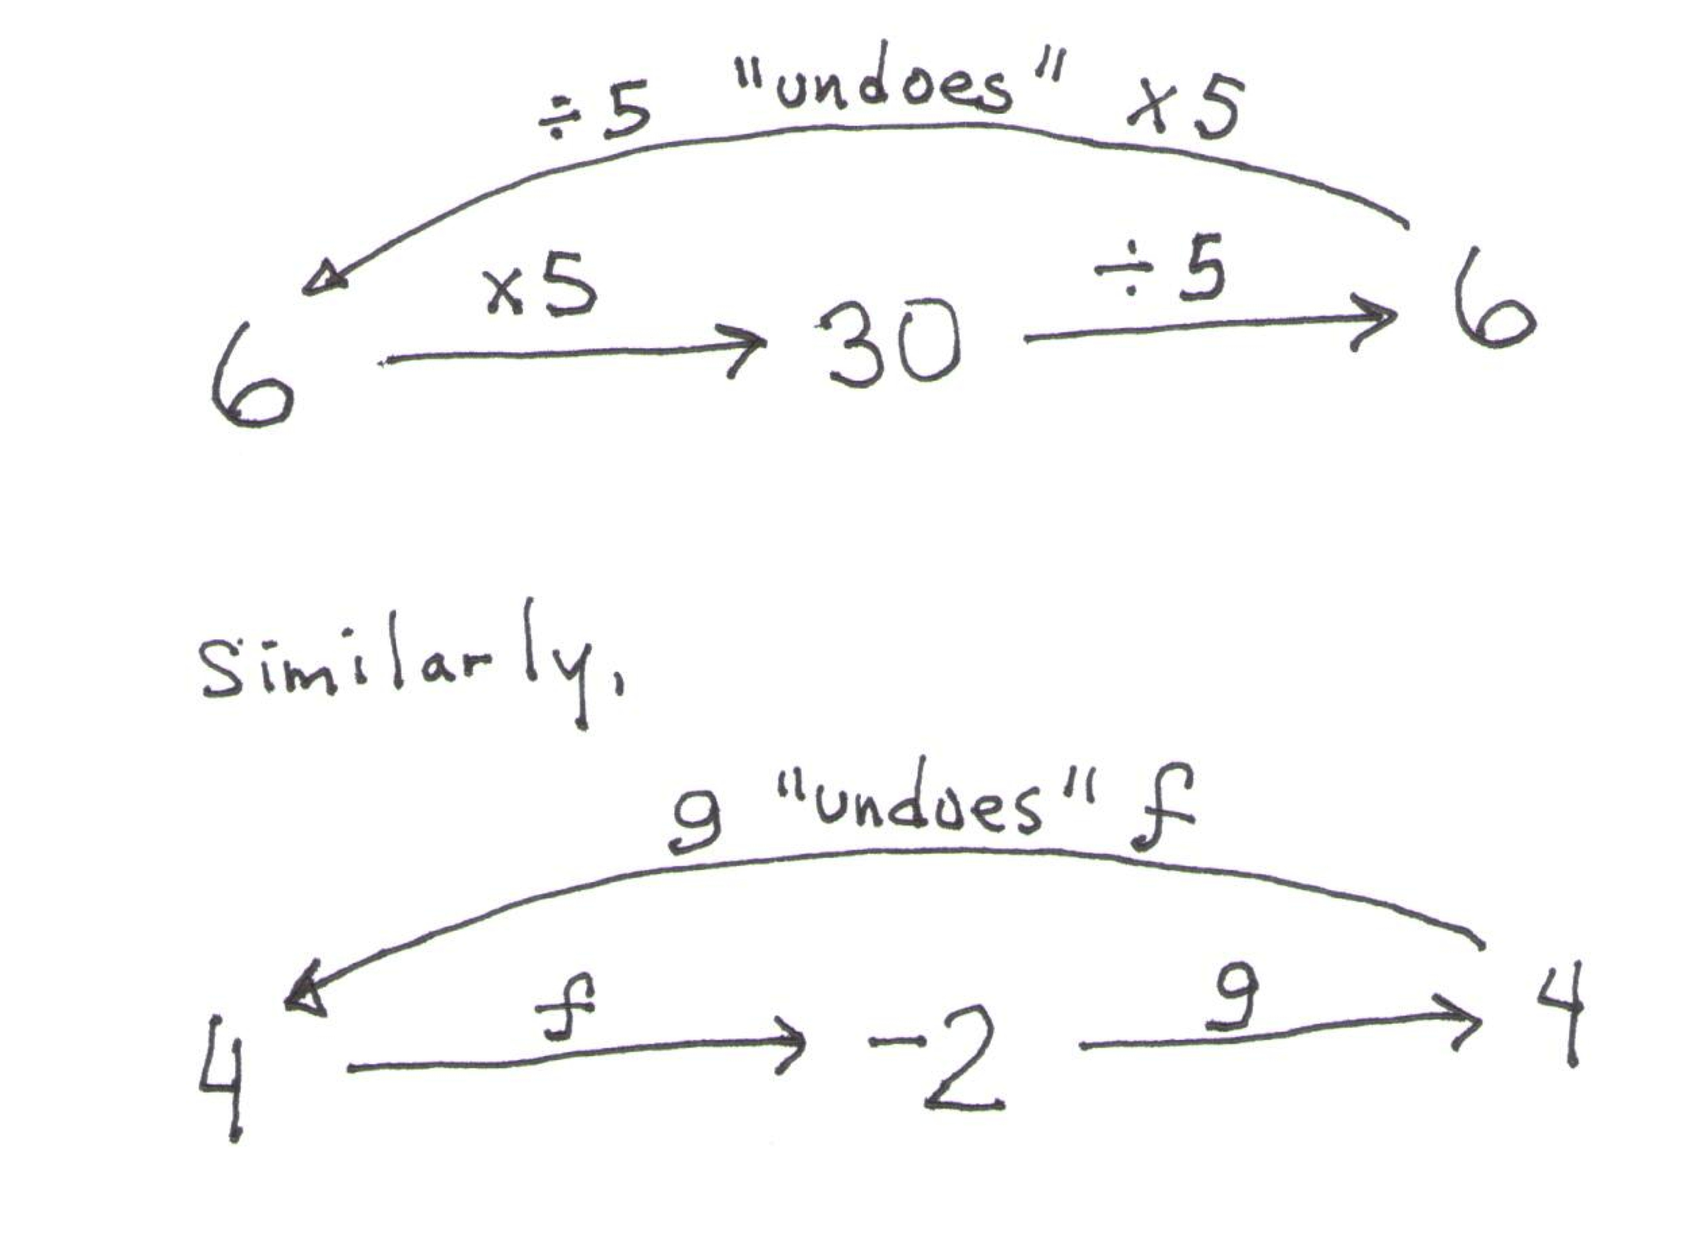

As you walk around the room, help struggling students by drawing the analogy of multiplication and division of what students are asked to do above.

  - Write the set of input-output pairs for the functions $f$ and $g$ by filling in the blanks below. (The set $F$ for the function $f$ has been done for you.)
$F=\left\{\left(1,3\right), \left(2,15\right), \left(3,8\right), \left(4,-2\right), \left(5,9\right)\right\}$
$$G=\{\left(-2,4\right), \left(3,1\right), \left(8,3\right), \left(9,5\right), \left(15, 2\right) \}$$

  - How can the points in the set $G$ be obtained from the points in $F$?
The points in $G$ can be obtained from the points in $F$ by switching the first entry (first coordinate) with the second entry (second coordinate), that is, if $(a,b)$ is a point of $F$, then $(b,a)$ is a point of $G$.

  - Peter studied the mapping diagrams of the functions $f$ and $g$ above and exclaimed, “I can get the mapping diagram for $g$ by simply taking the mapping diagram for $f$ and reversing all of the arrows!” Is he correct?
He is almost correct. It is true that he can reverse the arrows, but he would also need to switch the domain and range labels to reflect that the range of $f$ is the domain of $g$, and the domain of $f$ is the range of $g$.

We will explore Problems 1, 3 (as graphs), and 4 in more detail in the examples that follow.

Discussion (8 minutes)
You may need to point out to students the meaning of Let $y=f(x)$ in this context. Usually, the equation
$y=f(x)$ is an equation to be solved for solutions of the form $(x,y)$. However, when we state Let $y=f\left(x\right)$, we are using the equal symbol to assign the value $f(x)$ to $y$.
Complete this table either on the board or on an overhead projector.
- Consider the two functions $f\left(x\right)=3x$ and $g\left(x\right)=\frac{x}{3}$. What happens if we compose these two functions in sequence? Let’s make a table of values by letting $y$ be the value of $f$ when evaluated at $x$, then evaluating $g$ on the result.
$$x$$ | Let $y=f(x)$ | $$g\left(y\right)$$
$$-2$$ | $$-6$$ | $$-2$$
$$-1$$ | $$-3$$ | $$-1$$
$$0$$ | $$0$$ | $$0$$
$$1$$ | $$3$$ | $$1$$
$$2$$ | $$6$$ | $$2$$
$$3$$ | $$9$$ | $$3$$
- What happens when we evaluate the function $f$ on a value of $x$, then the function $g$ on the result?
  - We get back the original value of $x$.
- Now, let’s make a table of values by letting $y$ be the value of $g$ when evaluated at $x$, then evaluating $f$ on the result.
$$x$$ | Let $y=g(x)$ | $$f\left(y\right)$$
$$-2$$ | $$-\frac{2}{3}$$ | $$-2$$
$$-1$$ | $$-\frac{1}{3}$$ | $$-1$$
$$0$$ | $$0$$ | $$0$$
$$1$$ | $$\frac{1}{3}$$ | $$1$$
$$2$$ | $$\frac{2}{3}$$ | $$2$$
$$3$$ | $$1$$ | $$3$$
- What happens when we evaluate the function $g$ on a value of $x$, then the function $f$ on the result?
  - We get back the original value of $x$.
- Does this happen with any two functions? What is special about the functions $f$ and $g$?
The formula for the function $f$ multiplies its input by $3$, and the formula for $g$ divides its input by $3$. If we first evaluate $f$ on an input then evaluate $g$ on the result, we are multiplying by $3$ then dividing by $3$, which has a net effect of multiplying by $\frac{3}{3}=1$, so the result of the composition of $f$ followed by $g$ is the original input. Likewise, if we first evaluate $g$ on an input and then evaluate $f$on the result, we are dividing a number by $3$ then multiplying the result by $3$ so that the net effect is again multiplication by $\frac{3}{3}=1$, and the result of the composition is the original input.
This does not happen with two arbitrarily chosen functions. It is special when it does, and the functions have a special name:
- Functions $f\left(x\right)=3x$ and $g\left(x\right)=\frac{x}{3}$ are examples of inverse functions—functions that if you take the output of one function for a given input, and put the output into the other function, you get the original input back.
Inverse functions have a special relationship between their graphs. Let’s explore that now and tie it back to what we learned earlier.
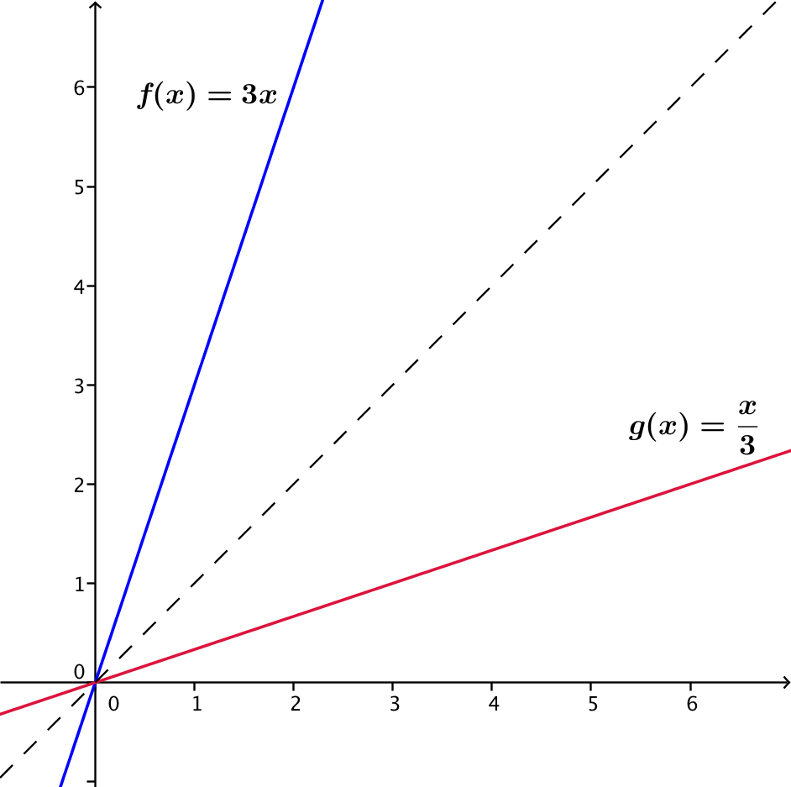
- Graph $f\left(x\right)=3x$ and $g\left(x\right)=\frac{x}{3}$. (Also, sketch in the graph of the diagonal line $y=x$.)

- What do we notice about these two graphs?
  - They are reflections of each other across the diagonal line given by $y=x$.
- What is the rule for the transformation that reflects the Cartesian plane across the line given by $y=x$?
  - $r_{y=x}\left(x,y\right)=(y,x)$.
- Where have we seen this switching of first and second coordinates before in this lesson? How is that situation similar to this one?
MP.7
  - In the Opening Exercise, to obtain the set $G$ from the set $F$, we took each ordered pair of $F$ and switched the first and second coordinates to get a point of $G$. Since plotting the points of $F$ and $G$ produce the graphs of those functions, we see that the graphs are reflections of each other across the diagonal given by $y=x$, that is, $r_{y=x}\left(F\right)=G$.
Similarly, for $f\left(x\right)=3x$ and $g\left(x\right)=\frac{x}{3}$, we get
$r_{y=x}\left(\text{Graph of} f\right)=\text{Graph of} g$.
Finally, let’s tie what we learned about graphs of inverse functions to what we learned in the previous lesson.
- What other two functions have we seen whose graphs are reflections of each other across the diagonal line?
  - The graph of a logarithm and an exponential function with the same base $b$ are reflections of each other across the diagonal line.
- Make a conjecture about logarithm and exponential functions.
  - A logarithm and an exponential function with the same base are inverses of each other.
- Can we verify that using the properties of logarithms and exponents? What happens if we compose the functions by evaluating them one right after another? Let $f\left(x\right)=\log\left(x\right)$ and $g\left(x\right)={10}^{x}$. What do we know about the result of evaluating $f$ for a number $x$ and then evaluating $g$ on the resulting output? What about evaluating $g$ and then $f$?
Scaffolding:
Remind students of the identities:
3. $\log_{b}\left(b^{x}\right)=x$,
4. $b^{\log_{b}{(x)}}=x$.
It may also be helpful to include an example next to each property, such as
$\log_{3}\left(3^{x}\right)=x$ and ${10}^{\log{(5)}}=5$.
  - Let $y=f(x)$. Then $y=log(x)$, so $g\left(y\right)={10}^{y}={10}^{\log\left(x\right)}$. By logarithmic property 4, ${10}^{\log\left(x\right)}=x$, so evaluating $f$ at $x$, and then $g$ on the results gives us the original input $x$ back.
  - Let $y=g(x).$ Then $y={10}^{x}$, so $f\left(y\right)=log({10}^{x})$. By logarithmic property 3, $\log\left({10}^{x}\right)=x$, so evaluating $g$ at $x$, and then $f$on the results gives us the original input $x$ back.
- So, yes, a logarithm function and its corresponding exponential function are inverse functions.

Discussion (8 minutes)
What if we have the formula of a function $f$, and we want to know the formula for its inverse function $g$? At this point, all we know is that if we have the graph of $f$ and reflect it across the diagonal line we get the graph of its inverse $g$. We can use this fact to derive the formula for the inverse function $g$ from the formula of $f$.
Above, we saw that
$r_{x=y}\left(Graph of f\right)=Graph of g$.
Let’s write out what those sets look like. For $f\left(x\right)=3x$, the graph of $f$ is the same as the graph of the equation $y=f(x)$, that is, $y=3x$:
$Graph of f=\left\{\left(x,y\right) \right| y=3x \}$.
For $g\left(x\right)=\frac{x}{3}$, the graph of $g$ is the same as the graph of the equation $y=\frac{x}{3}$, which is the same as the graph of the equation $x=3y$ (Why are they same?):
$Graph of g=\left\{\left(x,y\right) \right| x=3y\}$.
Thus, the reflection across the diagonal line of the graph of $f$ can be written as follows:
$\left\{\left(x,y\right) | y=3x\right\} \underset{→}{ r_{x=y} } \left\{\left(x,y\right) | x=3y\right\}$.
- What relationship do you see between the set $\left\{\left(x,y\right) | y=3x\right\}$ and the set $\left\{\left(x,y\right) | x=3y\right\}$? How does this relate to the reflection map $r_{x=y}\left(x,y\right)=(y,x)$?
MP.7
  - To get the second set, we interchange $x$ and $y$ in the equation that defines the first set. This is exactly what the reflection map is telling us to do.
- Let’s double-check your answer with $f\left(x\right)=\log{(x)}$ and its inverse $g\left(x\right)={10}^{x}$. Focusing on $g$, we see that the graph of $g$ is the same as the graph of the equation $y={10}^{x}$. We can rewrite the equation $y={10}^{x}$ using logarithms as $x=\log{(y)}$. (Why are they the same?) Thus, the reflection across the diagonal line of the graph of $f$ can be written as follows:
$\left\{\left(x,y\right) | y=log⁡(x)\right\} \underset{→}{ r_{x=y} } \left\{\left(x,y\right) | x=log⁡(y)\right\}$.
This pair of sets also has the same relationship.
- How can we use that relationship to obtain the equation for the graph of $g$ from the graph of $f$?
Scaffolding:
Use $f\left(x\right)=3x$ to help students discover the steps: $f\left(x\right)=3x→$ $y=3x$ $→x=3y→\frac{x}{3}=y→y=\frac{x}{3}$ $→g\left(x\right)=\frac{x}{3}$.
MP.7
  - Write the equation $y=f(x)$, and then interchange the symbols to get $x=f(y)$.
- How can we use the equation $x=f(y)$ to find the formula for the function $g$?
  - Solve the equation for $y$ to write $y$ as an expression in $x$. The formula for $g$ is the expression in $x$.
- In general, to find the formula for an inverse function $g$ of a given function $f$:
    - Write $y=f(x)$ using the formula for $f$.
    - Interchange the symbols $x$ and $y$ to get $x=f(y)$.
    - Solve the equation for $y$ to write $y$ as an expression in $x$.
    - Then, the formula for $g$ is the expression in $x$ found in step (iii).

Exercises 1–7 (8 minutes)
Give students a couple of minutes to use the procedure above on Exercise 1 (in groups of two). They will likely stumble, but that is okay; we want them to think through the procedure on their own and generate questions that they can ask (their partner or you). After giving students a couple of minutes, work through Exercise 1 as a whole class and move on to a selection of the remaining problems.
Scaffolding:
For Exercises 1–5, it may be useful to ask: What axes setting is required on a calculator to check whether the graphs of the two functions are reflections of each other? (The $x$-axis and $y$-axis must have the same scale.)
Exercises
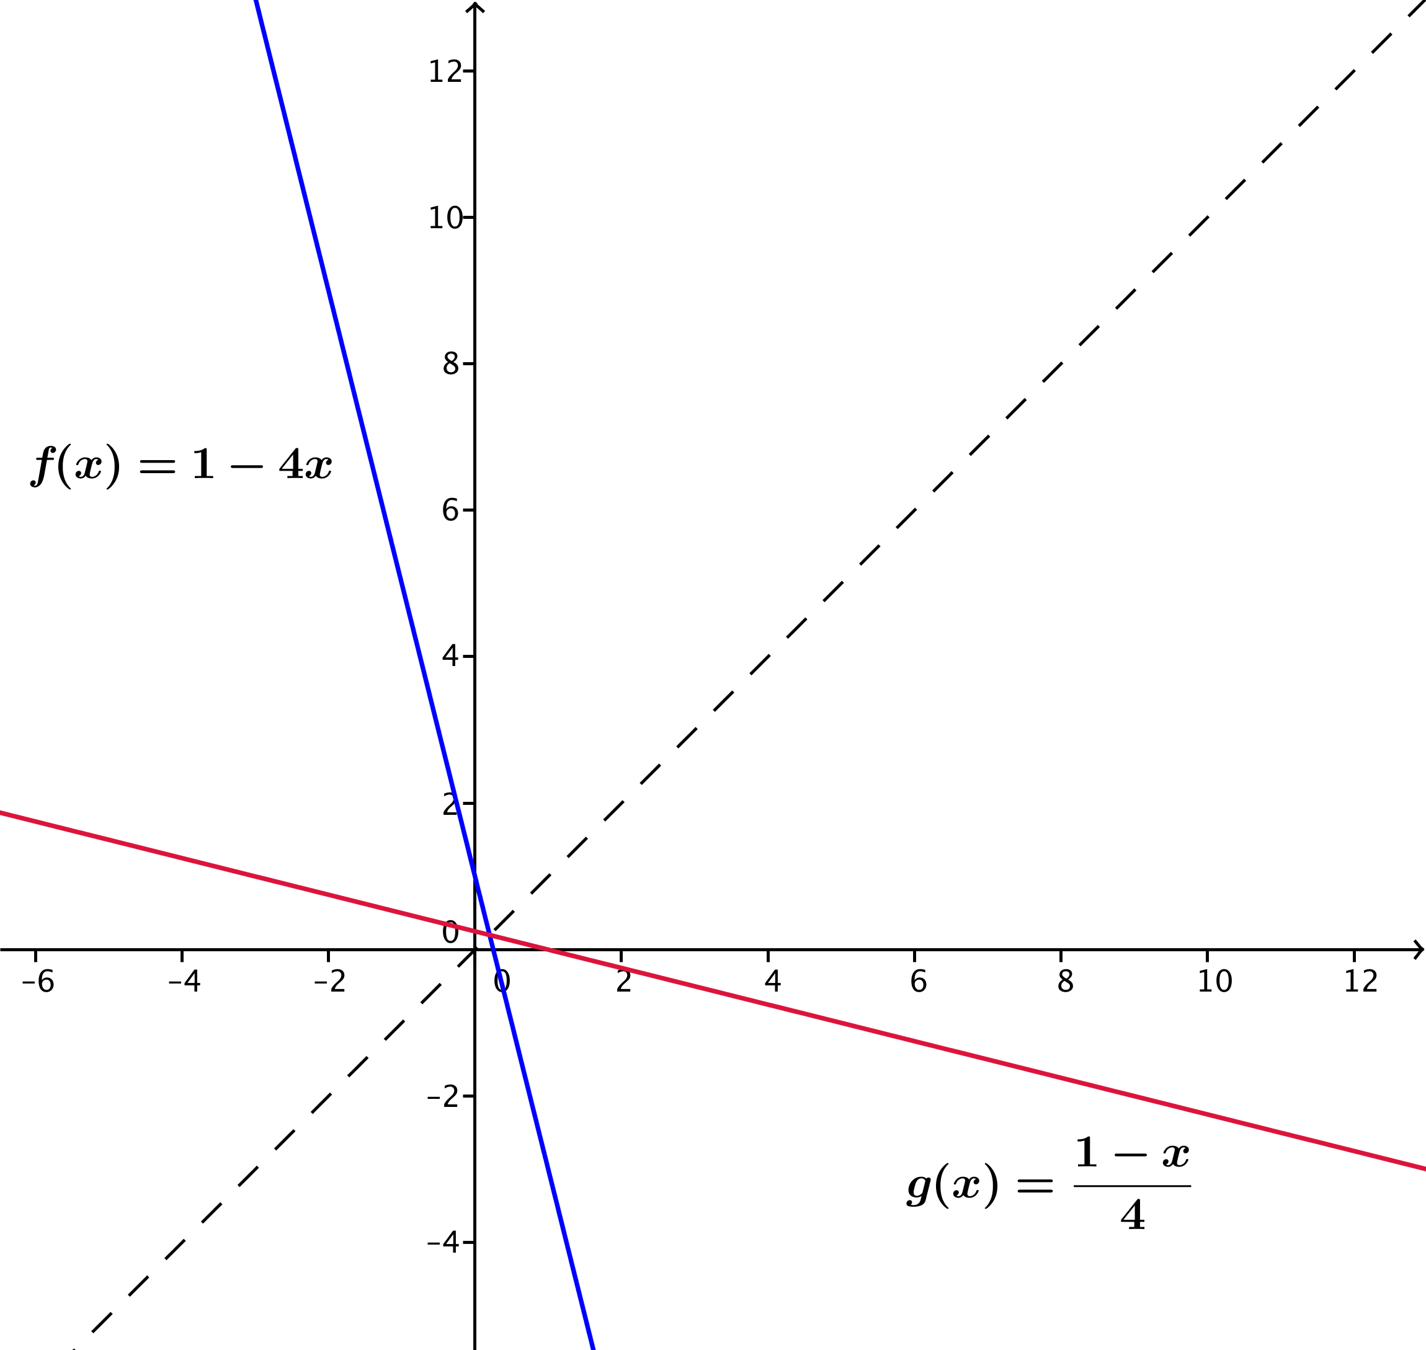
For each function $f$ in Exercises 1–5, find the formula for the corresponding inverse function $g$. Graph both functions on a calculator to check your work.
- $f\left(x\right)=1-4x$
$$y=1-4x \\ x=1-4y \\ 4y=1-x \\ y=\frac{\left(1-x\right)}{4} \\ g\left(x\right)=\frac{\left(1-x\right)}{4}$$

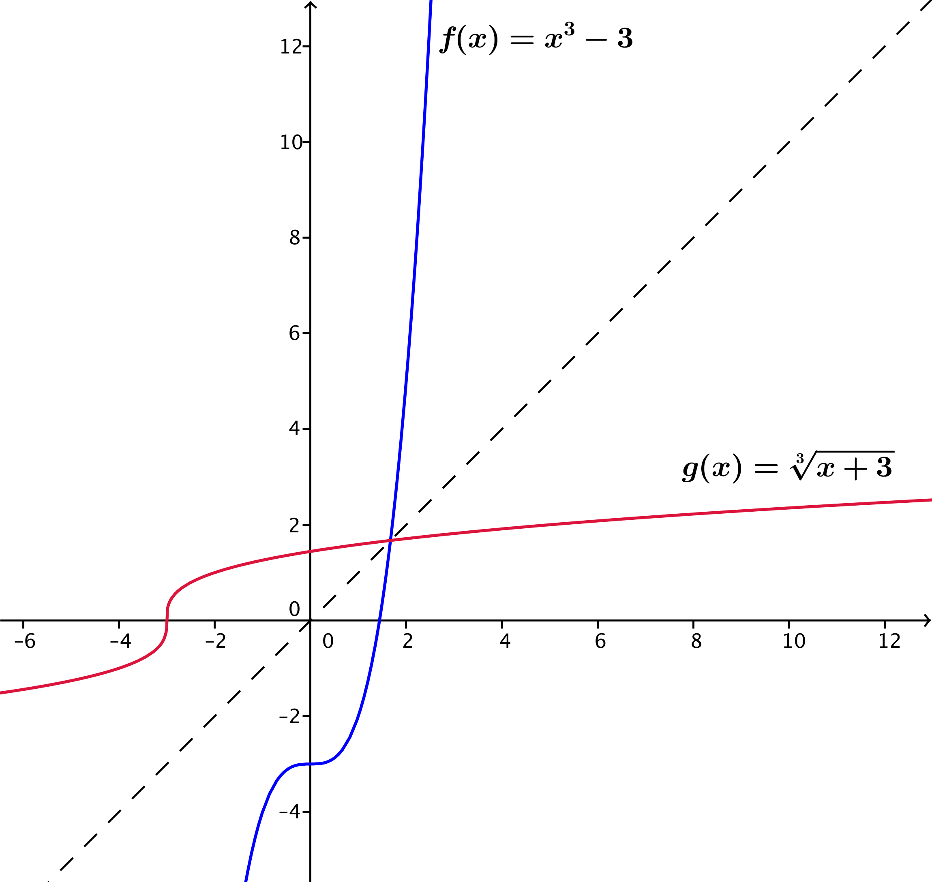
- $f\left(x\right)=x^{3}-3$
$$y=x^{3}-3 \\ x=y^{3}-3 \\ y^{3}=x+3 \\ y=\sqrt[3]{x+3} \\ g\left(x\right)=\sqrt[3]{x+3}$$

For Exercise 2, you may need to mention that, unlike principal square roots, there are real principal cube roots for negative numbers. This leads to the following identities that hold for all real numbers:
$\sqrt[3]{x^{3}}=x$ and ${\left(\sqrt[3]{x}\right)}^{3}=x$ for any real number $x$. These problems are practiced further in the Problem Set.

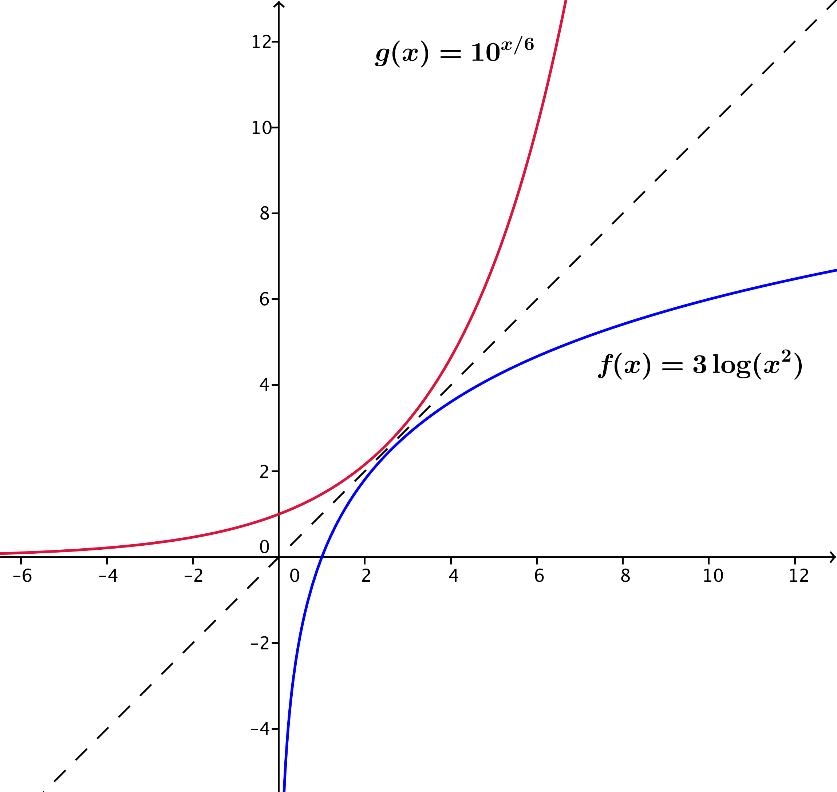
- $f\left(x\right)=3 log\left(x^{2}\right)$ for $x>0$
$$y=3 log\left(x^{2}\right) \\ x=3 log\left(y^{2}\right) \\ x=3∙2 log\left(y\right) \\ log\left(y\right)=\frac{x}{6} \\ y=10^{\frac{x}{6}} \\ g\left(x\right)=10^{\frac{x}{6}}$$

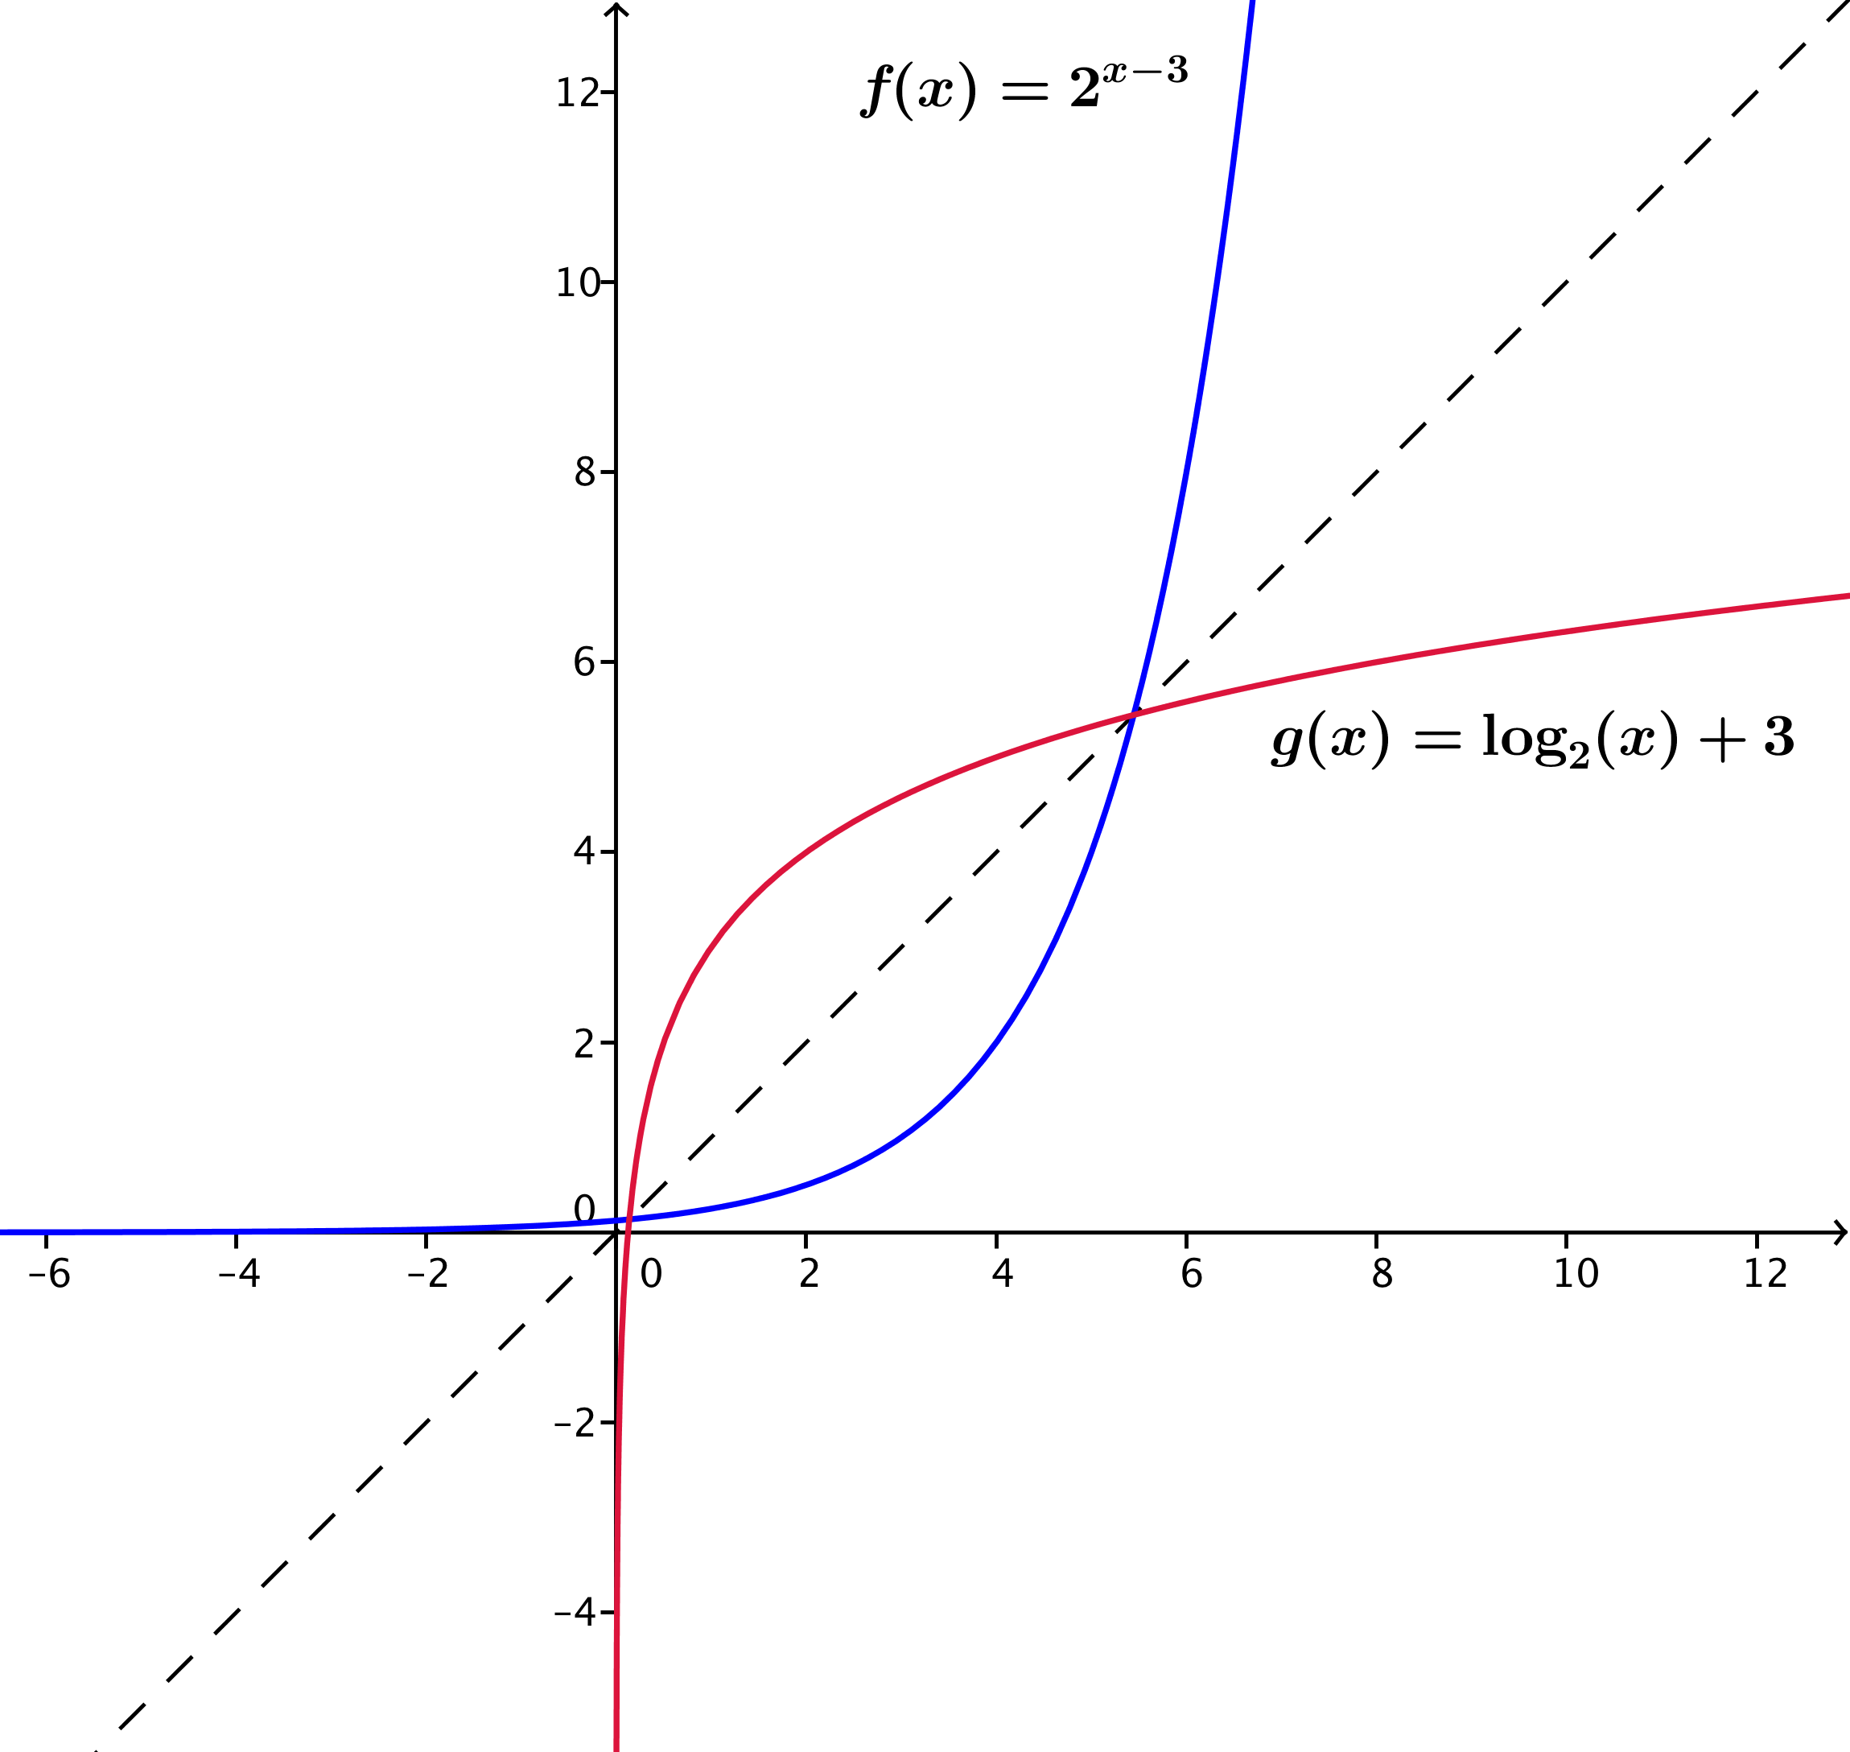
- $f\left(x\right)=2^{x-3}$
$$y=2^{x-3} \\ x=2^{y-3} \\ log_{2}\left(x\right)=y-3 \\ y=log_{2}\left(x\right)+3 \\ g\left(x\right)=log_{2}\left(x\right)+3$$

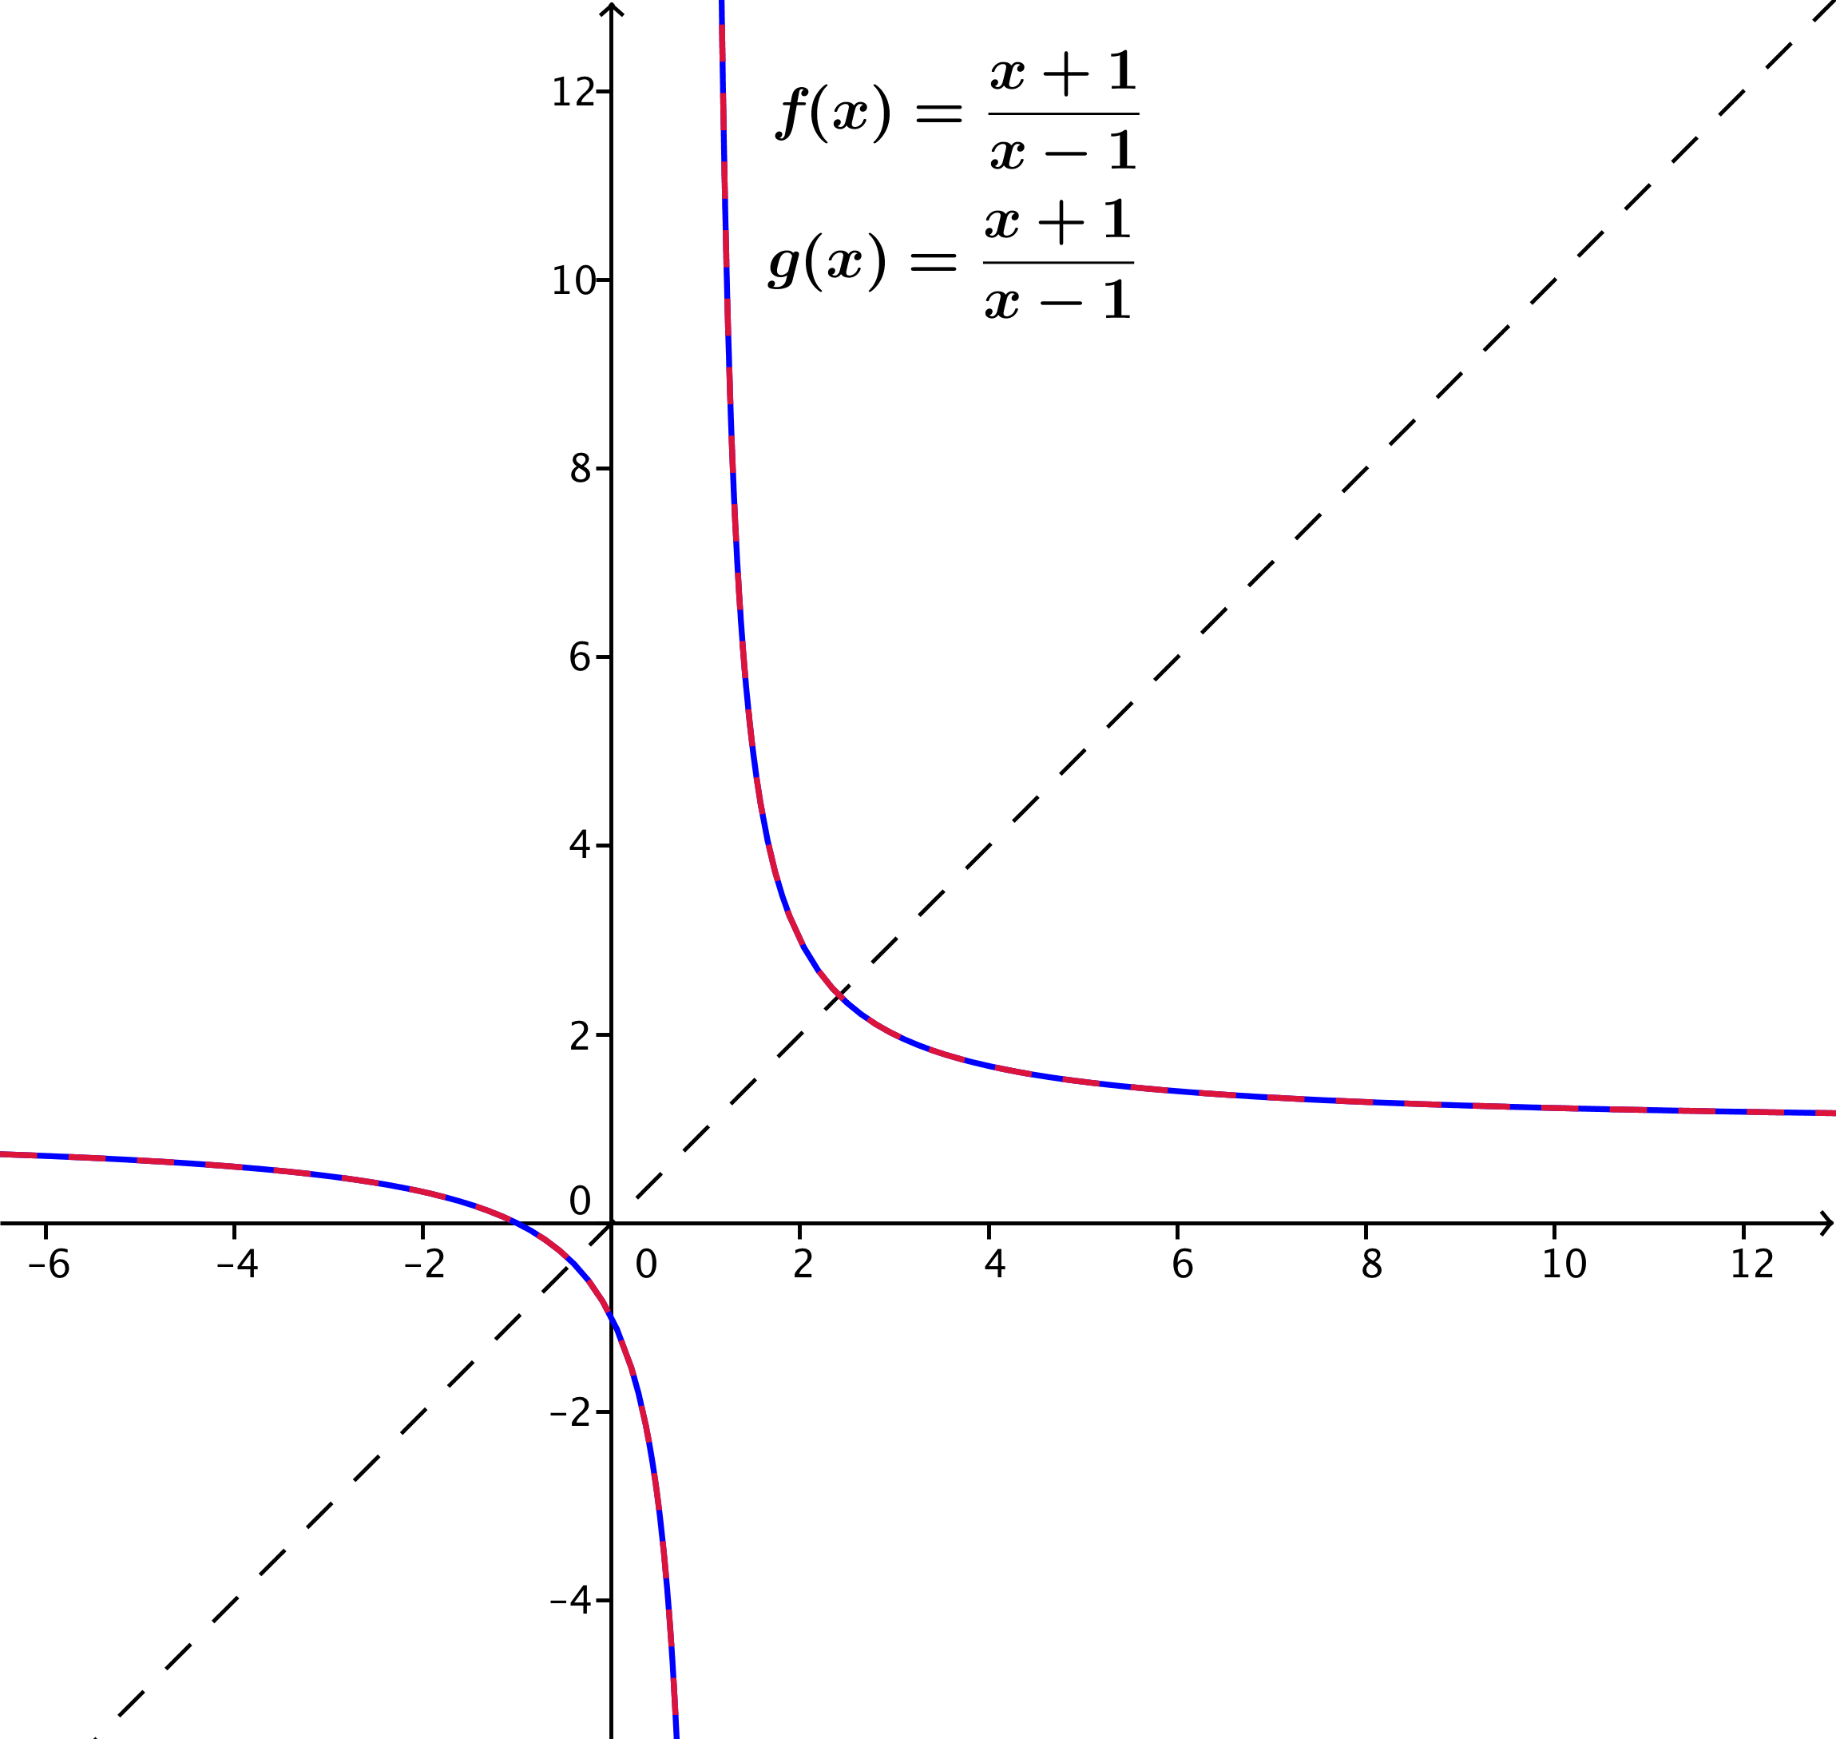
- $f\left(x\right)=\frac{x+1}{x-1}$ for $x≠1$
$$y=\frac{x+1}{x-1} \\ x=\frac{y+1}{y-1} \\ x\left(y-1\right)=y+1 \\ xy-x=y+1 \\ xy-y=x+1 \\ y\left(x-1\right)=x+1 \\ y=\frac{x+1}{x-1} \\ g(x)=\frac{x+1}{x-1}\text{ for} x≠1$$

Exercise 5 is quite interesting. You might have students note that the functions $f$ and $g$ are the same. What do students notice about the graph of $f$? (This issue is further explored in the Problem Set.)

- Cindy thinks that the inverse of $f\left(x\right)=x-2$ is $g\left(x\right)= 2-x$. To justify her answer, she calculates $f\left(2\right)=0$ and then substitutes the output $0$ into $g$ to get $g\left(0\right)=2$, which gives back the original input. Show that Cindy is incorrect by using other examples from the domain and range of $f$.
Answers will vary, but any other point other than$2$ will work. For example, $f\left(3\right)=1$, but $g\left(1\right)=1$, not $3$ as needed.

- After finding the inverse for several functions, Henry claims that every function must have an inverse. Rihanna says that his statement is not true and came up with the following example: If $f\left(x\right)=|x|$ has an inverse, then because $f\left(3\right)$ and $f(-3)$ both have the same output $3$, the inverse function $g$ would have to map $3$ to both $3$ and $-3$ simultaneously, which violates the definition of a function. What is another example of a function without an inverse?
Answers will vary. For example, $f\left(x\right)=x^{2}$ or any even degree polynomial function.

You might consider showing students graphs of functions without inverses and what the graphs look like after reflecting them along the diagonal line (where it becomes obvious that the reflected figure cannot be a graph of a function).

Example (5 minutes)
Scaffolding:
For students who are struggling, use concrete examples from the Opening Exercise or from the exercises they just did. For example, “If $f\left(x\right)=2^{x-3}$, what is an example of a number that is in the domain? The range?”
Now we need to address the question of how the domain and range of the function $f$ and its inverse function $g$ relate. You may need to review domain and range of a function with your students first.
- In all exercises we did above, what numbers were in the domain of $g$? Why?
  - The domain of $g$ contains the same numbers that were in the range of $f$. This is because as the inverse of $f$, the function $g$ takes the output of $f$ (the range) as its input.

- What numbers were in the range of $g$? Why?
  - The range of $g$ contains the same numbers that were in the domain of $f$. When the function $g$ is evaluated on an output value of $f$, its output is the original input of $f$ (the domain of $f$).
Example
Consider the function $f\left(x\right)=2^{x}+1$, whose graph is shown at right.
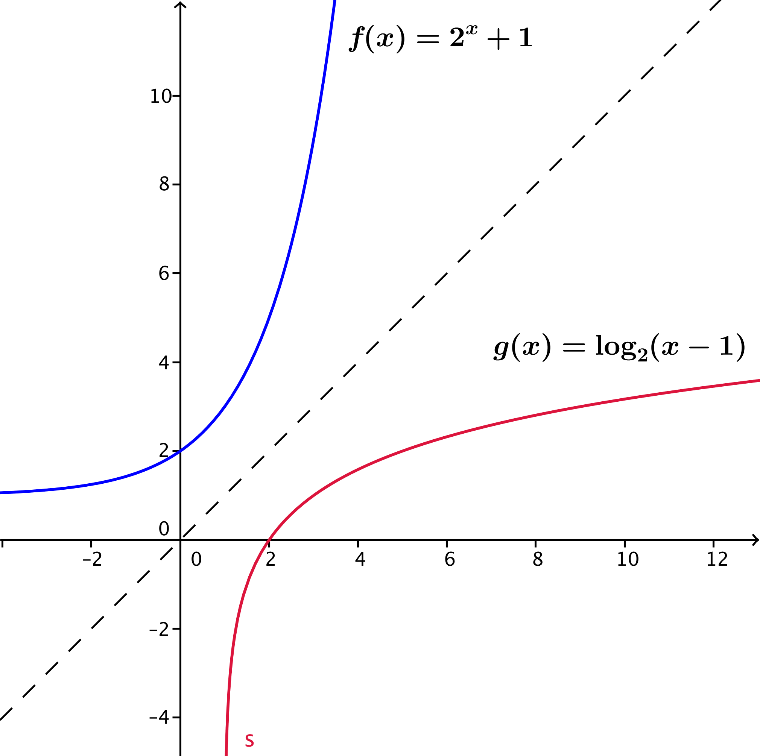
  - What are the domain and range of $f$?
Since the function $h\left(x\right)=2^{x}$ has domain all real numbers and range $(0,∞)$, we know that the translated function
$f\left(x\right)=2^{x}+1$ has domain all real numbers and range $\left(1,∞\right)$.

  - Sketch the graph of the inverse function $g$ on the graph. What type of function do you expect $g$ to be?
Since logarithm and exponential functions are inverses of each other, $g$ should be some form of a logarithmic function (shown in red).

  - What are the domain and range of $g$? How does that relate to your answer in part (a)?
The range of $g$ is all real numbers, and the domain of $g$ is $(1,∞)$, which makes sense since the range of $g$ is the domain of $f$, and the domain of $g$ is the range of $f$.

  - Find the formula for $g$.
$$y=2^{x}+1 \\ x=2^{y}+1 \\ 2^{y}=x-1 \\ y=log_{2}\left(x-1\right) \\ g\left(x\right)=log_{2}\left(x-1\right)\text{, for} x>1$$

Closing (3 minutes)
Ask students to summarize the important points of the lesson either in writing, orally with a partner, or as a class. Use this as an opportunity to informally assess understanding of the lesson. In particular, ask students to articulate the process for both graphing and finding the formula for the inverse of a given function. Some important summary elements are contained in the box below.
Exit Ticket (5 minutes)
Lesson Summary
- Invertible Function: Let $f$ be a function whose domain is the set $X$ and whose image is the set $Y$. Then $f$ is invertible if there exists a function $g$ with domain $Y$ and image $X$ such that $f$ and $g$ satisfy the property:
For all $x$ in $X$ and $y$ in $Y$, $f(x) = y$ if and only if $g(y)=x$.
The function $g$ is called the inverse of $f$.
- If two functions whose domain and range are a subset of the real numbers are inverses, then their graphs are reflections of each other across the diagonal line given by $y=x$in the Cartesian plane.
- If $f$ and $g$ are inverses of each other, then
  - The domain of $f$ is the same set as the range of $g$.
  - The range of $f$ is the same set as the domain of $g$.
- In general, to find the formula for an inverse function $g$ of a given function $f$:
  - Write $y=f(x)$ using the formula for $f$.
  - Interchange the symbols $x$ and $y$ to get $x=f(y)$.
  - Solve the equation for $y$ to write $y$ as an expression in $x$.
  - Then, the formula for $g$ is the expression in $x$ found in step (iii).
- The functions $f\left(x\right)=\log_{b}{(x)}$ and $g\left(x\right)=b^{x}$ are inverses of each other.

Name Date
Lesson 19: The Inverse Relationship Between Logarithmic and Exponential Functions

Exit Ticket

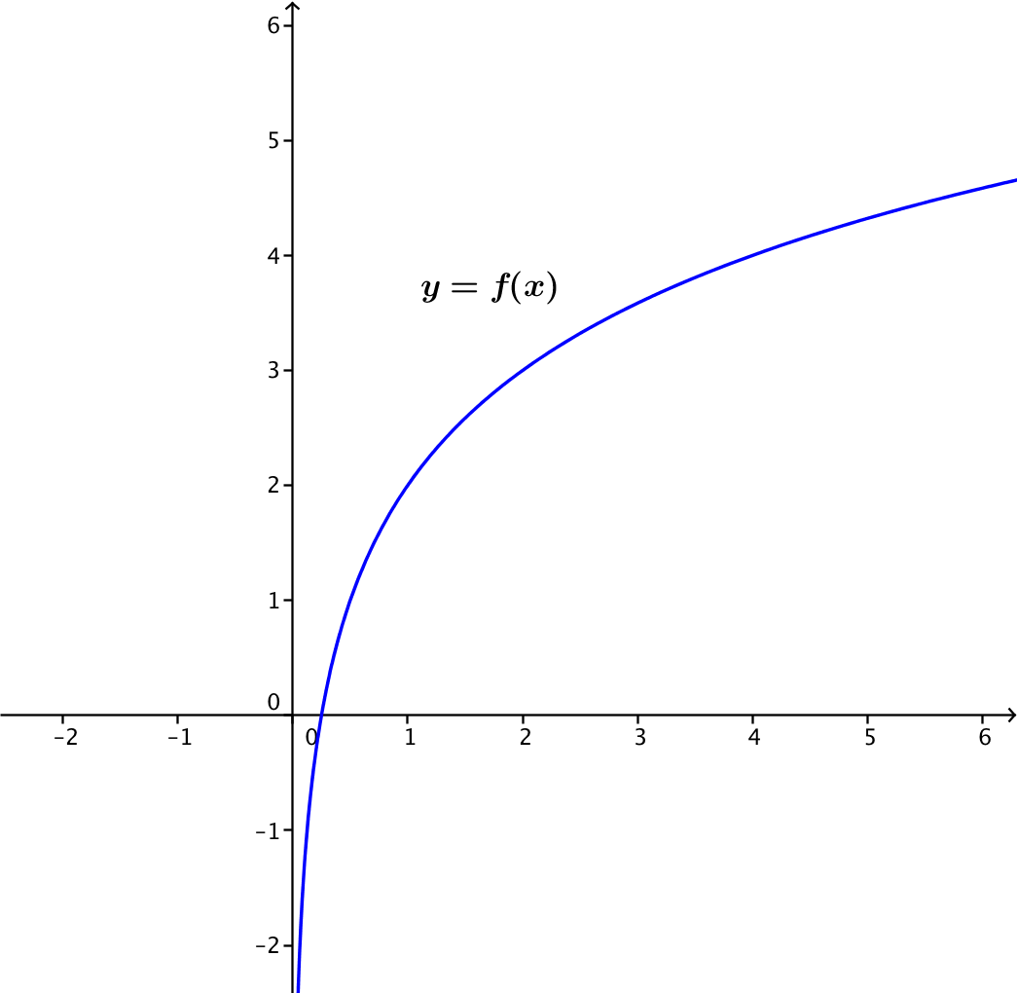
- The graph of a function $f$ is shown below. Sketch the graph of its inverse function $g$ on the same axes.

- Explain how you made your sketch.

- The function $f$ graphed above is the function $f\left(x\right)=\log_{2}\left(x\right)+2$ for $x>0$. Find a formula for the inverse of this function.

Exit Ticket Sample Solutions

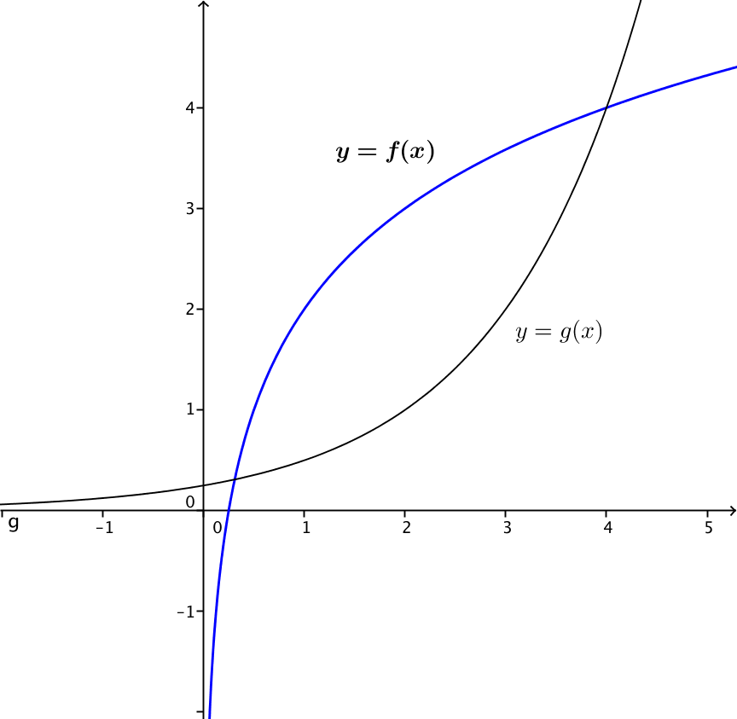
- The graph of a function $f$ is shown below. Sketch the graph of its inverse function $g$ on the same axes.

- Explain how you made your sketch.
Answers will vary. Example: I drew the line given by $y=x$ and reflected the graph of $f$ across it.

- The graph of the function $f$ above is the function $f\left(x\right)=\log_{2}\left(x\right)+2$ for $x>0$. Find a formula for the inverse of this function.
$$y=log_{2}\left(x\right)+2 \\ x=log_{2}\left(y\right)+2 \\ x-2=log_{2}(y) \\ log_{2}\left(y\right)=x-2 \\ y=2^{x-2} \\ g\left(x\right)=2^{x-2}$$

Problem Set Sample Solutions

- For each function $h$ below, find two functions $f$ and $g$ such that $h\left(x\right)=f\left(g\left(x\right)\right)$. (There are many correct answers.)
  - $h\left(x\right)={\left(3x+7\right)}^{2}$
Possible answer: $f\left(x\right)=x^{2}$,$g\left(x\right)=3x+7$

  - $h\left(x\right)=\sqrt[3]{x^{2}-8}$
Possible answer: $f\left(x\right)=\sqrt[3]{x}$,$g\left(x\right)=x^{2}-8$

  - $h\left(x\right)=\frac{1}{2x-3}$
Possible answer: $f\left(x\right)=\frac{1}{x}$ ,$g\left(x\right)=2x-3$
  - $h\left(x\right)=\frac{4}{{\left(2x-3\right)}^{3}}$
Possible answer: $f\left(x\right)=\frac{4}{x^{3}}$, $g\left(x\right)=2x-3$

  - $h\left(x\right)={\left(x+1\right)}^{2}+2\left(x+1\right)$
Possible answer: $f\left(x\right)=x^{2}+2x, g\left(x\right)=x+1$

  - $h\left(x\right)={\left(x+4\right)}^{\frac{4}{5}}$
Possible answer: $f\left(x\right)=x^{\frac{4}{5}}$, $g\left(x\right)=x+4$

  - $h\left(x\right)=\sqrt[3]{\log\left(x^{2}+1\right)}$
Possible answer: $f\left(x\right)=\sqrt[3]{log\left(x\right)}$, $g\left(x\right)=x^{2}+1$

  - $h\left(x\right)=\sin\left(x^{2}+2\right)$
Possible answer: $f\left(x\right)=\sin\left(x\right)$,$g\left(x\right)=x^{2}+2$

  - $h\left(x\right)=\ln\left(\sin\left(x\right)\right)$
Possible answer: $f\left(x\right)=ln\left(x\right)$, $g\left(x\right)=\sin\left(x\right)$

- Let $f$ be the function that assigns to each student in your class his or her biological mother.
  - Use the definition of function to explain why $f$ is a function.
The function has a well-defined domain (students in the class) and range (their mothers), and each student is assigned one and only one biological mother.

  - In order for $f$ to have an inverse, what condition must be true about the students in your class?
If a mother has several children in the same classroom, then there would be no way to define an inverse function that picks one and only one student for each mother. The condition that must be true is that there are no siblings in the class.

  - If we enlarged the domain to include all students in your school, would this larger domain function have an inverse?
Probably not. Most schools have several students who are siblings.

- The table below shows a partially filled-out set of input-output pairs for two functions $f$and $h$ that have the same finite domain of $\{0, 5, 10, 15, 20, 25, 30, 35, 40\}$.
$$x$$ | $$0$$ | $$5$$ | $$10$$ | $$15$$ | $$20$$ | $$25$$ | $$30$$ | $$35$$ | $$40$$
$$f(x)$$ | $$0$$ | $$0.3$$ | $$1.4$$ |  | $$2.1$$ |  | $$2.7$$ | $$6$$
$$h(x)$$ | $$0$$ | $$0.3$$ | $$1.4$$ |  | $$2.1$$ |  | $$2.7$$ | $$6$$
  - Complete the table so that $f$ is invertible but $h$ is definitely not invertible.
Answers will vary. For $f$, all output values should be different. For $g$, at least two output values for two different inputs should be the same number.
  - Graph both functions and use their graphs to explain why $f$ is invertible and $h$ is not.
Answers will vary. The graph of $f$ has one unique output for every input, so it is possible to undo $f$ and map each of its outputs to a unique input. The graph of $g$ has at least two input values that map to the same output value. Hence, there is no way to map that output value back to a unique multiple of $5$. Hence, $h$ cannot have an inverse function because such a correspondence is not a function.

- Find the inverse of each of the following functions. In each case, indicate the domain and range of both the original function and its inverse.
  - $f\left(x\right)=\frac{3x-7}{5}$
$$x=\frac{3y-7}{5} \\ 5x=3y-7 \\ \frac{5x+7}{3}=y$$
The inverse function is $g\left(x\right)=\frac{5x+7}{3}$. Both functions $f$ and $g$ have domain and range all real numbers.

  - $f\left(x\right)=\frac{5+x}{6-2x}$
$$x=\frac{5+y}{6-2y} \\ 6x-2yx=5+y \\ 6x-5 =2yx+y \\ 6x-5 =\left(2x+1\right)y \\ \frac{6x-5}{2x+1}=y$$
The inverse function is $g\left(x\right)=\frac{6x-5}{2x+1}$.
Domain of $f$ and range of $g$: all real numbers $x$ with $x≠ 3$
Range of $f$ and domain of $g$: all real numbers $x$ with $x≠-\frac{1}{2}$

  - $f\left(x\right)=e^{x-5}$
$$x=e^{y-5} \\ \ln{(x)}=y-5 \\ \ln\left(x\right)+5=y$$
The inverse function is $g\left(x\right)= \ln\left(x\right)+5$.
Domain of $f$ and range of $g$: all real numbers $x$
Range of $f$ and domain of $g$: all real numbers $x$ with $x>0$

  - $f\left(x\right)=2^{5-8x}$
$$x=2^{5-8y} \\ log_{2}\left(x\right)=5-8y \\ 8y=5-log_{2}\left(x\right) \\ y=\frac{1}{8}(5-log_{2}\left(x\right))$$The inverse function is $g\left(x\right)=\frac{1}{8}\left(5-log_{2}\left(x\right)\right)$.
Domain of $f$ and range of $g:$ all real numbers $x$
Range of $f$ and domain of $g$: all real numbers $x$ with $x>0$

  - $f\left(x\right)=7\log\left(1+9x\right)$
$$x=7\log{(1+9y)} \\ \frac{x}{7}=\log{(1+9y)} \\ {10}^{\frac{x}{7}}=1+9y \\ \frac{1}{9}(10^{\frac{x}{7}}-1)=y$$
The inverse function is $g\left(x\right)=\frac{1}{9}\left(10^{\frac{x}{7}}-1\right)$.
Domain of $f$ and range of $g$: all real numbers $x$ with $x>-\frac{1}{9}$
Range of $f$ and domain of $g$: all real numbers $x$

  - $f(x)=8+ \ln{(5+\sqrt[3]{x})}$
$$x=8+\ln{(5+\sqrt[3]{y}} ) \\ x-8=\ln{(5+\sqrt[3]{y}} ) \\ e^{x-8}=5+\sqrt[3]{y} \\ e^{x-8}-5=\sqrt[3]{y} \\ {{(e}^{x-8}-5)}^{3}=y$$
The inverse function is ${g\left(x\right)={(e}^{x-8}-5)}^{3}$.
Domain of $f$ and range of $g$: all real numbers $x$ with $x>-125$
Range of $f$ and domain of $g$: all real numbers $x$

  - $f\left(x\right)=log\left(\frac{100}{3x+2}\right)$
$$x=\log\left(\frac{100}{3y+2}\right) \\ x=\log\left(100\right)-\log\left(3y+2\right) \\ x=2-\log\left(3y+2\right) \\ 2-x=\log\left(3y+2\right) \\ {10}^{2-x}=3y+2 \\ \frac{1}{3}(10^{2-x}-2) =y$$
The inverse function is $g(x)=\frac{1}{3}(10^{2-x}-2)$.
Domain of $f$ and range of $g$: all real numbers $x$ with $x>-\frac{2}{3}$
Range of $f$ and domain of $g$: all real numbers $x$

  - $f\left(x\right)= \ln{(x)}- \ln{(x+1)}$
$$x=\ln\left(y\right)-\ln{(y+1)} \\ x= \ln\left(\frac{y}{y+1}\right) \\ e^{x}=\frac{y}{y+1} \\ ye^{x}+e^{x}=y \\ ye^{x}-y=-e^{x} \\ y\left(e^{x}-1\right)=-e^{x} \\ y=\frac{e^{x}}{1-e^{x}}$$
The inverse function is $g\left(x\right)=\frac{e^{x}}{1-e^{x}}$.
Domain of $f$ and range of $g$: all real numbers $x$ with $x>0$
Range of $f$ and domain of $g$: all real numbers $x<0$

  - $f\left(x\right)=\frac{2^{x}}{2^{x}+1}$
$$x=\frac{2^{y}}{2^{y}+1} \\ x2^{y}+x=2^{y} \\ x2^{y}-2^{y}=-x \\ 2^{y}\left(x-1\right)=-x \\ 2^{y}=\frac{-x}{x-1}=\frac{x}{1-x} \\ y\ln\left(2\right)=\ln\left(\frac{x}{1-x}\right) \\ y=\ln{\frac{\left(\frac{x}{1-x}\right)}{\ln\left(2\right)} }$$
The inverse function is $g(x)=\frac{ln\left(\frac{x}{1-x}\right)}{ln\left(2\right)}$ .
Domain of $f$ and range of $g$: all real numbers $x$
Range of $f$ and domain of $g$: all real numbers $x$, $0<x<1$
- Unlike square roots that do not have any real principal square roots for negative numbers, principal cube roots do exist for negative numbers: $\sqrt[3]{-8}$ is the real number $-2$ since it satisfies $-2⋅-2⋅-2=-8$. Use the identities
$\sqrt[3]{x^{3}}=x$ and ${\left(\sqrt[3]{x}\right)}^{3}=x$ for any real number $x$ to find the inverse of each of the functions below. In each case, indicate the domain and range of both the original function and its inverse.
  - $f\left(x\right)=\sqrt[3]{2x}$ for any real number $x$.
$$y=\sqrt[3]{2x} \\ x=\sqrt[3]{2y} \\ x^{3}=2y \\ 2y=x^{3} \\ y=\frac{1}{2}(x^{3}) \\ g\left(x\right)=\frac{1}{2}\left(x^{3}\right)$$
Domain of $f$ and range of $g$: all real numbers $x$
Range of $f$ and domain of $g$: all real numbers $x$

  - $f\left(x\right)=\sqrt[3]{2x-3}$ for any real number $x$.
$$y=\sqrt[3]{2x-3} \\ x=\sqrt[3]{2y-3} \\ x^{3}=2y-3 \\ 2y=x^{3}+3 \\ y=\frac{1}{2}\left(x^{3}+3\right) \\ g\left(x\right)=\frac{1}{2}\left(x^{3}+3\right)$$
Domain of $f$ and range of $g$: all real numbers $x$
Range of $f$ and domain of $g$: all real numbers $x$

  - $f\left(x\right)={\left(x-1\right)}^{3}+3$ for any real number $x$.
$$y={\left(x-1\right)}^{3}+3 \\ x={\left(y-1\right)}^{3}+3 \\ x-3={\left(y-1\right)}^{3} \\ \sqrt[3]{x-3}=y-1 \\ y-1=\sqrt[3]{x-3} \\ y=\sqrt[3]{x-3}+1 \\ g\left(x\right)=\sqrt[3]{x-3}+1$$
Domain of $f$ and range of $g$: all real numbers $x$
Range of $f$ and domain of $g$: all real numbers $x$

- Suppose that the inverse of a function is the function itself. For example, the inverse of the function
$f\left(x\right)=\frac{1}{x}$ (for $x≠0$) is just itself again, $g\left(x\right)=\frac{1}{x}$ (for $x≠0$). What symmetry must the graphs of all such functions have? (Hint: Study the graph of Exercise 5 in the lesson.)
All graphs of functions that are self-inverses are symmetric with respect to the diagonal line given by the equation $y=x$, i.e., a reflection across the line given by $y=x$ takes the graph back to itself.

- When traveling abroad, you will find that daily temperatures in other countries are often reported in Celsius. The sentence, “It will be $25°C$ today in Paris,” does not mean it will be freezing in Paris. It will often be necessary for you to convert temperatures reported in degrees Celsius to degrees Fahrenheit, the scale we use in the U.S. for reporting daily temperatures.
Let $f$ be the function that inputs a temperature measure in degrees Celsius and outputs the corresponding temperature measure in degrees Fahrenheit.
  - Assuming that $f$ is linear, we can use two points on the graph of $f$ to determine a formula for $f$. In degrees Celsius, the freezing point of water is $0$, and its boiling point is $100$. In degrees Fahrenheit, the freezing point of water is $32$, and its boiling point is $212$. Use this information to find a formula for the function $f$.
(Hint: Plot the points and draw the graph of $f$ first, keeping careful track of the meaning of values on the
$x$-axis and $y$-axis.)
$$f\left(t\right)=\frac{9}{5}t+32$$

  - What temperature will Paris be in degrees Fahrenheit if it is reported that it will be $25°C$?
Since $f\left(25\right)=77$, it will be $77°F$ in Paris that day.

  - Find the inverse of the function $f$ and explain its meaning in terms of degree scales that its domain and range represent.
$g\left(t\right)=\frac{5}{9}(t-32)$. Given the measure of a temperature reported in degrees Fahrenheit, the function converts that measure to degrees Celsius.

  - The graphs of $f$ and its inverse are two lines that intersect in one point. What is that point? What is its significance in terms of degrees Celsius and degrees Fahrenheit?
The point is $(-40, -40)$.
The temperature has the same measure in both degrees Celsius and in degrees Fahrenheit.

Extension: Use the fact that, for $b>1$, the functions $f\left(x\right)=b^{x}$ and $g\left(x\right)=\log_{b}{(x)}$ are increasing to solve the following problems. Recall that an increasing function $f$ has the property that if both $a$ and $b$ are in the domain of $f$ and
$a<b$, then $f\left(a\right)<f(b)$.
- For which values of $x$ is $2^{x}<\frac{1}{1,000,000}$?
$$2^{x}<\frac{1}{1,000,000} \\ x<\log_{2}\left(\frac{1}{1,000,000}\right)=-\log_{2}{(1,000,000)}$$

- For which values of $x$is $\log_{2}\left(x\right)<-1,000,000$?
$$\log_{2}\left(x\right)<-1,000,000 \\ x<2^{-1,000,000}$$

