Lesson 19: The Inverse Relationship Between Logarithmic and Exponential Functions

Classwork
Opening Exercise
  - Consider the mapping diagram of the function $f$ below. Fill in the blanks of the mapping diagram of $g$ to construct a function that “undoes” each output value of $f$ by returning the original input value of $f$. (The first one is done for you.)
$$1 \\ 2 \\ 3 \\ 4 \\ 5$$

$$3 \\ 15 \\ 8 \\ -2 \\ 9$$

Domain Range
$$f$$
$$-2$$ $3$
$8$
$9$
$$15$$

$$4$$___
___
___
___

Domain Range
$$g$$

  - Write the set of input-output pairs for the functions $f$ and $g$ by filling in the blanks below. (The set $F$ for the function $f$ has been done for you.)
$F=\{(1,3), (2,15), (3,8), (4,-2), (5,9)\}$
$G=\{\left(-2,4\right),$ _______, ________, ________, ________ $\}$
  - How can the points in the set $G$ be obtained from the points in $F$?

  - Peter studied the mapping diagrams of the functions $f$ and $g$ above and exclaimed, “I can get the mapping diagram for $g$ by simply taking the mapping diagram for $f$ and reversing all of the arrows!” Is he correct?

Exercises
For each function $f$ in Exercises 1–5, find the formula for the corresponding inverse function $g$. Graph both functions on a calculator to check your work.
- $f\left(x\right)=1-4x$

- $f\left(x\right)=x^{3}-3$

- $f\left(x\right)=3 log\left(x^{2}\right)$ for $x>0$

- $f\left(x\right)=2^{x-3}$

- $f\left(x\right)=\frac{x + 1}{x - 1}$ for $x≠1$

- Cindy thinks that the inverse of $f\left(x\right)=x-2$ is $g\left(x\right)= 2-x$. To justify her answer, she calculates $f\left(2\right)=0$ and then substitutes the output $0$ into $g$ to get $g\left(0\right)=2$, which gives back the original input. Show that Cindy is incorrect by using other examples from the domain and range of $f$.

- After finding the inverse for several functions, Henry claims that every function must have an inverse. Rihanna says that his statement is not true and came up with the following example: If $f\left(x\right)=|x|$ has an inverse, then because $f\left(3\right)$ and $f(-3)$ both have the same output $3$, the inverse function $g$ would have to map $3$ to both $3$ and $-3$ simultaneously, which violates the definition of a function. What is another example of a function without an inverse?

Example
Consider the function $f\left(x\right)=2^{x}+1$, whose graph is shown at right.
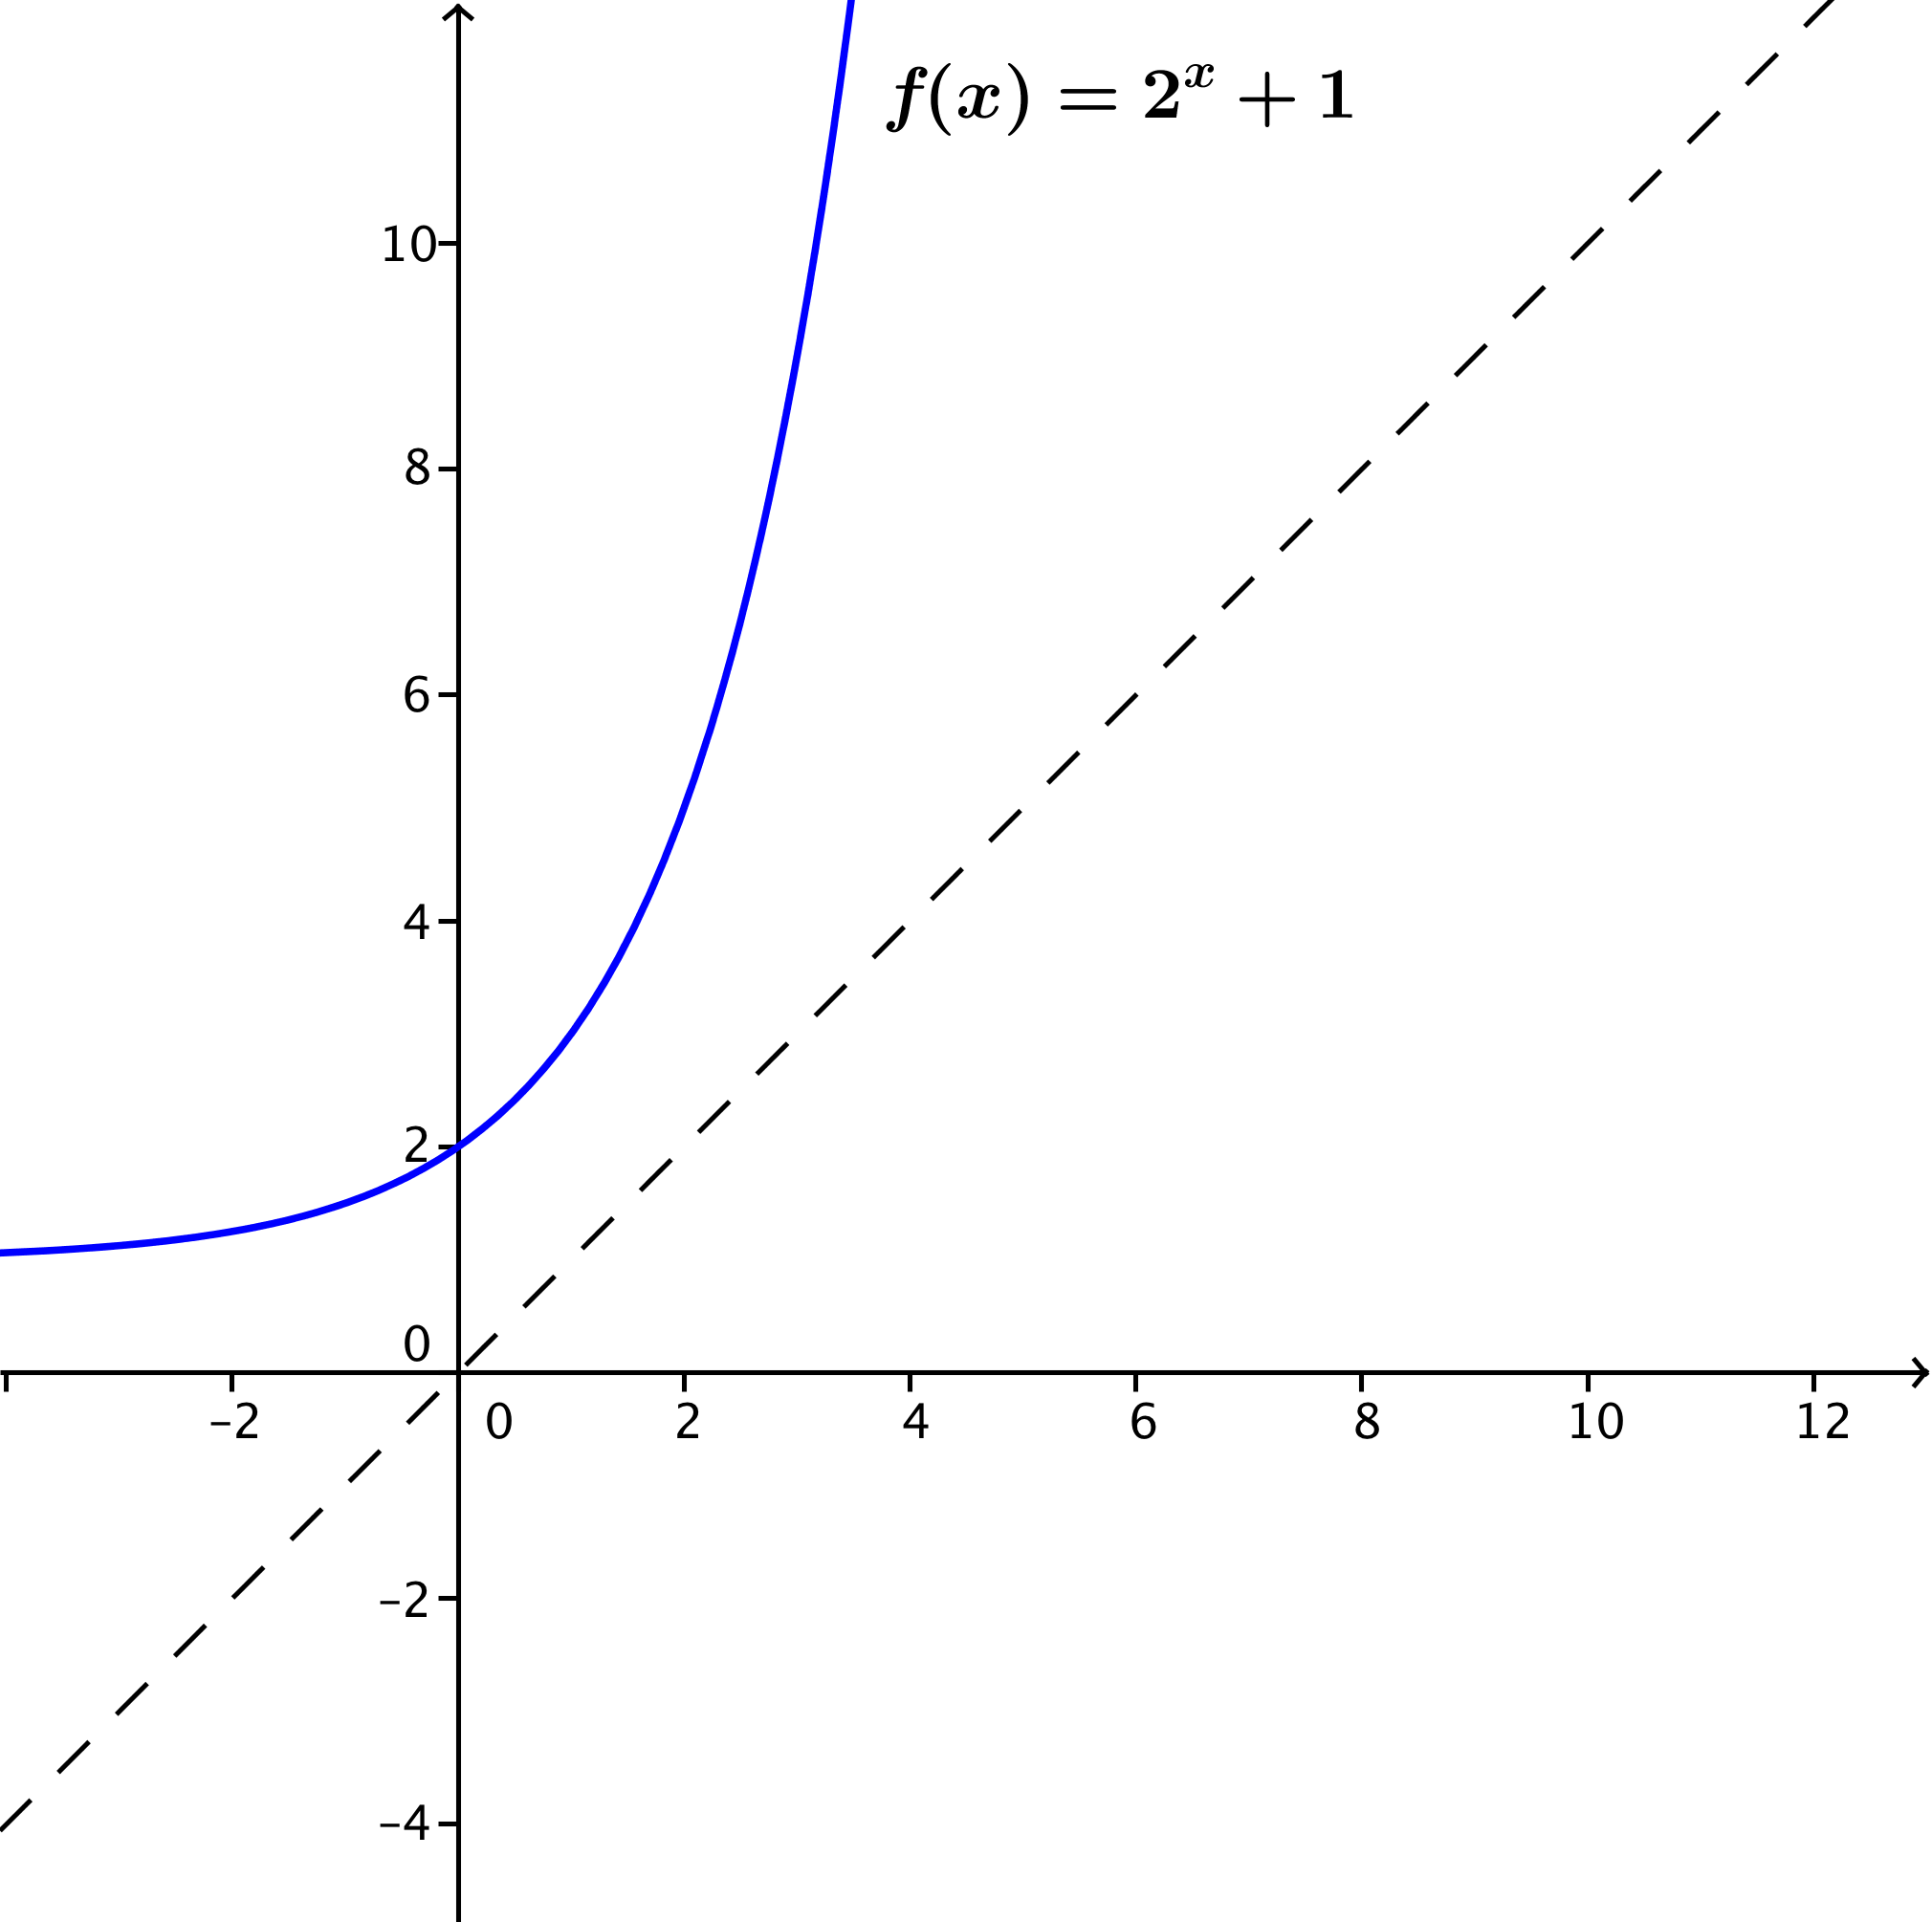
  - What are the domain and range of $f$?

  - Sketch the graph of the inverse function $g$ on the graph. What type of function do you expect $g$ to be?

  - What are the domain and range of $g$? How does that relate to your answer in part (a)?

  - Find the formula for $g$.

Lesson Summary
- Invertible Function: Let $f$ be a function whose domain is the set $X$ and whose image is the set $Y$. Then $f$ is invertible if there exists a function $g$ with domain $Y$ and image $X$ such that $f$ and $g$ satisfy the property:
For all $x$ in $X$ and $y$ in $Y,$ $f(x)=y$ if and only if $g(y)=x$.
- The function $g$ is called the inverse of $f$.
- If two functions whose domain and range are a subset of the real numbers are inverses, then their graphs are reflections of each other across the diagonal line given by $y=x$in the Cartesian plane.
- If $f$ and $g$ are inverses of each other, then
  - The domain of $f$ is the same set as the range of $g$.
  - The range of $f$ is the same set as the domain of $g$.
- In general, to find the formula for an inverse function $g$ of a given function $f$:
  - Write $y=f(x)$ using the formula for $f$.
  - Interchange the symbols $x$ and $y$ to get $x=f(y)$.
  - Solve the equation for $y$ to write $y$ as an expression in $x$.
  - Then, the formula for $g$ is the expression in $x$ found in step (iii).
- The functions $f\left(x\right)=\log_{b}{(x)}$ and $g\left(x\right)=b^{x}$ are inverses of each other.

Problem Set

- For each function $h$ below, find two functions $f$ and $g$ such that $h\left(x\right)=f\left(g\left(x\right)\right)$. (There are many correct answers.)
  - $h\left(x\right)={\left(3x+7\right)}^{2}$
  - $h\left(x\right)=\sqrt[3]{x^{2}-8}$
  - $h\left(x\right)=\frac{1}{2x - 3}$
  - $h\left(x\right)=\frac{4}{{\left(2x - 3\right)}^{3}}$
  - $h\left(x\right)={\left(x+1\right)}^{2}+2(x+1)$
  - $h\left(x\right)={\left(x+4\right)}^{\frac{4}{5}}$
  - $h\left(x\right)=\sqrt[3]{\log{(x^{2}+1)}}$
  - $h\left(x\right)=\sin{(x^{2}+2)}$
  - $h\left(x\right)=\ln\left(\sin\left(x\right)\right)$

- Let $f$ be the function that assigns to each student in your class his or her biological mother.
  - Use the definition of function to explain why $f$ is a function.
  - In order for $f$ to have an inverse, what condition must be true about the students in your class?
  - If we enlarged the domain to include all students in your school, would this larger domain function have an inverse?

- The table below shows a partially filled-out set of input-output pairs for two functions $f$and $h$ that have the same finite domain of $\{0, 5, 10, 15, 20, 25, 30, 35, 40\}$.
$$x$$ | $$0$$ | $$5$$ | $$10$$ | $$15$$ | $$20$$ | $$25$$ | $$30$$ | $$35$$ | $$40$$
$$f(x)$$ | $$0$$ | $$0.3$$ | $$1.4$$ |  | $$2.1$$ |  | $$2.7$$ | $$6$$
$$h(x)$$ | $$0$$ | $$0.3$$ | $$1.4$$ |  | $$2.1$$ |  | $$2.7$$ | $$6$$
  - Complete the table so that $f$ is invertible but $h$ is definitely not invertible.
  - Graph both functions and use their graphs to explain why $f$ is invertible and $h$ is not.

- Find the inverse of each of the following functions. In each case, indicate the domain and range of both the original function and its inverse.
  - $f\left(x\right)= \frac{3x - 7}{5}$
  - $f\left(x\right)=\frac{5 + x}{6 - 2x}$
  - $f\left(x\right)=e^{x-5}$
  - $f\left(x\right)=2^{5-8x}$
  - $f\left(x\right)=7\log\left(1+9x\right)$
  - $f(x)=8+\ln{(5+\sqrt[3]{x})}$
  - $f\left(x\right)= \log\left(\frac{100}{3x+2}\right)$
  - $f\left(x\right)= \ln{(x)}-\ln{(x+1)}$
  - $f\left(x\right)= \frac{2^{x}}{2^{x}+1}$

- Unlike square roots that do not have any real principal square roots for negative numbers, principal cube roots do exist for negative numbers: $\sqrt[3]{-8}$ is the real number $-2$ since it satisfies $-2⋅-2⋅-2=-8$. Use the identities
$\sqrt[3]{x^{3}}=x$ and ${\left(\sqrt[3]{x}\right)}^{3}=x$ for any real number $x$ to find the inverse of each of the functions below. In each case, indicate the domain and range of both the original function and its inverse.
  - $f\left(x\right)=\sqrt[3]{2x}$ for any real number $x$.
  - $f\left(x\right)=\sqrt[3]{2x-3}$ for any real number $x$.
  - $f\left(x\right)={\left(x-1\right)}^{3}+3$ for any real number $x$.

- Suppose that the inverse of a function is the function itself. For example, the inverse of the function $f\left(x\right)=\frac{1}{x}$ (for $x≠0$) is just itself again, $g\left(x\right)=\frac{1}{x}$ (for $x≠0$). What symmetry must the graphs of all such functions have?
(Hint: Study the graph of Exercise 5 in the lesson.)

- When traveling abroad, you will find that daily temperatures in other countries are often reported in Celsius. The sentence, “It will be $25°C$ today in Paris,” does not mean it will be freezing in Paris. It will often be necessary for you to convert temperatures reported in degrees Celsius to degrees Fahrenheit, the scale we use in the U.S. for reporting daily temperatures.
Let f be the function that inputs a temperature measure in degrees Celsius and outputs the corresponding temperature measure in degrees Fahrenheit.
  - Assuming that $f$ is linear, we can use two points on the graph of $f$ to determine a formula for $f$. In degrees Celsius, the freezing point of water is $0,$ and its boiling point is $100$. In degrees Fahrenheit, the freezing point of water is $32,$ and its boiling point is $212$. Use this information to find a formula for the function $f$.
(Hint: Plot the points and draw the graph of $f$ first, keeping careful track of the meaning of values on the
$x$-axis and $y$-axis.)
  - What temperature will Paris be in degrees Fahrenheit if it is reported that it will be $25℃$?
  - Find the inverse of the function $f$ and explain its meaning in terms of degree scales that its domain and range represent.
  - The graphs of $f$ and its inverse are two lines that intersect in one point. What is that point? What is its significance in terms of degrees Celsius and degrees Fahrenheit?

Extension: Use the fact that, for $b>1$, the functions $f\left(x\right)=b^{x}$ and $g\left(x\right)=\log_{b}{(x)}$ are increasing to solve the following problems. Recall that an increasing function $f$ has the property that if both $a$ and $b$ are in the domain of $f$ and $a<b$, then $f\left(a\right)<f(b)$.
- For which values of $x$ is $2^{x}<\frac{1}{1,000,000}$ ?
- For which values of $x$is $\log_{2}\left(x\right)<-1,000,000$?

