Lesson 18: Graphs of Exponential Functions and Logarithmic Functions

Student Outcomes
- Students compare the graph of an exponential function to the graph of its corresponding logarithmic function.
- Students note the geometric relationship between the graph of an exponential function and the graph of its corresponding logarithmic function.

Lesson Notes
In the previous lesson, students practiced graphing transformed logarithmic functions and observed the effects of the logarithmic properties in the graphs. In this lesson, students graph the logarithmic functions along with their corresponding exponential functions. Be careful to ensure that the scale is the same on both axes so that the geometric relationship between the graph of the exponential function and the graph of the logarithmic function is apparent. Part of the focus of the lesson is for students to begin seeing that these functions are the inverses of each other—but without the teacher actually saying it yet. Encourage students to draw the graphs carefully so that they can see that the two graphs are reflections of each other about the diagonal. The asymptotic nature of the two functions may be discussed. (F-IF.B.4, F-IF.C.7e) The teacher is encouraged to consider using graphing software such as GeoGebra.

Classwork
Opening Exercise (5 minutes)
Scaffolding:
- Model the process of reflecting a set of points, such as $△ABC$ with vertices $A(-3, 2)$, $B\left(-3, 7\right)$, and $C\left(2, 7\right)$, over the diagonal line
$y=x$ before asking students to do the same.
- After the graph of $y=2^{x}$ and its reflection are shown, ask advanced students, “If the first graph represents the points that satisfy $y=2^{x}$, then what equation do the points on the reflected graph satisfy?”
Allow students to work in pairs or small groups on the following exercise, in which they graph a few points on the curve $y=2^{x}$, reflect these points over the diagonal line with the equation $y=x$, and analyze the result.
Opening Exercise
Complete the following table of values of the function $f\left(x\right)=2^{x}$. We want to sketch the graph of $y=f(x)$ and then reflect that graph across the diagonal line with equation $y=x$.
$$x$$ | $$y=2^{x}$$ | Point $\left(x,y\right)$ on the graph of $y=2^{x}$
$$-3$$ | $$\frac{1}{8}$$ | $$\left(-3, \frac{1}{8}\right)$$
$$-2$$ | $$\frac{1}{4}$$ | $$\left(-2,\frac{1}{4}\right)$$
$$-1$$ | $$\frac{1}{2}$$ | $$\left(-1,\frac{1}{2}\right)$$
$$0$$ | $$1$$ | $$(0,1)$$
$$1$$ | $$2$$ | $$(1,2)$$
$$2$$ | $$4$$ | $$(2,4)$$
$$3$$ | $$8$$ | $$(3,8)$$
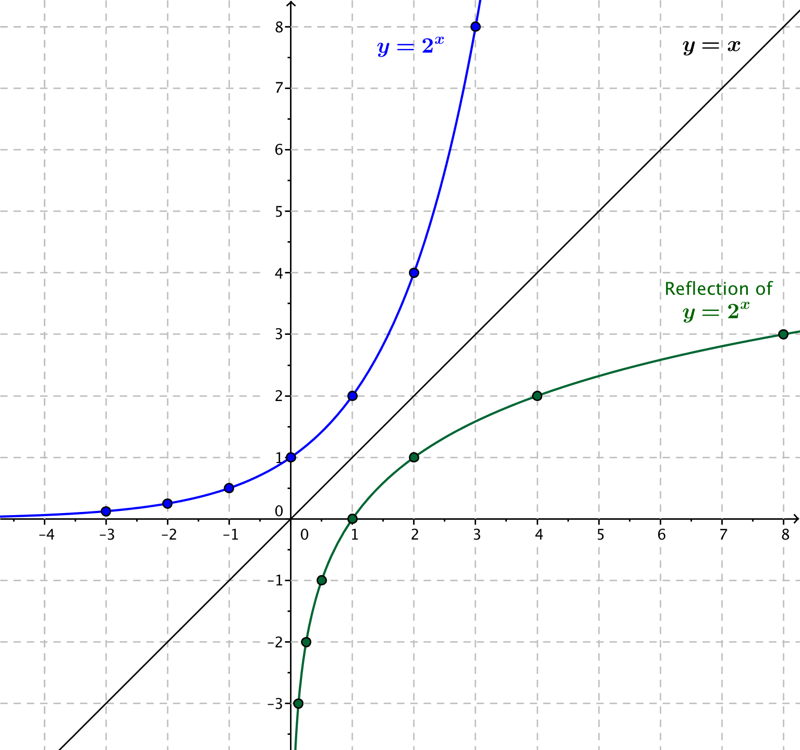
On the set of axes below, plot the points from the table and sketch the graph of $y=2^{x}$. Next, sketch the diagonal line with equation $y=x$, and then reflect the graph of $y=2^{x}$ across the line.

Discussion (4 minutes)
Use the following discussion to reinforce the process by which a point is reflected across the diagonal line given by
$y=x$ and the reasoning for why reflecting points on an exponential curve produces points on the corresponding logarithmic curve.
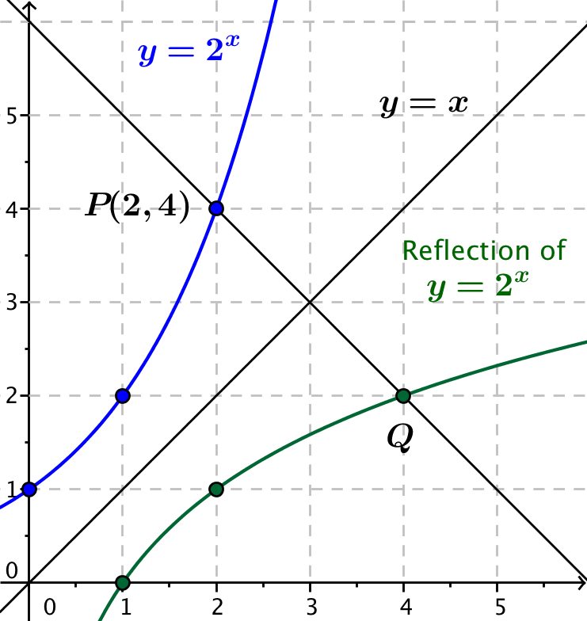
- How do we find the reflection of the point $P(2, 4)$ across the line given by $y=x$?
  - Point $P(2, 4)$ is reflected to point $Q$ on the line through $(2, 4)$ that is perpendicular to the line given by $y=x$ so that points $P$ and $Q$ are equidistant from the diagonal line.
- What is the slope of the line through$P$ and $Q$? Explain how you know. (Draw the figure at right.)
  - The slope is $-1$ because this line is perpendicular to the diagonal line that has slope $1$.
- We know that $P$ and $Q$ are the same distance from the diagonal line.
What are the coordinates of the point $Q$?
  - Point $Q$ has coordinates $(4, 2)$.
- What are the coordinates of the reflection of the point $(1, 2)$ across the line given by $y=x$?
  - The reflection of the point $(1, 2)$ is the point $(2, 1)$.
- What are the coordinates of the reflection of the point $(a,b)$ across the line given by $y=x$?
- When we reflect about the line with equation $y=x$, we actually switch the axes themselves by folding the plane along this line. Therefore, the reflection of the point $\left(a, b\right)$ is the point $(b,a)$.

Exercise 1 (7 minutes)
Exercises
- Complete the following table of values of the function $g\left(x\right)=log_{2}(x)$. We want to sketch the graph of
$y=g(x)$ and then reflect that graph across the diagonal line with equation $y=x$.
$$x$$ | $$y=log_{2}(x)$$ | Point $\left(x,y\right)$ on the graph of $y=log_{2}(x)$
$$-\frac{1}{8}$$ | $$-3$$ | $$\left(\frac{1}{8}, -3\right)$$
$$-\frac{1}{4}$$ | $$-2$$ | $$\left(\frac{1}{4}, -2\right)$$
$$-\frac{1}{2}$$ | $$-1$$ | $$\left(\frac{1}{2}, -1\right)$$
$$1$$ | $$0$$ | $$(1, 0)$$
$$2$$ | $$1$$ | $$(2, 1)$$
$$4$$ | $$2$$ | $$(4, 2)$$
$$8$$ | $$3$$ | $$(8, 3)$$
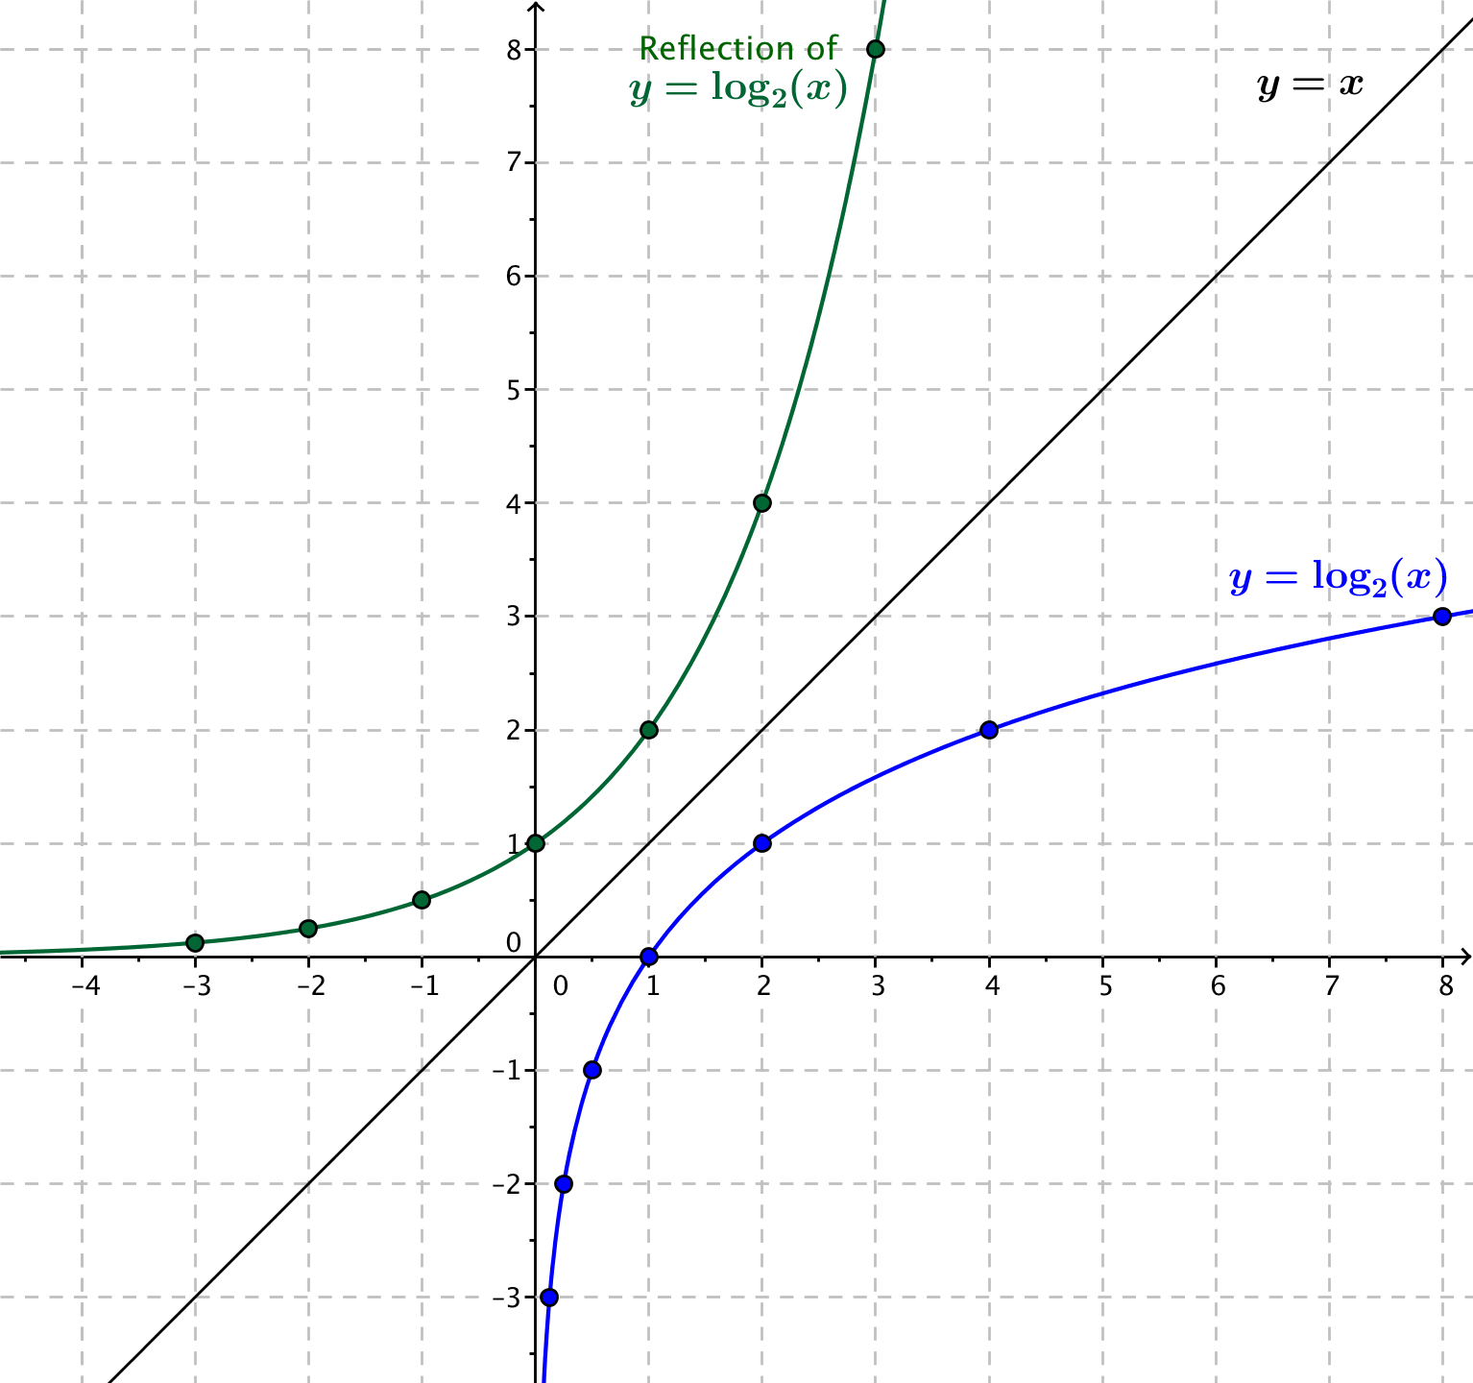
On the set of axes below, plot the points from the table and sketch the graph of $y=log_{2}(x)$. Next, sketch the diagonal line with equation $y=x$, and then reflect the graph of $y=log_{2}(x)$ across the line.

Discussion (5 minutes)
This discussion makes clear that the reflection of the graph of an exponential function is the graph of a corresponding logarithmic function, and vice-versa.
- How do we find the reflection of the point $P(2, 4)$ across the line given by $y=x$?
- What similarities do you notice about this exercise and the Opening Exercise?
MP.7
  - The points $\left(0, 1\right)$,$\left(2, 1\right)$, and $(4, 2)$ on the logarithmic graph are the reflections of the points we plotted on this first graph of $f\left(x\right)=2^{x}$ across the diagonal line.
  - The point $\left(2, 4\right)$ on the graph of the exponential function is the reflection across the diagonal line of the point $(4, 2)$ on the graph of the logarithm, and the point $\left(4, 2\right)$ on the graph of the logarithm function is the reflection across the diagonal line of the point $(2, 4)$ on the graph of the exponential function.
  - The point $\left(a,b\right)$ on the graph of the exponential function is the reflection across the diagonal line of the point $(b, a)$ on the graph of the logarithm, and the point $(b,a)$ on the graph of the logarithm function is the reflection across the diagonal line of the point $(a,b)$ on the graph of the exponential function.
  - The graphs of the functions $f\left(x\right)=2^{x}$and $g\left(x\right)=\log_{2}{(x)}$ are reflections of each other across the diagonal line given by $y=x$.
- Why does this happen? How does the definition of the logarithm tell us that if $(a,b)$ is a point on the exponential graph, then $(b,a)$ is a point on the logarithmic graph? How does the definition of the logarithm tell us that if $(b,a)$ is a point on the logarithmic graph, then $(a,b)$ is a point on the exponential graph?
  - If $\left(a,b\right)$ is a point on the graph of the exponential function$f\left(x\right)=2^{x}$, then
$$f\left(a\right)=2^{a} \\ b=2^{a} \\ \log_{2}\left(b\right)=a$$
  - So, the point $(b,a)$ is on the graph of the logarithmic function $g\left(x\right)=\log_{2}{(x)}$.
Likewise, if $\left(b,a\right)$ is a point on the graph of the logarithmic function $g\left(x\right)=\log_{2}{(x)}$, then:
$$g\left(b\right)=\log_{2}\left(b\right) \\ \log_{2}\left(b\right)=a \\ 2^{a} = b$$
- So, the point $(a,b)$ is on the graph of the exponential function $f\left(x\right)=2^{x}$.

Exercise 2 (5 minutes)

- Working independently, predict the relation between the graphs of the functions $f(x)=3^{x}$ and $g(x)=\log_{3}{(x)}$. Test your predictions by sketching the graphs of these two functions. Write your prediction in your notebook, provide justification for your prediction, and compare your prediction with that of your neighbor.
The graphs will be reflections of each other about the diagonal.
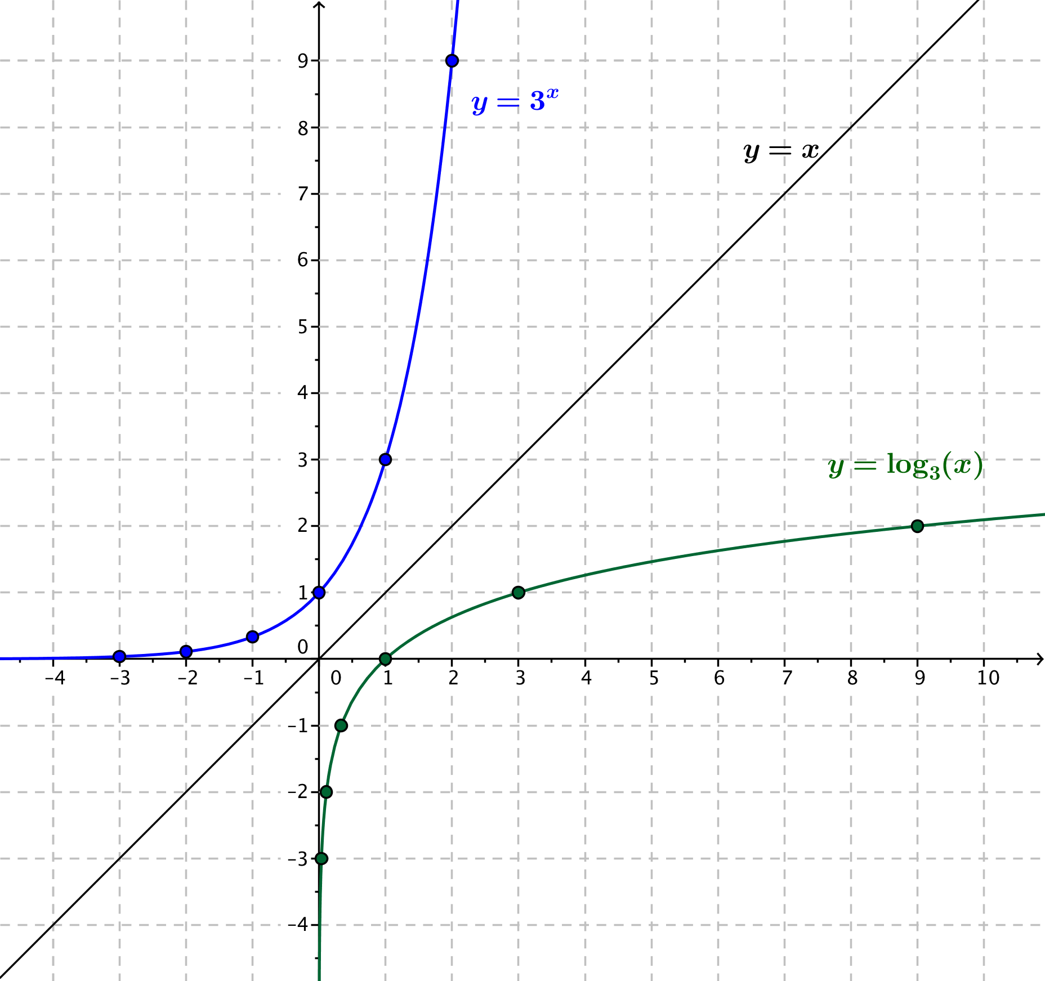

MP.3

Exercises 3–4 (10 minutes)

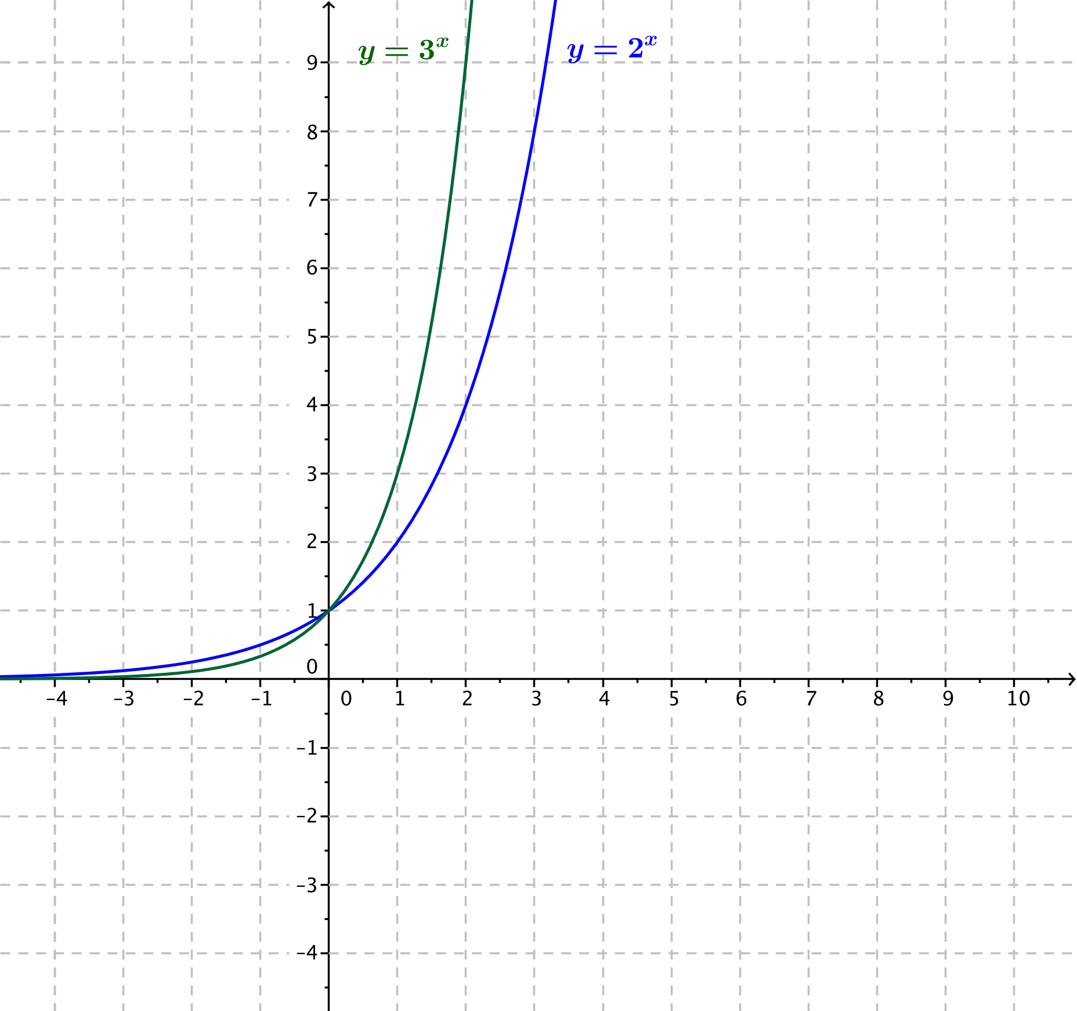
- Now let’s compare the graphs of the functions $f_{2}\left(x\right)=2^{x}$ and $f_{3}\left(x\right)=3^{x}$; sketch the graphs of the two exponential functions on the same set of axes; then, answer the questions below.

  - Where do the two graphs intersect?
The two graphs intersect at the point $(0,1)$.

  - For which values of $x$ is $2^{x}<3^{x}$?
If $x>0$, then $2^{x}<3^{x}$.

  - For which values of $x$ is $2^{x}>3^{x}$ ?
If $x<0$, then $2^{x}>3^{x}$.

  - What happens to the values of the functions $f_{2}$ and $f_{3}$ as $x→∞$?
As $x→∞$, both $f_{2}(x)→∞$ and $f_{3}(x)→∞$.

  - What happens to the values of the functions $f_{2}$ and $f_{3}$ as $x→-∞$?
As $x→-∞$, both $f_{2}(x)→0$ and $f_{3}(x)→0$.

  - Does either graph ever intersect the $x$-axis? Explain how you know.
No. For every value of $x$, we know $2^{x}≠0$ and $3^{x}≠0$.
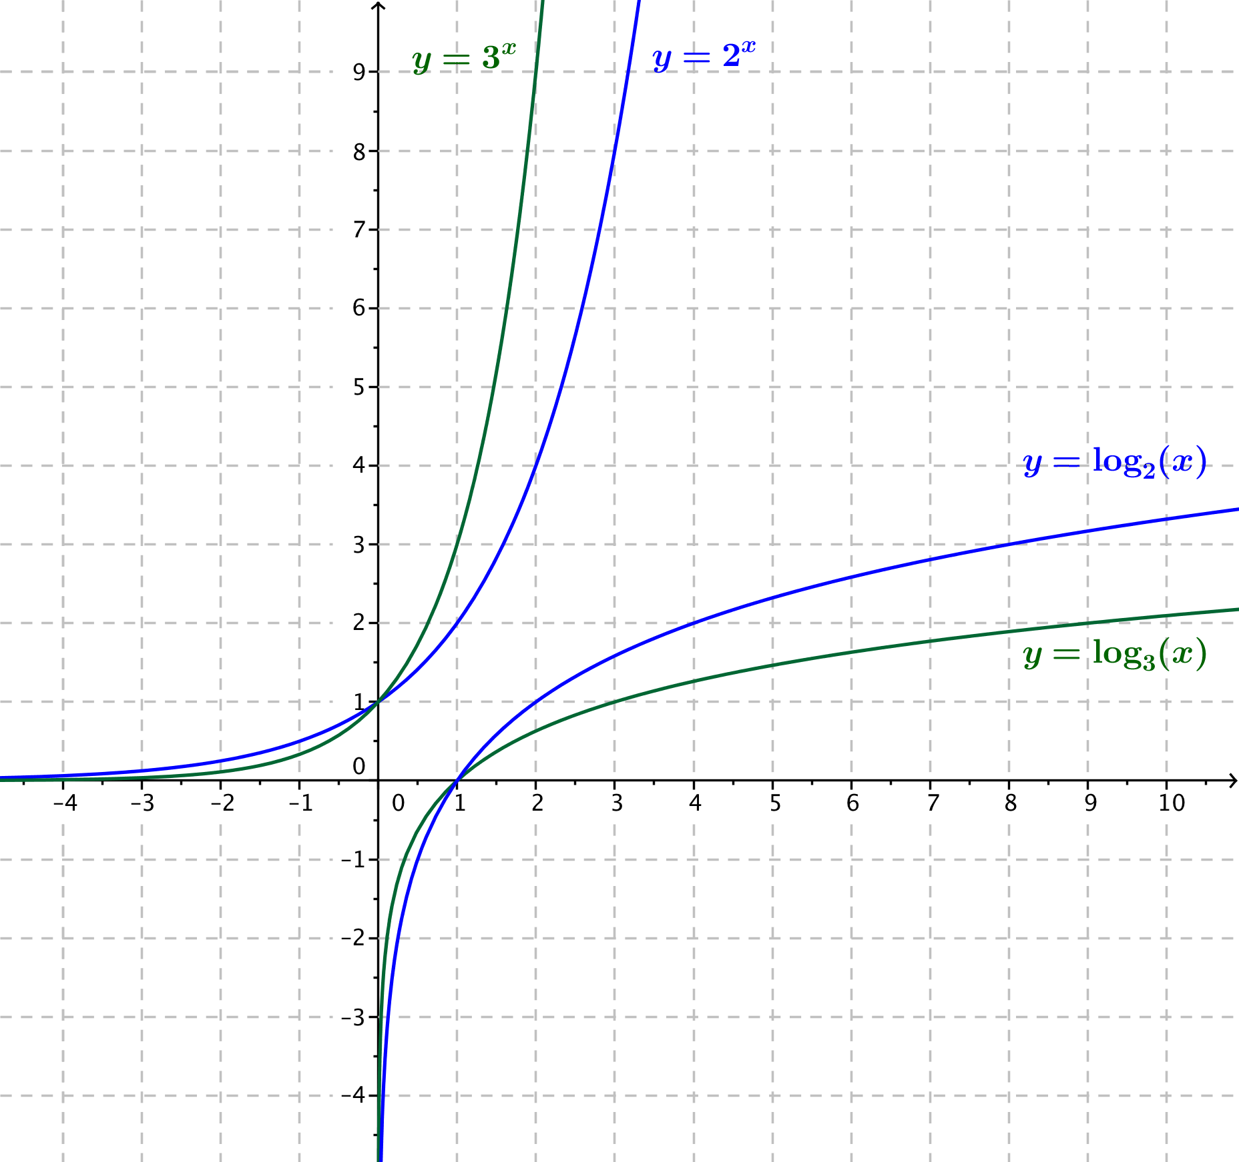
- Add sketches of the two logarithmic functions $g_{2}\left(x\right)=\log_{2}{(x)}$ and $g_{3}\left(x\right)=\log_{3}{(x)}$ to the axes with the graphs of the exponential functions; then, answer the questions below.

  - Where do the two logarithmic graphs intersect?
The two graphs intersect at the point $(1,0)$.

  - For which values of $x$ is $log_{2}\left(x\right)<log_{3}(x)$?
If $x<1$, then $log_{2}\left(x\right)<log_{3}(x)$.

  - For which values of $x$ is $g_{2}\left(x\right)>log_{3}(x)$?
If $x>1$, then $log_{2}\left(x\right)>log_{3}\left(x\right)$.

  - What happens to the values of the functions $f_{2}$ and $f_{3}$ as $x→∞$?
As $x→∞$, both $g_{2}(x)→∞$ and $g_{3}(x)→∞$.

  - What happens to the values of the functions $f_{2}$ and $f_{3}$ as $x→0$?
As $x→0$, both $g_{2}\left(x\right)→-∞$ and $g_{3}\left(x\right)→-∞$.

  - Does either graph ever intersect the $y$-axis? Explain how you know.
No. Logarithms are only defined for positive values of $x$.

  - Describe the similarities and differences in the behavior of $f_{2}(x)$ and $g_{2}(x)$ as $x→∞$.
As $x→∞$, both $f_{2}\left(x\right)→∞$ and $g_{2}\left(x\right)→∞$; however, the exponential function gets very large very quickly, and the logarithmic function gets large rather slowly.
Closing (4 minutes)
Ask students to summarize the key points of the lesson with a partner or in writing. Make sure that students have used the specific examples from the lesson to create some generalizations about the graphs of exponential and logarithmic functions.
- Graphical analysis was done for the functions $f{}_{2}\left(x\right)=2^{x}$and $f_{3}\left(x\right)=3^{x}$. What generalizations can we make about functions of the form $f\left(x\right)=a^{x}$ for $a>1$?
  - The function values increase to infinity as $x→∞$. The function values get closer to $0$ as $x→-∞$.
- Graphical analysis was done for functions $g_{2}\left(x\right)=\log_{2}{(x)}$ and $g_{3}(x)=\log_{3}{(x)}$. What generalizations can we make about functions of the form $g\left(x\right)=\log_{b}{(x)}$for $b>1$?
MP.8
  - The function values increase to infinity as $x→∞$. The function values approach $-∞$ as $x→0$.
- How are the graphs of the functions $f\left(x\right)=2^{x}$ and $g\left(x\right)=\log_{2}\left(x\right)$related?
  - They are reflections of each other across the diagonal line given by $y=x$.
- What can we say, in general, about the graphs of$f\left(x\right)=b^{x}$ and$g\left(x\right)=\log_{b}{(x)}$ where$b>1$?
  - They are reflections of each other about the diagonal line with equation $y=x$.

Exit Ticket (5 minutes)

Name Date
Lesson 18: Graphs of Exponential Functions and Logarithmic Functions

Exit Ticket

The graph of a logarithmic function $g\left(x\right)=\log_{b}{(x)}$ is shown below.
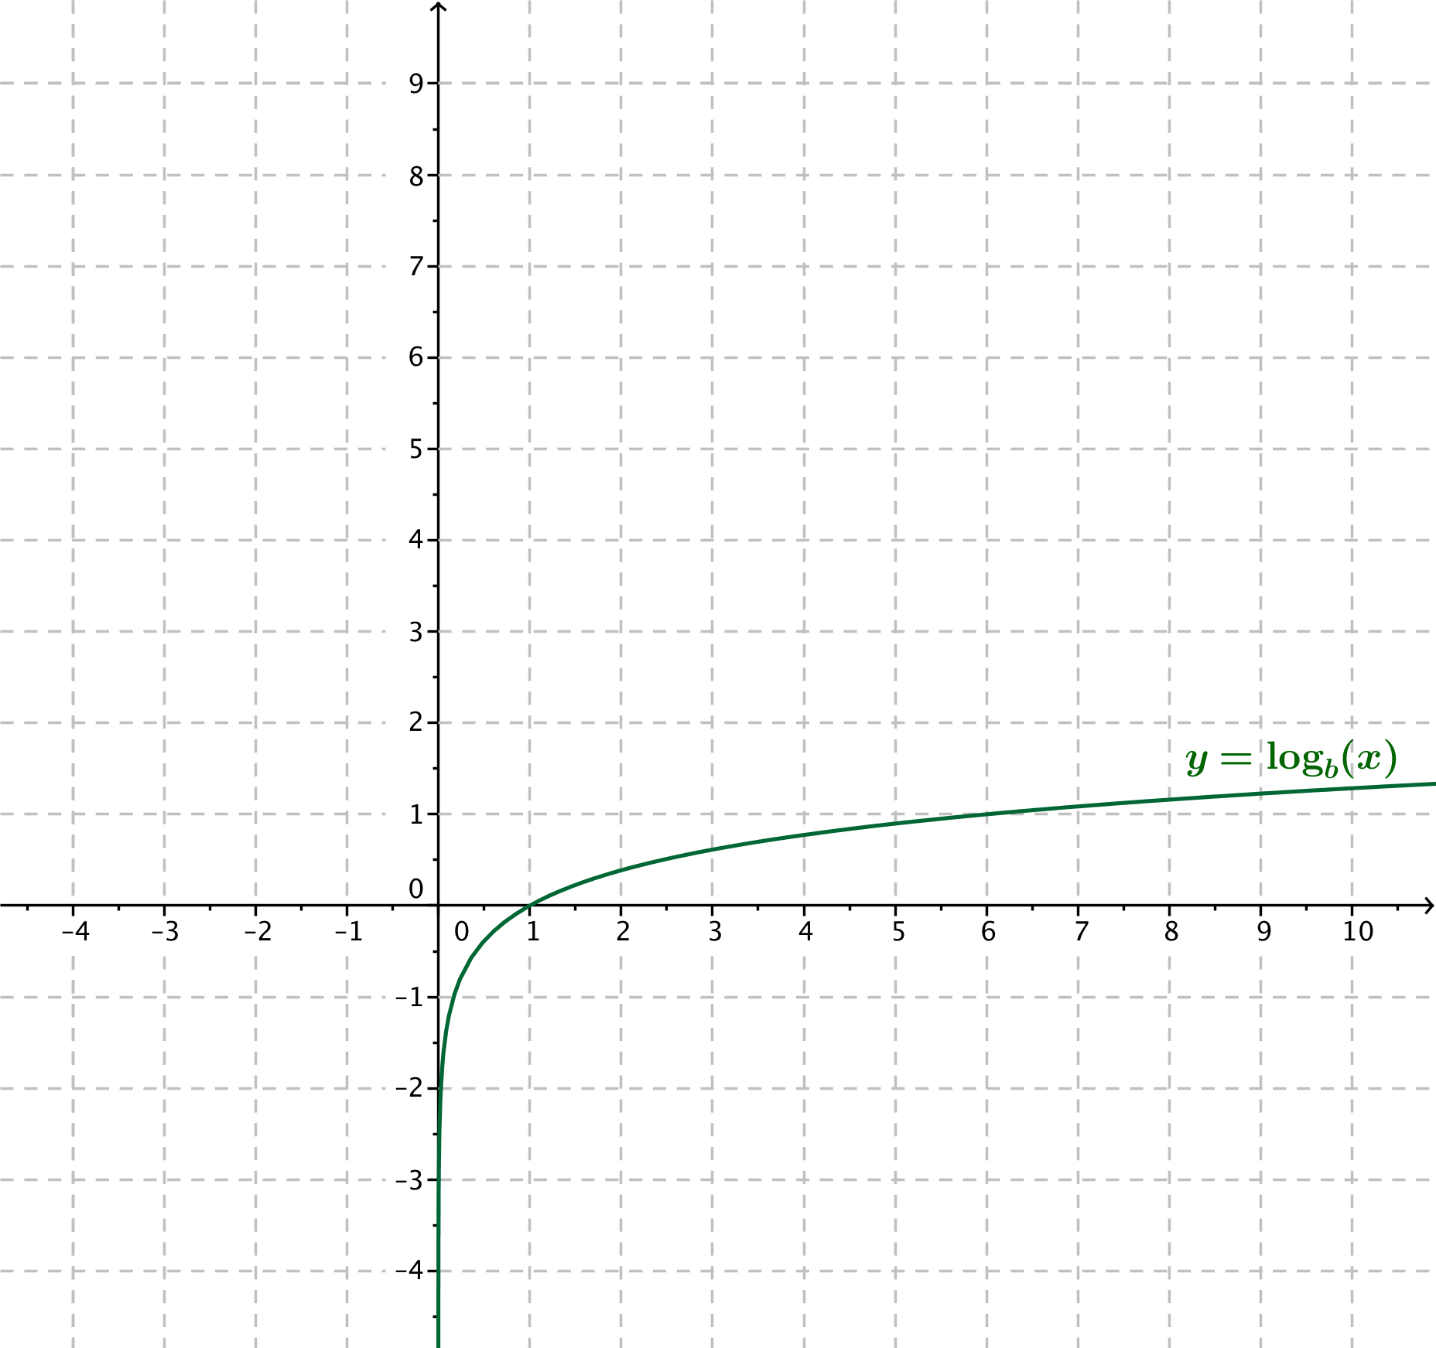
  - Explain how to find points on the graph of the function $f\left(x\right)=b^{x}$.

  - Sketch the graph of the function $f\left(x\right)=b^{x}$ on the same axes.
Exit Ticket Sample Solutions

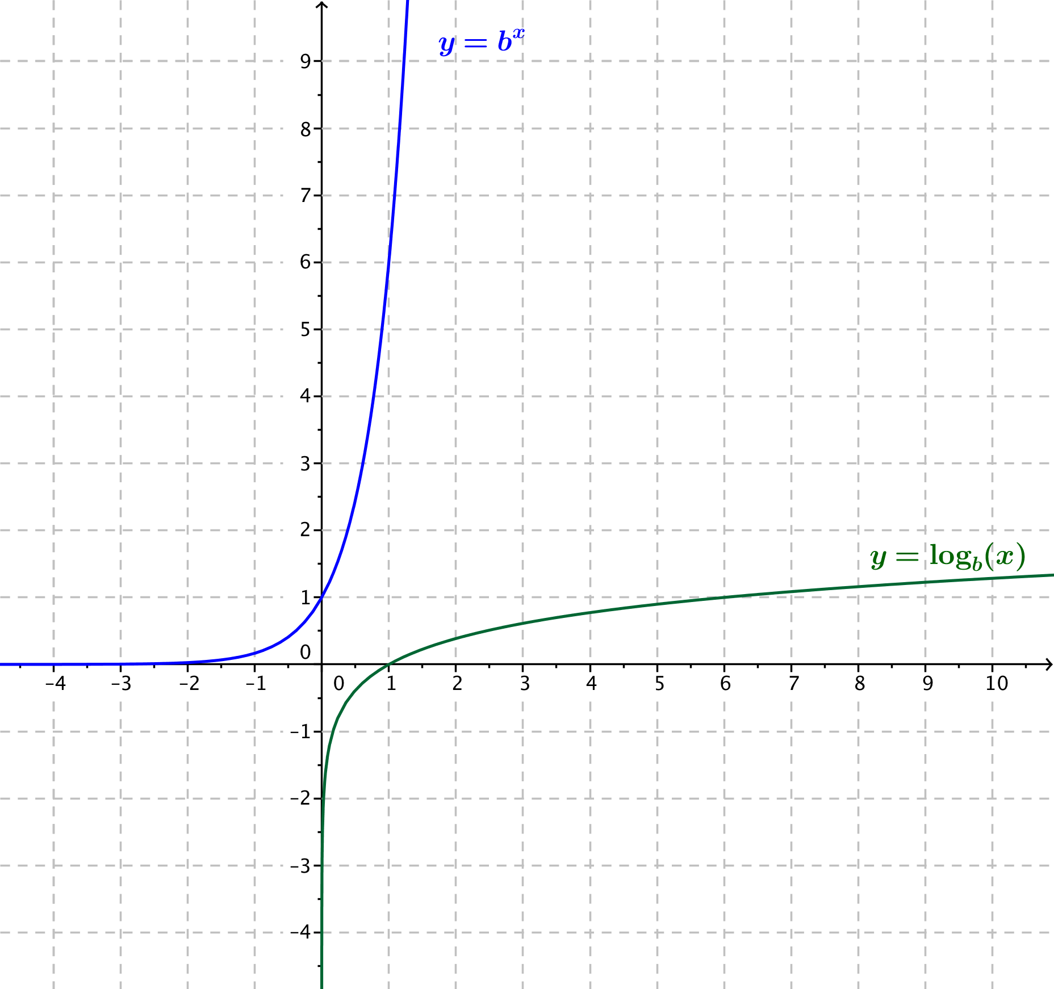
The graph of a logarithmic function $g\left(x\right)=\log_{b}{(x)}$ is shown below.

  - Explain how to find points on the graph of the function $f\left(x\right)=b^{x}$.
A point $(x,y)$ is on the graph of $f$ if the corresponding point $(y,x)$ is on the graph of $g$.

  - Sketch the graph of the function $f\left(x\right)=b^{x}$ on the same axes.

Problem Set Sample Solutions
Problems 5–7 serve to review the process of computing $f\left(g\left(x\right)\right)$ for given functions $f$ and $g$ in preparation for work with inverses of functions in Lesson 19.

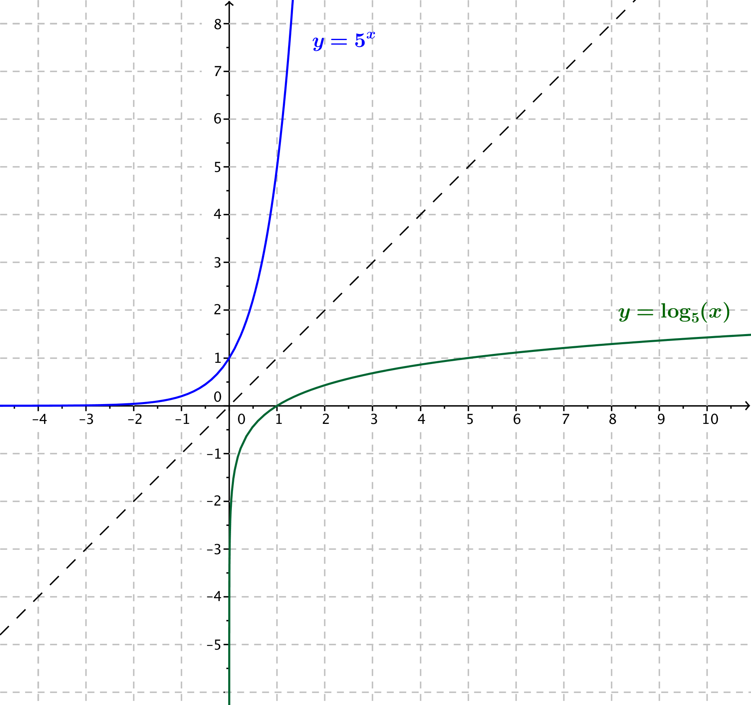
- Sketch the graphs of the functions $f\left(x\right)=5^{x}$ and $g\left(x\right)=\log_{5}{(x)}$.

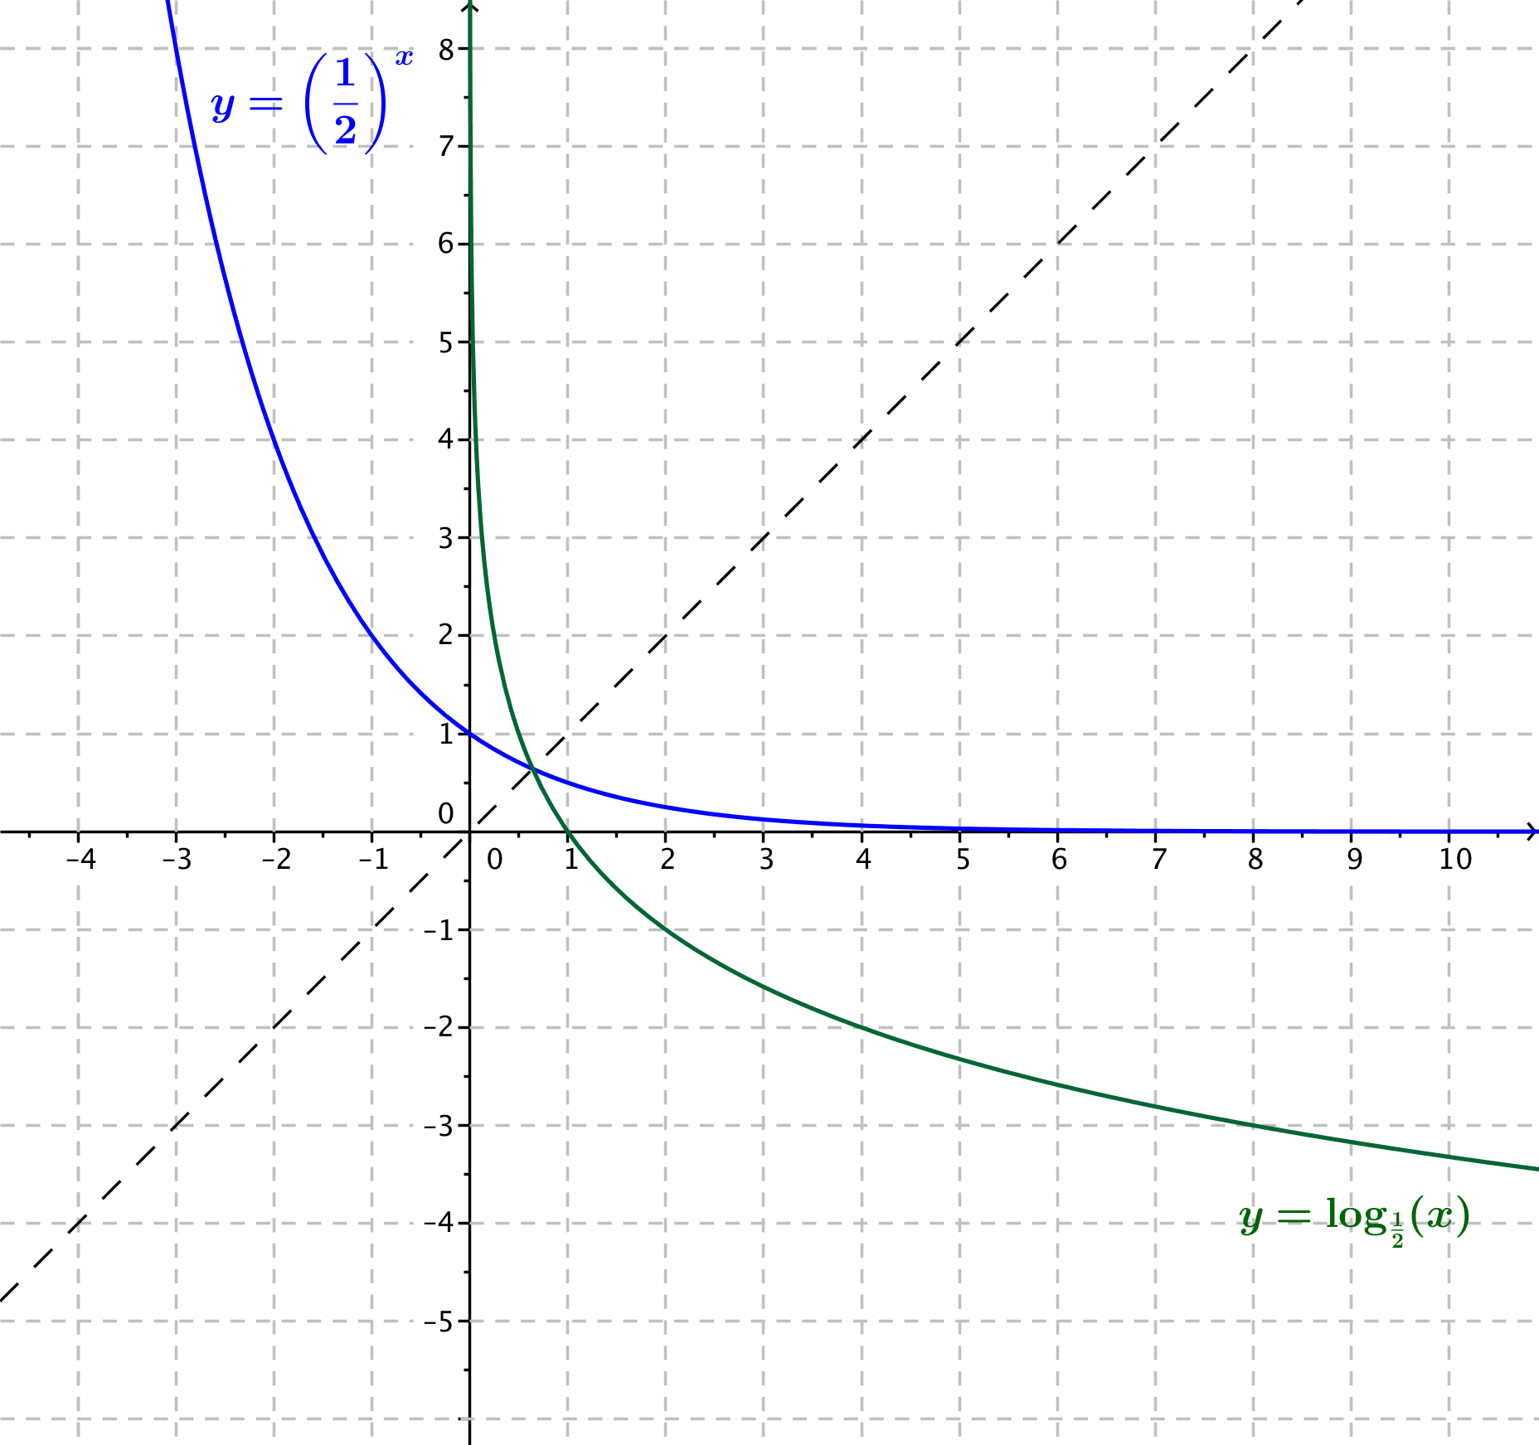
- Sketch the graphs of the functions $f\left(x\right)={\left(\frac{1}{2}\right)}^{x}$ and $g\left(x\right)=\log_{\frac{1}{2}}{(x)}$.
- Sketch the graphs of the functions $f_{1}\left(x\right)={\left(\frac{1}{2}\right)}^{x}$ and $f_{2}\left(x\right)={\left(\frac{3}{4}\right)}^{x}$ on the same sheet of graph paper and answer the following questions.
  - Where do the two exponential graphs intersect?
The graphs intersect at the point $\left(0,1\right)$.

  - For which values of $x$ is ${\left(\frac{1}{2}\right)}^{x}<$ ${\left(\frac{3}{4}\right)}^{x}$?
If $x>0$, then ${\left(\frac{1}{2}\right)}^{x}<{\left(\frac{3}{4}\right)}^{x}$.

  - For which values of $x$ is ${\left(\frac{1}{2}\right)}^{x}>{\left(\frac{3}{4}\right)}^{x}$?
If $x<0$, then ${\left(\frac{1}{2}\right)}^{x}>{\left(\frac{3}{4}\right)}^{x}$.

  - What happens to the values of the functions $f_{1}$ and$f_{2}$ as$x→∞$?
As $x→∞$, both $f_{1}\left(x\right)→0$ and $f_{2}\left(x\right)→ 0$.

  - What are the domains of the two functions $f_{1}$ and $f_{2}$?
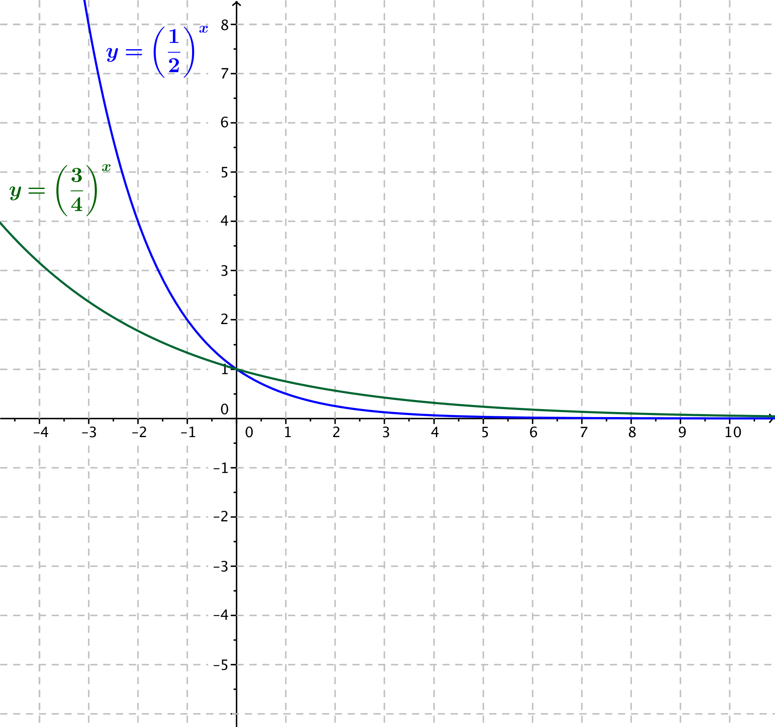
Both functions have domain $(-∞, ∞)$.

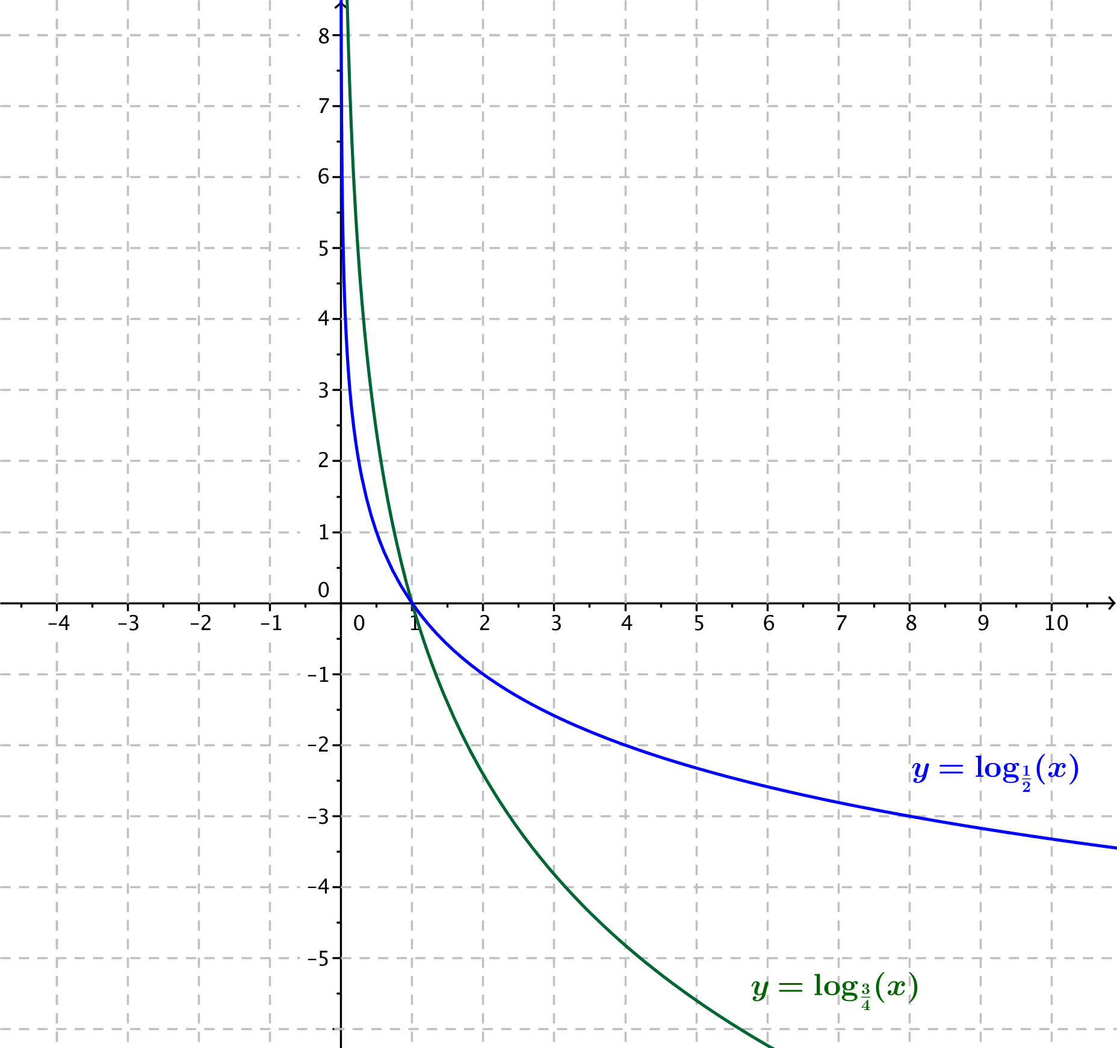
- Use the information from Problem 3 together with the relationship between graphs of exponential and logarithmic functions to sketch the graphs of the functions $g_{1}\left(x\right)=\log_{\frac{1}{2}}{(x)}$and $g_{2}\left(x\right)=\log_{\frac{3}{4}}{(x)}$on the same sheet of graph paper. Then, answer the following questions.

  - Where do the two logarithmic graphs intersect?
The graphs intersect at the point $\left(1,0\right)$.

  - For which values of $x$ is $\log_{\frac{1}{2}}{(x)}<\log_{\frac{3}{4}}{(x)}$?
When $x<1$, we have $\log_{\frac{1}{2}}{(x)}<\log_{\frac{3}{4}}{(x)}$.

  - For which values of $x$ is $\log_{\frac{1}{2}}{(x)}>\log_{\frac{3}{4}}{(x)}$?
When $x>1$, we have $\log_{\frac{1}{2}}{(x)}>\log_{\frac{3}{4}}{(x)}$.

  - What happens to the values of the functions $g_{1}$ and $g_{2}$ as $x→∞$?
As $x→∞$, both $g_{1}\left(x\right)→-∞$ and $g_{2}\left(x\right)→-∞$.

  - What are the domains of the two functions $g_{1}$ and $g_{2}$?
Both functions have domain $(0, ∞)$.

- For each function $f$, find a formula for the function $h$ in terms of $x$.
  - If $f\left(x\right)=x^{3}$, find $h\left(x\right)=128f\left(\frac{1}{4}x\right)+f(2x)$.
$$h\left(x\right)=10x^{3}$$

  - If $\left(x\right)=x^{2}+1$ , find $h\left(x\right)=f\left(x+2\right)-f(2)$.
$$h\left(x\right)=x^{2}+4x$$

  - If $f\left(x\right)=x^{3}+2x^{2}+5x+1$, find $h\left(x\right)=\frac{f\left(x\right)+f\left(-x\right)}{2}$.
$$h\left(x\right)=2x^{2}+1$$

  - If $f\left(x\right)=x^{3}+2x^{2}+5x+1$, find $h\left(x\right)=\frac{f\left(x\right)-f\left(-x\right)}{2}$.
$$h\left(x\right)=x^{3}+5x$$

- In Problem 5, parts (c) and (d), list at least two aspects about the formulas you found as they relate to the function $f\left(x\right)=x^{3}+2x^{2}+5x+1$.
The formula for 1(c) is all of the even power terms of $f$. The formula for 1(d) is all of the odd power terms of $f$. The sum of the two functions gives $f$ back again.

- For each of the functions $f$ and $g$ below, write an expression for (i) $f\left(g\left(x\right)\right)$, (ii) $g\left(f\left(x\right)\right)$, and (iii) $f\left(f\left(x\right)\right)$ in terms of $x$.
  - $f\left(x\right)=x^{\frac{2}{3}}$, $g\left(x\right)=x^{12}$
    - $x^{8}$
    - $x^{8}$
    - $x^{\frac{4}{9}}$

  - $f\left(x\right)=\frac{b}{x-a}$, $g\left(x\right)=\frac{b}{x}+a$ for two numbers $a$ and $b$, when $x$ is not $0$ or $a$
    - $x$
    - $x$
    - $\frac{b}{\frac{b}{x-a}-a}$ , which is equivalent to $\frac{b\left(x-a\right)}{b+a^{2}-ax}$

  - $f\left(x\right)=\frac{x+1}{x-1}$, $g\left(x\right)=\frac{x+1}{x-1}$, when $x$ is not $1$ or $-1$
    - $x$
    - $x$
    - $x$

  - $f\left(x\right)=2^{x}$, $g\left(x\right)=\log_{2}{(x)}$
    - $x$
    - $x$
    - $x$

  - $f\left(x\right)=\ln\left(x\right)$, $g\left(x\right)=e^{x}$
    - $x$
    - $x$
    - $\ln{(\ln\left(x\right)) }$

  - $f\left(x\right)={2⋅100}^{x}$, $g\left(x\right)=\frac{1}{2}log\left(\frac{1}{2}x\right)$
    - $x$
    - $x$
    - $2⋅{10000}^{{100}^{x}}$

