Lesson 18: Graphs of Exponential Functions and Logarithmic Functions

Classwork
Opening Exercise
Complete the following table of values of the function $f\left(x\right)=2^{x}$. We want to sketch the graph of $y=f(x)$ and then reflect that graph across the diagonal line with equation $y=x$.
$$x$$ | $$y=2^{x}$$ | Point $\left(x,y\right)$ on the graph  of $y=2^{x}$
$$-3$$
$$-2$$
$$-1$$
$$0$$
$$1$$
$$2$$
$$3$$

On the set of axes below, plot the points from the table and sketch the graph of $y=2^{x}$. Next, sketch the diagonal line with equation $y=x$, and then reflect the graph of $y=2^{x}$ across the line.

Exercises
- Complete the following table of values of the function $g\left(x\right)=log_{2}(x)$. We want to sketch the graph of $y=g(x)$ and then reflect that graph across the diagonal line with equation $y=x$.
$$x$$ | $$y=log_{2}(x)$$ | Point $\left(x,y\right)$ on the graph  of $y=log_{2}(x)$
$$-\frac{1}{8}$$
$$-\frac{1}{4}$$
$$-\frac{1}{2}$$
$$1$$
$$2$$
$$4$$
$$8$$
On the set of axes below, plot the points from the table and sketch the graph of $y=log_{2}(x)$. Next, sketch the diagonal line with equation $y=x$, and then reflect the graph of $y=log_{2}(x)$ across the line.

- Working independently, predict the relation between the graphs of the functions $f\left(x\right)=3^{x}$ and $g\left(x\right)=\log_{3}{(x)}$. Test your predictions by sketching the graphs of these two functions. Write your prediction in your notebook, provide justification for your prediction, and compare your prediction with that of your neighbor.

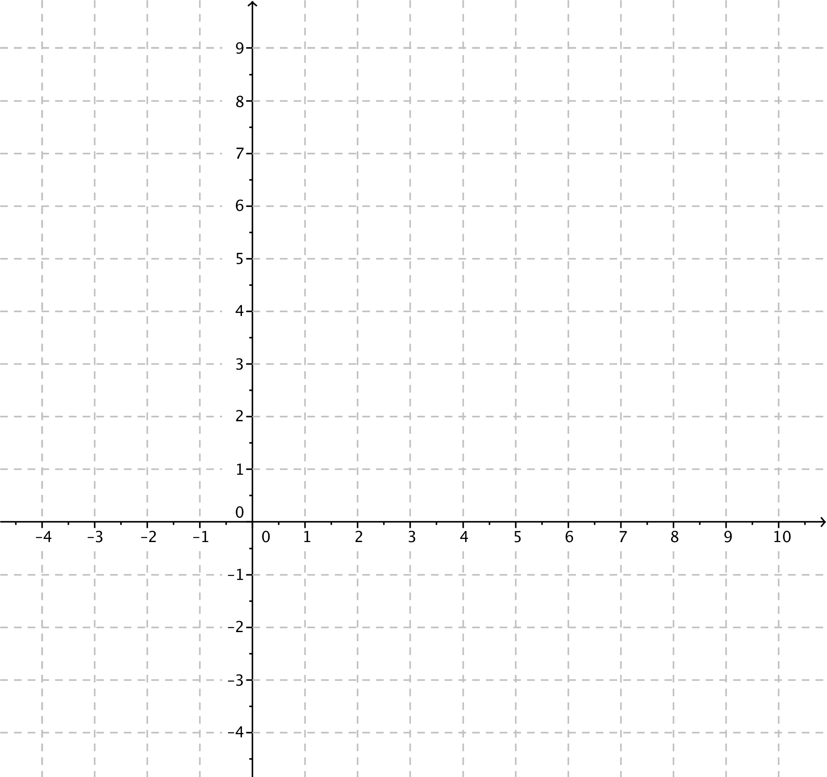

- Now let’s compare the graphs of the functions $f_{2}\left(x\right)=2^{x}$ and $f_{3}\left(x\right)=3^{x}$; sketch the graphs of the two exponential functions on the same set of axes; then, answer the questions below.
  - Where do the two graphs intersect?

  - For which values of $x$ is $2^{x}<3^{x}$?

  - For which values of $x$ is $2^{x}>3^{x}$?

  - What happens to the values of the functions $f_{2}$ and $f_{3}$ as $x→∞$?

  - What happens to the values of the functions $f_{2}$ and $f_{3}$ as $x→-∞$?

  - Does either graph ever intersect the $x$-axis? Explain how you know.

- Add sketches of the two logarithmic functions $g_{2}\left(x\right)=\log_{2}{(x)}$ and $g_{3}\left(x\right)=\log_{3}{(x)}$ to the axes with the graphs of the exponential functions; then, answer the questions below.
  - Where do the two logarithmic graphs intersect?

  - For which values of $x$ is $log_{2}\left(x\right)<log_{3}(x)$?

  - For which values of $x$ is $log_{2}\left(x\right)>log_{3}(x)$?

  - What happens to the values of the functions $f_{2}$ and $f_{3}$ as $x→∞$?

  - What happens to the values of the functions $f_{2}$ and $f_{3}$ as $x→0$?

  - Does either graph ever intersect the $y$-axis? Explain how you know.

  - Describe the similarities and differences in the behavior of $f_{2}(x)$ and $g_{2}(x)$ as $x→∞$.

Problem Set

- Sketch the graphs of the functions $f\left(x\right)=5^{x}$ and $g\left(x\right)=\log_{5}{(x)}$.

- Sketch the graphs of the functions $f\left(x\right)={\left(\frac{1}{2}\right)}^{x}$and $g\left(x\right)=\log_{\frac{1}{2}}{(x)}$.
- Sketch the graphs of the functions $f_{1}\left(x\right)={\left(\frac{1}{2}\right)}^{x}$and $f_{2}\left(x\right)={\left(\frac{3}{4}\right)}^{x}$on the same sheet of graph paper and answer the following questions.
  - Where do the two exponential graphs intersect?
  - For which values of $x$ is ${\left(\frac{1}{2}\right)}^{x}<{\left(\frac{3}{4}\right)}^{x}$?
  - For which values of $x$ is ${\left(\frac{1}{2}\right)}^{x}>{\left(\frac{3}{4}\right)}^{x}$?
  - What happens to the values of the functions $f_{1}$ and$f_{2}$ as$x→∞$?
  - What are the domains of the two functions $f_{1}$ and $f_{2}$?

- Use the information from Problem 3 together with the relationship between graphs of exponential and logarithmic functions to sketch the graphs of the functions $g_{1}\left(x\right)=\log_{\frac{1}{2}}{(x)}$and $g_{2}\left(x\right)=\log_{\frac{3}{4}}{(x)}$on the same sheet of graph paper. Then, answer the following questions.
  - Where do the two logarithmic graphs intersect?
  - For which values of $x$ is $\log_{\frac{1}{2}}{(x)}<\log_{\frac{3}{4}}{(x)}$?
  - For which values of $x$ is $\log_{\frac{1}{2}}{(x)}>\log_{\frac{3}{4}}{(x)}$?
  - What happens to the values of the functions $g_{1}$ and $g_{2}$ as $x→∞$?
  - What are the domains of the two functions $g_{1}$ and $g_{2}$?

- For each function $f$, find a formula for the function $h$ in terms of $x$.
  - If $f\left(x\right)=x^{3}$, find $h\left(x\right)=128f\left(\frac{1}{4}x\right)+f(2x)$.
  - If $f\left(x\right)=x^{2}+1$, find $h\left(x\right)=f\left(x+2\right)-f(2)$.
  - If $f\left(x\right)=x^{3}+2x^{2}+5x+1$, find $h\left(x\right)=\frac{f\left(x\right) + f(-x)}{2}$.
  - If $f\left(x\right)=x^{3}+2x^{2}+5x+1$, find $h\left(x\right)=\frac{f\left(x\right) - f(-x)}{2}$.

- In Problem 5, parts (c) and (d), list at least two aspects about the formulas you found as they relate to the function
$f\left(x\right)=x^{3}+2x^{2}+5x+1$.

- For each of the functions $f$ and $g$ below, write an expression for (i) $f\left(g\left(x\right)\right)$, (ii) $g\left(f\left(x\right)\right)$, and (iii) $f\left(f\left(x\right)\right)$ in terms of $x$.
  - $f\left(x\right)=x^{\frac{2}{3}}$, $g\left(x\right)=x^{12}$
  - $f\left(x\right)=\frac{b}{x-a}$ , $g\left(x\right)=\frac{b}{x}+a$ for two numbers $a$ and $b$, when $x$ is not equal to $0$ or $a$
  - $f\left(x\right)=\frac{x+1}{x-1}$ , $g\left(x\right)=\frac{x+1}{x-1}$ , when $x$ is not equal to $1$ or $-1$
  - $f\left(x\right)=2^{x}$, $g\left(x\right)=\log_{2}{(x)}$
  - $f\left(x\right)=\ln\left(x\right)$, $g\left(x\right)=e^{x}$
  - $f\left(x\right)={2⋅100}^{x}$, $g\left(x\right)=\frac{1}{2}log\left(\frac{1}{2}x\right)$

