!!!
Lesson 17: Graphing the Logarithm Function

Student Outcomes
- Students graph the functions $f(x)=log(x)$, $g(x)=log_{2}(x)$, and $h\left(x\right)=\ln\left(x\right)$ by hand and identify key features of the graphs of logarithmic functions.

Lesson Notes
In this lesson, students work in pairs or small groups to generate graphs of $f(x)=log(x)$, $g\left(x\right)=log_{2}(x)$, or
$h\left(x\right)=\log_{5}{(x)}$. Students compare the graphs of these three functions to derive the key features of graphs of general logarithmic functions for bases $b>1$. Tables of function values are provided so that calculators are not needed in this lesson; all graphs should be drawn by hand. Students will relate the domain of the logarithmic functions to the graph in accordance with F-IF.B.5. After the graphs are generated and conclusions drawn about their properties, students use properties of logarithms to find additional points on the graphs. Continue to rely on the definition of the logarithm, which was stated in Lesson 8, and properties of logarithms developed in Lessons 12 and 13:
Logarithm: If three numbers, $L$, $b$, and $x$ are related by $x=b^{L}$, then $L$is the logarithm base $b$ of $x$, and we write $log_{b}(x)$. That is, the value of the expression $L=log_{b}(x)$ is the power of $b$ needed to obtain $x$. Valid values of $b$as a base for a logarithm are $0<b<1$ and $b>1$.

Classwork
Opening (1 minute)
Divide the students into pairs or small groups; ideally, the number of groups formed will be a multiple of three. Assign the function $f\left(x\right)=\log\left(x\right)$ to one-third of the groups, and refer to these groups as the $10$-team. Assign the function $g\left(x\right)=\log_{2}{(x)}$ to the second
third of the groups, and refer to these groups as the $2$-team. Assign the function
$h\left(x\right)=\log_{5}{(x)}$ to the remaining third of the groups, and refer to these groups as the
$5$-team.
Scaffolding:
- Struggling students will benefit from watching the teacher model the process of plotting points.
- Consider assigning struggling students to the $2$-team because the function values are integers.
- Alternatively, assign advanced students to the $2$-team and ask them to generate the graph of
$y=\log_{2}{(x)}$ without the given table.

Opening Exercise (8 minutes)
While student groups are creating the graphs and responding to the prompts that follow, circulate and observe student work. Select three groups to present their graphs and results at the end of the exercise.
Opening Exercise
Graph the points in the table for your assigned function $f\left(x\right)=log(x)$, $g\left(x\right)=log_{2}\left(x\right)$, or $h\left(x\right)=log_{5}(x)$
for $0<x≤16$. Then, sketch a smooth curve through those points and answer the questions that follow.
$10$-team  $$f\left(x\right)=log(x)$$ |  |  | $2$-team  $$g(x)=log_{2}(x)$$ |  |  | $5$-team  $$h\left(x\right)=log_{5}(x)$$
$$x$$ | $$f(x)$$ |  | $$x$$ | $$g(x)$$ |  | $$x$$ | $$h(x)$$
$$0.0625$$ | $$-1.20$$ |  | $$0.0625$$ | $$-4$$ |  | $$0.0625$$ | $$-1.72$$
$$0.125$$ | $$-0.90$$ |  | $$0.125$$ | $$-3$$ |  | $$0.125$$ | $$-1.29$$
$$0.25$$ | $$-0.60$$ |  | $$0.25$$ | $$-2$$ |  | $$0.25$$ | $$-0.86$$
$$0.5$$ | $$-0.30$$ |  | $$0.5$$ | $$-1$$ |  | $$0.5$$ | $$-0.43$$
$$1$$ | $$0$$ |  | $$1$$ | $$0$$ |  | $$1$$ | $$0$$
$$2$$ | $$0.30$$ |  | $$2$$ | $$1$$ |  | $$2$$ | $$0.43$$
$$4$$ | $$0.60$$ |  | $$4$$ | $$2$$ |  | $$4$$ | $$0.86$$
$$8$$ | $$0.90$$ |  | $$8$$ | $$3$$ |  | $$8$$ | $$1.29$$
$$16$$ | $$1.20$$ |  | $$16$$ | $$4$$ |  | $$16$$ | $$1.72$$
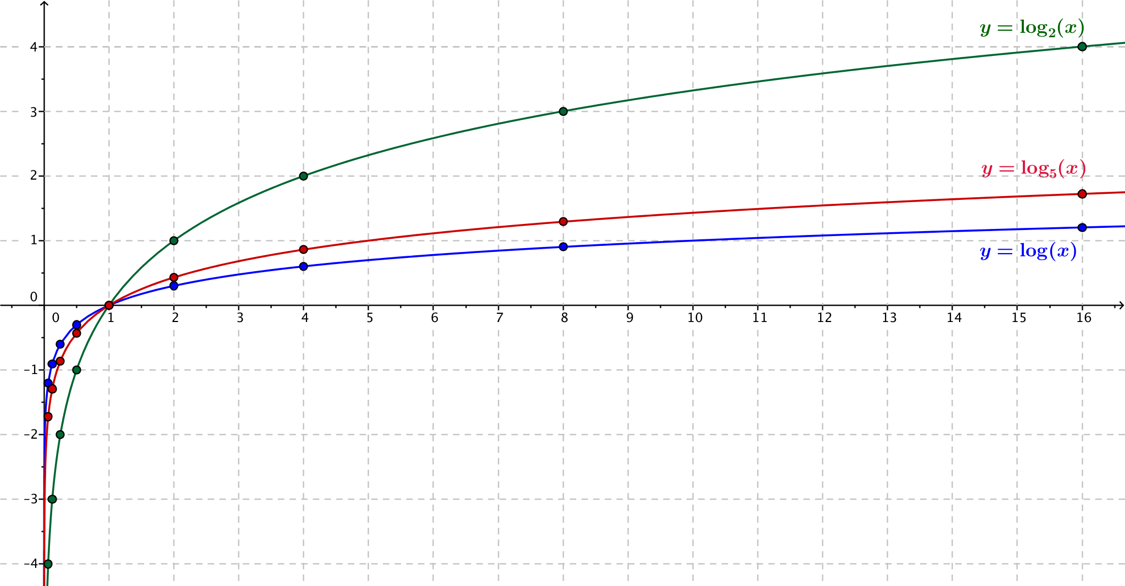
  - What does the graph indicate about the domain of your function?
The domain of each of these functions is the positive real numbers, which can be stated as $(0, ∞)$.

  - Describe the $x$-intercepts of the graph.
There is one $x$-intercept at $1$.

  - Describe the $y$-intercepts of the graph.
There are no $y$-intercepts of this graph.

  - Find the coordinates of the point on the graph with $y$-value $1$.
For the $10$-team, this is $\left(10,1\right)$. For the $2$-team, this is $\left(2,1\right)$. For the $5$-team, this is $(5,1)$.
  - Describe the behavior of the function as $x→0$.
As $x→0$, the function values approach negative infinity; that is, $f\left(x\right)→-∞$. The same is true for the functions $g$ and $h$.

  - Describe the end behavior of the function as $x→∞$.
As $x→∞$, the function values slowly increase. That is, $f\left(x\right)→∞$. The same is true for the functions $g$ and $h$.

  - Describe the range of your function.
The range of each of these functions is all real numbers, $(-∞, ∞)$.

  - Does this function have any relative maxima or minima? Explain how you know.
Since the function values continue to increase, and there are no peaks or valleys in the graph, the function has no relative maxima or minima.

Presentations (5 minutes)
Select three groups of students to present each of the three graphs, projecting each graph through a document camera or copying the graph onto a transparency sheet and displaying on an overhead projector. Ask students to point out the key features they identified in the Opening Exercise on the displayed graph. If students do not mention it, emphasize that the long-term behavior of these functions is they are always increasing, although very slowly.
As representatives from each group make their presentations, record their findings on a chart. This chart can be used to help summarize the lesson and to later display in the classroom.
 | $$f\left(x\right)=\log\left(x\right)$$ | $$g\left(x\right)=\log_{2}{(x)}$$ | $$h\left(x\right)=log_{5}\left(x\right)$$
Domain of the function | $$(0, ∞)$$ | $$(0, ∞)$$ | $$(0, ∞)$$
Range of the function | $$\left(-∞, ∞\right)$$ | $$\left(-∞, ∞\right)$$ | $$\left(-∞, ∞\right)$$
$x$-intercept | $$1$$ | $$1$$ | $$1$$
$y$-intercept | None | None | None
Point with $y$-value $1$ | $$(10,1)$$ | $$(2,1)$$ | $$(5,1)$$
Behavior as $x→0$ | $$f\left(x\right)→-∞$$ | $$g\left(x\right)→-∞$$ | $$h\left(x\right)→-∞$$
End behavior as $x→∞$ | $$f\left(x\right)→∞$$ | $$g\left(x\right)→∞$$ | $$h\left(x\right)→∞$$

Discussion (5 minutes)
Debrief the Opening Exercise by asking students to generalize the key features of the graphs $y=\log_{b}{(x)}$. If possible, display the graph of all three functions $f\left(x\right)=\log\left(x\right)$, $g\left(x\right)=\log_{2}\left(x\right)$, and $h\left(x\right)=\log_{5}{(x)}$ together on the same axes during this discussion.
We saw in Lesson 5 that the expression $2^{x}$ is defined for all real numbers $x$; therefore, the range of the function$g\left(x\right)=\log_{2}\left(x\right)$ is all real numbers. Likewise, the expressions ${10}^{x}$ and $5^{x}$ are defined for all real numbers $x$, so the range of the functions $f$ and $h$ are all real numbers. Notice that since the range is all real numbers in each case, there must be logarithms that are irrational. We saw examples of such logarithms in Lesson 16.
- What are the domain and range of the logarithm functions?
  - The domain is the positive real numbers, and the range is all real numbers.
- What do the three graphs of $f\left(x\right)=\log\left(x\right)$, $g\left(x\right)=\log_{2}\left(x\right)$, and $h\left(x\right)=\log_{5}\left(x\right)$ have in common?
  - The graphs all cross the $x$-axis at $(1, 0)$.
  - None of the graphs intersect the $y$-axis.
  - They have the same end behavior as $x→∞$, and they have the same behavior as $x→0$.
  - The functions all increase quickly for $0<x<1$, then increase more and more slowly.
- What do you expect the graph of $y=\log_{3}{(x)}$ will look like?
  - It will look just like the other graphs, except that it will lie between the graphs of $y=\log_{2}{(x)}$ and
$y=\log_{5}{(x)}$ because $2<3<5$.
- What do you expect the graph of $y=\log_{b}{(x)}$ will look like for any number $b>1$?
  - It will have the same key features of the other graphs of logarithmic functions. As the value of $b$ increases, the graph will flatten as $x→∞$.

Exercise 1 (8 minutes)
Keep students in the same groups for this exercise. Students will plot points and sketch the graph of $y=\log_{\frac{1}{b}}{(x)}$ for $b=10$, $b=2$, or$b=5$, depending on whether they are on the $10$-team, the $2$-team, or the$5$-team. Then, students will observe the relationship between their two graphs, justify the relationship using properties of logarithms, and generalize the observed relationship to graphs of $y=\log_{b}{(x)}$and $y=\log_{\frac{1}{b}}{(x)}$ for $b>0$, $b≠1$.
Exercises
- Graph the points in the table for your assigned function $r\left(x\right)=log_{\frac{1}{10}}(x)$, $s\left(x\right)=log_{\frac{1}{2}}\left(x\right)$, or $t\left(x\right)=log_{\frac{1}{5}}(x)$ for
$0<x≤16$. Then, sketch a smooth curve through those points, and answer the questions that follow.
$10$-team  $r\left(x\right)=log_{\frac{1}{10}}(x)$ |  |  | $2$-team  $$s\left(x\right)=log_{\frac{1}{2}}(x)$$ |  |  | $e$-team  $$t\left(x\right)=log_{\frac{1}{5}}(x)$$
$$x$$ | $$r(x)$$ |  | $$x$$ | $$s(x)$$ |  | $$x$$ | $$t(x)$$
$$0.0625$$ | $$1.20$$ |  | $$0.0625$$ | $$4$$ |  | $$0.0625$$ | $$1.72$$
$$0.125$$ | $$0.90$$ |  | $$0.125$$ | $$3$$ |  | $$0.125$$ | $$1.29$$
$$0.25$$ | $$0.60$$ |  | $$0.25$$ | $$2$$ |  | $$0.25$$ | $$0.86$$
$$0.5$$ | $$0.30$$ |  | $$0.5$$ | $$1$$ |  | $$0.5$$ | $$0.43$$
$$1$$ | $$0$$ |  | $$1$$ | $$0$$ |  | $$1$$ | $$0$$
$$2$$ | $$-0.30$$ |  | $$2$$ | $$-1$$ |  | $$2$$ | $$-0.43$$
$$4$$ | $$-0.60$$ |  | $$4$$ | $$-2$$ |  | $$4$$ | $$-0.86$$
$$8$$ | $$-0.90$$ |  | $$8$$ | $$-3$$ |  | $$8$$ | $$-1.29$$
$$16$$ | $$-1.20$$ |  | $$16$$ | $$-4$$ |  | $$16$$ | $$-1.72$$
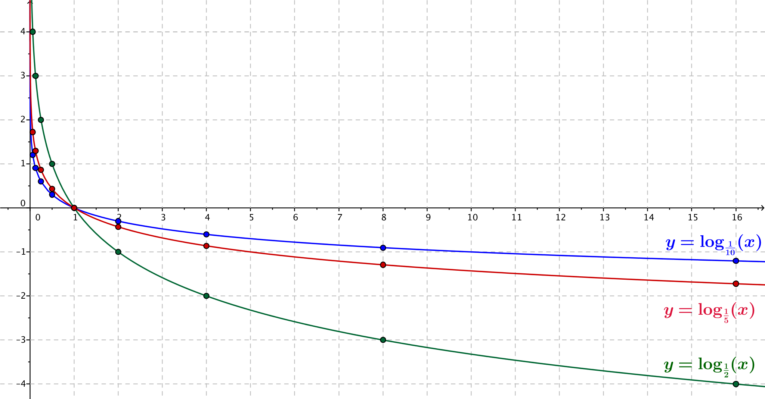
  - What is the relationship between your graph in the Opening Exercise and your graph from this exercise?
The second graph is the reflection of the graph in the Opening Exercise across the $x$-axis.
Scaffolding:
- Students struggling with the comparison of graphs may find it easier to draw the graphs on transparent plastic sheets and compare them that way.
  - Why does this happen? Use the change of base formula to justify what you have observed in part (a).
Using the change of base formula, we have $log_{\frac{1}{2}}\left(x\right)=\frac{log_{2}\left(x\right)}{log_{2}\left(\frac{1}{2}\right)}$. Since $log_{2}\left(\frac{1}{2}\right)=-1$, we have $log_{\frac{1}{2}}\left(x\right)=\frac{log_{2}\left(x\right)}{-1}$, so $log_{\frac{1}{2}}\left(x\right)=-log_{2}(x)$. Thus, the graph of $y=log_{\frac{1}{2}}\left(x\right)$ is the reflection of the graph of $y=log_{2}\left(x\right)$across the $x$-axis.

Discussion (4 minutes)
Ask students from each team to share their graphs results from part (a) of Exercise 1 with the class. During their presentations, complete the chart below.
 | $$r\left(x\right)=log_{\frac{1}{10}}{(x)}$$ | $$s\left(x\right)=log_{\frac{1}{2}}{(x)}$$ | $$t\left(x\right)=log_{\frac{1}{5}}{(x)}$$
Domain of the function | $$(0, ∞)$$ | $$(0, ∞)$$ | $$(0, ∞)$$
Range of the function | $$\left(-∞, ∞\right)$$ | $$\left(-∞, ∞\right)$$ | $$\left(-∞, ∞\right)$$
$x$-intercept | $$1$$ | $$1$$ | $$1$$
$y$-intercept | None | None | None
Point with $y$-value $-1$ | $$(10,-1)$$ | $$(2,-1)$$ | $$(5,-1)$$
Behavior as $x→0$ | $$r\left(x\right)→∞$$ | $$s\left(x\right)→∞$$ | $$t\left(x\right)→∞$$
End behavior as $x→∞$ | $$r\left(x\right)→∞$$ | $$s\left(x\right)→-∞$$ | $$t\left(x\right)→-∞$$

Then proceed to hold the following discussion.
- From what we have seen of these three sets of graphs of functions, can we state the relationship between the graphs of $y=\log_{b}\left(x\right)$ and $y=\log_{\frac{1}{b}}\left(x\right)$, for $b≠1$?
  - If $b≠1$, then the graphs of $y=\log_{b}\left(x\right)$ and $y=\log_{\frac{1}{b}}\left(x\right)$ are reflections of each other across the
$x$-axis.
- Describe the key features of the graph of $y=\log_{b}{(x)}$ for $0<b<1$.
  - The graph crosses the $x$-axis at $(1, 0)$.
  - The graph does not intersect the $y$-axis.
  - The graph passes through the point $\left(b, -1\right)$.
  - As $x→0$, the function values increase quickly; that is, $f\left(x\right)→∞$.
  - As $x→ ∞$, the function values continue to decrease; that is, $f\left(x\right)→-∞$.
  - There are no relative maxima or relative minima.

Exercises 2–3 (6 minutes)
Keep students in the same groups for this set of exercises. Students will plot points and sketch the graph of
$y=\log_{b}{(bx)}$ for $b=10$, $b=2$, or$b=5$, depending on whether they are on the $10$-team, the $2$-team, or the
$5$-team. Then, students will observe the relationship between their two graphs, justify the relationship using properties of logarithms, and generalize the observed relationship to graphs of $y=\log_{b}{(x)}$and $y=\log_{b}{(x)}$ for $b>0$, $b≠1$. If there is time at the end of these exercises, consider using GeoGebra or other dynamic geometry software to demonstrate the property illustrated in Exercise 3 below by graphing $y=\log_{2}{(x)}$, $y=log_{2}(2x)$, and $y=1+\log_{2}{(x)}$ on the same axes.
Consider having students graph these functions on the same axes as used in the Opening Exercise.

- In general, what is the relationship between the graph of a function $y=f(x)$ and the graph of $y=f(kx)$ for a constant $k$?
The graph of $y=f(kx)$ is a horizontal scaling of the graph of $y=f(x)$.

- Graph the points in the table for your assigned function $u\left(x\right)=log(10x)$, $v\left(x\right)=log_{2}\left(2x\right)$, or $w(x)=log_{5}(5x)$ for $0<x≤16$. Then sketch a smooth curve through those points, and answer the questions that follow.
$10$-team  $u\left(x\right)=log(10x)$ |  |  | $2$-team  $$v\left(x\right)=log_{2}(2x)$$ |  |  | $5$-team  $$w(x)=log_{5}(5x)$$
$$x$$ | $$u(x)$$ |  | $$x$$ | $$v(x)$$ |  | $$x$$ | $$w(x)$$
$$0.0625$$ | $$-0.20$$ |  | $$0.0625$$ | $$-3$$ |  | $$0.0625$$ | $$-0.72$$
$$0.125$$ | $$0.10$$ |  | $$0.125$$ | $$-2$$ |  | $$0.125$$ | $$-0.29$$
$$0.25$$ | $$0.40$$ |  | $$0.25$$ | $$-1$$ |  | $$0.25$$ | $$0.14$$
$$0.5$$ | $$0.70$$ |  | $$0.5$$ | $$0$$ |  | $$0.5$$ | $$0.57$$
$$1$$ | $$1$$ |  | $$1$$ | $$1$$ |  | $$1$$ | $$1$$
$$2$$ | $$1.30$$ |  | $$2$$ | $$2$$ |  | $$2$$ | $$1.43$$
$$4$$ | $$1.60$$ |  | $$4$$ | $$3$$ |  | $$4$$ | $$1.86$$
$$8$$ | $$1.90$$ |  | $$8$$ | $$4$$ |  | $$8$$ | $$2.29$$
$$16$$ | $$2.20$$ |  | $$16$$ | $$5$$ |  | $$16$$ | $$2.72$$
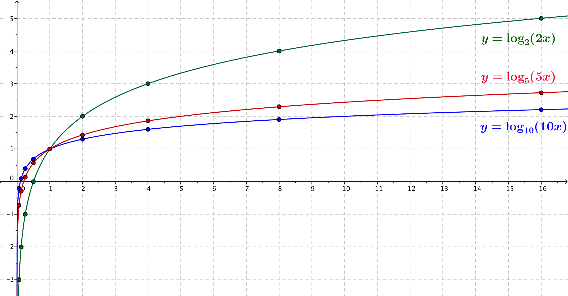

  - Describe a transformation that takes the graph of your team’s function in this exercise to the graph of your team’s function in the Opening Exercise.
MP.7
The graph produced in this exercise is a vertical translation of the graph from the Opening Exercise by one unit upward.

  - Do your answers to Exercise 2 and part (a) agree? If not, use properties of logarithms to justify your observations in part (a).
The answers to Exercise 2 and part (a) do not appear to agree. However, because $log_{b}\left(bx\right)= log_{b}\left(b\right)+ log_{b}\left(x\right)=1+log_{b}\left(x\right)$, the graph of $y= log_{b}(bx)$ and the graph of $y=1+log_{b}\left(x\right)$ coincide.

Closing (3 minutes)
Ask students to respond to these questions in writing or orally to a partner.
- In which quadrants is the graph of the function $f\left(x\right)=\log_{b}\left(x\right)$ located?
  - The first and fourth quadrants.
- When $b>1$, for what values of $x$ are the values of the function $f\left(x\right)=\log_{b}\left(x\right)$ negative?
  - When $b>1$, $f\left(x\right)=\log_{b}\left(x\right)$ is negative for $0<x<1$.
- When $0<b<1$, for what values of $x$ are the values of the function $f\left(x\right)=\log_{b}\left(x\right)$ negative?
  - When $0<b<1$, $f\left(x\right)=\log_{b}\left(x\right)$ is negative for $x>1$.
- What are the key features of the graph of a logarithmic function $f(x)=\log_{b}{(x)}$ when $b>1$?
  - The domain of the function is all positive real numbers, and the range is all real numbers. The
$x$-intercept is $1$, the graph passes through $(b,1)$ and there is no $y$-intercept. As $x→0$, $f\left(x\right)→-∞$ quickly, and as $x→∞$, $f\left(x\right)→∞$ slowly.
- What are the key features of the graph of a logarithmic function $f(x)=\log_{b}{(x)}$ when $0<b<1$?
  - The domain of the function is the positive real numbers, and the range is all real numbers. The
$x$-intercept is $1$, the graph passes through $\left(b,-1\right)$, and there is no $y$-intercept. As $x→0$, $f\left(x\right)→∞$ quickly, and as $x→∞$, $f\left(x\right)→-∞$slowly.
Lesson Summary
The function $f\left(x\right)=\log_{b}\left(x\right)$ is defined for irrational and rational numbers. Its domain is all positive real numbers. Its range is all real numbers.
The function $f\left(x\right)=\log_{b}\left(x\right)$goes to negative infinity as $x$ goes to zero. It goes to positive infinity as $x$ goes to positive infinity.
The larger the base $b$, the more slowly the function $f\left(x\right)=\log_{b}\left(x\right)$ increases.
By the change of base formula, $\log_{\frac{1}{b}}\left(x\right){=-log}_{b}\left(x\right)$.

Exit Ticket (5 minutes)

Name Date
Lesson 17: Graphing the Logarithm Function

Exit Ticket

Graph the function $f\left(x\right)=\log_{3}\left(x\right)$ without using a calculator, and identify its key features.

Exit Ticket Sample Solutions

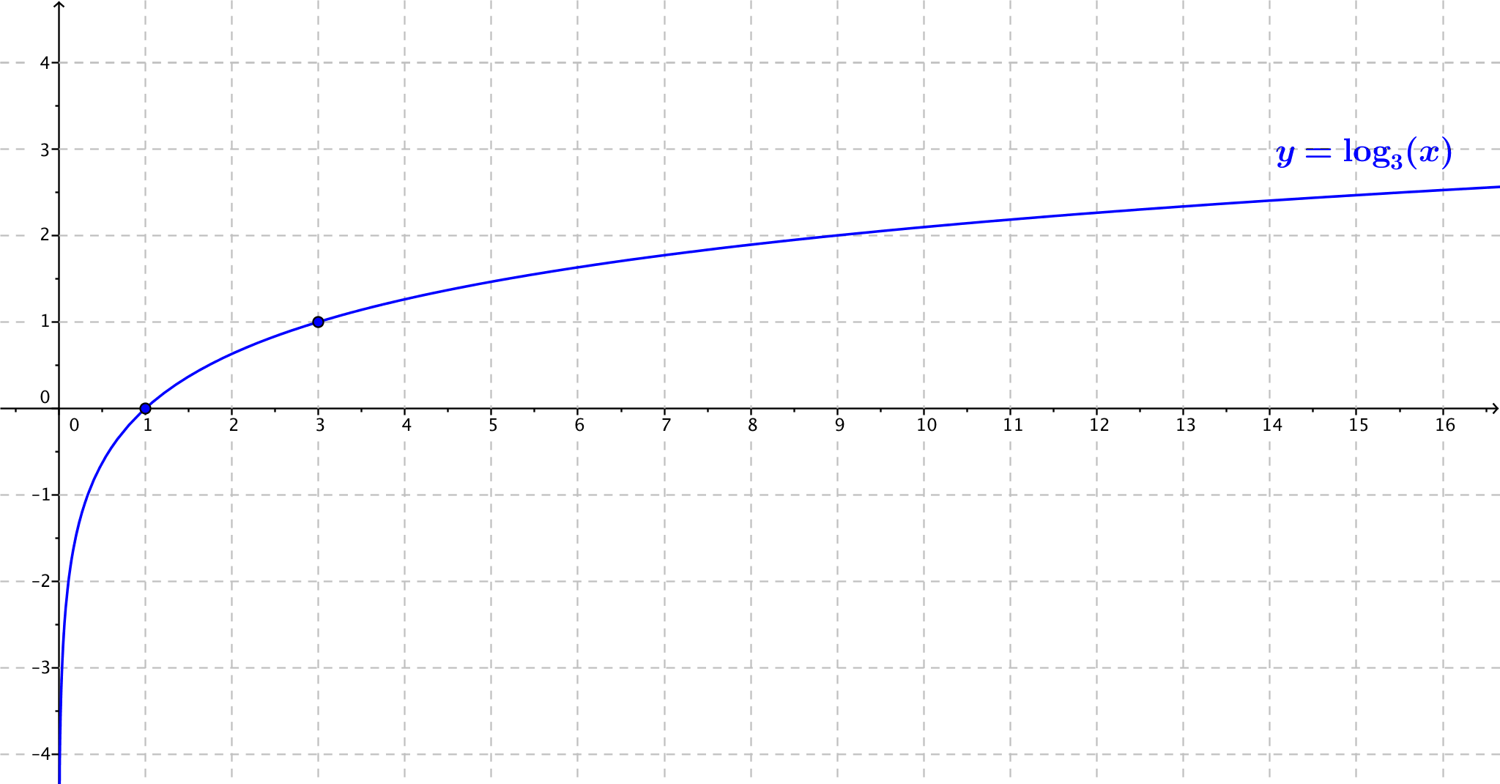
Graph the function $f\left(x\right)=\log_{3}\left(x\right)$ without using a calculator, and identify its key features.
Key features:
The domain is $\left(0, ∞\right)$.
The range is all real numbers.
End behavior:
As $x→0$, $f\left(x\right)→-∞$.
As $x→∞$, $f\left(x\right)→∞$.
Intercepts:
$x$-intercept: There is one $x$-intercept at$1$.
$y$-intercept: The graph does not cross the $y$-axis.
The graph passes through $\left(3,1\right)$.

Problem Set Sample Solutions
For the Problem Set, students will need graph paper. They should not use calculators or other graphing technology. In Problems 2 and 3, students compare different representations of logarithmic functions. Problems 4–6 continue the reasoning from the lesson in which students observed the logarithmic properties through the transformations of logarithmic graphs.
Fluency problems 9–10 are a continuation of work done in Algebra I and are in this lesson to recall concepts that are required in Lesson 19. Similar review problems occur in the next lesson.

$$x$$ | $$Q(x)$$
$$0.1$$ | $$1.66$$
$$0.3$$ | $$0.87$$
$$0.5$$ | $$0.50$$
$$1.00$$ | $$0.00$$
$$2.00$$ | $$-0.50$$
$$4.00$$ | $$-1.00$$
$$6.00$$ | $$-1.29$$
$$10.00$$ | $$-1.66$$
$$12.00$$ | $$-1.79$$
- The function $Q\left(x\right)=\log_{b}\left(x\right)$ has function values in the table at right.
  - Use the values in the table to sketch the graph of $y=Q\left(x\right)$.

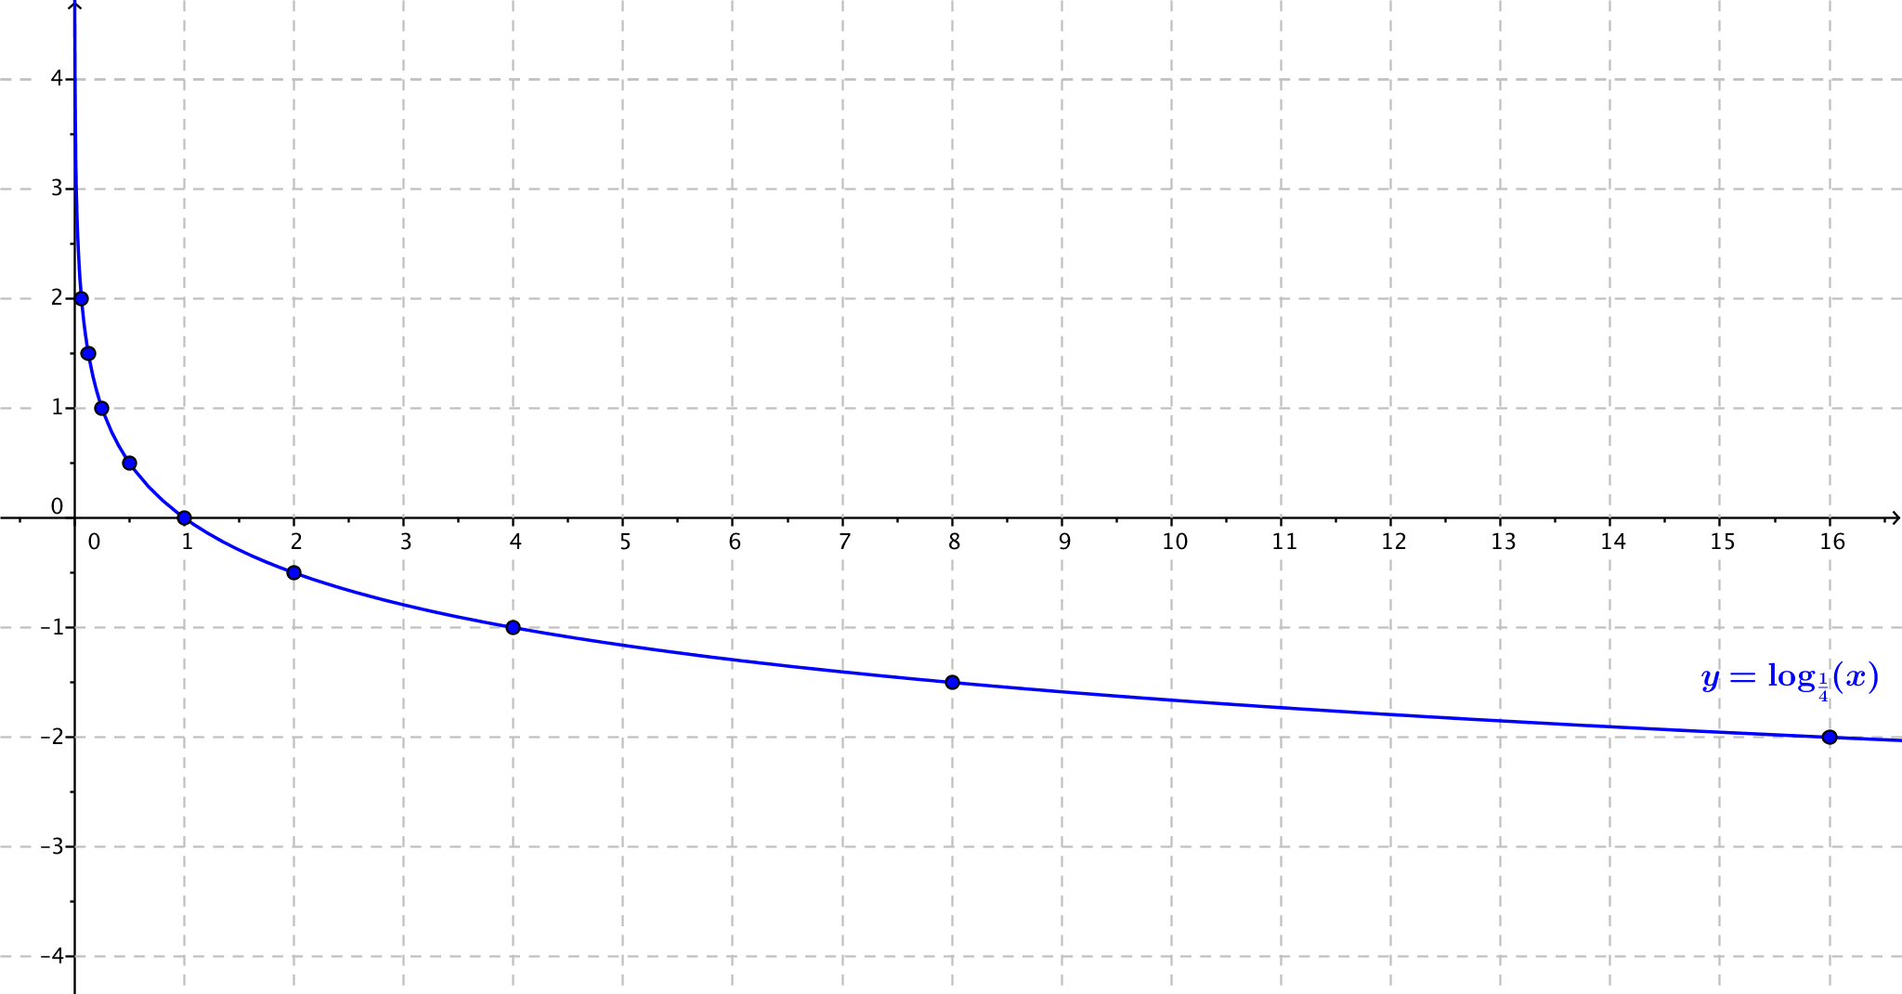

  - What is the value of $b$ in $Q\left(x\right)=\log_{b}\left(x\right)$? Explain how you know.
Because the point $(4, -1)$ is on the graph of $y=Q(x)$, we know $log_{b}\left(4\right)=-1$, so $b^{-1}=4$. It follows that $b=\frac{1}{4}$.

  - Identify the key features in the graph of $y=Q(x)$.
Because $0<b<1$, the function values approach $∞$ as $x→0$, and the function values approach $-∞$ as
$x→∞$. There is no $y$-intercept, and the $x$-intercept is $1$. The domain of the function is $(0, ∞)$, the range is $(-∞, ∞)$, and the graph passes through $(b, 1)$.
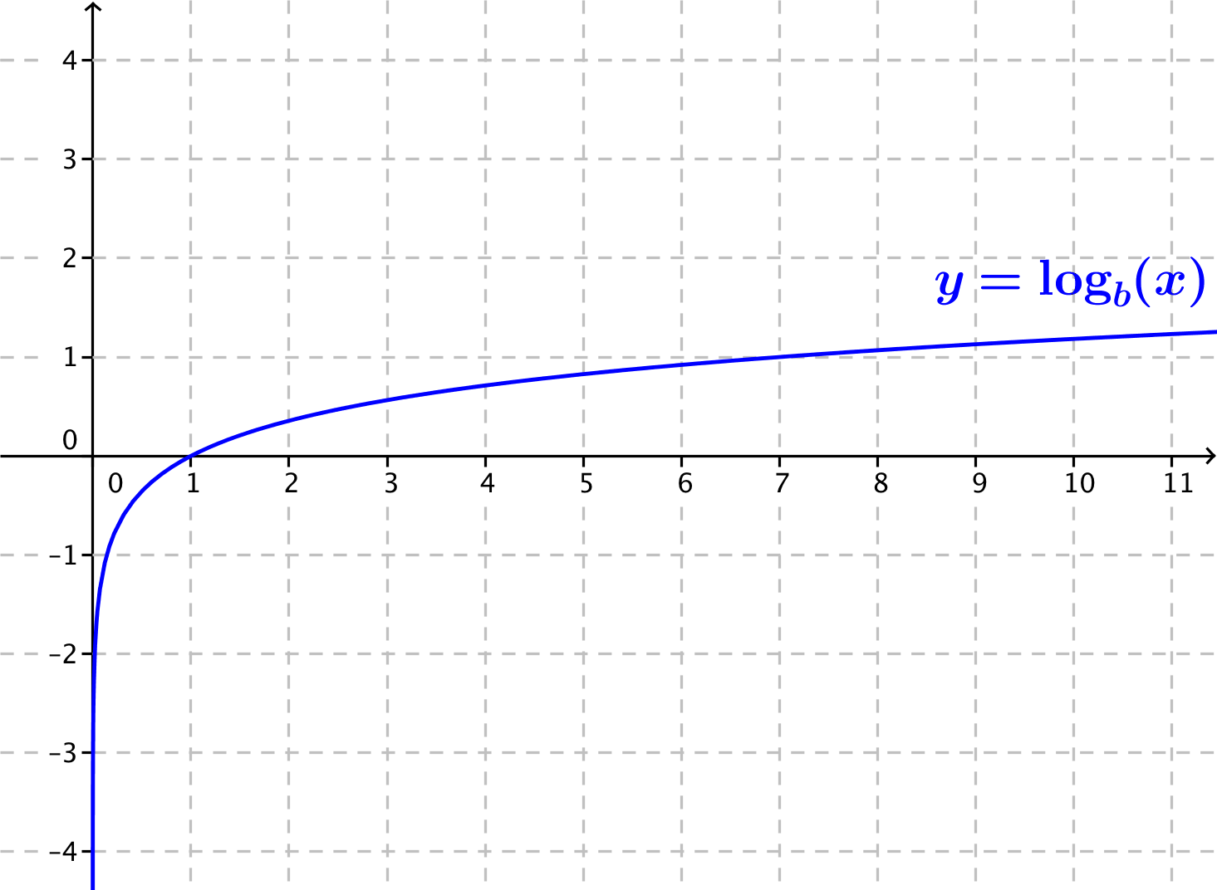
- Consider the logarithmic functions
$f\left(x\right)=log_{b}(x)$, $g\left(x\right)=log_{5}(x)$, where $b$ is a positive real number, and $b≠1$. The graph of $f$ is given at right.
  - Is $b>5$, or is $b<5$? Explain how you know.
Since $f\left(7\right)=1$, and $g\left(7\right)≈1.21$, the graph of $f$ lies below the graph of $g$ for$x≥1$. This means that $b$ is larger than $5$, so we have $b>5$. (Note: The actual value of $b$ is $7$.)

  - Compare the domain and range of functions $f$ and $g$.
Functions $f$ and $g$ have the same domain, $\left(0, ∞\right)$, and the same range, $\left(-∞, ∞\right)$.

  - Compare the $x$-intercepts and $y$-intercepts of $f$ and $g$.
Both $f$ and $g$ have an $x$-intercept at $1$ and no $y$-intercepts.

  - Compare the end behavior of $f$and$g$.
As $x→∞$, both $f\left(x\right)→∞$ and $g\left(x\right)→∞$.

- Consider the logarithmic functions $f\left(x\right)=log_{b}(x)$ and $g\left(x\right)=log_{\frac{1}{2}}(x)$, where $b$ is a positive real number and
$b≠1$. A table of approximate values of $f$ is given below.
$$x$$ | $$f(x)$$
$$\frac{1}{4}$$ | $$0.86$$
$$\frac{1}{2}$$ | $$0.43$$
$$1$$ | $$0$$
$$2$$ | $$-0.43$$
$$4$$ | $$-0.86$$

  - Is $b>\frac{1}{2}$, or is $b<\frac{1}{2}$? Explain how you know.
Since $g\left(2\right)=-1$, and $f\left(2\right)≈-0.43$, the graph of $f$ lies above the graph of $g$ for$x≥1$. This means that $b$ is closer to $0$ than $\frac{1}{2}$ is, so we have $b<\frac{1}{2}$. (Note: The actual value of $b$ is $\frac{1}{5}$.)

  - Compare the domain and range of functions $f$ and $g$.
Functions $f$ and $g$ have the same domain, $\left(0, ∞\right)$, and the same range, $\left(-∞, ∞\right)$.

  - Compare the $x$-intercepts and $y$-intercepts of $f$ and $g$.
Both $f$ and $g$ have an $x$-intercept at $1$ and no $y$-intercepts.

  - Compare the end behavior of $f$and$g$.
As $x→∞$, both $f\left(x\right)→-∞$ and $g\left(x\right)→-∞$.

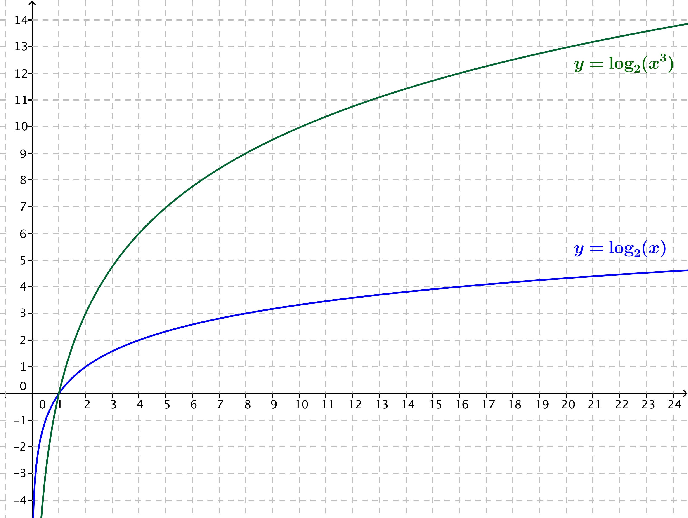
- On the same set of axes, sketch the functions $f\left(x\right)=log_{2}(x)$ and $g\left(x\right)=log_{2}(x^{3})$.

  - Describe a transformation that takes the graph of $f$ to the graph of $g$.
The graph of $g$ is a vertical scaling of the graph of $f$by a factor of $3$.

  - Use properties of logarithms to justify your observations in part (a).
Using properties of logarithms, we know that $g\left(x\right)=log_{2}\left(x^{3}\right)=3log_{2}\left(x\right)=3 f\left(x\right)$. Thus, the graph of $f$is a vertical scaling of the graph of$g$ by a factor of $3$.

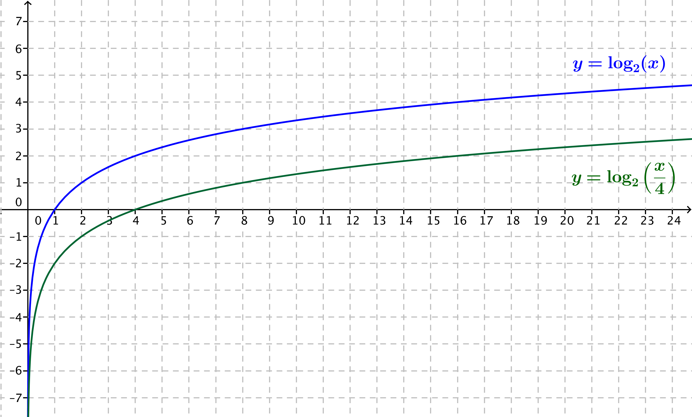
- On the same set of axes, sketch the functions $f\left(x\right)=log_{2}(x)$ and $g(x)=log_{2}\left(\frac{x}{4}\right)$.
  - Describe a transformation that takes the graph of $f$ to the graph of $g$.
The graph of $g$ is the graph of $f$ translated down by $2$ units.

  - Use properties of logarithms to justify your observations in part (a).
Using properties of logarithms, $g\left(x\right)=log_{2}\left(\frac{x}{4}\right)\left(\frac{x}{4}\right)=log_{2}\left(x\right)-log_{2}\left(4\right)=f\left(x\right)-2$. Thus, the graph of $g$ is a translation of the graph of $f$ down $2$ units.

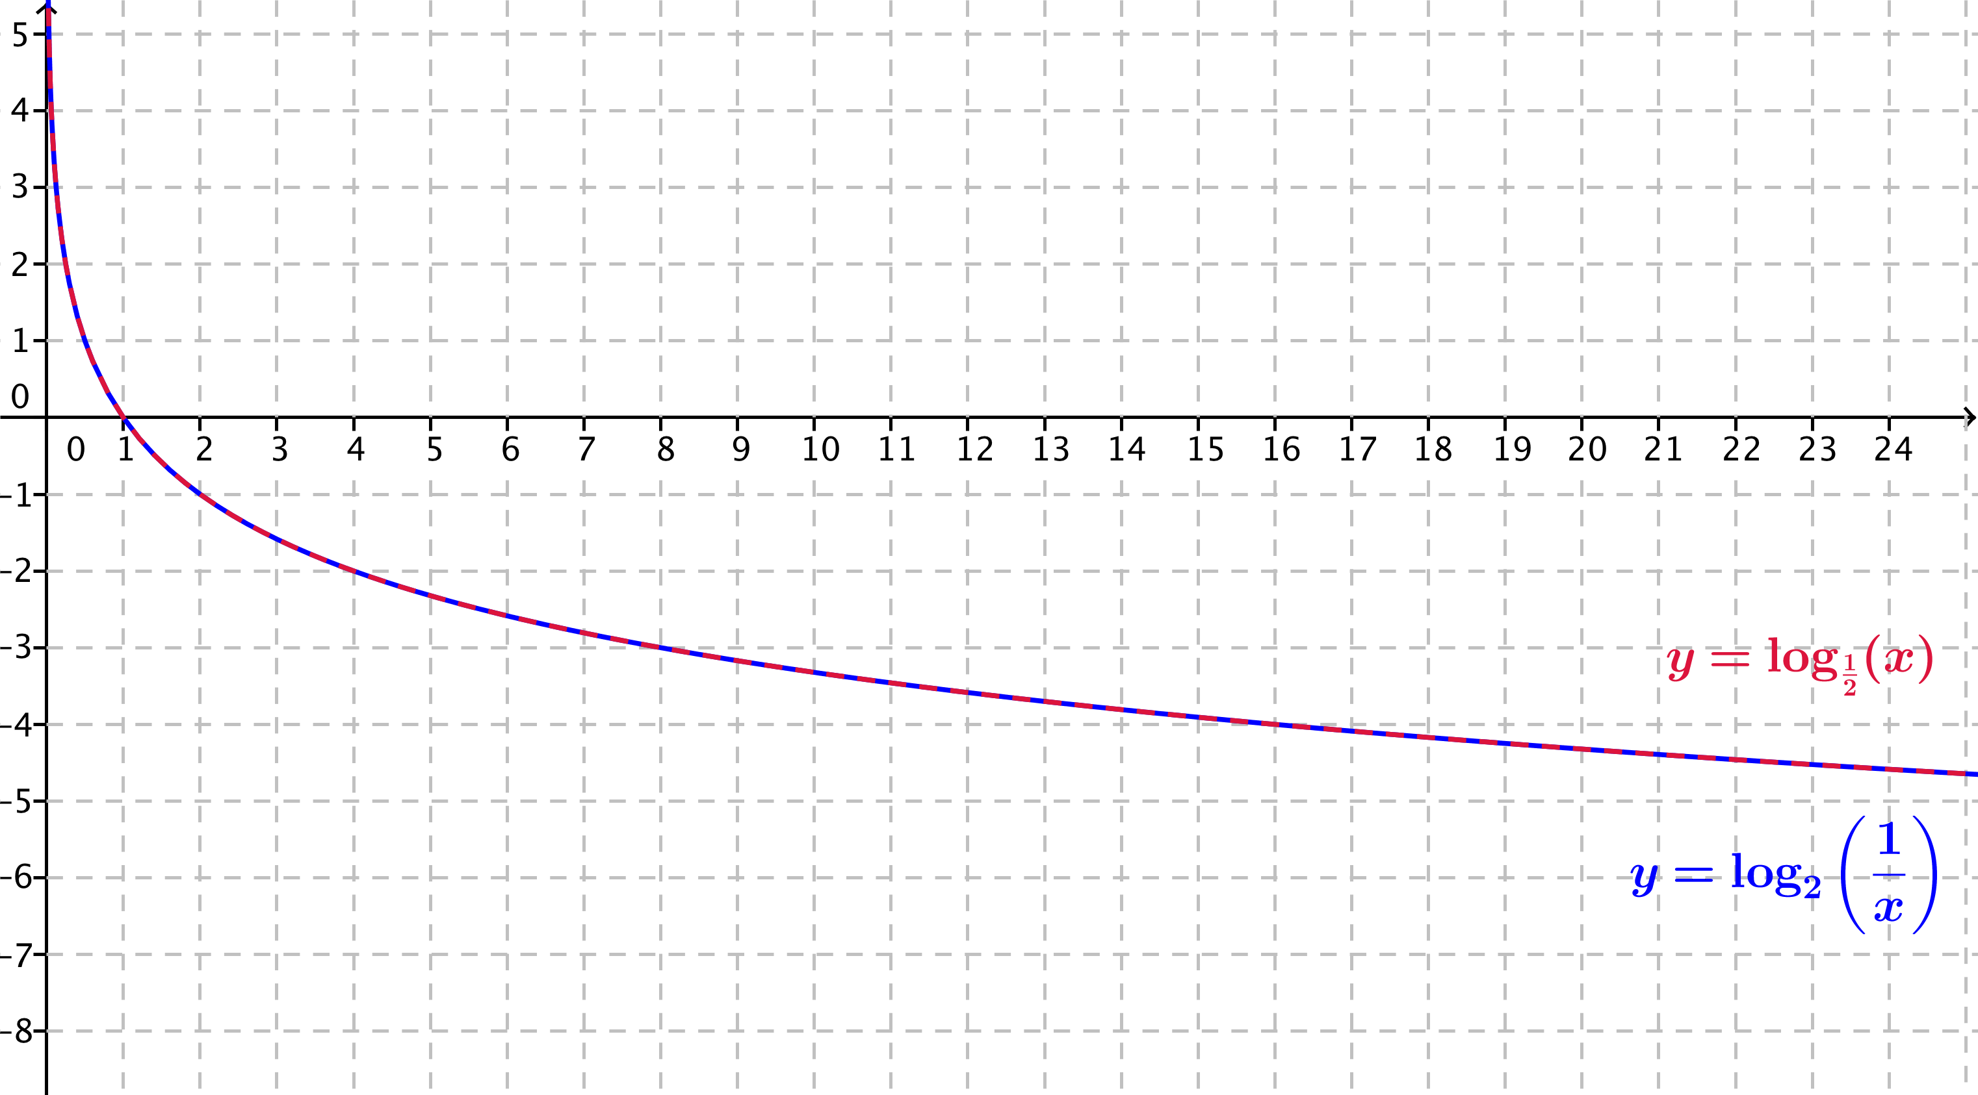
- On the same set of axes, sketch the functions $f\left(x\right)=log_{\frac{1}{2}}(x)$ and $g\left(x\right)=log_{2}\left(\frac{1}{x}\right)$.

  - Describe a transformation that takes the graph of $f$ to the graph of $g$.
These two graphs coincide, so the identity transformation takes the graph of $f$ to the graph of $g$.

  - Use properties of logarithms to justify your observations in part (a).
If $log_{\frac{1}{2}}\left(x\right)=y$, then ${\left(\frac{1}{2}\right)}^{y}=x$, so $\frac{1}{x}=2^{y}$. Then, $y=log_{2}$; so, $log_{2}\left(\frac{1}{x}\right)= log_{\frac{1}{2}}\left(x\right)$; thus, $g\left(x\right)=f\left(x\right)$ for all $x>0$.

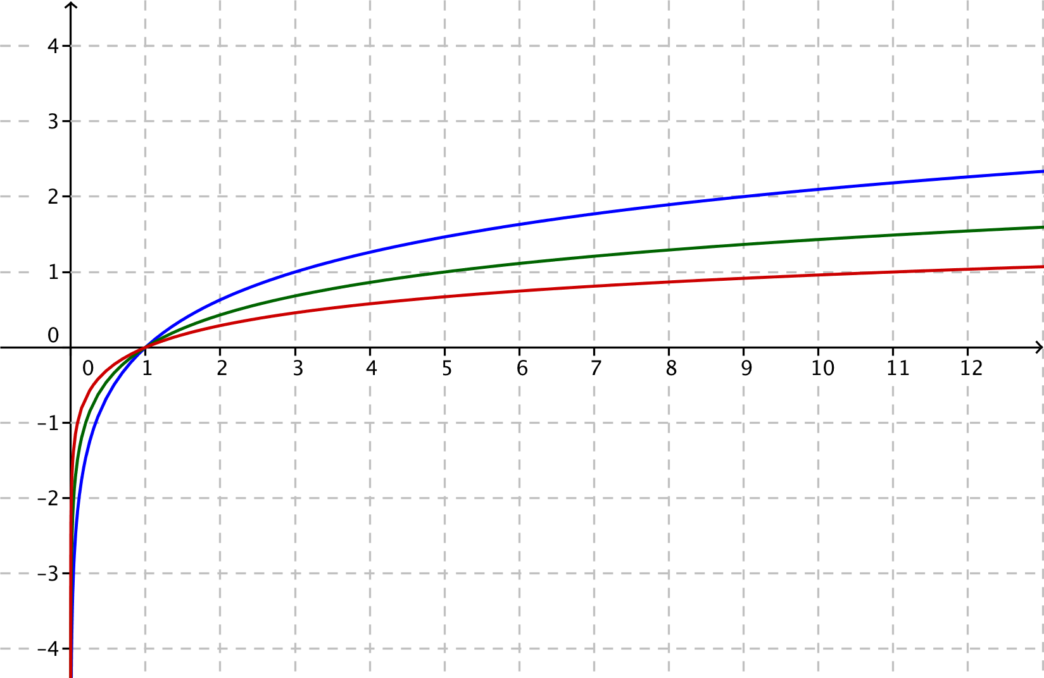
- The figure below shows graphs of the functions $f\left(x\right)=log_{3}(x)$, $g\left(x\right)=log_{5}\left(x\right)$, and $h\left(x\right)=log_{11}(x)$.

  - Identify which graph corresponds to which function. Explain how you know.
The top graph (in blue) is the graph of $f\left(x\right)=log_{3}(x)$, the middle graph (in green) is the graph of
$g\left(x\right)=log_{5}\left(x\right)$, and the lower graph (in red) is the graph of $h\left(x\right)=log_{11}(x)$. We know this because the blue graph passes through the point $(3,1)$, the green graph passes through the point $\left(5,1\right)$, and the red graph passes through the point $(11,1)$. We also know that the higher the value of the base $b$, the flatter the graph, so the graph of the function with the largest base, $11$, must be the red graph on the bottom, and the graph of the function with the smallest base, $3$, must be the blue graph on the top.

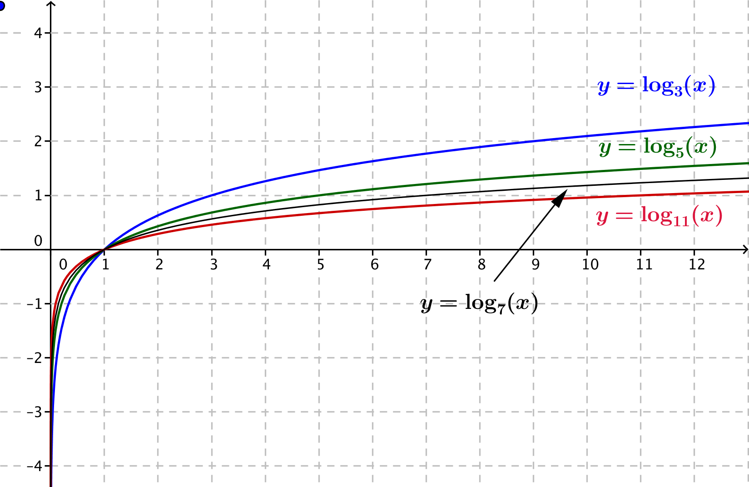
  - Sketch the graph of $k\left(x\right)=log_{7}(x)$ on the same axes.

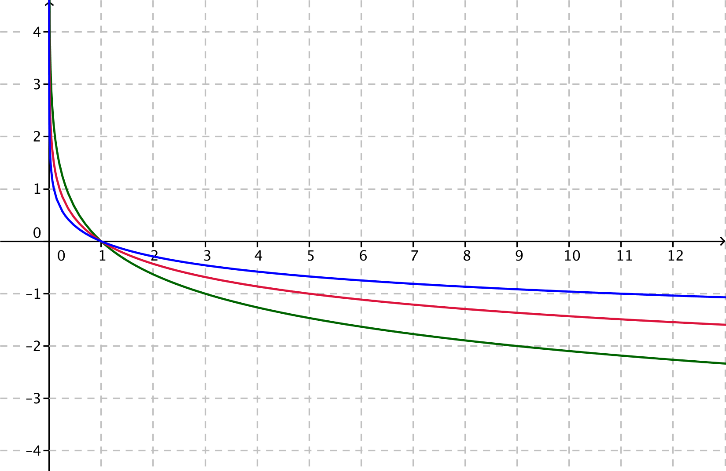
- The figure below shows graphs of the functions $f\left(x\right)=log_{\frac{1}{3}}(x)$, $g\left(x\right)=log_{\frac{1}{5}}\left(x\right)$, and $h\left(x\right)=log_{\frac{1}{11}}(x)$.

  - Identify which graph corresponds to which function. Explain how you know.
The top graph (in blue) is the graph of $h\left(x\right)=log_{\frac{1}{11}}(x)$, the middle graph (in red) is the graph of
$g\left(x\right)=log_{\frac{1}{5}}\left(x\right)$, and the lower graph is the graph of $f\left(x\right)=log_{\frac{1}{3}}(x)$. We know this because the blue graph passes through the point $(11,-1)$, the red graph passes through the point $\left(5,-1\right)$, and the green graph passes through the point $(3,-1)$.

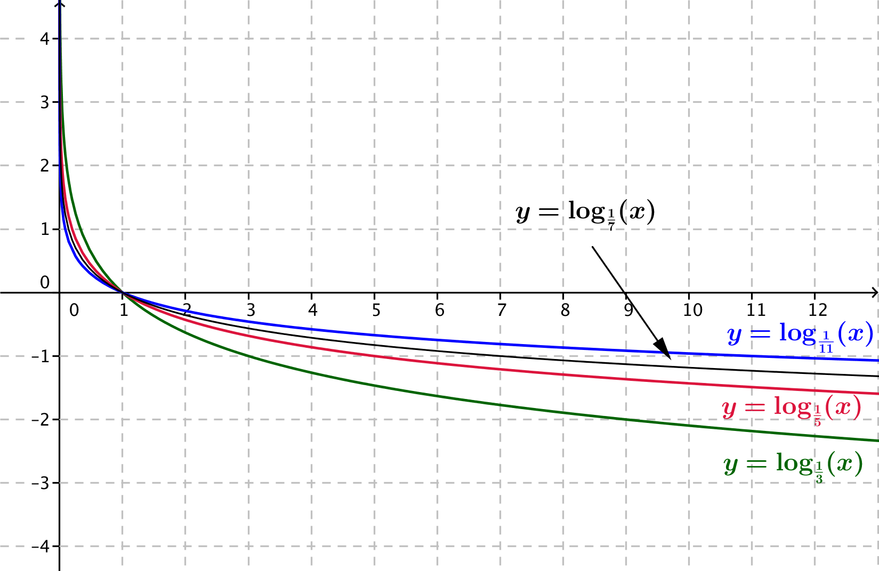
  - Sketch the graph of $k\left(x\right)=log_{\frac{1}{7}}(x)$ on the same axes.

- For each function $f$, find a formula for the function $h$ in terms of $x$. Part (a) has been done for you.
  - If $f\left(x\right)=x^{2}+x$, find $h\left(x\right)=f(x+1)$.
$$h\left(x\right)=f\left(x+1\right) \\ ={\left(x+1\right)}^{2}+\left(x+1\right) \\ =x^{2}+3x+2$$

  - If $f\left(x\right)=\sqrt{x^{2}+\frac{1}{4}}$, find $h\left(x\right)=f\left(\frac{1}{2}x\right)$.
$$h\left(x\right)=\frac{1}{2}\sqrt{x^{2}+1}$$

  - If $f\left(x\right)=log⁡(x)$, find $h\left(x\right)=f\left(\sqrt[3]{10x}\right)$ when $x>0$.
$$h(x)=\frac{1}{3}+\frac{1}{3}log(x)$$

  - If $f\left(x\right)=3^{x}$, find $h\left(x\right)=f\left(\log_{3}\left(x^{2}+3\right)\right)$.
$$h\left(x\right)=x^{2}+3$$

  - If $f\left(x\right)=x^{3}$, find $h\left(x\right)=f\left(\frac{1}{x^{3}}\right)$ when $x≠0$.
$$h(x)=\frac{1}{x^{6}}$$

  - If $f\left(x\right)=x^{3}$, find $h\left(x\right)=f\left(\sqrt[3]{x}\right)$.
$$h(x)=x$$

  - If $f\left(x\right)=\sin{(x)},$ find $h\left(x\right)=f(x+\frac{π}{2})$.
$$h(x)=sin\left(x+\frac{π}{2}\right)$$

  - If $f\left(x\right)=x^{2}+2x+2,$ find $h\left(x\right)=f\left(\cos\left(x\right)\right)$.
$$h(x)={\left(cos(x)\right)}^{2}+2\cos\left(x\right)+2$$
- For each of the functions $f$ and $g$ below, write an expression for (i) $f\left(g\left(x\right)\right)$, (ii) $g\left(f\left(x\right)\right)$, and (iii) $f\left(f\left(x\right)\right)$ in terms of $x$. Part (a) has been done for you.
  - $f\left(x\right)=x^{2}$, $g\left(x\right)=x+1$
$$f\left(g\left(x\right)\right)=f\left(x+1\right) \\ ={\left(x+1\right)}^{2} \\ g\left(f\left(x\right)\right)=g\left(x^{2}\right) \\ =x^{2}+1$$
$$f\left(f\left(x\right)\right)=f\left(x^{2}\right) \\ ={\left(x^{2}\right)}^{2} \\ =x^{4}$$

  - $f\left(x\right)=\frac{1}{4}x-8$, $g\left(x\right)=4x+1$
    - $x-\frac{31}{4}$
    - $x-31$
    - $\frac{1}{16}x-10$
  - $f\left(x\right)=\sqrt[3]{x+1},$ $g\left(x\right)=x^{3}1$
    - $x$
    - $x$
    - $\sqrt[3]{\sqrt[3]{x+1}+1}$

  - $f\left(x\right)=x^{3}$, $g\left(x\right)=\frac{1}{x}$
    - $\frac{1}{x^{3}}$
    - $\frac{1}{x^{3}}$
    - $x^{9}$
  - $f\left(x\right)=\left|x\right|$, $g\left(x\right)=x^{2}$
    - $|x^{2} |$ or $x^{2}$
    - ${\left(\left|x\right|\right)}^{2}$ or $x^{2}$
    - $\left|x\right|$

Extension:
- Consider the functions $f\left(x\right)=log_{2}(x)$ and $\left(x\right)=\sqrt{x-1}$.
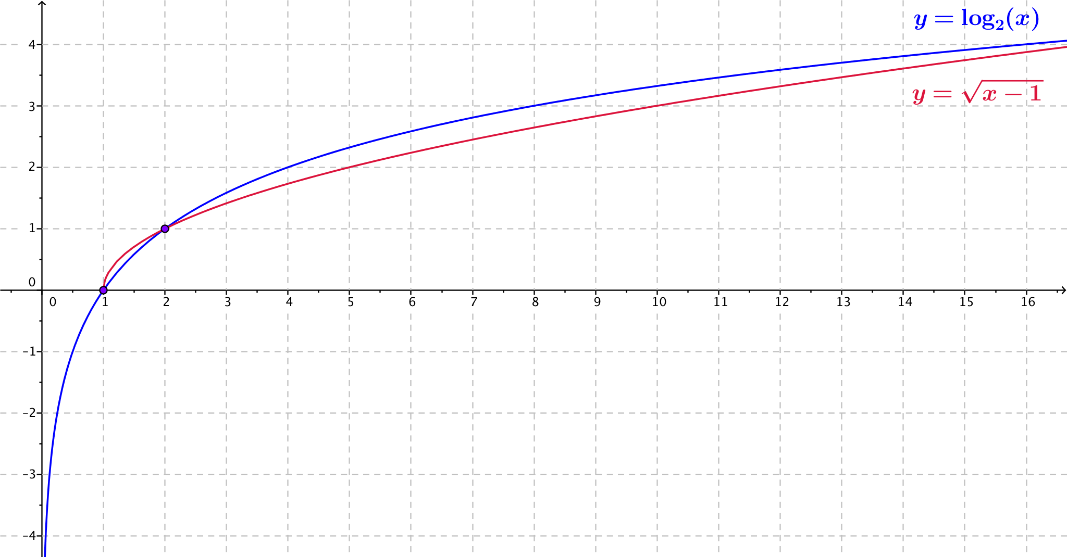
  - Use a calculator or other graphing utility to produce graphs of $f\left(x\right)=log_{2}(x)$ and $g\left(x\right)=\sqrt{x-1}$ for
$x≤17$.

  - Compare the graph of the function $f\left(x\right)=\log_{2}\left(x\right)$ with the graph of the function $g\left(x\right)=\sqrt{x-1}$. Describe the similarities and differences between the graphs.
They are not the same, but they have a similar shape when $x≥1$. Both graphs pass through the points $(1,0)$ and $(2,1)$. Both functions appear to approach infinity slowly as $x→∞$.
The graph of $f\left(x\right)=log_{2}(x)$ lies below the graph of $g\left(x\right)=\sqrt{x-1}$ on the interval $\left(1,2\right)$, and the graph of $f$appears to lie above the graph of$g$on the interval $(2,∞)$. The logarithm function $f$ is defined for $x>0$, and the radical function $g$ is defined for $x≥1$. Both functions appear to slowly approach infinity as $x→∞$.

  - Is it always the case that $\log_{2}\left(x\right)>\sqrt{x-1}$ for $x>2$?
No, for $2<x≤19$, $\log_{2}\left(x\right)>\sqrt{x-1}$. Between $19$ and $20$, the graphs cross again, and we have
$\sqrt{x-1}>\log_{2}\left(x\right)$ for $x≥20$.

- Consider the functions $f\left(x\right)=log_{2}(x)$ and $\left(x\right)=\sqrt[3]{x-1}$.
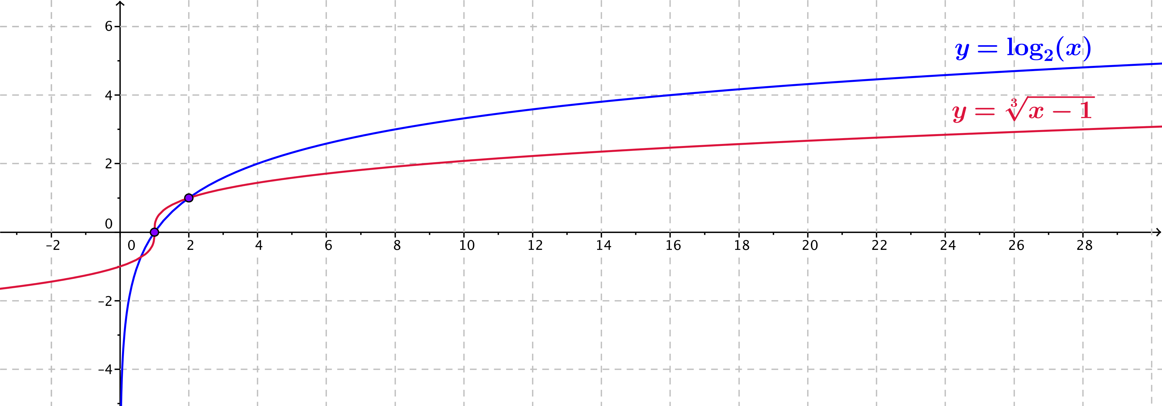
  - Use a calculator or other graphing utility to produce graphs of $f\left(x\right)=log_{2}(x)$ and $h\left(x\right)=\sqrt[3]{x-1}$ for
$x≤28$.

  - Compare the graph of the function $f\left(x\right)=\log_{2}\left(x\right)$ with the graph of the function $h\left(x\right)=\sqrt[3]{x-1}$. Describe the similarities and differences between the graphs.
They are not the same, but they have a similar shape when $x≥1$. Both graphs pass through the points $(1,0)$ and $(2,1)$. Both functions appear to approach infinity slowly as $x→∞$.
The graph of $f\left(x\right)=log_{2}(x)$ lies below the graph of $h\left(x\right)=\sqrt[3]{x-1}$ on the interval $\left(1,2\right)$, and the graph of $f$appears to lie above the graph of$h$ on the interval $(2,∞)$. The logarithm function $f$ is defined for $x>0$, and the radical function $h$ is defined for all real numbers $x$. Both functions appear to approach infinity slowly as $x→∞$.

  - Is it always the case that $\log_{2}\left(x\right)>\sqrt[3]{x-1}$ for $x>2$?
No, if we extend the viewing window on the calculator, we see that the graphs cross again between $983$and$984$. Thus, $\log_{2}\left(x\right)>\sqrt[3]{x-1}$ for $2<x≤983$, and $\log_{2}\left(x\right)<\sqrt[3]{x-1}$ for $x≥984$.

