Lesson 17: Graphing the Logarithm Function

Classwork
Opening Exercise
Graph the points in the table for your assigned function $f\left(x\right)=log(x)$, $g\left(x\right)=log_{2}\left(x\right)$, or $h\left(x\right)=log_{5}(x)$ for
$0<x≤16$. Then, sketch a smooth curve through those points and answer the questions that follow.
$10$-team  $$f\left(x\right)=log(x)$$ |  |  | $2$-team  $$g(x)=log_{2}(x)$$ |  |  | $5$-team  $$h\left(x\right)=log_{5}(x)$$
$$x$$ | $$f(x)$$ |  | $$x$$ | $$g(x)$$ |  | $$x$$ | $$h(x)$$
$$0.0625$$ | $$-1.20$$ |  | $$0.0625$$ | $$-4$$ |  | $$0.0625$$ | $$-1.72$$
$$0.125$$ | $$-0.90$$ |  | $$0.125$$ | $$-3$$ |  | $$0.125$$ | $$-1.29$$
$$0.25$$ | $$-0.60$$ |  | $$0.25$$ | $$-2$$ |  | $$0.25$$ | $$-0.86$$
$$0.5$$ | $$-0.30$$ |  | $$0.5$$ | $$-1$$ |  | $$0.5$$ | $$-0.43$$
$$1$$ | $$0$$ |  | $$1$$ | $$0$$ |  | $$1$$ | $$0$$
$$2$$ | $$0.30$$ |  | $$2$$ | $$1$$ |  | $$2$$ | $$0.43$$
$$4$$ | $$0.60$$ |  | $$4$$ | $$2$$ |  | $$4$$ | $$0.86$$
$$8$$ | $$0.90$$ |  | $$8$$ | $$3$$ |  | $$8$$ | $$1.29$$
$$16$$ | $$1.20$$ |  | $$16$$ | $$4$$ |  | $$16$$ | $$1.72$$

  - What does the graph indicate about the domain of your function?

  - Describe the $x$-intercepts of the graph.

  - Describe the $y$-intercepts of the graph.

  - Find the coordinates of the point on the graph with $y$-value $1$.

  - Describe the behavior of the function as $x→0$.

  - Describe the end behavior of the function as $x→∞$.

  - Describe the range of your function.

  - Does this function have any relative maxima or minima? Explain how you know.

Exercises
- Graph the points in the table for your assigned function $r\left(x\right)=log_{\frac{1}{10}}(x)$, $s\left(x\right)=log_{\frac{1}{2}}\left(x\right)$, or $t\left(x\right)=log_{\frac{1}{5}}(x)$ for
$0<x≤16$. Then sketch a smooth curve through those points, and answer the questions that follow.
$10$-team  $$r\left(x\right)=log_{\frac{1}{10}}(x)$$ |  |  | $2$-team  $$s\left(x\right)=log_{\frac{1}{2}}(x)$$ |  |  | $e$-team  $$t\left(x\right)=log_{\frac{1}{5}}(x)$$
$$x$$ | $$r(x)$$ |  | $$x$$ | $$s(x)$$ |  | $$x$$ | $$t(x)$$
$$0.0625$$ | $$1.20$$ |  | $$0.0625$$ | $$4$$ |  | $$0.0625$$ | $$1.72$$
$$0.125$$ | $$0.90$$ |  | $$0.125$$ | $$3$$ |  | $$0.125$$ | $$1.29$$
$$0.25$$ | $$0.60$$ |  | $$0.25$$ | $$2$$ |  | $$0.25$$ | $$0.86$$
$$0.5$$ | $$0.30$$ |  | $$0.5$$ | $$1$$ |  | $$0.5$$ | $$0.43$$
$$1$$ | $$0$$ |  | $$1$$ | $$0$$ |  | $$1$$ | $$0$$
$$2$$ | $$-0.30$$ |  | $$2$$ | $$-1$$ |  | $$2$$ | $$-0.43$$
$$4$$ | $$-0.60$$ |  | $$4$$ | $$-2$$ |  | $$4$$ | $$-0.86$$
$$8$$ | $$-0.90$$ |  | $$8$$ | $$-3$$ |  | $$8$$ | $$-1.29$$
$$16$$ | $$-1.20$$ |  | $$16$$ | $$-4$$ |  | $$16$$ | $$-1.72$$

  - What is the relationship between your graph in the Opening Exercise and your graph from this exercise?

  - Why does this happen? Use the change of base formula to justify what you have observed in part (a).

- In general, what is the relationship between the graph of a function $y=f(x)$ and the graph of $y=f(kx)$ for a constant $k$?

- Graph the points in the table for your assigned function $u\left(x\right)=log(10x)$, $v\left(x\right)=log_{2}\left(2x\right),$ or $w(x)=log_{5}(5x)$ for $0<x≤16$. Then sketch a smooth curve through those points, and answer the questions that follow.
$10$-team  $$u\left(x\right)=log(10x)$$ |  |  | $2$-team  $$v\left(x\right)=log_{2}(2x)$$ |  |  | $5$-team  $$w(x)=log_{5}(5x)$$
$$x$$ | $$u(x)$$ |  | $$x$$ | $$v(x)$$ |  | $$x$$ | $$w(x)$$
$$0.0625$$ | $$-0.20$$ |  | $$0.0625$$ | $$-3$$ |  | $$0.0625$$ | $$-0.72$$
$$0.125$$ | $$0.10$$ |  | $$0.125$$ | $$-2$$ |  | $$0.125$$ | $$-0.29$$
$$0.25$$ | $$0.40$$ |  | $$0.25$$ | $$-1$$ |  | $$0.25$$ | $$0.14$$
$$0.5$$ | $$0.70$$ |  | $$0.5$$ | $$0$$ |  | $$0.5$$ | $$0.57$$
$$1$$ | $$1$$ |  | $$1$$ | $$1$$ |  | $$1$$ | $$1$$
$$2$$ | $$1.30$$ |  | $$2$$ | $$2$$ |  | $$2$$ | $$1.43$$
$$4$$ | $$1.60$$ |  | $$4$$ | $$3$$ |  | $$4$$ | $$1.86$$
$$8$$ | $$1.90$$ |  | $$8$$ | $$4$$ |  | $$8$$ | $$2.29$$
$$16$$ | $$2.20$$ |  | $$16$$ | $$5$$ |  | $$16$$ | $$2.72$$

  - Describe a transformation that takes the graph of your team’s function in this exercise to the graph of your team’s function in the Opening Exercise.

  - Do your answers to Exercise 2 and part (a) agree? If not, use properties of logarithms to justify your observations in part (a).

Problem Set
Lesson Summary
The function $f\left(x\right)=\log_{b}\left(x\right)$ is defined for irrational and rational numbers. Its domain is all positive real numbers. Its range is all real numbers.
The function $f\left(x\right)=\log_{b}\left(x\right)$goes to negative infinity as $x$ goes to zero. It goes to positive infinity as $x$ goes to positive infinity.
The larger the base $b$, the more slowly the function $f\left(x\right)=\log_{b}\left(x\right)$ increases.
By the change of base formula, $\log_{\frac{1}{b}}\left(x\right){=-log}_{b}\left(x\right).$

$$x$$ | $$Q(x)$$
$$0.1$$ | $$1.66$$
$$0.3$$ | $$0.87$$
$$0.5$$ | $$0.50$$
$$1.00$$ | $$0.00$$
$$2.00$$ | $$-0.50$$
$$4.00$$ | $$-1.00$$
$$6.00$$ | $$-1.29$$
$$10.00$$ | $$-1.66$$
$$12.00$$ | $$-1.79$$

- The function $Q\left(x\right)=\log_{b}\left(x\right)$ has function values in the table at right.
  - Use the values in the table to sketch the graph of $y=Q\left(x\right).$
  - What is the value of $b$ in $Q\left(x\right)=\log_{b}\left(x\right)$? Explain how you know.
  - Identify the key features in the graph of $y=Q(x)$.

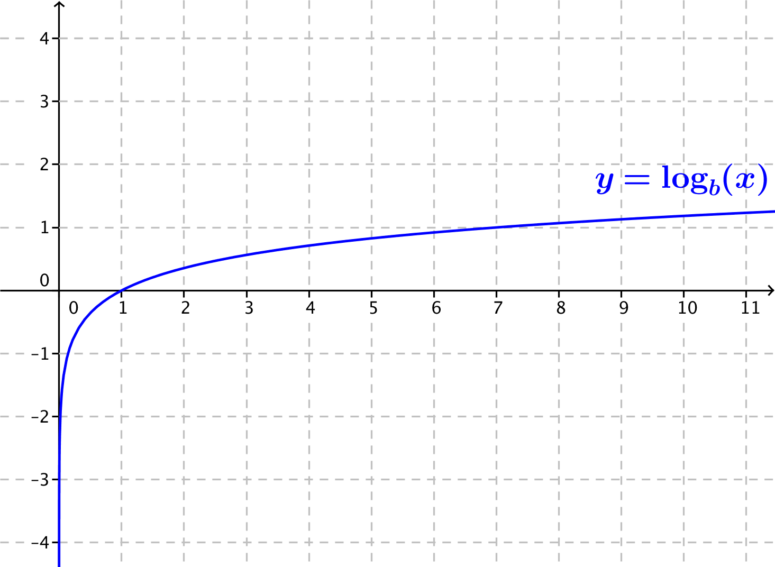
- Consider the logarithmic functions $f\left(x\right)=log_{b}(x)$,
$g\left(x\right)=log_{5}(x)$, where $b$ is a positive real number, and
$b≠1.$ The graph of $f$ is given at right.
  - Is $b>5$, or is $b<5$? Explain how you know.
  - Compare the domain and range of functions $f$ and $g$.
  - Compare the $x$-intercepts and $y$-intercepts of $f$ and $g$.
  - Compare the end behavior of $f$and$g$.

$$x$$ | $$f(x)$$
$$\frac{1}{4}$$ | $$0.86$$
$$\frac{1}{2}$$ | $$0.43$$
$$1$$ | $$0$$
$$2$$ | $$-0.43$$
$$4$$ | $$-0.86$$
- Consider the logarithmic functions $f\left(x\right)=log_{b}(x)$, $g\left(x\right)=log_{\frac{1}{2}}(x)$, where $b$ is a positive real number and $b≠1.$ A table of approximate values of $f$ is given below.
  - Is $b>\frac{1}{2}$ , or is $b<\frac{1}{2}$? Explain how you know.
  - Compare the domain and range of functions $f$ and $g$.
  - Compare the $x$-intercepts and $y$-intercepts of $f$ and $g$.
  - Compare the end behavior of $f$and$g$.

- On the same set of axes, sketch the functions $f\left(x\right)=log_{2}(x)$ and $g\left(x\right)=log_{2}(x^{3})$.
  - Describe a transformation that takes the graph of $f$ to the graph of $g$.
  - Use properties of logarithms to justify your observations in part (a).

- On the same set of axes, sketch the functions $f\left(x\right)=log_{2}(x)$ and $g\left(x\right)=log_{2}\left(\frac{x}{4}\right)$.
  - Describe a transformation that takes the graph of $f$ to the graph of $g$.
  - Use properties of logarithms to justify your observations in part (a).

- On the same set of axes, sketch the functions $f\left(x\right)=log_{\frac{1}{2}}(x)$ and $g\left(x\right)=log_{2}\left(\frac{1}{x}\right)$.
  - Describe a transformation that takes the graph of $f$ to the graph of $g$.
  - Use properties of logarithms to justify your observations in part (a).

- The figure below shows graphs of the functions $f\left(x\right)=log_{3}(x)$, $g\left(x\right)=log_{5}\left(x\right)$, and $h\left(x\right)=log_{11}(x)$.
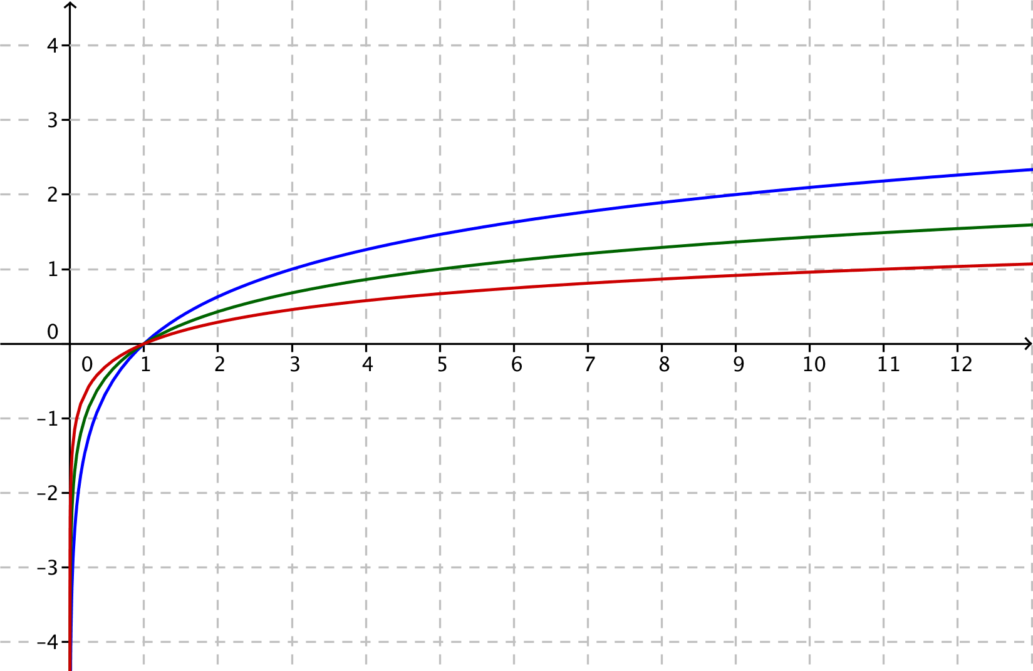
  - Identify which graph corresponds to which function. Explain how you know.
  - Sketch the graph of $k\left(x\right)=log_{7}(x)$ on the same axes.

- The figure below shows graphs of the functions $f\left(x\right)=log_{\frac{1}{3}}(x)$, $g\left(x\right)=log_{\frac{1}{5}}\left(x\right)$, and $h\left(x\right)=log_{\frac{1}{11}}(x)$.
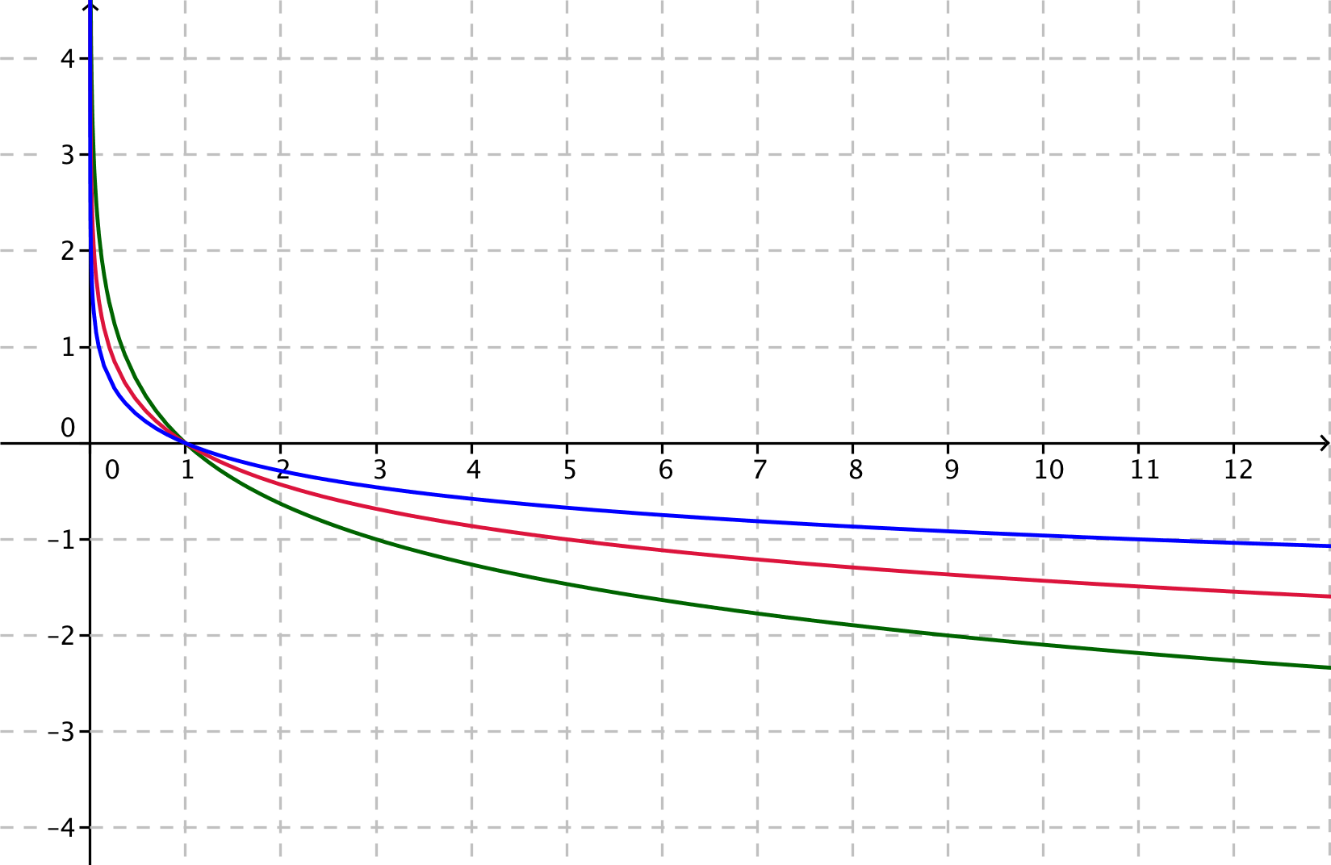
  - Identify which graph corresponds to which function. Explain how you know.
  - Sketch the graph of $k\left(x\right)=log_{\frac{1}{7}}(x)$ on the same axes.

- For each function $f$, find a formula for the function $h$ in terms of $x$. Part (a) has been done for you.
  - If $f\left(x\right)=x^{2}+x$, find $h\left(x\right)=f(x+1)$.
  - If $f\left(x\right)=\sqrt{x^{2}+\frac{1}{4}}$ , find $h\left(x\right)=f\left(\frac{1}{2}x\right)$.
  - If $f\left(x\right)=log⁡(x)$, find $h\left(x\right)=f\left(\sqrt[3]{10x}\right)$ when $x>0$.
  - If $f\left(x\right)=3^{x}$, find $h\left(x\right)=f\left(\log_{3}\left(x^{2}+3\right)\right).$
  - If $f\left(x\right)=x^{3}$, find $h\left(x\right)=f\left(\frac{1}{x^{3}}\right)$ when $x≠0$.
  - If $f\left(x\right)=x^{3}$, find $h\left(x\right)=f\left(\sqrt[3]{x}\right)$.
  - If $f\left(x\right)=\sin{(x)},$ find $h\left(x\right)=f\left(x+\frac{π}{2}\right)$.
  - If $f\left(x\right)=x^{2}+2x+2,$ find $h\left(x\right)=f\left(\cos\left(x\right)\right).$

- For each of the functions $f$ and $g$ below, write an expression for (i) $f\left(g\left(x\right)\right)$, (ii) $g\left(f\left(x\right)\right)$, and (iii) $f\left(f\left(x\right)\right)$ in terms of $x$. Part (a) has been done for you.
  - $f\left(x\right)=x^{2}$, $g\left(x\right)=x+1$
    - $f\left(g\left(x\right)\right)=f\left(x+1\right)$
$={\left(x+1\right)}^{2}$
    - $g\left(f\left(x\right)\right)=g\left(x^{2}\right)$
$=x^{2}+1$
    - $f\left(f\left(x\right)\right)=f\left(x^{2}\right)$
$$={\left(x^{2}\right)}^{2} \\ =x^{4}$$
  - $f\left(x\right)=\frac{1}{4}x-8$, $g\left(x\right)=4x+1$
  - $f\left(x\right)=\sqrt[3]{x+1},$ $g\left(x\right)=x^{3}-1$
  - $f\left(x\right)=x^{3}$, $g\left(x\right)=\frac{1}{x}$
  - $f\left(x\right)=\left|x\right|$, $g\left(x\right)=x^{2}$

Extension:
- Consider the functions $f\left(x\right)=log_{2}(x)$ and $\left(x\right)=\sqrt{x-1}$.
  - Use a calculator or other graphing utility to produce graphs of $f\left(x\right)=log_{2}(x)$ and $g\left(x\right)=\sqrt{x-1}$ for
$x≤17$.
  - Compare the graph of the function $f\left(x\right)=\log_{2}\left(x\right)$ with the graph of the function $g\left(x\right)=\sqrt{x-1}$. Describe the similarities and differences between the graphs.
  - Is it always the case that $\log_{2}\left(x\right)>\sqrt{x-1}$ for $x>2$?

- Consider the functions $f\left(x\right)=log_{2}(x)$ and $\left(x\right)=\sqrt[3]{x-1}$ .
  - Use a calculator or other graphing utility to produce graphs of $f\left(x\right)=log_{2}(x)$ and $h\left(x\right)=\sqrt[3]{x-1}$ for $x≤28$.
  - Compare the graph of the function $f\left(x\right)=\log_{2}\left(x\right)$ with the graph of the function $h\left(x\right)=\sqrt[3]{x-1}$. Describe the similarities and differences between the graphs.
  - Is it always the case that $\log_{2}\left(x\right)>\sqrt[3]{x-1}$ for $x>2$?

