t
Lesson 16: Rational and Irrational Numbers

Student Outcomes
- Students interpret addition and multiplication of two irrational numbers in the context of logarithms and find better-and-better decimal approximations of the sum and product, respectively.
- Students work with and interpret logarithms with irrational values in preparation for graphing logarithmic functions.

Lesson Notes
This foundational lesson revisits the fundamental differences between rational and irrational numbers. We begin by reviewing how to locate an irrational number on the number line by squeezing its infinite decimal expansion between two rational numbers, which students may recall from Grade 8, Module 7, Lesson 7. In preparation for graphing logarithm functions, the main focus of this lesson is to understand the process of locating values of logarithms on the number line (F-IF.C.7e). We then go a step further to understand this process in the context of adding two irrational logarithmic expressions (N-RN.B.3). Although students have addressed N-RN.B.3 in Algebra I and have worked with irrational numbers in previous lessons in this module, such as Lesson 5, students need to fully understand how to sum two irrational logarithmic expressions in preparation for graphing logarithmic functions in the next lesson, in alignment with F-IF.C.7e. Students have been exposed to two approaches to adding rational numbers: a geometric approach by placing the numbers on the number line, as reviewed in Module 1, Lesson 24, and a numerical approach by applying an addition algorithm. In the Opening Exercise, students are asked to recall both methods for adding rational numbers. Both approaches fail with irrational numbers, and we locate the sum of two irrational numbers (or a rational and an irrational number) by squeezing its infinite decimal expansion between two rational numbers. Emphasize to students that since they have been performing addition for many, many years, we are more interested in the process of addition than in the result.
This lesson emphasizes mathematical practice standard MP.3 as students develop and then justify conjectures about sums and products of irrational logarithmic expressions.

Classwork
Opening Exercise (4 minutes)
Have students work in pairs or small groups on the sums below. Remind them that we are interested in the process of addition as much as obtaining the correct result. Ask groups to volunteer their responses at the end of the allotted time.
Scaffolding:
- Ask struggling students to represent a simpler sum, such as $\frac{1}{5}+\frac{1}{4}$.
- Ask advanced students to explain how to represent the sum of two generic rational numbers, such as $\frac{a}{b}$ + $\frac{c}{d}$ , on the number line.

Opening Exercise
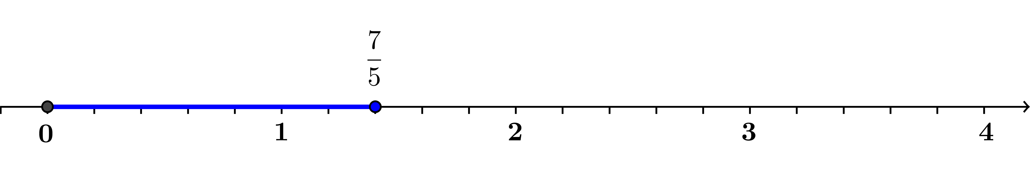
  - Explain how to use a number line to add the fractions $\frac{7}{5}+\frac{9}{4}$.
First, we locate the point $\frac{7}{5}$ on the number line by dividing each unit into $5$ intervals of length $\frac{1}{5}$.

Then, we locate the point $\frac{9}{4}$ on the number line by dividing each unit into $4$ intervals of length $\frac{1}{4}$.
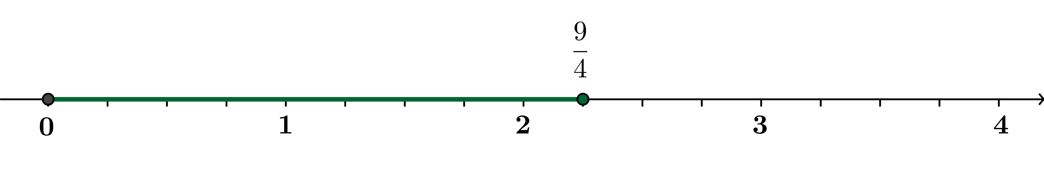

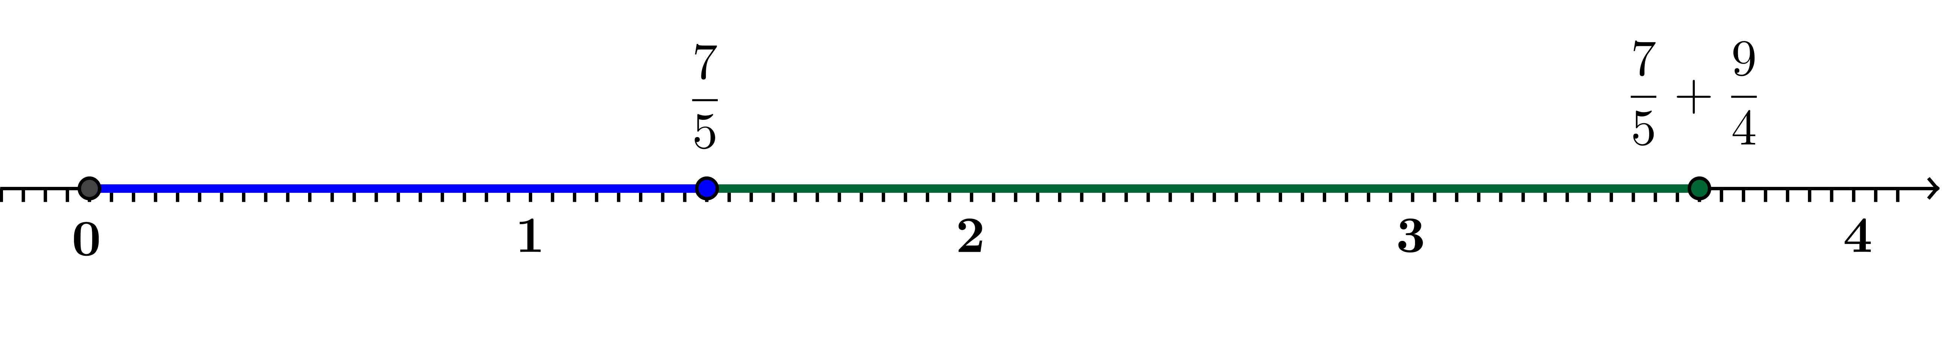
To find the sum, we place the green segment of length $\frac{9}{4}$ end-to-end with the blue segment of length $\frac{7}{5}$, and the right end point of the green segment is the sum. Since the tick marks at units of $\frac{1}{4}$ and $\frac{1}{5}$ do not align, we make new tick marks that are $\frac{1}{20}$ apart. Then $\frac{7}{5}=\frac{28}{20}$ and $\frac{9}{4}=\frac{45}{20}$ , so the sum is located at point $\frac{73}{20}$.

  - Convert $\frac{7}{5}$ and $\frac{9}{4}$ to decimals, and explain the process for adding them together.
We know that $\frac{7}{5}=1.4$ and $\frac{9}{4}=2.25$. To add these numbers, we add a zero placeholder to $1.4$ to get $1.40$ so that each number has the same number of decimal places. Then, we line them up at the decimal place and add from right to left, carrying over a power of $10$ if needed (we do not need to carry for this sum).
Step 1: Working from right to left, we first add $0$hundredths$+ 5$hundredths$=5$hundredths. $\frac{\begin{matrix} 1.40 \\ +2.25\end{matrix}}{ 5}$
Step 2: Then we add $4$tenths$+2$tenths$=6$tenths$.$ $\frac{\begin{matrix} 1.40 \\ +2.25\end{matrix}}{ 65}$
Step 3: And, finally, we add $1$one$+ 2$ones$=3$ones. $\frac{\begin{matrix} 1.40 \\ +2.25\end{matrix}}{ 3.65}$

Discussion (8 minutes)
- How would we add two numbers such as $π+\frac{7}{5}$?
  - Student answers will vary, but the point is that our algorithm, to add rational numbers in decimal form, does not apply to sums that involve irrational numbers.
- Many of the numbers we have been working with are irrational numbers, such as $\sqrt{2}$, $e$, $\log\left(2\right)$, and $π$ , meaning that we cannot write them as fractions. One of the key distinctions between rational and irrational numbers is that rational numbers can be expressed as a decimal that either terminates (such as $\frac{1}{8}=0.125$) or repeats infinitely (such as $\frac{1}{9}=0.11111…$). Irrational numbers cannot be exactly represented by a decimal expansion because the digits to the right of the decimal point never end and never repeat predictably. The best we can do to represent irrational numbers with a decimal expansion is to find an approximation.
- For example, consider the number $π$. What is the value of $π$?
  - $3.14$ (Students may answer this question with varying degrees of accuracy.)
- Is that the exact value of $π$?
  - No. We cannot write a decimal expansion for the exact value of $π$.
- What is the last digit of $π$?
  - Since the decimal expansion for $π$ never terminates, there is no last digit of $π$.
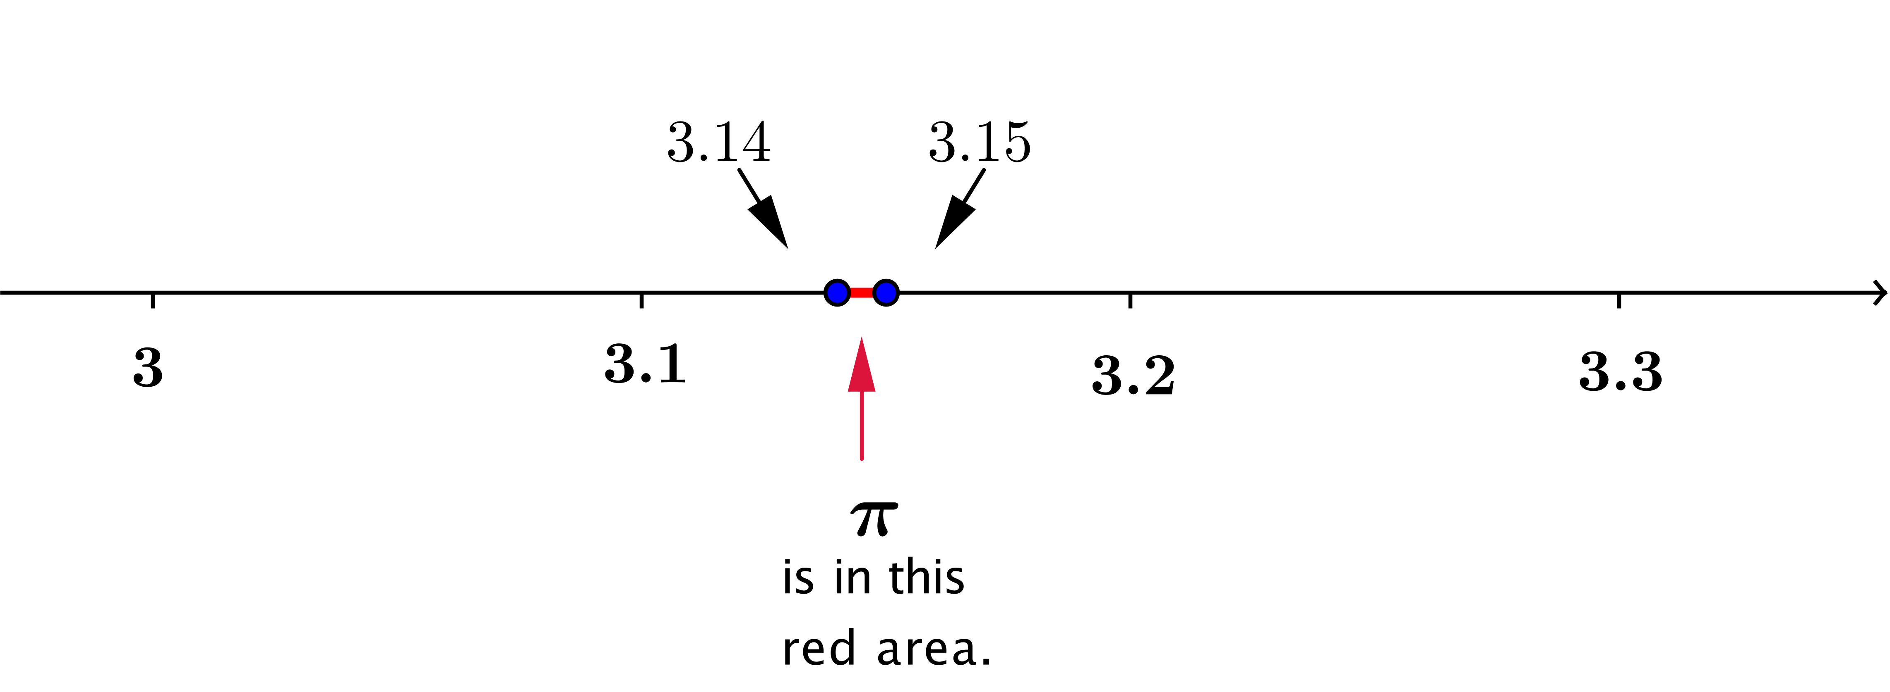

- Where is $π$ on the number line?
  - The number $π$ is between $3.14$ and $3.15.$
- What kind of numbers are $3.14$ and $3.15$?
  - Rational numbers.
- Can we get better under and over estimates than that?
  - Yes, since $π≈3.14159$, we know that $3.1415<π<3.1416.$
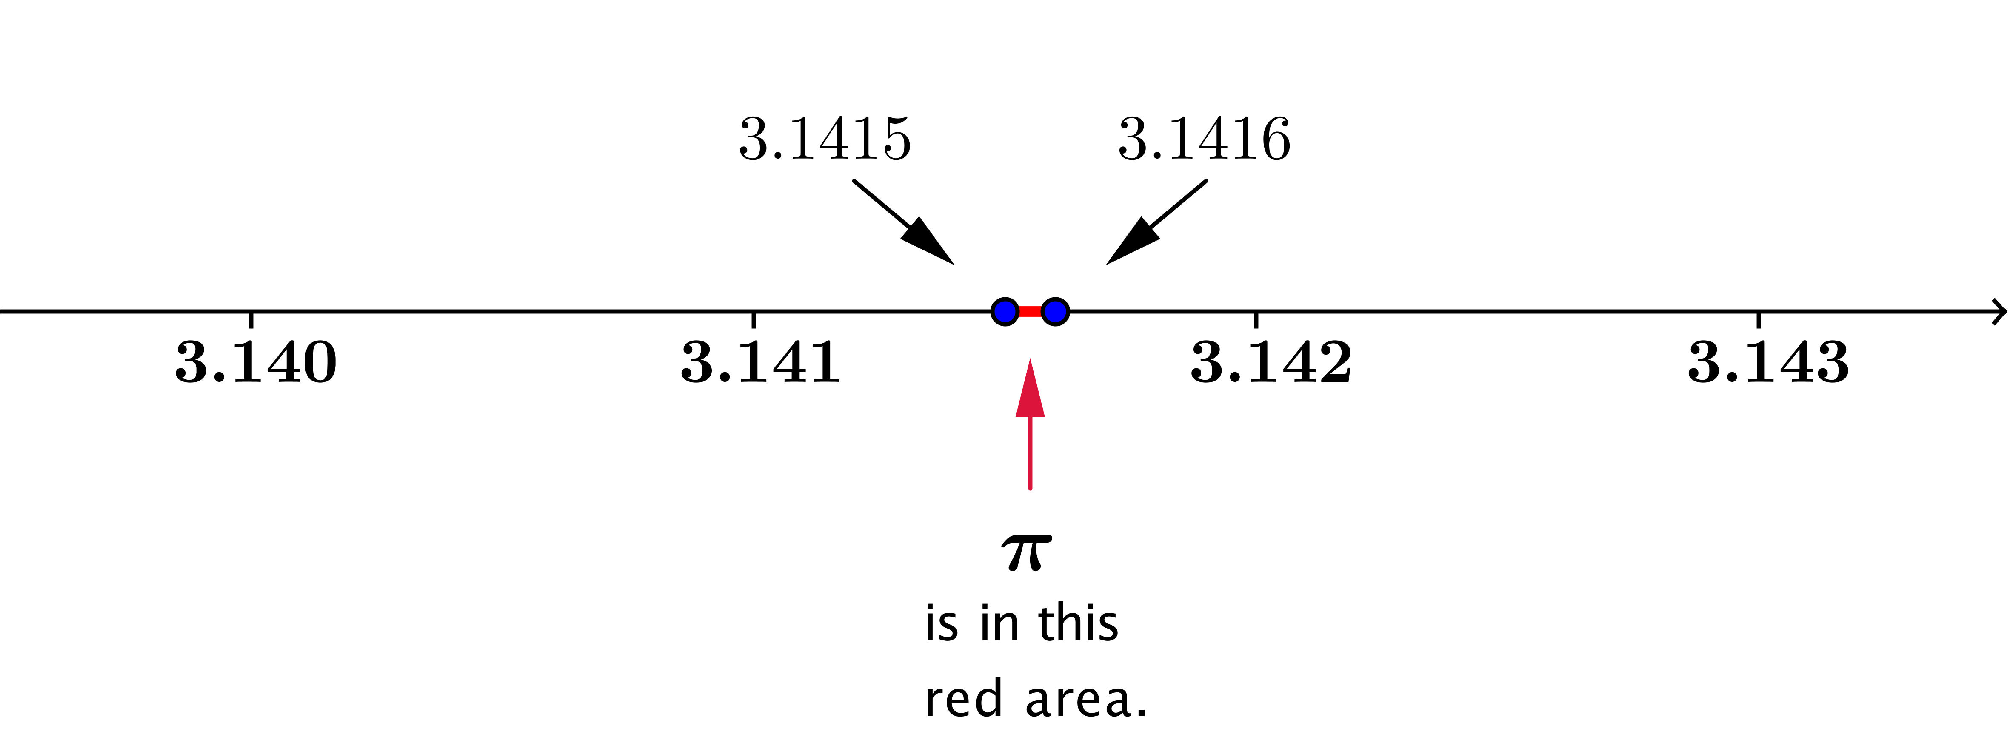

- What kind of numbers are $3.1415$ and $3.1416$?
  - Rational numbers.
- Can we find rational numbers with $10$ digits that are good upper and lower bounds for $π$? How?
  - Yes. Just take the expansion for $π$ on the calculator and round up and down.
- So, how can we add two irrational numbers? Let’s turn our attention back to logarithms.
- The numbers $log(3)$ and $log(4)$ are examples of irrational numbers. The calculator says that
$\log\left(3\right)=0.4771212547$ and $\log\left(4\right)=0.6020599913$. What is wrong with those two statements?
  - Since $\log\left(3\right)$ and $\log\left(4\right)$ are irrational numbers, their decimal expansions do not terminate so the calculator gives approximations and not exact values.

- So, we really should write $\log\left(3\right)=0.4771212547…$ and $\log\left(4\right)=0.6020599913…$. This means there are more digits that we cannot see. What happens when we try to add these decimal expansions together numerically?
  - There is no last digit for us to use to start our addition algorithm, which moves from right to left. We cannot even start adding these together using our usual method.
- So, our standard algorithm for adding numbers fails. How can we add $\log\left(3\right)+\log\left(4\right)$?

Example 1 (8 minutes)
Begin these examples with direct instruction and teacher modeling, and gradually release responsibility to the students when they are ready to tackle these questions in pairs or small groups.
- Since we do not have a direct method to add $\log\left(3\right)+log\left(4\right)$, we will need to try another approach. Remember that according to the calculator, $\log\left(3\right)=0.4771212547…$ and $\log\left(4\right)=0.6020599913…$. While we could use the calculator to add these approximations to find an estimate of $\log\left(3\right)+log\left(4\right)$, we are interested in making sense of the operation.
- What if we just need an approximation of $\log\left(3\right)+\log\left(4\right)$ to one decimal place, that is, to an accuracy of ${10}^{-1}$? If we do not need more accuracy than that, we can use $\log\left(3\right)≈0.477$ and $\log\left(4\right)≈0.602$. Then,
$$0.47≤\log\left(3\right)≤0.48; \\ 0.60≤\log\left(4\right)≤0.61.$$
- Based on these inequalities, what statement can we make about the sum $\log\left(3\right)+\log\left(4\right)$? Explain why you believe your statement is correct.
MP.3
  - Adding terms together, we have
$$1.07≤\log\left(3\right)+\log\left(4\right)≤1.09.$$
Rounding to one decimal place, we have
$$1.1≤\log\left(3\right)+\log\left(4\right)≤1.1.$$
So, to one decimal place, $\log\left(3\right)+\log\left(4\right)≈1.1.$
- What if we wanted to find the value of $\log\left(3\right)+\log\left(4\right)$ to two decimal places? What are the under and over estimates for $\log\left(3\right)$ and $\log\left(4\right)$ that we should start with before we add? What do we get when we add them together?
  - We should start with
$$0.477≤\log\left(3\right)≤0.478; \\ 0.602≤\log\left(4\right)≤0.603.$$
Then we have
$$1.079≤\log\left(3\right)+\log\left(4\right)≤1.081.$$
To two decimal places, $\log\left(3\right)+\log\left(4\right)≈1.08.$

- Now, find the value of $\log\left(3\right)+\log\left(4\right)$ to five decimal places, that is, to an accuracy of ${10}^{-5}$.
  - We should start with
$$0.477121≤\log\left(3\right)≤0.477122; \\ 0.602059≤\log\left(4\right)≤0.602060.$$
Then we have
$$1.079180≤\log\left(3\right)+\log\left(4\right)≤1.079182.$$
To five decimal places, $\log\left(3\right)+\log\left(4\right)≈1.07918.$
- Now, find the value of $\log\left(3\right)+\log\left(4\right)$ to eight decimal places, that is, to an accuracy of ${10}^{-8}$.
- We should start with
$$0.477121254≤\log\left(3\right)≤0.477121255 \\ 0.602059991≤\log\left(4\right)≤0.602059992.$$
Then we have
$$1.079181245≤\log\left(3\right)+\log\left(4\right)≤1.079181247.$$
To eight decimal places, $\log\left(3\right)+\log\left(4\right)≈1.07918125.$
- Notice that we are squeezing the actual value of $\log\left(3\right)+\log\left(4\right)$ between two rational numbers. Since we know how to plot a rational number on the number line (in theory, anyway), we can get really close to the location of the irrational number $\log\left(3\right)+\log\left(4\right)$ by squeezing it between two rational numbers.
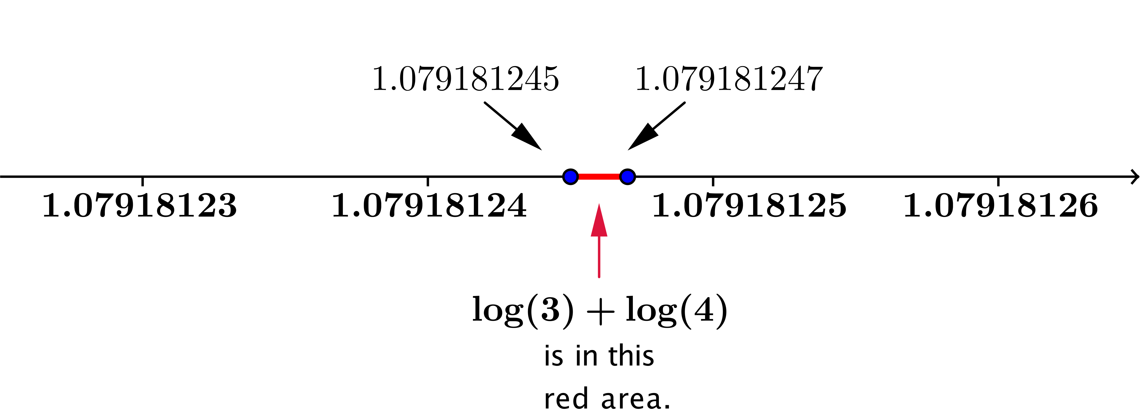

- Could we keep going? If we knew enough digits of the decimal expansions of $\log\left(3\right)$ and $\log\left(4\right)$, could we find an approximation of $\log\left(3\right)+\log\left(4\right)$ to $20$ decimal places? Or $50$ decimal places? Or $1,000$ decimal places?
  - Yes. There is no reason that we cannot continue this process, provided we know enough digits of the original irrational numbers $\log\left(3\right)$ and $\log\left(4\right)$.
- Summarize what you have learned from this example in your notebook. (Allow students a minute or so to record the main points of this example.)

Exercises 1–5 (8 minutes)
Have students complete these exercises in pairs or small groups. Expect students to react with surprise to the results: In the previous example, the sum $\log\left(3\right)+\log\left(4\right)$ was irrational, so the decimal expansion never terminated. In this set of exercises, the sum $\log\left(4\right)+\log\left(25\right)$ is rational with the exact value $2$, and at each step, their estimate of the sum will be exact.
Exercises 1–5
- According to the calculator, $\log\left(4\right)=0.6020599913…$ and $\log\left(25\right)=1.3979400087…$. Find an approximation of $\log\left(4\right)+\log\left(25\right)$ to one decimal place, that is, to an accuracy of ${10}^{-1}$.
$$0.60<\log\left(4\right)<0.61 \\ 1.39<\log\left(25\right)<1.40$$
$$1.99<\log\left(4\right)+\log\left(25\right)<2.01$$
$$\log\left(4\right)+\log\left(25\right)≈2.0$$

- Find the value of $\log\left(4\right)+\log\left(25\right)$ to an accuracy of $10^{-2}$.
$$0.602<\log\left(4\right)<0.603 \\ 1.397<\log\left(25\right)<1.398$$
$$1.999<\log\left(4\right)+\log\left(25\right)<2.001$$
$$\log\left(4\right)+\log\left(25\right)≈2.00$$

- Find the value of $\log\left(4\right)+\log\left(25\right)$ to an accuracy of $10^{-8}$.
$$0.602059991≤\log\left(4\right)≤0.602059992 \\ 1.397940008≤\log\left(25\right)≤1.397940009$$
$$1.999999999≤\log\left(4\right)+\log\left(25\right)≤2.000000001$$
$$\log\left(4\right)+\log\left(25\right)≈2.00000000$$
MP.3
- Make a conjecture: Is $log\left(4\right)+log(25)$ a rational or an irrational number?
It appears that $log\left(4\right)+ log\left(25\right)=2$, exactly.

- Why is your conjecture in Exercise 4 true?
The logarithm rule that says $log\left(x\right)+log\left(y\right)= log\left(xy\right)$ applies here.
$$log\left(4\right)+log\left(25\right)=log\left(4∙25\right) \\ =log\left(100\right) \\ =log\left(10^{2}\right) \\ =2$$

Discussion (3 minutes)
- We have seen how we can squeeze the sum of two irrational numbers between rational numbers and get an approximation of the sum to whatever accuracy we want. What about multiplication?
MP.3
- Make a conjecture: Without actually calculating it, what is the value of $\log\left(4\right)∙\log\left(25\right)$?
Allow students time to discuss this question with a partner and write down a response before allowing students to put forth their ideas to the class. This would be an ideal time to use personal white boards, if you have them, for students to record and display their conjectures. See that students have a written record of this conjecture that will be disproven in the next set of exercises.
  - Conjectures will vary; some might be $\log\left(4\right)∙\log\left(25\right)=\log\left(29\right)$, or $\log\left(4\right)∙\log\left(25\right)=\log\left(100\right)$.
Exercises 6–8 (6 minutes)
Exercises 6–8
Remember that the calculator gives the following values: $\log\left(4\right)=0.6020599913…$ and
$\log\left(25\right)=1.3979400087…$.
- Find the value of $\log\left(4\right)∙\log\left(25\right)$ to three decimal places.
$$0.6020≤\log\left(4\right)≤0.6021 \\ 1.3979≤\log\left(25\right)≤1.3980$$
$$0.8415358≤\log\left(4\right)∙\log\left(25\right)≤0.8417358$$
$$\log\left(4\right)∙\log\left(25\right)≈0.842$$

- Find the value of $\log\left(4\right)∙\log\left(25\right)$ to five decimal places.
$$0.602059≤\log\left(4\right)≤0.602060 \\ 1.397940≤\log\left(25\right)≤1.397941$$
$$0.8416423585≤\log\left(4\right)∙\log\left(25\right)≤0.8416443585$$
$$\log\left(4\right)∙\log\left(25\right)≈0.84164$$

- Does your conjecture from the above discussion appear to be true?
No. The work from Exercise 6 shows that $\log\left(4\right)∙\log\left(25\right)≠log(29)$, and $\log\left(4\right)∙\log\left(25\right)≠\log\left(100\right)$.

Closing (3 minutes)
Ask students to respond to the following prompts independently, and then have them share their responses with a partner. After students have a chance to write and discuss, go through the key points in the Lesson Summary below.
- List five rational numbers.
  - Student responses will vary; possible responses include $1, 10,\frac{3}{5},17,$and$-\frac{42}{13}.$
- List five irrational numbers.
  - Student responses will vary; possible responses include $\sqrt{3}, π, e, 1+\sqrt{2} ,$and$π^{3}$.
- Is $0$ a rational or irrational number? Explain how you know.
  - Since $0$ is an integer, we can write $0=\frac{0}{1}$ , which is a quotient of integers. Thus, $0$ is a rational number.
- If a number is given as a decimal, how can you tell if it is a rational or an irrational number?
  - If the decimal representation terminates or repeats at some point, then the number is rational and can be expressed as the quotient of two integers. Otherwise, the number is irrational.

Lesson Summary
- Irrational numbers occur naturally and frequently.
- The $n$ ^{th} roots of most integers and rational numbers are irrational.
- Logarithms of most positive integers or positive rational numbers are irrational.
- We can locate an irrational number on the number line by trapping it between lower and upper approximations. The infinite process of squeezing the irrational number in smaller and smaller intervals locates exactly where the irrational number is on the number line.
- We can perform arithmetic operations such as addition and multiplication with irrational numbers using lower and upper approximations and squeezing the result of the operation in smaller and smaller intervals between two rational approximations to the result.

Exit Ticket (5 minutes)
Name Date
Lesson 16: Rational and Irrational Numbers

Exit Ticket

The decimal expansion of $e$ and $\sqrt{5}$ are given below.
$$e≈2.71828182… \\ \sqrt{5}≈2.23606797…$$
  - Find an approximation of $\sqrt{5}+e$ to three decimal places. Do not use a calculator.

  - Explain how you can locate $\sqrt{5}+e$ on the number line. How is this different from locating $2.6+2.7$ on the number line?

Exit Ticket Sample Solutions

The decimal expansion of $e$ and $\sqrt{5}$ are given below.
$$e≈2.71828182… \\ \sqrt{5}≈2.23606797…$$
  - Find an approximation of $\sqrt{5}+e$to three decimal places. Do not use a calculator.
$$2.2360≤\sqrt{5}≤2.2361 \\ 2.7182≤e≤2.7183 \\ 4.9542≤\sqrt{5}+ e≤4.9544$$
Thus, to three decimal places, $\sqrt{5}+e≈4.954$.
  - Explain how you can locate $\sqrt{5}+e$ on the number line. How is this different from locating $2.6+2.7$ on the number line?
We cannot locate $\sqrt{5}+e$ precisely on the number line because the sum is irrational, but we can get as close to it as we want by squeezing it between two rational numbers, $r_{1}$ and $r_{2}$, that differ only in the last decimal place, $r_{1}≤\sqrt{5}+e≤r_{2}$. Since we can locate rational numbers on the number line, we can get arbitrarily close to the true location of $\sqrt{5}+e$ by starting with more and more accurate decimal representations of $\sqrt{5}$ and $e$. This differs from pinpointing the location of sums of rational numbers because we can precisely locate the sum $2.6+2.7=5.3$ by dividing the interval $[5,6]$ into $10$ parts of equal length $0.1$. Then, the point $5.3$ is located exactly at the point between the third and fourth parts.

Problem Set Sample Solutions

- Given that $\sqrt{5}≈2.2360679775$ and $π≈3.1415926535$, find the sum $\sqrt{5}+π$ to an accuracy of $10^{-8}$, without using a calculator.
From the estimations we are given, we know that
$$2.236067977<\sqrt{5}<2.236067978 \\ 3.141592653<π<3.141592654.$$Adding these together gives
$$5.377660630<\sqrt{5}+π<5.377660632.$$
Then, to an accuracy of $10^{-8}$, we have
$$\sqrt{5}+π≈5.37766063.$$

- Put the following numbers in order from least to greatest.
$$\sqrt{2}, π, 0, e,\frac{22}{7},\frac{π^{2}}{3},3.14, \sqrt{10}$$
$$0, \sqrt{2}, e, 3.14, π,\frac{22}{7}, \sqrt{10},\frac{π^{2}}{3}$$

- Find a rational number between the specified two numbers.
  - $\frac{4}{13}$ and $\frac{5}{13}$
Many answers are possible. Since $\frac{4}{13}=\frac{8}{26}$ and $\frac{5}{13}=\frac{10}{26}$, we know that $\frac{4}{13}<\frac{9}{26}<\frac{5}{13}$.

  - $\frac{3}{8}$ and $\frac{5}{9}$
Many answers are possible. Since $\frac{3}{8}=\frac{27}{72}$ and $\frac{5}{9}=\frac{40}{72}$, we know that $\frac{30}{72}=\frac{5}{12}$ is between $\frac{3}{8}$ and $\frac{5}{9}$.

  - $1.7299999$ and $1.73$
Many answers are possible. $1.7299999<1.72999995<1.73$.

  - $\frac{\sqrt{2}}{7}$ and $\frac{\sqrt{2}}{9}$
Many answers are possible. Since $\frac{\sqrt{2}}{9}≈0.157135$ and $\frac{\sqrt{2}}{7}≈0.202031$, we know $\frac{\sqrt{2}}{9}<0.2<\frac{\sqrt{2}}{7}$.

  - $π$ and $\sqrt{10}$
Many answers are possible. Since $π≈3.14159$ and $\sqrt{10}≈3.16228$, we know $π<3.15<\sqrt{10}$.

- Knowing that $\sqrt{2}$ is irrational, find an irrational number between $\frac{1}{2}$ and $\frac{5}{9}$.
One such number is $r\sqrt{2}$, so $\frac{1}{2}<$ $r \sqrt{2}$ $<\frac{5}{9}$. Then we have $\frac{1}{2\sqrt{2}}<r<\frac{5}{9\sqrt{2}}$. Since $\frac{1}{2\sqrt{2}}≈0.3536$ and $\frac{5}{9\sqrt{2}}≈0.3929$, we can let $r=0.36$. Then, $0.36\sqrt{2}$ is an irrational number between $\frac{1}{2}$ and $\frac{5}{9}$.

- Give an example of an irrational number between $e$ and $π$.
Many answers are possible, such as $\frac{π+e}{2}$, $\sqrt{πe}$, or $\frac{10}{11}π$.

- Given that $\sqrt{2}$ is irrational, which of the following numbers are irrational?
$$\frac{\sqrt{2}}{2}, 2+\sqrt{2}, \frac{\sqrt{2}}{2\sqrt{2}},\frac{2}{\sqrt{2}}, {\left(\sqrt{2}\right)}^{2}$$
The numbers $\frac{\sqrt{2}}{2}$ , $2+\sqrt{2}$, and $\frac{2}{\sqrt{2}}=$ $\sqrt{2}$ are irrational. (Note that $\frac{\sqrt{2}}{2\sqrt{2}}=\frac{1}{2}$ and ${\left(\sqrt{2}\right)}^{2}=2$ are rational numbers.)

- Given that $π$ is irrational, which of the following numbers are irrational?
$$\frac{π}{2},\frac{π}{2π}, \sqrt{π}, π^{2}$$
The numbers $\frac{π}{2}$,$\sqrt{π}$, and $π^{2}$ are irrational.

- Which of the following numbers are irrational?
$$1, 0, \sqrt{5}, \sqrt[3]{64}, e, π,\frac{\sqrt{2}}{2},\frac{\sqrt{8}}{\sqrt{2}},cos\left(\frac{π}{3}\right), sin\left(\frac{π}{3}\right)$$
The numbers $\sqrt{5}$, $e$,$π$, $\frac{\sqrt{2} }{2}$,$sin\left(\frac{π}{3}\right)$ are irrational.

- Find two irrational numbers $x$ and $y$ so that their average is rational.
If $x=1+\sqrt{2}$ and $y=3-\sqrt{2}$, then $\frac{x+y}{2}=\frac{1}{2}\left(\left(1+\sqrt{2}\right)+\left(3-\sqrt{2}\right)\right)=2$; so, the average of $x$ and $y$ is rational.

- Suppose that $\frac{2}{3}x$ is an irrational number. Explain how you know that $x$ must be an irrational number. (Hint: What would happen if there were integers $a$ and $b$ so that $x=\frac{a}{b}$?)
If $x$ is rational, then there are integers $a$ and $b$ so that $x=\frac{a}{b}$. Then$\frac{2}{3}x=\frac{2a}{3b}$ is rational. Since we know that$\frac{2}{3}x$ is irrational, we cannot have $x=\frac{a}{b}$. Thus, $x$ must be an irrational number.

- If $r$ and $s$ are rational numbers, prove that $r+s$ and $r-s$ are also rational numbers.
If $r$ and $s$ are rational numbers, then there exist integers $a$,$b$,$c$, $d$ with $b≠0$ and $d≠0$ so that $r=\frac{a}{b}$ and $s=\frac{c}{d}$. Then,
$$r+s=\frac{a}{b}+\frac{c}{d} \\ =\frac{ad}{bd}+\frac{bc}{bd} \\ =\frac{ad+bc}{bd}$$
$$r-s=\frac{a}{b}-\frac{c}{d} \\ =\frac{ad-bc}{bd}.$$
Since $ad+bc$, $ad-bc$, and $bd$ are integers, $r+s$ and $r-s$ are rational numbers.

- If $r$ is a rational number and $x$ is an irrational number, determine whether the following numbers are always rational, sometimes rational, or never rational. Explain how you know.
  - $r+x$
If $r+x=y$ and $y$ is rational, then $r-y=-x$ would be rational by Problem 10. Since $x$ is irrational, we know$-x$ is irrational, so $y$ cannot be rational. Thus, the sum $r+x$ is never rational.

  - $r-x$
If $r-x=y$ and $y$ is rational, then $r-y=x$ would be rational by Problem 10. Since $x$ is irrational, $y$ cannot be rational. Thus, the difference $r-x$ is never rational.

  - $rx$
If $rx=y$, $r≠0$, and $y$ is rational, then there are integers $a$, $b$, $c$, $d$ with $a≠0$, $b≠0$, and $d≠0$ so that $r=\frac{a}{b}$ and $y=\frac{c}{d}$. Then $x=\frac{y}{r}=\frac{cb}{ad}$ , so $x$ is rational. Since $x$ was not rational, the only way that $rx$can be rational is if$r=0$. Thus, $rx$ is sometimes rational (in only one case).
  - $x^{r}$
If $x=\sqrt[r]{k}$ for some rational number $k$, then $x^{r}=k$ is rational. For example, ${\left(\sqrt{5}\right)}^{2}=5$ is rational. But, $π^{r}$ is never rational for any exponent $r,$ so $x^{r}$ is sometimes rational.

- If $x$ and $y$ are irrational numbers, determine whether the following numbers are always rational, sometimes rational, or never rational. Explain how you know.
  - $x+y$
This is sometimes rational. For example, $π+\sqrt{2}$ is irrational, but $\left(1+\sqrt{2}\right)+\left(1-\sqrt{2}\right)=2$ is rational.

  - $x-y$
This is sometimes rational. For example, $π-\sqrt{2}$ is irrational, but $\left(1+\sqrt{2}\right)+\left(2+\sqrt{2}\right)=3$ is rational.

  - $xy$
This is sometimes rational. For example, $π\sqrt{2}$ is irrational, but $\sqrt{2}∙\sqrt{8}=4$ is rational.

  - $\frac{x}{y}$
This is sometimes rational. For example, $\frac{π}{\sqrt{2}}$ is irrational, but $\frac{\sqrt{8}}{\sqrt{2}}=2$ is rational.

