Table of Contents
GRADE PK • MODULE 5
Addition and Subtraction Stories and Counting to 20

Module Overview i

Family Math Newsletters 1

Topic A: Writing Numerals 0 to 5 5.A.1

Topic B: Contextualizing Addition Stories to Solve 5.B.1

Topic C: Contextualizing Subtraction Stories to Solve 5.C.1

Topic D: Decontextualizing Addition Stories to Solve Using Fingers, Objects,
and Drawings 5.D.1

Topic E: Decontextualizing Subtraction Stories to Solve Using Fingers, Objects,
and Drawings 5.E.1

Topic F: Duplicating and Extending Patterns 5.F.1

Module Assessments 5.S.1

Note: The student sheets were created using the KG Primary Penmanship font—a clear and simple font for Pre-Kindergarteners. Please download this font to ensure accurate depiction of numerals in the Word documents.

Grade PK • Module 5
Addition and Subtraction Stories and Counting to 20
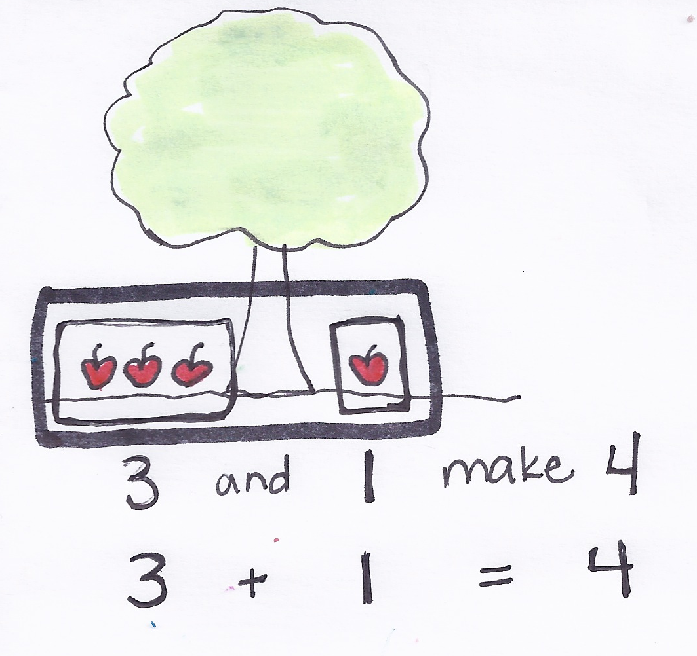
OVERVIEW
Module 5 is the culmination of children’s work with numbers in the Pre-K year. Throughout Modules 1 and 3, they had extensive counting experiences with numbers 0–10. In Module 4, they examined the relationships between numbers 1–5 through comparison. In Module 5, children transition from the comparative concept of more (4 apples is more than 1 apple) to the concept of addition (3 apples and 1 more apple make 4 apples, as shown to the right). They are ready to begin work with operations, focusing on addition and subtraction stories with numbers 1 to 5.
In Pre-K, addition and subtraction stories are limited to numbers 0–5. Children use Level 1 problem solving strategies to solve, meaning that stories can always be acted out, modeled with objects or fingers, drawn, or solved from pictorial representations. For example, a student might solve a problem such as "Two fish were splashing in the river. One more fish came to splash. How many fish are splashing now?" by demonstrating the story using picture cards, and then counting all three fish to find the total. At first, the teacher needs to provide the correct number of objects up front, but with practice, students learn to count out the number of objects needed to solve story problems. Throughout Module 5, children learn to represent addition and subtraction stories with abstract representations including fingers, cubes, and drawings.
Topic A starts the module with children learning to write numerals 0–5 (PK.CC.2). Students have been working with recognizing and matching these numerals to a quantity since Module 1. Now, their fine motor skills have developed to a point where they are ready to write the numerals with paper and pencil and tactile materials like dough and sand.
In Topic B, children begin work with addition stories by first acting them out, then manipulating objects, and finally drawing to model the problem (PK.OA.1). They work with two types of addition word problems, add to with result unknown, and put together with total unknown (A + B = ___). Though similar, there is a key distinction between these two problem types. Add to with result unknown problems involve adding to an existing set: "Two children are reading at the library. Two more children come to read. How many children are reading all together?" Put together with total unknown problems, conversely, involve a single whole decomposed into parts, as shown below: "There are 3 copies of Chicka Chicka Boom Boom. There are 2 copies of The Very Hungry Caterpillar. How many books are there in all?” Building language skills is a key part of this topic; students practice putting the story problem into their own words with careful focus on the question.

In Topic C, students shift focus to subtraction stories, again using actions, objects, and drawings to model the problem (PK.OA.1). Here, they focus on one subtraction word problem type, take from with result unknown (C – B = ___). Something is removed in take from with result unknown problems: "Five bears are eating dinner. Three bears leave to sleep in a cave. How many bears are eating now?" Children subtract by either hiding a part or crossing out. The Mid-Module Assessment should be administered after this topic.
Topics D and E enhance the work of Topics B and C, providing opportunities for children to solve addition and subtraction story problems with increasingly abstract representations (MP.4). In Topics B and C, children use actions, pictures, and drawings to demonstrate an understanding of addition and subtraction stories. In Topics D and E, students use fingers, cubes (shown to the right), or more abstract drawings to represent the objects in the story. Students decontextualize the story to represent it with fingers, cubes, or circles, and then recontextualize it to give an answer. For example, students might say "3 alligators were left” rather than “Three".
1 + 2 = 3
Topic F rounds out the module with an exploration of patterns. Children duplicate and extend simple repeated patterns using objects, sounds, and movements while identifying the repeating part of the pattern (PK.OA.2). Their work with repeating and growth patterns helps students to look for and make use of structure (MP.7).
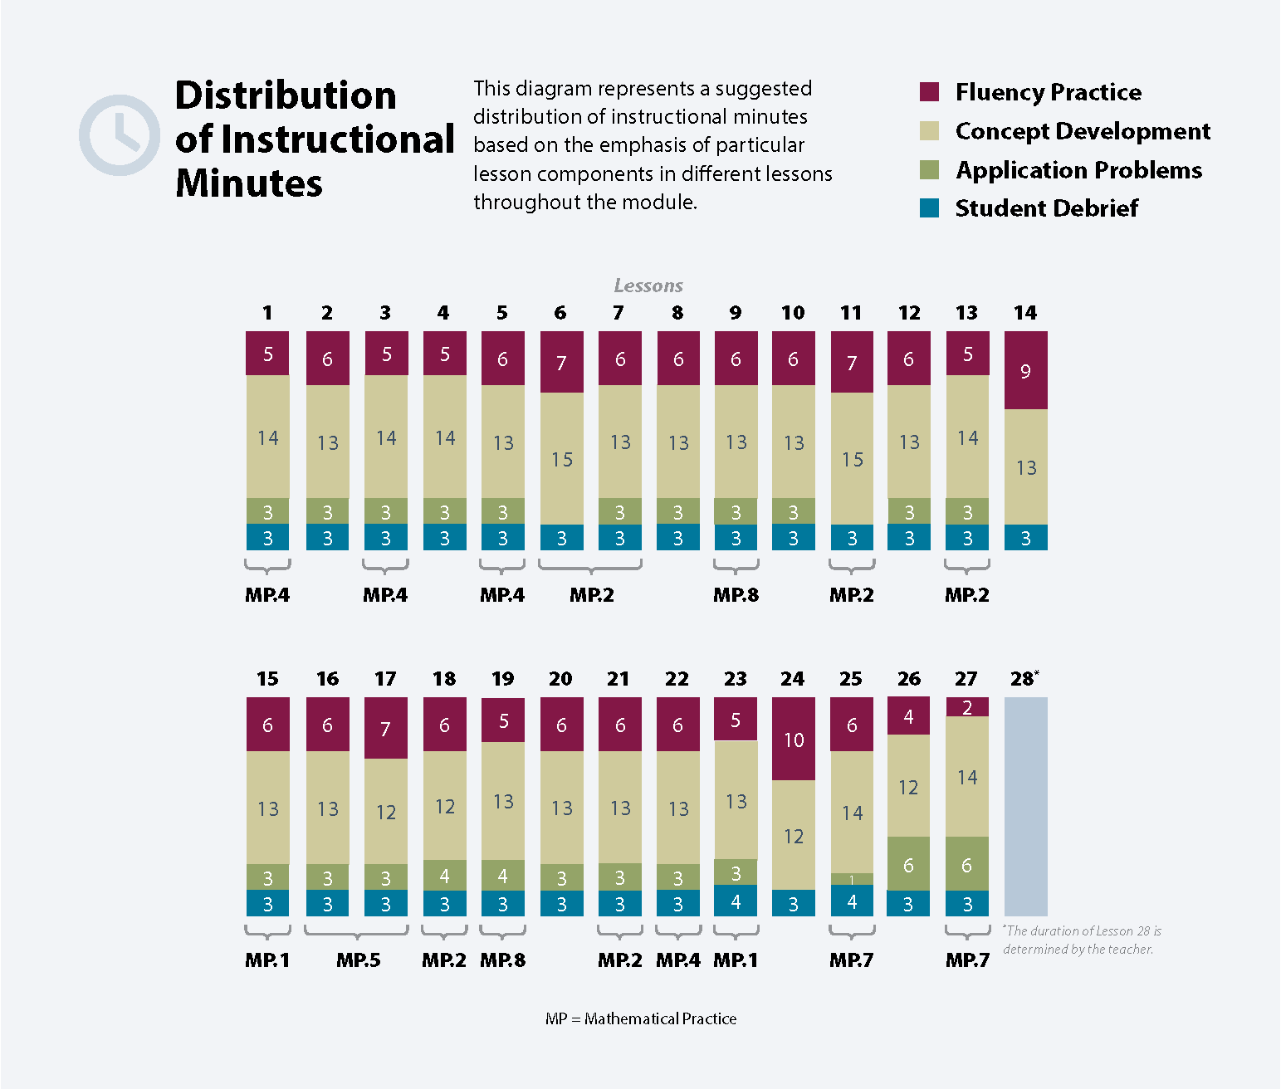

Focus Grade Level Standards
Know number names and the count sequence.
PK.CC.1 Count to 20.
PK.CC.2 Represent a number of objects with a written numeral 0–5 (with 0 representing a count of no objects).
Understand addition as adding to, and understand subtraction as taking from.
PK.OA.1 Demonstrate an understanding of addition and subtraction by using objects, fingers, and responding to practical situations (e.g., If we have 3 apples and add two more, how many apples do we have all together?).
Understand simple patterns.
PK.OA.2 Duplicate and extend (e.g., What comes next?) simple patterns using concrete objects.
Foundational Standards
Count to tell the number of objects.
PK.CC.3 Understand the relationship between numbers and quantities to 0–10; connect counting to cardinality.
- When counting objects, say the number names in the standard order, pairing each object with one and only one number name and each number name with one and only one object.
- Understand that the last number name said tells the number of objects counted. The number of objects is the same regardless of their arrangement or the order in which they were counted.
- Understand that each successive number name refers to a quantity that is one larger.
PK.CC.4 Count to answer "How many?" questions about as many as 0–10 things arranged in a line, a rectangular array, or a circle, or as many as 5 things in a scattered configuration; given a number from 10, count out that many objects.
Sort objects and count the number of objects in each category.
PK.MD.2 Sort objects into categories; count the numbers of objects in each category.
Focus Standards for Mathematical Practice
MP.1 Make sense of problems and persevere in solving them. Children identify story problems as addition or subtraction situations and find the unknown. They create and share their own addition and subtraction stories, and they identify how their representative drawings are similar to and different from their partner’s drawings.
MP.2 Reason abstractly and concretely. Children use actions, objects, and drawings to represent addition and subtraction stories, ultimately turning those experiences into number sentences. After students decontextualize the story to solve, they put the solution back into the context of the story, e.g., “There are 4 apples.”
MP.4 Model with mathematics. Children are able to use fingers, drawings, or abstract numerals to represent a set of up to 5 objects regardless of the type of object or its non-mathematical characteristics.
MP.5 Use appropriate tools strategically. Students use different tools, such as concrete objects, fingers, or drawings to solve simple addition and subtraction word problems.
MP.7 Look for and make use of structure. Children identify what is iterating (the structure) in a given pattern and therefore are able to extend the pattern indefinitely (use the structure).
MP.8 Look for and express regularity in repeated reasoning. Children see that 3 + 2 always represents a total of 5, whether the story problem involves linking cubes, bananas, elephants, or similar items.
Overview of Module Topics and Lesson Objectives
Standards | Topics and Objectives |  | Days
PK.CC.2 | A | Writing Numerals 0 to 5  Lesson 1: Write numerals 0 and 1.  Lesson 2: Write numeral 2.  Lesson 3: Write numeral 3.  Lesson 4: Write numeral 4.  Lesson 5: Write numeral 5. | 5
PK.OA.1  PK.CC.2  PK.CC.3  PK.CC.4 | B | Contextualizing Addition Stories to Solve  Lesson 6: Act out add to with result unknown story problems to solve.  Lesson 7: Solve add to with result unknown story problems using objects from the story.  Lesson 8: Represent add to with result unknown story problems using number sentences.  Lesson 9: Solve put together with total unknown story problems with objects from the story and drawings.  Lesson 10: Create and solve addition story problems using drawings. | 5
PK.OA.1  PK.CC.2  PK.CC.3  PK.CC.4 | C | Contextualizing Subtraction Stories to Solve  Lesson 11: Act out take from with result unknown story problems to solve.  Lesson 12: Solve take from with result unknown story problems using objects from the story.  Lesson 13: Represent take from with result unknown story problems using number sentences.  Lesson 14: Solve take from with result unknown story problems with objects from the story and drawings.  Lesson 15: Create and solve subtraction story problems by drawing. | 5
 |  | Mid-Module Assessment: Topics A–C (interview style assessment, 4 days) | 4
PK.OA.1  PK.CC.2 | D | Decontextualizing Addition Stories to Solve Using Fingers, Objects, and Drawings  Lessons 16–17: Solve addition story problems using fingers.  Lesson 18: Solve addition story problems with representative objects.  Lesson 19: Solve addition story problems with representative drawings. | 4
PK.OA.1  PK.CC.2 | E | Decontextualizing Subtraction Stories to Solve Using Fingers, Objects, and Drawings  Lessons 20–21: Solve subtraction story problems using fingers.  Lesson 22: Solve subtraction story problems with representative objects.  Lesson 23: Solve subtraction story problems with representative drawings. | 4
PK.OA.2  PK.CC.1  PK.CC.3c | F | Duplicating and Extending Patterns  Lesson 24: Identify patterns using objects.  Lesson 25: Identify and duplicate patterns using sounds and movement. Represent those patterns with objects.  Lesson 26: Duplicate and extend patterns with movement and objects.  Lesson 27: Identify a growth pattern using objects.  Lesson 28: Culminating task—create a story problem and act it out in the Children’s Math Theater. | 5
 |  | End-of-Module Assessment: Topics D–F (interview style assessment, 3 days) | 3
Total Number of Instructional Days |  |  | 35
Fluency
New Fluency Topics Appearing in Module 5 Instruction
- Count and read numerals to 10
- Rote count to 20
- Write numbers 0–5
- Decompose quantities 2–5
- Duplicate and extend an AB pattern
Familiar Fluency
- Rote count to 15
- Count one-to-one within 10
- Make a group of up to 10 objects
- Within 5, find 1 more/1 less
- Build numbers 0–5
Terminology
New or Recently Introduced Terms
- Add/Addition
- Addition story
- All together
- Are left
- Equals
- In all
- Math drawing
- Number sentence
- Pattern
- Plus
- Put together
- Repeating part
- Sixteen, seventeen, eighteen, nineteen, twenty (number words)
- Subtract/Subtraction
- Subtraction story
- Take away
- Total
Familiar Terms and Symbols
- 1, 2, 3, 4, 5, 6, 7, 8, 9, 10 (numerals)
- One, two, three, four, five, six, seven, eight, nine, ten, eleven, twelve, thirteen, fourteen, fifteen (number words)
- Counting the Math Way (count fingers from left pinky to right pinky)
- Group (objects sharing one or more attributes)
- How many
- Less
- More
- Number (numeral)
- Partners
- Set (group of objects)
Suggested Tools and Representations
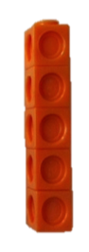
- 5 frogs picture (Lesson 14 Template)
Number Tower
Number Stairs
- Apple tree mat and cards (Lesson 8 Templates 1–2)
- Bean bags
- Concrete materials (e.g., linking cubes, teddy bear counters, blocks, beans, plastic animals, rocks, pebbles, large and small paper plates, pennies, etc.)
- Rice, sand, clay, dough
- Number stairs
- Number tower
- Numeral cards, 0–10
- Numeral writing rectangle (Lesson 5 Template 2)
- Paper doll cards (Lesson 6 Template)
- Personal white boards
- Picture Cards—6, 7, 8, 9, 10 (Lessons 20–23 Templates)
- Reader picture (Lesson 9 Template)
- Sun and star cards (Lesson 24 Template)
Scaffolds
The scaffolds integrated into A Story of Units give alternatives for how students access information as well as express and demonstrate their learning. Strategically placed margin notes are provided within each lesson elaborating on the use of specific scaffolds at applicable times. They address many needs presented by English language learners, students with disabilities, students performing above grade level, and students performing below grade level. Many of the suggestions are organized by Universal Design for Learning (UDL) principles and are applicable to more than one population. To read more about the approach to differentiated instruction in A Story of Units, please refer to "How to Implement A Story of Units."
Assessment Summary
Type | Administered | Format | Standards Addressed
Mid-Module Assessment Task | After Topic C | Interview with rubric. | PK.CC.2  PK.OA.1
End-of-Module Assessment Task | After Topic F | Interview with rubric. | PK.OA.1  PK.OA.2  PK.CC.1
Culminating Task | Lesson 28 | Create a story problem and act it out in the Children’s Math Theater. | PK.OA.1  PK.OA.2

Limit category counts to be less than or equal to 5
Students with disabilities may require Braille, large print, audio, or special digital files. Please visit the website www.p12.nysed.gov/specialed/aim for specific information on how to obtain student materials that satisfy the National Instructional Materials Accessibility Standard (NIMAS) format.

