Pre-Kindergarten Mid-Module 4 Assessment Instructions (Administer after Topic C)
Purpose: These assessments inform daily planning and track student skill development to support and strengthen parent–teacher communication of student progress, as well as provide valuable information for kindergarten teachers.
Materials Needed: Chopstick, toothpick, 15-inch strip of paper, 10 linking cubes, block, white board eraser, box with 2 heavy and 2 light objects, 3 containers (large, medium and small, relative to each other), beans, scissors.

Preparation: This may be a Pre-Kindergarten student's first assessment experience, so it is critical to make it a positive experience. Greet the child warmly, sitting next to the student rather than opposite. Tell the child that you want to play some number games together.
Procedure: Use the specific language of the assessment, translating as necessary for non-English speakers. Use the second hand of a watch or clock to ensure there is ample wait time and note when there is a significant delay in response, e.g., more than 20 seconds. Record the student's results in two ways: 1) the narrative documentation and 2) the overall score per topic. To ensure the most accurate results it is important to allow the child to explain his or her reasoning in his or her primary language.
Initial Assessment: Use the rubric to determine the step at which students are performing.
STEP 1  Little evidence of reasoning without a correct answer.  (1 point) | STEP 2  Evidence of some reasoning without a correct answer.  (2 points) | STEP 3  Evidence of some reasoning with a correct answer or evidence of solid reasoning with an incorrect answer.  (3 points) | STEP 4  Evidence of solid reasoning with a correct answer.  (4 points)
If the student is unable to get the correct answer on any part of the assessment, his or her score cannot exceed Step 3. However, if the student is unable to use his or her words to tell what he or she did, then it is not counted against the student quantitatively. (However, awareness exists regarding the difference between a non-English versus a native English speaker unable to articulate something.) If the student asks for or needs a hint or significant support, provide either, but the score is automatically lowered. This is to make sure that the assessment provides a true picture of what a student can do independently.
Repeated Assessment: If a student scores at Step 1 or 2, repeat that task again at two-week intervals, noting the date of the reassessment in the space at the top of the student’s record sheet. Document progress on this one form. If the student is very delayed in his or her response but completes it, reassess after two weeks to see if there is a change in the time elapsed.
Documentation Availability: Put the assessments in a three-ring binder or student portfolio. There are two assessments (mid and final) per module for each student. Use the Class Record Sheet following the rubric for an At-a-Glance look at students’ strengths and weaknesses and follow-up lesson planning.

 | Date 1 | Date 2 | Date 3
Topic A
Topic B
Topic C
Student Name _________________________
Topic A: Comparison of Length
Rubric Score ___________Time Elapsed ____________
Materials: (S) Chopstick, toothpick, 15-inch strip of paper, 10 linking cubes, scissors
1. (Hold a chopstick and a toothpick upright in front of the student.) Which words BEST describe these objects, big and small or tall and short?
2. (Hand a chopstick and a linking cube tower of 8 to the student.) Compare these two objects: which one is longer?
3. (Place a 15-inch strip of paper and the chopstick in front of the student.) Cut the paper. Give me the piece that is shorter than the chopstick.
4. (Hand two linking cube towers of 5 to the student.) Compare the towers: Are they the same as each other or is one longer or shorter than the other?

What did the student do? | What did the student say?
Topic B: Comparison of Weight
Rubric Score ___________Time Elapsed ____________
Materials: (S) Block, white board eraser, box with 2 heavy and 2 light objects
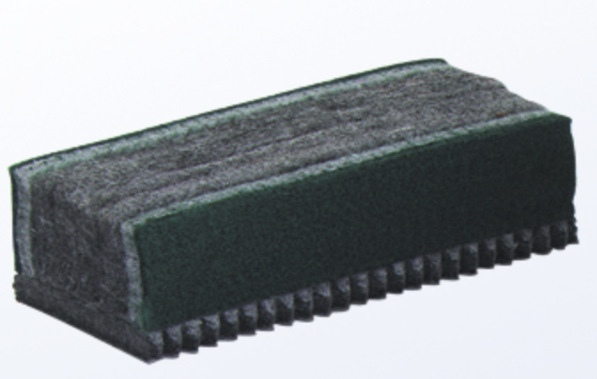
1. (Place a block and a white board eraser in front of the student.) Which words BEST describe these objects, heavy and light or big and small?
2. (Place the box with 2 heavy and 2 light objects in front of the student. Hold up the white board eraser.) Find something in the box that is heavier than this eraser. (Pause as the student does so.) Use your words to compare the weight of the eraser and the ____________.
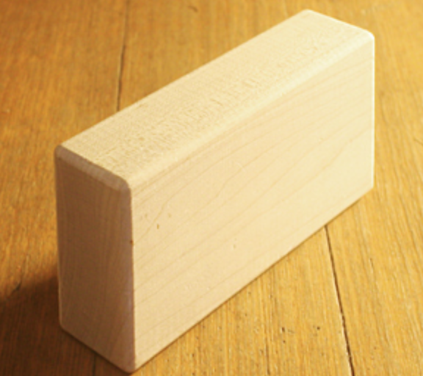
3. (Place the box with 2 heavy and 2 light objects in front of the student. Hold up the block.) Find something in the box that is lighter than this block. (Pause as the student does so.) Use your words to compare the weight of the block and the ____________.

What did the student do? | What did the student say?

Topic C: Comparison of Volume
Rubric Score ___________Time Elapsed ____________
Materials: (S) Large, medium, and small containers (relative to each other); beans
- (Place the large container and small container filled with beans in front of the student.) Which words BEST describe these objects, heavy and light or big and small?
2. (Place all 3 containers, with the medium-sized container filled with beans, in front of the student.) Which container holds more than this cup of beans? Use your words to compare how much these two containers hold.
3. Which container holds less than this cup of beans? Use your words to compare how much these two containers hold.

What did the student do? | What did the student say?
Mid-Module Assessment Task  Standards Addressed | Topics A–C
Describe and compare measurable attributes.
PK.MD.1 Identify measurable attributes of objects, such as length, and weight. Describe them using correct vocabulary (e.g., small, big, short, tall, empty, full, heavy, and light.)

Evaluating Student Learning Outcomes
A Progression Toward Mastery is provided to describe and quantify steps that illuminate the gradually increasing understandings that students develop on their way to proficiency. In this chart, this progress is presented from left (Step 1) to right (Step 4). The learning goal for each student is to achieve Step 4 mastery. These steps are meant to help teachers and students identify and celebrate what the students CAN do now and what they need to work on next.

A Progression Toward Mastery
Assessment  Task Item | STEP 1  Little evidence of reasoning without a correct answer.  (1 point) | STEP 2  Evidence of some reasoning without a correct answer.  (2 points) | STEP 3  Evidence of some reasoning with a correct answer or evidence of solid reasoning with an incorrect answer.  (3 points) | STEP 4  Evidence of solid reasoning with a correct answer.  (4 points)
Topic A  PK.MD.1 | The student shows little evidence of understanding how to compare objects according to length. Student needs teacher assistance to begin tasks. Student is uncertain when replying to length comparison questions and looks to the teacher for guidance. Time elapsed for each task is significant. | The student shows evidence of beginning to understand how to compare objects according to length. Student inconsistently uses length comparison vocabulary and/or is able to do 2 of the 4 tasks correctly. | The student is able to do three of the following:  - Describes the chopstick and toothpick as tall and short.  - Says, “The chopstick is longer than the linking cubes or tower,” and may align endpoints to compare length.  - Gives teacher the cut piece of paper that it is shorter than the chopstick.  - Counts the cubes or aligns endpoints and says, “The towers are the same as each other.”  Length comparison vocabulary is used even if sentences are incomplete or fragmented, e.g., “This is taller than this.” | The student correctly:  - Describes the chopstick and toothpick as tall and short.  - Says, “The chopstick is longer than the linking cubes or tower,” and may align endpoints to compare length.  - Gives teacher the cut piece of paper that is shorter than the chopstick.  - Counts the cubes or aligns endpoints and says, “The towers are the same as each other.”  Length comparison vocabulary is used even if sentences are incomplete or fragmented, e.g., “This is taller than this.”
Topic B  PK.MD.1 | The student shows little evidence of understanding how to compare objects according to weight. Student needs teacher assistance to choose items from the box. Student is unable to use words to tell about the weight comparisons. Time elapsed for each task is significant. | The student shows evidence of beginning to understand how to compare objects according to weight. Student inconsistently uses weight comparison vocabulary. When asked to compare two objects, the student chooses some of the correct objects. Student has some difficulty using words to tell about the weight comparisons. | The student is able to do two of the following:  - Describes the block and white board eraser as heavy and light.  - Chooses an object that is heavier than the eraser and says, “The ____ is heavier than the eraser.”  - Chooses an object that is lighter than the block and says, “The ______ is lighter than the block.”  Weight comparison vocabulary is used, even if sentences are incomplete or fragmented, e.g., “This is lighter than this.” | The student correctly:  - Describes the block and white board eraser as heavy and light.  - Chooses an object that is heavier than the eraser and says, “The ____ is heavier than the eraser.”  - Chooses an object that is lighter than the block and says, “The ______ is lighter than the block.”  Weight comparison vocabulary is used, even if sentences are incomplete or fragmented, e.g., “This is lighter than this.”
Topic C  PK.MD.1 | The student shows little evidence of understanding how to compare objects according to volume. Student incorrectly identifies the more than container and the less than container. Student is unable to use words to tell about the volume comparisons. Time elapsed for each task is significant. | The student shows evidence of beginning to understand how to compare objects according to volume. Student inconsistently uses volume comparison vocabulary. When asked to compare two containers, the student points to the correct container hesitantly. Student has some difficulty using words to tell about the volume comparisons. | The student is able to do two of the following:  - Describes the containers as big and small.  - Chooses the large container and says, “This container holds more than that cup of beans.”  - Chooses the small container and says, “This container holds less than that cup of beans.”  Volume comparison vocabulary is used, even if sentences are incomplete or fragmented, e.g., “Can put more in this cup than that.” | The student correctly:  - Describes the containers as big and small.  - Chooses the large container and says, “This container holds more than that cup of beans.”  - Chooses the small container and says, “This container holds less than that cup of beans.”  Volume comparison vocabulary is used even if sentences are incomplete or fragmented, e.g., “Can put more in this cup than that.”

Class Record Sheet of Rubric Scores: Mid-Module 4 Assessment
Student Names | Topic A:  Comparison of Length | Topic B:  Comparison of Weight | Topic C:  Comparison of Volume | Next Steps:

