Grade PK • Module 4 • Topics D–G
Family Math Newsletter
Suggested Words and Key Terms
(Below)
Attaching number to sets gradually leads students to compare numbers alone.
(Above)
Students compare game pieces.

How to Help at Home
- Before counting some tomatoes with your child, decide which tomato to count first and which to count last. After counting, make a new decision and see that the count is the same!
- Count toys and compare sets during play. Ask, “How many cars do you have?” “How many trucks?” “I wonder if you have fewer cars or trucks. Let’s line them up and see!”
- When walking, make comparison statements, “My steps are longer than your steps.” “I take fewer steps than you to go places.” “I took 4 steps and you took 5 steps.” “4 is less than 5.”
- Read counting books or recite nursery rhymes and encourage the child to count images. By the end of Pre-Kindergarten, students should be able to count to 20 by rote (on their own), but if they can touch and count to 20, that’s terrific!
Comparison of Length, Weight, Capacity, and Numbers to 5
The second half of Module 4 begins with an exploration of first and last when objects are counted in linear, array, circular, and scattered arrangements. Students use the language of comparison they began to develop when working with length, weight, and capacity as they compare sets of up to 5 objects. This module culminates with students counting to compare sets of objects, “4 cats is more than 3 cats” and finally, numbers, “4 is greater than 3.”
Key Standards
- Compare numbers.
- Identify first and last related to order or position.
Looking Back
In the first half of Module 4, students compared and explored length, weight, and capacity.
Looking Ahead
In Module 5, students will learn to write numbers to 5, explore addition and subtraction stories, and count to 20.

- Are there enough?
- Compare
- Equal to
- Exactly enough
- Exactly the same
- Extra
- Fewer
- Fewer than
- First
- Greater
- Greater than
- How many?
- Last
- Less
- Less than
- Match
- More
- More than
- Set
- The same as

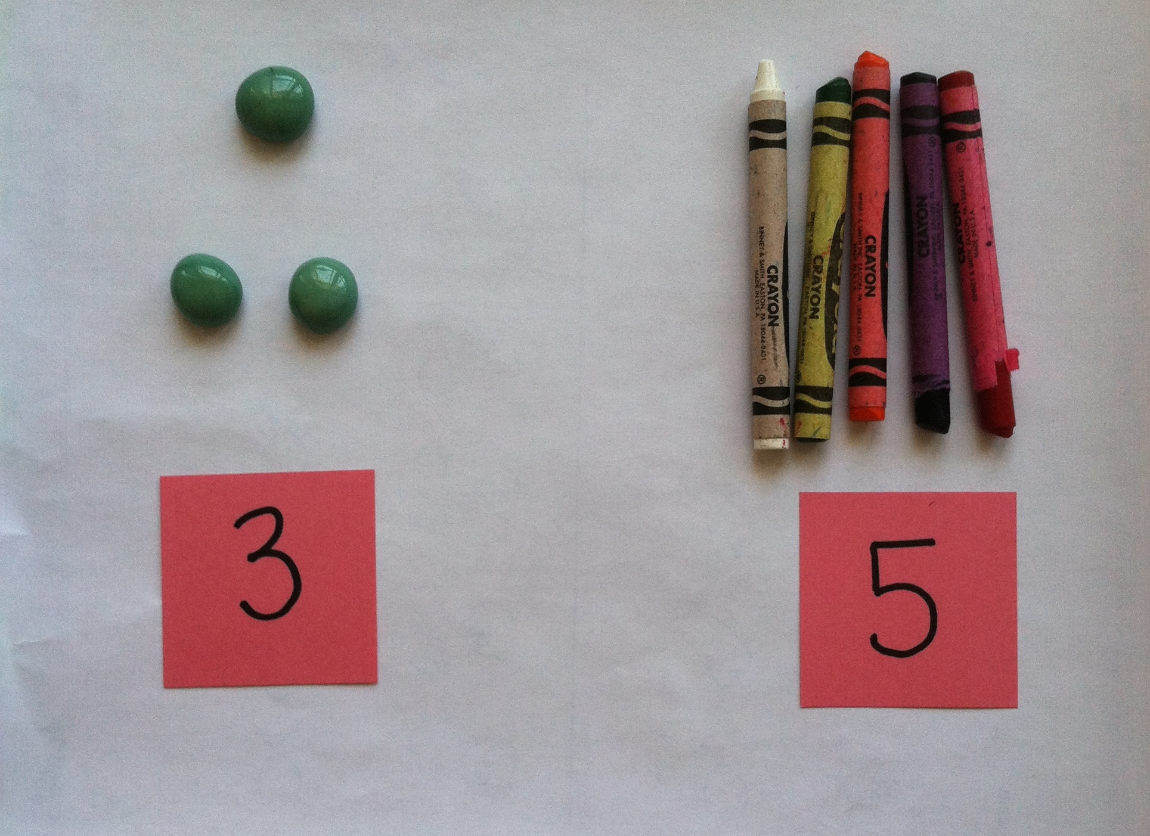
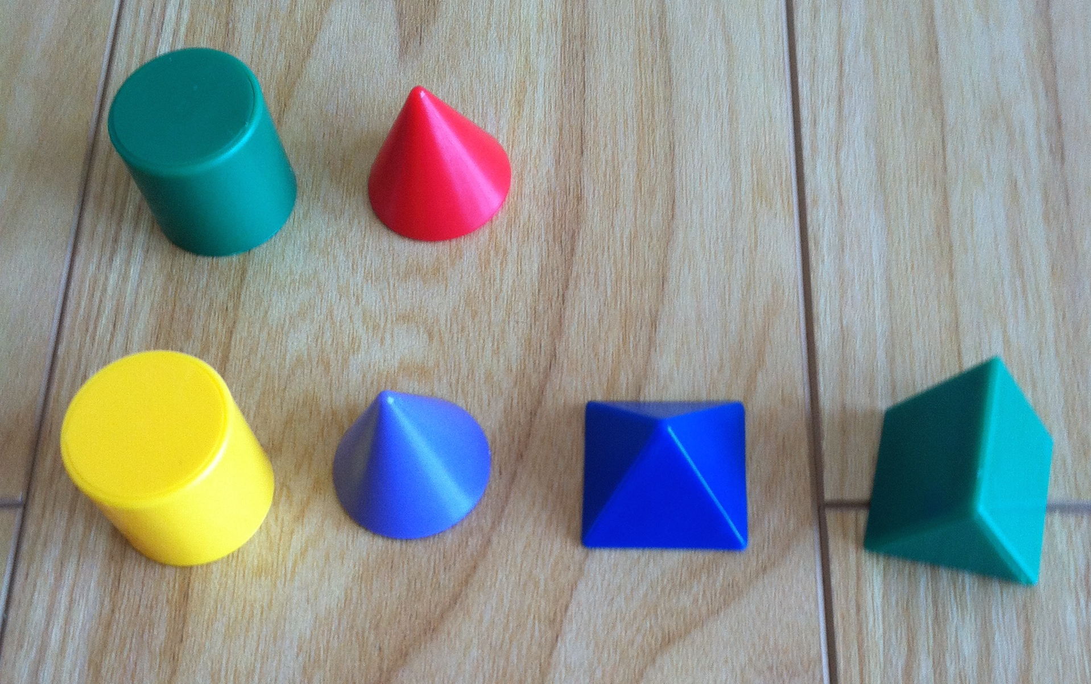

Spotlight on Math Vocabulary
Children will use key mathematical vocabulary throughout their elementary years. The language of comparison (greater than and less than) is vocabulary Pre-K students will use to compare numbers.
Sample Activity  (From Module 4, Lesson 20)  Clay Numeral 2  Teacher: Take your clay and roll it into a long, skinny, snake.  Students: (Manipulate clay.)  Teacher: Put your snake on the 2, starting at the star.  Students: (Use their clay to first make the curved part of the 2, and then the straight part.)  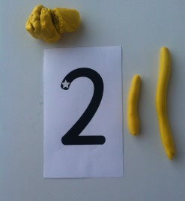  Teacher: If you finish early, use your finger to trace the 2, starting at the star.  This activity anticipates writing numerals in Module 5 and is intended to familiarize students with correct numeral formation. In addition, students use their fine motor skills to manipulate the clay. | A Focus on Models of Comparison  In the first half of this module, children compared length, weight, and capacity. Now, they transition into comparing numbers by matching two groups of objects and considering if there are enough, not enough, or more than enough. For example, the model below shows the following statement to be true, “There are not enough crayons for each paper.”  The next step in comparing numbers is to match the objects in each group to find out if there are “more crayons than papers,” “fewer crayons than papers,” or “the same number of crayons as papers.” At this point, the students are counting and saying the number of each group, but making their comparison statement as they match the two groups of objects.  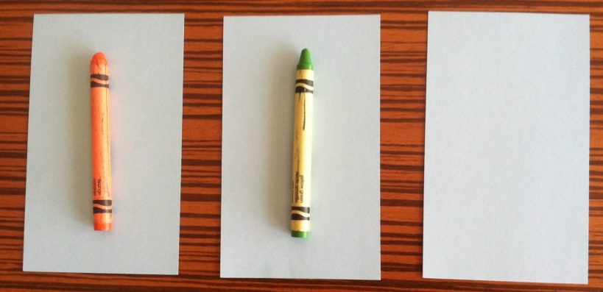  In the culminating lessons of this module, students attach a number card to each group of objects to make greater than or less than statements. For example, “3 is greater than 2” or “2 is less than 3.” Finally, students are shown a pair of number cards (up to 5) and are asked to make greater than or less than statements without objects. Then, they verify their statements by making linking cube towers/trains.  Working to compare by using the abstract (number cards) and the concrete (linking cube towers) develops students’ number sense as they relate numbers to each other. This point is emphasized, so when students work on comparison, they can answer questions such as, “How many more apples does Maria have than Armen?” A solid foundation is being carefully laid right now! Together, everyone can!

