Grade PK • Module 4 • Topics A–C
Family Math Newsletter
Key Standards
- Describe and compare measurable attributes of length, weight, and volume.
- Compare numbers.
- Identify first and last related to order or position.
Looking Back
In Module 3, students used what they learned about numbers to 5 to explore numbers 6–10 and 0. Using 5 as a starting point, they learned that 6 is one more than 5. They counted up to 10 objects in different arrangements, made tallies, and learned to recognize numerals to 10. Students also practiced counting 1 more and explored different ways to take apart numbers.
Looking Ahead
In Topics D–G of Module 4, students identify first and last and compare sets of up to 5 objects.

Comparison of Length, Weight, Capacity, and Numbers to 5
In Topics A–C of Module 4, students compare and explore lengths, weights, and capacities. For example, students learn to line up the endpoints when comparing length, use a balance scale to compare weight, and pour sand into containers of different sizes and shapes as they compare capacity.
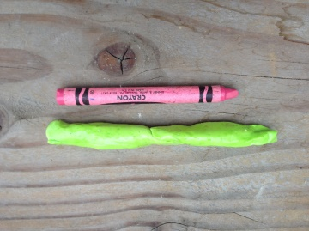
(Above) Children make clay snakes that are longer than a crayon.

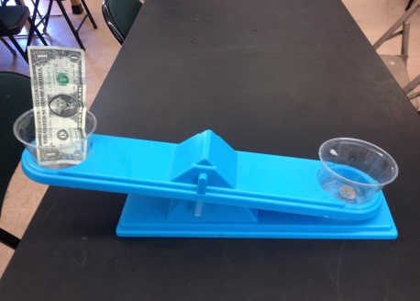
(Below) Students use a balance scale to compare the weight of a quarter and a dollar.
Suggested Words and Key Terms

How to Help at Home
- Play I Spy while walking or driving. Look for objects of different length or weight. “I spy something heavy and round.” (A rock!) “I spy something tall and green.” (A tree!) “I spy something shorter than a foot.” (A worm!)
- Use blocks to build trains of different lengths. Ask, “Which train is shorter?” Say, “Let’s try to build another train the same length!”
- Explore capacity with water play. Set out containers of different sizes and shapes. Ask, “Which container do you think can hold the most water?” or “Do you think all the water in your cup will fit in this bowl?” Pour water back and forth among the containers and make observations.
- Continue to find opportunities to count in everyday experiences. “I wonder how many steps there are. Let’s count as we walk up them!”
Suggested Words and Key Terms
- Greater than/less than
- Heavy/light
- Heavier than/ lighter than
- Length
- Less
- Longer than/ shorter than
- More
- More than/less than
- Tall/short

- About the
same as
- Are there enough?
- Balance
- scale
- Big/small
- Compare
- Exactly
- Extra
- Fewer
- First/last

Spotlight on Math Models
Children will use key mathematical models throughout their elementary years. One of these models is the linking cube tower/train, a tool Pre-K students will use to compare length and numbers.
Sample Counting Vignette  (From Module 4, Lesson 9)  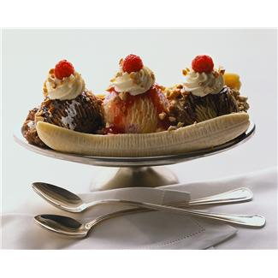  Ice Cream  Teacher: I’m going to count and make a mistake on purpose. Instead of saying a number, I’ll say “ice cream!” Isn’t that silly? Listen closely and see if you can tell what number I should’ve said.  1, 2, ice cream!  Students: 3.  Teacher: Very good. Listen again: 1, 2, 3, 4, ice cream!  Students: 5.  Teacher: Excellent. This one will be a bit of a challenge. Ready? 1, 2, ice cream, 4, 5.  At this point in the year, students are steadily gaining mastery of the counting sequence. This activity challenges them to detect an error in the familiar order of numbers. Teachers work within a range that is comfortable for all students, and slowly build up. | Linking Cube Tower and Linking Cube Train  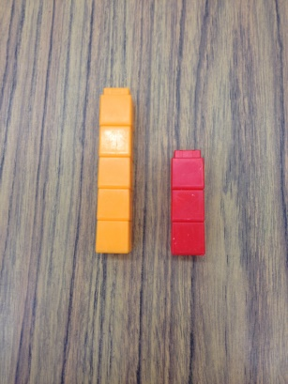  The linking cube tower and train are powerful tools that are used through Grade 2. In the first half of Module 4, students simply hold the towers (linking cubes situated vertically) next to each other to make longer than, shorter than, and same as statements. Informally, students notice that each tower is built from equal units, an important measurement concept setting the foundation for the ruler, number line, and fractions.  Toward the end of this module, students use the linking cube trains (linking cubes situated horizontally) to compare numbers. They count the cubes, and then build each train. From their work comparing towers and trains, they can say, “5 is more than 3.”  Because young children commonly use the words big and small to describe most objects, this module focuses on teaching students vocabulary that allows them to be more precise in their description of objects. Learning and using comparative statements like longer or shorter than, heavier or lighter than, and more or less than with objects is a bridge to comparison of number—greater or less than. Using number towers and trains is one of the first concrete steps in this process.

