Lesson 3: Rational Exponents—What Are and ?

Classwork

Opening Exercise

* 1. What is the value of ? Justify your answer.
  2. Graph for each integer from to . Connect the points on your graph with a smooth curve.



The graph at right shows a close-up view of for

* 1. Find two consecutive integers that are over and under estimates of the value of .
  2. Does it appear that is halfway between the integers you specified in Exercise 1?
  3. Use the graph of to estimate the value of .
  4. Use the graph of to estimate the value of .

**Example 1**

* 1. What is the th root of ?
  2. What is the cube root of ?
  3. What is the th root of ?

Exercise 1

Evaluate each expression.



Discussion

If and , what does equal? Explain your reasoning.

Exercises 2–8

Rewrite each exponential expression as an th root.



Rewrite the following exponential expressions as equivalent radical expressions. If the number is rational, write it without radicals or exponents.

4. Show why the following statement is true:

Rewrite the following exponential expressions as equivalent radical expressions. If the number is rational, write it without radicals or exponents.







Problem Set

Lesson Summary

**th root of a number:** Let and be numbers, and let be a positive integer. If , then is an *th root of .* If , then the root is a called a *square root*. If , then the root is called a *cube root*.

**Principal th root of a number:**  Let be a real number that has at least one real th root. The *principal th root of* is the real th root that has the same sign as and is denoted by a radical symbol: .

Every positive number has a unique principal th root. We often refer to the principal th root of as just the *th root of .* The th root of is .

For any positive integers and , and any real number for which the principal th root of exists, we have

1. Select the expression from (A), (B), and (C) that correctly completes the statement.

(A) (B) (C)

* 1. is equivalent to _.
  2. is equivalent to _.
  3. is equivalent to _.
  4. is equivalent to _.

1. Identify which of the expressions (A), (B), and (C) are equivalent to the given expression.

(A) (B) (C)



1. Rewrite in radical form. If the number is rational, write it without using radicals.
2. Rewrite the following expressions in exponent form.
3. 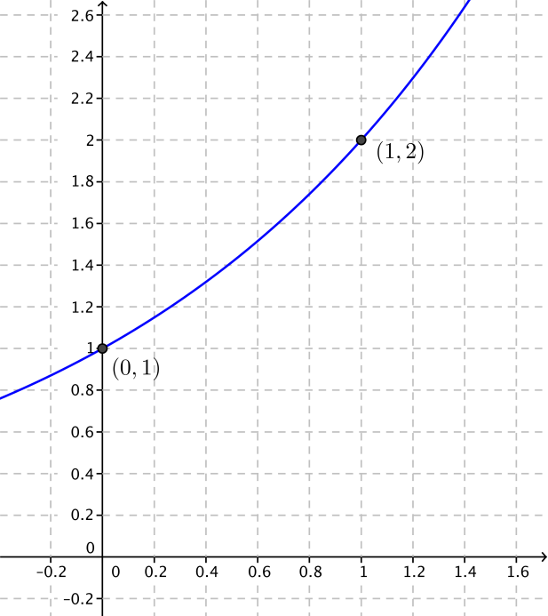Use the graph of shown to the right to estimate the following powers of .
4. Rewrite each expression in the form , where is a real number, is a positive real number, and is rational.
5. Find a value of for which .
6. Find a value of for which .
7. If , find the value of .
8. If , evaluate the following expressions.
9. Show that each expression is equivalent to . Assume is a positive real number.
10. Yoshiko said that because is one-fourth of . Use properties of exponents to explain why she is or is not correct.
11. Jefferson said that because and . Use properties of exponents to explain why he is or is not correct.
12. Rita said that because , so and then . Use properties of exponents to explain why she is or is not correct.
13. Suppose for some positive real number that .
    1. What is the value of ?
    2. Which exponent properties did you use to find your answer to part (a)?
14. In the lesson, you made the following argument:

Since is a number so that and is a number so that , you concluded that Which exponent property was used to make this argument?