Lesson 42
Culminating Task—represent numbers 6−10 using objects, images, and numerals in a number book.

Suggested Lesson Structure
 Culminating Task
(Times are flexible, see note in Lesson)
 Student Debrief
Total Time
Culminating Task (Duration to be determined.)
Part 1: Concept Introduction
Materials: (T) 3 trays, easel (if possible for demonstration), piece of chart paper, sample number book, manipulatives, (e.g., straws, puff balls), pre-cut magazine pictures and shapes (or Template), 1” strips of construction paper (to create 5-groups), various art supplies, (e.g., scissors, glue or glue sticks, dot painters, crayons, stickers)
Note: Due to possible duration of this project, consider allowing children to continue working during the first days of assessment, saving the last day for students to share with families or other members of the school community.
Gather materials on the carpet. On the first tray, place various manipulatives. On the second tray, place pre-cut magazine pictures, shapes, and/or the Template, and empty 5-group strips. On the third tray, place various art supplies, as noted in the materials. Distribute each child’s number book from GPK–Module 1.
NOTES ON
MULTIPLE MEANS
OF REPRESENTATION:
Some students may benefit from continuing to work at the concrete level. Provide children with teddy bear counters, linking cubes, etc. that they can arrange and count before drawing them on their number page. Then comment, “Pia, I see you drew 6 teddy bears to match your counters.”

- Tell students, “It is so nice to see your number books for 1, 2, 3, 4, and 5! Look at your work from the beginning of the year.”
- Ask, “What numbers have we learned about since we made these books?” As children share, write the numbers 0, 6, 7, 8, 9, and 10 on the board. Explain that they will add a page to the book for each new number they know.
- Show students a sample book and briefly explain materials. Turn to the 6 page, displaying it on the easel. Describe what you are seeing, using self-talk, e.g., “Look, I see the number 6 at the top. I drew a picture of Ansel Ant with his 6 legs to match the number. Then, I glued a picture of 6 bumblebees, (counting) 1, 2, 3, 4, 5, 6.”
- Ask students, “What can I add to my page to show 6?” Add suggestions, such as tracing 6 fingers or adding 6 stickers.
- Tell students, “Now, let’s make a giant 0 page together!” (Use chart paper.) Encourage students to think of different ways to show the number 0. The 0 page is likely to be relatively empty compared to other pages, but children might suggest a drawing like an empty bowl with 0 grapes inside. Take dictation to explain these types of drawings.
Part 2: Practice
Materials: (S) Per student: 6−8.5" x 11″ pieces of colored construction paper with numbers 0, 6─10 written in the upper left hand corner; per table: caddy with art supplies.
Send students to tables to make their own books. Have supplies ready on each table. Start all students with the number 6.
- As the students work, circulate and describe what they are doing, using parallel talk.
(e.g., “Andrew is drawing 6 cars on his paper to match the cars he plays with in our classroom,” or “Ian is showing 6 on his paper strip with the green dot painters.”)
- As you circulate, ask how the number is shown. You might record the dictation on the page. For example, write, “I drew 3 eggs here and 3 eggs here. That’s 6 eggs.”
- Since children will work at different rates, when they are finished, write each child’s name on the back of the page and set it aside. Give him/her the next numeral page to continue working.
On the last day of work, help children put their pages in order (0 should go before 1) and fasten the book together in preparation for the Student Debrief.
Student Debrief (Duration to be determined)
CENTER CONNECTION:
Consider creating a station for students to continue work on their number books during centers. This will support children who need significant amounts of uninterrupted time to complete their work and also encourages students to see more ways to represent their number, deepening their perspective and encouraging perseverance.
Lesson Objective: Culminating task—represent numbers 6−10 using objects, images, and numerals in a number book.
Note: Begin the Student Debrief with a 4–5 minute Gallery Walk, inviting students and guests to read and enjoy the number books. Then, invite children to bring their books to the circle for discussion.
The Student Debrief is intended to invite reflection and active processing of the total lesson experience. It is also an opportunity for informal assessment. Consider taking anecdotal notes or using a simple checklist to note each child’s progress towards meeting the lesson objective.
As students complete the Practice portion of the lesson, listen for evidence of student understanding that can be celebrated in the Debrief.

You may choose to use any combination of the questions below to help students express ideas, make connections, and use new vocabulary.
- Look at your book. Tell me what you used to show 10.
- Turn to the page that is your favorite. Share it with your partner. What did you use to show the number?
- Invite visiting community members to comment about the books.
- Who would like to share a number 6 page? (After student shares, invite students and community members to clap 6 times. Repeat with other number pages.)

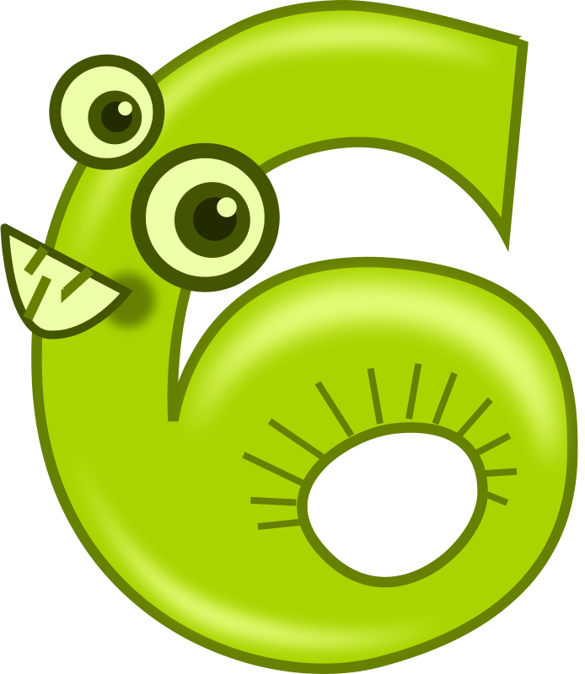 | 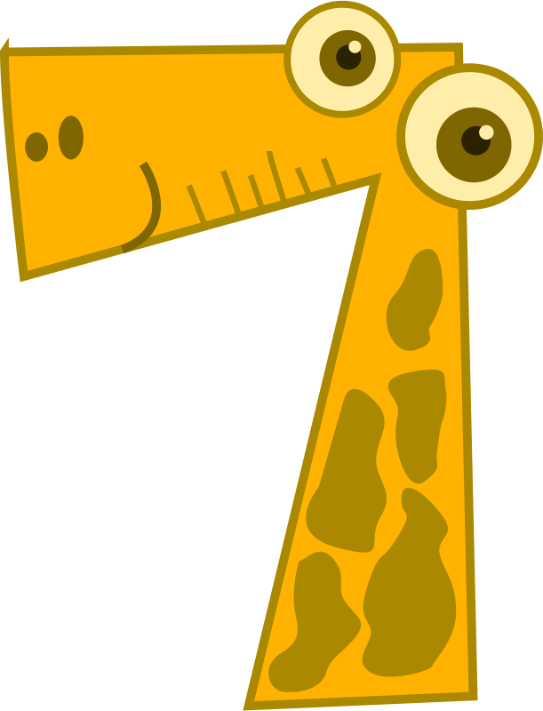
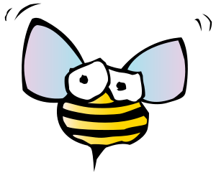

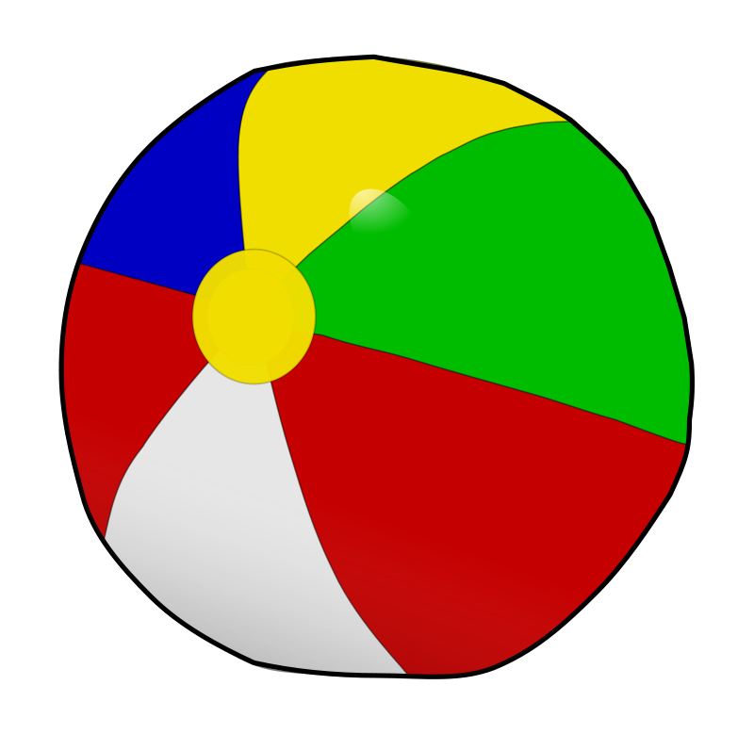
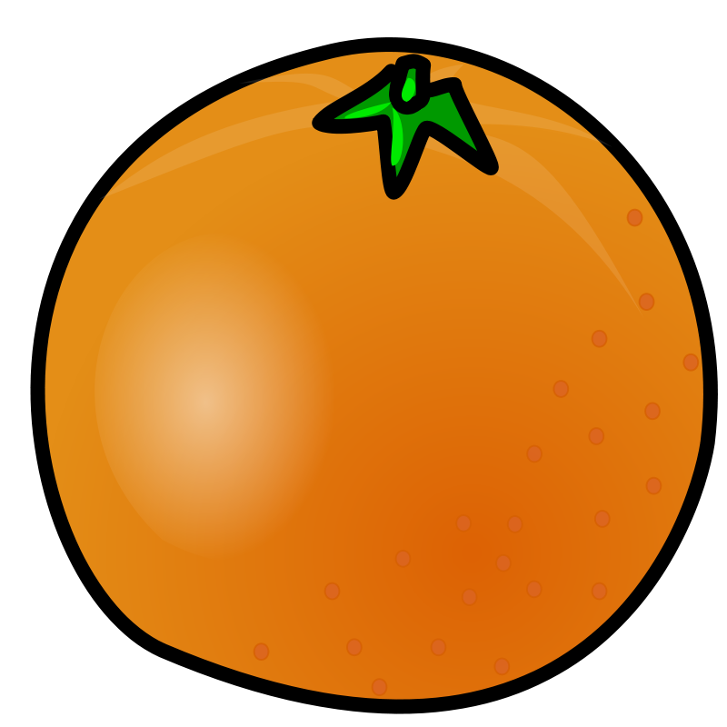

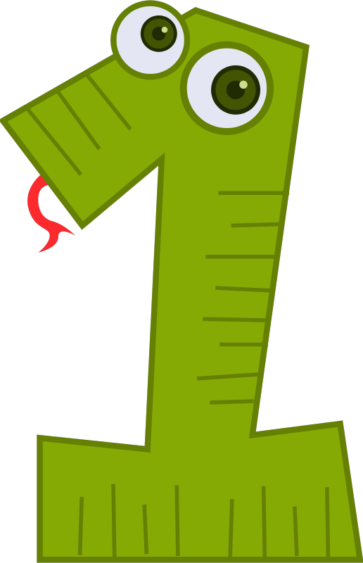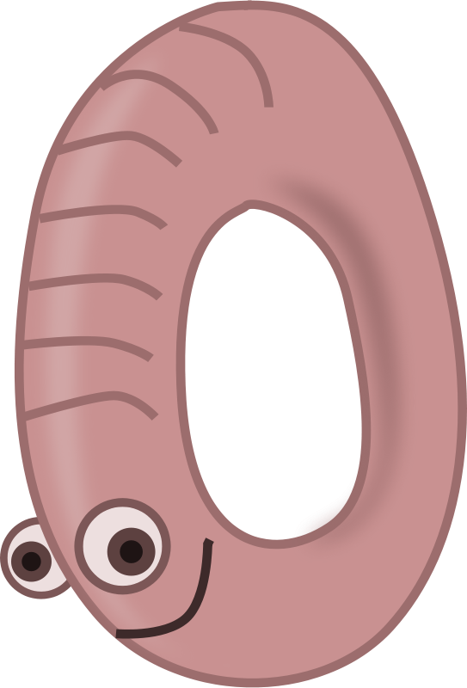

pictures and shapes
pictures and shapes

