Lesson 41
Objective: Look at a numeral and count out a group of up to 10 objects.

Suggested Lesson Structure
 Fluency Practice (3 minutes)
 Concept Development (18 minutes)
 Student Debrief (4 minutes)
Total Time (25 minutes)
Fluency Practice (3 minutes)
- The Fingers on One Hand, and Some More PK.CC.3abc (3 minutes)
The Fingers on One Hand, and Some More (3 minutes)
Note: Now that 3 lessons have been spent working with fingers in relationship to 5, students show some more and find the total.
T: Show me all the fingers on your left hand. (Pause.) Show me your thumb on your other hand. (Pause.) Put them next to each other.
T: Hide the thumb that is alone. (Meaning the thumb of the right hand.) Show some fingers on your right hand. Whatever you want. (Pause and observe.) When I signal tell me how many fingers you put on your right hand.
S: 5. 1. 3. 4.
T: Great. I want the following friends to stop showing their fingers. (Choose every other student.)
T: Count the number of fingers your partner has showing.
Have the students switch roles as time allows. This can clearly be modified to meet the needs of an individual class as is deemed appropriate.
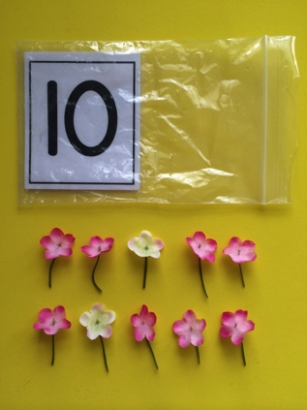
Concept Development (18 minutes)
Part 1: Concept Introduction
Materials: (T/S) Cup of 12 flowers, baggie containing the numeral card 10 (Lesson 35 Template 2)

- Tell students that today the chefs at the Pollen Café must prepare bags of flowers for their customers. They will have to count out the right number of flowers for each baggie.
- Invite children to take the numeral cards out of their bags. Ask all students to name the number and trace it with a finger. Ask, “How many flowers do we need for this baggie?” Guide children to respond, “10 flowers!”
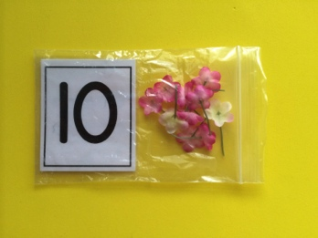
- Dump the flowers from the cup. Count out the correct number of flowers, using self-talk to describe your thinking, “I’ll make a line of 10 flowers for this baggie. I’ll count and stop when I get to 10. 1 flower, 2 flowers, … 10 flowers (place tenth flower in line). Stop.”
MP.7
- Ask students to count and make sure the flowers match the numeral card. Put the flowers in the bag.
- Invite children to count out their own line of 10 flowers. Encourage children to say, “Stop!” when they hear the target number. If children are not able to count and keep the target number in their mind, let them use the number path.
Part 2: Practice
Materials: (S) Teachers: cups containing 0–10 bee stickers; Waiters: number path (Lesson 10 Template), paper and crayon or white board and dry erase crayon; Chefs: 12 flowers, numeral cards 0–10 (Lesson 26 Template 2 and Lesson 35 Template 2)
Group students and assign roles of teacher, waiter and chef. Place the cups of bees in a central spot so students can get more customers as needed.
- Walk groups of 3 students through the following steps to play Pollen Café.
- Step 1: Teacher takes a cup of bees and places them in their seats on the number path.
A NOTE ON
MULTIPLE MEANS
OF REPRESENTATION:
Provide a visual model of the steps for playing Pollen Café for students who may have difficulty following multi- step directions. The visual model could be drawings or photos of students completing each step.
- Step 2: Waiter makes tally marks to show the number of flower orders and takes order to chef.
- Step 3: Chef finds the numeral that matches the tally and fills the flower order.
- Step 4: Waiter checks to see that the chef counted the right number of flowers and takes the flowers to the seated bees.
- Have partners switch roles and materials after each turn.
- Circulate and support children as they tally bees and count out flowers. Help teachers select cups of bees that will provide a challenge, (i.e., if a child continues to pick cups with 0−3 bees, suggest a cup with a larger number of bees).

Student Debrief (4 minutes)
Lesson Objective: Look at a numeral and count out a group of up to 10 objects.
The Student Debrief is intended to invite reflection and active processing of the total lesson experience. It is also an opportunity for informal assessment. Consider taking anecdotal notes or using a simple checklist to note each child’s progress towards meeting the lesson objective.
As students complete the Practice portion of the lesson, listen for misconceptions or misunderstandings that can be addressed in the Debrief. You may choose to use any combination of the questions below to help students express ideas, make connections, and use new vocabulary.
- Chefs, how did you know when to stop putting more flowers in the order?
CENTER CONNECTION:
Continue to set up the dramatic play center as Pollen Café. As children play today, have the chefs create a group of flowers based on the tallies brought by the waiter instead of relying on pre-prepared baggies. If students are ready for an additional challenge, allow bees to order more than 1 flower.

- (Show an itemized check from a restaurant, or if available, the line ticket used in a restaurant kitchen.) Look at this order from a real restaurant. How did the chef know how many of each item to buy?
- Look at the ticket. How can computers help waitresses and chefs get the right orders for customers?
- (Show 10 cubes.) Can you count out 10 cubes from this pile? (Show a big bucket of cubes.) Can you count out 10 cubes from this bucket? What is different about counting 10 from this bucket?

