Lesson 40
Objective: Tally 10 objects.

Suggested Lesson Structure
 Fluency Practice (3 minutes)
 Application Problem (5 minutes)
 Concept Development (14 minutes)
 Student Debrief (3 minutes)
Total Time (25 minutes)
Fluency Practice (3 minutes)
- The Fingers on One Hand, and 1 More PK.CC.3abc (3 minutes)
The Fingers on One Hand, and 1 More (3 minutes)
NOTES ON
MULTIPLE MEANS
OF EXPRESSION:
Have students make a print of their right hand during art and place it next to the print they made of their left hand. They can, again, cover certain fingers, and have a wonderful model of 10 for use during a variety of activities, such as placing a bean on each fingernail, or some fingernails. These “templates” can be posted around the classroom in a plastic storage bag for easy access.

Note: Now that two lessons have been spent playing with 5 fingers, students show 1 more using the thumb on the right hand.
T: Show me all the fingers on your left hand. (Pause.) Show me your thumb on your other hand. (Pause.) Put your hands next to each other.
T: Hide the thumb that is alone. (Meaning the thumb of the right hand.) Show your thumb. Hide your thumb. How many fingers are showing? Wait for the signal to tell me. (Pause and observe.)
S: 5.
T: Show your thumb. (Pause.) How many fingers are showing now? Wait for the signal to tell me. (Pause and observe.)
S: 6.
Move between 5 and 6 playfully, gradually inserting the language of 1 more and 1 less as they are ready.

Application Problem (5 minutes)
Materials: (T) numeral cards 0 and 5–10 (1 to match each cup, Lesson 26 Template 2 and Lesson 35 Template 2) (S) Cup containing 0 or 5–10 bee stickers
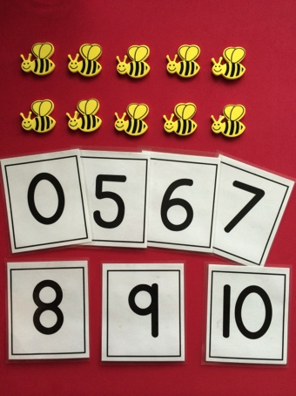
Distribute a cup to each child and spread the numeral cards in the center of the circle.
It’s time to open up the Pollen Café again! Let’s get the bees ready. Find the number that tells how many bees are in your cup.
Circulate and make sure that students are lining up their bees and counting with one-to-one correspondence. Once children have found the correct numeral, have them place it in the cup with the bees.
Note: This application sets the context for the Concept Development. Create cups with 5–7 bees for students who are just starting to master bigger numbers, but have 8–10 bees in most cups. Consider having an extra cup ready for students who start with 0 bees to keep them engaged in the counting.
Concept Development (14 minutes)
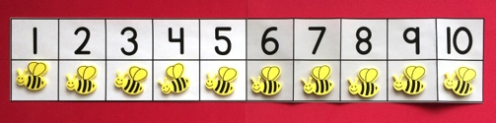
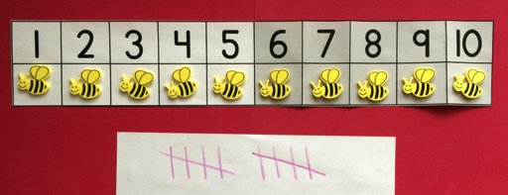
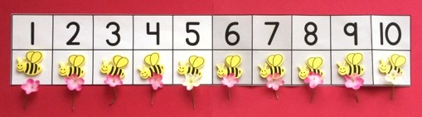
Part 1: Concept Introduction
Materials: (T) Cup containing 10 bee stickers, number path (Lesson 10 Template), paper and crayon (or white board), 10 flowers (S) Paper and crayon (or white board)
- Select a child to bring the bee customers to the Pollen Café. Give her the cup of bees. Display the number path. Say, “Put the customers in these special bee seats.”
- Ask, “How many bees did Rachna seat in the Pollen Café?” Give students a moment to think before prompting the count. Touch and count along with the class. Ask, “Is there a way we could have known there were 10 bees without counting?” Help children see the relationship between the count and the numerals.
- Say, “I’ll be the waiter. I’ll make a tally for each order to show how many flowers I need to get.” Direct 10 students to place an order for the bees by saying one at a time, “Please may I have 1 flower?”
- Tally the flowers as each one orders. Have students count the number of tallies in each group (5), and then count all the tallies (10).
- Next, make an order for each bee as students tally. Signal the fifth and tenth orders so that children remember to make a diagonal tally.
- Say, “Now, the waiter is ready to take the order to the chef!” Take out the order of 10 flowers. Have children count the flowers with you, giving each bee a flower as they count.
Part 2: Practice
Materials: (S) Cup containing 0 or 5–10 bee stickers, number path (Lesson 10 Template), paper and crayon (or white board)
Assign each student to be either the person to seat the bees or a waiter. Distribute the appropriate materials.
- Have one partner seat the bee customers on the number path, then order by saying, “Please may I have 1 flower?” for each bee. Have the waiters tally the flower orders, 1 per bee.
A NOTE ON
MULTIPLE MEANS
OF ENGAGEMENT:
Differentiate your questioning as you circulate. Students who are ready for a challenging extension could be asked: “How many more bees could sit at your café?” “How many tally marks would you make if one more bee was seated?”
MP.7
- Support waiters as they tally the order. Encourage the other partner to count the tally to make sure it matches the order.
- Have children switch roles and repeat with a new cup of bees, ensuring that everyone has a chance to practice making tally marks.
Student Debrief (3 minutes)
Lesson Objective: Tally 10 objects.
The Student Debrief is intended to invite reflection and active processing of the total lesson experience. It is also an opportunity for informal assessment. Consider taking anecdotal notes or using a simple checklist to note each child’s progress towards meeting the lesson objective.
As students complete the Practice portion of the lesson, listen for misconceptions or misunderstandings that can be addressed in the Debrief. You may choose to use any combination of the questions below to help students express ideas, make connections, and use new vocabulary.
- (Show number path.) What do you notice about the number of white spaces and gray spaces on the number path?
CENTER CONNECTION:
Continue to run the Pollen Café in the dramatic play center. Make sure students take turns seating customers and being waiters so everyone has a chance to practice tallying. Prepare a few bags with flowers (5–10 to match the bees) and include the matching numeral. Waiters can deliver the flowers to the customers.
- (Show 10 tallies and a number tower of 10 with color change at 5.) Can you break this tower to match the tallies? Put it back together. How many cubes are in the tower?
- (Show a few numerals including 0 and 10.) What did you do when you had zero bees? Which number matches 0? How many tally marks do you make to show 0?

