Lesson 39
Objective: Count up to 10 objects in varied configurations.

Suggested Lesson Structure
 Fluency Practice (3 minutes)
 Application Problem (3 minutes)
 Concept Development (16 minutes)
 Student Debrief (3 minutes)
Total Time (25 minutes)
Fluency Practice (3 minutes)
- The Fingers on One Hand PK.CC.3abc (3 minutes)
The Fingers on One Hand (3 minutes)
Note: This fluency asks students to show fingers on one hand, encouraging them to informally notice number relationships within 5 of 1 more and 2 more.
NOTES ON
MULTIPLE MEANS
OF EXPRESSION:
Have students make a print of their left hand during art and use it during fluency. Have them cover one finger, then 2 fingers, then 3 fingers, with a hiding card (a piece of paper) to see how many fingers are still showing. Then have them repeat The Fingers on One Hand, placing their hand directly on top of their handprint to see if they improve in fluently working within five. Keep it playful, brief and interesting.

T: Let’s only use one hand again today! Put your right hand behind your back. Show me 5 fingers on your left hand.
T: Hide your thumb. (Pause.) When I give the signal, tell me how many fingers are showing.
S: 4.
T: Show me 1 more finger. How many fingers are showing now? (Pause.)
S: 5.
T: Hide your thumb and your pointer finger. (Pause and demonstrate.) How many fingers are showing now?
S: 3.
T: Show me 2 more fingers. (Demonstrate.) How many fingers are showing now?
S: 5.
Move between 3 and 5 playfully. Once they are fluent, move between 4 and 5, 3 and 5, and 3 and 4.

Application Problem (3 minutes)
Materials: (S) Baggie containing 10 counters (the same as those to use during Bingo in the Concept Development)
Say, “Ms. Lee runs a store. She needs to organize her apples so they are easy to count every morning. Use your counters to show one way Ms. Lee could organize her apples.”
After the apples are organized, ask how many apples Ms. Lee has. Give students a chance to observe other ways to organize the apples. Invite them to share why they think certain organizations would work best.
Note: This activity gives children a chance to apply what they know about organizing objects for counting. Note students who are using lines, 5-groups, or arrays to organize their count. If students are attempting to count using a scattered configuration, support them to find a more efficient configuration during the discussion.
Concept Development (16 minutes)
Part 1: Concept Introduction
Materials: (T) Large Bingo board on chart paper (see Bingo Template 1), chips, numeral cards 0–10 (Lesson 26 Template 2 and Lesson 35 Template 2) (S) Per student: Bingo board (Templates 1–8), baggie with chips
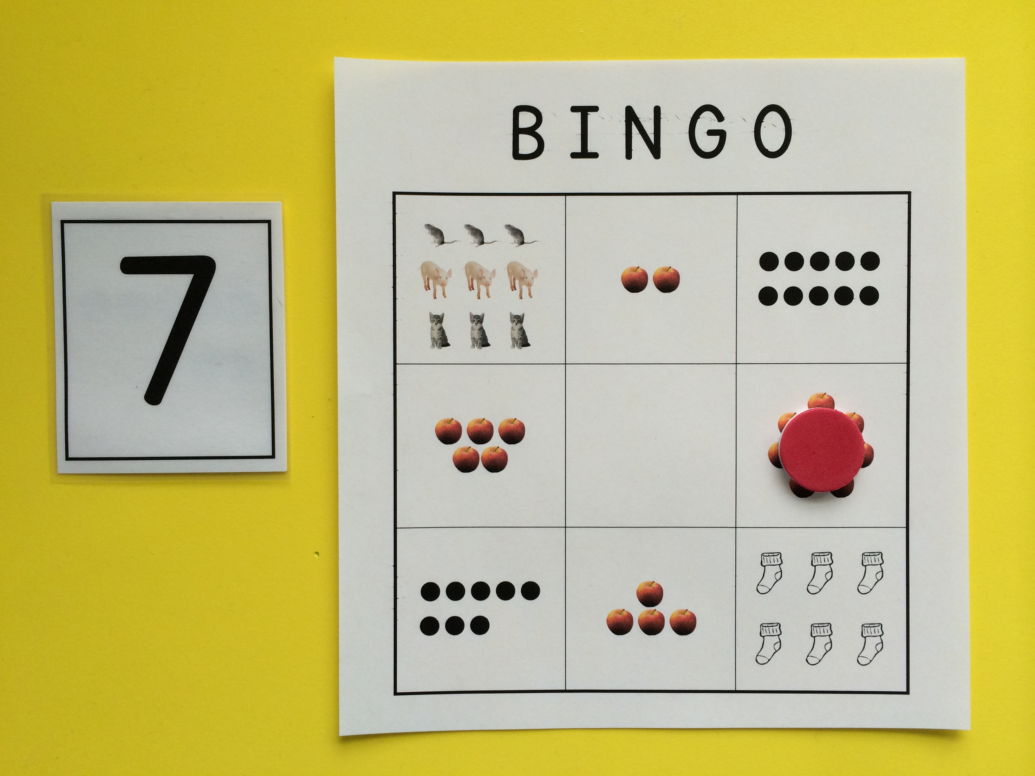
- Distribute a Bingo board and baggie with chips to each student. Place a large Bingo board in the center of the carpet. “Let’s play Bingo! What do you see on your Bingo board?
- Guide students to see different representations of the numbers 0–10. Take a moment to point out the empty space and help children realize that nothing represents zero. Explain that they should say Bingo when they have 3 in a row. Model all possible ways students could have 3 in row.
- Choose a numeral card. Say, “I chose this number so you put your chip on a space that shows that number of objects.” (If students do not recognize the number, whisper its name to them.) Invite a volunteer to place a chip on the large Bingo board. Have students do the same on their boards.
- Continue to select cards and demonstrate on the large board. Monitor student boards to help them say, “Bingo!”
Part 2: Practice
A NOTE ON
MULTIPLE MEANS
FOR ACTION AND EXPRESSION:
Provide an ample amount of wait-time for students to find a correct space to place their chip. For some children, counting all the squares on the board in advance of the game may be helpful.
Consider allowing a child to call the numbers (this will provide practice identifying numerals). While students continue to play, monitor the class and help the student who is calling the numbers move on at an appropriate rate.
Materials: (T) Numeral cards 0−10 (Lesson 26 Template 2 and Lesson 35 Template 2) (S) Per student: Bingo boards (Templates 1–8), baggie with chips
- Have students pass their board to the person on the right. Remove the teacher model, and play again.
- Watch as children play, making sure that they are counting and correctly placing chips on their boards.
- Each time Bingo is called, point out the different ways a line of 3 chips can look (vertical, horizontal, or diagonal).
Student Debrief (3 minutes)
Lesson Objective: Count up to 10 objects in varied configurations.
The Student Debrief is intended to invite reflection and active processing of the total lesson experience. It is also an opportunity for informal assessment. Consider taking anecdotal notes or using a simple checklist to note each child’s progress towards meeting the lesson objective.
CENTER CONNECTION:
Give children an opportunity to continue playing the game during centers. One student can take on the role of the teacher, picking a card and calling out the number. Children who are ready can even create their own game boards.
As students complete the Practice portion of the lesson, listen for misconceptions or misunderstandings that can be addressed in the Debrief.
You may choose to use any combination of the questions below to help students express ideas, make connections, and use new vocabulary.
Note: Have children bring their Bingo boards to the Debrief.
- (Choose a numeral card.) Which box on your Bingo board matches this number? Is it the same as your friend’s? Are there the same number of (e.g., apples, chickens) in that box?
- Which numbers on your Bingo board were the easiest to find? Why were they easiest to find?
- Which numbers on your Bingo board were the hardest to find? Why were they hardest to find?

B I N G O
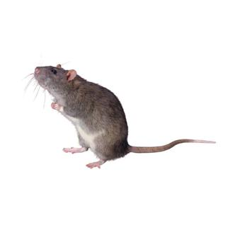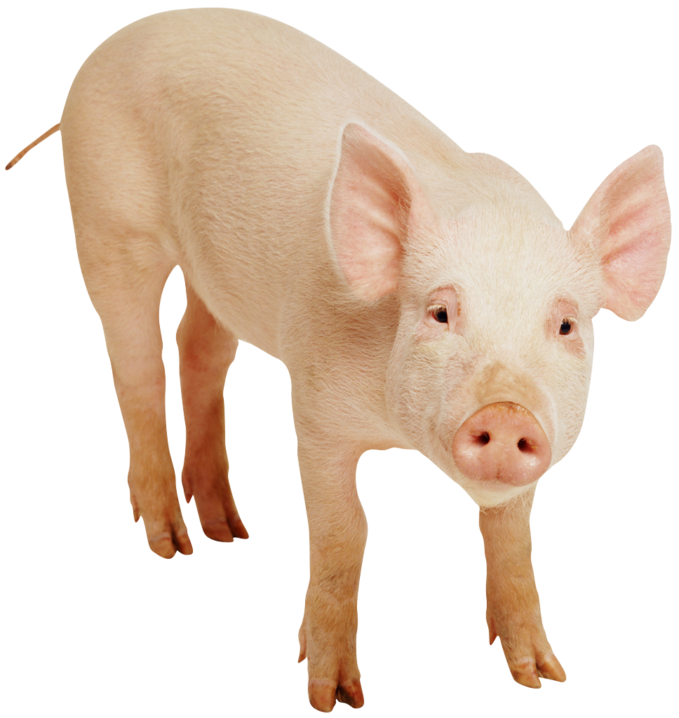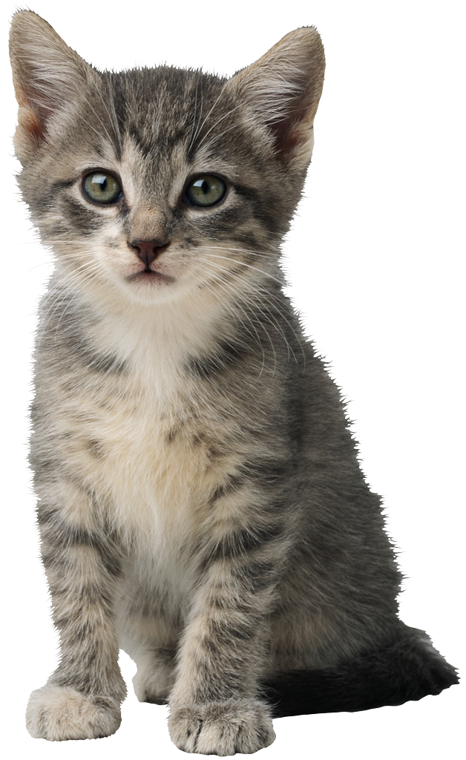
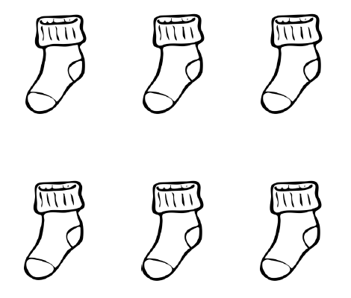

B I N G O
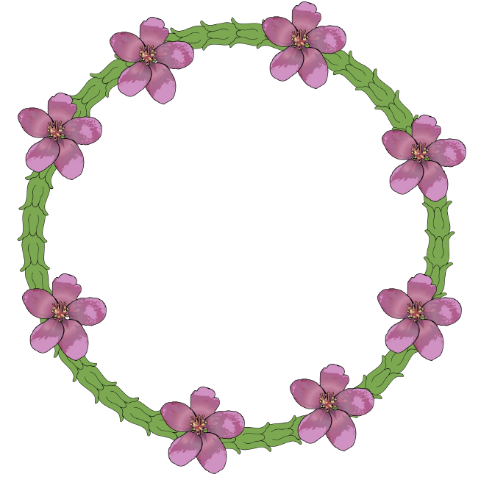

B I N G O
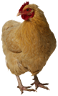
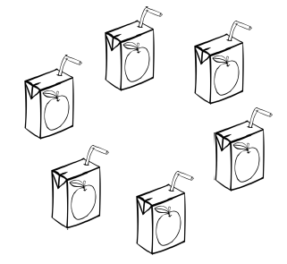
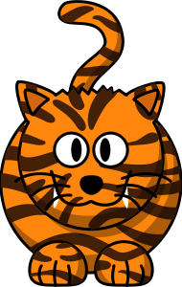

B I N G O
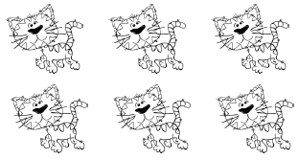

B I N G O
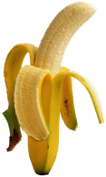
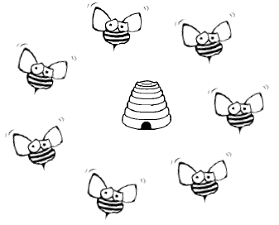

B I N G O

B I N G O
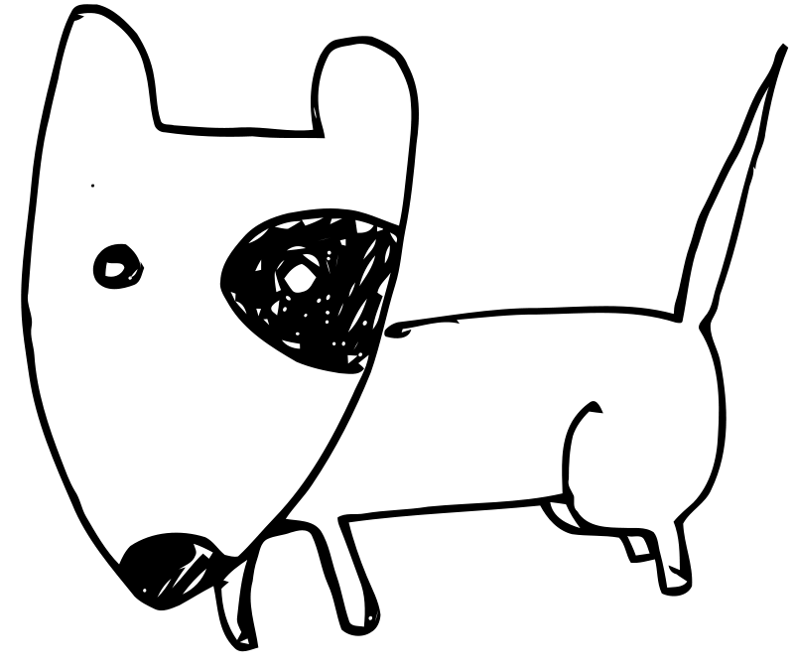 |  | 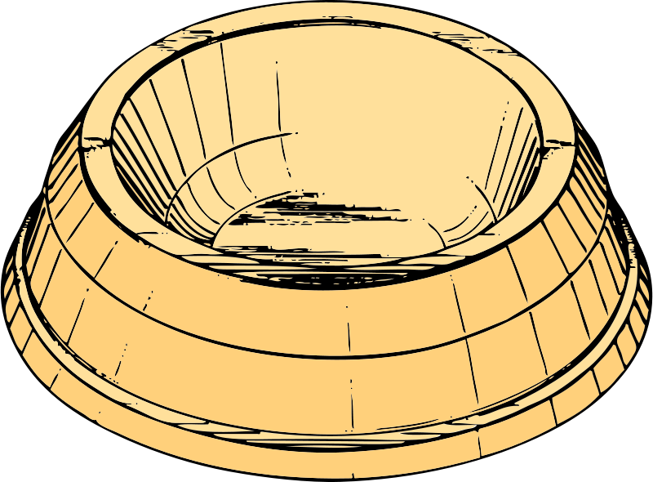

B I N G O

Bingo card 1
Bingo card 2
Bingo card 3
Bingo card 4
Bingo card 5
Bingo card 6
Bingo card 7
Bingo card 8

