Lesson 36
Objective: Decompose numbers 6–10.

Suggested Lesson Structure
 Fluency Practice (6 minutes)
 Concept Development (14 minutes)
 Student Debrief (5 minutes)
Total Time (25 minutes)
Fluency Practice (6 minutes)
- Shake the Beans: Part 1 PK.CC.3ab (4 minutes)
- Shake the Beans: Part 2 PK.CC.3ab (2 minutes)
Shake the Beans: Part 1 (4 minutes)
Materials: (S) 6 beans in a small paper cup, a pile of at least 12 more beans for every 3 students
NOTES ON
MULTIPLE MEANS
OF EXPRESSION
Exposing students to different percussion instruments gets them thinking about sound in interesting ways. Compare the sound of their paper maraca to a real maraca. What if we take the 10 beans and put them in a bigger container to be the maraca, what does that sound like? How does the sound change when the container or the beans change?
Note: In this fluency activity, students are composing 10 and getting a feeling for the volume the additional beans create in the cup.
T: Pour out your beans and count them. (Observe strategies.) How many beans do you have?
S: 6.
T: Put them back in your cup. Put your hand over the top and shake your beans 6 times. Ready?
S: 1, 2, 3, 4, 5, 6.
T: Let’s put 4 more beans and see if our shaker sounds different. (Pause.)
T: Put your hand over the top and shake your beans 10 times. Ready? Shake!
T: Did it sound different?
T: Pour out your beans and count them. (Observe strategies.) How many beans do you have now? Who remembers how many we started with? Who remembers how many more we put in the cup?
T: Put your beans back in your cup now.

Shake the Beans: Part 2 (2 minutes)
Materials: (S) 10 beans in a small paper cup from the first fluency activity
Note: In this fluency exercise, students decompose ten gradually; in the process they hear and see the difference between 10 beans, 6 beans, and 2 beans without numerical analysis.
T: Take 4 beans out of your cup. Put them out of sight.
T: Put your hand over the top and shake your beans 6 times. Ready?
S: 1, 2, 3, 4, 5, 6.
T: Let’s take out 4 more beans and put them away. (Pause.) Put your hand over the top of your cup and shake your beans, how many times?
S: 2.
T: Yes, because that is the number we have left! Ready?
S: 1, 2.
T: Did it sound different?
Concept Development (14 minutes)
Part 1: Concept Introduction
Materials: (T) Tub of 10 dinosaurs (or other counters), circle and square, chart as shown below
Any counters can be used for this lesson if dinosaurs are not available. Consider using teddy bear counters or have linking cubes represent the dinosaurs.
- Display the circle and square. Say, “This is the dinosaur preschool with a circle center (point to circle) and a square center (point). On Monday, 6 dinosaurs came to school. Help me count out 6 dinosaurs.” One at a time, place dinosaurs in a line under the shapes as children count.
- Say, “Some of the dinosaurs want to go to the circle center and some want to play in the square center.” Move 3 dinosaurs to the circle and 3 dinosaurs to the square. Ask children how many questions about each place.
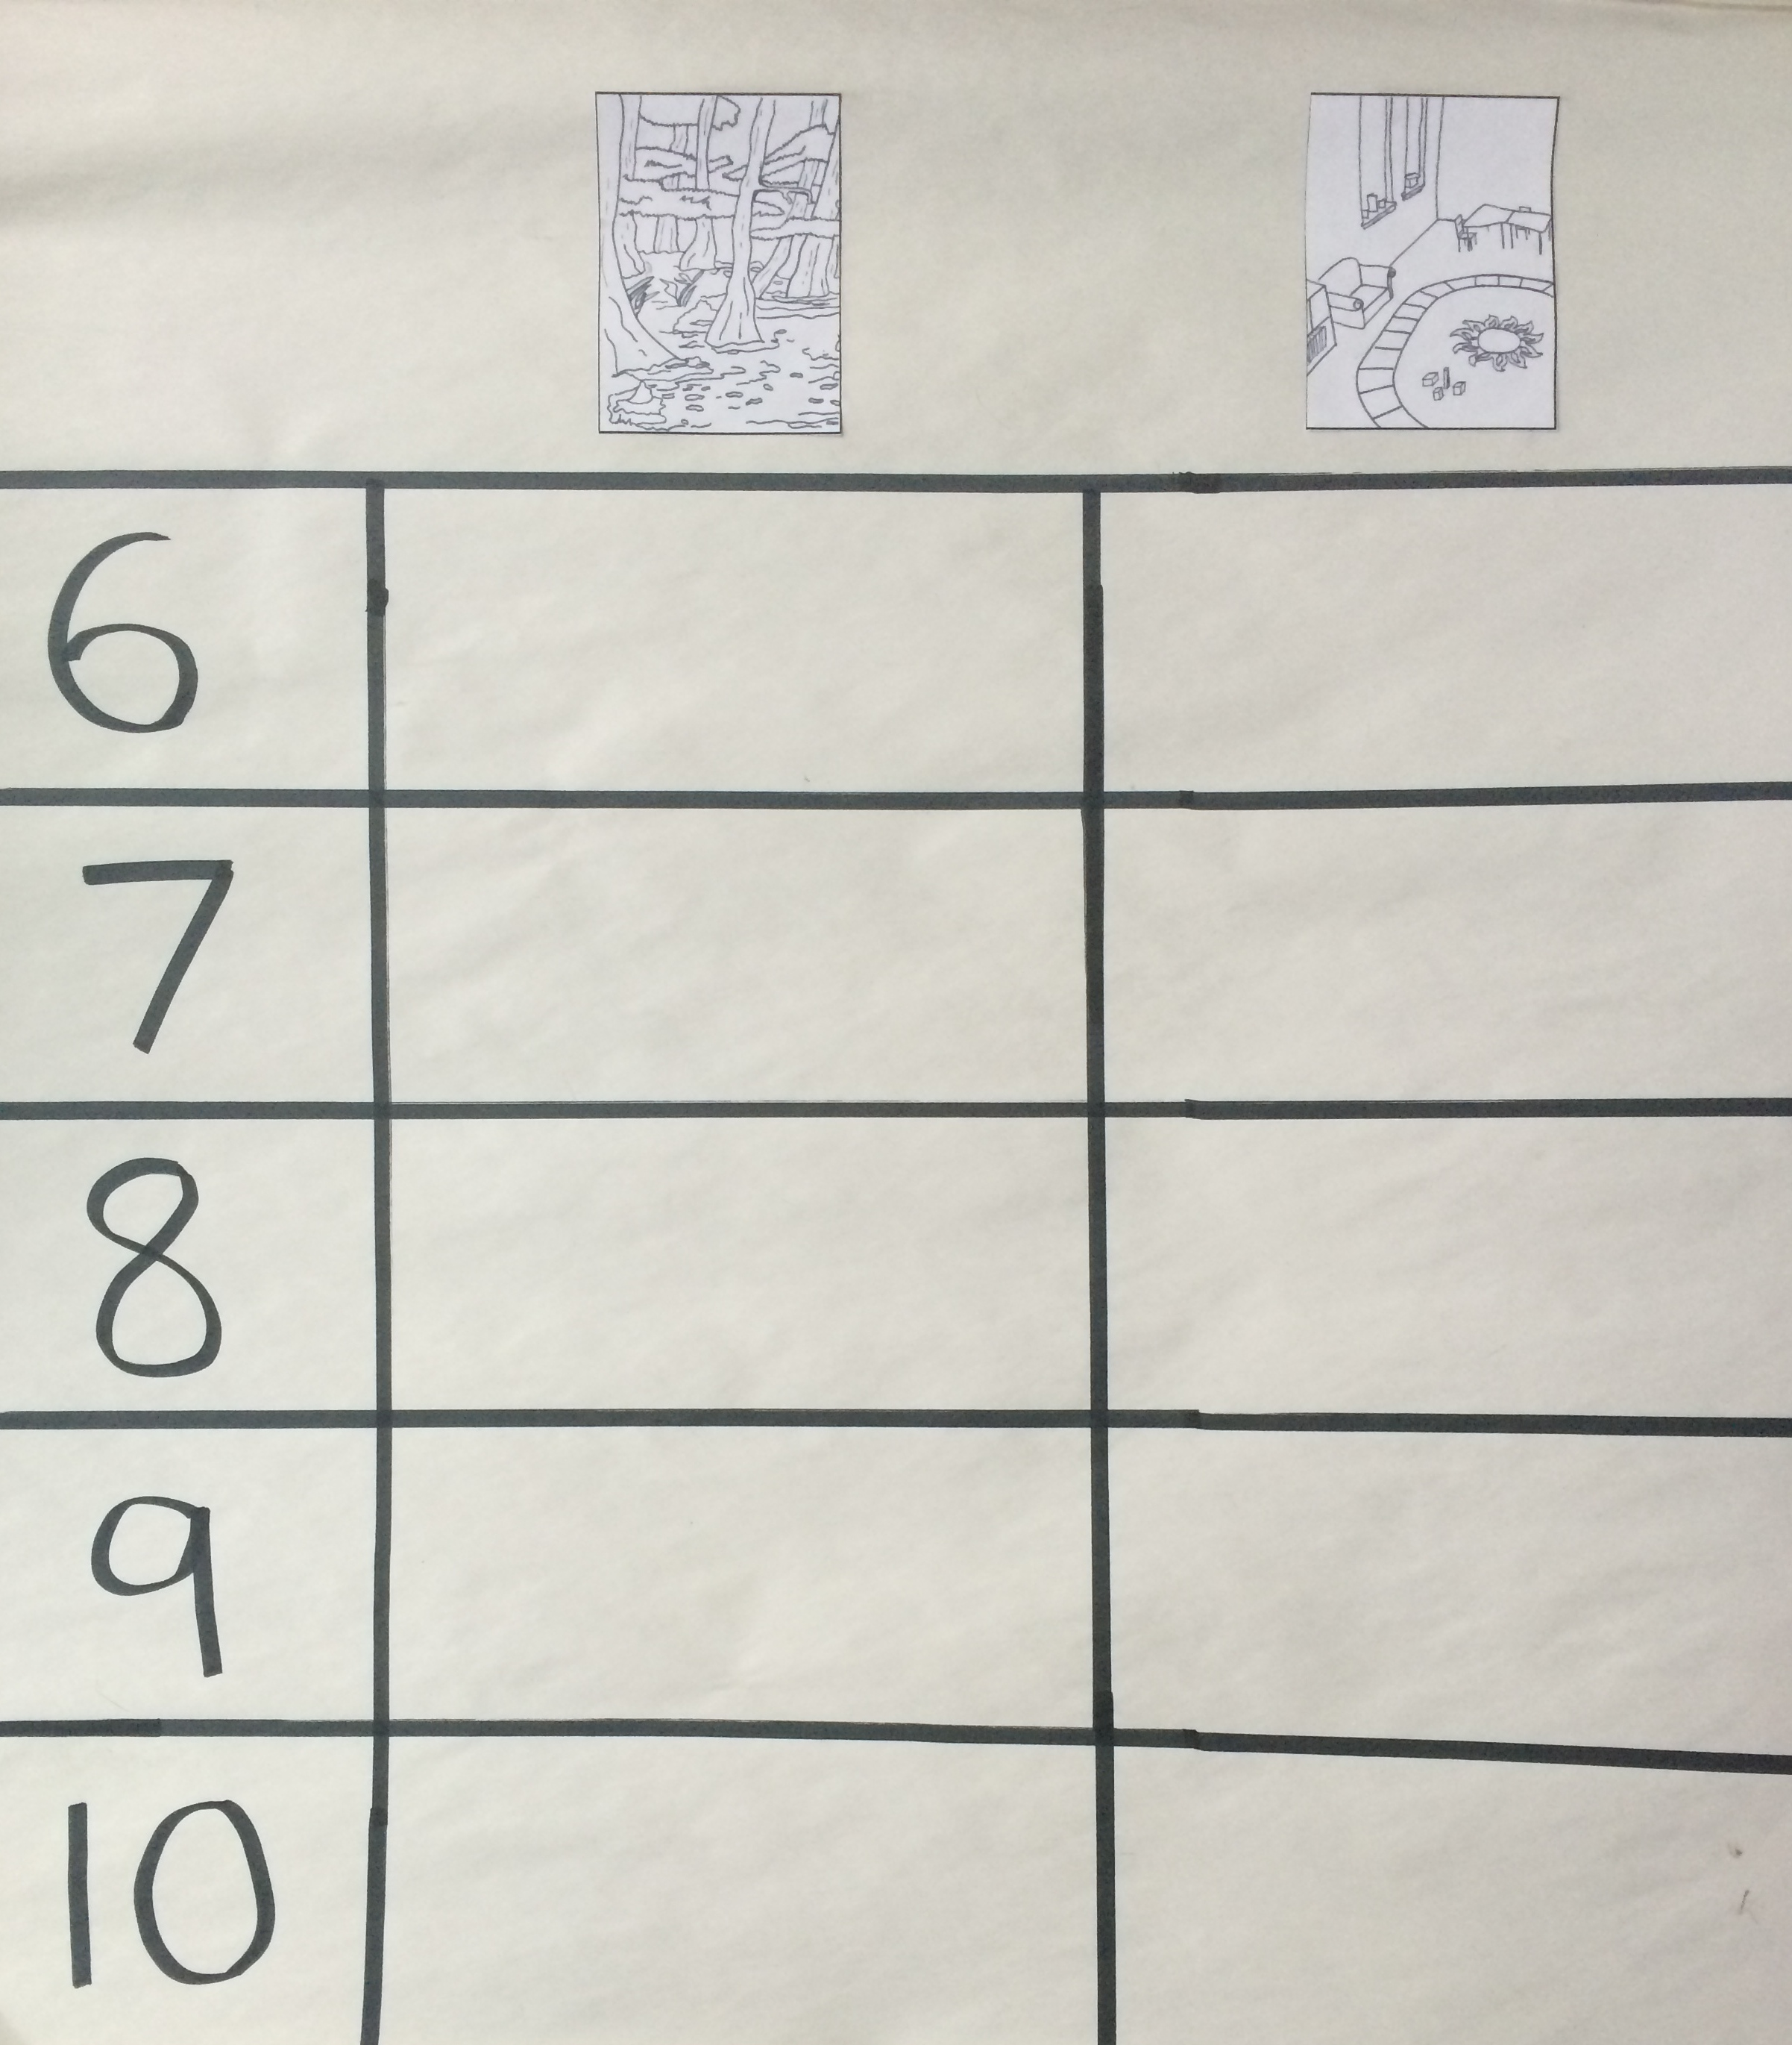
- Help the teacher keep track of the little dinosaurs by tallying the number of dinosaurs in each place. Display the chart paper.
- Show children how to find the row showing numeral 6 on the chart. Then, show them the circle. Ask how many dinosaurs are in the circle center. Let children answer and make 3 tally marks right under the picture. Repeat with the square.
- Say, “It’s time for the dinosaurs to come back together (put all dinosaurs in one line). Do we still have 6 dinosaurs?” Help children count and see that they still have the same number of dinosaurs.
Part 2: Practice
Materials: (S) Tub of 10 dinosaurs (or other counters), circle and square
Have children move to prepared table. Use linking cubes to represent dinosaurs if there are not enough dinosaurs for every student to have 10.
- Say, “It is Tuesday and there are now 7 dinosaurs at school. Make a line of 7 dinosaurs.” Circulate and support as needed.
- Say, “Some of the dinosaurs want to explore the circle center and some want to play in the square center. Move your dinosaurs where you think they want to go.” Provide support as children move the dinosaurs.
MP.7
- Say, “Bring your dinosaurs back together in a line. Tell your neighbor how many dinosaurs you have in your line.”
- Say, “Now it is Wednesday, and there are 8 dinosaurs at school. Make a line of 8 dinosaurs” Repeat Steps 2−3.
- Repeat this pattern with 9 dinosaurs on Thursday, and 10 dinosaurs on Friday.
Student Debrief (5 minutes)
CENTER CONNECTION:
Before dismissing children to centers, help them count the number of children in the group. Dismiss. On chart paper, make a tally of the number of students in each center. At the end of centers, bring the group back together. Note that the students were able to break into small groups and then come back together to make the original big group. Compare this to what happened with the dinosaurs.
Lesson Objective: Decompose numbers 6–10.
The Student Debrief is intended to invite reflection and active processing of the total lesson experience. It is also an opportunity for informal assessment. Consider taking anecdotal notes or using a simple checklist to note each child’s progress towards meeting the lesson objective.
As students complete the Practice portion of the lesson, listen for misconceptions or misunderstandings that can be addressed in the Debrief. You may choose to use any combination of the questions below to help students express ideas, make connections, and use new vocabulary.
Note: Have students bring their Problem Sets to the Debrief.
- (Display the circle and square from the Concept Development and 7 dinosaurs.) Three dinosaurs go to the circle center. Let’s move the rest to the square center. How many dinosaurs are in the classroom?” (Repeat for 8−10, recording the results on the chart each time.)
- Look at the chart. How many dinosaurs are in the circle center every day? (Point to orient them to look vertically at the chart.) What do you notice about the dinosaurs in the square center each day?
- What is the same about all of these ways that the dinosaurs broke into 2 groups? What is different?
- Do you think we could come up with another way that the dinosaurs went to the centers? How?

