Lesson 35
Objective: Compose 10, and decompose into two parts. Match to the numeral 10.

Suggested Lesson Structure
 Fluency Practice (6 minutes)
 Application Problem (3 minutes)
 Concept Development (13 minutes)
 Student Debrief (3 minutes)
Total Time (25 minutes)
Fluency Practice (6 minutes)
- Count 10 Jumps PK.CC.3a (2 minutes)
- Match and Count 10 Cubes PK.CC.4 (4 minutes)
Count 10 Jumps (2 minutes)
Note: This fluency activity lets students have fun with big motions as they count.
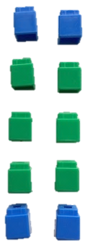
T: Let’s pretend we are kangaroos and jump 10 times. Join in when you are ready! (Repeat until all are participating.) 1, 2, 3, 4, 5, 6, 7, 8, 9, 10.
While keeping it playful, don’t let the students count ahead of each jump.
Match and Count 10 Cubes (4 minutes)
Materials: (S) 10 cubes, 4 of one color and 6 of another
Note: In this fluency activity, students are given the opportunity to practice counting 10 objects in an array configuration.

NOTES ON
MULTIPLE MEANS
OF REPRESENTATION:
Check for understanding of the term pair. Model matching a pair of cubes for students who may be struggling with the vocabulary.
T: Match a pair of cubes by color. (Pause.) Match another. (Pause.) Keep matching until all your cubes are in pairs by color.
T: Put your cubes like this. (Demonstrate as pictured to the right.) Count all the cubes. (Observe their counting strategies.) How many did you count?
S: 8. 9. 10.
T: Hmmm. There should be exactly 10. Try again and be sure to touch and count carefully.
Watch carefully to know who is able to count to 10 correctly. Support students as needed and possibly have another student demonstrate counting correctly.
Application Problem (3 minutes)
Materials: (S) 10 cubes from Fluency Activity, Match and Count 10 Cubes
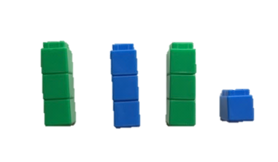
Have students take apart their 10 cubes from the fluency activity. “Make a stack of 3 cubes that are the same color.” (Pause.) “Make another.” (Pause.) “Make another.” What do you notice?
Note: Changing between twos in the fluency activity and threes in the Application Problem allows students to make some important informal observations about the number 10. “When we make pairs of cubes there are no leftovers. When we make stacks of 3, there is 1 left over!”
Concept Development (13 minutes)
Part 1: Concept Introduction
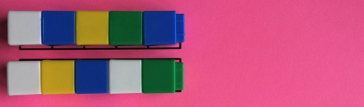
Materials: (T) 10 loose cubes (mixed colors), Partners of 10 Puzzle (5- and 5-stick, Template 1), numeral card 10 (Template 2)
- Place the 10 loose cubes on the floor. Invite two students forward. Tell both students to make a stick of 5 cubes.
- Display the puzzle template. Invite the students to place their sticks on the matching puzzle places.
- Use self-talk while joining the two sticks, “Five is such a familiar number! It helped us count to 6, 7, 8, 9, and 10. I wonder what would happen if I put these two 5-sticks together?” Join the sticks to make 1 longer stick. Count the 10 cubes as a class.
- Introduce the numeral 10. “This is how we show the number 10! It is very special because we write it using two numbers we know, 1 and 0. Everyone, trace it with your finger in the air.” Invite students to share other special things they notice about the numeral.
Note: If students inquire as to why 10 is written using 2 other numerals you might say, “In Grade 1 you will learn we write it this way because it is 1 ten and 0 leftovers. (Point to the digits as you speak.) That will be very exciting!”
Part 2: Practice
Materials: (S) Baggie with 10 cubes of varied colors, Partners of 10 Puzzles (Template 1, cut apart), numeral card 10 (Template 2)

Continue to work in the circle so children can easily pass the puzzles.
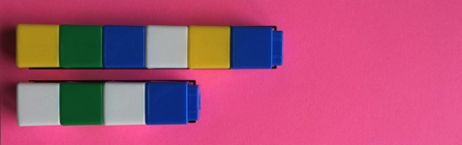
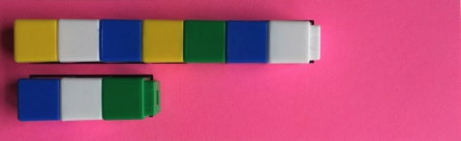
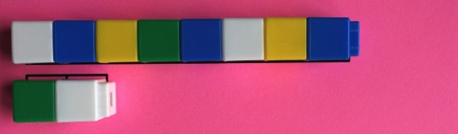
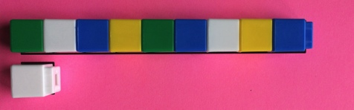
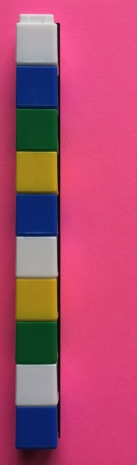
- Distribute a baggie to each student. Invite children to touch and count the number of cubes in their sticks. Have them use the numeral card to trace 10 with a finger and say, “ten” as they do so.
- Have children break their sticks to match their puzzles. Guide them to describe their work as they are able, for example, “I made smaller sticks.” “I broke my 10 stick.” “I made 2 parts.” “I have some cubes here and some cubes here.” “My 4-stick and 6-stick are partners.” Support children with the 10 and 0 puzzle to see zero as a partner.
MP.2
- Instruct children to put their sticks back together to form the original stick. Every time they count and make 10 again, have them use the numeral card to trace 10 with a finger.
- Have students pass their puzzle to the right while supplementing early finishers with additional puzzles to keep them engaged.
Student Debrief (3 minutes)
Lesson Objective: Compose 10, and decompose into two parts. Match to the numeral 10.
The Student Debrief is intended to invite reflection and active processing of the total lesson experience. It is also an opportunity for informal assessment. Consider taking anecdotal notes or using a simple checklist to note each child’s progress towards meeting the lesson objective.
As students complete the Practice portion of the lesson, listen for misconceptions or misunderstandings that can be addressed in the Debrief. You may choose to use any combination of the questions below to help students express ideas, make connections, and use new vocabulary.
- (Show Partners of 9 Puzzles.) What was the same about all of your puzzles today?

CENTER CONNECTION:
Add the Partners of 10 Puzzles to the block or puzzle center. Use a coding system so children are able to find the puzzles that go with each number, (e.g., all Partners of 10 Puzzles on pink paper).
- (Show Partners of 10 puzzles.) Who can tell me some of the ways that you broke your 10-stick? What partners did you find inside?
- Show me 10 fingers. Wiggle 1 finger. When you wiggle 1 finger, how many fingers are not wiggling? (Repeat with other numbers as time allows.)
- (Show numeral card 10.) What is special about the number 10? What do you notice about its shape?

Cut along dashed lines to prepare Partners of 10 Puzzles.

Cut along dashed lines to prepare Partners of 10 Puzzles.

To create numeral cards: 1) Print. 2) Fold lengthwise so the outline on the numeral side matches the outline on the dot side. 3) While the paper is folded, cut out individual cards. Do not cut along the fold! 4) Laminate with cards folded so that numeral and dots match. |  | 10
 |  | 10
 |  | 10
_________________
numeral card 10

