Lesson 34
Objective: Count 10 objects in array configurations.

Suggested Lesson Structure
 Fluency Practice (6 minutes)
 Application Problem (3 minutes)
 Concept Development (13 minutes)
 Student Debrief (3 minutes)
Total Time (25 minutes)
Fluency Practice (6 minutes)
- Change of Pace Counting from 0 to 10 PK.CC.1 (2 minutes)
- Compose a Tower of 10 PK.CC.3c (4 minutes)
Change of Pace Counting from 0 to 10 (2 minutes)
Materials: (T) 10 small paper plates, 10 forks
Note: By using a change of pace, students also learn to pay attention to the precision of the “touch” and the “count.”
T: (Place the 10 plates as if at a rectangular table.) Who remembers how many plates we set yesterday?
S: Not me! 10.
T: How many forks are already on the table?
S: 0.
T: Let’s count a fork for each plate so the guests can eat birthday cake!
S: 1, 2,…. 3,… 4, 5,...6, 7, …8, …9, 10.
As in Lesson 33, use a change of pace starting with zero, while counting out the forks for each plate. Don’t let the students count ahead of the placement of each fork. Keep it playful and fun!
Compose a Tower of 10 (4 minutes)
Materials: (S) 10 loose cubes in one color
Note: This adds a degree of complexity in that the cubes are all the same color, making it harder to count.

T: Use all your blocks to make 2 towers that are exactly the same. (Pause and observe.)
T: Put your 2 small towers together to make 1 tall tower. (Pause and observe.)
T: Break your tower again into 2 towers that are exactly the same. How many cubes are in 1 small tower? (Pause and observe counting strategies.)
T: Put your tower together again. Touch and count to find how many cubes there are in all. (Pause and observe counting strategies.)
Application Problem (3 minutes)
Materials: (S) Per pair: 1 paper, 1 purple and 1 green crayon
T: Partner A, draw 5 eggs in a line with your purple crayon.
T: Partner B, draw 5 eggs in a line with your green crayon.
T: Count all the eggs.
T: Turn your paper upside down. Count the eggs now!
T: Are there more eggs? Fewer eggs? The same number of eggs?
Note: This problem is designed for students to count 10 with a small taste of the commutative property, that the total doesn’t change when the order of the groups is switched.
Concept Development (13 minutes)
Part 1: Concept Introduction
Materials: (T) 5 pairs of clean socks, dot cards 8–10 (Template 1)
- Line up 5 socks without their partners as shown on right. Say, “Last time I did the laundry, I had all these socks with no matches!” Have children count and tell how many socks have no match.
- Show students the 5 matching socks in a pile. Say, “When I did the laundry this morning, I found more socks. Can you help me find their matches?” As children find matches, make sure pairs stay in an array configuration as shown on right.

NOTES ON
MULTIPLE MEANS
FOR ACTION AND EXPRESSION:
Allow an adequate amount of wait time for students to find the correct dot card. After providing wait time, have a student who needs practice with touching and counting each dot model for the class.
- Say, “Help me count my clean socks.” Point to each sock as children count to 10, moving from left to right, top to bottom. Reinforce that the last number said was the total by asking, “How many clean socks are there?”
- Place the Dot Cards with the rows of 2 going vertically. Ask children to point to the card with 10 dots to match the socks. As necessary you might count the dots on each card. If students do not need to count, ask them to share how they knew which card had the same number of dots as socks.
- Mix up the Dot Cards and place them with the rows of 5 going horizontally. Repeat the process in Step 4.
- You might say, “Hey, changing the position of the Dot Card didn’t change the number of dots, like when we turned the nest upside down, the number of eggs stayed the same!”
Part 2: Practice
Materials: (S) Per pair: 10 linking cubes from Fluency, animal array cards (Template 2)
Keep students in a circle for easy passing of cards. Pair students and give each pair 10 linking cubes and an Animal Array Card.
- Say, “We are going to be zookeepers again. Pretend these cubes are food.”
- Have Partner A count the animals on the card and tell Partner B how many pieces of food are needed.
- Tell Partner B, “Each animal on your card gets 1 piece of food. Count the food as you give each animal 1 piece.” Support students to count accurately as they match each piece of food to an animal.
- Have partners switch roles. Have each pair pass their card to the right and repeat. You might supplement early finishers with extra cards since the time students use to count may vary considerably.
Student Debrief (3 minutes)
Lesson Objective: Count 10 objects in array configurations.
The Student Debrief is intended to invite reflection and active processing of the total lesson experience. It is also an opportunity for informal assessment. Consider taking anecdotal notes or using a simple checklist to note each child’s progress towards meeting the lesson objective.

CENTER CONNECTION:
Have children take 5 blocks (or other objects) and line them up to make a train. Invite them to put another line of 5 blocks next to the first. Have them count the total number of blocks.
Note the difference in asking for 5 blocks in two lines (count out 5 twice) and for 10 blocks total (count out 10). Children will learn to create a group of 10 from a larger set in M3-Lesson 41.
As students complete the Practice portion of the lesson, listen for misconceptions or misunderstandings that can be addressed in the Debrief. You may choose to use any combination of the questions below to help students express ideas, make connections, and use new vocabulary.
- (Show Animal Array Cards with 8, 9, and 10 animals.) What is different about all of these cards? (Help children consider the total number of animals, the number of rows/columns, and the number of animals in each row/column.)
- (Show the elephant card with only 9 linking cubes.) How many more pieces of food do I need? How do you know? How many pieces of food should be in each row? (Point so that students are clear as to what you are calling a row.)
- (Show the elephant card and the 5-group formations for 8–10.) Which of these dot cards matches our elephants? How do we know that?

_______________________________
dot cards 8–10 (5-group formation)

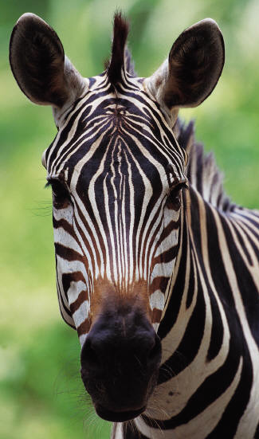

_________________
animal array cards

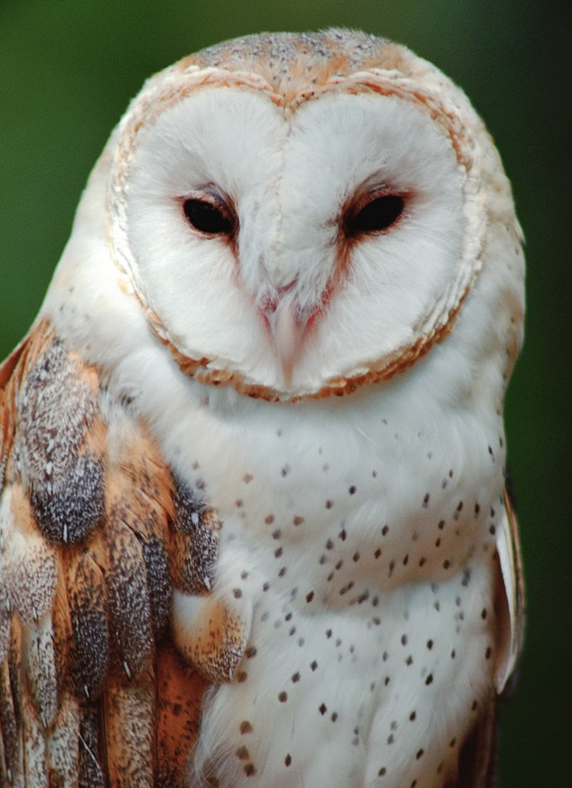
_________________
animal array cards

