Lesson 33
Objective: Count from 0 to 10 from left to right on the fingers.

Suggested Lesson Structure
 Fluency Practice (6 minutes)
 Application Problem (3 minutes)
 Concept Development (13 minutes)
 Student Debrief (3 minutes)
Total Time (25 minutes)
Fluency Practice (6 minutes)
- Change of Pace Counting from 0 to 10 PK.CC.1 (2 minutes)
- Use “1 More” to Make a Tower of 10 PK.CC.3c (4 minutes)
Change of Pace Counting from 0 to 10 (2 minutes)
Materials: (T) 10 small paper plates
Note: By using a change of pace, students start to retain the number words for longer periods of time, helping them to remember what is 1 more, which lays the foundation for counting on in Grade 1. If paper plates are unavailable cubes are a good substitution and can be reused in the next fluency activity.
T: Let’s set the table for 10 people today. (Perhaps place 2 rows of 4 plates with the last plate at the “head”of the table.) Only say the number when the plate touches the carpet. (Hover the first plate over the “table.”) How many plates are on the table now?
S: Zero!
T: (Place the first plate.) Now?
S: 1.
T: (Place the 2nd and 3rd plates quickly.)
S: 2, 3.
T: (Pause significantly before placing the 4th and 5th quickly. Again, there should be laughter and false starts.)
Continue changing the pace up to 10 plates.

Use “1 More” to Make a Tower of 10 (4 minutes)
Materials: (S) 10 loose cubes with 5 of one color and 5 of another color
Note: Observe, rather than direct, the students. Note that the directions do not indicate to separate the colors. Notice that “taller” is embedded informally, preparing students for Module 4.
T: Open your bags and take out 0 cubes to start your tower.
T: Put together 5 cubes. Use 1 more cube to make your tower get taller.
T: Take out 1 more cube. Put 1 more cube to make your tower get taller. How many cubes does your tower have now?
Continue the process until the tower reaches a height of 10 cubes. Have students compare their towers and notice the possible differences in their appearances.
Application Problem (3 minutes)
Materials: (S) per pair: 2 nests (e.g., plastic grass or yarn, small bowl), 5 plastic eggs of one color, 5 plastic eggs of another color
Pair students and give each pair 2 nests and 10 eggs. Say, “5 yellow eggs are in a nest. Put 5 yellow eggs in one nest.” (Pause.) “There are 5 eggs in another nest. Put 5 purple eggs in the other nest.” (Pause.) “Count how many eggs are in the two nests.”
Note: This is a repetition of almost the same context from Lesson 24 in Topic E. This repetition allows students to focus more on the number relationships. The egg colors are changed from Lesson 24 so that students do not overly relate 5 with the color orange and the “extras” with the color green. Place a cotton ball “chick” in each egg in advance as children will count these in the Concept Development.
Concept Development (13 minutes)
Part 1: Concept Introduction
Note: Remember to demonstrate with the right hand first if standing or sitting in front of the children.
- Say, “It’s almost spring, and all the baby chicks (wiggle fingers) are warm inside their eggs inside their nests (make 2 fists on a surface).”
- Say, “When spring comes, the chicks in this nest (shake left hand) hatch first and stand up. This one hatched first (raise left pinky).” Demonstrate the first 5 hatching and standing up, starting with the pinky (left to right starting from the pinky and moving to the thumb of the left hand). Have the children count the chicks as they emerge, “1, 2, 3, 4, 5.”
- Say, “There are more chicks hatching in this nest! (Shake your right fist.) Five of them hatch and stand, starting with the shortest one!” Have 5 more chicks come out by showing the thumb, index finger, middle, ring finger, and pinky of the right hand.
- Say, “Let’s count how many chicks have hatched.” To support a precise count, lift your fingers off the surface and drop them as the students count, “1, 2, 3, 4, 5, 6, 7, 8, 9, 10.”
- Have the children show their nests and eggs. Have them pretend all the chicks are in the eggs in the nests again (2 fists), and then count 10 chicks hatching again, starting with the pinky.
- Ask them how many eggs are still in their nests.
Part 2: Practice

NOTES ON
MULTIPLE MEANS
OF ENGAGEMENT:
Differentiate your questioning by asking more challenging questions for students who are ready. For example, some students may be ready to answer the following questions: “If one more chick hatched, how many chicks would be in the nests?” “If five chicks hatch in this nest and 3 hatch in this nest, how many eggs are in the nests?”
Materials: (S) Per pair: nests and eggs from Application Problem, cotton ball “chick” in each egg
Send students to prepared tables.
- Have pairs “hatch” the chicks in their nests by opening the plastic eggs. Invite partners to touch and count the cotton ball “chicks.”
- Have students make their fists next to the nests. Tell them, “Ten chicks (fingers) hatch and stand, one at a time. Let’s count them as they hatch!” Have them count from left to right as they show each finger.
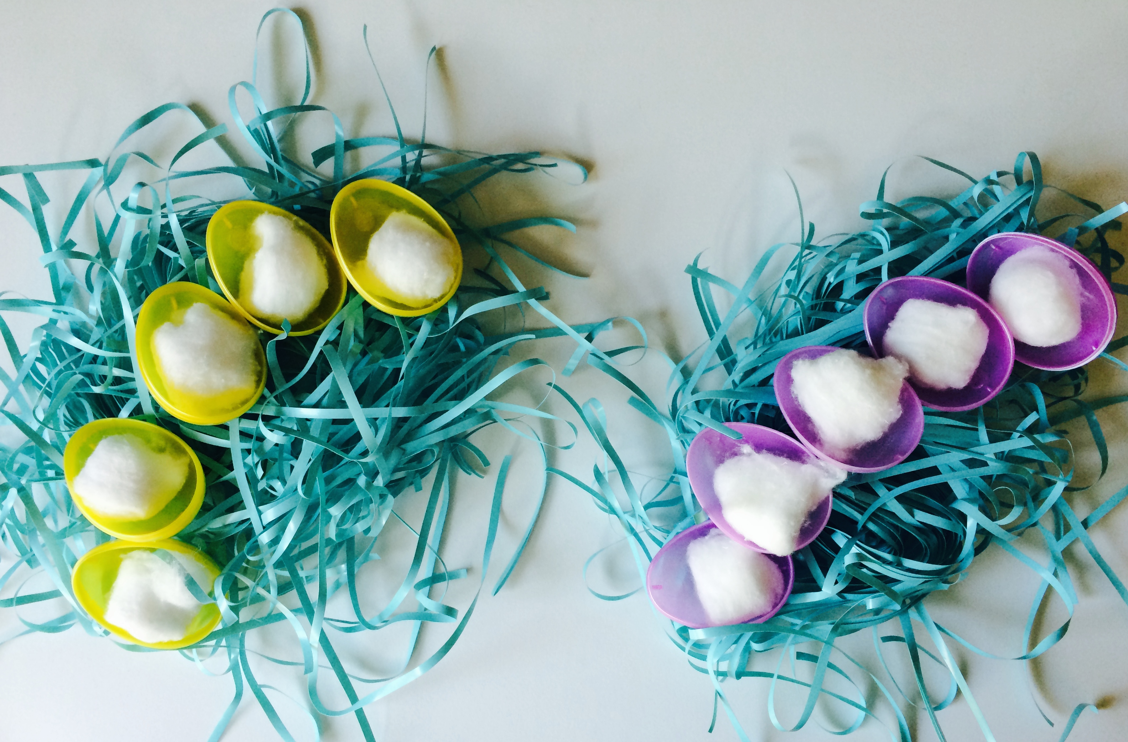
- Ask questions as you circulate such as, “How many chicks hatched?” “How many chicks hatched in this nest? This one?” “Who was the first chick to come out? Who was the last?”
MP.6
- Ask the children to show their partner two ways to count the chicks who hatched, by touching and counting using the chicks and by counting on their fingers.
Student Debrief (3 minutes)

CENTER CONNECTION:
In the sensory center, provide opportunities for students to practice moving 9 fingers through a variety of materials (e.g., sand, oatmeal, shaving cream, finger paint). Use the nest context as a starting point, but invite children to make up other stories about their 9 fingers and the 9 paths that they create, e.g 9 bicycles riding in mud, 9 bugs in the earth, etc.
Lesson Objective: Count from 0 to 10 from left to right on the fingers.
The Student Debrief is intended to invite reflection and active processing of the total lesson experience. It is also an opportunity for informal assessment. Consider taking anecdotal notes or using a simple checklist to note each child’s progress towards meeting the lesson objective.
As students complete the Practice portion of the lesson, listen for misconceptions or misunderstandings that can be addressed in the Debrief.
You may choose to use any combination of the questions below to help students express ideas, make connections, and use new vocabulary.
- Show me your two nests. (Students show 2 fists.) Show me all the chicks. (Students show all their fingers.) On your fingers, show me the chicks that hatched today.
- (Show numeral cards 0, 1, and 2.) Which number tells how many eggs are still in the nests?
- Let’s count to 5 using our fingers. Now, let’s count to 10. What is different about counting to 5 and counting to 10? How are they the same?

