Lesson 32
Objective: Use linear configurations to count 10 in relation to 5.

Suggested Lesson Structure
 Fluency Practice (6 minutes)
 Application Problem (3 minutes)
 Concept Development (13 minutes)
 Student Debrief (3 minutes)
Total Time (25 minutes)
Fluency Practice (6 minutes)
- Count to 10 PK.CC.1 (1 minute)
- The Wind and the Trees! PK CC.3abc (5 minutes)
Count to 10 (1 minute)
Note: By moving from loud to silent counting, students may start to realize they can count inside their brains without being heard.
T: Count to 10 for me so that I can hear you.
S: (Do so.)
T: Count to 10 for me so that I almost can’t hear.
S: (Do so.)
T: Count to 10 so I can’t hear.
S: (Do so.)
T: Close your eyes and count to 10 without moving your lips. (Provide wait time.)
T: I can count in my mind and no one hears me or sees me counting.
The Wind and the Trees! (5 minutes)
Materials: (S) Baggie with 10 manipulatives, (i.e. dominoes or blocks)
Note: This fluency activity allows students both to count 10 trees and revisit zero.
T: Let’s pretend that we are gardeners planting trees. There are some trees in our truck. How many trees have we planted?
S: Zero! None. Not any.

T: Let’s take 10 trees out of the truck and lay them flat. (Pause.) Let’s plant 10 trees in a short line. (Demonstrate planting a tree by standing up the blocks facing each other.) What is the last number you said?
S: 10.
T: How many trees are planted?
S: 10.
T: A big wind came and knocked one tree down so that it knocked all the others down! (Tap the last tree so that it knocks the other trees down.) How many trees are standing up now?
S: Zero! None. Not any.
Application Problem (3 minutes)
Materials: (T) Backpack (S) 10 black manipulatives (cubes or dominoes), baggie
Say, “Pretend you and your friends are going camping and the leader needs charcoal (hold up a domino) to grill some fish. Make a decision about how many pieces of charcoal to bring and put that many in a line. (Pause.) Tell your partner how many you are bringing. (Pause.) Count your partners’ charcoal pieces to be sure they are bringing the right number. (Pause.) Put them in your baggie, and I’ll collect them for the class backpack. We are going to have some gooood fish!”
Note: This Application Problem asks the students to determine for themselves how many pieces of charcoal they will contribute. Observe the choices and those who struggle either to decide or to remember their decision once they start to count. Also, check for understanding of the vocabulary included as the context of this problem, (e.g. camping, charcoal etc.)
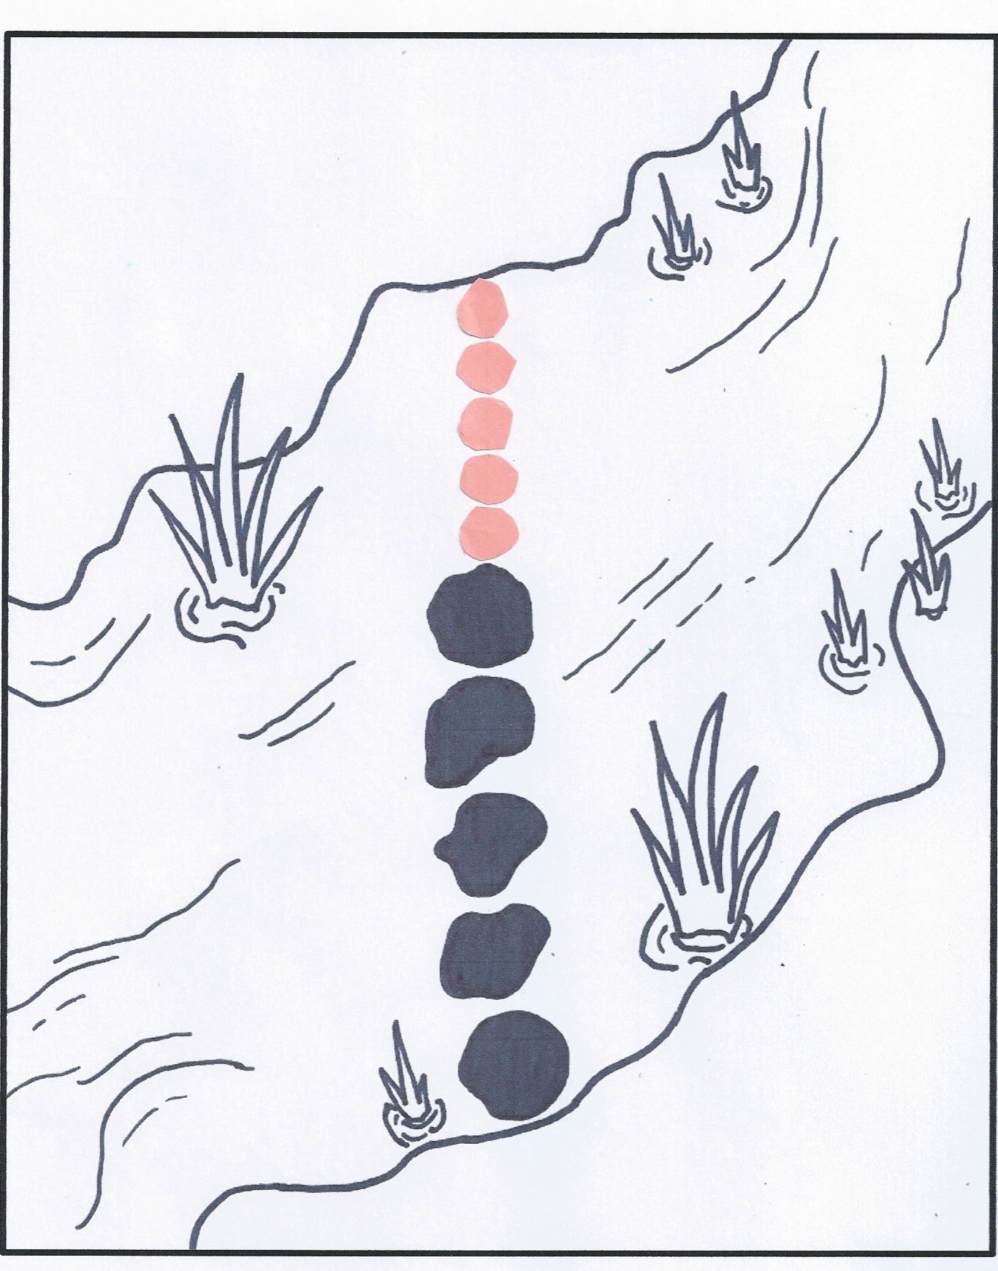
Concept Development (13 minutes)
Part 1: Concept Introduction
Materials: (T) Creek mat (Lesson 2 Template), 5 small round stickers, explorer figurine (optional)
Gather children in a circle around the creek mat.
- Say, “A different explorer has reached the same creek that her friend crossed before, but all the extra rocks washed away. Only smaller rocks are left!” Point out the line of rocks. Ask a volunteer to move the explorer across each rock while the class counts, “1, 2, 3, 4, 5.”
- Ask, “Do you think the explorer could reach the other side if there was 1 more rock?” Say, “Pretend this is a rock.” Add 1 sticker to the line.
- Ask, “How many rocks are there now?” Have another volunteer move the explorer across each rock while the class recounts 5 with 1 more, “1, 2, 3, 4, 5, 6. There are 6 rocks.”
- Say, “We had 5 rocks and we added…?” “1 more!” Say, “Now we have 6!”
- Ask, “Is she there yet?” “No!” “Let’s put another rock.” Repeat Steps 2–5 to count 7, 8, 9, and then 10 rocks.
- Ask, “How many black rocks were there?” Challenge students to ask a how many question about the new rocks. Guide students to notice the size of the new rocks.
- Ask, “How many rocks did the explorer walk on to cross the creek?” Students recount to 10.
Part 2: Practice
Materials: (S) Creek mat (Lesson 2 Template), 10 small counters or stickers

NOTES ON
MULTIPLE MEANS
OF ENGAGEMENT:
Cultivate excitement by providing a challenging extension for students who are ready. Partner students who are ready for a challenge and have each partner complete the practice activity with different-sized stickers. Have the students compare their results and determine why they each used a different number of stickers.
Send children to prepared tables.
- Tell students, “It’s your turn to help the explorer cross the creek.”
- Say, “First, take out your counters and cover the rocks in the creek. Tell your partner how many rocks are in the line.”
- Say, “Now, put 1 more rock in the line.”
MP.6
- Guide students to count the covered black rocks, count the new rocks, and then count all the rocks each time they put 1 more in the line. Instruct them to ask and answer how many questions.
- Repeat Steps 3 and 4 so that there are 7, 8, 9, and then 10 rocks. Celebrate the explorer’s crossing.
Student Debrief (3 minutes)
Lesson Objective: Use linear configurations to count 10 in relation to 5.

CENTER CONNECTION:
At the block center, give each child 5 of one type of block and 5 of a different type of block, (e.g., 5 rectangular blocks and 5 triangular blocks). First have them line up their 10 blocks and count. Then have them build with their 10 blocks. Compare the structures and help the children count the number of blocks in each structure. Notice that all the structures are different, but each has 10 blocks.
The Student Debrief is intended to invite reflection and active processing of the total lesson experience. It is also an opportunity for informal assessment. Consider taking anecdotal notes or using a simple checklist to note each child’s progress towards meeting the lesson objective.
As students complete the Practice portion of the Concept Development, listen for misconceptions or misunderstandings that can be addressed in the Debrief.
You may choose to use any combination of the questions below to help students express ideas, make connections, and use new vocabulary.
- How many rocks were in the creek at first? What did you need to do to help the explorer to cross the creek?
- Count the black rocks. (Pause as students count.) Count the new rocks. (Pause.) Count all the rocks. (Pause.) How many did you count altogether?
- (Show the creek template, the large counters used in Lesson 2, and the small counters used in this lesson.) The first explorer to cross the creek only needed 2 more rocks. (Demonstrate.) The last explorer to cross the creek needed 5 more rocks. (Demonstrate.) Why did they need a different number of rocks?

