Lesson 31
Objective: Introduce 10, and relate 10 to 9 and 1 more.

Suggested Lesson Structure
 Fluency Practice (6 minutes)
 Application Problem (5 minutes)
 Concept Development (11 minutes)
 Student Debrief (3 minutes)
Total Time (25 minutes)
Fluency Practice (6 minutes)
- Count Jumps and Pats from 0 to 10 PK.CC.1 (2 minutes)
- Decompose 9 PK.CC.3ab (4 minutes)
Count Jumps and Pats from 0 to 10 (2 minutes)
Note: Counting jumps/pats from 0 to 10 prepares students for the lesson’s objective of touching and counting to 10 and contextualizes zero in the count sequence.
T: Let’s count jumps from 0 to 10! Here we go. We say “zero” when there are no jumps yet. 0, 1, 2, 3, 4, 5, 6, 7, 8, 9, 10. (Repeat until all are engaging at some level with the activity.)
T: Let’s count pats from 0 to 10. (Model patting the top of your head.) Ready? 0, 1, 2, 3, 4, 5, 6, 7, 8, 9, 10. (Same process as above.)
Decompose 9 (4 minutes)
Materials: (S) 5 loose cubes of one color and 4 of another color. (Vary the colors from earlier fluency activities so that students do not come to believe that 5 is always one particular color.)
Note: Moving forward from Lesson 28, today’s fluency activity decomposes 9 into a tower of 5 and 4. Notice who counts the number of cubes in each part. As you circulate, whisper, “How many cubes are in this short tower? This one?” and other questions while circulating.
T: Open your bags and make one tall tower with all the cubes of one color touching.
S: (Do so.)
T: Count the number of cubes in your tall tower.
S: (Do so.)
T: Break your tower into parts by color.
S: (Do so.)
T: Put your tall tower back together.
S: (Do so.)
Application Problem (5 minutes)
Materials: (T) 10 pieces of bread or 10 pieces of brown construction paper if real bread is unavailable (as slices of bread)
Place a plate with 10 slices of bread in the center of the circle. Say, “Let’s pretend we are making sandwiches at Simon’s Sandwich Shop.”
T: How many slices of bread do we use to make 1 sandwich?
S: 2.
T: (Lay 2 slices down next to each other.) Do I have bread for more sandwiches?
S: Yes!
T: (Lay 2 slices down next to each other.) I’ll touch, and you count the slices.
S: 1, 2, 3, 4.
Continue the pattern until 9 slices of bread are laid down.
T: Oh no! What do I need to make my last sandwich?
S: Another piece of bread. 1 more slice.
T: Here is one more! (Count the total number of slices of bread with the students.)
T: (Put pairs of slices together to make 5 pretend sandwiches in a line.) Wait for the signal to tell me the answer to this question. How many sandwiches did I make with my bread? (Pause as students count in whatever way they choose. Give the signal when they are ready.)
S: 5.
Note: This task serves as a introduction to today’s objective of seeing 9 and 1 more is 10.
Concept Development (11 minutes)
Part 1: Concept Introduction
Materials: (T) Orange slices or orange slice template if oranges are not readily available (Template cut apart)
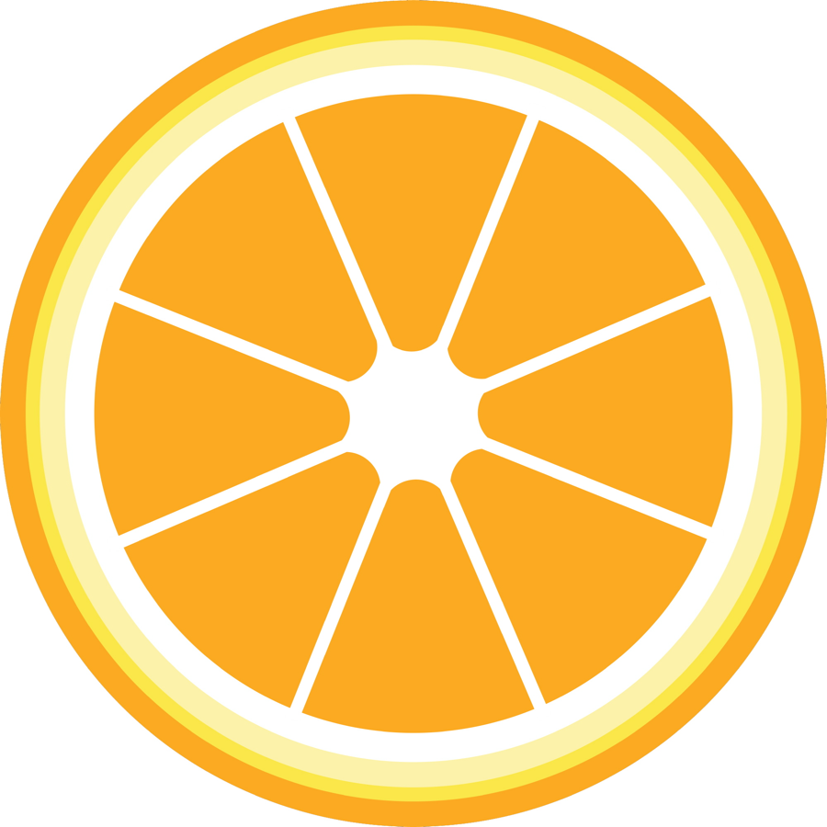
- Tell students, “We have orange slices for snack time today! Let’s count how many slices there are.” Guide students to count as you place the orange slices in a 5-group formation (as pictured on right). “1, 2, 3, 4, 5, 6, 7, 8, 9.”

- Say, “Wait! There’s 1 more slice.” Show the slice and have students count as you touch each one, “1, 2, 3, 4, 5, 6, 7, 8, 9, 10! 10 slices.”
- Touch the last slice and ask, “What is 9 and 1 more?” “10!” Tell students, “Let’s count again. I’ll touch as you count. 1, 2, 3, 4, 5, 6, 7, 8, 9, 10.”
- Ask, “How many slices are there?” Lead students to use a complete sentence, “There are 10 slices.”
- Say, “Yes! So 9 and 1 more is… (point to the last orange)?” “10.”
- Tell students, “Let’s put these away until snack time.” Once all slices are away, show your empty hands and guide students to say how many there are, “0 slices!”
Part 2: Practice
Materials: (S) per pair of students: baggy with 9 orange slices (Template cut apart), one additional slice for each pair.
Before sending partners to tables, place the bag with 9 orange slices at Partner A’s seat.

NOTES ON
MULTIPLE MEANS
OF REPRESENTATION:
Students develop a deeper understanding of math concepts as they apply them in a variety of settings. Therefore, facilitate the discovery of 1 more in the classroom environment. They may discover this when counting blocks in the building area, during calendar time, lining up to go to the playground, or using their fingers to count.
- Say, “Let’s pass out the orange slices for snack time! Let’s count how many slices there are in your baggies. Partner A, put 5 slices in a line.”
- Invite Partner B to put the rest of the slices in the baggie in a line right under his friends. Invite the partners to count all the slices. “1, 2, 3, 4, 5, 6, 7, 8, 9. 9 slices.”
- Say, “But let’s say there are 10 students who want a slice. How can you make the number of slices change from 9 to 10? What do you need to do? Tell your partner.” Guide students to see that they need 1 more slice. Pass out the additional slice so they can make 10.
- Say, “Touch and count the slices now.” “1, 2, 3, 4, 5, 6, 7, 8, 9, 10. 10 slices.”
- Say, “You had 9 orange slices and you added…?” “1 more!” Have students repeat, “9 and 1 more is 10.”
- Invite students to eat the slices by taking them off the plate, and to count 0 slices when they are all gone.
- If possible, serve orange slices at snack time arranged on plates in arrays.

Student Debrief (3 minutes)
Lesson Objective: Introduce 10, and relate 10 to 9 with 1 more.
The Student Debrief is intended to invite reflection and active processing of the total lesson experience. It is also an opportunity for informal assessment. Consider taking anecdotal notes or using a simple checklist to note each child’s progress towards meeting the lesson objective.
As students complete the Practice portion of the lesson, listen for misconceptions or misunderstandings that can be addressed in the Debrief. You may choose to use any combination of the questions below to help students express ideas, make connections, and use new vocabulary.
- Close your eyes and picture the orange slices. Do you remember how many slices you counted at first? What did you notice when you put the 9 slices out? How did you change 9 slices to make 10?

CENTER CONNECTION:
In the kitchen center, you might have students make a fruit plate by cutting each piece of paper fruit into 2 smaller pieces: red ovals for strawberries, yellow circles for grapefruits, orange circles for oranges, green circles for apples. Guide them to cut each piece of fruit into 2 parts and count how many pieces of fruit are on each plate!
- What is 9 with 1 more? Do you need to count to answer that question? Can you just remember the answer?
- Let’s see which of these answers you know now. (Show 5 fingers.) “What is 5 and 1 more?” (Pause, give time to respond, pop up one finger.) Yes! Six. (Continue to show 6 fingers.) “What is 6 and 1 more?” etc. (Continue the pattern to 10.)

orange slices

