Name Date
- Consider a right triangle drawn on a page with sides of lengths $3 cm$, $4 cm$, and $5 cm$.

  - Describe a sequence of straightedge and compass constructions that allow you to draw the circle that circumscribes the triangle. Explain why your construction steps successfully accomplish this task.

  - What is the distance of the side of the right triangle of length $3 cm$ from the center of the circle that circumscribes the triangle?

  - What is the area of the inscribed circle for the triangle?

- A five-pointed star with vertices $A$, $M$, $B$, $N$, and $C$ is inscribed in a circle as shown. Chords $\overline{AB}$ and $\overline{MC}$ intersect at point $P$.
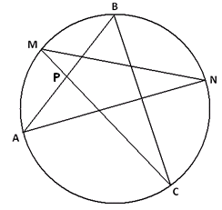

  - What is the value of $m∠BAN+m∠NMC+m∠CBA+m∠ANM+m∠MCB$, the sum of the measures of the angles in the points of the star? Explain your answer.

  - Suppose $M$ is the midpoint of the arc $AB$, $N$ is the midpoint of arc $BC$, and $m∠BAN=\frac{1}{2}m∠CBA$. What is $m∠BPC$, and why?

- Two chords, $\overline{AC}$ and $\overline{BD}$ in a circle with center $O$, intersect at right angles at point $P$. $\overline{AB}$ equals the radius of the circle.
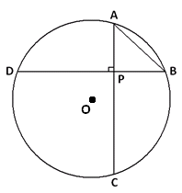

  - What is the measure of the arc $AB$?

  - What is the value of the ratio $\frac{DC}{AB}$? Explain how you arrived at your answer.

  - An arc of a circle has length equal to the diameter of the circle. What is the measure of that arc in radians? Explain your answer.

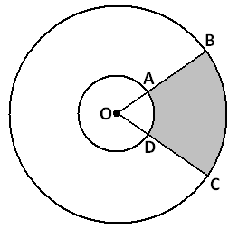
  - Two circles have a common center $O$. Two rays from $O$ intercept the circles at points $A$, $B$, $C$, and $D$ as shown.

Suppose $OA∶OB=2∶5$ and that the area of the sector given by $A$, $O$, and $D$ is $10 {cm}^{2}$.

    - What is the ratio of the measure of the arc $AD$ to the measure of the arc $BC$?

    - What is the area of the shaded region given by the points $A$, $B$, $C$, and $D$?

    - What is the ratio of the length of the arc $AD$ to the length of the arc $BC$?

- In this diagram, the points $P$, $Q$, and $R$ are collinear and are the centers of three congruent circles. $Q$ is the point of contact of two circles that are externally tangent. The remaining points at which two circles intersect are labeled $A$, $B$, $C$, and $D,$ as shown.
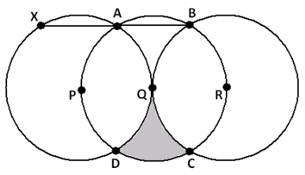
  - $\overline{AB}$ is extended until it meets the circle with center $P$ at a point $X$. Explain, in detail, why $X$, $P$, and $D$ are collinear.

  - In the diagram, a section is shaded. What percent of the full area of the circle with center $Q$ is shaded?

A Progression Toward Mastery
Assessment  Task Item |  | STEP 1  Missing or incorrect answer and little evidence of reasoning or application of mathematics to solve the problem. | STEP 2  Missing or incorrect answer but evidence of some reasoning or application of mathematics to solve the problem. | STEP 3  A correct answer with some evidence of reasoning or application of mathematics to solve the problem, or an incorrect answer with substantial evidence of solid reasoning or application of mathematics to solve the problem. | STEP 4  A correct answer supported by substantial evidence of solid reasoning or application of mathematics to solve the problem.
1 | a  G-C.A.1  G-C.A.2 | Student does not describe an accurate construction procedure. | Student describes an accurate construction procedure but does not fully justify its validity. | Student accurately describes the construction procedure and justifies its validity but with a few minor errors. | Student accurately describes the construction procedure and correctly justifies its validity.
 | b  G-C.A.1  G-C.A.2 | Student does not attempt to find the distance of the side from the center. | Student makes some progress toward finding the distance but is using the wrong side. | Student attempts to find the distance of the correct side but makes a minor mathematical error leading to an incorrect answer. | Student finds the correct distance of the side to the radius with supporting work.
 | c  G-C.A.1  G-C.A.2 | Student does not draw an inscribed circle or calculate the area. | Student draws an inscribed circle, but does not calculate the area or calculates that area showing no evidence of understanding. | Student draws an inscribed circle and attempts to calculate the area but makes a minor mathematical error leading to an incorrect answer. | Student accurately draws an inscribed circle and calculates the area.
2 | a  G-C.A.2 | Student is unable to find a relevant geometric result that aids in answering the question. | Student makes some progress applying the inscribed angle theorem and answering the question. | Student makes correct use of the inscribed angle results to answer the question, but justification is not fully explained. | Student makes correct use of the inscribed angle results to fully answer the question with clear justifications.
 | b  G-C.A.2 | Student is unable to find a relevant geometric result that aids in answering the question. | Student makes some progress applying the inscribed angle theorem and answering the question. | Student makes correct use of the inscribed angle results to answer the question, but justification is not fully explained. | Student makes correct use of the inscribed angle results to fully answer the question with clear justifications.
3 | a  G-C.A.2 | Student does not identify the relevant central angle to the problem and makes little progress toward finding the solution. | Student makes some progress identifying the relevant central angle for the problem, and there is evidence of some steps toward finding the solution. | Student provides the correct solution but does not give complete details as to how the solution was obtained. | Student provides the correct solution and gives a complete, detailed explanation of how the solution was obtained.
 | b  G-C.A.2 | Student does not identify the relevant central angle to the problem and makes little progress toward finding the solution. | Student makes some progress identifying the relevant central angle and inscribed angles needed for the problem, and there is evidence of some steps toward finding the solution. | Student provides the correct solution but does not give complete details as to how the solution was obtained. | Student provides the correct solution and gives a complete, detailed explanation of how the solution was obtained.
4 | a  G-C.B.5 | Student does not connect one radius of the circle to one radian of turning. | Student exhibits some understanding of the relationship between one radius and one radian and makes some progress in providing an answer. | Student provides the correct solution but does not give complete details as to how the solution was obtained. | Student provides the correct solution and gives a complete, detailed explanation of how the solution was obtained.
 | b (i)  G-C.B.5 | Student does not distinguish between arc measure and arc length and does not make use of the arc length/radius proportionality. | Student exhibits some understanding of the arc measure, arc length, and radius relationships and makes some progress in providing the answer. | Student exhibits some clear understanding of the arc measure, arc length, and radius relationships and makes good progress in providing an answer but with a minor mathematical mistake. | Student provides a correct answer with accurate supporting work.
 | b (ii)  G-C.B.5 | Student shows no knowledge of calculating the area of a sector. | Student shows some knowledge of finding the area of a sector but does not calculate the area of either sector correctly. | Student calculates the area of each sector correctly but does not calculate the area of the shaded region. | Student calculates the area of the shaded region correctly.
 | b (iii)  G-C.B.5 | Student does not distinguish between arc measure and arc length and does not make use of the arc length/radius proportionality. | Student exhibits some understanding of the arc measure, arc length, and radius relationships and makes some progress in providing the answer. | Student exhibits some clear understanding of the arc measure, arc length, and radius relationships and makes good progress in providing the answer but with a minor mathematical mistake. | Student provides a correct answer with accurate supporting work.
5 | a  G-C.A.2  G-C.A.3  G-C.B.5 | Student does not articulate a clear and correct explanation. | Student makes some attempt to provide a clear explanation but with major mathematical mistakes. | Student provides a clear explanation but with minor mathematical mistakes. | Student gives a complete and thorough explanation.
 | b  G-C.A.2  G-C.A.3  G-C.B.5 | Student does not develop a plan for computing the desired area. | Student makes some movement toward computing the desired area. | Student develops a correct plan for computing the desired area but makes minor mathematical mistakes. | Student develops a correct plan and computes the desired area correctly.

Name Date
- Consider a right triangle drawn on a page with sides of lengths $3 cm$, $4 cm$, and $5 cm$.

  - Describe a sequence of straightedge and compass constructions that allow you to draw the circle that circumscribes the triangle. Explain why your construction steps successfully accomplish this task.
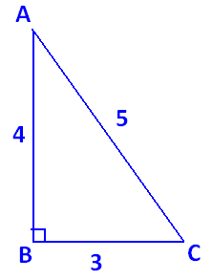
Label the vertices of the right triangle $\text{A}$, $\text{B}$, and $\text{C}$ as shown. Because $\text{∠}\text{ABC}$ is a right angle, $\overline{\text{AC}}$ will be the diameter of the circle. So, the midpoint of $\overline{\text{AC}}$ is the center. We first need to construct that midpoint.
- Set a compass at point A with its width equal to AC. Draw a circle.
- Set the compass at point C with the same width AC. Draw a circle.
- Connect the two points of intersection of these circles with a line segment. This line segment intersects $\overline{\text{AC}}$ at its midpoint. Call it M.
- Set the compass at point M with width MA. Draw the circle. This is the circumscribing circle for the triangle.
(Note that we could also locate the center of the circumscribing circle by constructing the perpendicular bisectors of any two sides of the triangle. Their point of intersection is the center.)

  - What is the distance of the side of the right triangle of length $3 cm$ from the center of the circle that circumscribes the triangle?
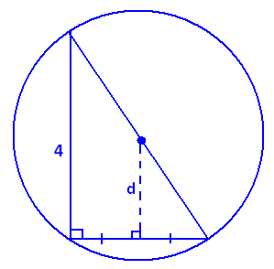
The distance, d, we seek is the length of the line segment connecting the center of the circumscribing circle to the midpoint of the side of the triangle of length 3. This segment is perpendicular to that side. Thus, we see two similar right triangles with scale factor 2. It follows that
$\text{d} \text{= }\frac{\text{1}}{\text{2}}\text{ ⋅ }\text{4 cm = 2 cm}$.

  - What is the area of the inscribed circle for the triangle?
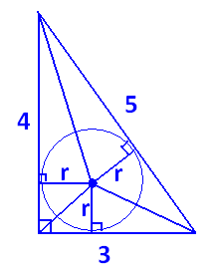
Draw in three radii for the inscribed circle, as shown. They meet the sides of the triangle at right angles. Each radius can be thought of as the height of a small triangle within the larger 3-4-5 triangle. If the radius of the inscribed circle is r, then the area of the whole 3-4-5 triangle is $\left(\frac{\text{1}}{\text{2}}\text{ ⋅ }\text{3} \text{⋅ }\text{r}\right)\text{+}\left(\frac{\text{1}}{\text{2}}\text{ ⋅ }\text{4} \text{⋅ }\text{r}\right)\text{+}\left(\frac{\text{1}}{\text{2}}\text{ ⋅ }\text{5} \text{⋅ }\text{r}\right)\text{ = }\text{6r}$.
However, the area of the triangle is $\frac{\text{1}}{\text{2}}\text{ ⋅ }\text{3} \text{⋅ }\text{4} \text{=} \text{6}$; so, $\text{r} \text{=} \text{1} \text{cm}$, and the area of the inscribed circle is $\text{π}{\text{1}}^{\text{2}} \text{=} \text{π}$ cm².

- A five-pointed star with vertices $A$, $M$, $B$, $N$, and $C$ is inscribed in a circle as shown. Chords $\overline{AB}$ and $\overline{MC}$ intersect at point $P$.

  - What is the value of $m∠BAN+m∠NMC+m∠CBA+m∠ANM+m∠MCB$, the sum of the measures of the angles in the points of the star? Explain your answer.
The measure of $\text{∠BAN}$ is half the measure of the arc BN; the same is true for the four remaining angles. Thus, the sum of all five angle measures is half the sum of the measures of ALL the arcs in the circle.
The sum of angle measures is $\frac{\text{1}}{\text{2}}\text{ ⋅ }\text{360°} \text{=} \text{180°}$.

  - Suppose $M$ is the midpoint of the arc $AB$, $N$ is the midpoint of arc $BC$, and $m∠BAN=\frac{1}{2}m∠CBA$. What is $m∠BPC$, and why?
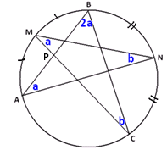
The angles marked a are congruent because they are inscribed angles from congruent arcs. This is similar for the angles marked b. We are also told that $\text{m}\text{∠}\text{CBA}$ is double $\text{m}\text{∠}\text{BAN}$.

From part (a), we have $\text{4a} \text{+} \text{2b} \text{=} \text{180°}$; so, $\text{2a} \text{+} \text{b} \text{=} \text{90°}$.

Using the fact that angles in $\text{△}\text{BPC}$ add to 180°, we get
$\text{m}\text{∠}\text{BPC} \text{=} \text{180}\text{°} - \text{2a} - \text{b} \text{=} \text{90}\text{°}$.
- Two chords, $\overline{AC}$ and $\overline{BD}$ in a circle with center $O$, intersect at right angles at point $P$. $\overline{AB}$ equals the radius of the circle.

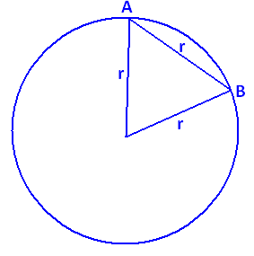
  - What is the measure of the arc $AB$?

Draw in the central angle to chord $\overline{\text{AB}}$. We see an equilateral triangle. The central angle, and hence arc AB, has measure 60°.

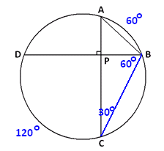
  - What is the value of the ratio $\frac{DC}{AB}$? Explain how you arrived at your answer.
Draw chord $\overline{\text{BC}}$. By the inscribed/central angle theorem, $\text{m}\text{∠}\text{ACB} \text{=} \text{30°}$. In $\text{△}\text{PBC}$, it then follows that $\text{m}\text{∠}\text{PBC} \text{=} \text{60}\text{°}$; so, arc DC has a measure of 120°. Draw this central angle.
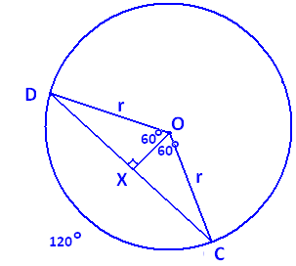
Draw the line segment $\overline{\text{OX}}$ perpendicular to $\overline{\text{DC}}$, as shown.
We see that $\text{△}\text{DXO}$ is half an equilateral triangle, so $\overline{\text{XOOX}} \text{=} \frac{\text{r}}{\text{2}}$.

Thus, $\text{DX} \text{=} \sqrt{{\text{r}}^{\text{2}}-{\left(\frac{\text{r}}{\text{2}}\right)}^{\text{2}}}\text{=}\frac{\sqrt{\text{3}}\text{r}}{\text{2}}$, and $\text{DC} \text{=} \sqrt{\text{3}}\text{r}$, so $\frac{\text{DC}}{\text{AB}} \text{=} \sqrt{\text{3}}$.

  - An arc of a circle has length equal to the diameter of the circle. What is the measure of that arc in radians? Explain your answer.
An arc of length one radius of the circle represents one radian of turning. Thus, an arc of length two radii, a diameter, has a measure of 2 radians.

  - Two circles have a common center $O$. Two rays from $O$ intercept the circles at points $A$, $B$, $C$, and $D$ as shown.

Suppose $OA∶OB=2∶5$ and that the area of the sector given by $A$, $O$, and $D$ is $10 cm^{2}$.

    - What is the ratio of the measure of the arc $AD$ to the measure of the arc $BC$?
Both arcs represent the same amount of turning (i.e., they have the same central angle), so they have the same measure. This ratio is 1.

    - What is the area of the shaded region given by the points $A$, $B$, $C$, and $D$?
Let $\text{θ}$ be the measure of $\text{∠}\text{AOD}$ in radian. Since OA : OB = 2 : 5, we have that
OA = 2x, and OB = 5x for some value x.
Now the area of sector AOD is $\text{10 }{\text{cm}}^{\text{2}} \text{=} \frac{\text{θ}}{\text{2π}}\text{ ⋅ }\text{π}{\left(\text{2x}\right)}^{\text{2} }\text{=} \text{2θ}{\text{x}}^{\text{2}}$, so $\text{θ}{\text{x}}^{\text{2}} \text{=} \text{5} {\text{cm}}^{\text{2}}$.
The area of sector BOC is $\frac{\text{θ}}{\text{2π}}-\text{π}{\left(\text{5x}\right)}^{\text{2}}\text{ = }\frac{\text{25}}{\text{2}}\text{θ}{\text{x}}^{\text{2}}\text{ = }\frac{\text{25}}{\text{2}}\left(\text{5 c}{\text{m}}^{\text{2}}\right)= \frac{\text{125}}{\text{2}}$ cm².
Thus, the area of the shaded region is $\frac{\text{125}}{\text{2}} {\text{cm}}^{\text{2}}-\text{10} \text{c}{\text{m}}^{\text{2}} \text{= }\text{52.5}$ cm².
(Alternatively: The sectors AOD and BOC are similar with scale factor $\frac{\text{5}}{\text{2}}$. Thus, the area of sector BOC is $\text{10} \text{×} {\left(\frac{\text{5}}{\text{2}}\right)}^{\text{2}}\text{=} \frac{\text{125}}{\text{2}}$, and the area of the shaded region is
$\frac{\text{125}}{\text{2}} -\text{10} \text{= }\text{52.5}$ cm².)

    - What is the ratio of the length of the arc $AD$ to the length of the arc $BC$?
Since the radii of the circles come in a 2 to 5 ratio, the same is true for these arc lengths.

- In this diagram, the points $P$, $Q$, and $R$ are collinear and are the centers of three congruent circles. $Q$ is the point of contact of two circles that are externally tangent. The remaining points at which two circles intersect are labeled $A$, $B$, $C$, and $D,$ as shown.
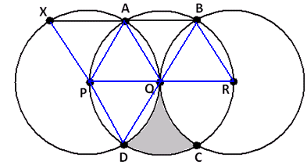

  - $\overline{AB}$ is extended until it meets the circle with center $P$ at a point $X$. Explain, in detail, why $X$, $P$, and $D$ are collinear.
Draw in the radii shown.
Triangles $\text{APQ}$, $\text{QBR}$, and $\text{PQD}$ are equilateral, so all angles in those triangles have measure 60°. $\text{△}\text{ABQ}$ is isosceles with an angle at Q of measure 180° $-$60° $-$ 60° $=$ 60°. It follows that it is equilateral as well.
We have $\text{m}\text{∠}\text{XAP} \text{= }\text{180}\text{°}-\text{m}\text{∠}\text{PAQ}-\text{m}\text{∠}\text{QAB} \text{= }\text{180}\text{°}-\text{60}\text{°}-\text{60}\text{°} \text{= }\text{60}\text{°}$. Since $\text{△}\text{XPA}$ is isosceles, with one angle of measure 60°, it follows that it is also equilateral. In particular, $\text{m}\text{∠}\text{XPA} \text{=} \text{60°}$.
Thus, $\text{m}\text{∠}\text{XPD} \text{= }\text{60}\text{°} \text{+} \text{60}\text{°} \text{+} \text{60}\text{°} \text{= }\text{180}\text{°}$, showing that X, P, and D are collinear.

  - In the diagram, a section is shaded. What percent of the full area of the circle with center $Q$ is shaded?
Draw the segment $\overline{\text{AD}}$ shown. We see that it divides a sector of the circle with center Q into two regions, which we have labeled I and II.
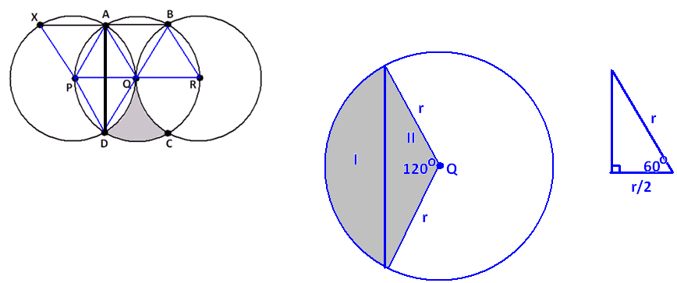
If we can determine the area of region I, then we see that the area of the desired shaded region is $\frac{\text{1}}{\text{2}}\left(\text{area full circle}-\text{4} \text{× }\text{area}\text{(}\text{region I}\right)$.
Now $\text{area}\left(\text{I} \text{+} \text{II}\right)\text{ = }\frac{\text{120}}{\text{360}}\text{π}{\text{r}}^{\text{2}}\text{ = }\frac{\text{1}}{\text{3}}\text{π}{\text{r}}^{\text{2}}$, where r is the radius of the circle.
Region II is composed of two congruent right triangles, each containing a 60° angle and each with hypotenuse r. It follows that the remaining sides of each are $\frac{\text{r}}{\text{2}}$ and $\sqrt{{\text{r}}^{\text{2}}-{\left(\frac{\text{r}}{\text{2}}\right)}^{\text{2}}}\text{ = }\frac{\sqrt{\text{3}}\text{r}}{\text{2}}$. Thus, region II is a triangle with base $\sqrt{3}$r and height $\frac{\text{r}}{\text{2}}$, so it has an area of $\frac{\text{1}}{\text{2}}\text{ × }\sqrt{\text{3}}\text{r} \text{× }\frac{\text{r}}{\text{2}}\text{ = }\frac{\sqrt{\text{3}}}{\text{4}}\text{r}$. We have $\text{area I} \text{=} \text{area}\left(\text{I} \text{+} \text{II}\right)-\text{area II} \text{= }\frac{\text{1}}{\text{3}}\text{π}{\text{r}}^{\text{2}}-\frac{\sqrt{\text{3}}}{\text{4}}{\text{r}}^{\text{2}}$.
Thus, the shaded region in question has an area of
$$\frac{\text{1}}{\text{2}}\left(\text{π}{\text{r}}^{\text{2}}-\text{4}\left(\frac{\text{1}}{\text{3}}\text{π}{\text{r}}^{\text{2}}-\frac{\sqrt{\text{3}}}{\text{4}}{\text{r}}^{\text{2}}\right)\right)\text{= }\frac{\text{1}}{\text{2}}\text{π}{\text{r}}^{\text{2}}-\frac{\text{2}}{\text{3}}\text{π}{\text{r}}^{\text{2}}\text{ = }\left(\frac{\sqrt{\text{3}}}{\text{2}}-\frac{\text{π}}{\text{6}}\right){\text{r}}^{\text{2}}.$$
The proportion of the full area $\text{π}{\text{r}}^{\text{2}}$ this represents is
$$\frac{\left(\frac{\sqrt{\text{3}}}{\text{2}}-\frac{\text{π}}{\text{6}}\right){\text{r}}^{\text{2}}}{\text{π}{\text{r}}^{\text{2}}}\text{ = }\frac{\sqrt{\text{3}}}{\text{2π}}-\frac{\text{1}}{\text{6}}$$
$$\frac{\text{1}}{\text{2}}\left(\text{π}{\text{r}}^{\text{2}}-\text{4}\left(\frac{\text{1}}{\text{3}}\text{π}{\text{r}}^{\text{2}}-\frac{\sqrt{\text{3}}}{\text{4}}{\text{r}}^{\text{2}}\right)\right)\text{= }\frac{\text{1}}{\text{2}}\text{π}{\text{r}}^{\text{2}}-\frac{\text{2}}{\text{3}}\text{π}{\text{r}}^{\text{2}}\text{ = }\left(\frac{\sqrt{\text{3}}}{\text{2}}-\frac{\text{π}}{\text{6}}\right){\text{r}}^{\text{2}}.$$
$$\text{10.9\%}$$

