Name Date

- Let $C$ be the circle in the coordinate plane that passes though the points $\left(0, 0\right)$, $\left(0, 6\right)$, and $\left(8, 0\right)$.

  - What are the coordinates of the center of the circle?

  - What is the area of the portion of the interior of the circle that lies in the first quadrant? (Give an exact answer in terms of $π$.)

  - What is the area of the portion of the interior of the circle that lies in the second quadrant? (Give an approximate answer correct to one decimal place.)

  - What is the length of the arc of the circle that lies in the first quadrant with endpoints on the axes? (Give an exact answer in terms of $π$.)

  - What is the length of the arc of the circle that lies in the second quadrant with endpoints on the axes? (Give an approximate answer correct to one decimal place.)

  - A line of slope $-1$ is tangent to the circle with point of contact in the first quadrant. What are the coordinates of that point of contact?

  - Describe a sequence of transformations that show circle $C$ is similar to a circle with radius one centered at the origin.

  - If the same sequence of transformations is applied to the tangent line described in part (f), will the image of that line also be a line tangent to the circle of radius one centered about the origin? If so, what are the coordinates of the point of contact of this image line and this circle?

- In the figure below, the circle with center $O$ circumscribes $△ABC$.

Points $A$, $B$, and $P$ are collinear, and the line through $P$ and $C$ is tangent to the circle at $C$. The center of the circle lies inside $△ABC$.
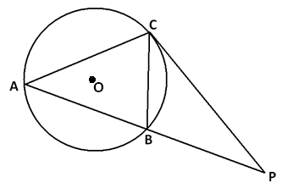
  - Find two angles in the diagram that are congruent, and explain why they are congruent.

  - If $B$ is the midpoint of $\overline{AP}$ and $PC=7$, what is the length of $\overline{PB}$?

  - If $m∠BAC=50°$, and the measure of the arc $AC$ is $130°$, what is $m∠P$?

- The circumscribing circle and the inscribed circle of a triangle have the same center.
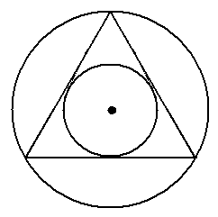
  - By drawing three radii of the circumscribing circle, explain why the triangle must be equiangular and, hence, equilateral.

  - Prove again that the triangle must be equilateral, but this time by drawing three radii of the inscribed circle.

  - Describe a sequence of straightedge and compass constructions that allows you to draw a circle inscribed in a given equilateral triangle.

  - Show that

$$\left(x-2\right)\left(x-6\right)+\left(y-5\right)\left(y+11\right)=0$$

is the equation of a circle. What is the center of this circle? What is the radius of this circle?

  - A circle has diameter with endpoints $\left(a, b\right)$ and $(c,d)$. Show that the equation of this circle can be written as

$(x-a)(x-b)+(y-c)(y-d)=0$.

- Prove that opposite angles of a cyclic quadrilateral are supplementary.
A Progression Toward Mastery
Assessment  Task Item |  | STEP 1  Missing or incorrect answer and little evidence of reasoning or application of mathematics to solve the problem. | STEP 2  Missing or incorrect answer but evidence of some reasoning or application of mathematics to solve the problem. | STEP 3  A correct answer with some evidence of reasoning or application of mathematics to solve the problem, or an incorrect answer with substantial evidence of solid reasoning or application of mathematics to solve the problem. | STEP 4  A correct answer supported by substantial evidence of solid reasoning or application of mathematics to solve the problem.
1 | a  G-GPE.A.1 | Student shows no understanding of finding the center of the circle. | Student attempts to find the diameter of the circle but finds it incorrectly. | Student finds the correct diameter of the circle but does not find the center. | Student correctly finds the coordinates of the center of the circle.
 | b  G-C.B.5  G-GPE.B.4 | Student shows no understanding of finding the area of the region. | Student finds the area of the entire circle correctly but does not find the area of the shaded region. | Student finds the area of the shaded region but not in terms of pi. | Student correctly finds the area of the shaded region in terms of pi.
 | c  G-C.B.5 | Student shows no understanding of finding the area of the region in the second quadrant. | Student finds the area of the entire circle but not the region in the second quadrant. | Student finds the area of the circle in the second quadrant but does not round correctly. | Student correctly finds the area of the circle in the second quadrant.
 | d  G-C.A.2 | Student shows no understanding of finding the length of an arc of a circle. | Student finds the length of an arc, but it is not in the first quadrant. | Student finds the length of the arc in the first quadrant but not in terms of pi. | Student correctly finds the length of the arc in the first quadrant in terms of pi.
 | e  G-C.A.2 | Student shows no understanding of finding the length of an arc of a circle. | Student finds the length of an arc, but it is not in the second quadrant. | Student finds the length of the arc in the second quadrant but does not round correctly. | Student correctly finds the length of the arc in the second quadrant.
 | f  G-GPE.A.1 | Student shows no knowledge of tangent lines to a circle. | Student shows some understanding of the relationship between a tangent line and the radius. | Student correctly writes the equation of the tangent line and the circle but makes a mathematical error in solving for the point of contact. | Student correctly finds the coordinates of the point of contact with supporting work.
 | g  G-C.A.1 | Student shows no knowledge of transformations or circle similarity. | Student shows some knowledge of transformations and circle similarity. | Student translates the circle but does not dilate or dilates but does not translate. | Student correctly describes the translation and dilation of the circle.
 | h  G-GPE.A.1  G-GPE.B.4 | Student shows no knowledge of transformations or circle similarity. | Student states that the circle and tangent line will still touch at one point but does not attempt to find the new point or states that it is the same point in part (f). | Student states that the circle and tangent line will still touch and attempts to find the new point but makes a mathematical mistake. | Student states that the circle and tangent line will still touch and correctly finds the coordinates of the new point.
2 | a  G-C.A.2 | Student shows little or no understanding of inscribed and central angles and their relationships. | Student shows some understanding of inscribed and central angles and their relationships but does not find congruent angles. | Student finds two congruent angles but does not explain their congruence accurately. | Student finds two congruent angles and accurately explains their congruence.
 | b  G-C.A.2 | Student does not identify similar triangles and makes little progress with this question. | Student identifies similar triangles but does not use the ratio of the sides to determine segment length. | Student identifies similar triangles and sets up the ratio of sides, but a mathematical mistake leads to an incorrect answer. | Student uses similar triangles and the ratio of sides to find the correct segment length.
 | c  G-C.A.2 | Student shows little or no understanding of inscribed and central angles and their relationships. | Student shows some understanding of inscribed and central angles but does not use the secant/tangent theorem to find the angle measure. | Student shows an understanding of inscribed and central angles and the secant/tangent theorem but does not arrive at the correct angle measure. | Student shows an understanding of inscribed and central angles and the secant/tangent theorem and arrives at the correct angle measure.
3 | a  G-C.A.3 | Student shows little or no understanding of an inscribed triangle. | Student draws the correct radii of the circumscribing circle but cannot explain why the triangle is equilateral. | Student identifies base angles of an isosceles triangle as congruent and recognizes that the radii are angle bisectors of the triangle but does not prove the triangle is equilateral. | Student identifies base angles of an isosceles triangle as congruent, recognizes that the radii are angle bisectors, and uses those relationships to prove the triangle is equilateral.
 | b  G-C.A.3 | Student shows little or no understanding of an inscribed circle. | Student draws the correct radii of the inscribed circle but cannot explain why the triangle is equilateral. | Student recognizes that the radii are perpendicular bisectors of the sides of the triangle but does not prove the triangle is equilateral. | Student recognizes that the radii are perpendicular bisectors of the sides of the triangle and uses the two tangent theorem to prove the triangle is equilateral.
 | c  G-C.A.3 | Student does not recognize angle bisectors or perpendicular bisectors and makes little progress on the proof. Student does not describe a suitable construction process. | Student recognizes just the angle bisectors or just the perpendicular bisectors needed to complete the proof. Student makes some progress for describing a suitable construction process. | Student recognizes the angle bisectors and perpendicular bisectors and makes progress towards completing the proof. Student makes good progress towards describing a complete construction process. | Student recognizes the angle bisectors and perpendicular bisectors and provides a well-articulated proof. Student also gives a complete description of a construction process.
4 | a  G-GPE.A.1 | Student does not complete the square correctly and does not interpret the center and radius from the equation obtained. | Student attempts to complete the square but makes mathematical mistakes leading to incorrect answers for both center and radius. | Student confuses the signs of the coordinates of the center or fails to give the square root of the quantity for the radius after conducting the correct algebraic process. | Student finds the correct center and radius with supporting work.
 | b  G-GPE.A.1 | Student does not find the center or the radius of the circle. | Student finds the center and radius of the circle correctly but does not transform the equation. | Student writes the equation of the circle using the coordinates of the center and the radius, but mathematical mistakes lead to an incorrect answer. | Student writes the equation of the circle using the coordinates of the center and the radius and shows the steps to transform the equation into the stated form.
5 | G-C.A.3 | Student does not set up a suitable scenario for constructing the proof. | Student describes a potentially suitable scenario for constructing a proof but does not complete the proof. | Student makes some good progress for establishing a proof with only minor inconsistencies in reasoning or explanation. | Student provides a thorough and elegant proof.

Name Date
- Let $C$ be the circle in the coordinate plane that passes though the points $\left(0, 0\right)$, $\left(0, 6\right)$, and $\left(8, 0\right)$.

  - What are the coordinates of the center of the circle?

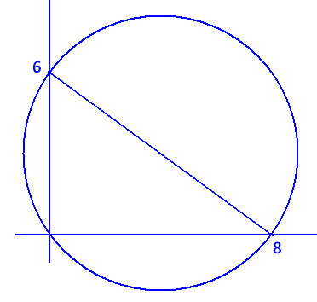
Since the angle formed by the points $\text{(0,} \text{6)}$, $\text{(0,} \text{0)}$, and $\text{(8,} \text{0)}$ is a right angle, the line segment connecting $\text{(0,} \text{6)}$ to $\text{(8,} \text{0)}$ must be the diameter of the circle. Therefore, the center of the circle is $\text{(4,} \text{3)}$, the midpoint of this diameter.

  - What is the area of the portion of the interior of the circle that lies in the first quadrant? (Give an exact answer in terms of $π$.)

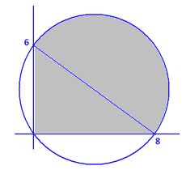
The distance between $\text{(0,} \text{6)}$ and $\text{(8,} \text{0)}$ is $\sqrt{{\text{6}}^{\text{2}} \text{+} {\text{8}}^{\text{2}}} \text{=} \text{10}$, so the circle has radius 5. The area in question is composed of half a circle and a right triangle.

Its area is $\left(\frac{\text{1}}{\text{2}} \text{∙} \text{8} \text{∙} \text{6}\right) \text{+} \left(\frac{\text{1}}{\text{2}}\text{π}{\text{5}}^{\text{2}}\right) \text{=} \frac{\text{25π}}{\text{2}} \text{+} \text{24}$ square units.

  - What is the area of the portion of the interior of the circle that lies in the second quadrant? (Give an approximate answer correct to one decimal place.)
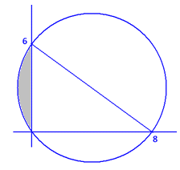
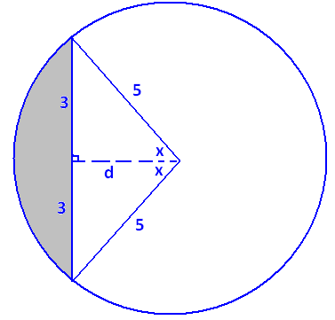
We seek the area of the region shown. We have a chord of length 6 in a circle of radius 5.
Label the angle x as shown and distance d. By the Pythagorean theorem,
d = 4. We also have that $\text{sin}\left(\text{x}\right)\text{=}\frac{\text{3}}{\text{5}}$, so $\text{x} \text{≈} \text{36.9°}$.
The shaded area is the difference of the area of a sector and of a triangle. We have
$$\text{area} \text{=} \left(\frac{\text{2x}}{\text{360}}\text{π}{\text{5}}^{\text{2}}\right)-\left(\frac{\text{1}}{\text{2}}\text{∙} \text{6}\text{∙} \text{4}\right) \text{≈} \left(\frac{\text{73.8}}{\text{360}} \text{×} \text{25π}\right)-\text{12} \text{≈} \text{4.1 square units.}$$

  - What is the length of the arc of the circle that lies in the first quadrant with endpoints on the axes? (Give an exact answer in terms of $π$.)

Since this arc is a semicircle, it is half the circumference of the circle in length: $\frac{\text{1}}{\text{2}} \text{×} \text{2π} \text{×} \text{5} \text{=} \text{5π}$ units.

  - What is the length of the arc of the circle that lies in the second quadrant with endpoints on the axes? (Give an approximate answer correct to one decimal place.)

Using the notation of part (c), this length is $\frac{\text{2x}}{\text{360}}\text{ ⋅ }\text{2π} \text{⋅ }\text{5} \text{≈} \frac{\text{73.8}}{\text{360}} \text{×} \text{10π} \text{≈} \text{6.4 }$units.

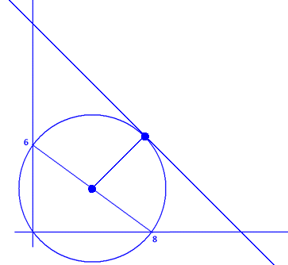
  - A line of slope $-1$ is tangent to the circle with point of contact in the first quadrant. What are the coordinates of that point of contact?
Draw a radius from the center of the circle, $\text{(4,} \text{3)}$, to the point of contact, which we will denote $\text{(x,} \text{y)}$.
This radius is perpendicular to the tangent line and has slope 1. Consequently, $\frac{\text{y} - \text{3}}{\text{x} - \text{4}} \text{=} \text{1}$; that is, $\text{y}-\text{3} \text{=} \text{x}-\text{4}$.
Also, since $\text{(x,} \text{y)}$ lies on the circle, we have
$${\left(\text{x}-\text{4}\right)}^{\text{2}} \text{+} {\left(\text{y}-\text{3}\right)}^{\text{2}} \text{=} \text{25.}$$
For both equations to hold, we must have
${\left(\text{x}-\text{4}\right)}^{\text{2}} \text{+} {\left(\text{x}-\text{4}\right)}^{\text{2}} \text{=} \text{25}$, giving $\text{x} \text{=} \text{4} \text{+} \frac{\text{5}}{\sqrt{\text{2}}}$, or $\text{x} \text{=} \text{4}-\frac{\text{5}}{\sqrt{\text{2}}}$. It is clear from the diagram that the point of contact we seek has its x-coordinate to the right of the x-coordinate of the center of the circle. So, choose $\text{x} \text{=} \text{4} \text{+} \frac{\text{5}}{\sqrt{\text{2}}}$. The matching y-coordinate is
$\text{y} \text{=} \text{x}-\text{4} \text{+} \text{3} \text{=} \text{x}-\text{1} \text{=} \text{3} \text{+} \frac{\text{5}}{\sqrt{\text{2}}}$, so the point of contact has coordinates $\left(\text{4} \text{+} \frac{\text{5}}{\sqrt{\text{2}}}\text{,} \text{3} \text{+} \frac{\text{5}}{\sqrt{\text{2}}}\right)$.

  - Describe a sequence of transformations that show circle $C$ is similar to a circle with radius one centered at the origin.
Circle C has center $\left(\text{4,} \text{3}\right)$ and radius 5.
First, translate the circle four units to the left and three units downward. This gives a congruent circle with the origin as its center. (The radius is still 5.)
Perform a dilation from the origin with scale factor $\frac{\text{1}}{\text{5}}$. This will produce a similar circle centered at the origin with radius 1.

  - If the same sequence of transformations is applied to the tangent line described in part (f), will the image of that line also be a line tangent to the circle of radius one centered about the origin? If so, what are the coordinates of the point of contact of this image line and this circle?
Translations and dilations map straight lines to straight lines. Thus, the tangent line will still be mapped to a straight line. The mappings will not alter the fact that the circle and the line touch at one point. Thus, the image will again be a line tangent to the circle.
Under the translation described in part (g), the point of contact, $\left(\text{4} \text{+} \frac{\text{5}}{\sqrt{\text{2}}}\text{,} \text{3} \text{+} \frac{\text{5}}{\sqrt{\text{2}}}\right)$, is mapped to $\left(\frac{\text{5}}{\sqrt{\text{2}}}\text{, }\frac{\text{5}}{\sqrt{\text{2}}}\right)$. Under the dilation described, this is then mapped to $\left(\frac{\text{1}}{\sqrt{\text{2}}}\text{, }\frac{\text{1}}{\sqrt{\text{2}}}\right)$.
- In the figure below, the circle with center $O$ circumscribes $△ABC$.

Points $A$, $B$, and $P$ are collinear, and the line through $P$ and $C$ is tangent to the circle at $C$. The center of the circle lies inside $△ABC$.
  - Find two angles in the diagram that are congruent, and explain why they are congruent.
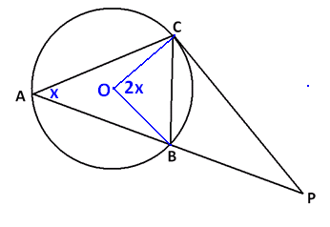
Draw two radii as shown. Let $\text{m}\text{∠}\text{BAC} \text{=} \text{x}$. Then by the inscribed/central angle theorem, we have $\text{m}\text{∠}\text{BOC} \text{=} \text{2x}$.
Since $\text{△}\text{BOC}$ is isosceles, it follows that $\text{m}\text{∠}\text{OCB} \text{=} \frac{\text{1}}{\text{2}}\left(\text{180°}-\text{2x}\right) \text{=} \text{90°}-\text{x}$.
By the radius/tangent theorem, $\text{m}\text{∠}\text{OCP} \text{=} \text{90}\text{°}$, so $\text{m}\text{∠}\text{BCP} \text{=} \text{x}$.
We have $\text{∠}\text{BAC} \text{≅ ∠}\text{BCP}$ because they intercept the same arc and have the same measure.

  - If $B$ is the midpoint of $\overline{AP}$ and $PC=7$, what is the length of $\overline{PB}$?
By the previous question, $△$ACP and $△$CBP each have an angle of measure x and share the angle at P. Thus, they are similar triangles.
Since $△$ACP and $△$CBP are similar, matching sides come in the same ratio. Thus,
$\frac{\text{PB}}{\text{PC}} \text{=} \frac{\text{PC}}{\text{AP}}$. Now, $\text{AP} \text{=} \text{2} \text{⋅ }\text{PB}$, and $\text{PC} \text{=} \text{7}$, so $\frac{\text{PB}}{\text{7}} \text{=} \frac{\text{7}}{\text{2PB}}$. This gives $\text{PB} \text{=} \frac{\text{7}}{\sqrt{\text{2}}}$.

  - If $m∠BAC=50°$, and the measure of the arc $AC$ is $130°$, what is $m∠P$?
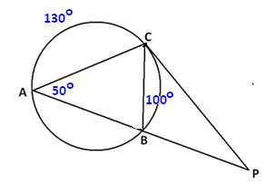
By the inscribed/central angle theorem, arc BC has measure 100°. By the secant/tangent angle theorem,
$$\text{m}\text{∠}\text{P} \text{=} \frac{\text{130°} - \text{100°}}{\text{2}} \text{=} \text{15°}.$$
(One can also draw in radii and base angles in triangles to obtain the same result.)

- The circumscribing circle and the inscribed circle of a triangle have the same center.
  - By drawing three radii of the circumscribing circle, explain why the triangle must be equiangular and, therefore, equilateral.
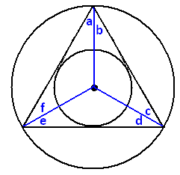
Draw the three radii as directed, and label six angles a, b, c, d, e, and f as shown.
We have a = f because they are base angles of an isosceles triangle. (We have congruent radii.) In the same way, b = c and d = e.
From the construction of an inscribed circle, we know that each radius drawn is an angle bisector of the triangle. Thus, we have
a = b, c = d, and e = f.
It now follows that a = b = c = d = e = f. In particular, a + b = c + d = e + f, and the triangle is equiangular. Therefore, the triangle is equilateral.
  - Prove again that the triangle must be equilateral, but this time by drawing three radii of the inscribed circle.
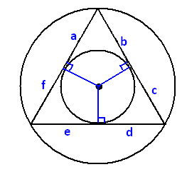
By the construction of the circumscribing circle of a triangle, each radius in this picture is the perpendicular bisector of a side of the triangle. If we label the lengths a, b, c, d, e, and f as shown, it follows that b = c, d = e, and a = f.
By the two-tangents theorem, we also have a = b, c = d, and e = f.
Thus, a = b = c = d = e = f, and in particular,
b + c = d + e = a + f; therefore, the triangle is equilateral.

  - Describe a sequence of straightedge and compass constructions that allows you to draw a circle inscribed in a given equilateral triangle.
The center of an inscribed circle lies at the point of intersection of any two angle bisectors of the equilateral triangle.
To construct an angle bisector:
    - Draw a circle with center at one vertex P of the triangle intersecting two sides of the triangle. Call those two points of intersection A and B.
    - Setting the compass at a fixed width, draw two congruent intersecting circles, one centered at A and one centered at B. Call a point of intersection of these two circles Q. (We can assume Q is different from P.)
    - The line through P and Q is an angle bisector of the triangle.
Next, construct two such angle bisectors and call their point of intersection O. This is the center of the inscribed circle. Finally, draw a line through O perpendicular to one side of the triangle. To do this:
    - Draw a circle centered at O that intersects one side of the triangle at two points. Call those points C and D.
    - Draw two congruent intersecting circles, one with center C and one with center D.
    - Draw the line through the points of intersection of those two congruent circles. This is a line through O perpendicular to the side of the triangle.
Suppose this perpendicular line through O intersects the side of the triangle at the point R. Set the compass to have width equal to OR. This is the radius of the inscribed circle; so, drawing a circle of this radius with center O produces the inscribed circle.

  - Show that
$$\left(x-2\right)\left(x-6\right)+\left(y-5\right)\left(y+11\right)=0$$

is the equation of a circle. What is the center of this circle? What is the radius of this circle?
We have
$$\left(\text{x}-\text{2}\right)\left(\text{x}-\text{6}\right) \text{+} \left(\text{y}-\text{5}\right)\left(\text{y} \text{+} \text{11}\right) \text{=} \text{0} \\ {\text{x}}^{\text{2}}-\text{8x} \text{+} \text{12} \text{+} {\text{y}}^{\text{2}} \text{+} \text{6y}-\text{55} \text{=} \text{0} \\ {\text{x}}^{\text{2}}-\text{8x} \text{+} \text{16} \text{+} {\text{y}}^{\text{2}} \text{+} \text{6y} \text{+} \text{9} \text{=} \text{4} \text{+} \text{64 } \\ {\left(\text{x}-\text{4}\right)}^{\text{2}} \text{+} {\left(\text{y} \text{+} \text{3}\right)}^{\text{2}} \text{=} \text{68}\text{.}$$
This is the equation of a circle with center $\left(\text{4,} \text{-3}\right)$ and radius $\sqrt{\text{68}}$.

  - A circle has diameter with endpoints $\left(a, b\right)$ and $(c,d)$. Show that the equation of this circle can be written as
$(x-a)(x-b)+(y-c)(y-d)=0$.
The midpoint of the diameter, which is $\left(\frac{\text{a} \text{+} \text{c}}{\text{2}}\text{,}\frac{\text{b} \text{+} \text{d}}{\text{2}}\right)$, is the center of the circle; half the distance between the endpoints, which is $\frac{\text{1}}{\text{2}}\sqrt{{\left(\text{c}-\text{a}\right)}^{\text{2}} \text{+} {\left(\text{d}-\text{b}\right)}^{\text{2}}}$, is the radius of the circle. Thus, the equation of the circle is
$${\left(\text{x}-\frac{\text{a} \text{+} \text{c}}{\text{2}}\right)}^{\text{2}} \text{+} {\left(\text{y}-\frac{\text{b} \text{+} \text{d}}{\text{2}}\right)}^{\text{2}} \text{=} \frac{\text{1}}{\text{4}}\left({\left(\text{c}-\text{a}\right)}^{\text{2}} \text{+} {\left(\text{d}-\text{b}\right)}^{\text{2}}\right)\text{. }$$
Multiplying through by 4 gives
$${\left(\text{2x}-\text{a}-\text{c}\right)}^{\text{2}} \text{+} {\left(\text{2y}-\text{b}-\text{d}\right)}^{\text{2}} \text{=} {\left(\text{c}-\text{a}\right)}^{\text{2}} \text{+} {\left(\text{d}-\text{b}\right)}^{\text{2}}\text{.}$$
This becomes
$$\text{4}{\text{x}}^{\text{2}} \text{+} {\text{a}}^{\text{2}} \text{+} {\text{c}}^{\text{2}}-\text{4xa}-\text{4xc} \text{+} \text{2ac} \text{+} \text{4}{\text{y}}^{\text{2}} \text{+} {\text{b}}^{\text{2}} \text{+} {\text{d}}^{\text{2}}-\text{4yb}-\text{4yd} \text{+} \text{2bd} \text{=} {\text{c}}^{\text{2}} \text{+} {\text{a}}^{\text{2}}-\text{2ac} \text{+} {\text{d}}^{\text{2}} \text{+} {\text{b}}^{\text{2}}-\text{2bd.}$$
That is,
$$\text{4}{\text{x}}^{\text{2}}-\text{4xa}-\text{4xc} \text{+} \text{4ac} \text{+} \text{4}{\text{y}}^{\text{2}}-\text{4yb}-\text{4yd} \text{+} \text{4bd} \text{=} \text{0.}$$
Dividing through by 4 gives
$${\text{x}}^{\text{2}}-\text{xa}-\text{xc} \text{+} \text{ac} \text{+} {\text{y}}^{\text{2}}-\text{yb}-\text{yd} \text{+} \text{bd} \text{=} \text{0.}$$
That is,
$$\left(\text{x}-\text{a}\right)\left(\text{x}-\text{c}\right) \text{+} \left(\text{y}-\text{b}\right)\left(\text{y}-\text{d}\right) \text{=} \text{0,}$$
as desired.
- Prove that opposite angles of a cyclic quadrilateral are supplementary.
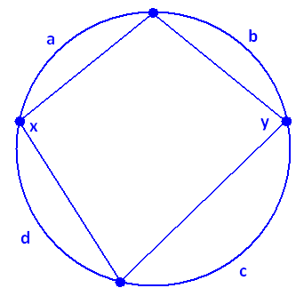
Consider a cyclic quadrilateral with two interior opposite angles of measures x and y, as shown.
The vertices of the quadrilateral divide the circle into four arcs. Suppose these arcs have measures a, b, c, and d, as shown.
By the inscribed/central angle theorem, we have
a + d = 2y and b + c = 2x. So, a + b + c + d = 2(x + y).
But, a + b + c + d = 360°. Thus, it follows that
$\text{x} \text{+} \text{y} \text{=} \frac{\text{360°}}{\text{2}} \text{=} \text{180°}$.
By analogous reasoning, the angles in the second pair of interior opposite angles are supplementary as well. (This also follows from the fact that the interior angles of a quadrilateral add to 360°. The second pair of interior angles have measures adding to
360° $-$ x $-$ y = 360° $-$ 180° = 180°.)

