Lesson 29
Objective: Tally 9 objects.

Suggested Lesson Structure
 Fluency Practice (2 minutes)
 Application Problem (3 minutes)
 Concept Development (17 minutes)
 Student Debrief (3 minutes)
Total Time (25 minutes)
Fluency Practice (2 minutes)
- March and Count from 0 to 10 PK.CC.1 (2 minutes)
March and Count from 0 to 10 (2 minutes)
Note: Marching and counting to 10 prepares students for upcoming objective of touching and counting to 10.
T: Let’s count from 0 to 10 and count each march. 0, 1, 2, 3, 4, 5, 6, 7, 8, 9, 10. Remember, don’t march when we count 0! (Repeat until all are marching. Pause between counts.)
Application Problem (3 minutes)
Materials: (T) Numeral Cards 4–9 (1 to match each cup, Lesson 26 Template 2) (S) Cup containing 4–9 bee stickers
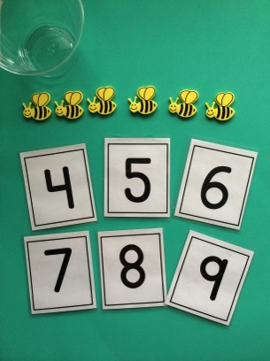
Distribute a cup to each child and spread the numeral cards in the center of the circle.
It’s time to open up the Pollen Café again! Let’s get the bees ready. Find the number that tells how many bees are in your cup.
Circulate and make sure that students are lining up their bees and counting with
one-to-one correspondence. Once children have found the correct numeral, have them place it in the cup with the bees.
Note: This application sets the context for the Concept Development. Create cups with 4–5 bees for students who are still mastering smaller numbers, but have 6–9 bees in most cups.

Concept Development (17 minutes)
Part 1: Concept Introduction
Materials: (T) Cup containing 9 bee stickers, number path folded to 9 (Lesson 10 Template), paper and crayon (or white board), 9 flowers (S) Paper and crayon (or white board)
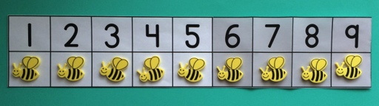
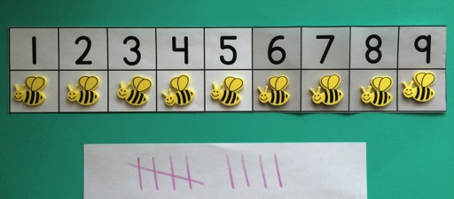
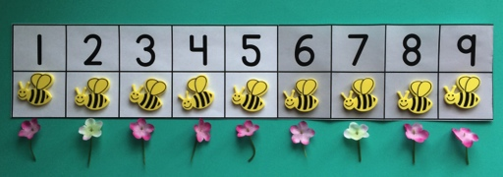
- Select a child to bring the bee customers to the Pollen Café. Give him/her the cup of bees. Display the number path. Say, “Carefully put the customers in these special bee seats.” Help the student place 1 bee in each spot on the number path.
- Ask, “How many bees did our friend seat in the Pollen Café?” Give students a moment to think before prompting the count. Touch as the class counts. Use self-talk to point out the relationship between the count and the number path, “We counted 9 bees. Look! The last bee is sitting in the chair next to the number 9. That is the same as our count.”
- Tell the students that you will order for each bee. Say, “May I have 1 flower please?” in a variety of voices while giving students the chance to tally. Guide them to make 1 tally mark for each order. Signal the fifth order so that children remember to make a diagonal tally.
- Say, “Now the waiter is ready to take the order to the chef!” Take the order of 9 flowers back to the customers. Have children count the flowers with you, giving each bee a flower as they count.
Part 2: Practice
Materials: (S) Cup containing 4–9 bee stickers, number path folded to 9 (Lesson 10 Template), paper and crayon (or white board)

NOTES ON
MULTIPLE MEANS
OF ENGAGEMENT:
Planning other meaningful times in the day that would give students an opportunity to practice tally marks will support effort and persistence, e.g. taking attendance, counting snacks, taking lunch count for a group of students, or tallying the students in a center.

Assign each student to be either the person to seat the bees or a waiter. Distribute the appropriate materials.
- Have one partner seat the bee customers from their cup on the number path, then order by saying, “May I have one flower please?,” for each bee. Have the waiters tally the flower orders, 1 per bee. (If students still need to match 1-to-1 in order to make tallies, allow them to match each tally to a bee as learned in earlier lessons.)
- Support waiters as they tally the order. Encourage the other partner to count the tally to make sure it matches the order.
- Have children switch roles and repeat with a new cup of bees, ensuring that everyone has a chance to practice making tally marks.
Student Debrief (3 minutes)
Lesson Objective: Tally 9 objects.
The Student Debrief is intended to invite reflection and active processing of the total lesson experience. It is also an opportunity for informal assessment. Consider taking anecdotal notes or using a simple checklist to note each child’s progress towards meeting the lesson objective.
As students complete the Practice portion of the lesson, listen for misconceptions or misunderstandings that can be addressed in the Debrief. You may choose to use any combination of the questions below to help students express ideas, make connections, and use new vocabulary.
- (Display an example of student work from the Practice including the number path, bees, and tally.) How could these tally marks help the waiter remember how many flowers to get in the kitchen?

CENTER CONNECTION:
Continue to run the Pollen Café in the dramatic play center. Make sure students take turns seating customers and being waiters so everyone has a chance to practice tallying. Prepare a few bags with flowers (4-9 to match the bees) and include the matching numeral. Waiters can deliver the flowers to the customers.

- (Show number path and white board.) What if none of our bees ordered a flower? How would I tally up zero orders?
- (Show number path.) What do you know about 9?
- (Show 9 tallies. Point to the group of 5.) How many tally marks are in this group? (Point to the group of 4.) How many tally marks are in this group? How many tallies would be in the group if I made 1 more tally?

