Lesson 27
Objective: Count 9 objects in circular configurations.

Suggested Lesson Structure
 Fluency Practice (5 minutes)
 Application Problem (4 minutes)
 Concept Development (13 minutes)
 Student Debrief (3 minutes)
Total Time (25 minutes)
Fluency Practice (5 minutes)
- Clap and Count from 0 to 10! PK.CC.3a (1 minutes)
- Make a Line of 9 Beans PK.CC.3a (4 minutes)
Clap and Count from 0 to 10! (1 minute)

NOTES ON
MULTIPLE MEANS
OF EXPRESSION:
You might make a musical counting band of percussion instruments with different students using cow bells, shakers, drums of various kinds, tambourines, etc. If students excel, let it be a marching band!

Note: Students count from 0 to 10 while making one clap for one counting word, a bridge between rote counting and one touch for one count. By drawing out the “fiiiive” the students have a chance to see the relationship of 9 and 10 to 5.
T: Let’s clap and count to 10. Join in when you are ready. 0, 1, 2, 3, 4, fiiiive, 6, 7, 8, 9, 10. (Repeat the count until all are participating.)
Make a Line of 9 Beans (4 minutes)
Materials: (S) 5 red beans, 4 white beans
Note: During this fluency activity, circulate and watch students’ counting strategies.
T: Put your red beans in a line. (Pause.) Count them. Let me hear you counting!
S: 1, 2, 3, 4, 5.
T: Put your white beans in a different line. (Pause.) Count them! Let me hear you counting!
S: 1, 2, 3, 4.
T: Move your line of white beans to the end of your line of red beans to make one long line of beans.
T: Touch and count to find out how many beans are in your line now.
S: 1, 2, 3, 4, 5, 6, 7, 8, 9.
Show students the numerals from 1 to 9. Ask them which one shows the number 9.
Application Problem (4 minutes)
Materials: (T) 1-5 white board or poster from GPK–M1–Lesson 22, 6-8 white board or poster from Lesson 17, 9 snails (Template 1), magnetic numerals 1–9.
Gather children in a circle. Say the following rhyme while gesturing to each object on the chart:
One little flower, 2 little bees,
3 little birds in a tree.
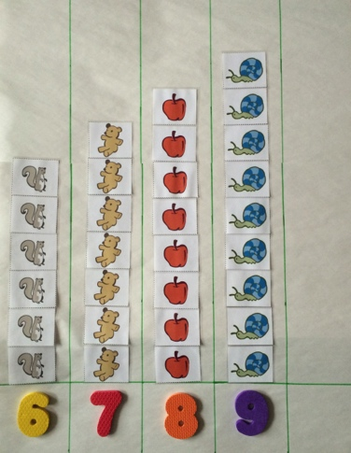
Nice warm sun shines down on me.
I can count! 1, 2, 3!

4 little kittens come out to play,
On this warm and sunny day.
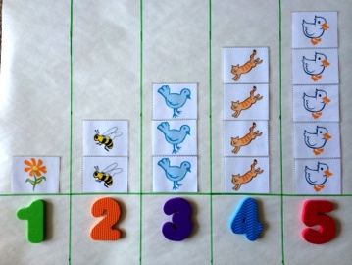
Five little ducks take a dive.
Count them: 1, 2, 3, 4, 5!

6 little squirrels, quick as can be,
Climbing up the old oak tree.
In its shade sit 7 chairs,
1, 2, 3, 4, 5, 6, 7 bears!

8 little apples up in the tree,
Some for you and some for me.
9 little snails in a line,
1, 2, 3, 4, 5, 6, 7, 8, 9!

Pass out the magnetic numerals 2, 5, 7, and 9. Ask, “Who has the number to show how many bees, (chicks, bears, and snails) there are?” Have students put the magnetic numerals on the chart to match. Say, “Clap when I touch the number 9!” Point to each number in order from 1. The students should be silent to encourage internal counting, clapping only once when the number 9 is touched.
Note: In Topic G, 10 will be added to this chart. Select a white board that can be used for this purpose for several days and leave space on the right side for the addition. Alternatively, use chart paper and objects/numerals with tape on the back.

Concept Development (13 minutes)
Part 1: Concept Introduction
Materials: (T) Magnetic numerals 0 and 6–9, 9 snails (Template 1), table template (Template 2)
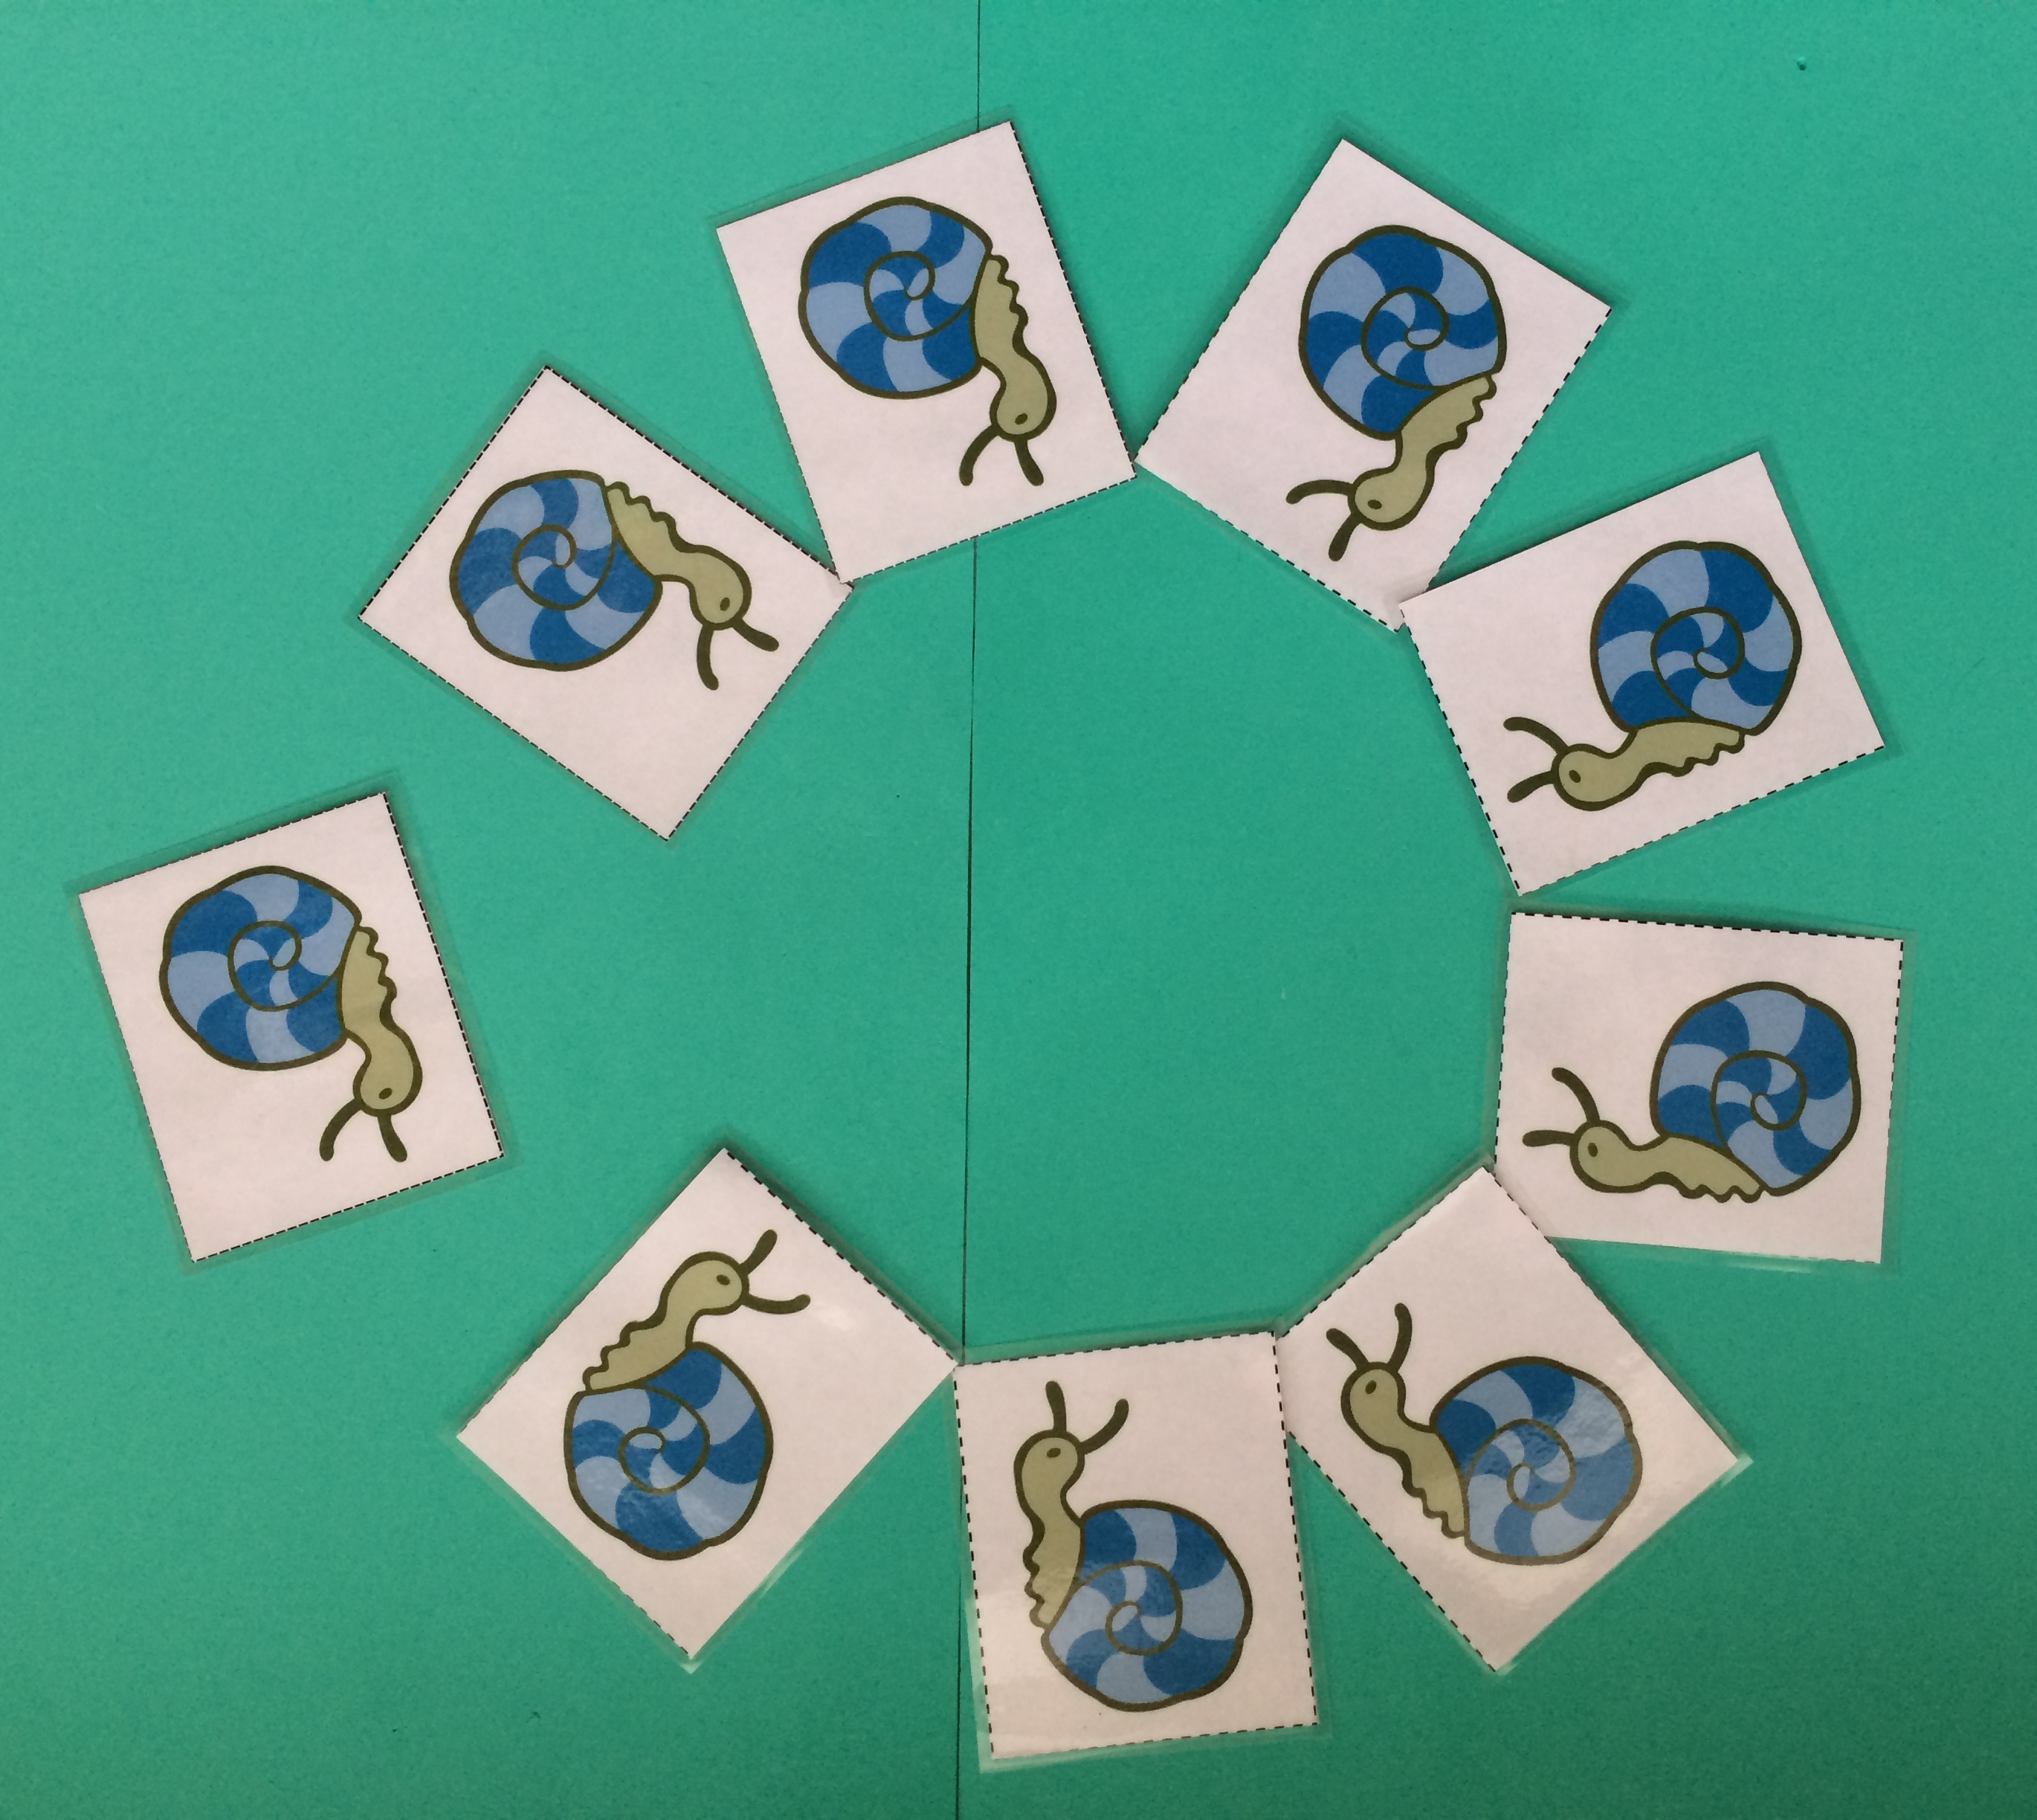
- Take the snails off the board and put them in a circle. Say, “These snails are in a circle to play Duck, Duck, Goose. Let’s count how many snails are in the circle.” Touch and count each snail. Instead of stopping at 9, continue around the circle until students notice a problem.
- Ask students for ideas about how to count things in a circle. Support them as they remember how to mark the start. Repeat the count, perhaps moving one snail out of the circle to mark the start of the count.
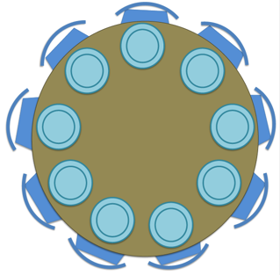
- Ask children, “Point to the number that shows how many snails are playing Duck, Duck, Goose.” Ask them, “This number? This number?” etc.
- Display the table template. Say, “After playing the game, the snails are hungry for snack and want to sit at a table with chairs (gesture to be sure the template is understood.) Are there 9 plates at the table?” Call a student forward to touch and count each plate. Suggest making a dot on the first plate with a crayon to mark the start of the count if the students do not offer a strategy. Repeat with the chairs if needed.
- Ask, “How many snails are at the table right now?” Guide children to see that there are 0 snails at the table and ask them to find the matching numeral.
Part 2: Practice

NOTES ON
MULTIPLE MEANS
OF ENGAGEMENT:
Providing all partners with beans or cubes to help mark the start of the count or to place on each object assists in counting circular configurations, and it respectfully and privately allows partners to self -monitor and use cubes if needed.

Materials: (S) Per pair: Numeral cards 5–9 (cut apart, Lesson 26 Template 2), baggies containing circular configuration cards (cut apart, Template 3), sticker or bean (to mark start)
- Match students with a partner and tell them, “Let’s play school! One of you will be the teacher and one of you will be the student.”
- Say, “Teachers, pick a bag and choose a card. Ask your student how many things are in the circle.”
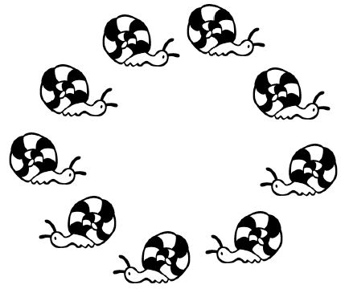
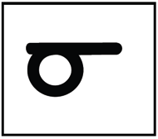
- After students have done so, say, “Teachers, find the number that matches.”
- Students switch roles, repeating Steps 2 and 3.
- Circulate among groups and support as necessary. In particular, watch to see whether students are marking a starting point for the count and whether they realize the marked object is the first one counted and does not get recounted at the end of the count.
Student Debrief (3 minutes)
Lesson Objective: Count 9 objects in circular configurations.
The Student Debrief is intended to invite reflection and active processing of the total lesson experience. It is also an opportunity for informal assessment. Consider taking anecdotal notes or using a simple checklist to note each child’s progress towards meeting the lesson objective.
As students complete the Practice portion of the lesson, listen for misconceptions or misunderstandings that can be addressed in the Debrief. You may choose to use any combination of the questions below to help students express ideas, make connections, and use new vocabulary.
- When counting the snails, what did you do to know where to stop counting? How did that help you know where to stop counting?

CENTER CONNECTION:
Invite children to help set up a circular snack table for the snails in the dramatic play center. Provide cups, plates, and napkins. Have children count the animals, cups, etc. as they are laid out in the circle. Assist them in marking the starting point of their count if needed.
- (Draw or display 5 objects in a circle. Display numerals 1–9 on the carpet.) Which number tells how many objects I have? (Pause as students will need time to count.) What if I put 1 more in the circle? (Continue adding 1 more until there are 9 objects.)
- Tell your partner if you like counting things better in a circle or a line. Why?

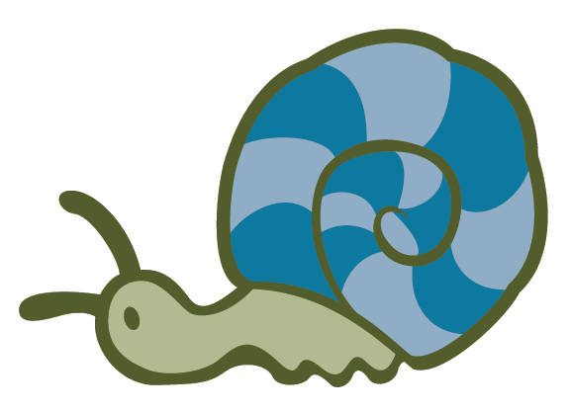
_________________
9 snails

_________________
table template

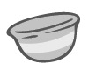
_________________________
circular configuration cards

