Lesson 26
Objective: Compose 9, and decompose into two parts. Match numerals 0 and 9 to no objects and 9 objects.

Suggested Lesson Structure
 Fluency Practice (6 minutes)
 Application Problem (3 minutes)
 Concept Development (13 minutes)
 Student Debrief (3 minutes)
Total Time (25 minutes)
Fluency Practice (6 minutes)
- Count Flaps to 10 PK.CC.1 (2 minutes)
- Count Tennis Balls PK.CC.4 (4 minutes)
Count Flaps to 10 (2 minutes)
Note: This fluency activity addresses rote counting to 10 in preparation for Topic G.
T: Let’s pretend we are baby birds again and proudly count our new skill of flapping our wings 10 times. Join in when you are ready! (Repeat until all are participating. Silence your voice for at least one entire count to ten.) 1, 2, 3, 4, 5, 6, 7, 8, 9, 10.
While keeping it playful, don’t let the students count ahead of each flap.
Count Tennis Balls (4 minutes)
Materials: (S) 9 circular counters, 3 each of 3 different colors (red, green, and orange)
Note: In this fluency activity, students are given the opportunity to practice counting 9 objects in an array configuration.
T: Pretend your counters are tennis balls. Put together a can of tennis balls that are the same color. (Pause as students stack 3 counters of the same color.)
T: Put together a different can of tennis balls. (Pause and observe.) And another. (Pause.)
T: Stack your cans like this. (Demonstrate stacking all 3 sets of counters into one stack). Count the tennis balls in your stack. (Observe their counting strategies.) How many did you count?
S: 8. 9. 10.
T: Hmmm. There should be exactly 9. Try again, and be sure to touch and count carefully.
Watch carefully to see who is able to count to 9 correctly.
Application Problem (3 minutes)

NOTES ON
MULTIPLE MEANS
OF REPRESENTATION:
If students are unable to count 9 objects in an array correctly, find time to briefly sit with them alone and observe precisely where the one-to-one correspondence is getting lost. Guide their hand gently through the number of cubes 1 or 2 less than the confusion point so that they see what they did correctly. It may be that their rote counting needs work or that the clarity between two distinct number words has not yet emerged.

Materials: (T) 9 student actors (S) 9 loose cubes, 3 each of 3 different colors (same as fluency activity)
Invite 9 students to the front and quietly ask them to form pairs (define the term pair as needed.) Have the rest of the class represent the student actors with the cubes. Ask, “What happens when you put your friends in pairs? What does it look like?”
Next have the 9 students pretend they are sitting together on a bus, where 3 children can sit in each row. Have the rest of the students represent the student actors with their cubes. What happens when you put 3 friends in a row? What does it look like?
Note: Changing between partners of 2 and groups of 3 allows students to make some important informal observations about the number 9.
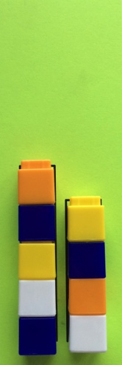
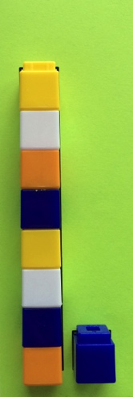
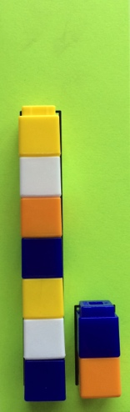
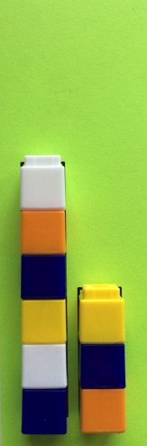
Concept Development (13 minutes)
Part 1: Concept Introduction
Materials: (T) 9 loose cubes (mixed colors with 0 red cubes), Partners of 9 Puzzles (start with 5- and 4-stick, Template 1), numeral cards 9 and 0 (Template 2)
- Place the 9 loose cubes on the floor. Invite two students forward. Tell one student to make a stick of 5 cubes and the other to make a stick of 4 cubes.
- Display the 5- and 4-stick puzzle. Invite the students to place their sticks on the matching puzzle places.
- Use self-talk while joining the two sticks: “These are such familiar numbers! Five and 4 are our good friends! I wonder what would happen if I put these two sticks together.” Join the sticks and guide children to see that there is now one longer stick. Count the 9 cubes as a class.
- Introduce the numeral 9. “This is how we show the number 9! Everyone trace it with your finger in the air.” Invite students to share about its shape and what it reminds them of.

- Ask, “Can I break this 9-stick so that I have the same two small sticks again?” Invite a student to demonstrate and prove that they are the same by placing sticks on the puzzle.
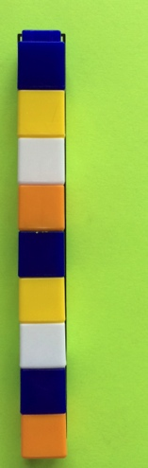
- Have students make one long stick of 9 again. Ask, “How many cubes are there in your stick?” (Pause.) How many cubes are red?” Use parallel talk to say, “Hmmm. I have 9 cubes of many colors and 0 red cubes! It’s a puzzle with 9 and 0!” Display all the Partners of 9 Puzzles. Ask, “Can you help me find the puzzle that shows 9 and 0 as partners? It should match our 9-stick and our 0-stick.” Guide children to find the matching puzzle using trial and error.
- Introduce the numeral 0. “This is how we show the number 0. Everyone trace it with your finger in the air.” Invite students to share about its shape and what it reminds them of.
Part 2: Practice
Materials: (S) 9-stick, Partners of 9 Puzzles (Template 1), numeral card 9 (Template 2)
Continue to work in the circle so children can easily pass the puzzles.
- Distribute a Partners of 9 Puzzle to each child.
- Give students a chance to break their stick and place it on a puzzle. Guide them to describe their work as they are able. For example, students may say: “I made smaller sticks.” “I broke my 9-stick into two parts.” “I have some cubes here and some cubes here.” “I have 3 cubes here and 6 cubes here.”
MP.2
- Have children put the parts together again. Guide them to count and tell how many are in their 9-stick. Each time they make 9 again, have them trace the numeral and say, “nine.”
- Have children pass the puzzle to the right and repeat Steps 2 and 3.
Student Debrief (3 minutes)
Lesson Objective: Compose 9, and decompose into two parts. Match numerals 0 and 9 to no objects and 9 objects.
The Student Debrief is intended to invite reflection and active processing of the total lesson experience. It is also an opportunity for informal assessment. Consider taking anecdotal notes or using a simple checklist to note each child’s progress towards meeting the lesson objective.

CENTER CONNECTION:
Add the Partners of 9 Puzzles to the block or puzzle center. Use a coding system so children are able to find the puzzles that go with each number (e.g., all Partners of 9 Puzzles on green paper).

As students complete the Practice portion of the lesson, listen for misconceptions or misunderstandings that can be addressed in the Debrief. You may choose to use any combination of the questions below to help students express ideas, make connections, and use new vocabulary.
- (Show Partners of 9 Puzzles.) What was the same about all of your puzzles today?
- (Show a stick of 9.) How many are in this stick? (Break the 9-stick into two smaller sticks. Then, put it back together.) How many are in this one stick? Do we have to count?
- Show me 9 fingers. Wiggle 4 fingers. (Repeat wiggling different numbers of fingers. Let them use their fingers in any way they wish.)
- (Show numeral cards 9 and 0.) Let’s compare the number 9 with the number 0. How do they look different? (Repeat with 2, 3, etc.)

Cut along dashed lines to prepare Partners of 9 Puzzles.
cvc

cvc

cvc
cvc
cvc
cvc

cvc

cvc

cvc
cvc
cvc
cvc
cvc

cvc

cvc
cvc
cvc
cvc
Cut along dashed lines to prepare Partners of 9 Puzzles.
cvc

cvc

cvc
cvc
cvc
cvc

_________________
partners of 9 puzzles

cvc

cvc
cvc
cvc
cvc
cvc
To create numeral cards: 1) Print. 2) Fold lengthwise so the outline on the numeral side matches the outline on the dot side. 3) While the paper is folded, cut out individual cards. Do not cut along the fold! 4) Laminate with cards folded so that numerals and dots match. |  | 1
 |  | 2
_________________  numeral cards |  | 3
 |  | 4 .,,,,,,,,,,,,,,,,,,,,
 |  | 5
 |  | 6
 |  | 7
 |  | 8
 |  | 9
 |  | 0

