Lesson 25
Objective: Count 9 objects in array configurations.

Suggested Lesson Structure
 Fluency Practice (6 minutes)
 Application Problem (4 minutes)
 Concept Development (12 minutes)
 Student Debrief (3 minutes)
Total Time (25 minutes)
Fluency Practice (6 minutes)
- Change of Pace Counting from 0 to 9 PK.CC.1 (2 minutes)
- Compose a Tower of 9 PK.CC.3c (4 minutes)
Change of Pace Counting from 0 to 9 (2 minutes)
Materials: (T) 9 small paper plates, 9 forks
Note: By using a change of pace, students also learn to pay attention to the precision of the “touch” and the “count.”
T: (Place the plates in an array of 2 fours and an extra at the “head” as if at a rectangular table.) Who remembers how many plates we set yesterday?
S: Not me! 9.
T: Let’s count a fork for each plate so the guests can eat birthday cake! Start with 0.
S: 0, 1, 2,…. 3,… 4, 5,...6, 7, …8, …9.
As in Lesson 24, use a change of pace starting with zero, while counting out the forks for each plate. Don’t let the students count ahead of the placement of each fork. Keep it playful and fun.
Compose a Tower of 9 (4 minutes)
Materials: (S) 9 loose cubes (3 in one color, 3 in another, and 3 in another)
Note: Moving forward from Lesson 15, this fluency activity sets the stage for the Concept Development’s array configuration. Observe the choices students make when you ask them to make 3 towers that are the same. (Do they make towers that are simply the same size? Or, are they also the same color? Or, are they the same color pattern?) Assure students that there are many correct ways to make the towers.

T: Use all your blocks to make 3 towers that are the same. (Pause and observe.)
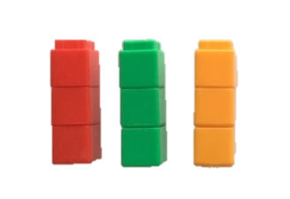
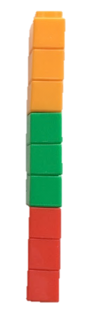
T: Put your 3 small towers together to make 1 tall tower. (Pause and observe.)
T: Break your tower again into 3 towers that are the same. How many cubes are in 1 small tower? (Pause and observe counting strategies.)
T: Put your tower together again. Touch and count to find how many cubes there are in all. (Pause and observe counting strategies.)
Application Problem (4 minutes)
Materials: (T) 3 cans of tennis balls (each with 3 balls), or tennis ball images (Template 1)
T: One morning, Bailey and Maya wanted to play tennis. Bailey found a can of tennis balls. (Invite Bailey to place the can of tennis balls on her desk, or attach the image to the board.)
T: How many tennis balls are there? I’ll touch while you count!
S: 1, 2, 3.
T: When they were playing, Victoria brought another can of tennis balls! (Invite Victoria to place another can of tennis balls next to the first on the desk.)
T: How many tennis balls are there now? I’ll touch while you count!
S: 1, 2, 3, 4, 5, 6.
T: Spencer came to play and brought another can. (Invite Spencer to place another can of tennis balls next to the first on the desk.)
T: How many tennis balls are there now? I’ll touch while you count!
S: 1, 2, 3, 4, 5, 6, 7, 8, 9.
T: How many cans of balls are there?
S: 3.
T: How many tennis balls are there? (Some students may need to recount while others remember.)
Note: This problem is designed for students to count 9 in an array configuration while also seeing 9 composed of 3 groups within the story context.
Concept Development (12 minutes)
Part 1: Concept Introduction
Materials: (T) 9 student actors, Nursery Rhymes (Template 2)
Note: The stories and songs provide a playful context for students to count an array of 9 objects. Limit the details so that counting remains the primary objective. Also, if preferred, change the words of “Three Blind Mice” from …They all ran after the farmer’s wife, who cut off their tails with a carving knife… to …who chased them away with a fork and a knife. If using your students as the animals in the story distracts from the counting, consider using toy animals (3 mice, 3 pigs, and 3 cats).
- Tell students, “I had the funniest dream last night! The animals from different storybooks and songs came to visit me! First it was the mice from “Three Blind Mice.” They were trying to get away from the farmer’s wife.” Line up 3 students to act as mice as you sing the song. Ask students, “How many mice are there? I’ll touch while you count.” “1, 2, 3.”
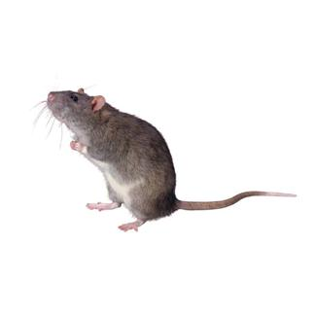
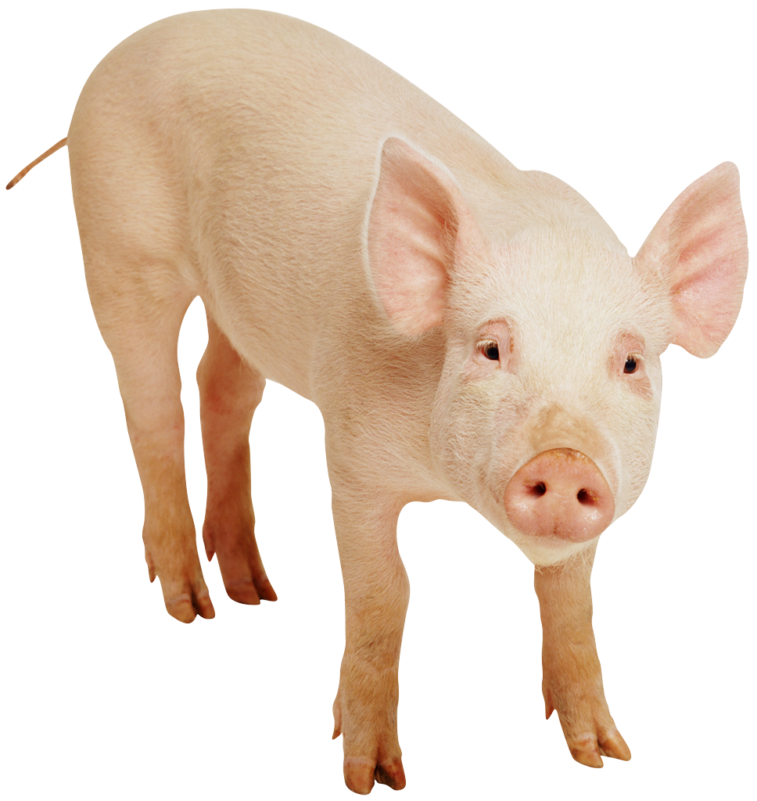
- Say, “Next, the three little pigs showed up! They were trying to get away from the big bad wolf who wanted to huff and puff and blow their house down!”
- Line up 3 students to act as pigs, and ask students to count all the animals as you touch them from left to right and top to bottom.
“I, 2, 3, 4, 5, 6.”
- Say, “Then, the three little kittens came. They needed help finding their mittens.” Line up 3 students to act as kittens as you sing the song. Ask students, “How many animals are there now?” “1, 2, 3, 4, 5, 6, 7, 8, 9.”
- Ask, “How many different kinds of animals are there?” Point to each row and guide them to say, “3.”
- Ask, “How many animals are there? Let’s count together.” Touch each actor as students count, “1, 2, 3, 4, 5, 6, 7, 8, 9.”
Part 2: Practice

NOTES ON
MULTIPLE MEANS
OF REPRESENTATION:
Provide opportunities throughout the day for the students to form 3 by 3 arrays to support comprehension. Some possible opportunities include: sitting on the rug for a story in 3 by 3 arrays, lining up in 3 by 3 arrays, etc. Make adjustments as necessary for the number of students in the class.
Materials: (T) 9 small counters (each set of 3 a different color), animal array (Template 3) (S) Per student: 9 small counters (each set of 3 a different color), animal array (Template 3)
Gather students in a circle before sending them to the prepared tables.
- Show students the template and the counters. Tell them, “Let’s pretend the counters are the mice, pigs, and kittens. Now, the animals want to visit you!”
- Show students how to line up the counters, moving from left to right and top to bottom. Have them count aloud as they place each counter.
- Instruct students to ask and answer how many questions about the animals as they place and count the counters.
- Circulate as students work, guiding them to place the counters from left to right and top to bottom, counting as they go.

Student Debrief (3 minutes)
Lesson Objective: Count 9 objects in array configurations.
The Student Debrief is intended to invite reflection and active processing of the total lesson experience. It is also an opportunity for informal assessment. Consider taking anecdotal notes or using a simple checklist to note each child’s progress towards meeting the lesson objective.
As students complete the Practice portion of the lesson, listen for misconceptions or misunderstandings that can be addressed in the Debrief. You may choose to use any combination of the questions below to help students express ideas, make connections, and use new vocabulary.
- (Using the Animal Array Template, count in a disorganized manner to 9.) Is this the best way to count these animals? What should I do differently?

CENTER CONNECTION:
Use the dramatic play or library center as a place for children to work with 3 mice, 3 pigs, and 3 kittens on the felt board. First, have children line them up in an array and count all the animals. Then, invite children to retell the stories of each threesome or make up a new story including all of the characters.
- (Show a completed Animal Array Template with 1 pig counter missing.) How many pigs are missing? How do you know? How many animals need to be in each row?
- (Show images of 8 and 9 dots in array configurations.) Which set of dots shows how many animals we counted today?

Three Blind Mice

Three blind mice. Three blind mice.
See how they run. See how they run.
They all ran after the farmer’s wife, who chased them away with a fork and a knife.
Did you ever see such a sight in your life,
As three blind mice?

Three Little Kittens
Three little kittens they lost their mittens,
And they began to cry,
Oh, mother dear, we sadly fear
Our mittens we have lost.
What! Lost your mittens, you naughty kittens!
Then you shall have no pie.
Mee-ow, mee-ow, mee-ow.
No, you shall have no pie.

tennis ball images
nursery rhymes
animal array

