Lesson 23
Objective: Use linear configurations to count 9 in relation to 5.

Suggested Lesson Structure
 Fluency Practice (6 minutes)
 Application Problem (3 minutes)
 Concept Development (13 minutes)
 Student Debrief (3 minutes)
Total Time (25 minutes)
Fluency Practice (6 minutes)
- Count to 9 PK.CC.1 (2 minutes)
- The Wind and the Trees! PK CC.3abc (4 minutes)
Count to 9 (2 minutes)
Note: Skill with rote counting gives students greater freedom to focus on the relationships between the numbers rather than struggling to retrieve the number words. By moving from loud to silent, students may start to realize they can count “inside their brains” without being heard.
T: Count to 9 for me so that I can hear you. (Students do so.)
T: Count to 9 for me so that I almost can’t hear you. (Students do so.)
T: Count to 9 so I can’t hear you. (Students do so.)
T: Close your eyes and count to 9 without moving your lips. (There is no way of knowing if students do so. Provide wait time.)
T: When I count in my mind, no one hears me or sees me counting.
The Wind and the Trees! (4 minutes)
Materials: (S) Bag with 9 manipulatives (e.g., blocks or dominoes)
Note: This fluency activity allows students to count 9 “trees” and to revisit zero.
T: Let’s pretend that we are gardeners planting trees. There are some trees in our truck. (Show the bag to make it clear you are pretending it is the truck.) How many trees have we planted?
S: Zero! None. Not any.
T: Let’s take 9 trees out of the truck and lay them flat. (Pause.) Let’s plant 9 trees in a short line.
(Demonstrate “planting a tree” by standing up the blocks facing each other.) What is the last number you said?
S: 9.
T: How many trees are planted?
S: 9.
T: A big wind came and knocked one tree down so that it knocked all the others down! (Tap the last tree so that it knocks the other trees down.) How many trees are standing up now?
S: Zero! None. Not any.
Application Problem (3 minutes)
Materials: (T) Backpack (S) Per pair: baggie with 9 manipulatives (e.g., square tiles or counters)
Say, “Now, let’s pretend we are explorers about to go on a long hike, and these are granola bars we’ll need.” I will tell you and your partner exactly how many granola bars to put in your bag.” Tell each pair of students a different number, preferably 6–8. This is a moment to differentiate by giving struggling students smaller numbers. Circulate and observe students’ counting strategies.
After students have counted their given number into their bags, collect and count the bags as you put them into the lead explorer’s backpack.
Note: Children need many opportunities to count larger groups of objects (6–9) within engaging contexts. Remember, there is at least 1 extra manipulative here. The purpose of this is to create a little complexity. Watch how students take the extra manipulative(s) into consideration (or not) when making their bags.
Concept Development (13 minutes)
Part 1: Concept Introduction
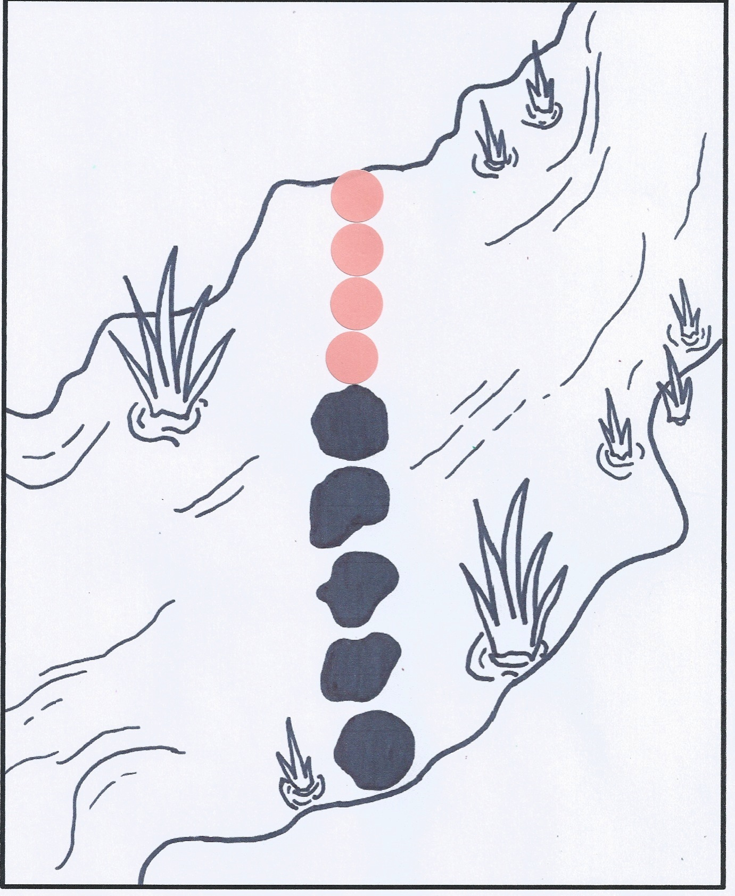
Materials: (T) Creek mat (Lesson 2 Template), 4 small round stickers, explorer figurine (optional)
Gather children in a circle around the creek mat.
- Say, “A different explorer has reached the same creek that his friend has already crossed.” Point out the line of rocks. Ask a volunteer to move the explorer across each rock while the class counts, “1, 2, 3, 4, 5.”
- Hold up a sticker and say, “Pretend this is a rock. Do you think the explorer could reach the other side if there was 1 more rock?” Add 1 sticker to the line.
- Ask, “How many rocks are there now?” Have another volunteer move the explorer across each rock while the class recounts 5 with 1 more, “1, 2, 3, 4, 5, 6. There are 6 rocks.”
- Say, “We had 5 rocks and we added…?” Students respond, “1 more!” Say, “Now, we have 6!”
- Ask, “Is he there yet?” (No.) “Let’s add another rock.” Repeat Steps 2 through 4 to count 7, then 8, and then 9 rocks.
- Ask, “How many black rocks were there?” Challenge students to ask a how many question about the new rocks.
- Ask, “How many rocks did the explorer walk on to cross the creek?” Students recount to 9.
Part 2: Practice
Materials: (S) Creek mat (Lesson 2 Template), 9 small counters or stickers

NOTES ON
MULTIPLE MEANS
OF ENGAGEMENT:
While circulating during the practice portion of the lesson, highlight student success with counting, especially for students who previously had difficulty counting a set of objects .
Send children to prepared tables.
- Tell students, “It’s your turn to help the explorer cross the creek.”
- Say, “First, take out your counters and cover the rocks in the creek.” Tell your partner how many rocks are in the line.
- Say, “Now, put 1 more rock in the line.”
- Guide students to count the black rocks, count the new rocks, and then count ALL the rocks each time they put 1 more in the line. Instruct them to ask and answer how many questions.
- Repeat Steps 3 and 4 so that there are 7, then 8, then 9 rocks. Celebrate the explorer’s crossing.
Student Debrief (3 minutes)
Lesson Objective: Use linear configurations to count 9 in relationship to 5.
The Student Debrief is intended to invite reflection and active processing of the total lesson experience. It is also an opportunity for informal assessment. Consider taking anecdotal notes or using a simple checklist to note each child’s progress towards meeting the lesson objective.
As students complete the Practice portion of the lesson, listen for misconceptions or misunderstandings that can be addressed in the Debrief. You may choose to use any combination of the questions below to help students express ideas, make connections, and use new vocabulary.
- How many rocks were in the creek at first? What did you need to do to help the explorer cross the creek?

CENTER CONNECTION:
If space permits, have students pretend to be explorers who need to travel across a creek (a pre-determined area in the classroom). Carpet squares can be used as the rocks needed to cross the creek.
- Count the black rocks. (Pause as students count.) Count the new rocks. (Pause.) Count ALL the rocks. (Pause.) How many did you count all together?
- (If your students are ready, you might ask the following question and demonstrate with linking cubes in a line.) Listen to my pattern: 5 and 1 more is 6. 6 and 1 more is 7. 7 and 1 more is 8. 8 and 1 more is…?

