Lesson 22
Objective: Introduce 9, and relate 9 to 8 and 1 more.

Suggested Lesson Structure
 Fluency Practice (6 minutes)
 Application Problem (3 minutes)
 Concept Development (13 minutes)
 Student Debrief (3 minutes)
Total Time (25 minutes)
Fluency Practice (6 minutes)
- Count Claps from 0 to 9 PK.CC.1 (2 minutes)
- Decompose 8 PK.CC.3ab (4 minutes)
Count Claps from 0 to 9 (2 minutes)
Note: Counting claps from 0 to 9 prepares students for the upcoming objective of touching and counting to 9 in the lesson and contextualizes zero in the count sequence. Be aware that many students will clap by mistake on zero. Keep it fun and playful, “Oops! There weren’t any claps to count yet! Ha-ha! Let’s try again.”
T: We are going to count to 9. I’m going to say a number, and we are going to clap that many times.
T: Zero.
S: (Claps zero times.)
T: One.
S: (Claps one time.)
T: Two.
S: (Claps two times.)
Continue with the counting sequence to 9. Continue the activity replacing claps with flaps (same process as above.)
Decompose 8 (4 minutes)
Materials: (S) 5 loose cubes of one color and 3 of another color
Note: Moving forward from Lesson 18, this fluency activity focuses on decomposing 8 into a tower of 5 and 3. Observe the students. Notice who counts the number of cubes in each part. As you circulate, whisper, “How many cubes are in this short tower? How many cubes are in this one?”
T: Open your bags and make one tall tower with all the cubes of one color touching. (Students do so.)
T: Count the number of cubes in your tall tower. (Students do so.)
T: Break your tower into parts by color. (Students do so.)
T: Put your tall tower back together. (Students do so.)
Application Problem (3 minutes)
Materials: (T) 8 small potatoes, shopping bag
Tell students that you are going to make your own French fries. “Let’s count how many potatoes I’ll need to slice.” Say the One Potato, Two Potato rhyme from Lesson 12 while touching and counting 7 potatoes.
One potato, two potato,
Three potato, four,
Five potato, six potato,
Seven potato, more.
Ask, “What does more mean?” Add another potato to the group. Say, “What is 7 and 1 more? Let’s count!” Variations on this task can include each child holding a potato and saying a part of the rhyme (e.g., “Three potato”) when it’s his turn.
Note: This task serves as a lead-in to today’s Concept Development, where children relate 8 and 1 more to 9.
Concept Development (13 minutes)
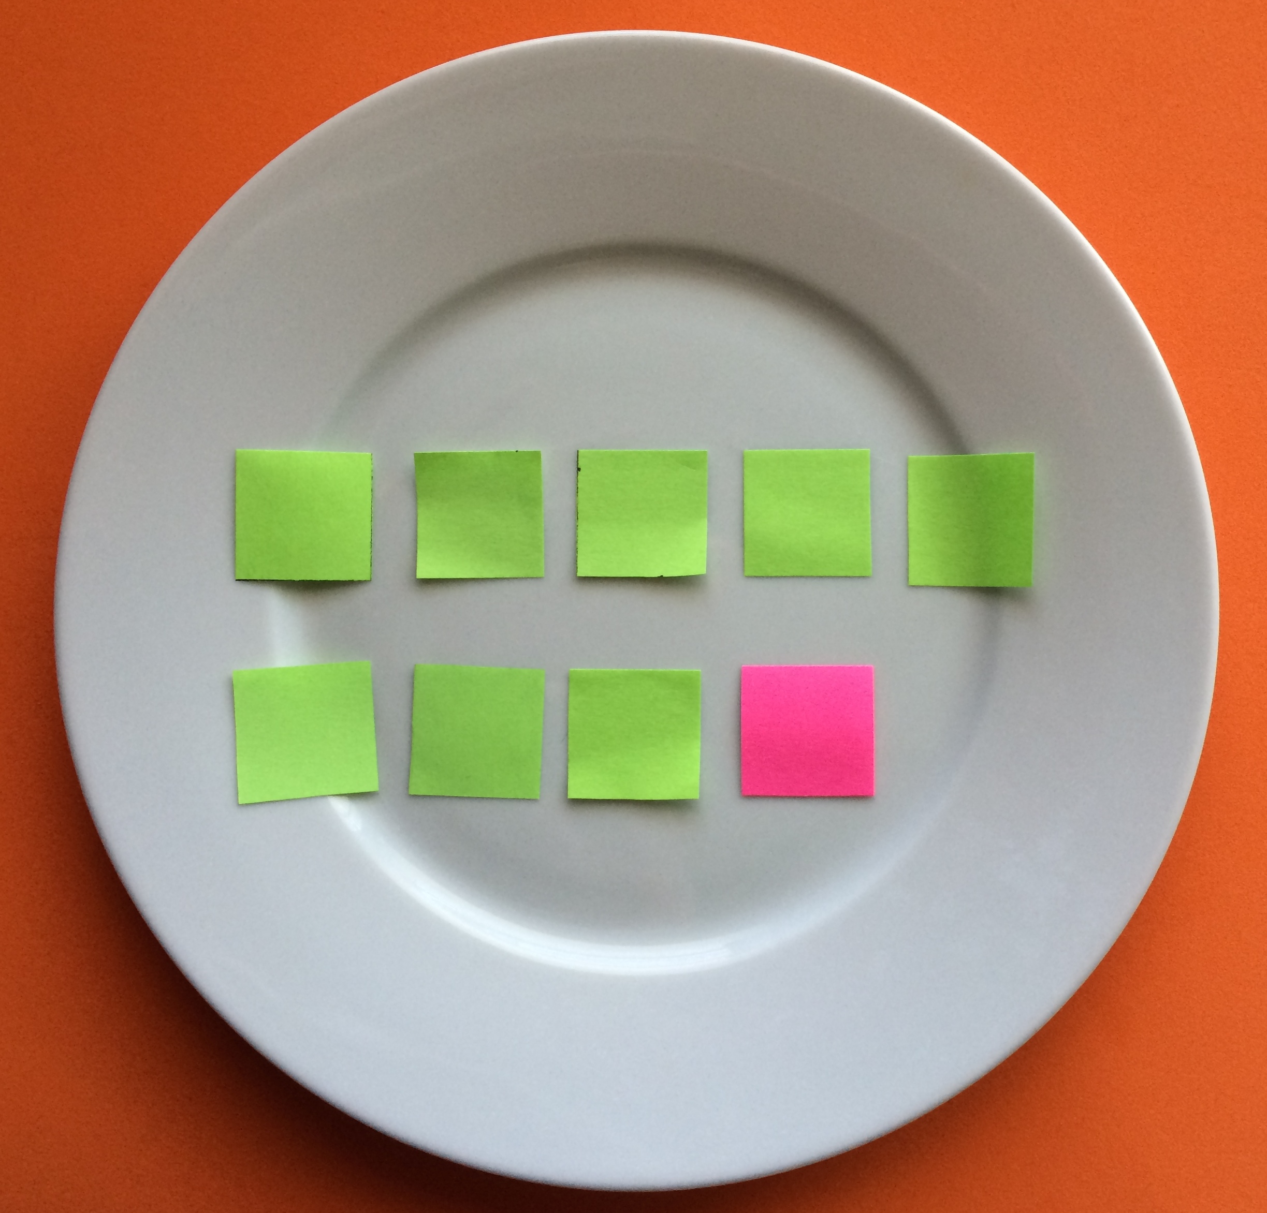
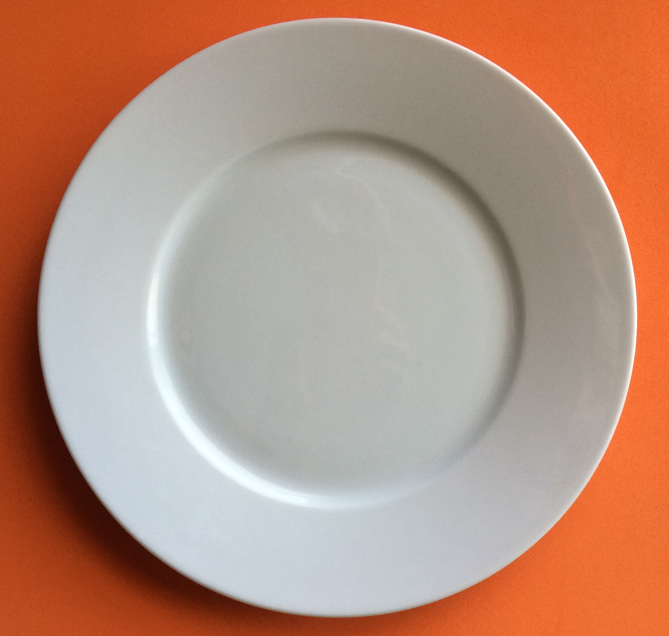
Part 1: Concept Introduction
Materials: (T) Plate, 8 grapes, and 1 blueberry
1. Show students the plate and say, “Let’s have some fruit for a snack. Here’s a plate to put our fruit on. How many pieces of fruit are on the plate?” Help students respond, “0.”
2. Say, “Count the grapes with me as I put them on the plate. Start at 0. 0, 1, 2, 3, 4, 5, 6, 7, 8. 8 grapes.”
3. Tell students, “I’m really hungry! Let’s add one more piece of fruit!” Put a blueberry on the plate. Say, “I’ll touch while you count together: 1, 2, 3, 4, 5, 6, 7, 8, 9.”
4. Touch the blueberry and ask, “What is 8 and 1 more?” Help students respond, “9.” Tell them, “Let’s find out (or check) by counting, 1, 2, 3, 4, 5, 6, 7, 8, 9.”
5. Ask, “How many pieces of fruit are there now?” Lead students to use a complete sentence, “There are 9 pieces of fruit.”
6. Say, “Yes! So, 8 and 1 more is…(point to the blueberry)?” Pause so students can respond, “9!”
7. Tell students, “Now I get to eat the fruit, but I’ll share!” Pretend to eat one, hide it behind your back, and invite 8 more students to do the same. Hold up the empty plate and ask, “How many pieces of fruit are there?”
Part 2: Practice
Materials: (S) Per student: plate, baggie containing 9 pieces of fruit (e.g., 8 grapes and 1 blueberry)
Send partners to prepared tables.

NOTES ON
MULTIPLE MEANS
FOR ACTION AND EXPRESSION:
While circulating during the practice portion of the lesson, help students who are still struggling with counting a set of objects to analyze their error and determine a way to remedy it; for example, they might organize the fruit to make counting easier.
- Tell students, “Now you get to make a snack.” Have them place each grape on the plate and say, “Count all the grapes.” Observe the configuration they use and how they count. Have them touch and count and tell their partner how many they counted (8).
- Ask them to add another piece of fruit. Have students put the blueberry on the plate and count, “1, 2, 3, 4, 5, 6, 7, 8, 9.” Say, “So, there are 8 grapes and 1 blueberry.” Tell your partner: “8 and 1 more is…?”
MP.6
- Instruct students to count as they touch each piece of fruit. Lead them to say, “1, 2, 3, 4, 5, 6, 7, 8, 9. 8 and 1 more is 9.”
- Invite students to “eat” the fruit by taking them off the plate, and to say how many there are after they are all eaten.
Student Debrief (3 minutes)

CENTER CONNECTION:
In the block center, give pairs of students 8 of the same blocks and have them count. Have them build a tower with their 8 blocks. Give each pair 1 more block to add to their structures. Have them count the total number of blocks. Invite each pair to make a new structure with their 9 blocks. Discuss why the structures all look different, even though everyone had 9 blocks.

Lesson Objective: Introduce 9, and relate 9 to 8 and 1 more.
The Student Debrief is intended to invite reflection and active processing of the total lesson experience. It is also an opportunity for informal assessment. Consider taking anecdotal notes or using a simple checklist to note each child’s progress towards meeting the lesson objective.
As students complete the Practice portion of the lesson, listen for misconceptions or misunderstandings that can be addressed in the Debrief. You may choose to use any combination of the questions below to help students express ideas, make connections, and use new vocabulary.
- Close your eyes and picture the fruit on your plate. Do you remember how many were grapes? How many were blueberries? How many pieces of fruit were there all together?
- Tell me at the signal if you can: What is 8 and 1 more without counting? (Give signal.) Let’s count to make sure (or find out).
- Let’s see which of these answers you know now. (Show 5 fingers.) “What is 5 and 1 more?” (Pause, give time to respond, pop up one finger.) Yes! Six. (Continue to show 6 fingers.) “What is 6 and 1 more?” (Continue the pattern to 9.)

